Upcoming Webinars by Our Sunday Visitor

PROMOTE IN YOUR BULLETIN, WEBSITE OR SHARE ON SOCIAL MEDIA

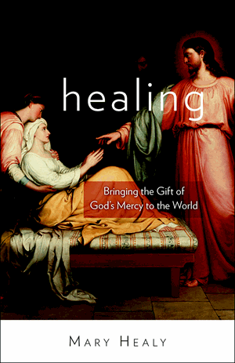
Free AUTHOR SERIES:
Healing: Bringing the Gift of God's Mercy to the World
Presented by Dr. Mary Healy
Many Catholics today think of miraculous healings as something relatively rare, found mainly in the lives of great saints or at shrines like Lourdes. Yet Scripture shows that healings, signs and wonders are meant to be a normal part of the life of the Church, especially in the context of evangelization. This webinar will explain how we can experience Jesus' healing power in our own lives, and even more, how we can be an instrument of his healing for others through the power of the Holy Spirit.

Dr. Mary Healy, professor of Sacred Scripture at Sacred Heart Major Seminary in Detroit, will discuss her recent book Healing Bringing the Gift of God's Mercy to the World and a new documentary, Fearless, which shows how the Lord heals people miraculously through the faith and prayer of ordinary Catholics.

March 15, 2017: 10-11 a.m. Eastern
Copy this link to share: http://bit.do/Healing-with-Healy

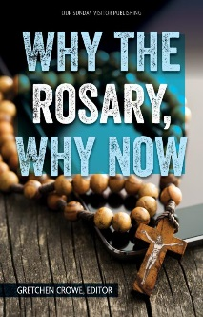
Free AUTHOR SERIES: Why the Rosary, Why Now
Presented by Gretchen Crowe, editor-in-chief of OSV Newsweekly
Without a doubt, one of the most familiar and beloved prayers within the tradition of the Catholic Church is the Rosary. But do Catholics today have a clear comprehension of the benefits of this centuries-old devotion?

Using the eloquent and inspiring writings of holy men and women who share a love of, and commitment to, the Marian prayer, editor Gretchen R. Crowe makes a compelling case for why praying the Rosary is more critical in today's twenty-first-century world than ever before.

March 20, 2017: noon-1 p.m. Eastern
Copy this link to share: http://bit.do/Why-the-Rosary

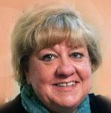
Free SAINTLY SECRETS: Saint Joseph
Presented by Woodeene Koenig-Bricker
For a man who doesn't have a single recorded word in the Gospels, we know a good deal more about St. Joseph than you might think. And it isn't all just pious legends and stories. For instance, we can be almost 100% certain that he could read and write, in a time when few were literate. Sort out fact from fiction when we discuss the foster father of Jesus.
March 21, 2017: 2-3 p.m. Eastern
Copy this link to share: http://bit.do/St-Joseph

Free MEDIA MATTERS:
Why the Couples that Pray Together Stay Together
Presented by Teresa Tomeo
You've heard the saying "the family that prays together, stays together." Well the same holds true for married couples. Join Teresa Tomeo and the Couple Prayer movement as they provide great suggestions to jump start your prayer life and also encourage you in the final weeks of Lent.
March 22, 2017: 11-12 p.m. Eastern
Copy this link to share: http://bit.do/Couples

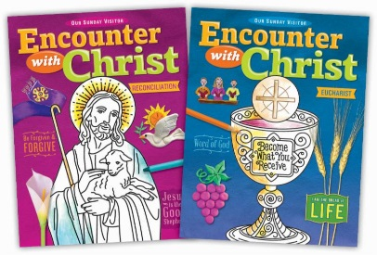
Free Encounter with Christ:
Sacrament Preparation Program Demo
Discover the BRAND NEW sacrament preparation program for Reconciliation and Eucharist- Encounter with Christ. Centered on the encounter with Christ, children meet Jesus in every session as they reflect upon the many titles and images through which we come to know him. Designed flexible for use in a parish setting, in the home, or in combination. Parents are provided with tools to foster faith-filled conversations at home, while staying connected to the parish. Each session provides options for adaptive learning and special needs, video and digital resources, and age-appropriate activities.
March 23, 2017: noon-1 p.m. Eastern

