*FREE MCA supplies available for Lenten MCA Mite Box Program (Mission Office pays each $10.00 shipment charge for any amount of free materials you request). These supplies include:
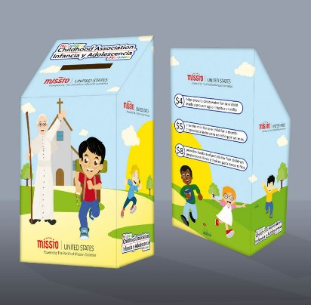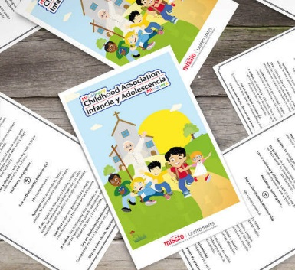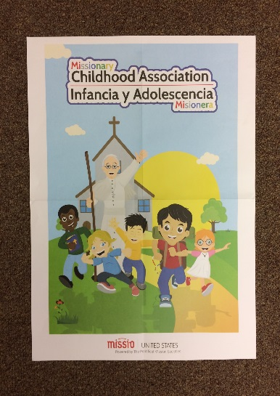
Mite Boxes Prayer Cards Posters

Please remit Lenten Mite Box Contributions as before, with checks payable to Society for the Propagation of the Faith and mail to MISSION OFFICE/Diocese of La Crosse, PO Box 4004, La Crosse, WI 54602-4004 with “MCA” in memo

To have more accurate details, save expenses, and assure your timely receipt of supplies, please fill out this form for your school or Religious Ed Program and return it as soon as possible to the Mission Office (address above) or email to mapel@diolc.org :
School or Parish Religious Ed Program: __________________________________________________________________
ATTENTION: (Principal, Teacher, or DRE name): __________________________________________________________
Shipping Address: ___________________________________________________________________________________
Number of Students: ____________
Number of Mite Boxes Requested: _________ (FREE)
Number of Prayer Cards Requested: ________ (FREE)
Number of Posters Requested: _____________(FREE)
Additional information/requests: ____________________________________________________________________________________________________________________________________________________________________________________________________

