Dear Parents and Teacher,

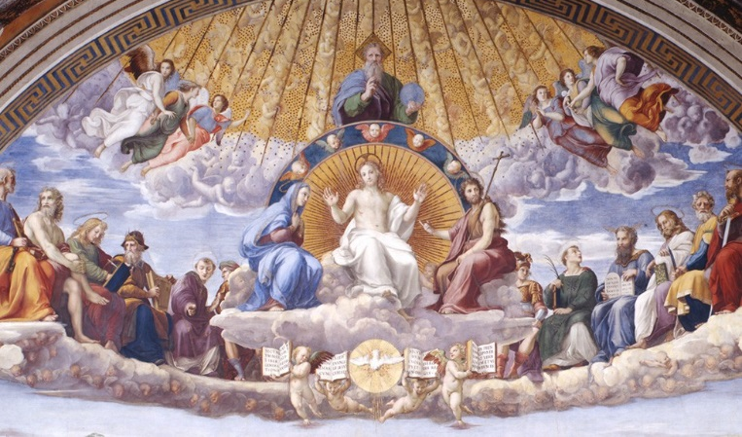
We are very excited to provide you with an initiative that has been requested over the last five years by, most notably, students, as well as parents, Catholic school teachers, DREs, CREs, youth ministers and priests. “Going Deeper: A Specific Focus on One Prayer at each Grade Level” is the title of this initiative.

The vision:
Many prayers and ways of praying are taught each year, and that needs to continue. However, there is a need for parents, their children, young people and indeed, all of us who hand on the Faith, to go deeper and deeper in our understanding of one prayer. Praying the Our Father each day allows for an encounter with Him.

“Going Deeper in Prayer” needs to begin and continue in an ongoing manner primarily in the family:
- “Family catechesis,… precedes, accompanies, and enriches all other forms of catechesis. Parents have the mission of teaching their children to pray.” (Catechism of the Catholic Church, paragraph 2226)
- “Parents are the primary educators in the faith.” (General Directory for Catechesis for the Universal Church, n. 225).
- “…With their parents leading the way by family prayer, children… will find a readier path to human maturity, salvation and holiness. (The Church in the Modern World – Gaudium et Spes, Second Vatican Ecumenical Council, n. 48)

The role of the family is so vital to each child’s understanding of the importance of and commitment to a daily habit of prayer that starting this initiative must be preceded by intentional parent engagement. In other words, you may not start “Going Deeper with Prayer” in the Catholic school or Parish Faith Formation Program until the parents are on-board. This could take place, for example, through a parent gathering where the initiative can be explained, the Prayer Card read over and the Prayer modeled, and possibly formation on prayer can take place. As each school and parish has unique family needs, it is suggested that you determine the best way to introduce this initiative while keeping in mind the need to provide formation on family prayer in an ongoing manner. If you need assistance in ways to engage your families contact either Ann Lankford or Alice Heinzen.

The goal:
The goal is that children pray in the home with their parents each day as well as in the Catholic School and Parish Program in order to continue to deepen their friendship with Jesus Christ. When the students complete the year of praying and learning about this specific prayer, it will become a part of their life that they will never forget.

Parent Resources
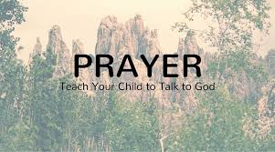
First, parents are to receive the page entitled “My Family Prayer Time” with the designated prayer on one side and information on the back that explains the initiative. This page needs to be inserted into a plastic sleeve for use throughout the year.
Young people, parents and each one of us need to continue learning about Jesus, being committed to speaking with and listening to Him on a daily basis and receiving the Sacraments in order to be strengthened to love God and our neighbor. This is the path to interior peace and true joy.
If the parents have more than one child, encourage them to begin with the prayer of the smallest child.

The following Parents and Teacher Resources are also provided online for use in helping children to go deeper in their understanding of the Our Father:
- A simple introduction about God’s love
- The goals for praying this prayer each day
- The meaning of the words of the prayer
- Learning the Principles
- Activities to help students remember the words
- Spiritual Comprehension: do they understand
- Encountering God in Prayer
- The Scriptural Foundation of the words of the prayer
- Resources

The following truths underlie any formation in prayer:

- The Person of Christ desires that we develop a friendship with Him. This relationship is prayer. We must teach about Jesus, but even more importantly, we must help students to encounter and develop a relationship with the Person of Christ in personal and communal prayer.

- We need to learn how to pray. “Like a wise teacher Jesus takes hold of us where we are and leads us progressively toward the Father.” (CCC 2607). Jesus teaches us how to pray!

- The Holy Spirit dwells within us and guides us in prayer! “The Holy Spirit is the interior Master of Christian prayer” (CCC 2672). The Holy Spirit helps and guides us to develop a daily habit of prayer. If we ask, He will even give us the desire to pray.

