World Mission Sunday Report directly from ParishSOFT
Use ParishSOFT Contribution List to generate the World Mission Sunday donor list. Navigate to the Offering tab (1) and below that select Contribution List (2). Enter Start Date and End Date in the Contribution List Filters section (3). Next, position the cursor and enter the first few letters of the appropriate Fund name in the input box below Fund, in the example below the parish Fund name is World Mission Sunday (4). A listing of contributions will be returned by the software. To export the listing choose the Export List, a right facing arrow icon (5). This will download a CSV file of your donors. You can open the file, check it for accuracy and then email it as an attachment to Marga Apel in the Mission Office (mapel@diolc.org)
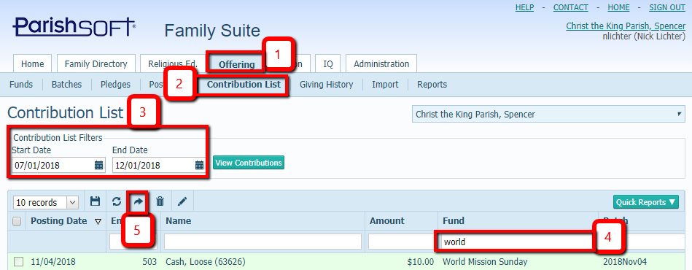

The only donor information to be forwarded includes name, address, and donation amount. Other contact information may be deleted from the emailed report.
Thank you.

