Diocese of La Crosse PNQ Accounting Transition Guide

Preparation (work to be done in your parish’s existing accounting software)
  - In ParishSOFT Accounting (PSA) login to diolc.parishsoftaccounting.com See Help and Support in the right side panel titled Support & Services
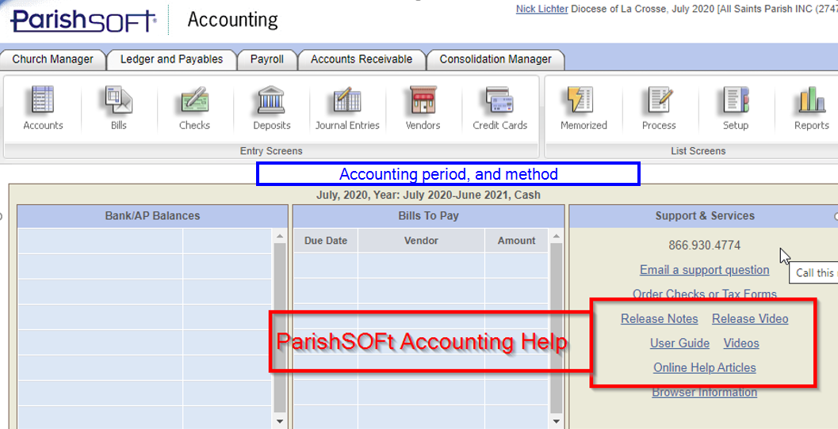
  - Verify the accounting period and accounting method. Available methods are Cash or Accrual. For a discussion of cash vs accrual methods see PSAv L&P - Accounting Methods: Cash vs Accrual (Video) or PSA L&P - Accounting Basis: How to change from cash basis accounting to accrual basis.
    - If you wish to change your account method contact ParishSOFT support.
    - The accounting period should be set for whichever date you plan to enter Beginning Balances, also known as Opening Balances. (see page 8). For PSA see PSA L&P - Accounting Period: How to increment the current accounting period (or close the month)
      - Period should be set to July, 2021, Year: July 2021-June 2022 if you do not want to enter prior year comparative data.
      - Period should be set to July, 2020, Year: July 2020-June 2021 if you plan to enter prior year comparative data.
    - In QuickBooks Online set the Company type and accounting method
      - Select Settings ⚙, then select Account and Settings.
      - The second section is Company type
      - Set Tax form to Nonprofit organization (Form 990) and Industry to Religious Organization
      - Next, from the left sidebar select the Advanced tab.
      - In the Accounting section, select Edit ✎ icon.
      - Choose the Accounting method.
      - Select Save, then Done.
  - Review inactive accounts and archive those that are not in use. See PSA L&P - Accounts: How to archive an account
  - Review 1099 vendors and remove inactive vendors. See PSA L&P or Payroll - 1099/1096: Reporting Requirements
  - Review and pay outstanding bills. If your parish uses the accrual method pay or delete as many outstanding bills as possible.
  - Review and reconcile bank accounts. These include all checking, savings, investment, endowment and credit card accounts. Reconcile to the most current available bank statement. If necessary, request a current available statement from institution where the account is held. See PSA L&P - Bank Reconciliation: How to reconcile your bank statement Basic Steps/Instructions. Or for QBO, Reconcile an account in QuickBooks Online
    - Clear and reconcile as many outstanding transactions as possible.
    - Any outstanding uncashed checks and unrecorded bank deposits will need to be re-entered in the new site.
  - Prepare archived reports. Nonprofits are required to keep financial statements indefinitely. It is important to extract a report for each years of records in your current accounting software. Export the following reports as a PDF file for each year of historical accounting recorded.
    - Detailed General Ledger Reports for each and all years. Ledgers & Payables -> Reports -> Transactions -> General Ledger See PSA L&P - Reports: General Ledger detailed transactions
        - Specify Detail Report Format
    - Statement of Financial Position (Balance Sheet) for each and all years. Ledgers & Payables -> Reports -> Statements -> Statement of Financial Position See PSA L&P - Reports: How to get a Balance Sheet
    - Profit and Loss Statements (Statement of Activities) for each and all years. Ledgers & Payables -> Reports -> Statements -> Statement of Activities See PSA L&P - Statement of Activities (Video)
    - Trial Balance for each and all years.
      - Ledgers & Payables -> Reports –> Transactions –> Trial Balance Report
        - Use Custom Date Range for fiscal year
        - Use Summary Report Format
        - Print Shortcuts in Report Options
    - Detailed Accounts Payable Ledger for last four years. This is for Accrual method parishes only. Ledgers & Payables -> Reports → Transactions → A/P Aging Detail By Period Report See PSA L&P - Reports: How to find the transactions that make up the balance of your A/P account
- Cash method parishes should run this report if you are doing Payroll. It will record any open blances in payroll withholding accounts.
    - Accounts Receivable Customer Invoices - Transactions This is for Accrual method parishes only. Accounts Receivable -> Reports –> Aging –> A/R Aging Detail By Period
      - Filter on Invoice Date
      - Custom Date Range for each fiscal year
      - Choose preferred sort option
- Only if you have the Accounts Receivable Module
- Cash method parishes do not need to run this report.

Execution (work to be done in your new accounting software)
- Click here for a Google sheet listing of all DIOLC Chart of Accounts (COA), old account cross-references and account descriptions. Navigate to the tab labeled COA References. Most parishes can be operated with 100-150 accounts.
- 1000 series accounts are Assets
- 2000 series accounts are Liabilities
- 3000 series accounts are Net Assets/Fund Balance
- 4000 series accounts are Income
- 5000 series accounts are Expense
- 6000 series accounts are Other Expense
- 8000 series accounts are Other Income
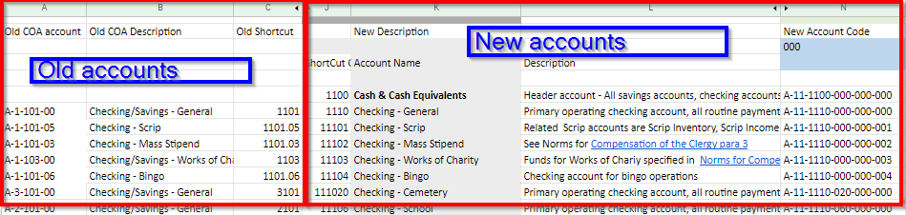
Only use the accounts which are appropriate to your parish. The process of cross-referencing your old accounts from your old system to the new chart of accounts is called account mapping. Old accounts can be found in columns A, B and C of the Google sheet. The corresponding new accounts can be found in columns J, K, L and M as shown below.
  - The new PSA site is https://diolc.parishsoftaccounting.com/ Login using the same login and password as the old site. The full set of parish chart of accounts is pre-loaded into PSA at the consolidated level. PSA parishes need to select accounts appropriate to their parish from the consolidated listing of the new chart of accounts. See PSA Getting Started - Accounts: How to add an account when part of a diocese.
  - QuickBooks Online (QBO) parishes have approximately 138 pre-loaded accounts and 13 pre-loaded classes. Review the video QBO Accounts and Classes, March 19, 2021 to learn how to properly use accounts and classes in the new COA as intended.
- Enter your 2021-2022 Fiscal year budget. Budgets only apply to Income and Expense accounts. Use the current year Statement of Activities, also known as the Profit and Loss Detail Report, from your old system as the dollar amount basis for your budget. Preparing the budget is required and a good way to verify that you’ve brought all the new income and expense accounts needed into your parish accounts. It helps verify your account mapping between new and old accounts.
  - Ledgers & Payables -> Process -> Budget Entry. In PSA Support see PSA - Ledger & Payables - Budget Entry, and PSA L&P - Budgets: How to create next year's budget using the screen entry option (used most often).
    - Verify your current accounting period as displayed in the top right portion of the application screen. The Next Year Budget will record budget figures for the fiscal year that follows whatever current accounting period your parish is currently using.
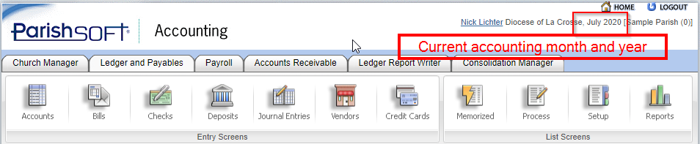
    - Click on Process
    - Click Budget Entry
    - Select Next Year Budget
    - The screen displays your active Income and Expense accounts and subaccounts. Enter an annual budget amount in the Next Year Budget column at right. The database automatically allocates the budgeted amount equally into each month of the fiscal year.
    - To edit the monthly amounts click Edit Months and enter values.
    - Click Submit at the bottom of the page to save your entries.
  - In QBO see Create budgets in QuickBooks Online
    - Select Settings ⚙️ and then Budgeting.
    - Select Add budget.
    - Enter a budget name in the Name field.
    - From the Fiscal Year dropdown, select the fiscal year for the budget.
    - Use the Interval dropdown options to set the budget as Monthly, Quarterly, or Yearly.
    - From the Subdivide by dropdown, select Class.
    - Select Next.
    - Enter your budget data into the table.
    - Select the Settings ⚙ icon at right, above the Total column to toggle the Hide blank rows checkbox and view your budgeted accounts.
    - When you're done select Save or Save and close.
- Begin recording transactions on your transition date. Once you have identified which new accounts to use, and have mapped cross-references from the new accounts to the old accounts you are ready to begin using the new Chart of Accounts for your daily transactions. Begin recording transactions in the new site as of the first day of your transition. If your transition date is April 1, then begin recording transactions April 1, and if July 1, then begin on July 1.
- Import vendors, or add new vendors into the new site. Review this support article to identify which vendors require 1099 reporting. PSA L&P or Payroll - 1099/1096: Reporting Requirements
  - 1099 vendors need to have their have their non-employee compensation calendar year 2021 balances transferred from the old system. To obtain 1099 non-employee compensation calendar year 2021 balances run Vendor Audit Report. PSA L&P - Vendor 1099: How to get a list of 1099 vendors and amounts
    - Click Reports.
    - Select Vendors. Then, select Vendor Audit.
    - In the Date Range section, select Custom Date Range Specified. In the Start Date field, select January 1, 2021 and in the End Date field, select December 31, 2021.
    - In the Report Options section, select Include Only 1099 Transactions.
    - Click Preview Report. The report lists the vendors marked as 1099 vendors and the transactions as 1099 transactions.
    - If you find that you are missing a vendor on this list, go back to that vendor and review the 1099/ Checks tab to ensure the vendor is correctly marked as a 1099 vendor.
In QBO go to Reports -> Vendor Balance Summary.
  - To enter 1099 non-employee compensation balances for calendar year 2021 navigate to the vendor record. Select 1099/Checks (1), verify that the Print 1099 box is checked (2) and add the balance as an Adjustment Amount (3).
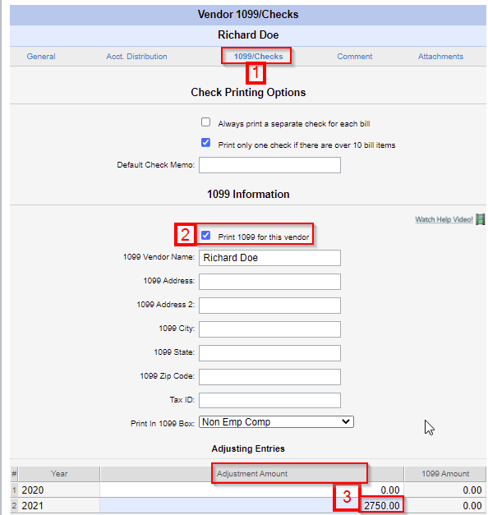
For QBO the process is very similar, as shown below:
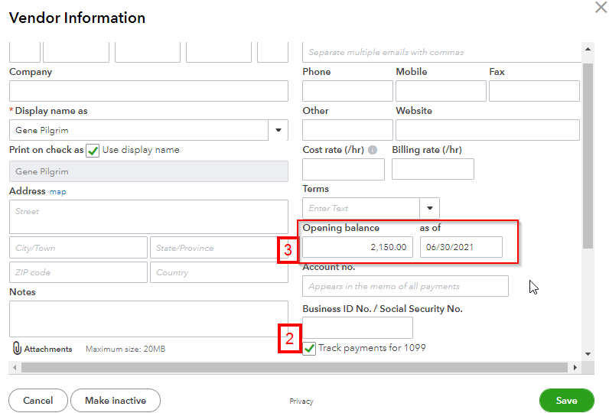
See PSA L&P - Vendor 1099: How to resolve missing or incorrect 1099 amounts
- Record uncleared and unreconciled Bills, Checks, Deposits in your new system.
- Parishes using the Accrual method should record outstanding unpaid bills. See PSA Getting Started - Bills: How to enter bills already recorded in your old system ("pseudo bills").
  - Don’t void any pseudo checks, or pseudo deposits.
  - When voiding current checks or deposits use the present date, not the date of issue.
- Record uncleared checks from last bank reconciliation
https://support.parishsoft.com/hc/en-us/articles/115002119728-PSA-Getting-Started-Checks-How-to-record-prior-system-outstanding-checks-pseudo-checks-
For Accrual Method use the 2110 Accounts Payable account for both the AP Account and the Account distribution (1). Click Assign Check Number (2). Enter the Bank Account applicable to the uncleared check, in this example 1110 Checking –General (3). Set the Check Number to that of the uncleared check (4). Set the Check Date to the Invoice Date of the Bill (5).
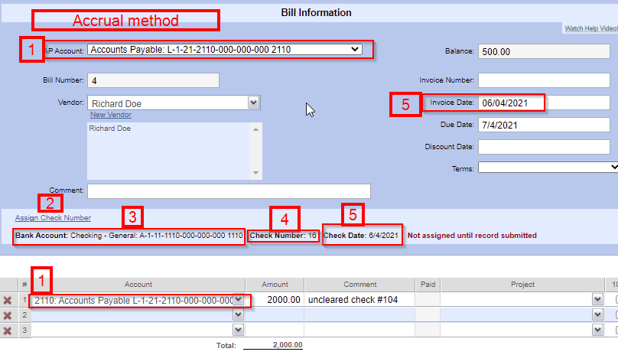
For Cash Method use account 1110 Checking- General for AP Account, Account Distribution (1) and Bank Account (3). All other data is entered as for Accrual Method.

For QBO the process for making a pseudo check is very similar. Create a Bill and simply assign Category to the applicable checking account, in this example 1110 Checking – General (1). In the top right select Mark as paid (2).
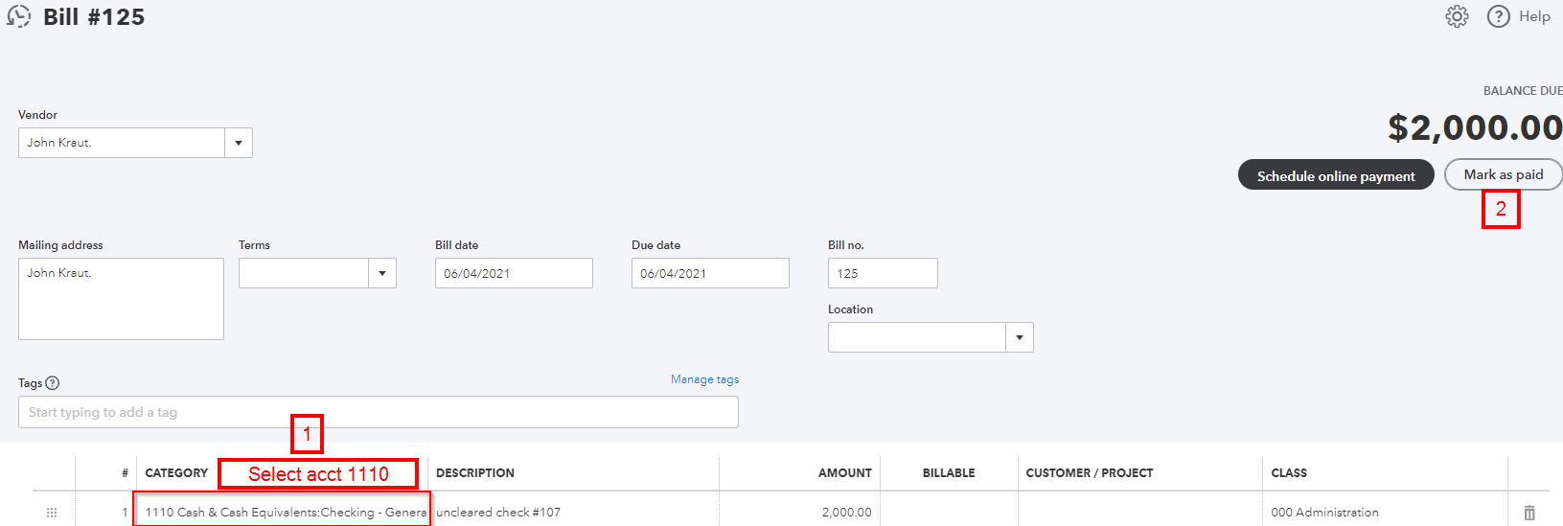
For parishes using the Accrual method of accounting it is also necessary to generate a Journal Entry to clear the pseudo transaction from 1110 Checking – General and move it to 2110 Accounts Payable, as shown in the screenshot below.
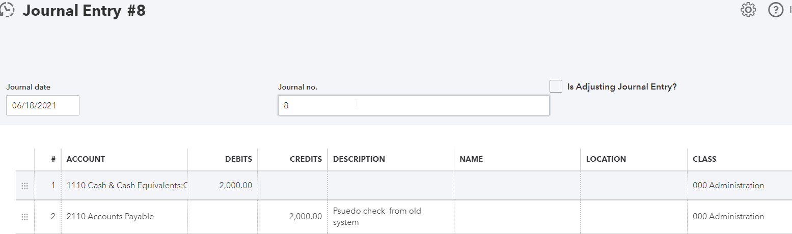
- Add uncleared deposits from last bank reconciliation
https://support.parishsoft.com/hc/en-us/articles/360000066011-PSA-Getting-Started-Deposits-How-to-Record-Prior-System-Outstanding-Deposits
- Check Layout
- Setup check layout for new bank accounts
- Enter Beginning Balances, also known as Opening Balance Equity in QuickBooks Online (QBO).
Parishes transitioning July 1, 2021 should use that date.
- Don’t do any bank reconciliations until the opening balances are recorded.
- You will need to enter beginning balances for Asset, Liability and Net Asset (ALN) accounts as of July 1, 2021, the beginning of the parish fiscal year. Beginning balances are not applicable to Income or to Expense accounts. Beginning balance of those accounts are always zero as each fiscal year begins.
      - The basis for ALN accounts beginning balances are ending balance values from your previous fiscal year, the Statement of Financial Position (Balance Sheet) balances as of the last fiscal day in your previous application. Total the end of period balances for all the old accounts that map into the new account.
      - Make sure the previous period was closed and balanced. https://support.parishsoft.com/hc/en-us/articles/115002783651-PSA-Getting-Started-Beginning-balances-Considerations-for-converting-balances-and-or-summary-activity
      - Enter a Beginning Balance for your new ALN accounts. Entering Beginning Balances is similar to creating a Journal Entry, the amounts are entered as debits and credits which must balance to zero. Unlike a journal entry, values entered using the Beginning Balance process are undated, they do not affect monthly reports or comparisons to other periods.
        - In PSA Support see PSAv L&P - Enter Beginning Balances (Video), PSA Getting Started - Basic Setup: Enter beginning balances
          - Click Process
          - Click Other Processes
          - Click Beginning Balance to display the Beginning Balance Information page.
          - The system automatically supplies a number for the entry and the date. In the Comment field, type a comment, such as “Beginning Balance.”
          - Enter ending balance values from your old system’s Statement of Financial Position (Balance Sheet) as new ALN accounts beginning balances. Remember to total together end of period balances for all the old accounts that map into the new account.
          - All ALN accounts can be recorded in a single Beginning Balance entry.
            - Asset (savings and checking): Enter the opening balance in the Debit column.
            - Liability and equity accounts: Enter the opening balance in the Credit column.
            - Accounts Payable: Enter the opening balance as a credit to increase the balance, or enter the opening balance as a debit to decrease the balance.
            - Accounts Receivable: Enter the opening balance as a debit to increase the balance, or enter the opening balance as a credit to decrease the balance.
          - The total of debit entries should equal the total of credit entries for the combined ALN accounts. The net balancing account is 3040 Fund Balance – Parish account.
          - Any subsequent adjustments to Beginning Balances can be made using the same Process screens as above. Adjustments are always recorded as double-entry transactions. The first line records whichever account balance is being adjusted, debit or credit. The second line records an offsetting balance adjustment, credit or debit, to 3040 Fund Balance – Parish account.

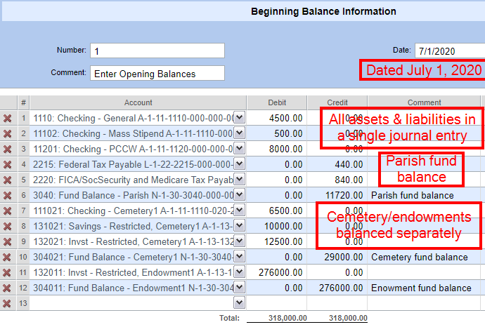
        - In QBO Support see Enter an opening balances for an account in QuickBooks Online, and What to do if you didn't enter an opening balance in QuickBooks Online
          - The QBO Support articles listed above are helpful but don’t quite fit for several reasons.
            - QBO instructions specify “When you create a new account in QuickBooks, you pick a day to start tracking transactions. Then, you enter the balance of your real-life bank account for whatever day you choose. (DOES NOT APPLY TO DIOLC) This amount and start date set the account's opening balance.” The fiscal year began July 1, 2020. This is the date to use for Opening Balance.
            - Because our Opening Balance date is the start of the fiscal year the Income account and Expense account balances are all zero.
            - QBO instructions state “Use your bank statements to enter the opening balance.” No, use the account balance from your old system’s Statement of Financial Position.
          - We recommend entering ending balance values from your old system’s Statement of Financial Position (Balance Sheet) as new ALN accounts beginning balances. Remember to total together end of period balances for all the old accounts that map into the new account.
          - Verify that your First month of fiscal year is July.
            - Go to the Gear icon.
            - Select Account and Settings.
            - Select Advanced.
            - In the Accounting section, verify that the setting in the First month of fiscal year field is “July”, or select Edit ✎ to change the setting.
            - Select Save.
            - Click Done.
          - Number the Opening Balance Equity to 3010 Opening Balance Equity. Number and rename the Retained Earnings account to 3040 Fund Balance – Parish.
            - Select Edit from the Opening Balance Equity account View register dropdown in the rightmost Action column.
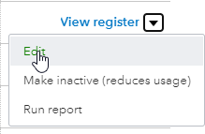
- Enter 3010 in the Number field of the Account edit screen.
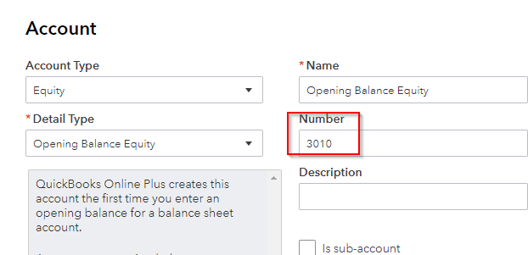
- Number and rename the Retained Earnings account as 3040 Fund Balance – Parish.
          - Connect bank and credit card accounts to QuickBooks Online In some cases QBO may automatically create an Opening Balance Equity transaction when a bank account first connects. To avoid duplicate entry, connect bank accounts before making manual entries for Opening Balance Equity.
          - Check for automated Opening Balance Equity transactions.
            - Go to the Accounting menu.
            - Select Chart of Accounts.
            - Find the account and select View register from the Action column.
            - Search for an opening balance entry. It may have Opening Balance Equity in the Payee/Account column and Opening Balance in the Memo column. Contact Nick Lichter, or Claudia Weinberger for further consultation on how best to handle these automated entries.
          - All ALN accounts Opening Balances can be recorded in a single QBO journal entry. The QBO articles recommend a paired journal entry per ALN account, but it is possible to record all the ALN accounts in one journal entry.
            - Asset (savings and checking): Enter the opening balance in the Debit column.
            - Liability and equity accounts: Enter the opening balance in the Credit column.
            - Accounts Payable: Enter the opening balance as a credit to increase the balance, or enter the opening balance as a debit to decrease the balance.
            - Accounts Receivable: Enter the opening balance as a debit to increase the balance, or enter the opening balance as a credit to decrease the balance.
            - The total of debit entries should equal the total of credit entries for the combined ALN accounts. The net balancing account is 3010 Opening Balance Equity account. Calculate the difference between the total debits and total credits, this will be the balance that you will record as the Opening Balance Equity. If the debits are more than the credits then Opening Balance Equity will be a credit (usually the case). If the credits are more than the debits, the Opening Balance Equity will be a debit (unusual).
          - Any subsequent adjustments to Opening Balance Equity can be made by editing the original journal entry. Adjustments are always recorded as double-entry transactions. The first line records whichever account balance is being adjusted, debit or credit. The second line records an offsetting balance adjustment, credit or debit, to 3010 Opening Balance Equity account.
          - Each Cemetery and each endowment should be recorded to their respective Class and balanced separately of the parish Admin Class as shown in the screenshot below.
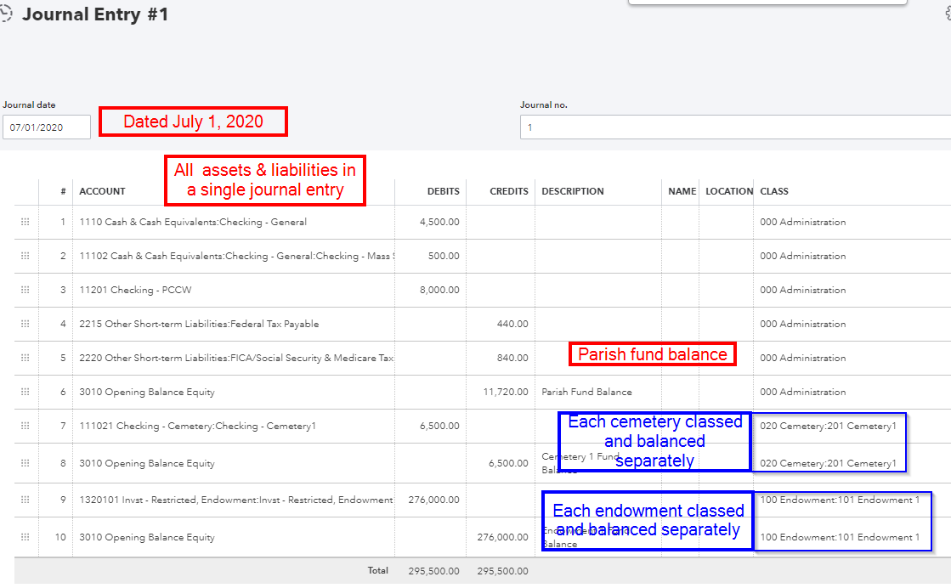
- Enter monthly net changes in assets, liabilities, income and expense accounts using a summary journal entry for each month since July 1, 2020. The number of months to enter will vary depending on when your parish transitions. Run a Trial Balance Report for each month of the current fiscal year from your old system to obtain current month change in account balances. For parishes transitioning April 1, 2021 run 9 monthly Trial Balance Reports.
    - For parishes choosing 1/1/2021 transition date enter previous 6 months’ data, July through December, 2020.
    - For parishes choosing 4/1/2021 transition date enter previous 9 month’s data, July through December, 2020 and January through March, 2021.
    - Parishes wishing to access additional months of historical data for budget and report comparison purposes can enter data for additional months of data as needed.
- Parishes transitioning July 1, 2021 do not need to enter monthly journal entries.
    - Select appropriate old accounts to map to the new chart of accounts. Make sure to total mapped accounts as needed to get an accurate mapping into the new accounts.
    - Enter an appropriate change in account balance for each month. Always record amounts using positive numbers, it is never acceptable to record a negative amount. Typically, if an asset net change increases, record it as a positive amount debit. If a liability net change is an increase, record it as a positive amount credit. Typically, an income account net change increase is recorded as a credit, and an expense account net change increase is recorded as a debit.
      - Make a separate journal entry for each fiscal month of data recorded. Verify (see step 5 below) each month’s journal entry before proceeding to enter the subsequent month.
      - Date each journal entry as of the last day of each fiscal month.
      - The journal entry must balance; total debits must equal total credits displayed at the bottom of the journal entry screen.
      - The journal entry total credits and total debits should equal total credits and total debits from the prior system Trial Balance report for the same fiscal month.
      - To verify accuracy of all accounts, run a Statement of Financial Position (Balance Sheet) for both the new and old system for each month of the current fiscal year. The Total Net Assets (in QBO Total Liabilities and Equity) shown at the report bottom should match between the old system and new one.

Review (work to be done in both your new and old accounting software)
- Run bank and credit card reconciliations in new site. Verify that the Reconciled Balance equals the System Balance (in QBO Cleared Balance).
- Report key financial statements in new site and compare account type totals with statements from the old site.
- Statement of Financial Position (in QBO Balance Sheet) old vs. new
- Statement of Activities (in QBO Profit and Loss) old vs. new

Payroll

Preparation (work to be done in your old accounting software)
  - Export the following reports in PDF file format for all available years of historical data. Retain the printed reports as an archive record of Payroll records. Later, you will use calendar year-to-date data to update employee records.
    - Payroll Summary report for all the available payrolls in your old system.
      - IN PSA, Reports –> Paycycle – > Payroll Summary
      - Select all payrolls for the calendar year
      - Sort by Employee Name
    - Deductions/Benefits Accumulations report
      - In PSA, Payroll-> Reports –> End of Period –> Deductions/Benefits Accumulations
        - Filter for the calendar year. Note that the dropdown box only allows filters for fiscal year. Choose the appropriate month ending of fiscal year ending 6-30-2021 to overlap all of the needed months in the appropriate calendar year. 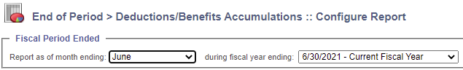
        - The calendar year total accumulations will appear in the column second from right, labeled Calendar Year.
      - Payroll Account Distribution Links. This report is helpful for entering new payroll account distributions in the new system. These are reported out on a per payroll account basis.
        - Payroll Reports –> Finance –> Account Distribution Links
      - In QBO, see “QBO: What you need to setup Payroll” attached at the end of this document as Appendix A.

Execution (work to be done in your new accounting software)
  - Setup. In QBO see Getting Started in QuickBooks Online Payroll | QuickBooks Training Webinars
    - IN PSA, Payroll -> Setup -> Pay Groups
      - Pay Groups define the number of pay periods per year. Note that the PSA Support documentation, PSA Payroll - Setup: (2) Set Up Pay Groups offers poor examples for possible Pay Group categories, as follows.
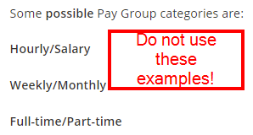
Instead, we recommend time period Pay Groups such as the following.
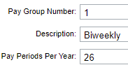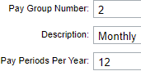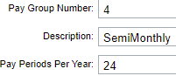
    - Payroll -> Setup -> Pay Items
      - Pay Items are pay categories that will appear on the employees pay stub. Review pay items and add any default gross pay accounts needed. In PSA see PSAv Payroll Set Up - Pay Data, Pay Items & Pay Groups (Video) or PSA Payroll - Setup: (3) Enter Pay Items We recommend the following Pay Items and default gross pay account setups:
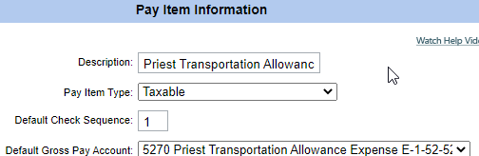
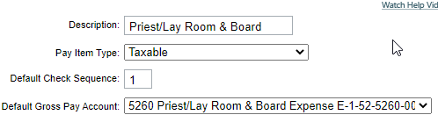
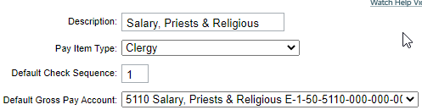
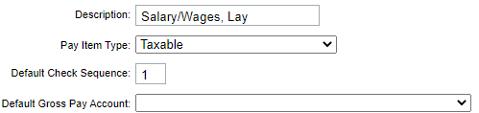
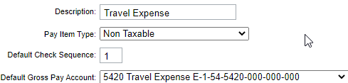

    - Payroll -> Setup -> Deductions/Benefit List
      - The Deduction/Benefit List defines the various withholding deductions (paid by the employee and recorded as liabilities) and benefits (paid by the employer and recorded as expenses). Payroll -> Setup -> Deduction/Benefit List. In PSA see PSA Payroll - Setup: (4) Manage Deductions and Benefits
      - The six System category Deductions/Benefits cannot be edited (1). All other Deductions/Benefits are optional as defined per parish. Click the Add a New Deduction…Template (2) to include additional line items in your payroll. Use the Edit button at left to change Deductions/Benefits Descriptions so they correspond with chart of accounts names as shown below:
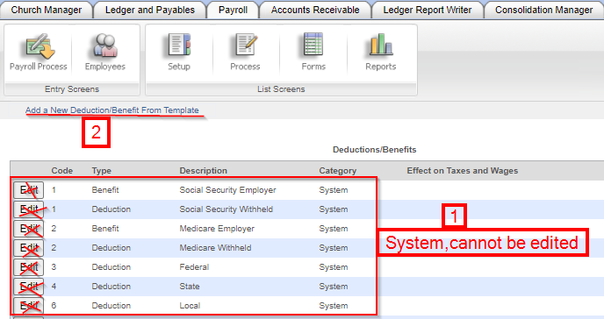
The template screen display prompts you to select appropriate Benefits (which correspond to parish expense accounts) or Deductions (which correspond to employee withholdings, as recorded in parish liability accounts).
The screenshot below specifies which available expense and liability accounts correspond to seven of the listed template Benefit and Deductions.
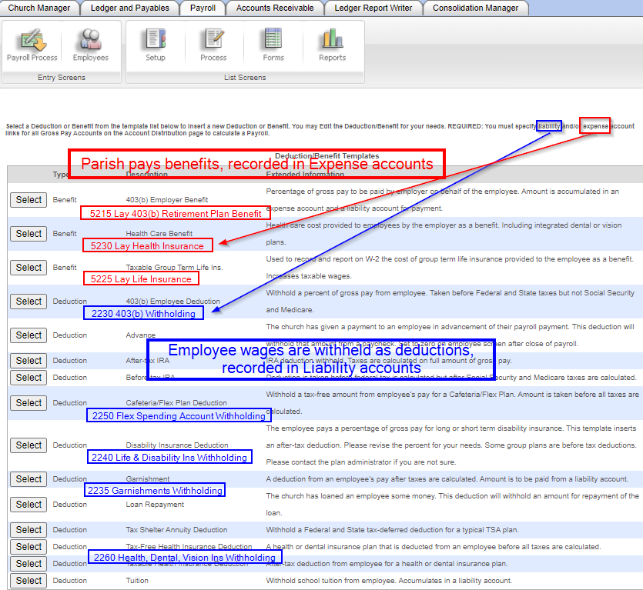
After selecting the needed Deductions/Benefits use the Edit button at left in the Deductions/Benefit screen to update the Description to match the corresponding account name.
    - Account Distributions
      - Account Distributions specify which expense and liability accounts will record deductions, benefits, taxes, etc. Populate account distributions with new accounts for all gross pay expense accounts. In PSA see PSAv Payroll - Account Distributions (Videos) or PSA Payroll - Setup: (5) Enter Account Distributions.
        - To see a screen shot example of Account Distribution setup for any of the gross pay expense accounts click here for the COA Google sheet. Next, locate the Salary & Wage account ShortCut (column K), then hover your cursor over the account Description (column M). A thumbnail screenshot will display. Click on the thumbnail (3) to display the full size screenshot example of the Account Distribution.
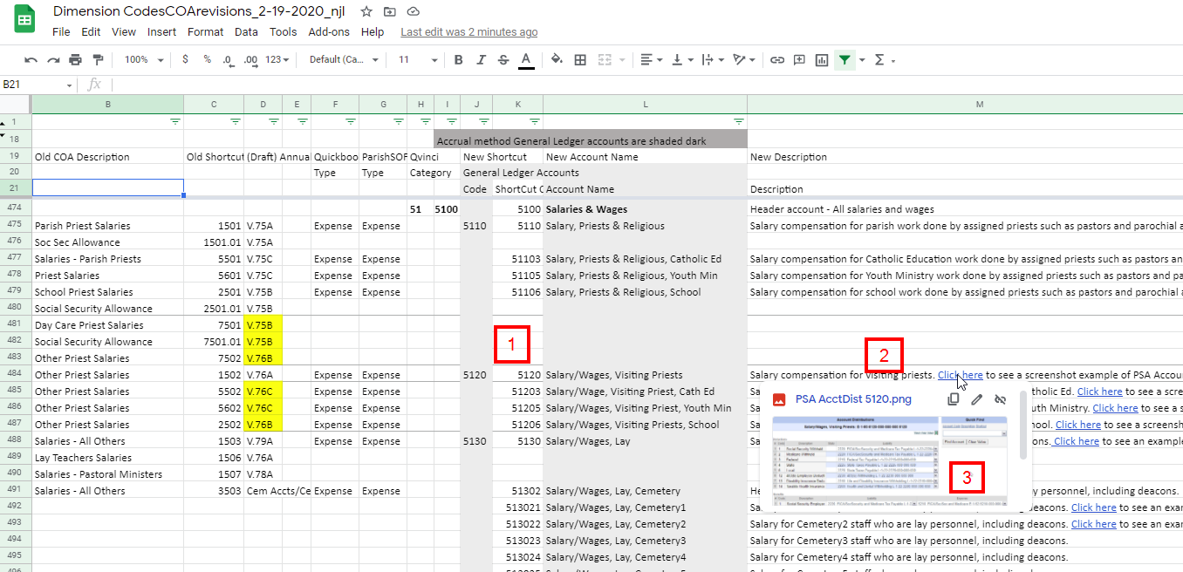
    - Payroll Check Layout
      - Setup payroll check layouts for new bank accounts. In PSA see PSA Payroll - Setup: (6) Set up Payroll Check Layout
  - Employees
    - In PSA, the previous list of employees along with the General, Emp/Cust and Tax Data information was transferred from the old system.
- It is important to update the list of employees before opening the Start-Up Employee Totals screen. Once the Start-Up screen has been opened it is much more difficult to remove employees from the rolls.
- Remove inactive employees.
      - Payroll–>Employees–>Go–>Delete
    - Verify active employee’s Employee Information. In PSA see PSA Payroll - Setup: (7.0) Enter Employee Information.
    - Transfer 2021 calendar year-to-date payroll account totals for active employees from your old system. In PSA the data basis PSA for employee calendar year-to-date payroll information requires data from 2 reports.
      - To obtain Start-Up Gross Wages use data from the old system Taxable Wages report.
        - Payroll–>Reports–>Paycycle–>Taxable Wages
        - In the Payroll block choose all of the 2021 payrolls (use Ctrl key to select multiple payrolls). Sort by Employee name.
        - Navigate to the Start-Up Employee Totals screen. Payroll–>Setup–>Start-Up Employees Totals. Transfer the Taxable Wages total for the calendar year-to-date to Gross Wages data per employee as shown in the screenshot below. Leave the Non Taxable field blank.
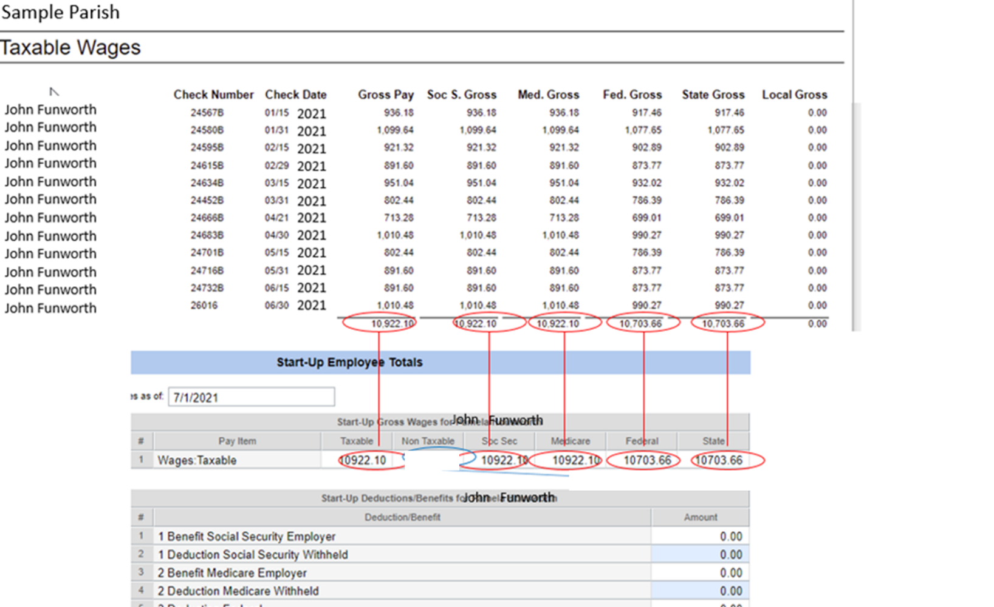

      - To obtain the Start-Up Deductions/Benefits use data from the old system Deductions/Benefits Accumulations report.
        - Payroll–>Reports–>End of Period –>Deductions/Benefits Accumulations
        - In the Fiscal Period Ended block select the last calendar month for completed Payroll. Parishes transitioning July 1 should report as of month ending June during the fiscal year ending 6/30/2021.
Parishes transitioning July 1 should use June
        - Navigate to the Start-Up Employee Totals screen. Payroll–>Setup–>Start-Up Employees Totals. Transfer the Deductions/Benefits Accumulations to Start-Up Deductions/Benefits data as shown in the screenshot below.
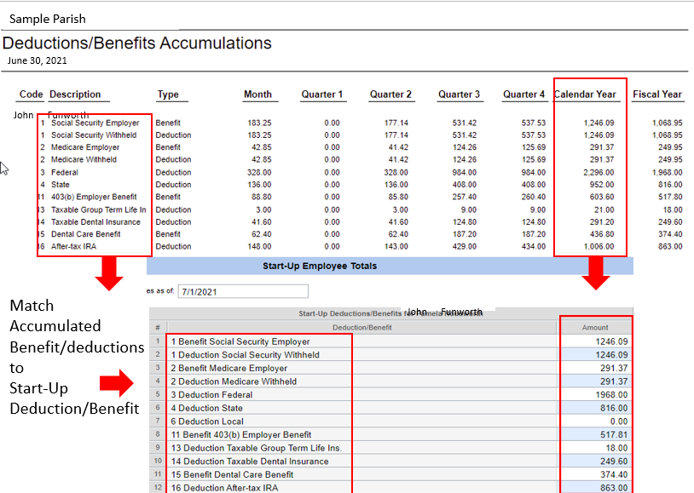
      - Run first payroll in new site

Review
  - Reports
    - Review payroll summary report for first payroll run in the new system

Appendix A
QBO: What you need to setup Payroll
Company information
You'll need your company bank account for direct deposit, or electronic tax payments.
Employees

- Completed Form W-4 for each employee. This is the Employee’s Withholding Certificate with personal data such as name, address, social security number, dependents and adjustments. Your employees can enter this info when you invite them, but you are required to keep a copy of this for your records.
  - Tip: If not available, enter "single" and "0" allowances. You can change these values later.
  - Clergy and church payroll Learn about the clergy and church payroll in Intuit Online Payroll, including clergy who do not want withholding and how to handle housing allowance.
- Quickbooks Online Payroll and the W4 This online QBO support article says “For now, we can only withhold employees' taxes as single with no withholding allowances or zeroing the fields if employees don't have W4 rather than entering any value. “
- I-9: A form used to verify employment eligibility in the United States.
- Email Address: Send your employees an invite to add their personal info and have access to
their pay stubs and W-2s online.
- Pay rate: hourly, salary, commission, etc.
- Paycheck deductions: employee contributions to health insurance, retirement plans, or garnishments (child/spousal support)

- Pay schedule: weekly, bi-weekly, semi-monthly and monthly
- Sick/vacation hours policy and balance: if applicable
- Hire and termination date.

Direct deposit
You'll need your employees' bank account and routing numbers for direct deposits to their bank accounts (additional fees may apply depending on your product).
Compensation and benefits
QuickBooks uses various terms when referring to ‘compensation and benefits’, or to ‘deductions’, or ‘Employee deduction’ and ‘Company-paid contribution’. ParishSOFT handles these payroll related concepts and “Benefits” when the cost is borne by the parish and “Deduction” when the cost is borne by the employee. For instance, the employer paid portion of Social Security tax is referred to as a “Benefit” because it is paid by the parish, it is a “Company-paid contribution”. The distinction between “benefit” on the one hand and “deduction” on the other are important when setting up payroll because the “Company-paid contribution” needs to be recorded to a parish expense account, while the employee deduction must be recorded to a parish liability account. Use the link below to read descriptions of the supported pay types and deductions in QuickBooks Online Payroll as well as how each impacts federal taxes and forms.
Supported pay types and deductions explained
- Types of employee benefits: such as hourly wages, salaries, bonuses, commissions, and tips
- Types of employee compensation: such as health and dental insurance, 401(k), retirement plans, vacation/sick leave, or Flexible Spending Account (FSA)
- Other additions and deductions: such as cash advances, mileage and travel reimbursements, union dues, and wage garnishments.

Transfer 2021 calendar year-to-date payroll account totals for active employees from your old system. To obtain the YTD accumulated salary, tax, deduction and benefits for all employees run a Payroll Summary by Employee report from you Desktop software. Set the date range to Calendar year to capture data since January 1, 2021.

Set up a prior payroll for QuickBooks Online Payroll

Step1: Collect employee info
Gather employee W-4s, pay stubs, or other payroll reports to help you enter employee's details and what each employee has been paid so far this year. We recommend using employee pay stubs and reports that may have employee year to date amounts. Check out the reports needed for each employee you paid.

Step 2: Get started
- Select Payroll then Overview.
- You will see tasks you need to complete on your TO DO. When you're done adding your business info, it's time to tell us about your team. Select Let's go to start adding your employees.
- Enter your employees' info. After you complete the questions, select Done. Select Add an employee to add the rest of your employees.
- Complete the onscreen steps. If your employee doesn't have any wages to enter this year, select Done and add additional employees as needed.

Step 3: Enter how much you paid the employee this year
Complete the following steps only if you have paid employees this year.
- Under How much did you pay [employee] this year?, select +Enter [year] prior pay details.
- Answer the questions to select the time period the employee got paid. In Colorado, you may see additional questions.
- Depending on your answers, use the reports and pay stubs you gathered to enter how much you’ve paid your employee so far this year in the Year-to-date totals as of today column.
Note: Missing items? You need to set up all pay types, deductions, and company contributions as applicable.
- Be sure to include all types of compensation, deductions, taxes, and company contributions including.
  - Regular Wages - Total employee compensation (salary or hourly) in $ amount.
  - Overtime Pay, Bonus Pay, etc - any additional employee compensation $ amount.
  - Federal Income Tax - Also known as federal withholding or FIT.
  - Social Security & Medicare - Both are known as FICA taxes.
  - State Income Tax - Also known as state withholding or PIT/SIT.
  - State Disability Insurance - This tax item only shows if the state has SDI.
  - Net Pay - This is optional. You can leave it blank as it automatically calculates after you select Continue.
- If you're in quarters 2 - 4, enter the amounts you paid the employee for previous quarters in the Year-to-date totals as of [date] column.

Step 4: Repeat for all employees paid this year
Enter pay information for all employees paid in the current calendar year, including those that are no longer with your company.
In QuickBooks Online “benefits” and “deductions” are setup on a per employee basis. Each time an employee record is created there is a prompt, in this case labeled similarly as in the screenshot below:
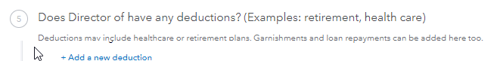
The standard federal and state tax, social security, unemployment and medicare are configured automatically in QBO. Click on the “Add a new deduction” to add parish-specific, or employee-specific optional benefits and deductions. Below are screenshots for how your parish might configure some typical, elective, benefits and deductions.

To setup a 403(b) Retirement that includes both an employee deduction and a Company-paid contribution.
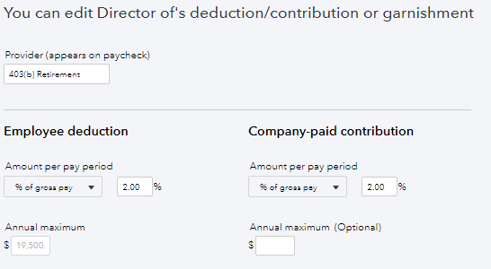
To setup a Health, Dental or Vision insurance plan that includes both an employee deduction and a Company-paid contribution.
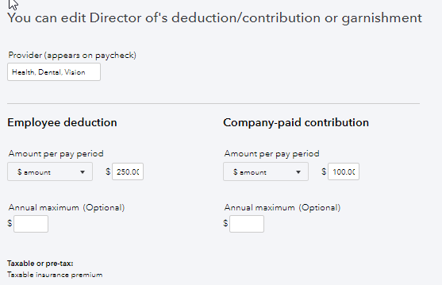
To setup a Flex Spending Account having only an employee deduction.
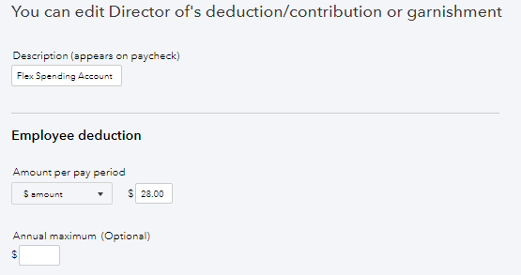

Payroll Accounting Preferences
View and Edit your current payroll account preferences to assign Pay Items to the appropriate general ledger accounts.

To view and edit:
- Go to Settings (the gear icon at top left) and then select Payroll Settings.
- Select Accounting (at the bottom of the page). Click on the pencil icon at right.
- The Accounting preferences – Review page displays. It shows which default Payroll Expense and Payroll Liabilities general ledger accounts QBO assigns when you create a paycheck, make a tax payment or create a deduction. These system-generated accounts will be used until you edit the account preferences. Payroll Expenses or Payroll Liabilities will reflect on your Profit & Loss or Balance Sheet reports.
Note: Account numbers do not appear in these selection boxes.
- Choose the pencil icon to Edit and select standard general ledger accounts from your parish standard Chart of Accounts in the drop-down.
- Select OK after choosing all your desired accounts.
- You will be prompted to update Classes.
- You will receive a confirmation screen that your accounting preferences have been updated.
Notes:
- The change of account preference settings affect future transactions. However, you have an option to apply these changes to your past transactions too. If needed, you can backdate these changes for all transactions to the beginning of the year (does not affect changes to selected Bank account).
- When setting up your accounting preferences, any pay type that doesn't increase your employee's gross pay, such as Cash Tips or Personal Use of Company Car will not appear for you to assign an account.

The screenshots below illustrate some typical assignments of DIOLC standard Chart of Accounts in Accounting preferences:
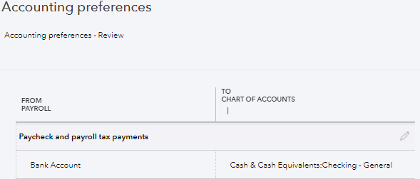

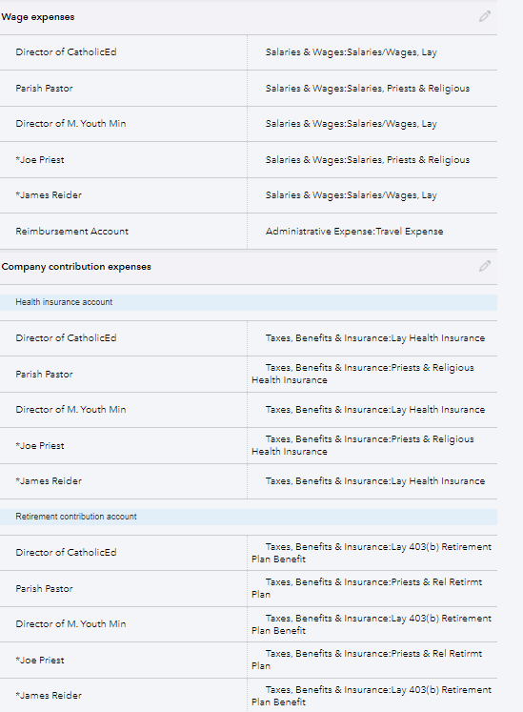

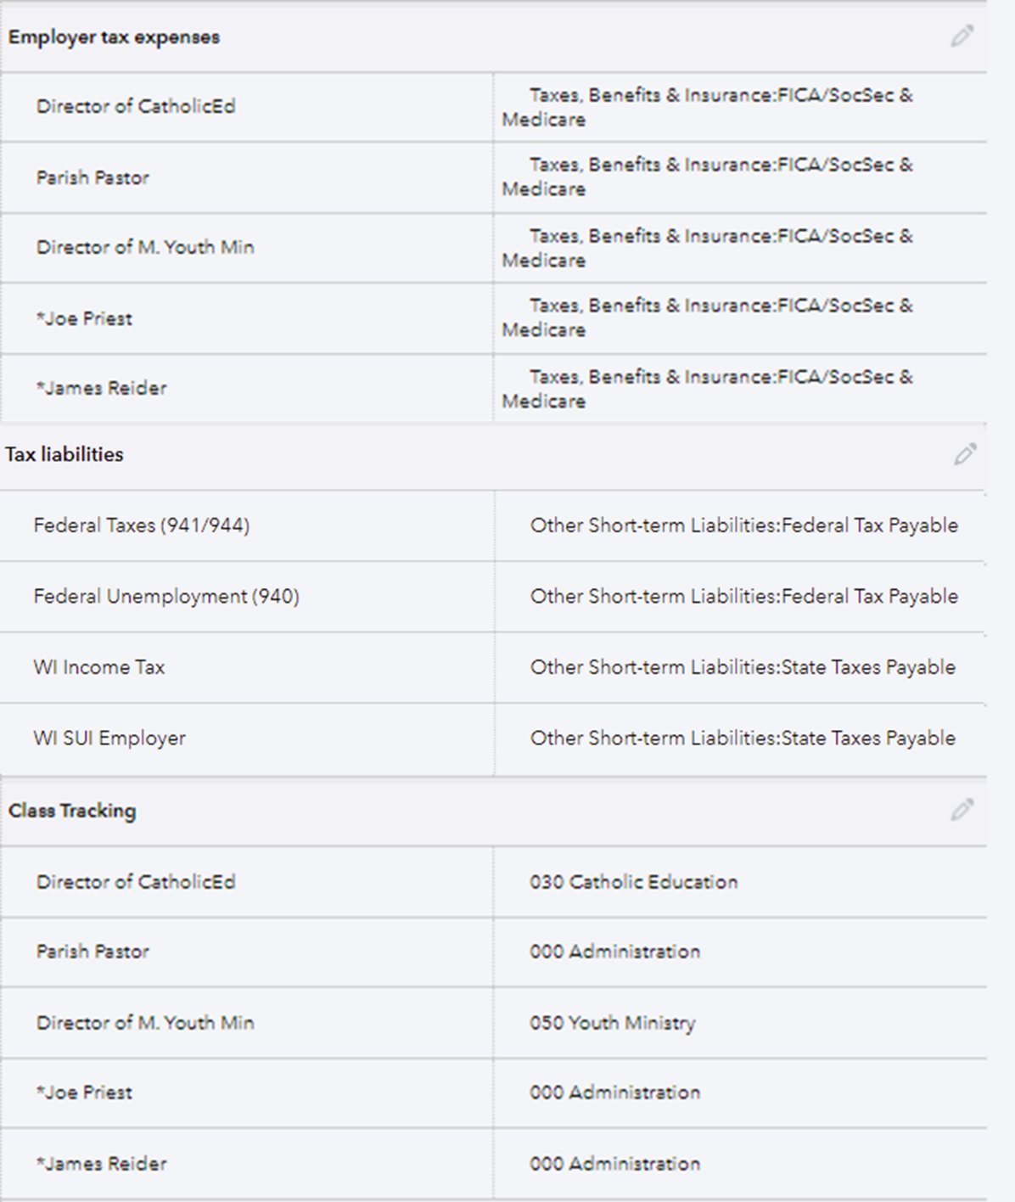
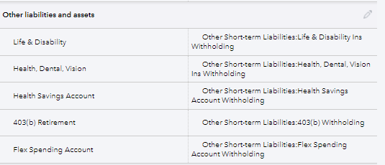

Tax information
Federal Employer Identification Number (FEIN) and state agency ID numbers: You'll need unique ID numbers from the IRS and state agencies to file and pay taxes. Contact the agencies to apply for these ID numbers (see Federal and State payroll tax forms and resources).
- Filing requirement and deposit schedule for payroll taxes: Requirements for when to file and deposit payroll taxes vary. Companies that owe more payroll tax typically pay and file more frequently. See Federal and State payroll tax forms and resources or contact the IRS and your state agency to determine your requirements.
- Electronic Federal Tax Payment System (EFTPS) enrollment: It's mandatory to submit federal tax deposit payments electronically. You can enroll in EFTPS at www.eftps.gov/eftps. You can learn more about EFTPS here.
Note: If you have Assisted or Full Service Payroll, we'll submit the EFTPS enrollment on your behalf.
- Other tax information: Such as state unemployment, assessment, surcharge, administrative or training tax rates, tax deposit schedules, and local or other taxes, if applicable.
Prior payrolls
If you've already paid employees this calendar year, we need to know the amounts to accurately calculate new paychecks and complete your tax forms.
- For the current quarter: payroll details from each paycheck
- For each prior quarter of this calendar year: summary by employee and summary for all employees (total company payroll)
- Year to date totals for each employee: summary by employee
- Year to date totals for each employee as of the last paycheck in the previous quarter: summary by employee
- See QBO Online Payroll Get Started Videos for customers with pay history Part 1 & 2

Liability information
For the current quarter: copies of all payroll liability checks
- For each prior quarter of this year: summary of payroll liability payments

