Retreat With

The Rite of Consecration

Introduction, Nature & Value

Principal Duties of those Consecrated

Calling of the Candidate

Examination

Renewal of Intention

Presentation of the Insignia

MC900439072[1]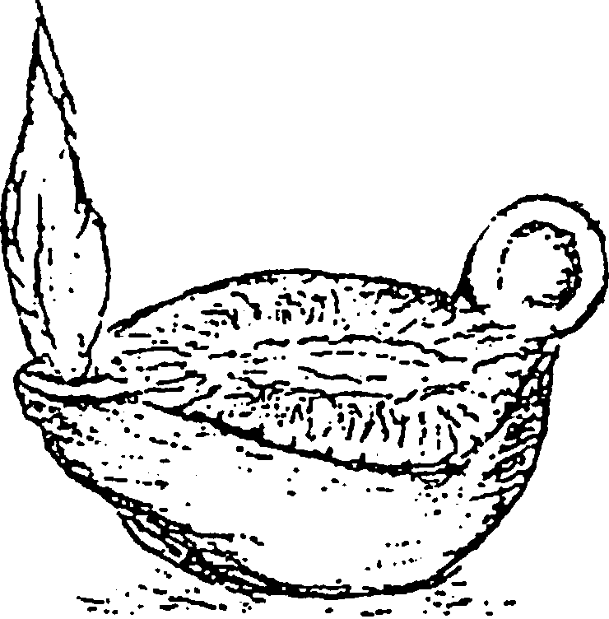

MC900048038[1]

Come, Holy Spirit, fill the hearts of Thy faithful and enkindle in them the fire of Thy love.

Send forth Thy Spirit and they shall be created.

And Thou shalt renew

the face of the earth.

O God, Who didst instruct the hearts of the faithful by the light of the Holy Spirit, grant us in the same Spirit to be truly wise, and ever to rejoice in His consolation.

Retreat With

The Homily

MC900048271[1]

MC900048038[1]

Come, Holy Spirit, fill the hearts of Thy faithful and enkindle in them the fire of Thy love.

Send forth Thy Spirit and they shall be created.

And Thou shalt renew

the face of the earth.

O God, Who didst instruct the hearts of the faithful by the light of the Holy Spirit, grant us in the same Spirit to be truly wise, and ever to rejoice in His consolation.

Retreat With

The Prayer of Consecration

MC900048271[1]

MC900048038[1]

Come, Holy Spirit, fill the hearts of Thy faithful and enkindle in them the fire of Thy love.

Send forth Thy Spirit and they shall be created.

And Thou shalt renew

the face of the earth.

O God, Who didst instruct the hearts of the faithful by the light of the Holy Spirit, grant us in the same Spirit to be truly wise, and ever to rejoice in His consolation.

Retreat With

The Proper Parts of the Mass

MC900048271[1]

MC900048038[1]

Come, Holy Spirit, fill the hearts of Thy faithful and enkindle in them the fire of Thy love.

Send forth Thy Spirit and they shall be created.

And Thou shalt renew

the face of the earth.

O God, Who didst instruct the hearts of the faithful by the light of the Holy Spirit, grant us in the same Spirit to be truly wise, and ever to rejoice in His consolation.

Retreat With

The Sacred Heart of Jesus

Rite of Consecration Chapter I Introduction 1

Rite of Consecration, Homily

Solemn Blessing at the end of Mass

Liturgy of the Hours, Office of Readings, Volume IV page 1331 St John Eudes

Litany of the Sacred Heart

MC900048038[1]

Come, Holy Spirit, fill the hearts of Thy faithful and enkindle in them the fire of Thy love.

Send forth Thy Spirit and they shall be created.

And Thou shalt renew

the face of the earth.

O God, Who didst instruct the hearts of the faithful by the light of the Holy Spirit, grant us in the same Spirit to be truly wise, and ever to rejoice in His consolation.

Retreat With

The Holy Spirit

Rite of Consecration, Introduction,

Nature & Value #1

Principal Duties #2

Homily

Litany of Supplication

Prayer of Consecration

Solemn Blessing at the end of Mass

Liturgy of the Hours, Office of Readings, Volume II, page 2090

Mirror of Faith, William of Tierry

MC900048038[1]

MC900048038[1]

Come, Holy Spirit, fill the hearts of Thy faithful and enkindle in them the fire of Thy love.

Send forth Thy Spirit and they shall be created.

And Thou shalt renew

the face of the earth.

O God, Who didst instruct the hearts of the faithful by the light of the Holy Spirit, grant us in the same Spirit to be truly wise, and ever to rejoice in His consolation.

Retreat With

Our Lady

Rite of Consecration, Chapter I, #1

Rite of Consecration, Homily

Joseph Cardinal Ratzinger, 1988 Homily

Pope John Paul II, 1995 Address

Pope Benedict XVI, 2008 Address

MC900439072[1] Mary MC900439072[1]

MC900048038[1]

Come, Holy Spirit, fill the hearts of Thy faithful and enkindle in them the fire of Thy love.

Send forth Thy Spirit and they shall be created.

And Thou shalt renew

the face of the earth.

O God, Who didst instruct the hearts of the faithful by the light of the Holy Spirit, grant us in the same Spirit to be truly wise, and ever to rejoice in His consolation.

Retreat With

Pope John Paul II

MC900439072[1]

Theology of the Body

Dignity of Women

1995 Address

MC900439072[1] 

MC900048038[1]

Come, Holy Spirit, fill the hearts of Thy faithful and enkindle in them the fire of Thy love.

Send forth Thy Spirit and they shall be created.

And Thou shalt renew

the face of the earth.

O God, Who didst instruct the hearts of the faithful by the light of the Holy Spirit, grant us in the same Spirit to be truly wise, and ever to rejoice in His consolation.

A Retreat With

Joseph Cardinal Ratzinger/

Pope Benedict XVI

1988 Homily

MC900439072[1]

2008 Address

MC900439072[1]

MC900048038[1]

Come, Holy Spirit, fill the hearts of Thy faithful and enkindle in them the fire of Thy love.

Send forth Thy Spirit and they shall be created.

And Thou shalt renew

the face of the earth.

O God, Who didst instruct the hearts of the faithful by the light of the Holy Spirit, grant us in the same Spirit to be truly wise, and ever to rejoice in His consolation.

A Retreat With

MC900304935[1]

Saint Joseph

Liturgy of the Hours, Office of Readings, Volume I, page 426, Pope Paul VI

Liturgy of the Hours, Office of Readings,

Volume II, page 1721

From a Sermon by Saint Bernadine, priest

Rite of Consecration, Litany of Supplication

Catechism of Catholic Church

#437

#497

#532

MC900048038[1]

Come, Holy Spirit, fill the hearts of Thy faithful and enkindle in them the fire of Thy love.

Send forth Thy Spirit and they shall be created.

And Thou shalt renew

the face of the earth.

O God, Who didst instruct the hearts of the faithful by the light of the Holy Spirit, grant us in the same Spirit to be truly wise, and ever to rejoice in His consolation.

Retreat With

The Fathers of the Church

Saint Ambrose of Milan

Complete text may be found in the

Liturgy of the Hours, Office of Readings,

Volume I page 1242

Volume III pages 1310

Saint Cyprian

Complete text may be found in the

Liturgy of the Hours, Office of Readings,

Common of Virgins

Volume I 1478

Saint Methodius of Sicily

Complete text may be found in the

Liturgy of the Hours, Office of Readings,

Volume II page 1661 or

Volume III page 1365



MC900048038[1]

Come, Holy Spirit, fill the hearts of Thy faithful and enkindle in them the fire of Thy love.

Send forth Thy Spirit and they shall be created.

And Thou shalt renew

the face of the earth.

O God, Who didst instruct the hearts of the faithful by the light of the Holy Spirit, grant us in the same Spirit to be truly wise, and ever to rejoice in His consolation.

A Retreat with the Virgin Saints

Saint Agatha

MC900439072[1]

Saint Agnes

MC900439072[1]

Saint Lucy

MC900439072[1]

Saint Kateri Tekakwitha

MC900439072[1] 

MC900048038[1]

Come, Holy Spirit, fill the hearts of Thy faithful and enkindle in them the fire of Thy love.

Send forth Thy Spirit and they shall be created.

And Thou shalt renew

the face of the earth.

O God, Who didst instruct the hearts of the faithful by the light of the Holy Spirit, grant us in the same Spirit to be truly wise, and ever to rejoice in His consolation.

Retreat with

The Teachings of the Church

Sacred Congregation for Divine Worship

31 May 1970 Decree

Code of Canon Law

Canon 604

Catechism of the Catholic Church

MC900048271[1]

MC900048038[1]

Come, Holy Spirit, fill the hearts of Thy faithful and enkindle in them the fire of Thy love.

Send forth Thy Spirit and they shall be created.

And Thou shalt renew

the face of the earth.

O God, Who didst instruct the hearts of the faithful by the light of the Holy Spirit, grant us in the same Spirit to be truly wise, and ever to rejoice in His consolation.