“Receive..”

Retreat Journal #2
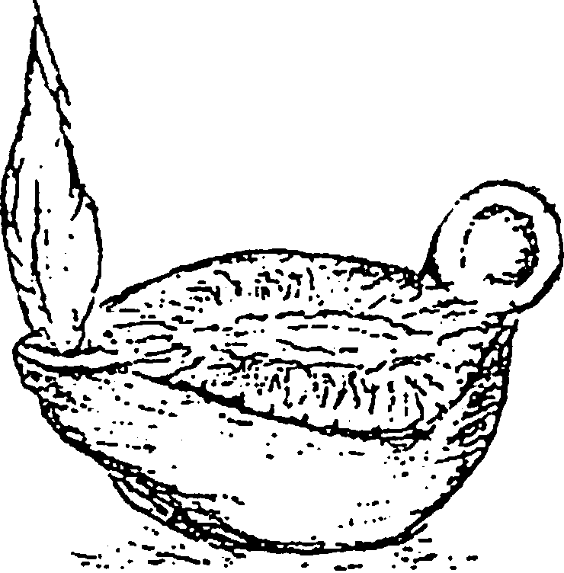
The first Retreat Journal used the first word in the Renewal of Intention, “Father” .
Meditations for this is a grace.
This is the second Retreat Journal ponders and prays with the second word in the Renewal of Intention, “receive”.
This simple word has a depth of meaning when pondering the lives of Jesus, Mary and Joseph in the Mysteries of the Rosary.
And so begins this retreat time of grace…
“Come receive the Holy Spirit…”

From Reflections on the Rite page 158

Receive. The virgin places her hands in the hands of the Bishop. She prays, receive the treasure of my life, my virginity. Receive my free will, my entire being. “I lay my life down freely, no one takes it from me.”64 She believes that he, as Bishop, is acting as spiritual father and the presence of God the Father, who is able to receive her resolve, her solemn resolution. It is an act of obedience, the freedom of faithful obedience. Seeing the Bishop as one who, himself, has been set aside to follow Christ as Bishop, it is fitting that he receives of her solemn resolve to follow Christ as His bride. It is to be a way of life. The solemn consecration is for living in the world as a bride of Jesus. It is the Gospel way of life, the way of the cross, the way of love. It is an affirmation of the way of life she has been living. She presents her life for consecration. She asks the Bishop to receive it. 64 John 10:17, 18

She has heard the words of Jesus, “Be perfect as my heavenly Father is perfect.” ₆₅ She knows the gift of perfect continence for the sake of the Kingdom is given to some, not to all. “It is not everyone who can accept what I have said, but only those to whom it is granted.” ₆₆ “Let anyone accept this who can.”₆₇ She remembers the Annunciation. Our Lady was open to receive. Our
Lady was open to give.

The candidate acknowledges, with humility, that this gift has been given to her. She knows she will need the help of God, the Trinity of Persons, each helping her with the gifts and graces she needs. “Clothe yourselves with humility.” 68
This solemn time is one of great joy. New life surges from the Holy Spirit through the hands from the Bishop to the bride of Christ.
The renewal of this intention daily in her personal prayer establishes the bride as a soul longing to do the Father’s will each day of her life.

65 Matthew 5:48 66 Matthew 19:11 67 Matthew 19:12 68 1 Peter 5:5

Today, Heavenly Father, I renew my resolution to follow Christ in a life of perfect chastity.

