“To reflect the life of Angels…”
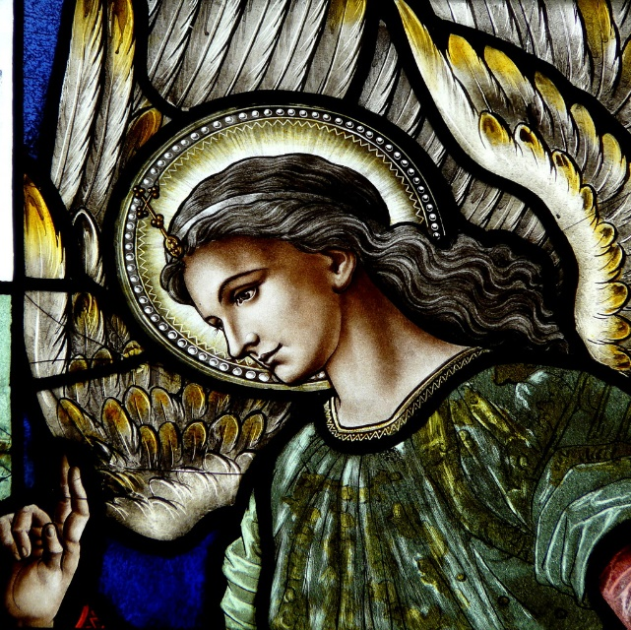

Angels in the life of a consecrated virgin.
Retreat Reflection
September 2021
Each time we take that special time away to be with the Lord on retreat, avenues of grace are ready to come our way. How we respond and accept these graces depend on our free will and our openness to conversion.
We recall the life of Our Lady. As a child tradition tells us she was presented and received into the temple there to learn.
What great Mysteries of God’s love were revealed into her chosen soul.
Following her example we take time to come away to rest a while, to ponder the movement of grace within our life.
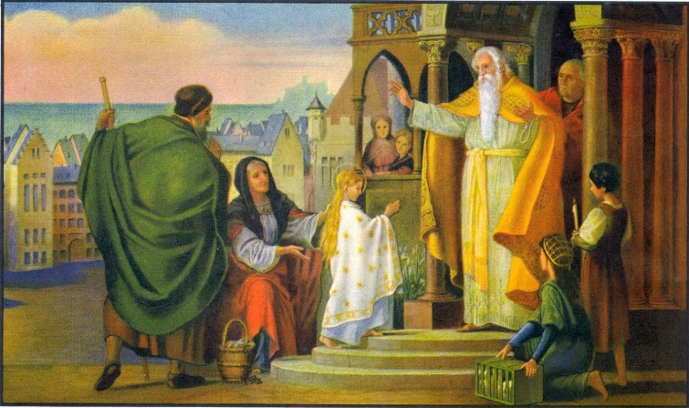

This gift of retreat, pondering the Renewal of Intention and the Mysteries of the Rosary, the role of angels in the life of the Holy Family throughout their lives and especially after the death of Joseph, recall our role in the life of the Church…remember the Homily from the Rite?
In the Prayer of Consecration, we are called to “reflect the life of Angels.”
May I be so bold to invite the pondering of not only the gift of purity and total gift of self to will of the Father through consecration but also in the example the angels give us in their role as messengers, protectors, generally being of service to the people of God.
In pondering our lives before consecration, how many times have the angels been there for us to light to guard to rule and guide, as we pray in the beloved Guardian Angel Prayer learned as a child. Now as consecrated virgins we pray with Our Lady “Behold the handmaid of the Lord…”
May these simple reflections helps enter into the mystery of love the Lord invites us accompanied by His angels as we follow Him with our whole being.
Praying for you.
In the Hearts of Jesus, Mary and Saint Joseph
barb

Joyful Mysteries
In the Name of the Father and of the Son and of the Holy Spirit. Amen.
I believe in God the Father almighty, Creator of Heaven and earth,,,
As we begin this rosary, the Joyful Mysteries, as we pray the Creed, we recall the creation of the angels. They are there at the beginning. They are ready to do whatever the Father asks, needs.
So too Our Blessed Lady, Saint Joseph and all those we encounter these 5 Joyful Mysteries.
Let us also take at look at the hidden presence of those guardian angels truly present in the lives of these chosen souls.
Let us ponder how we as virgins, consecrated to God for the sake of the Kingdom, may bring our support of quiet presence, a helping hand, a reassuring word, a silent prayer, a hidden suffering,
All part of the Joys of the Lives of those with whom we live and move and have our being.
Our Father…
3 Hail Mary’s (Increase in the fullness of faith, the steadfastness of our hope, the single heartedness of our love)
Glory be to the Father…

The Five Joyful Mysteries
Annunciation
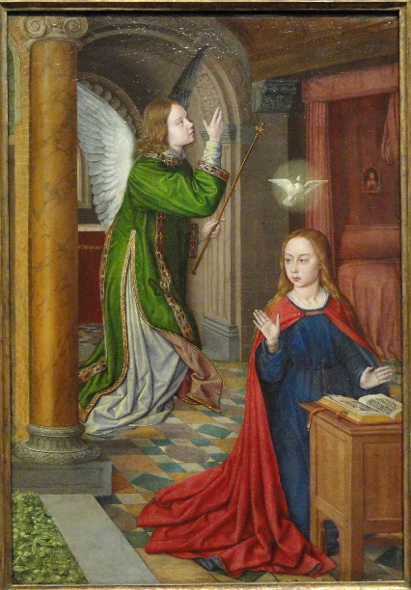
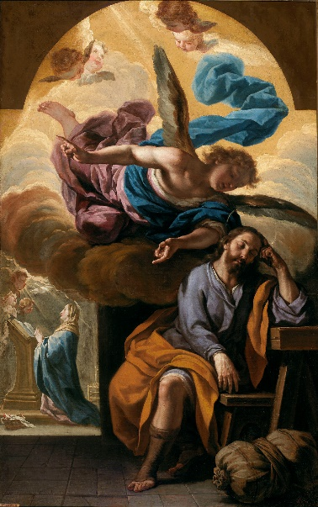

Our Father
10 Hail Mary’s
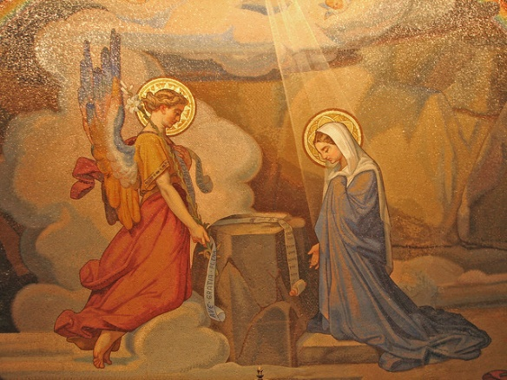
Glory be to the Father

O Mary Queen of Virgins, pray for us.
St Joseph, protector of virgins pray for us.
The Second Joyful Mysteries
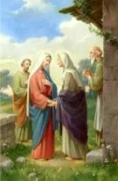
Visitation

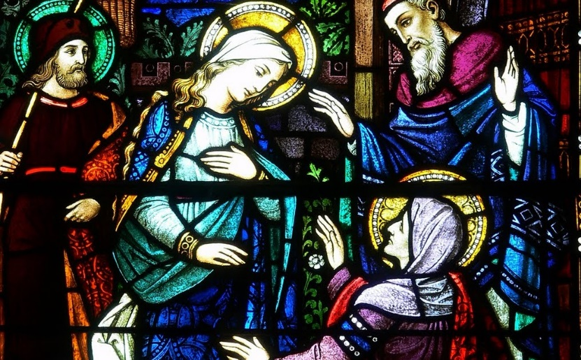

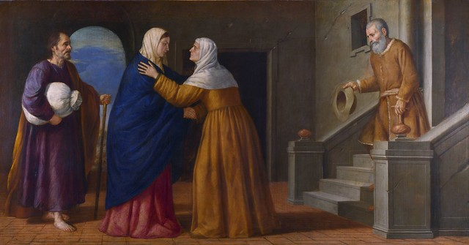

O Mary Queen of Virgins, pray for us.
St Joseph, protector of virgins pray for us.

The Third Joyful Mysteries
The Birth of Our Lord
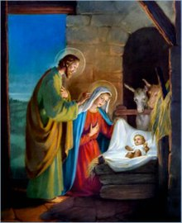
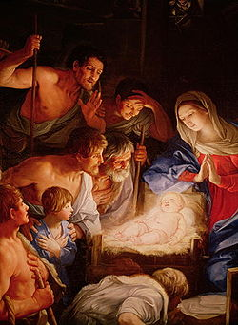

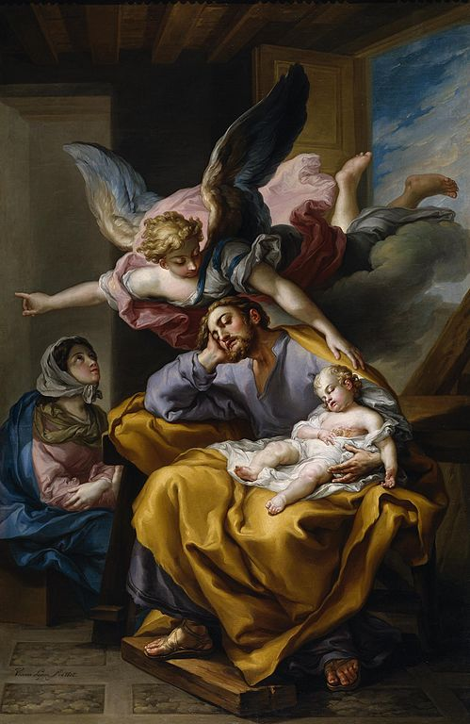
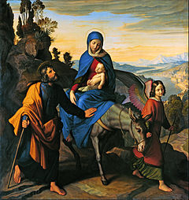

O Mary Queen of Virgins, pray for us.
St Joseph, protector of virgins pray for us.

The Fourth Joyful Mysteries
The Presentation of Jesus in the Temple
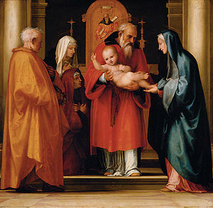

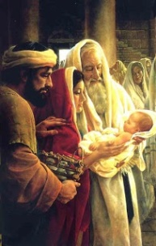

O Mary Queen of Virgins, pray for us.
St Joseph, protector of virgins pray for us.
The Fifth Joyful Mysteries
The Finding of Jesus in the Temple

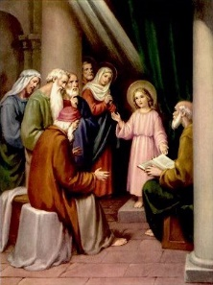
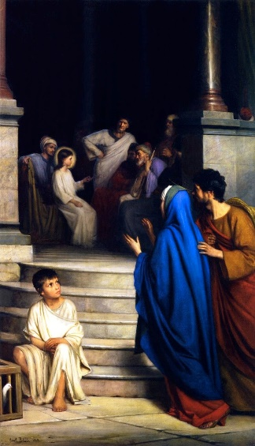
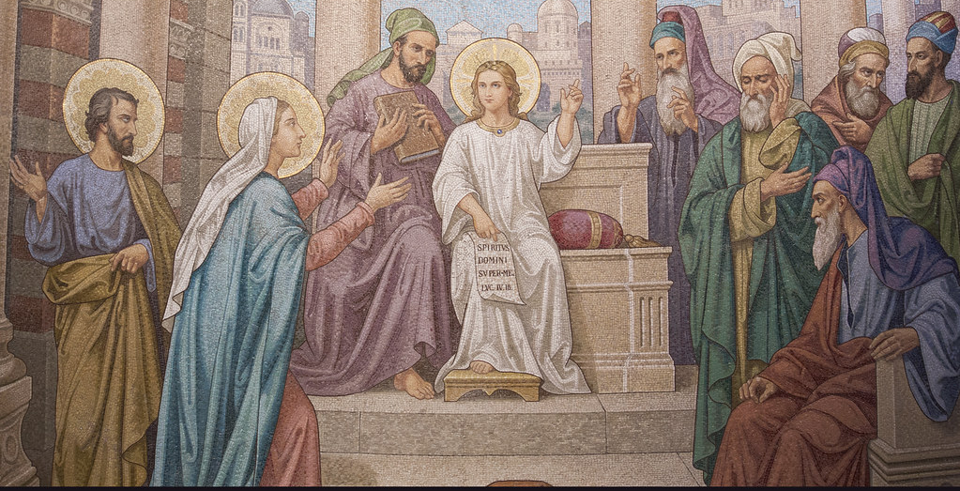

O Mary Queen of Virgins, pray for us.
Saint Joseph, protector of virgins, pray for us.
The Luminous Mysteries
When we pray the Luminous Mysteries, the Mysteries of Light, there are many opportunities to see the presence of the angels in these years of the public ministry of Jesus.
Beginning with His coming to the Jordan River to be baptized by His cousin John. These angels were present when Jesus, still in His Mother’s womb, was present when John received his name, the name given before his birth by an angel. Now the Father is present, and one can only imagine the angels that were present there at this proclamation “This is My Beloved Son, listen to Him.”
The wedding at Cana, the proclamation of the kingdom, just filled with angels’ protection of those who came to these special times in the life of Jesus. The Transfiguration and the Institution of the Eucharist was of course right over the top when it came to angels and their presence. Silent awe and wonder at all that was happening. Here they see the son of God whom they know from His heavenly presence before He came to earth, the image of God the Father. Now all this wonder of His public life.
May we not take their presence in our live for granted but be ever grateful for their daily care for our needs.

Mary, Queen of the angels, pray for us.
Saint Joseph, splendor of Patriarchs, pray for us.

First Luminous Mystery
Baptism of Jesus

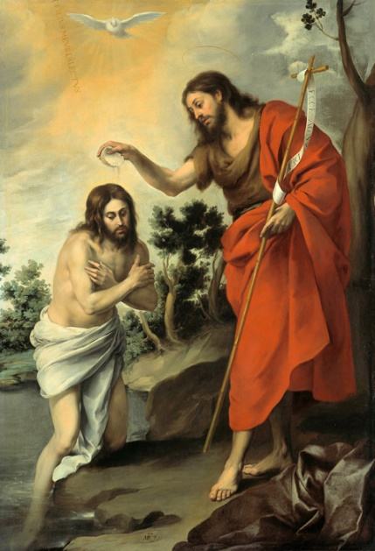
Mary, Queen of the angels, pray for us.
Saint Joseph, splendor of Patriarchs, pray for us.

Second Luminous Mystery
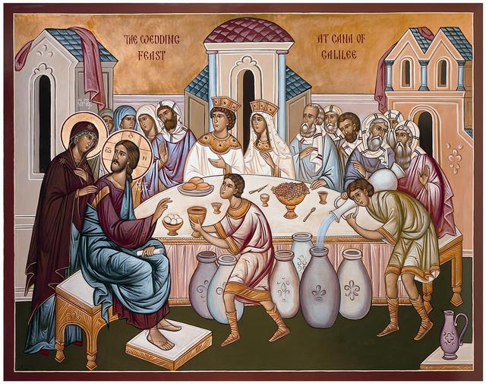
Wedding at Cana

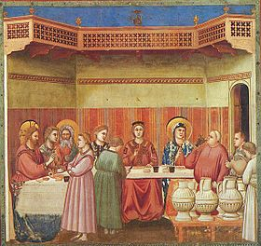
Mary, Queen of the angels, pray for us.
Saint Joseph, splendor of Patriarchs, pray for us.

Third Luminous Mystery
Proclamation of the Kingdom

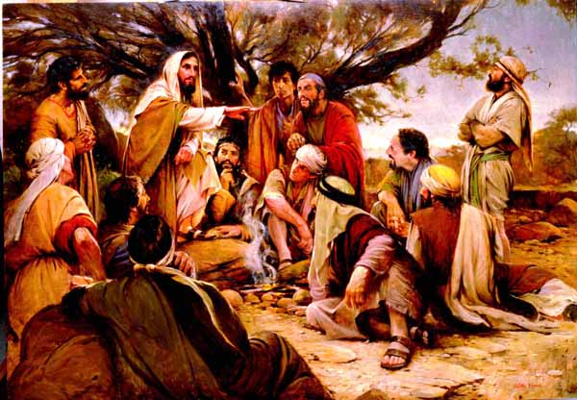
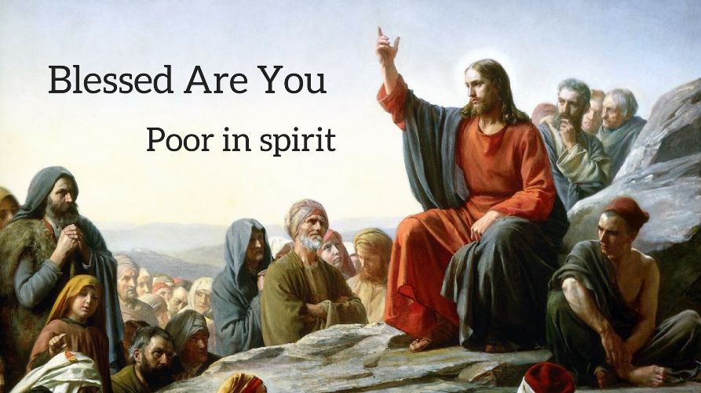

Mary, Queen of the angels, pray for us.
Saint Joseph, splendor of Patriarchs, pray for us.

Fourth Luminous Mystery
Transfiguration

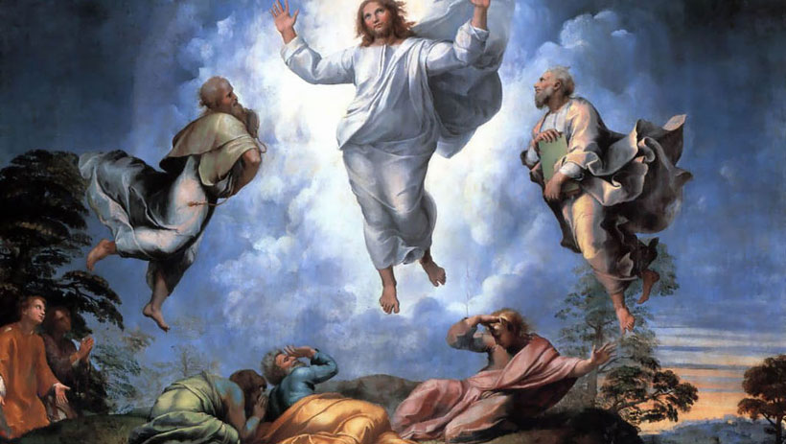

Mary, Queen of the angels, pray for us.
Saint Joseph, splendor of Patriarchs, pray for us.

Fifth Luminous Mystery
Institution of the Eucharist
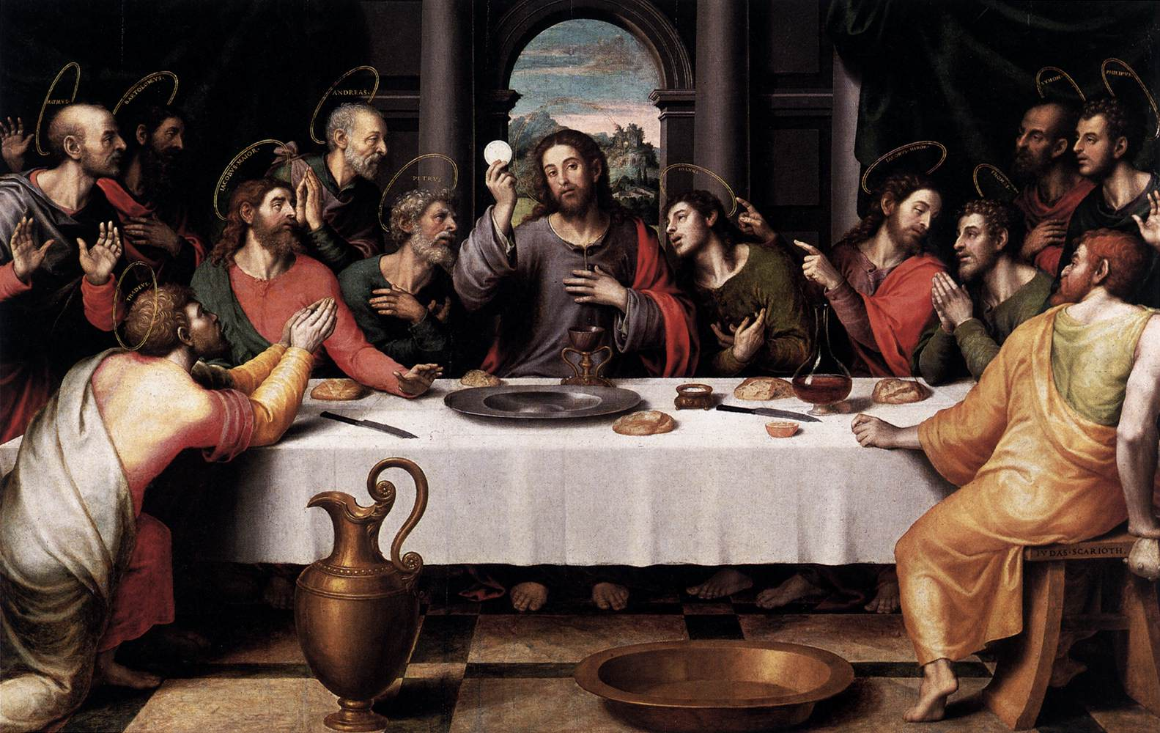

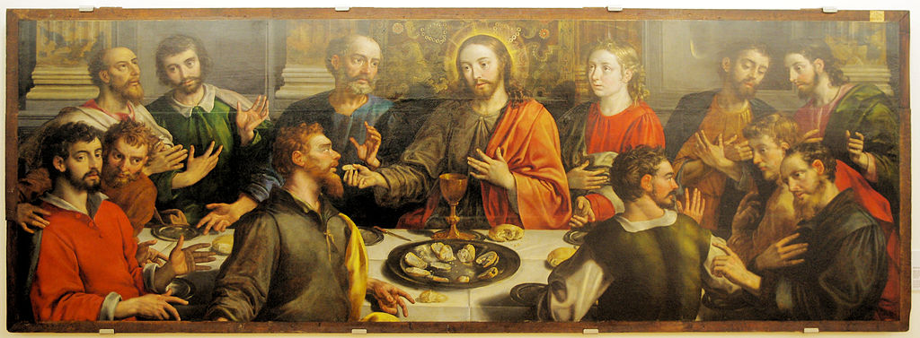

The Sorrowful Mysteries
My child, there were many angels along the road to Calvary. Beginning in the Garden when I heard My Son’s petition. But it was to do My will that He was sent to save souls, save those who had, have fallen from the graces of their Baptism.
That Angel of comfort in the Garden surrounded by so many of the guardian angels looked with deep sorrow that their Beloved God would chose to suffer for mankind for the souls they were sent to guard and protect. Yet others choose evil. What else but to surrender them to Me as their Father I continue to hold them for I have created them. They are precious to me even when they chose to sin.
These witnesses, the guardian angels of the Passion, of the way of the Cross continue to this day walking with souls who long to do My will yet are at times overwhelmed with the pains and sorrows, sufferings of life of this world. My angels sent to encourage, and guide will continue to walk with you all along the way. Take their hand and trust in their protections and care.
Go forth with confidence. Do My will in all things and you will reach the reward I have promised to faithful souls.

Our Lady of Sorrows, pray for us.
Saint Joseph, comfort of the afflicted, hope of the sick, patron of the dying, terror of demons, pray for us.
First Sorrowful Mystery
The Agony in the Garden

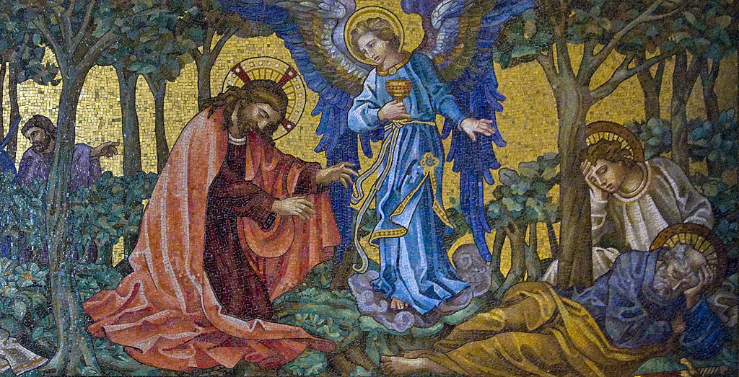

Our Lady of Sorrows, pray for us.
Saint Joseph, comfort of the afflicted, hope of the sick, patron of the dying, terror of demons, pray for us.
Second Sorrowful Mystery
Jesus is Scourged at the Pillar

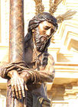

Our Lady of Sorrows, pray for us.
Saint Joseph, comfort of the afflicted, hope of the sick, patron of the dying, terror of demons, pray for us.
Third Sorrowful Mystery
Jesus is Crowned with Thorns

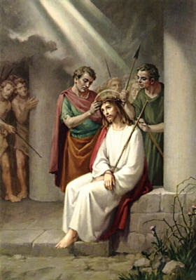

Our Lady of Sorrows, pray for us.
Saint Joseph, comfort of the afflicted, hope of the sick, patron of the dying, terror of demons, pray for us.
Fourth Sorrowful Mystery
Jesus Carries His Cross

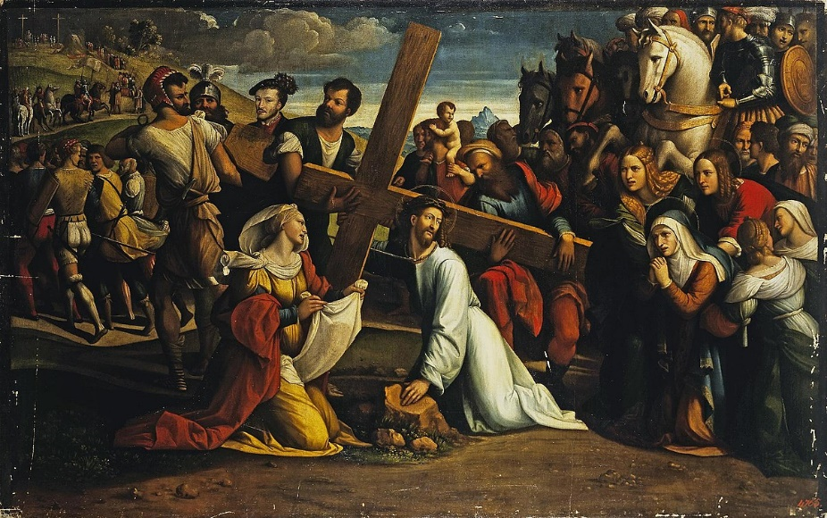

Our Lady of Sorrows, pray for us.
Saint Joseph, comfort of the afflicted, hope of the sick, patron of the dying, terror of demons, pray for us.
Fifth Sorrowful Mystery
Jesus is Crucified and Dies on the Cross
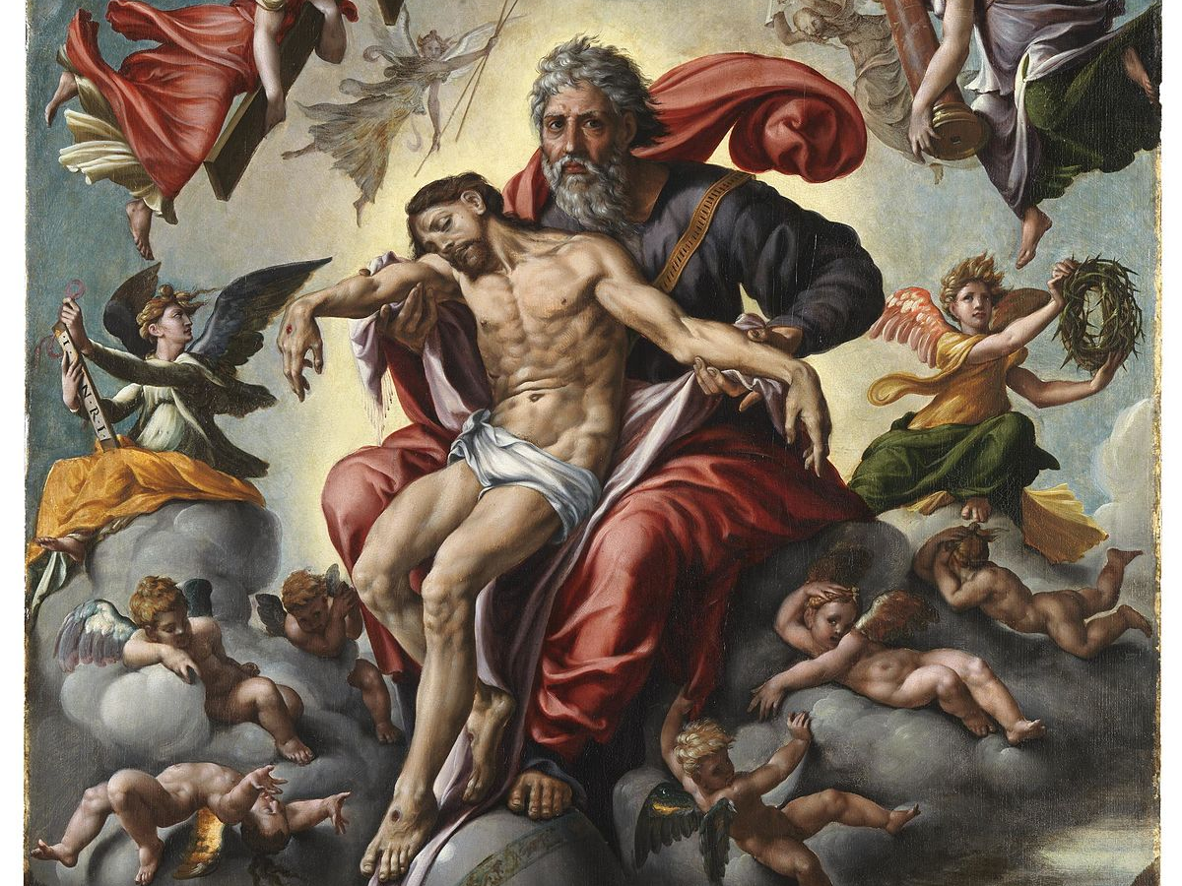

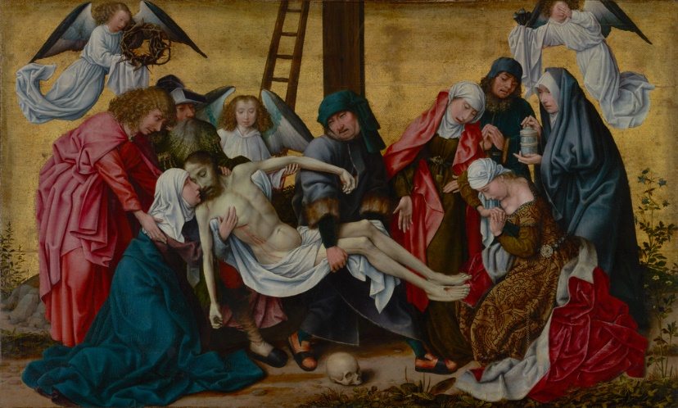

Our Lady of Sorrows, pray for us.
Saint Joseph, comfort of the afflicted, hope of the sick, patron of the dying, terror of demons, pray for us.
The Glorious Mysteries
This Photo by Unknown Author is licensed under CC BY-SA

These glorious mysteries show forth the fruit of suffering. Doing the Father’s will is the food that sustains Me were the words Jesus gave us.
Our Angels have been our guide through these mysteries of life and death. Now with great joy and excitement they share with us the GLORY that is promised those who faithfully BELIEVE in the one the Father has sent, they, we believe in Jesus and ALL HE has taught us by word and by deed.
Here we are at the TOMB, the place where they had so lovingly placed the body of Jesus. How many angels were present to watch with those who waited in spirit. How many angels rejoiced as He ROSE as HE PROMISED! What great joy! What a SURPRISE to the guards! Their guardian angels were anxiously awaiting this fullness of time.
As these Glorious Mysteries continue with so many graces the joy of the angels were quick with every step along the way. Supporting those awaiting in the upper room, with Our Lady and the apostles, disciples as they watched with mirids of angels as Jesus returned to His Father, back at the Upper room to await the Holy Spirit, marveling at Our Lady’s Assumption into Heaven. And of course, their GREAT JOY to see her crowned by the Most Holy Trinity as Queen of Heaven and Earth…Queen of the Angels. May we rejoice with them as we ponder and pray these Glorious Mysteries.

O Mary, Queen of virgins, Queen of Heaven and Earth, pray for us.
Saint Joseph, pray for us!

First Glorious Mystery
The Resurrection of Jesus

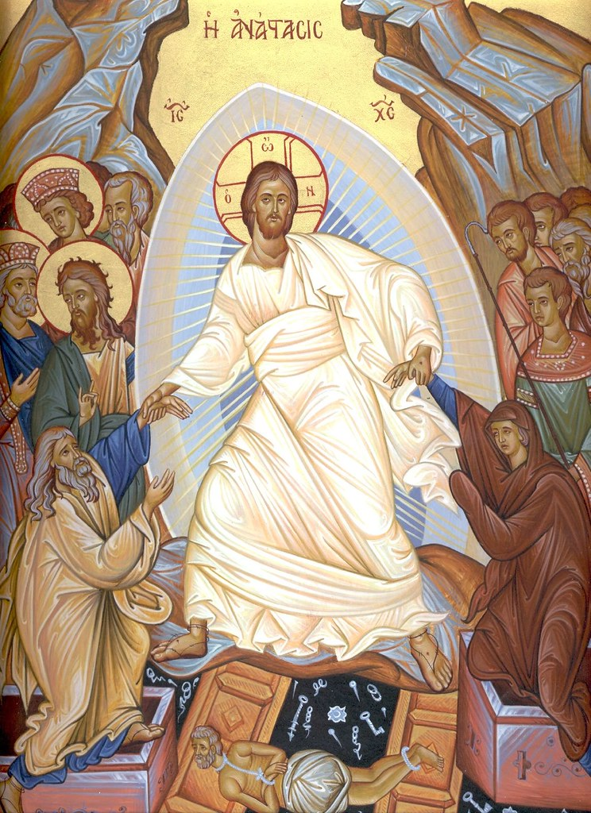

O Mary, Queen of virgins, Queen of Heaven and Earth, pray for us.
Saint Joseph, pray for us!

The Second Glorious Mystery
The Ascension of Our Lord into Heaven

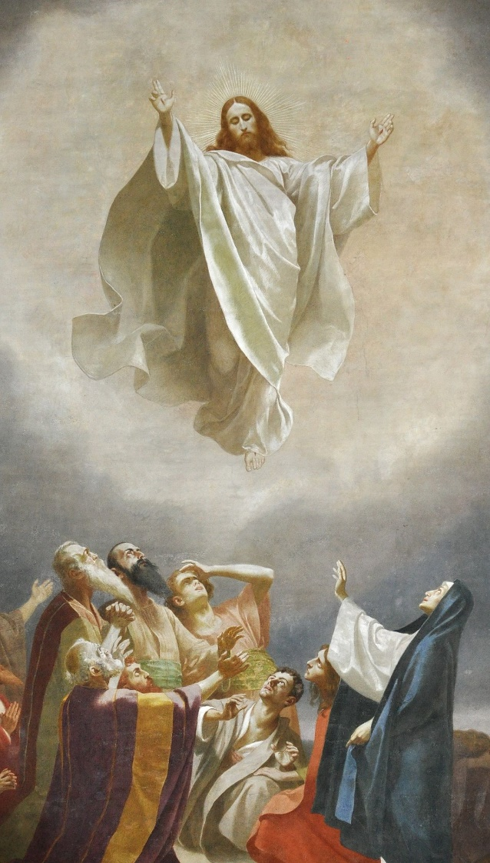

O Mary, Queen of virgins, Queen of Heaven and Earth, pray for us.
Saint Joseph, pray for us!

The Third Glorious Mystery
The Descent of the Holy Spirit

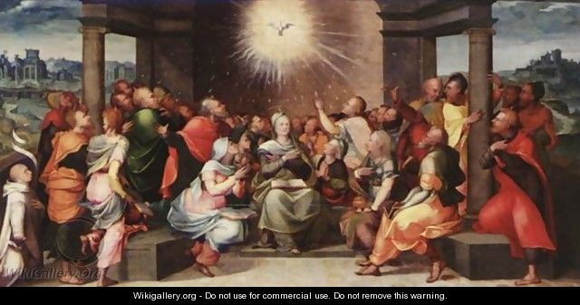

O Mary, Queen of virgins, Queen of Heaven and Earth, pray for us.
Saint Joseph, pray for us!

The Fourth Glorious Mystery
The Assumption of Our Lady into Heaven

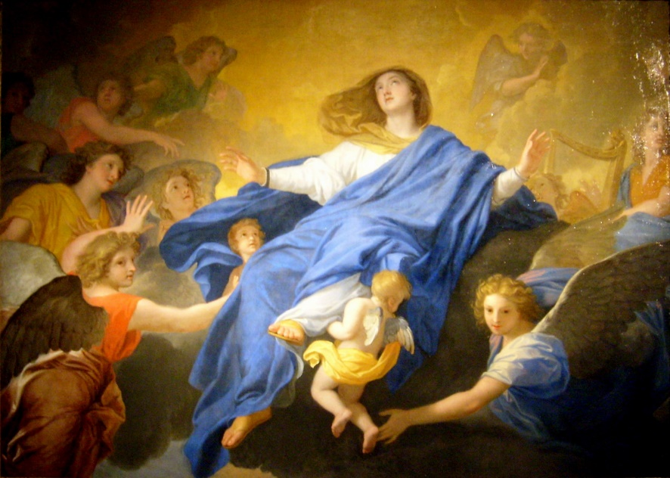

O Mary, Queen of virgins, Queen of Heaven and Earth, pray for us.
Saint Joseph, pray for us!

The Fifth Glorious Mystery
The Crowning of Mary as Queen of Heaven and Earth

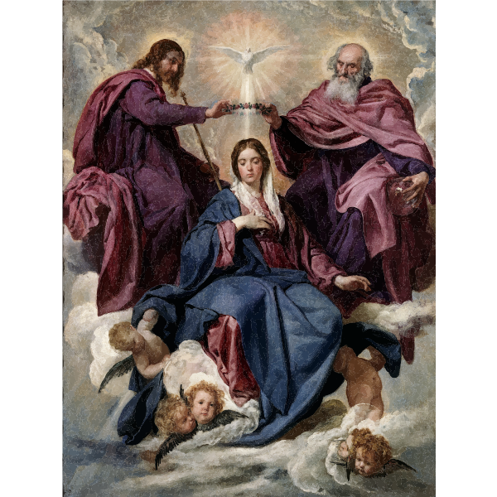

O Mary, Queen of virgins, Queen of Heaven and Earth, pray for us.
Saint Joseph, pray for us!

Heavenly Father, as we have journeyed with the angels through these
Mysteries of the Rosary may we be always mindful and grateful for their presence in our daily lives.
Keep us close to You as we grow in grace and fidelity to Your Holy Will.

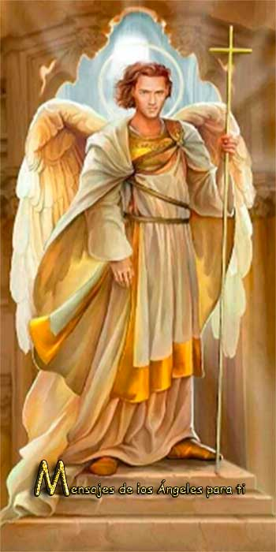
Saint Michael….

In the Name of the Father and the Son and the Holy Spirit. Amen
Queen of the Most Holy Rosary, pray for us.
Saint Joseph, pray for us.

