Chancery Bulletin - Vol. 8, No. 4.2 | April 18, 2023

- Catechesis & Evangelization  - Chancery  - Communications  - Consecrated Life  - Diaconate  - Marriage & Family Life  - Ministries  - Mission Office  - Sacred Worship | - Safe Environment  - Schools Office  - Social Concerns  - Stewardship and Development  - Temporalities  - Vocations  - Vicar for Clergy  - Youth and Young Adult Ministry  - Past Chancery Bulletins
No items this week.

<<Top >>

Chancellor Very Rev. William Dhein – 608.791.2655 | wdhein@diolc.org

No items this week.

<<Top >>

As of April 18
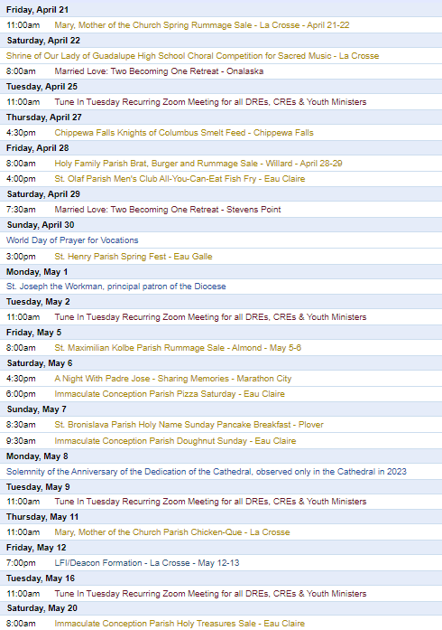
To get your parish events listed on the diocesan calendar, diolc.org/calendar, and in Catholic Life magazine, please send an email to datebook@diolc.org. Make sure you include the following details: date, beginning/ending times, event location, description, menu and cost, etc. If you have any questions, please call Pam Willer at 608.788.1524 for more information.
Director: Ann Lankford – 608.791.2658 | alankford@diolc.org
For your parish bulletin - May 7
Parents: Protect Your Children
The culture is bombarding your children and young people with lies about their identity. The stark reality is that the “gender revolution” is being streamed into your children’s daily lives, offering a seductive vision that is deeply disturbing and untrue. The work of Person and Identity Project is an excellent service to parents navigating urgent issues around ‘gender identity’ and ‘gender transition.’ The information on their website is objective and up to date. personandidentity.com
Eucharistic Revival Events / Communication Updates
For your parish bulletin – May 7: Fifth Week of Easter
A Minute with Jesus
29) Confession – a preparation for receiving the Eucharist
The best way to prepare to receive Jesus in the Holy Eucharist is by going to Confession (also known as the Sacrament of Reconciliation, Penance). We want to receive Him with a clean heart. If it is not possible to go to Confession before receiving Jesus, make a sincere Act of Contrition in your heart, and as always pray with sincerity the prayer at Mass, “I confess to Almighty God…”
A sin that is mortal – serious or grave – requires Sacramental Confession before receiving Holy Communion. If you are not sure about this, speak with a priest.
Let’s pray this right now and every day this week: Jesus, please give me the grace to be truly sorry for my sins.
This week read how God calls us out of darkness into His own wonderful light in 1 Peter 2:9-10.
For a list of all weekly proclamations through May 21 (with more to be added regularly), click here: diolc.org/eucharist/learn or use your smartphone’s camera to scan this QR code. Scroll to A Minute with Jesus.
Catechetical Leader Information
Eucharistic Revival for Parish / School Formation
A Minute with Jesus - April 23 – Third Week of Easter
27) The Eucharist is the Risen Christ
On Easter Sunday, two disciples were leaving Jerusalem without hope as they believed that the Savior was dead. Jesus joined then as they walked but the disciples did not recognize Him as He now had a glorified body. When Jesus sat down with the disciples at Emmaus, they recognized Him in the “breaking of bread,” which was the Eucharist.
Let’s pray this right now and every day this week: Lord, make my heart burn with a desire to read Your Word in Sacred Scripture.
This week, read how Jesus explained how He fulfilled the Old Testament in His Passion, Death and Resurrection, and allowed the disciples to recognize Him in the breaking of the bread in Luke 24:13-35.
Picture of Jesus walking with the disciples on the road to Emmaus
A Minute with Jesus: An ongoing list of concise proclamations are available, up to and including May 21, with more to follow: diolc.org/catechesis/catechetical-leaders-info
Parent’s Participation: Provide parents with A Minute with Jesus, and encourage them to have a 5-minute conversation with their children, regarding what stood out for them from this brief explanation.
What are Parents Searching For? Why is this Important in Helping Parents Come to Mass?
Webinar – May 2nd or May 5th
You won’t want to miss Dr. Bill Keimig, a sought after presenter on Franciscan at Home online learning. Bill will address this critically important topic in an interactive webinar on Tuesday, May 2nd from 6-7:30 p.m. or Friday, May 5th from 1-2:30 p.m. Email Beth Johnson at bjohnson@diolc.org to register for this free webinar.

Catechist Years of Service
Catechetical Leaders are encouraged to complete the form, listing catechists who have served 5, 10 or 15 years of service etc. found at: diolc.org/catechesis/catechetical-leaders-info Certificates are given only for 5 year increments.

<<Top >>

Director: Erik Archer– 608.791.2661 | earcher@diolc.org

Sending a note of encouragement to your pastor
We encourage everyone to recognize the good work done by their pastor. You can send a note of encouragement, a promise of prayer or share your favorite story by visiting diolc.org/notes-to-clergy or by using your Smartphone’s camera to scan this QR code.

Listing your parish events in the July/Aug issue of Catholic Life
If your parish has events for inclusion in the July/Aug issue of Catholic Life, please submit them by April 28. To get your parish events listed on diolc.org/calendar, and in Catholic Life magazine, please send an email to datebook@diolc.org. Make sure to include the following details: date, beginning/ending times, event location, description, menu and cost, etc. If you have any questions, please call Pam Willer at 608.788.1524.
Reminder: Spring Parish Roundtable Registration
Our team is grateful for the opportunity to travel across our Diocese of La Crosse footprint and dialogue with our parish teams. The Spring Roundtable schedule is below. Roundtable locations shift each iteration and are designed to help each parish have a nearby roundtable to attend. Several curia leaders will join the communications team in attending these roundtable meetings. The registration link is at the top of this page: diolc.org/pims
April 19 from 9:30 a.m. to 11 a.m. - St. Patrick, Onalaska Register
April 19 from 2 p.m. to 3:30 p.m. - St. Mary, Richland Center Register
April 26 from 9:30 a.m. to 11 a.m. - St. Paul, New Lisbon Register
April 26 from 2 p.m. to 3:30 p.m. - St. Philip, Rudolph Register
May 2 from 1:30 p.m. to 3 p.m. - St. Mary, Durand Register
May 3 from 9:30 a.m. to 11 a.m. - St. Mary, Neillsville Register
May 3 from 2 p.m. to 3:30 p.m. - St. Anne, Wausau Register
<<Top >>

Director: Sr. Donna Krzmarzick, ISSM – 608.791.2690 | dkrzmarzick@diolc.org
Attention Parish Administrative Assistants and Secretaries: The deadline for entering changed quantities for materials for the Retirement Fund for Religious (year 2024) is April 28. For more information, refer to Sr. Donna’s email of March 29 or contact her: dkrzmarzick@diolc.org
<<Top >>

Director: Deacon Bryan Hilts – 608.791.2665| bhilts@diolc.org

Reminder: Fall Ministry Days: Oct. 16-17, 2023 – This is a good way to take advantage of Continuing Education Credits. Attendance is encouraged.

Reminder: Bishop’s Day with Deacons and their wives: Aug. 12, 2023 – Holy Cross Diocesan Center, La Crosse. Attendance expected.

<<Top >>

Director: Christopher Rogers – 608.791.2659 | crogers@diolc.org

No items this week.

<<Top >>

Director: Christopher Ruff – 608.791.0161 | cruff@diolc.org

No items this week.

<<Top >>

Director: Fr. Woodrow Pace – 608.791.2676 | wpace@diolc.org
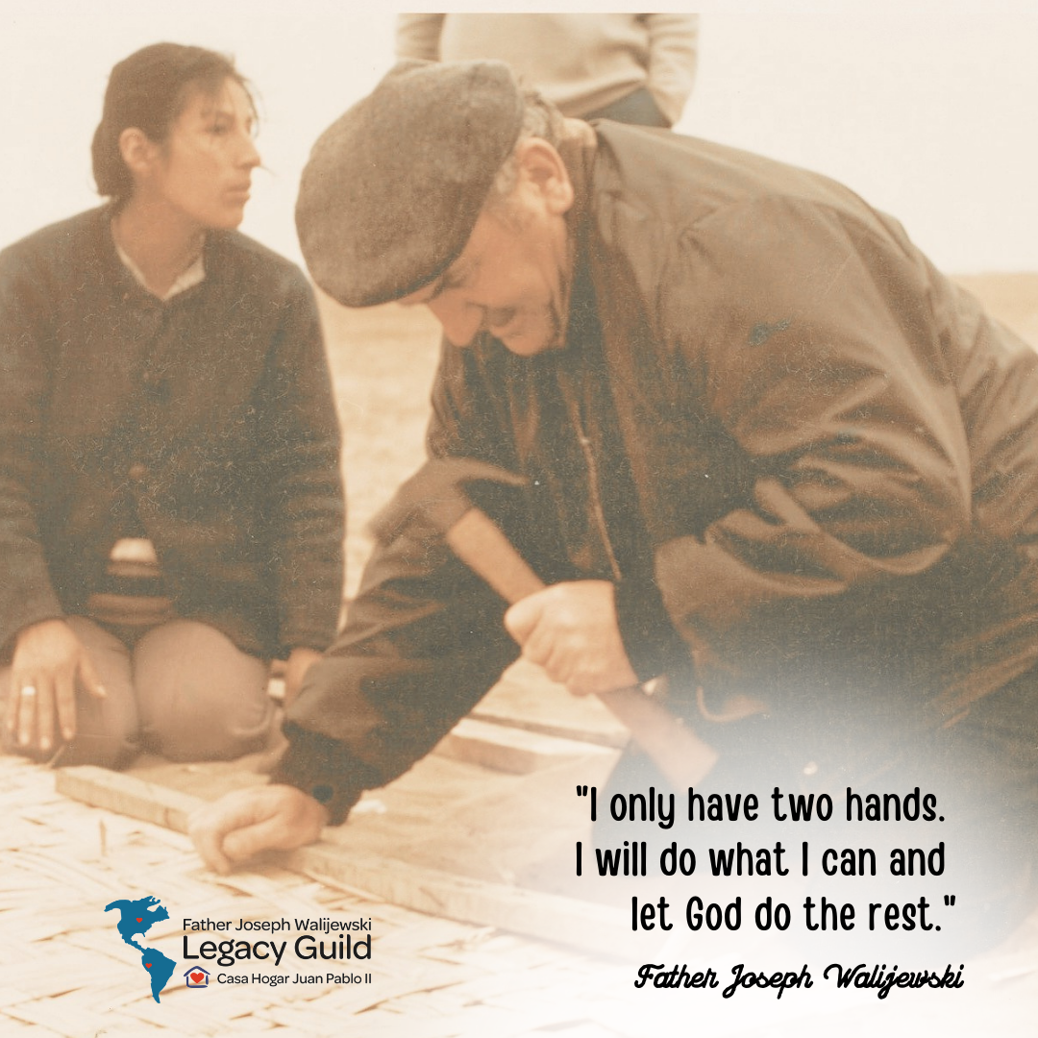
For your parish bulletin: A Night with Padre Jose – Sharing Memories
Please join us Saturday, May 6th in Marathon City, as we come together to share memories of the good work Servant of God, Father Joseph Walijewski did for the people in Bolivia and Peru, along with messages from individuals who saw firsthand how he used just his two hands to make a big difference in the lives of so many people. This event is a celebration of the life of Father Walijewski and his legacy that lives on at Casa Hogar Juan Pablo orphanage, a direct mission of the Diocese of La Crosse.
Guest speakers for the evening will be Msgr. Joseph Hirsch, Director of Casa Hogar Juan Pablo II, and Fr. Sebastian Kolodziejczyk, previous Director of Casa Hogar (2001-2013), both continuing the work started by Padre Jose.
Saturday, May 6, 2023 at Memories Ballroom in Marathon City
Social 4:30 p.m. – Dinner at 6:15 p.m.
Cost – $30 adults, $10 for children 5-10 years, and free for 4 years and under
Register at homeajpm.org/events or use your smartphone’s camera to scan the QR code to the right. For questions, or to register by phone, call 715-297-5139.
<<Top >>

Director: Christopher Carstens – 608.791.0161 | ccarstens@diolc.org

No items this week.

<<Top >>

Director: Teresa Brown – 608.791.2679 | tbrown@diolc.org

DIOCESE OF LA CROSSE GUIDELINES FOR REPORTING INSTANCES OF CHILD ABUSE

The Diocese of La Crosse, through its policies and procedures, seeks to provide a prompt, appropriate and compassionate response to reporters of sexual abuse of a child by any diocesan agent (bishop, priest, deacon, employee, religious, vendor or volunteer). Anyone wishing to make a report of an allegation of sexual abuse should send that report to Mrs. Teresa Brown, Complaint Intake Agent, at the Diocese of La Crosse, P.O. Box 4004, La Crosse, WI 54602-4004. Alternatively, you can contact Mrs. Brown at 608.791.0179 or intakeagent@diolc.org. The reporting form is available through the Diocese of La Crosse Office of Safe Environment or on the diocesan website at: diolc.org/safe-environment/reporting. Individuals are also encouraged to take their reports directly to civil authorities. Copies of the diocesan policy are available through your local Parish and on the diocesan website. If you have any questions about the Diocese of La Crosse and the implementation of the Charter for the Protection of Children and Young People, please contact Teresa Brown, Diocese of La Crosse, at 608.791.2679 or tbrown@diolc.org.

<<Top >>

Superintendent: Thomas Reichenbacher – 608.788.7707 | treichenbacher@diolc.org

No items this week.

<<Top >>

Director: Christopher Ruff – 608.791.0161 | cruff@diolc.org
From Seminarians David Nowicki and Kyle Lang:
Help us provide aid to the victims of the earthquakes in Turkey and Syria!
In February 2023, southern Turkey and northern Syria were hit by a magnitude 7.8 earthquake. The death toll surpassed fifty thousand, and millions more were made homeless or otherwise afflicted, making the unusually cold winter even harder to endure.
Each year, seminarians from the Pontifical North American College in Rome run a relay across the Italian peninsula to raise money for a Catholic charity. This Saturday, April 22, two teams will start at the coasts and meet in the middle of the peninsula, running a collective 180 miles. This year, we are partnering with Catholic Relief Services to provide aid to the victims of this earthquake, in the assurance that the Lord can take what we have to bring hope to those who are in greatest need. Scan the QR code to the right to see how you can donate.
For La Crosse area Parish Bulletins:
You are Invited to the May 4 Mayoral Prayer BreakfastCome to the 27th Annual Greater La Crosse Area Mayoral Prayer Breakfast, at the Cargill Room of the Waterfront Restaurant in La Crosse, on Thursday, May 4 from 7:29-8:45 AM. This beautiful ecumenical event is attended by community church, political, and business leaders, teachers, first responders, military members, and more. The keynote speaker will be Dr. Mark Barclay, a Vietnam combat veteran and the founding Pastor of Living Word International Church. The Diocese of La Crosse is a contributing sponsor of this prayer breakfast. For tickets, visit crprayer.org.
Reminder: For Your Parish Bulletin:
April is Abortion Recovery Awareness Month
Do you know someone who is carrying the grief and sorrow of past abortions? Project Rachel Ministry of the Diocese of La Crosse offers a compassionate heart and confidential help. Call 608.860.6698 or email projectrachel@diolc.org.
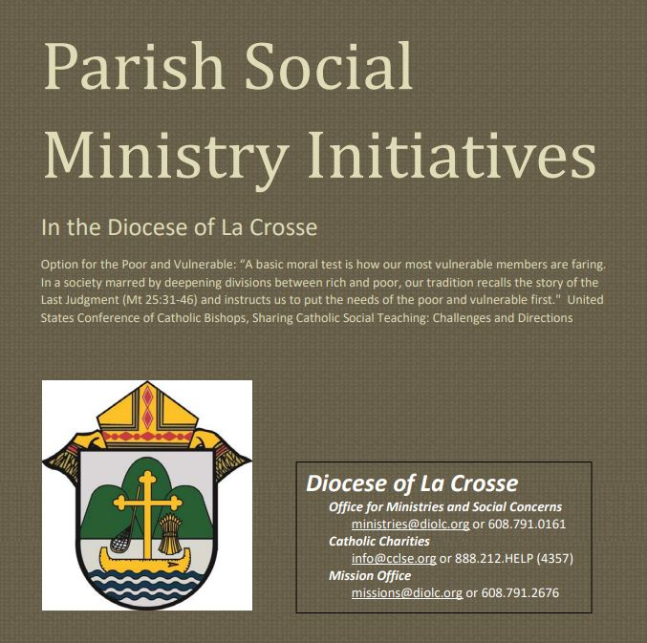
Pastors, Deacons, Parish Social Concerns Representatives:
Are Your Social Ministry Initiatives listed in the Directory?
In order to address most fruitfully the social concerns within our diocese, we are asking the parishes of the diocese to review their current social ministry initiatives (any outreach of charity or social advocacy). If these are not already listed in the diocesan Directory of Parish Social Ministry Initiatives, or if updating is needed, the pastor or someone authorized by him is asked to take a moment to complete and submit this form for each organization/resource.
For Your Parish Bulletin:
CALIX – For Help with Addiction from a Catholic Perspective
Do you or a family member or friend need help with an addiction concern? Or, do you just need someone to talk with? You can reach out to a member of CALIX. CALIX (calixsociety.org) is an association of Catholics in addiction and family members and friends affected by addiction, who are maintaining their sobriety through participation in their Catholic faith and a 12 Step program. You can make a confidential call to 612.383.8232 (Jim R.) or 651.587.4668 (Jim B.), for information on meetings and recovery support. You need not disclose your name.

<<Top >>

Director: Jeff Reiter – 608.791.2653 | jreiter@diolc.org

No items this week.

<<Top >>

Diocesan Finance Officer: James Reider – 608.791.2668 | jreider@diolc.org

2023 Parish Finance Seminar, Wednesday, May 10, 8:30a.m. – 4 p.m.
Three Bears Lodge, 701 Yogi Circle, Warrens, WI 54666
Notice! Registration is required by close of business Friday, Apr 28, 2023

The Office for Temporalities is hosting the parish finance seminar at Three Bears Lodge. This will be our first in-person seminar since 2018. Please don’t miss this opportunity to meet principals from our financial services vendors, your parish counterparts and curia staff. Registration is required and must be received by April 28, 2023. Click here to register, or use the link on the diolc.org/temporalities website. Registration fee of $50.00 per person includes breakfast, lunch and break – snacks and refreshments. Priest registration is free. Attendees may include the pastor, pastoral associate, parochial administrator, parish bookkeeper, secretary, members of the Parish Finance Council and lay directors of Parish Corporations. If you wish to stay overnight, please contact Three Bears Lodge directly at 608.378.2500. Rooms are available at $89.00 per night plus taxes for a double queen room.

Meeting Agenda
8:30 Registration/Continental Breakfast
9:10 Opening Prayer – Very Rev. William Dhein
- Welcome/Introductions – James Reider, Finance Officer
9:15 Session I: Very Rev. William Dhein, Vicar General, Chancellor and Moderator of the Curia:
- New – Promulgating Norms for the Clergy Compensation, Diocese of La Crosse
- Diocese Investment Policy – USCCB Guidelines and Withdrawals
Allowable investments
10:00 Session II: Catholic Mutual Group – Ben Burrow
- Review of Coverage for Property, Liability and Workers Comp
- Special Event and Incident Report Forms
- Nurse’s Hotline - Medcor
10:45 Break
11:00 Session III: Mutual of America - Lisa Lipusch, Maggie Haze, and Paul Wierzba
- Employee 403b Retirement Plan - Plan Updates
- New Website Platform
11:45 Lunch – Sponsored by Mutual of America
12:45 Session IV: Jessica Kirchner – Attorney from Moen, Sheehan and Meyer, Ltd.
- New Diocesan Contract Form for Larger Projects
- Leases
1:45 Session V: St. Ambrose Financial Services – Dennis Herricks, Executive Director
- Responsibilities-Health/Dental/All Risk/Deposits & Loans
- Billing Statements and Other Information
- Open Enrollment
2:45 Break
3:00 Session VI: James Reider – Diocesan Finance Officer
- Annual Reports – 2021-2022 recap
- Annual Report Due Dates – August or October
- Chart of Accounts – Questions
- Open Questions and Answers of Any Presenter
3:45 Closing Remarks, Prayer and Dismissal

Click here to register. Forward any questions to nlichter@diolc.org.

Payments to Diocese of La Crosse, St. Ambrose, St. Joseph Priest Fund/Mission

There has been some confusion on payments in general to the entities that are housed at the Holy Cross Diocesan Center and in particular relating to the payments for the Lay Employee Retirement Plan.
1. The St. Joseph's Priest Fund assesses twice a year. The March assessment funds the St. Joseph's Priest Fund, while the September assessment has in recent years been a Board-designated redirect to the frozen Lay Employee Retirement Plan. The March assessment is billed by the St. Joseph's Priest Fund and is payable to the St. Joseph's Priest Fund using account 5250 Priest & Religious Retirement Pension Expense. The September assessment is billed by the Diocese of La Crosse for the Lay Employee Retirement Plan and thus payable to the Diocese of La Crosse. Use account 5216 Lay Retirement Pension Expense to record this payment.
2. St. Ambrose Financial Services assesses annually in April for the frozen Lay Employee Retirement Plan and should be made payable to St. Ambrose Financial Services. Use account 5216 Lay Retirement Pension Expense to record the payment.
3. Invoices payable to the Diocese of La Crosse should be paid separately from collections payable to the Diocese of La Crosse.
4. Collections for Good Friday – Holy Land are made payable to the Diocese of La Crosse, while Student Lenten Mite Box collections are made payable to the Society for the Propagation of the Faith.
<<Top >>

Director of Vocation Recruitment: Fr. Nate Kuhn – 608.791.2666 | nkuhn@diolc.org

Please include the following intercession for vocations for your Sunday prayers of the faithful.
That through our vocations to marriage, priesthood, single life, and religious life we may be signs of God's presence and love in the world.
Consider adding a vocations paragraph to your parish bulletin. Below is an example – they will be changed each week. Feel free to use any or all of them.
What does your future hold?
When we are young, we look towards the future and wonder what’s in store. Perhaps there are dreams of accomplishing great things, helping others, or being able to change the world. Well, there is a vocational calling that can provide the opportunity to do all of that and so much more: the priesthood! Consider the Lord’s call to the priesthood, a calling that gives young men the opportunity to be part of something greater, the Church. It provides an opportunity to be part of God’s healing mission, a mission to save souls and bring people into deeper relationship with Him. If you or someone you know is interested in discovering this call, please contact me at: Fr. Nate Kuhn, Director of Vocational Recruitment for the Diocese of La Crosse, 3710 East Ave. S. PO Box 4004, La Crosse, WI 54602; or by phone at: 608.791.2667. God bless you!
<<Top >>

Director: Very Rev. Woodrow H. Pace – 608.791.2689 | wpace@diolc.org
Priest Reminder for Evenings of Recollection: Thank you to the many priests who participated in the first effort on Dec. 1, 2022. The evening was grace-filled and uplifting. This continued support for priests through the scheduled Evenings of Recollection are posted for the year on the Vicar for Clergy webpage. Please scroll down the page and select the location, either La Crosse or Wausau. Once you indicate that you are registering one participant, a menu will appear. Then you can select the date from the drop down menu titled, “Evening of Recollection.”
Next Dates:
May 4, 2023 at the Shrine in La Crosse
May 18, 2023 at Holy Name Parish in Wausau.

<<Top >>

Director: Christopher Rogers – 608.791.2659 | crogers@diolc.org

No items this week.

<<Top >>

Diocese of La Crosse | 3710 East Ave S | La Crosse, WI 54601 | 608-788-7700
To unsubscribe from this e-mail message contact mwilson@diolc.org

