Chancery Bulletin - Vol. 8, No. 8.1 | August 1, 2023

- Catechesis & Evangelization  - Chancery  - Communications  - Consecrated Life  - Diaconate  - Marriage & Family Life  - Ministries  - Mission Office  - Sacred Worship | - Safe Environment  - Schools Office  - Social Concerns  - Stewardship and Development  - Temporalities  - Vocations  - Vicar for Clergy  - Youth and Young Adult Ministry  - Past Chancery Bulletins

National Eucharistic Congress Pilgrimage:
In July 2024, the National Eucharistic Congress will be held in Indianapolis, Ind. This 5-day experience, "Eyes Opened, Hearts on Fire," will be held July 17-24, 2024. Speakers such as Bishop Robert Barron, Fr. Mike Schmitz, Fr. John Burns, Bishop Andrew Cozzens, and many more, will inspire and invite people to return to the source and summit of our Faith in the celebration of the Eucharist. In addition to the work being done in our Diocese as part of the Eucharistic Procession to Indianapolis, we are exploring the possibility of taking a group from the Diocese of La Crosse to attend the Eucharistic Congress. To prepare for such a pilgrimage, we need to know the number of pilgrims interested in joining a group from the Diocese of La Crosse to attend the National Eucharistic Congress. If you are interested in being part of this special pilgrimage, please email dbrannon@diolc.org with the number of people interested in attending. Once we know the number of people wishing to participate, we can provide further information related to costs, travel, and registration.

No items this week.

<<Top >>

Chancellor Very Rev. William Dhein – 608.791.2655 | wdhein@diolc.org

No items this week.

<<Top >>

As of Aug. 1

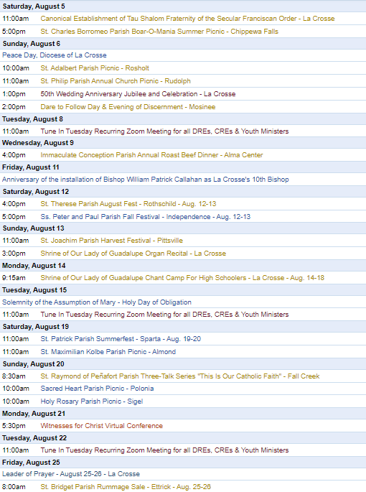
To get your parish events listed on the diocesan calendar, diolc.org/calendar, and in Catholic Life magazine, please send an email to datebook@diolc.org. Make sure you include the following details: date, beginning/ending times, event location, description, menu and cost, etc. If you have any questions, please call Pam Willer at 608.788.1524 for more information.

<<Top >>

Director: Ann Lankford – 608.791.2658 | alankford@diolc.org
Eucharistic Revival Communication / Event Updates:
For your Parish Bulletin:
Mark Hart to speak on the Eucharist in Scripture
During this National Eucharistic Revival, all Catholics are invited to grow in their understanding of Jesus’ True Presence in the Eucharist. Join Mark Hart, the renowned “Bible Geek,” on Monday, Aug. 21st from 5:30-8 p.m. for this live, virtual Conference on the Eucharist in Scripture. Mark presents in a compelling way, making the Scriptures on the Eucharist come alive. Register: diolc.org/witness or by using your smartphone’s camera to scan the QR code to the right. Cost is $10 per person and includes Mark’s book entitled “The Divine Encounter” (a $7.95 value). Join with others at the parish or family at home. – Don’t miss it!
(Reminder) Parish Point Persons: Stoking the flames of Eucharistic Revival: | Aug. 1st at 7 p.m.
Join Bishop Cozzens on Aug. 1, 2023 at 7 p.m., as he explains how every one of us plays a key role in spearheading this exciting movement at the local level. He will also show you how to get all the help you need to answer God’s call.
We’re living through a pivotal moment in the history of the American Church, and now is the time for all of us to rise up and spread true love of Jesus in the Eucharist. That’s why this webinar is open to all, and thousands of people are expected to attend. Don’t miss out on this chance to learn and grow as a parish leader—sign up today, and invite a friend! Click here: eucharisticrevival.org/bishop-cozzens-webinar or use your smartphone’s camera to scan the QR code to the right
(Reminder) Planning for Fall with Bible Studies and Faith Studies:
Training for Facilitators of Small Groups
Our greatest need is the formation of adults in the Catholic Faith. Small groups are a unique and essential avenue for parishioners to encounter Jesus, learn more about His teaching, grow in fellowship with one another which strengthens the community, prepare to participate in the Eucharistic celebration, and pray together.
Clergy, your promotion of small groups is needed! Facilitators can be trained through a workshop on Franciscan at Home online learning. This training is most beneficial when the workshop is completed together with a group. Through generous donors, every parish/school has a free year-long subscription. For further information and simple directions to register (at no cost) for Franciscan at Home, visit diolc.org/catechesis/bible-studies-and-small-group-resources or by using your smartphone’s camera to scan the QR code to the right.
For your parish bulletin:
A Minute with Jesus: August 13
43) The Eucharist is called Holy Mass
The word “Mass” comes from the Latin word “Missa.” Missa is related to the word “missio,” the root of the English word “mission.” At Mass, we come to receive the Eucharist—the Real Presence of Jesus. He gives Himself to us out of love, to strengthen us in living out the Christian life. At the end of Mass, we are dismissed with the words, “The Mass is ended, let us go in peace to love and serve the Lord.” Each of us is sent on mission, to show our love for God by loving and serving others and passing on the Catholic Faith to them. We want to help others to know the Truth – Jesus Christ – so that they also can find peace, which only He can give. Let’s pray this right now and every day this week: “Jesus, please give me the courage to speak about my friendship with You in simple ways to others, when the opportunity arises. And let my actions speak louder than any words I say.”
This week, read how we are to serve others in Hebrews 6:10. “Only do not use your freedom as an opportunity for the flesh, but through love serve one another.”
For a list of all weekly proclamations up to Aug. 20 (with more to be added regularly), click here: diolc.org/eucharist/learn
Catechetical Leader Information:
Catechetical Leader Calendar 2023-2024
The calendar for 2023-2024 is available for all DREs, CREs and Youth Ministers in both a word format and a pdf here: diolc.org/catechesis/catechetical-leaders-info
New DREs, CREs and Youth Ministers:
Parishes are asked to inform Ann Lankford at alankford@diolc.org with the name and email of any new DRE, CRE and/or Youth Minister. The person’s name needs to be included in ParishSoft with the designated title so that he/she will receive the weekly Chancery Bulletin.
New Catechetical Leader Formation at the Holy Cross Diocesan Center:
New DREs, CREs and Youth Ministers are asked to attend a day of formation in September. This training includes formation in Evangelizing Catechesis with an explanation of best practices and resources available to you. We will also discuss the Certification Program with Franciscan at Home free for every parish, guidelines on the preparation for Sacraments, implementing Theology of the Body in a gradual way, answer your Safe Environment questions, and have interactive discussion on organizing, developing, and coordinating the Faith Formation Program, including parent involvement, in the parish.
Standards for Educators in Catholic Parishes and Schools:
The Bishops in the State of Wisconsin (Wisconsin Catholic Conference) have updated the standards. The standards are available here: diolc.org/catechesis/catechetical-leaders-info It is still the case that DREs, CREs and Youth Ministers are to work Basic/Advanced by receiving 12 hours of certification per year. Parish Catechists are to work toward Basic by receiving six hours of certification per year. The preferred means for earning certification credit is Franciscan at Home online learning, which is best completed in groups. Completion of a workshop provides 6 hours of credit. See details below for apPractice workshop to see how user-friendly the system is and the effects of a group session.
Franciscan at Home “Practice” Workshop for DREs, CREs, YMs:
If you would like to participate in a workshop by Zoom to see how Franciscan at Home is user-friendly, there will be two choices of times:
- Thursday, August 17 from 1:30 - 3 p.m.
- Thursday, August 17 from 6:30 - 8 p.m.
Contact Beth Johnson at bjohnson@diolc.org to register for one of these “practice” sessions. There is no cost to participate. Join with a group of catechetical leaders and enjoy yourself while appreciating good discussion and sound teaching.
Eucharistic Revival for Vacation Bible School and Parent Communications:
A Minute with Jesus: August 6
42) The Eucharist is called the Holy Sacrifice
A sacrifice is an offering of love for someone. Jesus rescued us and set us free from the bondage of sin by offering Himself through His painful sacrifice on the Cross. At each Mass, Jesus offers Himself to the Father for love of us. Jesus is not being “re-sacrificed” but the sacrifice of Calvary is being made present at each Mass. To express our gratitude and to open our hearts more deeply to Him, we can show our love by offering small sacrifices to Him: our willingness to forgive after being hurt by someone, cutting our time short with TV to take time for prayer, visiting someone who is sick etc.
Let’s pray this right now and every day this week: “Thank You, Jesus, for loving me so much that You were willing to die in order to save me and set me free from the bondage of sin.”
This week, read how we are to imitate Jesus by walking in the way of love in Ephesians 5:2
“Walk in the way of love, just as Christ loved me and gave Himself up for me as a fragrant offering and sacrifice to God” (Ephesians 5:2).
Suggested: Picture of Jesus on the Cross
Click here for entries before and after Aug. 20: diolc.org/catechesis/catechetical-leaders-info
<<Top >>

Director: Erik Archer– 608.791.2661 | earcher@diolc.org

No items this week.

<<Top >>

Director: Sr. Donna Krzmarzick, ISSM – 608.791.2690 | dkrzmarzick@diolc.org

No items this week.

<<Top >>

Director: Deacon Robert Riedl – 608.791.2665 | rriedl@diolclergy.org
(Reminder) Bishop’s Day with Deacons and their wives | Aug. 12, 2023:
August 12th, 2023 is Bishop’s Day with the Deacons and their wives. The refectory will be open at 11:00 am until registration begins at 12:30 pm for anyone who may want to come early and bring their own lunch to eat and visit with others. Please contact Renee’ to register at rorth@diolc.org or if you did not receive an invitation in the mail. Attendance is expected!
<<Top >>

Director: Christopher Rogers – 608.791.2659 | crogers@diolc.org

No items this week.

<<Top >>

Director: Christopher Ruff – 608.791.0161 | cruff@diolc.org

(Reminder) For Your Parish Bulletin:
Video Testimonials on the Lay Formation Institute (LFI)
Watch short videos of what the most recent graduates are saying about their Lay Formation experience, how it has deepened their relationship with Christ and their Faith! Registration is now open for the next two-year cycle that begins in the fall of 2023. For the video clips and more information, visit diolc.org/lay-formation, or use your smartphone’s camera to scan the QR code to the right. Discuss enrollment with your pastor and contact the Office for Ministries and Social Concerns at ministries@diolc.org or call 608.791.0161.

<<Top >>

Director: Fr. Woodrow Pace – 608.791.2676 | wpace@diolc.org

No items this week.

<<Top >>

Director: Christopher Carstens – 608.791.0161 | ccarstens@diolc.org
Vatican Issues Suggested Lectionary Readings for Mass “For Chastity”:
From the Bishops’ Committee on Divine Worship Newsletter, May-June 2023
On March 20, 2023, the Dicastery for Divine Worship and the Discipline of the Sacraments promulgated a set of suggested readings in the Ordo lectionum Missæ for the Mass “For Chastity,” found in no. 39 of the Masses and Prayers for Various Needs and Occasions in the Roman Missal. The Mass formulary was inserted into the Missal beginning with the editio typica tertia in 2002 but there were no corresponding suggestions for Lectionary readings until the present. The Dicastery’s decree was publicly announced on June 22. More information on this Mass, citations of the suggested readings, and free PDF downloads in English and Spanish, are available at USCCB.org/prayer-worship/the-mass/votive-masses-and-various-needs/mass-for-chastity-readings.
(Reminder) The Divine Office Hymnal: Available for Purchase and Optional Liturgical Use:
From the Bishops’ Committee on Divine Worship Newsletter, May-June 2023
The USCCB’s Secretariat of Divine Worship announces the publication of The Divine Office Hymnal and its availability for optional liturgical use in the United States, now available for purchase at GIAmusic.com/divineoffice. The pew edition costs $25, while the accompaniment book for piano and organ costs $100. Several indices are included, and it is organized to follow the structure of the Liturgy of the Hours; these features help facilitate the use of the hymnal in a variety of circumstances.
<<Top >>

Director: Teresa Brown – 608.791.2679 | tbrown@diolc.org

DIOCESE OF LA CROSSE GUIDELINES FOR REPORTING INSTANCES OF CHILD ABUSE:
The Diocese of La Crosse, through its policies and procedures, seeks to provide a prompt, appropriate and compassionate response to reporters of sexual abuse of a child by any diocesan agent (bishop, priest, deacon, employee, religious, vendor or volunteer). Anyone wishing to make a report of an allegation of sexual abuse should send that report to Mrs. Teresa Brown, Complaint Intake Agent, at the Diocese of La Crosse, P.O. Box 4004, La Crosse, WI 54602-4004. Alternatively, you can contact Mrs. Brown at 608.791.0179 or intakeagent@diolc.org. The reporting form is available through the Diocese of La Crosse Office of Safe Environment or on the diocesan website at: diolc.org/safe-environment/reporting. Individuals are also encouraged to take their reports directly to civil authorities. Copies of the diocesan policy are available through your local Parish and on the diocesan website. If you have any questions about the Diocese of La Crosse and the implementation of the Charter for the Protection of Children and Young People, please contact Teresa Brown, Diocese of La Crosse, at 608.791.2679 or tbrown@diolc.org.

Out of Office:
As a reminder, I will be out of the office August 3-21. Please send all background requests to Renee Orth at Rorth@diolc.org. I will not have access to email or voicemail during this time.
Safe Environment Training:
If you would like a pre-recorded Safe Environment Training Video to train your School or Parish staff and volunteers, please contact the office prior to Aug. 2. Onsite training is still available. Open dates in August include Aug. 25 and 28 all day and after 12 p.m. Aug. 29 and all day on Aug. 31. The only dates not available in September are the 13th and 20th.
Letters of Suitability:
Requests for Letters of Suitability are now sent to the Office of the Vicar for Clergy attention: Renee Orth at rorth@diolc.org. Please remember to include the following:
Who: State your name
What: State what you will be doing outside the Diocese that requires a letter: A wedding, funeral, pilgrimage etc.
Where: State where are you traveling
When: State the date you will be outside the Diocese
You must have a current background check and training to receive a letter.
<<Top >>

Superintendent: Thomas Reichenbacher – 608.788.7707 | treichenbacher@diolc.org

No items this week.

<<Top >>

Director: Christopher Ruff – 608.791.0161 | cruff@diolc.org

(Reminder) For Parish Bulletins in La Crosse and Coulee Region:
Special Morning Event Aug. 19 - Catholic Medical Association, La Crosse Guild
The La Crosse Guild of the Catholic Medical Association (CMA) is sponsoring an event at the Shrine of Our Lady of Guadalupe open to all persons on Saturday, August 19.
- 8:30 AM - Holy Mass
- 9:30 - Buffet breakfast in the Culina Mariana (Shrine restaurant).
- 10:00 - Presentation by Rev. Randal Kasel, pastor of St. Michael’s Parish, Pine Island, on “Spiritual Armor for Everyday Life: Prayer, Humility, and Hope.”
Cost - $15/person. Register by Aug. 14 - Make check payable to "La Crosse Guild of the CMA" and mail to: Charlie Peters, MD, La Crosse Guild, N8536 County Road TT, Holmen, WI 54636.
Questions? Contact Dr. Stephen Pavela at: slpavela@gmail.com

For Your Parish Bulletin:
Sept. 13 - Rural Life Day - Marshfield - All are Welcome
The 42nd Annual Rural Life Day will be held on Sept. 13, 2023, hosted by Ken and Joellen Heiman of Heiman Holsteins, at 11875 US Hwy 10 in Marshfield. The day begins with a 10:00 AM Mass celebrated by Bishop Callahan, followed by awards, recognitions, the blessing of crops and machinery and a catered meal. There will also be wagon rides to tour the ridge-top farm. All are welcome to this celebration of the uniqueness of rural life, giving thanks to God for the contribution of rural values to the life of the Church in the Diocese of La Crosse.

(Reminder) NOTE: Pastors and Social Concerns Representatives:
Karen Becker has been hired part-time to assist in the Office for Ministries and Social Concerns. The plan is for her to make the rounds of deanery clergy meetings, and also to gather the social ministry/social concerns leaders and volunteers of our parishes, one deanery at a time, for fellowship and idea-sharing. Karen retired from her full-time executive position with Catholic Charities but continues to work limited hours there as well. Her connections and much practical experience with Catholic Charities will be a great asset as we continue to strive to be the hands and heart of Jesus Christ to our neighbor in need. I thank you in advance for welcoming Karen in this new role as she reaches out to you. This project will be taken a year at a time, with the goal of providing a spark to the wonderful social ministry already being carried out, as evidenced in the Directory of Parish Social Ministry Initiatives.
Karen's contact information is the following: Email - kbecker@diolc.org; Phone - 608-519-9886.
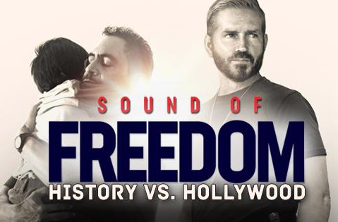
(Reminder) For Your Parish Bulletin:
See SOUND OF FREEDOM – Powerful Movie on Daring Rescue of Trafficked Children
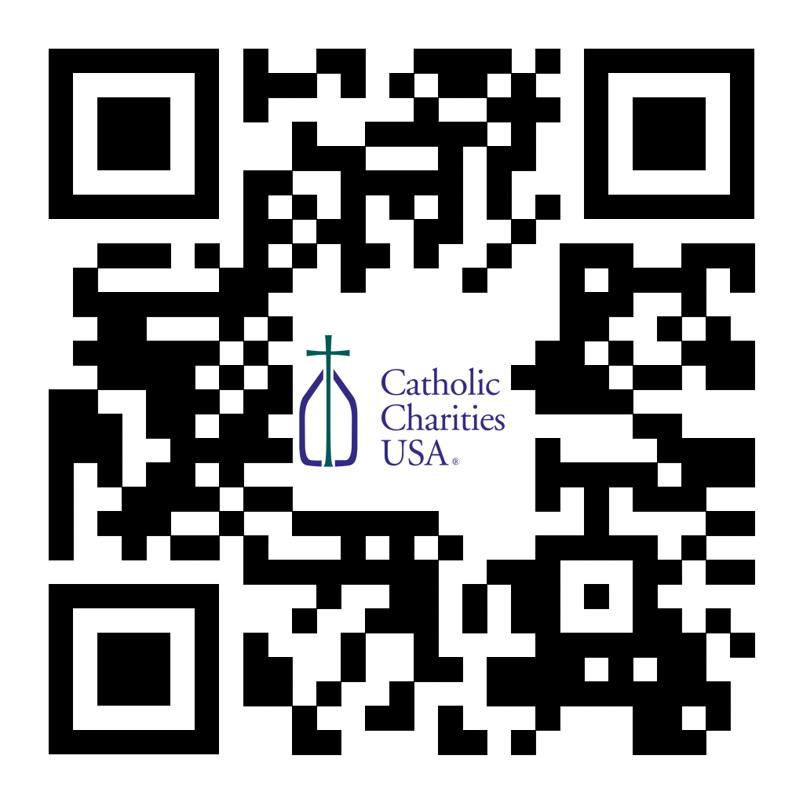
See the movie taking the country by storm – SOUND OF FREEDOM, a true story starring Jim Caviezel as Tim Ballard, a Homeland Security agent who quits his job and puts his life at risk to go on a dangerous journey through the Colombian jungle to rescue hundreds of children from human traffickers. This powerful drama raises awareness about the 2 million children exploited every year in the international sex-trafficking trade. To find out where you can see it, visit angel.com/watch/sound-of-freedom, or scan the QR code to the right.

(Reminder) For Your Parish Bulletin:
Post-Abortion Healing Ministry in the Diocese of La Crosse
Do you know someone who is carrying the grief and sorrow of past abortions? Project Rachel Ministry offers a compassionate heart and confidential help. Call 608.860.6698 or email projectrachel@diolc.org.

See U.S. Bishops’ Action Alerts on Hunger, Abortion and other Issues:
Visit votervoice.net/USCCB/home to learn how to make your voice heard.

<<Top >>

Director: Jeff Reiter – 608.791.2653 | jreiter@diolc.org
Inspired By The Spirit:
Thank you to all those who worked hard to make the campaign successful. We raised over $55 million in total, with 68.4% or over $37.7 million supporting our parishes' efforts.
Remember, despite the consultants no longer being in the Diocese, the campaign continues, and we still accept gifts through June 30, 2028, the campaign's official end. You may want to every so often remind people that they can still give to the campaign and support the efforts. New gifts and encouraging fulfillment of existing pledges can help offset some cost increases. Deferring maintenance for three years increases costs by 78% in just three years due to inflationary product and labor costs and further damage. In fact, according to Facilitiesnet, a facilities management website:
"Studies of organizations show that on average, for every dollar "saved" by deferring maintenance, there comes a four-dollar increase in future capital renewal costs. Those are the direct costs for that specific asset. There are additional indirect costs that may have an even larger impact. Over the life of that asset, those additional costs may total more than 15 times what would have been spent on the maintenance had it not been deferred."
But it is not only the charity of cost savings and the stewardship of the gifts we have received; renovations, new builds, and quality improvements to our parishes' environments spark interest and create excitement in and around our communities that are opportunities for evangelization.
New Weekly Stewardship quotes (shorter bulletin reflections)
- July - September
https://diolc.org/wp-content/uploads/2023/07/July-Sept-Stewardship-Quotes.pdf
New Weekly Stewardship Prayers of the Faithful
- July - September
https://diolc.org/wp-content/uploads/2023/07/July-Sept-Weekly-Prayers-of-the-Faithful.pdf
Stewardship Bulletin Reflections for Weekends:
- 08/06
https://diolc.org/wp-content/uploads/2023/07/08.06.23-stewardship-bulletin-announcements.pdf
- 08/13
https://diolc.org/wp-content/uploads/2023/07/08.13.23-stewardship-bulletin-announcements.pdf
- 08/20
https://diolc.org/wp-content/uploads/2023/07/08.20.23-stewardship-bulletin-announcements.pdf
- 08/27
https://diolc.org/wp-content/uploads/2023/07/08.27.23-stewardship-bulletin-announcements.pdf
Stewardship Homily Reflections:
Stewardship reflections for your homily development:
- For Weeks 08/06 - 08/27/23:
https://diolc.org/wp-content/uploads/2023/07/Homily-Guide-08.01.23.pdf
Reminder: Planned Giving – Leaving a Legacy, Wills, Bequest and Endowments:
We have inherited such treasures from our parents, grandparents and great-grandparents, those whose shoulders we stand on today. Now it is our turn to ensure future generations can enjoy the reverence and beauty of a well-maintained parish. Leveraging the Capital Campaign and providing parishioners with information on Endowments, Trusts and Bequests are just a few ways a parish can help prepare for its future.
Our Estate Planning Guide can help people save several hundred dollars in legal and financial estate planning costs. We have sent out several hundred copies per individual request, and each Parish has received a copy. Do not hesitate to contact our office if you want additional copies.
Our Planned Giving website is diolclegacy.org. People can find calculators, additional information, sign up for a newsletter and request copies of specific estate planning guides and information.
If you would like more legacy-giving information, presentations or ads for your Parish bulletin, please do not hesitate to contact our office or the Catholic Foundation of West Central Wisconsin (cfwcw.org) at 608.519.9892 or email: jreiter@cfwcw.org.

<<Top >>

Diocesan Finance Officer: James Reider – 608.791.2668 | jreider@diolc.org

Guidance for online Statement of Spiritual Statistics question:
For the question: "Are your parishioners still paying on pledges from a parish capital campaign?"

The Inspired by the Spirit Campaign counts as a “Yes” answer to this question. Though the Inspired by the Spirit Campaign was initiated by the diocese, parishes receive direct benefits and it is considered a parish campaign.

Steps for requesting your parish 2022-3 Annual Report:
We have been contacted by several parishes who have closed their FY2022-3 books and have completed the Statement of General Statistics, requesting a final copy of their Annual Report. Congratulations to Kristi Vuorinen who's parish, St. Mary Parish (Torun) (560) (Stevens Point), is the first to record a complete FY2022-3 Annual Report. A reminder, your parish has until Aug. 31, 2023 to close its books for the Annual Report. For parishes with a Voucher school the deadline is Oct. 31, 2023. Your parish can request to file their final FY2022-3 Annual Report at any time. Please be sure to complete these steps prior to requesting to file a final Annual Report:
- Complete the online Statement of General Statistics for this past fiscal year (2022-2023).
- Close the books in your online accounting software.
- Run the Parish Balance Tool and verify that all reports for the parish, and any cemeteries or endowments are balanced and complete.
- Verify that any allocation for School (column B) or Evangelization (column C) is accurate and complete.
When the above steps are complete, please request to file a final Annual Report via email to nlichter@diolc.org. We will reply with a copy of your final Annual Report file attached.

<<Top >>

Director of Vocation Recruitment: Fr. Nate Kuhn – 608.791.2666 | nkuhn@diolc.org

Dare To Follow—Additional Date Added:
We are adding one additional Dare to Follow Day and Evening of Discernment at St. Paul Catholic Church (603 4th St.) in Mosinee on Aug. 6.
- 2pm - 5pm: Ages 12-16
- 6pm - 9ppm: Ages 17+

To register please contact abrueggen@diolc.org or rorth@diolc.org 608-791-2667

Vocations Intercessions:
Please include the following intercession for vocations for your Sunday prayers of the faithful.
For an up-building of all vocations in the Church and in a particular way for priestly vocations to the Diocese of La Crosse from our parish.
Consider adding a vocations paragraph to your parish bulletin. Below is an example – they will be changed each week. Feel free to use any or all of them.
How does God speak to me?
Have you ever wondered how God may be speaking to you? Perhaps you are waiting to hear a loud, booming voice come from the heavens to tell you what to do or which way to go. While this isn’t completely out of the question, often God takes a much subtler approach. In 1 Kings, we have the account of the Prophet Elijah standing at the entrance of a cave, waiting for the Lord to appear. As he waits, he encounters a strong, violent wind, a powerful earthquake, and a consuming fire, yet God was not revealing Himself in any of those powerful examples. Finally, as Elijah waited, he heard a soft, quiet whisper. At that, he knelt to the ground and prayed. God often speaks to us, not in grand and impressive ways, but in the silence. When we can still our hearts, that’s when we begin to hear His voice, calling us into relationship and to follow Him. Sometimes that invitation is to follow the Lord as one who lovingly serves others in the priesthood. If you or someone you know is interested in discovering more about this call to the priesthood, please contact me at: Fr. Nate Kuhn, Director of Vocational Recruitment for the Diocese of La Crosse, 3710 East Ave. S. PO Box 4004, La Crosse, WI 54602; or by phone at: 608.791.2667. God bless you!
<<Top >>

Director: Very Rev. Woodrow H. Pace – 608.791.2689 | wpace@diolc.org

No items this week.

<<Top >>

Director: Christopher Rogers – 608.791.2659 | crogers@diolc.org

No items this week.

<<Top >>

Diocese of La Crosse | 3710 East Ave S | La Crosse, WI 54601 | 608-788-7700
To unsubscribe from this e-mail message contact mwilson@diolc.org

