Chancery Bulletin - Vol. 8, No. 8.4 | August 29, 2023

- Catechesis & Evangelization  - Chancery  - Communications  - Consecrated Life  - Diaconate  - Marriage & Family Life  - Ministries  - Mission Office  - Sacred Worship | - Safe Environment  - Schools Office  - Social Concerns  - Stewardship and Development  - Temporalities  - Vocations  - Vicar for Clergy  - Youth and Young Adult Ministry  - Past Chancery Bulletins
No items this week.

<<Top >>

Chancellor Very Rev. William Dhein – 608.791.2655 | wdhein@diolc.org

No items this week.

<<Top >>

As of Aug. 29

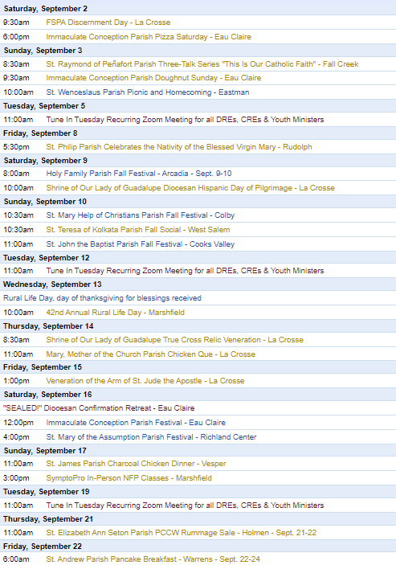
To get your parish events listed on the diocesan calendar, diolc.org/calendar, and in Catholic Life magazine, please send an email to datebook@diolc.org. Make sure you include the following details: date, beginning/ending times, event location, description, menu and cost, etc. If you have any questions, please call Pam Willer at 608.788.1524 for more information.

<<Top >>

Director: Ann Lankford – 608.791.2658 | alankford@diolc.org
Thank you to the 72 Parishes that participated
For the 72 parishes that participated in the virtual Witnesses for Christ Conference featuring Mark Hart, thank you to those who organized it! We received very positive feedback that parishioners enjoyed hearing the two lively presentations on the Eucharist as found in Scripture, followed by discussion and prayer before the Blessed Sacrament. The support of pastors, DREs, CREs, Youth Ministers and parish leaders is much appreciated.
Study Programs on the Eucharist for Fall
In light of the Eucharistic Revival, please check out and promote small groups in the parish. The list of Study Programs on the Eucharist for Fall is available here: diolc.org/catechesis/bible-studies-and-small-group-resources
For your parish bulletin:
A Minute with Jesus is meant to inspire parishioners during the Eucharistic Revival, a movement to help all Catholics know and believe that the Eucharist is Jesus.
We respond with thanksgiving after receiving Jesus in Holy Communion
Through the power of the Holy Spirit, and the words of Jesus repeated by the priest, a miracle happens at every Mass. The substance of the bread and wine become the Body, Blood, Soul and Divinity of Jesus, even though the bread and wine still look the same. When we receive Jesus, we want to thank Him for this incredible Gift. Then we can speak with Him about anything that is on our heart. We also want to listen to what He might say to us in the quiet of our heart.
Let’s pray this right now and every day this week: Jesus, I believe in you. Jesus, I hope in You. Jesus, I want to love You with all my heart Jesus, I thank You for having come to dwell in me as I receive You in Holy Communion. I welcome You into my heart and I ask you to “crowd out” whatever might be there that is not of You. And I desire to give You full reign as my Lord, my Savior and my King. Thank You for giving Your life for me on the Cross, loving me this much and allowing me to receive You into my heart in this present moment. And now that You are so close to me, please help me love You more and more, and serve You by loving the people around me. Amen. (Visit diolc.org/deeper for a downloadable Prayer Card with this prayer.)
This week, read Psalm 107:1. "Oh give thanks to the Lord, for He is good, for His steadfast love endures forever!"
For a list of all weekly proclamations up to Oct. 1 (with more to be added regularly), click here: diolc.org/eucharist/learn.
Reminder: For Your Parish Bulletin
Midwest EnCourage Fall Retreat | Sept. 29 - Oct 1 | Minneapolis, MN
A weekend of prayer and reflection for family and friends of people who experience same-sex attractions or gender identity discordance. Pray, meditate, share and discuss ways to maintain a loving relationship with your loved one while continuing to uphold the wisdom and truth found in the teachings of the Church.
5 p.m. Friday, Sept. 29 - 1 p.m. Sunday, Oct. 1 at a Retreat Center in the Minneapolis, MN area. For more information and to register go to: couragerc.org/event/encourage-fall-retreatsave-the-date or use your smartphone’s camera to scan the QR code to the right
Reminder: For Your Parish Bulletin
Getting to know Jesus Christ in a deeper way: Reading the Catechism in 10 months
We grow in our love for someone as we get to know them better. Would you like to grow in your love for Jesus Christ through coming to know Him better? Reading a few pages of the Catechism each day will help you deepen your understanding of His incredible love for you. A modest schedule of 15 paragraphs per night (roughly 3 pages) has been arranged that will take about 10-15 minutes of reflective reading, 5 nights a week over 38 weeks, beginning Sept. 18th. A schedule is emailed to participants every two weeks. To sign up, email Ann Lankford at alankford@diolc.org with the word Catechism in the subject line. There are usually more than 100 people who participate each year and they express that the fruits are well worth the effort. Please invite your friends to join.
Catechetical Leader Information:
Proven Tools to help Children, Youth and Adults to encounter Christ
- Praying with Scripture (lectio divina) prayer worksheet: diolc.org/catechesis/catechist-training-resources-for-teaching/praying-with-scripture
- Teaching for Conversion lesson plan format: diolc.org/catechesis/catechist-training-resources-for-teaching/lesson-plan-format
- Going Deeper in Prayer for each grade level with a major focus on one prayer: diolc.org/catechesis/prayer
(Reminder) New Catechetical Leader Formation | Sep. 15
Holy Cross Diocesan Center
New DREs, CREs and Youth Ministers are asked to attend a day of formation on Friday, Sept. 15th. This training includes formation in evangelizing catechesis with an explanation of best practices and resources available to you. We will also discuss the Certification Program with Franciscan at Home free for every parish, guidelines on the preparation for Sacraments, implementing Theology of the Body in a gradual way, answer your Safe Environment questions, and have interactive discussion on organizing, developing, and coordinating the Faith Formation Program, including parent involvement, in the parish. The form is available here: diolc.org/catechesis/catechetical-leaders-info
(Reminder) Franciscan at Home – Suggested Workshops for Catechist Training
Ongoing personal formation is necessary for every Catholic, and most certainly needed for those handing on the Faith at the parish and school. All parish leaders are to earn a minimum of 12 hours of certification per year and catechists are to receive 6 hours per year. Each workshop provides 6 hours of credit. The format of a 10-minute video followed by application discussion provides the opportunity for processing, which best serves adult learning. Simple directions to register for FREE are found here for the Catechist Track, DRE/CRE Track and Youth Ministry Track. (A track is a grouping of workshops). diolc.org/catechesis/catechetical-leaders-info Here are three suggested workshops
- A Vision for Effective Youth Ministry
- Partnering with Families in Youth Ministry
- Forming Disciples for the New Evangelization
(Reminder) Catechetical Sunday 2023
September 17 Catechetical Sunday is a wonderful opportunity to reflect on the role that each person plays, by virtue of Baptism, in handing on the faith and being a witness to the Gospel. This year, the Church will celebrate Catechetical Sunday on September 17, 2023 , and the theme is: “Come to Me all you who labor and are burdened” (Matthew 11:28). Those who the parish community has designated to serve as catechists are to be called forth to be commissioned for their service. Please click here for supporting resources from the USCCB: https://www.usccb.org/committees/evangelization-catechesis/come-me-all-you-who-labor-and-are-burdened
Eucharistic Revival for Parent Communications:
A Minute with Jesus is being provided in light of the Eucharistic Revival - a movement to help all Catholics know and believe that the Eucharist is Jesus.
Jesus Wants to Remain within Us
The second part of the Mass is the Liturgy of the Eucharist. We know that Jesus wants to remain with us – to abide within us. We celebrate at Mass the enduring self-gift of Jesus Christ by which He fulfills His promise to remain with us always (unless we choose to separate ourselves from Him through serious sin.) When we receive the Eucharist, we are united to Jesus. He dwells within our heart. This is why the Eucharist is called Holy Communion.
Let’s pray this right now and every day this week: Jesus, please continue to “stay with us”, to abide in us so that we can be strengthened as Your faithful followers.
This week, read how after the Resurrection Jesus walked with two disciples, explained the Scriptures to them and then celebrated the Eucharist so that they could abide in Him in Luke 24: 13-35
Click here for entries before and after Oct 1: diolc.org/catechesis/catechetical-leaders-info
<<Top >>

Director: Erik Archer– 608.791.2661 | earcher@diolc.org
Email Scam Alert – Update
Phishing is a type of cyber-attack involving fraudulent emails or websites appearing to be from a legitimate source, with the intent of tricking the recipient into revealing sensitive information such as passwords, credit card numbers and other personal information. A phishing email may also lead to the recipient unknowingly downloading harmful software.
Phishing attacks continue to grow in sophistication. We have recently seen several phishing attempts in the diocese disguised as emails from trusted people. Most successful phishing attacks create a sense of urgency and take advantage of people’s trust. The best and first line of defense is your vigilance. If in doubt, do not open the email and call the sender to verify the email’s validity.
To help you become more sensitized to phishing attacks and receive training geared to helping you spot characteristics of phishing messages and reinforce best practices for security awareness, we have partnered with Wizer Training. They have several excellent short training videos on a wide range of security topics. The video “4 Easy Ways To Detect A Phishing Email” can be found here: videos.wizer-training.com/videos/3WlpubMXbpSYm2rYFyYh?utm_source=sharing_video_page&utm_medium=referral&utm_campaign=page_sharing
Another video called “Why A Phone Call Is Always Best” is found here: videos.wizer-training.com/videos/2a8d6c6725824cab99197d6d69f55ee3?utm_source=sharing_video_page&utm_medium=referral&utm_campaign=page_sharing
More training videos from Wizer can be found at: www.wizer-training.com/employee-security-awareness-videos
Please use this training for your parish or school. You will need to set up an account to get started. The free version includes their annual video training and quizzes for an unlimited number of users. The Boost (paid) version gives access to their full training library, phishing simulations and exercises. Contact ztudahl@diolc.org for special pricing should you want to purchase the Boost version.
Thank you for your attention to this serious matter. Email security awareness and testing will help us avoid a possible future attack.
Listing your parish events in the Nov/Dec issue of Catholic Life
If your parish has events for inclusion in the Nov/Dec issue of Catholic Life, please submit them by Sept. 1. To get your parish events listed on diolc.org/calendar, and in Catholic Life magazine, please send an email to datebook@diolc.org. Make sure to include the following details: date, beginning/ending times, event location, description, menu and cost, etc. If you have any questions, please call Pam Willer at 608.788.1524.

<<Top >>

Director: Sr. Donna Krzmarzick, ISSM – 608.791.2690 | dkrzmarzick@diolc.org

No items this week.

<<Top >>

Director: Deacon Robert Riedl – 608.791.2665 | rriedl@diolclergy.org

Mark Your Calendars!
- Deacon Ongoing Education Days:
  - Marathon - St. Anthony’s Retreat Center - Dec 2, 2023
  - La Crosse - Diocesan Center - May 4, 2024
- Deacon Days with the Bishop: (Attendance is Expected)
  - 2024 - August 10
  - 2025 - August 9
  - 2026 - August 8

<<Top >>

Director: Christopher Rogers – 608.791.2659 | crogers@diolc.org

For Your Parish Bulletin:
(Reminder) Men of the Cross Conference|Oct. 14 (8:30 a.m.-5:15 p.m.)
The La Crosse Center, La Crosse, WI
Connect with other Catholic men from around the Diocese of La Crosse who will lift you in this role and be encouraged and challenged by men of deep faith. Tickets are $45 per person. Fathers, make this a Father/Son day and bring your high school-age son for free! If you are planning to bring your son, please put his name in the comment section on the online registration form.
So get your family members, best buds, men at your parish, and even acquaintances, together and join your brothers from all over the Diocese of La Crosse to reignite your identity as a Catholic man.
For registration and more information, visit www.menofthecross.org or use your smartphone’s camera to scan the QR code to the right.

(Reminder) Natural Family Planning
For Priests, Deacons and Parish staff:
USCCB Free Resources to Download
Diocese of La Crosse NFP Brochure (use diolc.org email for access)

NFP classes are offered to interested couples by the Marriage and Family Life Office. To
inquire about diocesan classes, go to diolc.org/nfp or email ckitzhaber@diolc.org. Read
more regarding NFP on the USCCB web site at www.usccb.org/prolife/issues/nfp.
(Reminder) For Your Parish Bulletin:
A SymptoPro NFP In-Person Class will be offered in the Wausau Deanery at St. John the Baptist Parish, 103 N. 4th Ave., Edgar, WI 54426 on:
Sunday, Sept. 17 at 3-5 p.m.
Saturday, Sept. 30 at 1:30-3:30 p.m.
Sunday, Oct. 15 at 3-5 p.m.
Please contact Nancy Hackel at nhackel@stjohnedgar.org to register for this 3-session course. Please download the poster here.
(Reminder) For Pastors and Marriage Preparation coordinators:
The Sympto-Pro online course is $135. The in-person course is $100. We are offering a premium product for a discount price to encourage couples to take the course in person, if possible. If you would like to discuss the possibility of having an in-person course in your deanery, please contact Christy Kitzhaber at ckitzhaber@diolc.org. (Most of our SymptoPro instructors are located on the East side of the diocese.)
(Reminder) For your parish bulletin:
Worldwide Marriage Encounter
Do you know a couple who has been married for 70, 75 or more years? Worldwide Marriage Encounter highlights and honors couples who have very long marriages. Every state in the U.S. will honor one nominated couple who is married the longest. Please nominate a couple by going to wwme.org or use your smartphone’s camera to scan the QR code to the right and nominate them at the top of the page. Nominations should be in by Sept. 15. For questions, call 641.753.6953.

(Reminder) Marriage Enrichment and Parenting Resources.
For your marriage website: foryourmarriage.org/ or use your smartphone’s camera to scan the QR code to the right. This website from the USCCB helps couples at all stages of life to understand and live God’s plan for happy, holy marriages.

(Reminder) Teaching the Way of Love:
Please visit twl4parents.com/ or use your smartphone’s camera to scan the QR code to the right. This website is full of encouragement and tips for parents to continue to be the primary educators of their children.

(Reminder) Diocesan Website for Clergy and Marriage Ministers Regarding Marriage Preparation:
Use this link: diolc.org/marriage/marriage-preparation/marriage-preparation-for-ministers/ to go directly to the section of our website containing resources for clergy and marriage ministers. There are step-by-step instructions, downloadable guidelines, downloadable forms and much more! Please let us know if we can assist you in this ministry.

(Reminder) Process for Training FOCCUS Facilitators:
The process for training FOCCUS facilitators is as follows: Each parish needs to contact FOCCUS directly to set up an account for your parish, if one has not already been set up and then train your couples directly through FOCCUS. The contact person at FOCCUS is Max Allen. He is happy to work directly with your parish priest or contact person. His contact information is: email: mrallen@foccusinc.com or phone: 402.827.3735, ext. 1317.

<<Top >>

Director: Christopher Ruff – 608.791.0161 | cruff@diolc.org

No items this week.

<<Top >>

Director: Fr. Woodrow Pace – 608.791.2676 | wpace@diolc.org

No items this week.

<<Top >>

Director: Christopher Carstens – 608.791.0161 | ccarstens@diolc.org
RCIA Calendar of Teachings and Liturgies
Please find a 9-month calendar of teachings, retreats, and liturgies for the RCIA here, while a 15-month calendar is available here. Resources for purchase are available here.
<<Top >>

Director: Teresa Brown – 608.791.2679 | tbrown@diolc.org

DIOCESE OF LA CROSSE GUIDELINES FOR REPORTING INSTANCES OF CHILD ABUSE
The Diocese of La Crosse, through its policies and procedures, seeks to provide a prompt, appropriate and compassionate response to reporters of sexual abuse of a child by any diocesan agent (bishop, priest, deacon, employee, religious, vendor or volunteer). Anyone wishing to make a report of an allegation of sexual abuse should send that report to Mrs. Teresa Brown, Complaint Intake Agent, at the Diocese of La Crosse, P.O. Box 4004, La Crosse, WI 54602-4004. Alternatively, you can contact Mrs. Brown at 608.791.0179 or intakeagent@diolc.org. The reporting form is available through the Diocese of La Crosse Office of Safe Environment or on the diocesan website at: diolc.org/safe-environment/reporting. Individuals are also encouraged to take their reports directly to civil authorities. Copies of the diocesan policy are available through your local Parish and on the diocesan website. If you have any questions about the Diocese of La Crosse and the implementation of the Charter for the Protection of Children and Young People, please contact Teresa Brown, Diocese of La Crosse, at 608.791.2679 or tbrown@diolc.org.

<<Top >>

Superintendent: Thomas Reichenbacher – 608.788.7707 | treichenbacher@diolc.org

Catholic School Students and Prayer
Please keep all students in your prayers. Students returned to Catholic schools throughout the Diocese of La Crosse last week; more students’ first day will be this week and next week. We are grateful for the support we receive from our parishes!

<<Top >>

Director: Christopher Ruff – 608.791.0161 | cruff@diolc.org

For Your Parish Bulletin:
(Reminder) Rural Life Mass | September 13th
11875 US Hwy. 10 in Marshfield
The 42nd Annual Rural Life Day will be held on Sept. 13, 2023, hosted by Ken and Joellen Heiman of Heiman Holsteins, at 11875 US Hwy 10 in Marshfield. The day begins with a 10:00 AM Mass celebrated by Bishop Callahan, followed by awards, recognitions, the blessing of crops and machinery and a catered meal. There will also be wagon rides to tour the ridge-top farm. All are welcome to this celebration of the uniqueness of rural life, giving thanks to God for the contribution of rural values to the life of the Church in the Diocese of La Crosse.

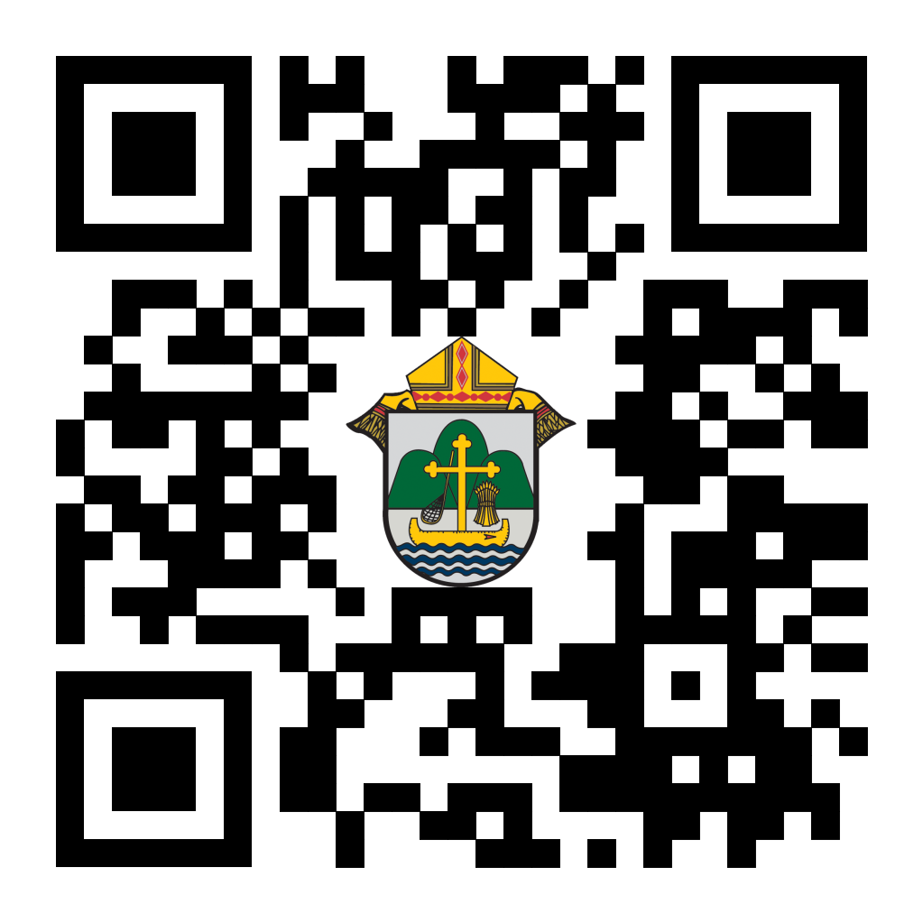
(Reminder) For Your Parish Bulletin:
Chalice of Mercy is in Ukraine, Needs our Help
Please donate to the Ukrainian relief efforts of Chalice of Mercy if you are able, and pray for the safety of their volunteers on the ground there, who put their lives on the line. Financial assistance is the biggest need at this time. To give, visit chaliceofmercy.org/donate or use your smartphone’s camera to scan the QR code to the right.
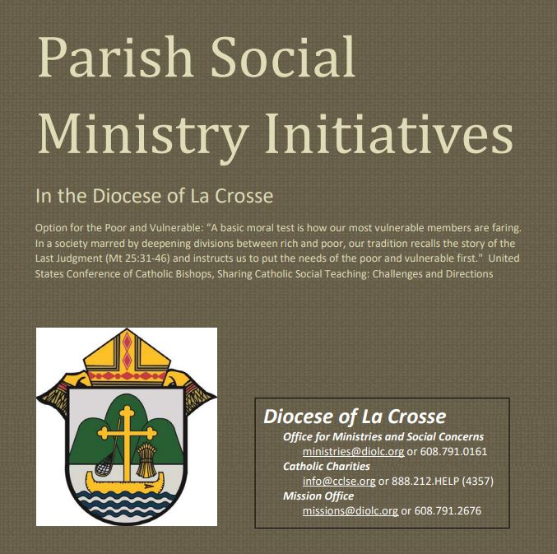
Pastors, Deacons, Parish Social Concerns Representatives:
Are Your Social Ministry Initiatives listed in the Directory?
In order to address most fruitfully the social concerns within our diocese, we are asking the parishes of the diocese to review their current social ministry initiatives (any outreach of charity or social advocacy). If these are not already listed in the diocesan Directory of Parish Social Ministry Initiatives, or if updating is needed, the pastor or someone authorized by him is asked to take a moment to complete and submit this form for each organization/resource.
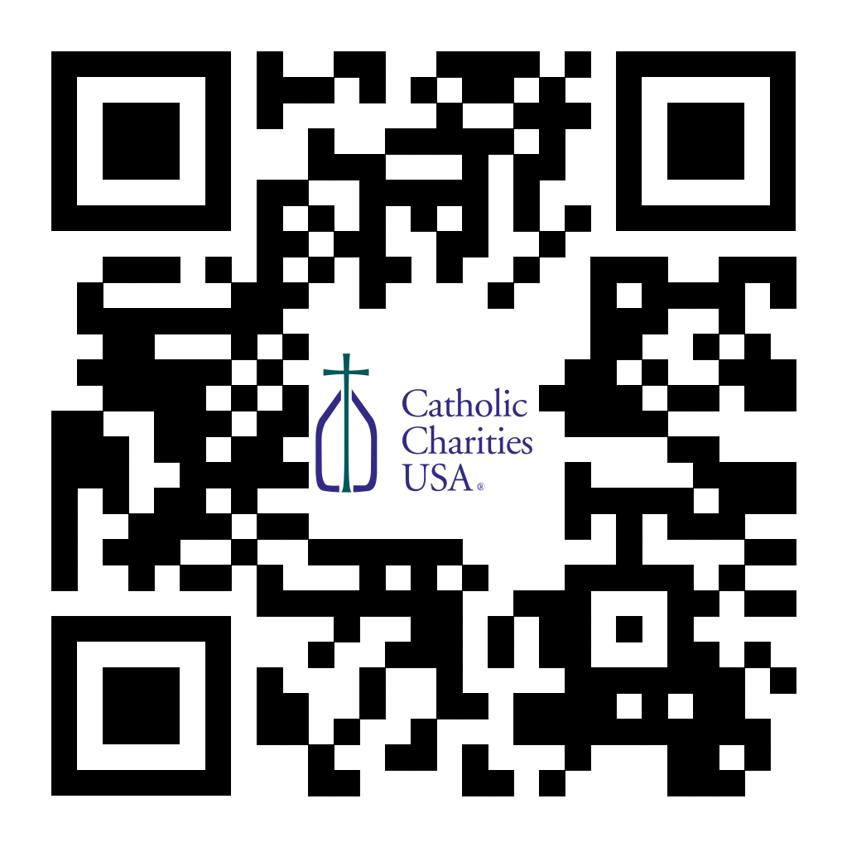
(Reminder) For Your Parish Bulletin:
Pregnant and in distress? Confidential help is available.
Make a confidential call to Catholic Charities at 844.644.7223 (844.64.GRACE) or text 715.600.6391. To learn more, visit cclse.org/i-think-im-pregnant. For additional pregnancy support resources and locations, visit diolc.org/pregnancy-resources.
<<Top >>

Director: Jeff Reiter – 608.791.2653 | jreiter@diolc.org
Diocesan Annual Appeal
Ecclesiastes 4:12: "Where one alone may be overcome, two together can resist. A three-ply cord is not easily broken."
This year’s theme will focus on the power of triune relationships; God, Church, and oneself. Back in May, the Surgeon General declared loneliness as an epidemic in this country. (https://www.hhs.gov/about/news/2023/05/03/new-surgeon-general-advisory-raises-alarm-about-devastating-impact-epidemic-loneliness-isolation-united-states.html).
The Church and her communities and ministries are the perfect antidote to this epidemic and ECC 4:12 underscores the importance of strength through unity, emphasizing the importance of bringing together in faith and community.
Weekly Stewardship quotes (shorter bulletin reflections)
- July - September
https://diolc.org/wp-content/uploads/2023/07/July-Sept-Stewardship-Quotes.pdf
Weekly Stewardship Prayers of the Faithful
- July - September
https://diolc.org/wp-content/uploads/2023/07/July-Sept-Weekly-Prayers-of-the-Faithful.pdf
Stewardship Bulletin Reflections for Weekends:
- 09/03
https://diolc.org/wp-content/uploads/2023/08/09.03.23-stewardship-bulletin-announcements.pdf
- 09/10
https://diolc.org/wp-content/uploads/2023/08/09.10.23-stewardship-bulletin-announcements.pdf
- 09/17
https://diolc.org/wp-content/uploads/2023/08/09.17.23-stewardship-bulletin-announcements.pdf
- 09/24
https://diolc.org/wp-content/uploads/2023/08/09.24.23-stewardship-bulletin-announcements.pdf
Stewardship Homily Reflections:
Stewardship reflections for your homily development:
- For Weeks 09/03 - 09/24/23:
https://diolc.org/wp-content/uploads/2023/08/Homily-Guide-08.29.23.pdf
Update: Planned Giving – Leaving a Legacy, Wills, Bequest and Endowments:
We have inherited such treasures from our parents, grandparents and great-grandparents, those whose shoulders we stand on today. Now it is our turn to ensure future generations can enjoy the reverence and beauty of a well-maintained parish. Leveraging the Capital Campaign and providing parishioners with information on Endowments, Trusts and Bequests are just a few ways a parish can help prepare for its future.
Our Estate Planning Guide can help people save several hundred dollars in legal and financial estate planning costs. We have sent out several hundred copies per individual request, and each Parish has received a copy. Do not hesitate to contact our office if you want additional copies.
Our Planned Giving website is diolclegacy.org. People can find calculators, additional information, sign up for a newsletter and request copies of specific estate planning guides and information.
Just Added: Instructions on how to do an IRA Rollover, the creation of Donor Advised Funds (DAF), Beneficiary Designations and Stock Transfers. https://diolclegacy.org/?pageID=5
If you would like more legacy-giving information, presentations or ads for your Parish bulletin, please do not hesitate to contact our office or the Catholic Foundation of West Central Wisconsin (cfwcw.org) at 608.519.9892 or email: eboos@cfwcw.org.

<<Top >>

Diocesan Finance Officer: James Reider – 608.791.2668 | jreider@diolc.org

Health Enews from Catholic Mutual Group
Please click here for the August edition of CMG Health Enews.

<<Top >>

Director of Vocation Recruitment: Fr. Nate Kuhn – 608.791.2666 | nkuhn@diolc.org

Vocations Intercessions:
Please include the following intercession for vocations for your Sunday prayers of the faithful.
In thanksgiving for those marriages, priests, sisters, brothers, and those living a holy single life who inspire and strengthen us by the witness of their commitment.
Consider adding a vocations paragraph to your parish bulletin. Below is an example – they will be changed each week. Feel free to use any or all of them.
Called to More
What if there was more? What if I could be more? Sometimes we can look around and think that there isn’t anything more that can be offered to us, that this is the best I can get. We settle for something that leaves us feeling empty and hungering for more. Perhaps this is an opportunity to ask the Lord what He is calling you to do. As we turn to God in the midst of human mediocrity, we can find something that is eternally greater. Consider your vocation and where God may be leading you. Could it be a call to the priesthood? To begin the conversation or to inquire about what it means to be a priest, please contact me: Fr. Nate Kuhn, Director of Vocational Recruitment for the Diocese of La Crosse, 3710 East Ave. S. PO Box 4004, La Crosse, WI 54602; or by phone at: 608.791.2667. God bless you!
<<Top >>

Director: Very Rev. Woodrow H. Pace – 608.791.2689 | wpace@diolc.org

No items this week.

<<Top >>

Director: Christopher Rogers – 608.791.2659 | crogers@diolc.org

Office for Family Life Calendar of Events Through 2025
We, in the Office for Family Life, are working to keep our event planning at least two years out. We have created a calendar that may help you in planning for the next couple of years. You will see the dates have hyperlinks that allow you to add this event to your Google Calendar. Below each event is a hyperlink to the page on our website with more information, including registration links for that particular event. Please follow this link to get a list of events planned so far: https://drive.google.com/file/d/1KVA4kwQcB2LKDfa4HKGfodnMMcC6Vbta/view?usp=sharing

(Reminder) National Federation for Catholic Youth Ministry (NFCYM) Field Survey
The National Federation for Catholic Youth Ministry (NFCYM) recently launched the 2023 National Youth Ministry Field Survey. This annual survey serves as a crucial instrument to capture the realities and evolving needs of youth ministers in the field. The results of this annual survey allows NFCYM to formulate actionable plans and advocacy initiatives that directly address the needs of youth ministries and the young people they serve.

We firmly believe that the richness and accuracy of the survey's findings are amplified when it resonates with experiences and insights from diverse corners of our national youth ministry landscape. This is where we seek your invaluable support. Please use the link below to complete the survey: https://www.surveymonkey.com/r/YMSurvey23

Every response deepens our understanding and solidifies the foundation upon which we base our future initiatives. Furthermore, NFCYM pledges transparency by sharing a detailed report derived from the survey, ensuring that the insights contributed by youth ministry leaders are accessible to all. You can view the results of past field surveys here: https://nfcym.org/field-survey/

(Reminder) LifeTeen Genesis Conference Scholarship| Sept. 24-26
The sole focus of this conference is helping you start solid youth ministry in your parish! The conference will be held Sept. 24-26, 2023 in Boerne, Texas. This scholarship covers the lodging for conference days, flight and registration costs. If you know of anyone who might be interested, please invite them to fill out this application.

(Reminder) Newman Connection for outgoing high school seniors
We are once again partnering with the Newman Connection to assist getting incoming college Freshmen connected with the Newman Center on their campus. You may have already received an email from the Newman Connection.

- You may sign up for the program by following this link: share.hsforms.com/1GLP12-1tQ_OL7pZyvpVWNA2t65q or use your smartphone’s camera to scan the QR code to the right.
- You may also view the marketing materials at the following links:
  - Parishes: landing.newmanministry.com/outreach2023
  - Schools: landing.newmanministry.com/hs-materials-2023

<<Top >>

Diocese of La Crosse | 3710 East Ave S | La Crosse, WI 54601 | 608-788-7700
To unsubscribe from this e-mail message contact mwilson@diolc.org

