Chancery Bulletin - Vol. 8, No. 9.2 | September 12, 2023

- Catechesis & Evangelization  - Chancery  - Communications  - Consecrated Life  - Diaconate  - Marriage & Family Life  - Ministries  - Mission Office  - Sacred Worship | - Safe Environment  - Schools Office  - Social Concerns  - Stewardship and Development  - Temporalities  - Vocations  - Vicar for Clergy  - Youth and Young Adult Ministry  - Past Chancery Bulletins
The Most Reverend William Patrick Callahan, D.D., Bishop of La Crosse, makes the following announcements:

The Reverend Stanislaus Michael Antony, Parochial Administrator of St. Bernard-St. Hedwig Parish in Thorp and Holy Rosary Parish in Owen, is appointed Pastor, with continued residence at Holy Rosary Parish rectory, effective September 5, 2023.

The Reverend Anbalagan Shanmugam, Parochial Administrator of Sacred Heart Parish in Elmwood, Sacred Heart Parish in Spring Valley, and St. Luke Parish in Boyceville, is appointed Pastor, with continued residence at Sacred Heart Parish rectory in Elmwood, effective September 5, 2023.

The Reverend Kyle N. Laylan, Parochial Administrator of Holy Family Parish in Arcadia and Most Sacred Heart Parish in Pine Creek, is appointed Pastor, with continued residence at Holy Family Parish rectory in Arcadia, effective September 5, 2023.

The Reverend Aaron J. Becker, Parochial Administrator of St. Paul Parish in Mosinee, is appointed Pastor, with continued residence at the parish rectory, effective September 5, 2023.
Mr. Kevin C. Louis has been dispensed by His Holiness Pope Francis from the obligations of Sacred Orders including celibacy, effective September 6, 2023.

<<Top >>

Chancellor Very Rev. William Dhein – 608.791.2655 | wdhein@diolc.org

The Annual Mass Counts will be conducted again this year during the month of October. Please find more information and the form here.

<<Top >>

As of Sept. 12

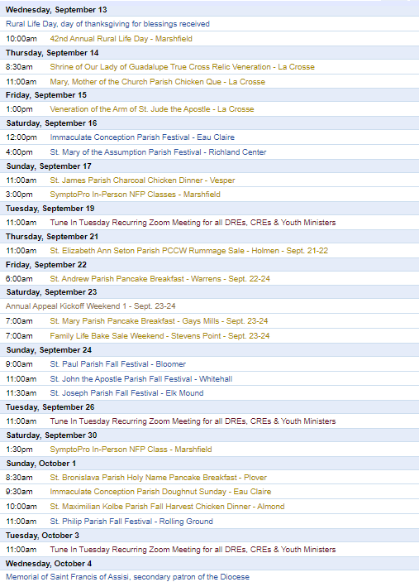
To get your parish events listed on the diocesan calendar, diolc.org/calendar, and in Catholic Life magazine, please send an email to datebook@diolc.org. Make sure you include the following details: date, beginning/ending times, event location, description, menu and cost, etc. If you have any questions, please call Pam Willer at 608.788.1524 for more information.

<<Top >>

Director: Ann Lankford – 608.791.2658 | alankford@diolc.org
Clergy and Parish Point Person: Small Group Bible Studies on the Eucharist
During this year of Parish Revival, the focus is on “Encounter” and the goal is to help people in the pew to know and love Jesus, truly present in the Eucharist. The highlighted means to achieve this goal is through small groups. A new small group study has been developed for the entire country, especially for the Year of Parish Revival. In addition to beautiful video presentations featuring Chris Stefanick, Edward Sri and others, there are also two personal testimonies about the Eucharist for each session, small group discussion questions, praying with Eucharistic passages in Scripture (lectio divina) and a closing prayer with a litany. This program includes training for facilitators and table leaders of small groups. Click the link for further information on this resource entitled “Jesus and the Eucharist Study.” diolc.org/eucharist/lead There is also information about six other excellent bible studies or faith studies on the Eucharist at this link: diolc.org/eucharist/lead
For your parish bulletin:
Online Facilitator Training for leading a Bible Study or Faith Study for Adults - Oct. 2 or Oct 3
If you will be facilitating a small group of adults this fall, you are invited to a training on ZOOM led by Ann Lankford, the Director for Catechesis & Evangelization. This training will provide resources to help facilitators:
- run the group smoothly amidst varying personalities
- implement Mother Church’s vision of fostering deeper conversion to Jesus Christ and growing in faith
- know the stages of conversion so that participants may also understand and seek deeper conversion
- recognize the boundaries of facilitating and have confidence in leading a group
Anyone interested in being part of this training on Monday, Oct. 2rd, 6:30-8 p.m. or Tuesday, Oct. 3rd from 10:30 a.m.-12 noon, please register by emailing Beth Johnson at bjohnson@diolc.org.
For your parish bulletin:
(Reminder) A Minute with Jesus is meant to inspire parishioners during the Eucharistic Revival, a movement to help all Catholics know and believe that the Eucharist is Jesus.
Preparing to Receive Holy Communion
When we are at Mass, and preparing to receive Jesus in Holy Communion, our minds will sometimes wander. When we find ourselves distracted in this way, simply return our eyes to the altar and listen with our hearts as the priest prays the words of Jesus, asking the Holy Spirit to change the bread and wine into His Body and Blood of Jesus. As we go forward to receive Jesus in Holy Communion, it is a good practice to repeat the following prayer: “Lord, I am not worthy that You should come under my roof, but only say the word and my soul shall be healed.” (Matthew 8:8)
Let’s pray this right now and every day this week in preparation for next Sunday: “Lord, I am not worthy that You should come under my roof, but only say the word and my soul shall be healed.” (Matthew 8:8)
This week, read Isaiah 26:3: He does keep in perfect peace, whose mind is stayed on Thee.
For a list of all weekly proclamations up to Oct. 1 (with more to be added regularly), click here: diolc.org/eucharist/learn.
(Reminder) For Your Parish Bulletin
Getting to know Jesus Christ in a deeper way: Reading the Catechism in 10 months
We grow in our love for someone as we get to know them better. Would you like to grow in your love for Jesus Christ through coming to know Him better? Reading a few pages of the Catechism each day will help you deepen your understanding of His incredible love for you. A modest schedule of 15 paragraphs per night (roughly 3 pages) has been arranged that will take about 10-15 minutes of reflective reading, 5 nights a week over 38 weeks, beginning Sept. 18th. A schedule is emailed to participants every two weeks. To sign up, email Ann Lankford at alankford@diolc.org with the word Catechism in the subject line. There are usually more than 100 people who participate each year and they express that the fruits are well worth the effort. Please invite your friends to join.
(Reminder) New Catechetical Leader Formation | Sept. 15
Holy Cross Diocesan Center
New DREs, CREs and Youth Ministers are asked to attend a day of formation on Friday, Sept. 15th. This training includes formation in evangelizing catechesis with an explanation of best practices and resources available to you. We will also discuss the Certification Program with Franciscan at Home free for every parish, guidelines on the preparation for Sacraments, implementing Theology of the Body in a gradual way, answer your Safe Environment questions, and have interactive discussion on organizing, developing, and coordinating the Faith Formation Program, including parent involvement, in the parish. The form is available here: diolc.org/catechesis/catechetical-leaders-info
(Reminder) Catechetical Sunday 2023 | Sept. 17
Catechetical Sunday is a wonderful opportunity to reflect on the role that each person plays, by virtue of Baptism, in handing on the faith and being a witness to the Gospel. This year, the Church will celebrate Catechetical Sunday on Sept. 17, 2023 , and the theme is: “Come to Me all you who labor and are burdened” (Matthew 11:28). Those who the parish community has designated to serve as catechists are to be called forth to be commissioned for their service. Please click here for supporting resources from the USCCB: https://www.usccb.org/committees/evangelization-catechesis/come-me-all-you-who-labor-and-are-burdened
Eucharistic Revival for Parent Communications:
A Minute with Jesus is being provided in light of the Eucharistic Revival - a movement to help all Catholics know and believe that the Eucharist is Jesus.
The Vital Connection between the Eucharist and Confession
Part of the greatest preparation we can make to receive Jesus’s Body and Blood is to experience His forgiveness and healing in the Sacrament of Reconciliation. If there is sin in my heart, there is no room for Christ. Jesus forgives us of our sins in confession and this frees us, opens our heart to fulfill the deepest desire of our heart – to receive Him. Receiving Jesus brings about a strengthening of faith, hope and charity - a desire to love Him, ourselves, and others.
Let’s pray this right now and every day this week: Jesus, please give me the desire as soon as possible to make a good confession
This week, read how St. John describes the importance of confession in 1 John 1:9.
Suggested: Picture of a person in confession
Click here for entries before and after Oct 1: diolc.org/catechesis/catechetical-leaders-info
<<Top >>

Director: Erik Archer– 608.791.2661 | earcher@diolc.org
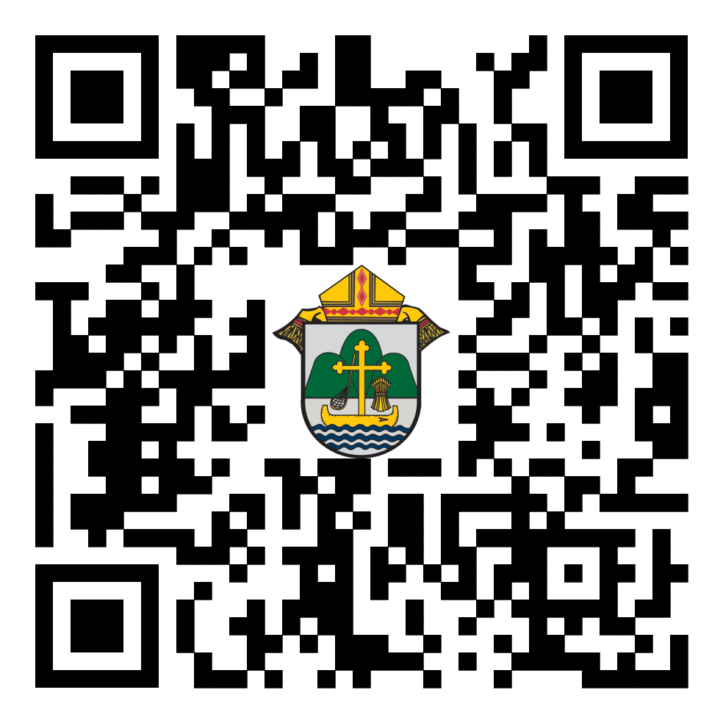
Parish Roundtables | October 9th - 13th
Pleae register at: https://forms.office.com/r/HsV4R9JrBE or use your smartphone’s camera to scan the QR code to the right.
Our next iteration of Parish Roundtables are scheduled for October 9th - 13th. Thank you so much to the parishes that agreed to host. We have one roundtable left to schedule in Stevens Point on the afternoon of the 12th and the registration form will reflect that location shortly. The rest are scheduled and confirmed. Our intent continues to meet parishes where they’re at, to listen to what parishes need from us, what we’re doing well and what we can do better. Curia directors will join our communications team to share their updates as well as listen to what parishes need from them. The registration form will be out shortly. 27 individuals completed the post-roundtable survey in the spring and we’re going to factor those comments into our planning process for these fall roundtables.
THANK YOU!
We recently asked for your help in gathering new writers for our Catholic Life magazine and you responded! Thank you for sharing this with your parishioners and in your bulletins. We now have EIGHT NEW WRITERS and they are from all corners of the diocese, one just graduated from college and several have degrees in journalism and communications. I am tremendously grateful to you for helping us here. Thank you.
Your Parish Stories in Catholic Life
Please send story ideas to Erik at earcher@diolc.org. Catholic Life is our diocesan magazine featuring our parishes, our parishioners, our Faith events and writers from across the deaneries. The stories are a witness to Christ’s love and action in our lives. Many people with compelling stories are hesitant to share their stories, but their experiences inspire others and draw them more deeply into the Faith - we need to tell these joyous stories.
<<Top >>

Director: Sr. Donna Krzmarzick, ISSM – 608.791.2690 | dkrzmarzick@diolc.org

No items this week.

<<Top >>

Director: Deacon Robert Riedl – 608.791.2665 | rriedl@diolclergy.org

Fall Ministry Days
Please log into the website to register for Fall Ministry Days using this link: https://diolc.org/vicarforclergy/
Deacon Days with the Bishop: (Attendance is Expected)
- 2024 – August 10
- 2025 – August 9
- 2026 – August 8

<<Top >>

Director: Christopher Rogers – 608.791.2659 | crogers@diolc.org

For Your Parish Bulletin:
(Reminder) Men of the Cross Conference|Oct. 14 (8:30 a.m.-5:15 p.m.)
The La Crosse Center, La Crosse, WI
Connect with other Catholic men from around the Diocese of La Crosse who will lift you in this role and be encouraged and challenged by men of deep faith. Tickets are $45 per person. Fathers, make this a Father/Son day and bring your high school-age son for free! If you are planning to bring your son, please put his name in the comment section on the online registration form.
So get your family members, best buds, men at your parish, and even acquaintances, together and join your brothers from all over the Diocese of La Crosse to reignite your identity as a Catholic man.
For registration and more information, visit www.menofthecross.org or use your smartphone’s camera to scan the QR code to the right.

(Reminder) Natural Family Planning
For Priests, Deacons and Parish staff:
USCCB Free Resources to Download
Diocese of La Crosse NFP Brochure (use diolc.org email for access)

NFP classes are offered to interested couples by the Marriage and Family Life Office. To
inquire about diocesan classes, go to diolc.org/nfp or email ckitzhaber@diolc.org. Read
more regarding NFP on the USCCB web site at www.usccb.org/prolife/issues/nfp.
(Reminder) For Your Parish Bulletin:
A SymptoPro NFP In-Person Class will be offered in the Wausau Deanery at St. John the Baptist Parish, 103 N. 4th Ave., Edgar, WI 54426 on:
Sunday, Sept. 17 at 3-5 p.m.
Saturday, Sept. 30 at 1:30-3:30 p.m.
Sunday, Oct. 15 at 3-5 p.m.
Please contact Nancy Hackel at nhackel@stjohnedgar.org to register for this 3-session course. Please download the poster here.
(Reminder) For Pastors and Marriage Preparation coordinators:
The Sympto-Pro online course is $135. The in-person course is $100. We are offering a premium product for a discount price to encourage couples to take the course in person, if possible. If you would like to discuss the possibility of having an in-person course in your deanery, please contact Christy Kitzhaber at ckitzhaber@diolc.org. (Most of our SymptoPro instructors are located on the East side of the diocese.)
(Reminder) For your parish bulletin:
Worldwide Marriage Encounter
Do you know a couple who has been married for 70, 75 or more years? Worldwide Marriage Encounter highlights and honors couples who have very long marriages. Every state in the U.S. will honor one nominated couple who is married the longest. Please nominate a couple by going to wwme.org or use your smartphone’s camera to scan the QR code to the right and nominate them at the top of the page. Nominations should be in by Sept. 15. For questions, call 641.753.6953.

(Reminder) Marriage Enrichment and Parenting Resources.
For your marriage website: foryourmarriage.org/ or use your smartphone’s camera to scan the QR code to the right. This website from the USCCB helps couples at all stages of life to understand and live God’s plan for happy, holy marriages.

(Reminder) Teaching the Way of Love:
Please visit twl4parents.com/ or use your smartphone’s camera to scan the QR code to the right. This website is full of encouragement and tips for parents to continue to be the primary educators of their children.

(Reminder) Diocesan Website for Clergy and Marriage Ministers Regarding Marriage Preparation:
Use this link: diolc.org/marriage/marriage-preparation/marriage-preparation-for-ministers/ to go directly to the section of our website containing resources for clergy and marriage ministers. There are step-by-step instructions, downloadable guidelines, downloadable forms and much more! Please let us know if we can assist you in this ministry.

(Reminder) Process for Training FOCCUS Facilitators:
The process for training FOCCUS facilitators is as follows: Each parish needs to contact FOCCUS directly to set up an account for your parish, if one has not already been set up and then train your couples directly through FOCCUS. The contact person at FOCCUS is Max Allen. He is happy to work directly with your parish priest or contact person. His contact information is: email: mrallen@foccusinc.com or phone: 402.827.3735, ext. 1317.

<<Top >>

Director: Christopher Ruff – 608.791.0161 | cruff@diolc.org

No items this week.

<<Top >>

Director: Fr. Woodrow Pace – 608.791.2676 | wpace@diolc.org

No items this week.

<<Top >>

Director: Christopher Carstens – 608.791.0161 | ccarstens@diolc.org
(Reminder) RCIA Calendar of Teachings and Liturgies
Please find a 9-month calendar of teachings, retreats, and liturgies for the RCIA here, while a 15-month calendar is available here. Resources for purchase are available here.
(Reminder) Some Liturgical Dates and Notes for the Liturgical Year 2024
Please click here for a list of significant liturgical celebrations for the liturgical year 2024.
<<Top >>

Director: Teresa Brown – 608.791.2679 | tbrown@diolc.org

DIOCESE OF LA CROSSE GUIDELINES FOR REPORTING INSTANCES OF CHILD ABUSE
The Diocese of La Crosse, through its policies and procedures, seeks to provide a prompt, appropriate and compassionate response to reporters of sexual abuse of a child by any diocesan agent (bishop, priest, deacon, employee, religious, vendor or volunteer). Anyone wishing to make a report of an allegation of sexual abuse should send that report to Mrs. Teresa Brown, Complaint Intake Agent, at the Diocese of La Crosse, P.O. Box 4004, La Crosse, WI 54602-4004. Alternatively, you can contact Mrs. Brown at 608.791.0179 or intakeagent@diolc.org. The reporting form is available through the Diocese of La Crosse Office of Safe Environment or on the diocesan website at: diolc.org/safe-environment/reporting. Individuals are also encouraged to take their reports directly to civil authorities. Copies of the diocesan policy are available through your local Parish and on the diocesan website. If you have any questions about the Diocese of La Crosse and the implementation of the Charter for the Protection of Children and Young People, please contact Teresa Brown, Diocese of La Crosse, at 608.791.2679 or tbrown@diolc.org.

I’d like to thank all the Parishes and Schools who have sent in initial background forms and renewals for their staff and volunteers. As of Monday, September 11, I have submitted more than 800 background checks. Excellent job!! As a reminder, all staff and volunteers are required to be background checked prior to working with children.

Equally impressive is that 1356 people have logged in online to complete Protect and Heal Training. I also went to several schools and parishes to train so I’d estimate the number of trained people since August 1 is closer to 2000.

THANK YOU for taking Safe Environment seriously.

If you have any questions about the program or would like to have me come to your parish to train your staff and volunteers, please let me know. tbrown@diolc.org or 608-791-2679.

Letters of Suitability are now being done in the Office of the Vicar for Clergy. Contact Renee Orth at rorth@diolc.org or 608-791-2652.

Superintendent: Thomas Reichenbacher – 608.788.7707 | treichenbacher@diolc.org

No items this week.

<<Top >>

Director: Christopher Ruff – 608.791.0161 | cruff@diolc.org

For Your Parish Bulletin:
(Reminder) Gospel of Life White Mass, Banquet & Presentation - Oct. 18
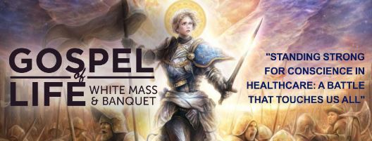
Join us at the Cathedral of St. Joseph the Workman on Wednesday, Oct. 18, the Feast of St. Luke, Patron of Physicians, for the ‘White Mass’ celebrated by Bishop Callahan, in which the faithful honor and pray for Catholic healthcare professionals. The Mass will be followed by a banquet and a keynote presentation by Fr. Justin Kizewski on “Standing Strong for Conscience in Healthcare: A Battle that Touches us All.” Cost for the banquet and presentation is $20/person, $10/students. All the faithful are warmly invited. To learn more and to register, visit www.diolc.org/GospelofLife or scan the QR code to the right.

For La Crosse Area Parish Bulletins:
Join 40 Days for Life Sept. 24 Kick-Off Rally and Vigil Campaign
Join pro-life people of the Coulee Region at a kick-off rally for 40 Days for Life on Sunday, Sept. 24th at 2 p.m. at the Black River Beach Neighborhood Center, 1433 Rose St. in La Crosse. Matt Sande, Pro-Life Wisconsin Legislative Director, will provide a state legislative update and call to action entitled “Embrace Them Both: Protecting and Supporting Moms and Babies.” The fall campaign to end abortion will run Sept. 27-Nov. 5 on the sidewalk outside Planned Parenthood, 1201 Caledonia in La Crosse. Please consider coming to pray for an hour, anytime between 7 a.m. and 7 p.m. Sign up at 40daysforlife.com/en/. Call Marie Allen for more information or signs: 608-784-5189.

For Your Parish Bulletin:
Help Relief Efforts for Morocco After the Devastating Earthquake
On Friday, Sept. 8, a magnitude 6.8 earthquake struck Morocco. More than 300,000 people were affected and at least 2,490 were killed. Access to remote areas with the worst destruction—especially in mountain towns—remains difficult. Catholic Relief Services is supporting Caritas Rabat, whose teams mobilized a response within 24 hours to the hardest-to-reach areas. To donate to these efforts, visit www.crs.org or scan the QR code to the right.

(Reminder) Catholic Charities USA -- Hurricane Relief after Idalia
To assist those suffering in the wake of Hurricane Idalia, consider giving to Catholic Charities USA, which has established a relief fund specifically for this purpose. To learn how to donate, visit www.catholiccharitiesusa.org or scan the QR code to the right.

(Reminder) For Your Parish Bulletin:
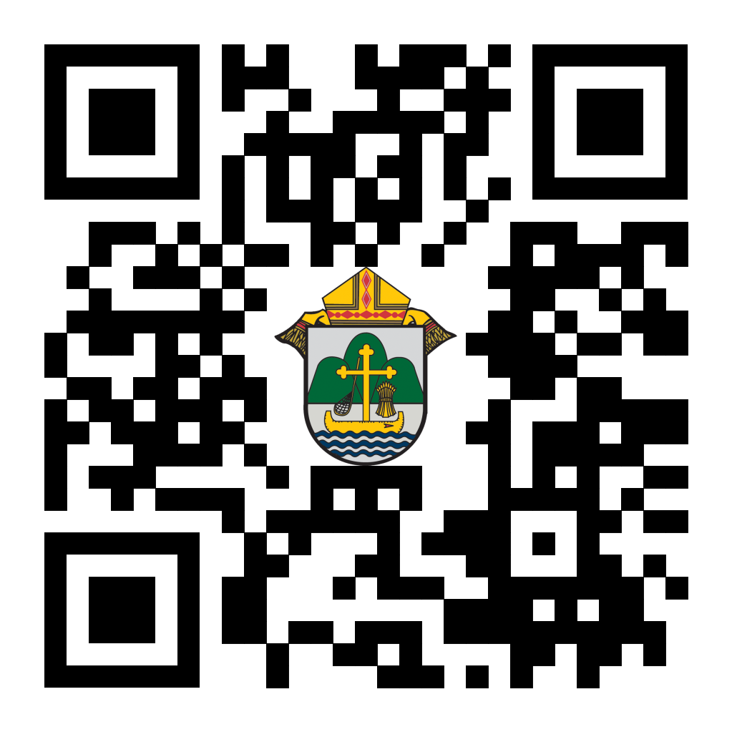
Chalice of Mercy is in Ukraine, Needs our Help
Please donate to the Ukrainian relief efforts of Chalice of Mercy if you are able, and pray for the safety of their volunteers on the ground there, who put their lives on the line. Financial assistance is the biggest need at this time. To give, visit chaliceofmercy.org/donate or use your smartphone’s camera to scan the QR code to the right.
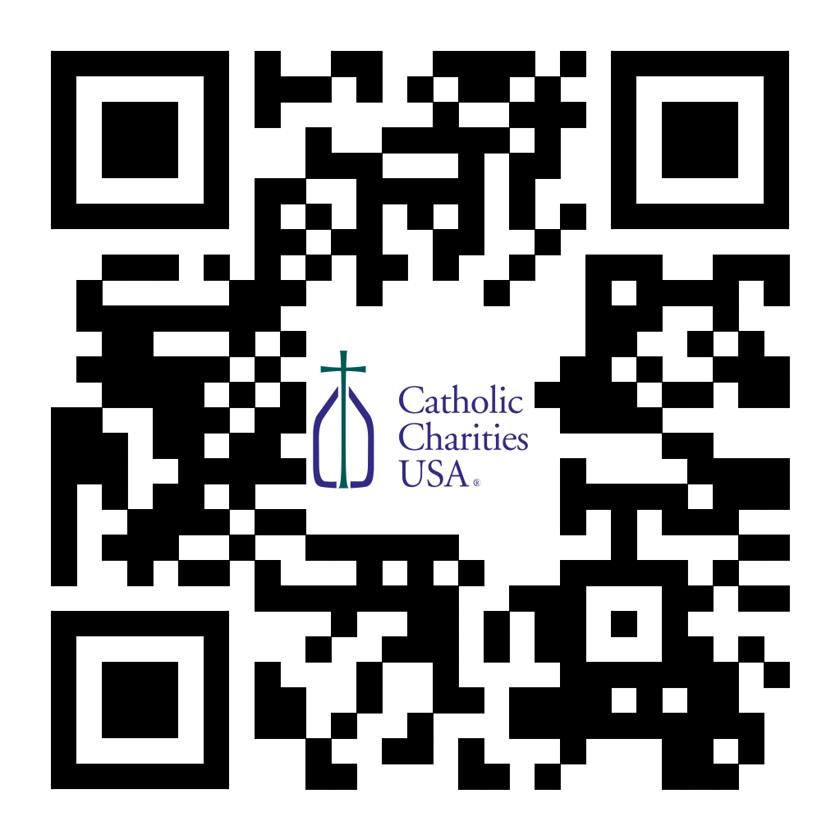
(Reminder) For Your Parish Bulletin:
Pregnant and in distress? Confidential help is available.
Make a confidential call to Catholic Charities at 844.644.7223 (844.64.GRACE) or text 715.600.6391. To learn more, visit cclse.org/i-think-im-pregnant. For additional pregnancy support resources and locations, visit diolc.org/pregnancy-resources.

<<Top >>

Director: Jeff Reiter – 608.791.2653 | jreiter@diolc.org
Diocesan Annual Appeal
Ecclesiastes 4:12: "Where one alone may be overcome, two together can resist. A three-ply cord is not easily broken."
This year’s theme will focus on the power of triune relationships; God, Church, and oneself. Back in May, the Surgeon General declared loneliness as an epidemic in this country. (https://www.hhs.gov/about/news/2023/05/03/new-surgeon-general-advisory-raises-alarm-about-devastating-impact-epidemic-loneliness-isolation-united-states.html).
The Church and her communities and ministries are the perfect antidote to this epidemic and ECC 4:12 underscores the importance of strength through unity, emphasizing the importance of bringing together in faith and community.
- Last week we sent to all the parishes the number of envelope holders and Parish kids in Catholic schools for the parish to confirm and reconcile. Most did not have changes but there are a couple reconciliations we are awaiting confirmation of numbers on. These are due back no later than this Wednesday 9/13/23. Allocations of target will be sent out this week on Thursday 9/14/23.
Weekly Stewardship quotes (shorter bulletin reflections)
- July - September
https://diolc.org/wp-content/uploads/2023/07/July-Sept-Stewardship-Quotes.pdf
- October - December
https://diolc.org/wp-content/uploads/2023/09/Stewardship-Bulletin-Reflections-Oct-Dec-2023.pdf
- Spanish Version
https://diolc.org/wp-content/uploads/2023/09/Stewardship-Bulletin-Reflections-Oct-Dec-2023-Spanish.pdf
Weekly Stewardship Prayers of the Faithful
- July - September
https://diolc.org/wp-content/uploads/2023/07/July-Sept-Weekly-Prayers-of-the-Faithful.pdf
- October - December
https://diolc.org/wp-content/uploads/2023/09/Prayers-of-the-Faithful-Oct-Dec-2023.pdf
- Spanish Version
https://diolc.org/wp-content/uploads/2023/09/Prayers-of-the-Faithful-Oct-Dec-2023-Spanish.pdf
Stewardship Bulletin Reflections for Weekends:
- 09/17
https://diolc.org/wp-content/uploads/2023/08/09.17.23-stewardship-bulletin-announcements.pdf
- 09/24
https://diolc.org/wp-content/uploads/2023/08/09.24.23-stewardship-bulletin-announcements.pdf
- 10/01
https://diolc.org/wp-content/uploads/2023/09/10.01.23-stewardship-bulletin-announcements.pdf
- 10/08
https://diolc.org/wp-content/uploads/2023/09/10.08.23-stewardship-bulletin-announcements.pdf
Stewardship Homily Reflections:
Stewardship reflections for your homily development:
- For Weeks 09/17 - 10/08/23:
https://diolc.org/wp-content/uploads/2023/09/Homily-Guide-09.12.23.pdf
Planned Giving – Leaving a Legacy, Wills, Bequest and Endowments:
We have inherited such treasures from our parents, grandparents and great-grandparents, those whose shoulders we stand on today. Now it is our turn to ensure future generations can enjoy the reverence and beauty of a well-maintained parish. Leveraging the Capital Campaign and providing parishioners with information on Endowments, Trusts and Bequests are just a few ways a parish can help prepare for its future.
Our Estate Planning Guide can help people save several hundred dollars in legal and financial estate planning costs. We have sent out several hundred copies per individual request, and each Parish has received a copy. Do not hesitate to contact our office if you want additional copies.
Our Planned Giving website is diolclegacy.org. People can find calculators, additional information, sign up for a newsletter and request copies of specific estate planning guides and information.
Our website includes instructions on how to do an IRA Rollover, the creation of Donor Advised Funds (DAF), Beneficiary Designations and Stock Transfers. https://diolclegacy.org/?pageID=5
If you would like more legacy-giving information, presentations or ads for your Parish bulletin, please do not hesitate to contact our office or the Catholic Foundation of West Central Wisconsin (cfwcw.org) at 608.519.9892 or email: eboos@cfwcw.org.

<<Top >>

Diocesan Finance Officer: James Reider – 608.791.2668 | jreider@diolc.org

Catholic Mutual Group - Risk Management Minute
When you think of a workplace accident, you probably think of something traumatic. For example, an explosion or an amputation. However, OSHA reports the second most common cause of workplace injuries is falls, trips and slips. According to OSHA, falls, trips and slips account for nearly 700 (15%) of workplace fatalities. You may be surprised to know that nearly 25% of workplace injuries across all industries stem from falls, trips and slips. The trouble is that circumstances which lead to falls, trips and slips tend to be spontaneous and changeable. They don’t exist until they suddenly do. That means preventing falls, trips and slips is an ongoing process that relies heavily on employees being able to recognize related hazards.
The leading cause of injuries within the Diocese of La Crosse (DOL) are falls, trips and slips. The DOL is nearly double the national average with falls, trips and slips accounting for 44% of the causes for injuries over an 8-year trend. This alarming statistic begs the question, what can parishes and schools do to help protect employees and reduce this trend. Please review this week’s Risk Management Minute on ways to reduce falls, trips and slips. If you would like a brief presentation for your employees or have concerns related to fall, trip and slip hazards please contact Ben Burrow with Catholic Mutual.
<<Top >>

Director of Vocation Recruitment: Fr. Nate Kuhn – 608.791.2666 | nkuhn@diolc.org

Please keep David Nowicki in prayer as he prepares for ordination to the Diaconate on Sept. 28 in Rome. It will be broadcast on EWTN. You can find the TV schedule at this link. It will also most likely be posted on the EWTN Youtube channel as well.

Vocations Intercessions
Please include the following intercession for vocations for your Sunday prayers of the faithful.
That those who feel a call to and desire for single blessedness, marriage, for priesthood and for religious life may find the courage to say yes to what God asks of them.
Consider adding a vocations paragraph to your parish bulletin. Below is an example – they will be changed each week. Feel free to use any or all of them.
Have you ever wondered if the Lord is calling you to be a priest? To begin the conversation or to inquire about what it means to be a priest, please contact me: Fr. Nate Kuhn, Director of Vocational Recruitment for the Diocese of La Crosse, 3710 East Ave. S. P.O. Box 4004, La Crosse, WI 54602; or by phone at: 608.791.2667. God bless you!
<<Top >>

Director: Very Rev. Woodrow H. Pace – 608.791.2689 | wpace@diolc.org

Fall Ministry Days
Please log into the website to register for Fall Ministry Days using this link: https://diolc.org/vicarforclergy/

Evenings of Reflection
Please register for these sessions by emailing rorth@diolc.org.

La Crosse (Shrine) – 1st Thursdays
Sept. 7, 2023
Oct. 5, 2023
Nov. 2, 2023
Dec. 7, 2023
Jan. 4, 2024
Feb. 1, 2024
March 7, 2024
April 4, 2024
May 2, 2024

Mosinee – 2nd Thursdays
Sept. 14, 2023
Oct. 12, 2023
Nov. 9, 2023
Dec. 14, 2023
Jan. 11, 2024
Feb. 8, 2024
March 14, 2024
April 11, 2024
May 9, 2024

Durand – 3rd Tuesdays
Sept. 19, 2023
Nov. 14, 2023
Dec. 19, 2023
Jan. 16, 2024
Feb. 13, 2024
March 19, 2024
April 16, 2024
May 14, 2024

<<Top >>

Director: Christopher Rogers – 608.791.2659 | crogers@diolc.org

SEALED! Fall Diocesan Confirmation Retreat Postponed
We are finding that September is too early to hold this retreat. Therefore, we are moving it from September 16, 2023 to December 9, 2023, and will still be held at St. Olaf Catholic Church in Eau Claire, WI. We also looked ahead to 2024 and 2025 and have moved those retreats from September to December 7, 2024 and December 6, 2025.

NCYC (National Catholic Youth Conference) Last Call
If you have a group interested in attending NCYC with us November 16-19, 2023, please contact our office ASAP.

Updated Office for Family Life Calendar of Events Through 2025
We, in the Office for Family Life, are working to keep our event planning at least two years out. We have created a calendar that may help you in planning for the next couple of years. You will see the dates have hyperlinks that allow you to add this event to your Google Calendar. Below each event is a hyperlink to the page on our website with more information, including registration links for that particular event. Please follow this link to get a list of events planned so far: https://drive.google.com/file/d/17YHE2dCa267CYfgCXZVP1hSwjTMNfhY-/view?usp=sharing

(Reminder) National Federation for Catholic Youth Ministry (NFCYM) Field Survey
The National Federation for Catholic Youth Ministry (NFCYM) recently launched the 2023 National Youth Ministry Field Survey. This annual survey serves as a crucial instrument to capture the realities and evolving needs of youth ministers in the field. The results of this annual survey allows NFCYM to formulate actionable plans and advocacy initiatives that directly address the needs of youth ministries and the young people they serve.

We firmly believe that the richness and accuracy of the survey's findings are amplified when it resonates with experiences and insights from diverse corners of our national youth ministry landscape. This is where we seek your invaluable support. Please use the link below to complete the survey: https://www.surveymonkey.com/r/YMSurvey23

Every response deepens our understanding and solidifies the foundation upon which we base our future initiatives. Furthermore, NFCYM pledges transparency by sharing a detailed report derived from the survey, ensuring that the insights contributed by youth ministry leaders are accessible to all. You can view the results of past field surveys here: https://nfcym.org/field-survey/

(Reminder) LifeTeen Genesis Conference Scholarship| Sept. 24-26
The sole focus of this conference is helping you start solid youth ministry in your parish! The conference will be held Sept. 24-26, 2023 in Boerne, Texas. This scholarship covers the lodging for conference days, flight and registration costs. If you know of anyone who might be interested, please invite them to fill out this application.

<<Top >>

Diocese of La Crosse | 3710 East Ave S | La Crosse, WI 54601 | 608-788-7700
To unsubscribe from this e-mail message contact mwilson@diolc.org

