Chancery Bulletin - Vol. 8, No. 9.3 | September 19, 2023

- Catechesis & Evangelization  - Chancery  - Communications  - Consecrated Life  - Diaconate  - Marriage & Family Life  - Ministries  - Mission Office  - Sacred Worship | - Safe Environment  - Schools Office  - Social Concerns  - Stewardship and Development  - Temporalities  - Vocations  - Vicar for Clergy  - Youth and Young Adult Ministry  - Past Chancery Bulletins
No items this week.

<<Top >>

Chancellor Very Rev. William Dhein – 608.791.2655 | wdhein@diolc.org
The Annual Mass Counts will be conducted again this year during the month of October. Please find more information and the form here.
<<Top >>

As of Sept. 19

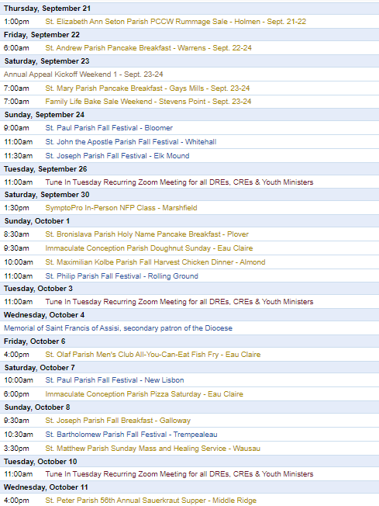
To get your parish events listed on the diocesan calendar, diolc.org/calendar, and in Catholic Life magazine, please send an email to datebook@diolc.org. Make sure you include the following details: date, beginning/ending times, event location, description, menu and cost, etc. If you have any questions, please call Pam Willer at 608.788.1524 for more information.

<<Top >>

Director: Ann Lankford – 608.791.2658 | alankford@diolc.org
(Reminder) Clergy and Parish Point Person: Small Group Bible Studies on the Eucharist
During this year of Parish Revival, the focus is on “Encounter” and the goal is to help people in the pew to know and love Jesus, truly present in the Eucharist. The highlighted means to achieve this goal is through small groups. A new small group study has been developed for the entire country, especially for the Year of Parish Revival. In addition to beautiful video presentations featuring Chris Stefanick, Edward Sri and others, there are also two personal testimonies about the Eucharist for each session, small group discussion questions, praying with Eucharistic passages in Scripture (lectio divina) and a closing prayer with a litany. This program includes training for facilitators and table leaders of small groups. Click the link for further information on this resource entitled “Jesus and the Eucharist Study.” diolc.org/eucharist/lead There is also information about six other excellent bible studies or faith studies on the Eucharist at this link: diolc.org/eucharist/lead
(Reminder) For your parish bulletin:
Online Facilitator Training for leading a Bible Study or Faith Study for Adults |Oct. 2 (6:30 p.m. - 8:00 p.m.) and Oct 3 (10:30 a.m. - 12:00 p.m.)
If you will be facilitating a small group of adults this fall, you are invited to a Zoom training session led by Ann Lankford, the Director for Catechesis & Evangelization. This training will provide resources to help facilitators:
- run the group smoothly amidst varying personalities
- implement Mother Church’s vision of fostering deeper conversion to Jesus Christ and growing in faith
- know the stages of conversion so that participants may also understand and seek deeper conversion
- recognize the boundaries of facilitating and have confidence in leading a group
Anyone interested in being part of this training on Monday, Oct. 2rd, 6:30-8 p.m. or Tuesday, Oct. 3rd from 10:30 a.m.-12 noon, please register by emailing Beth Johnson at bjohnson@diolc.org.
For your Parish Bulletin:
A Minute with Jesus is meant to inspire parishioners during the Eucharistic Revival, a movement to help all Catholics know and believe that the Eucharist is Jesus.
The Eucharist strengthens our love for our neighbor
In reading the life of any saint, we see clearly that they “constantly renewed their capacity for love of neighbor from their encounter with the Eucharistic Lord” (Pope Benedict XVI’s encyclical “God is Love”). When we receive Jesus in Holy Communion, He strengthens us with His Divine power to seek to live with charity toward every person that we meet. We cooperate with this power – His grace – by asking for His help as we encounter any situations, particularly difficult ones. In continuing to seek to live with love, we become more and more the person that God created us to be.
Let’s pray this right now and every day this week: Jesus, as I receive You in Holy Communion, help me to see You in every person I meet and give me Your love for them in my heart.
For a list of all weekly proclamations up to Oct. 1 (with more to be added regularly), click here: diolc.org/eucharist/learn.
Catechetical Leader Information:
A Minute with Jesus is being provided in light of the Eucharistic Revival - a movement to help all Catholics know and believe that the Eucharist is Jesus. Keeping the Eucharistic Revival in front of Parents through communications
Preparing to Receive Holy Communion
When we are at Mass, and preparing to receive Jesus in Holy Communion, our minds will sometimes wander. When we find ourselves distracted in this way, simply return our eyes to the altar and listen with our hearts as the priest prays the words of Jesus, asking the Holy Spirit to change the bread and wine into His Body and Blood of Jesus. As we go forward to receive Jesus in Holy Communion, it is a good practice to repeat the following prayer: “Lord, I am not worthy that You should come under my roof, but only say the word and my soul shall be healed.” (Matthew 8:8)
Let’s pray this right now and every day this week in preparation for next Sunday: “Lord, I am not worthy that You should come under my roof, but only say the word and my soul shall be healed.” (Matthew 8:8)
This week, read Isaiah 26:3: He does keep in perfect peace, whose mind is stayed on Thee.
Suggested: Picture of a person going up to receive Holy Communion
Click here for entries before and after Oct 1: diolc.org/catechesis/catechetical-leaders-info
Year-long schedule for Catechetical Leaders
To access this year-long schedule, and other helpful resources provided by the Office, visit diolc.org and
- Click on the “hamburger” in the right, upper corner
- Click on “Offices & Ministries”
- Click on Catechesis
- Click on the “hamburger” again and the list of resources/information etc. is shown
- Click on Catechetical Leader Info to see the calendar

Confirmation Brochure for Confirmandi and Parents:
A helpful brochure regarding the purpose of Confirmation and the necessary components is available for download here: diolc.org/catechesis/sacramental-prep/confirmation Scroll down to Confirmation Guidelines / Resources.

Confirmation Schedules for 4 Approved Resources:
Schedules are available for 4 approved Confirmation Programs. These schedules include Theology of the Body, which is required for both Middle School and High School in Parish Programs and Catholic Schools. diolc.org/catechesis/sacramental-prep/confirmation Scroll to “Schedules for 4 different Programs…”

Safe Environment Training for Students Grades Kindergarten through 12th Grade:
For Safe Environment training regarding students in schools and parish programs, age-appropriate powerpoints are available here: diolc.org/safe-environment/library Scroll down to “Diocese of La Crosse Protect and Heal Religious Education Lesson Plans.” Directions for using the power points and/or printing the slides of each powerpoint for teaching students is provided on the webpage. All students are to receive training for Safe Environment each year.

The Office for Catechesis & Evangelization is here to serve the Parish Catechetical Leaders.
Please contact us so we can answer your questions, and hear how we can best support you.

<<Top >>

Director: Erik Archer– 608.791.2661 | earcher@diolc.org

Parish Roundtables | October 9th - 13th
Please register at: https://forms.office.com/r/HsV4R9JrBE or use your smartphone’s camera to scan the QR code to the right.
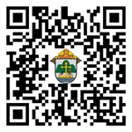
Our next iteration of Parish Roundtables are scheduled for October 9th - 13th. Thank you so much to the parishes that agreed to host. Our intent continues to meet parishes where they’re at, to listen to what parishes need from us, what we’re doing well and what we can do better. Curia directors will join our communications team to share their updates as well as listen to what parishes need from them. The registration form will be out shortly. 27 individuals completed the post-roundtable survey in the spring and we’re going to factor those comments into our planning process for these fall roundtables.

<<Top >>

Director: Sr. Donna Krzmarzick, ISSM – 608.791.2690 | dkrzmarzick@diolc.org

No items this week.

<<Top >>

Director: Deacon Robert Riedl – 608.791.2665 | rriedl@diolclergy.org

Fall Ministry Days
Please log into the website to register for Fall Ministry Days using this link: https://diolc.org/vicarforclergy/
Deacon Days with the Bishop: (Attendance is Expected)
- 2024 – August 10
- 2025 – August 9
- 2026 – August 8

<<Top >>

Director: Christopher Rogers – 608.791.2659 | crogers@diolc.org

For Your Parish Bulletin:
(Reminder) Men of the Cross Conference|Oct. 14 (8:30 a.m.-5:15 p.m.)
The La Crosse Center, La Crosse, WI
Connect with other Catholic men from around the Diocese of La Crosse who will lift you in this role and be encouraged and challenged by men of deep faith. Tickets are $45 per person. Fathers, make this a Father/Son day and bring your high school-age son for free! If you are planning to bring your son, please put his name in the comment section on the online registration form.
So get your family members, best buds, men at your parish, and even acquaintances, together and join your brothers from all over the Diocese of La Crosse to reignite your identity as a Catholic man.
For registration and more information, visit www.menofthecross.org or use your smartphone’s camera to scan the QR code to the right.

(Reminder) Natural Family Planning
For Priests, Deacons and Parish staff:
USCCB Free Resources to Download
Diocese of La Crosse NFP Brochure (use diolc.org email for access)

NFP classes are offered to interested couples by the Marriage and Family Life Office. To
inquire about diocesan classes, go to diolc.org/nfp or email ckitzhaber@diolc.org. Read
more regarding NFP on the USCCB web site at www.usccb.org/prolife/issues/nfp.
(Reminder) For Your Parish Bulletin:
A SymptoPro NFP In-Person Class will be offered in the Wausau Deanery at St. John the Baptist Parish, 103 N. 4th Ave., Edgar, WI 54426 on:
Sunday, Sept. 17 at 3-5 p.m.
Saturday, Sept. 30 at 1:30-3:30 p.m.
Sunday, Oct. 15 at 3-5 p.m.
Please contact Nancy Hackel at nhackel@stjohnedgar.org to register for this 3-session course. Please download the poster here.
(Reminder) For Pastors and Marriage Preparation coordinators:
The Sympto-Pro online course is $135. The in-person course is $100. We are offering a premium product for a discount price to encourage couples to take the course in person, if possible. If you would like to discuss the possibility of having an in-person course in your deanery, please contact Christy Kitzhaber at ckitzhaber@diolc.org. (Most of our SymptoPro instructors are located on the East side of the diocese.)
(Reminder) For your parish bulletin:
Worldwide Marriage Encounter
Do you know a couple who has been married for 70, 75 or more years? Worldwide Marriage Encounter highlights and honors couples who have very long marriages. Every state in the U.S. will honor one nominated couple who is married the longest. Please nominate a couple by going to wwme.org or use your smartphone’s camera to scan the QR code to the right and nominate them at the top of the page. Nominations should be in by Sept. 15. For questions, call 641.753.6953.

(Reminder) Marriage Enrichment and Parenting Resources.
For your marriage website: foryourmarriage.org/ or use your smartphone’s camera to scan the QR code to the right. This website from the USCCB helps couples at all stages of life to understand and live God’s plan for happy, holy marriages.

(Reminder) Teaching the Way of Love:
Please visit twl4parents.com/ or use your smartphone’s camera to scan the QR code to the right. This website is full of encouragement and tips for parents to continue to be the primary educators of their children.

(Reminder) Diocesan Website for Clergy and Marriage Ministers Regarding Marriage Preparation:
Use this link: diolc.org/marriage/marriage-preparation/marriage-preparation-for-ministers/ to go directly to the section of our website containing resources for clergy and marriage ministers. There are step-by-step instructions, downloadable guidelines, downloadable forms and much more! Please let us know if we can assist you in this ministry.

(Reminder) Process for Training FOCCUS Facilitators:
The process for training FOCCUS facilitators is as follows: Each parish needs to contact FOCCUS directly to set up an account for your parish, if one has not already been set up and then train your couples directly through FOCCUS. The contact person at FOCCUS is Max Allen. He is happy to work directly with your parish priest or contact person. His contact information is: email: mrallen@foccusinc.com or phone: 402.827.3735, ext. 1317.

<<Top >>

Director: Christopher Ruff – 608.791.0161 | cruff@diolc.org

No items this week.

<<Top >>

Director: Fr. Woodrow Pace – 608.791.2676 | wpace@diolc.org

No items this week.

<<Top >>

Director: Christopher Carstens – 608.791.0161 | ccarstens@diolc.org
Liturgical Calendar
September 27 (Wed.): Rural Life Day, day of thanksgiving for blessings received. Prayer texts from Mass for Various Needs and Occasions: After the Harvest (n.28) can be used with Preface V of the Sundays in Ordinary Time. Readings may be taken from After the Harvest in Lectionary (n.20), nos. 917-921. The Gloria also ought to be said.
Christmas Mass Schedule
The Fourth Sunday of Advent this year falls on Dec. 24. Masses during the day will celebrate the Fourth Sunday of Advent, while Masses on Sunday evening will observe the Vigil for Christmas. Catholics are to attend Mass twice for these two occasions.
One week later, Sunday, Dec. 31, will celebrate the Feast of the Holy Family during the morning, while Sunday evening Masses can observe either the Feast of the Holy Family or the Solemnity of Mary, Mother of God; either Mass will fulfill the faithful’s Sunday obligation. Monday, Jan. 1, is not a Holy Day of obligation in 2024.
(Reminder) RCIA Calendar of Teachings and Liturgies
Please find a 9-month calendar of teachings, retreats, and liturgies for the RCIA here, while a 15-month calendar is available here. Resources for purchase are available here.
(Reminder) Some Liturgical Dates and Notes for the Liturgical Year 2024
Please click here for a list of significant liturgical celebrations for the liturgical year 2024.
<<Top >>

Director: Teresa Brown – 608.791.2679 | tbrown@diolc.org

DIOCESE OF LA CROSSE GUIDELINES FOR REPORTING INSTANCES OF CHILD ABUSE

The Diocese of La Crosse, through its policies and procedures, seeks to provide a prompt, appropriate and compassionate response to reporters of sexual abuse of a child by any diocesan agent (bishop, priest, deacon, employee, religious, vendor or volunteer). Anyone wishing to make a report of an allegation of sexual abuse should send that report to Mrs. Teresa Brown, Complaint Intake Agent, at the Diocese of La Crosse, P.O. Box 4004, La Crosse, WI 54602-4004. Alternatively, you can contact Mrs. Brown at 608.791.0179 or intakeagent@diolc.org. The reporting form is available through the Diocese of La Crosse Office of Safe Environment or on the diocesan website at: diolc.org/safe-environment/reporting. Individuals are also encouraged to take their reports directly to civil authorities. Copies of the diocesan policy are available through your local Parish and on the diocesan website. If you have any questions about the Diocese of La Crosse and the implementation of the Charter for the Protection of Children and Young People, please contact Teresa Brown, Diocese of La Crosse, at 608.791.2679 or tbrown@diolc.org.

<<Top >>

Superintendent: Thomas Reichenbacher – 608.788.7707 | treichenbacher@diolc.org

No items this week.

<<Top >>

Director: Christopher Ruff – 608.791.0161 | cruff@diolc.org

For Your Parish Bulletin:
(Reminder) Gospel of Life White Mass, Banquet & Presentation - Oct. 18
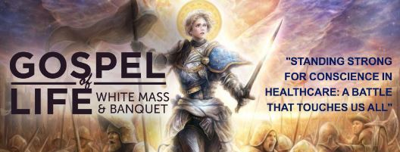
Join us at the Cathedral of St. Joseph the Workman on Wednesday, Oct. 18, the Feast of St. Luke, Patron of Physicians, for the ‘White Mass’ celebrated by Bishop Callahan, in which the faithful honor and pray for Catholic healthcare professionals. The Mass will be followed by a banquet and a keynote presentation by Fr. Justin Kizewski on “Standing Strong for Conscience in Healthcare: A Battle that Touches us All.” Cost for the banquet and presentation is $20/person, $10/students. All the faithful are warmly invited. To learn more and to register, visit www.diolc.org/GospelofLife or scan the QR code to the right.

(Reminder) For La Crosse Area Parish Bulletins:
Join 40 Days for Life Sept. 24 Kick-Off Rally and Vigil Campaign
Join pro-life people of the Coulee Region at a kick-off rally for 40 Days for Life on Sunday, Sept. 24th at 2 p.m. at the Black River Beach Neighborhood Center, 1433 Rose St. in La Crosse. Matt Sande, Pro-Life Wisconsin Legislative Director, will provide a state legislative update and call to action entitled “Embrace Them Both: Protecting and Supporting Moms and Babies.” The fall campaign to end abortion will run Sept. 27-Nov. 5 on the sidewalk outside Planned Parenthood, 1201 Caledonia in La Crosse. Please consider coming to pray for an hour, anytime between 7 a.m. and 7 p.m. Sign up at 40daysforlife.com/en/. Call Marie Allen for more information or signs: 608-784-5189.

For La Crosse Area Parish Bulletins:
Participate in Life Chain on Respect Life Sunday, Oct. 1
The annual Life Chain in La Crosse will take place from 2:00-3:00 PM along Losey Blvd. from La Crosse St. to Ferry St., with signs available at each of the intersections. Participants stand silently and prayerfully on the public sidewalks on both sides of the street, holding signs witnessing to the sanctity of human life. Join us for this public witness on Sunday, Oct. 1.
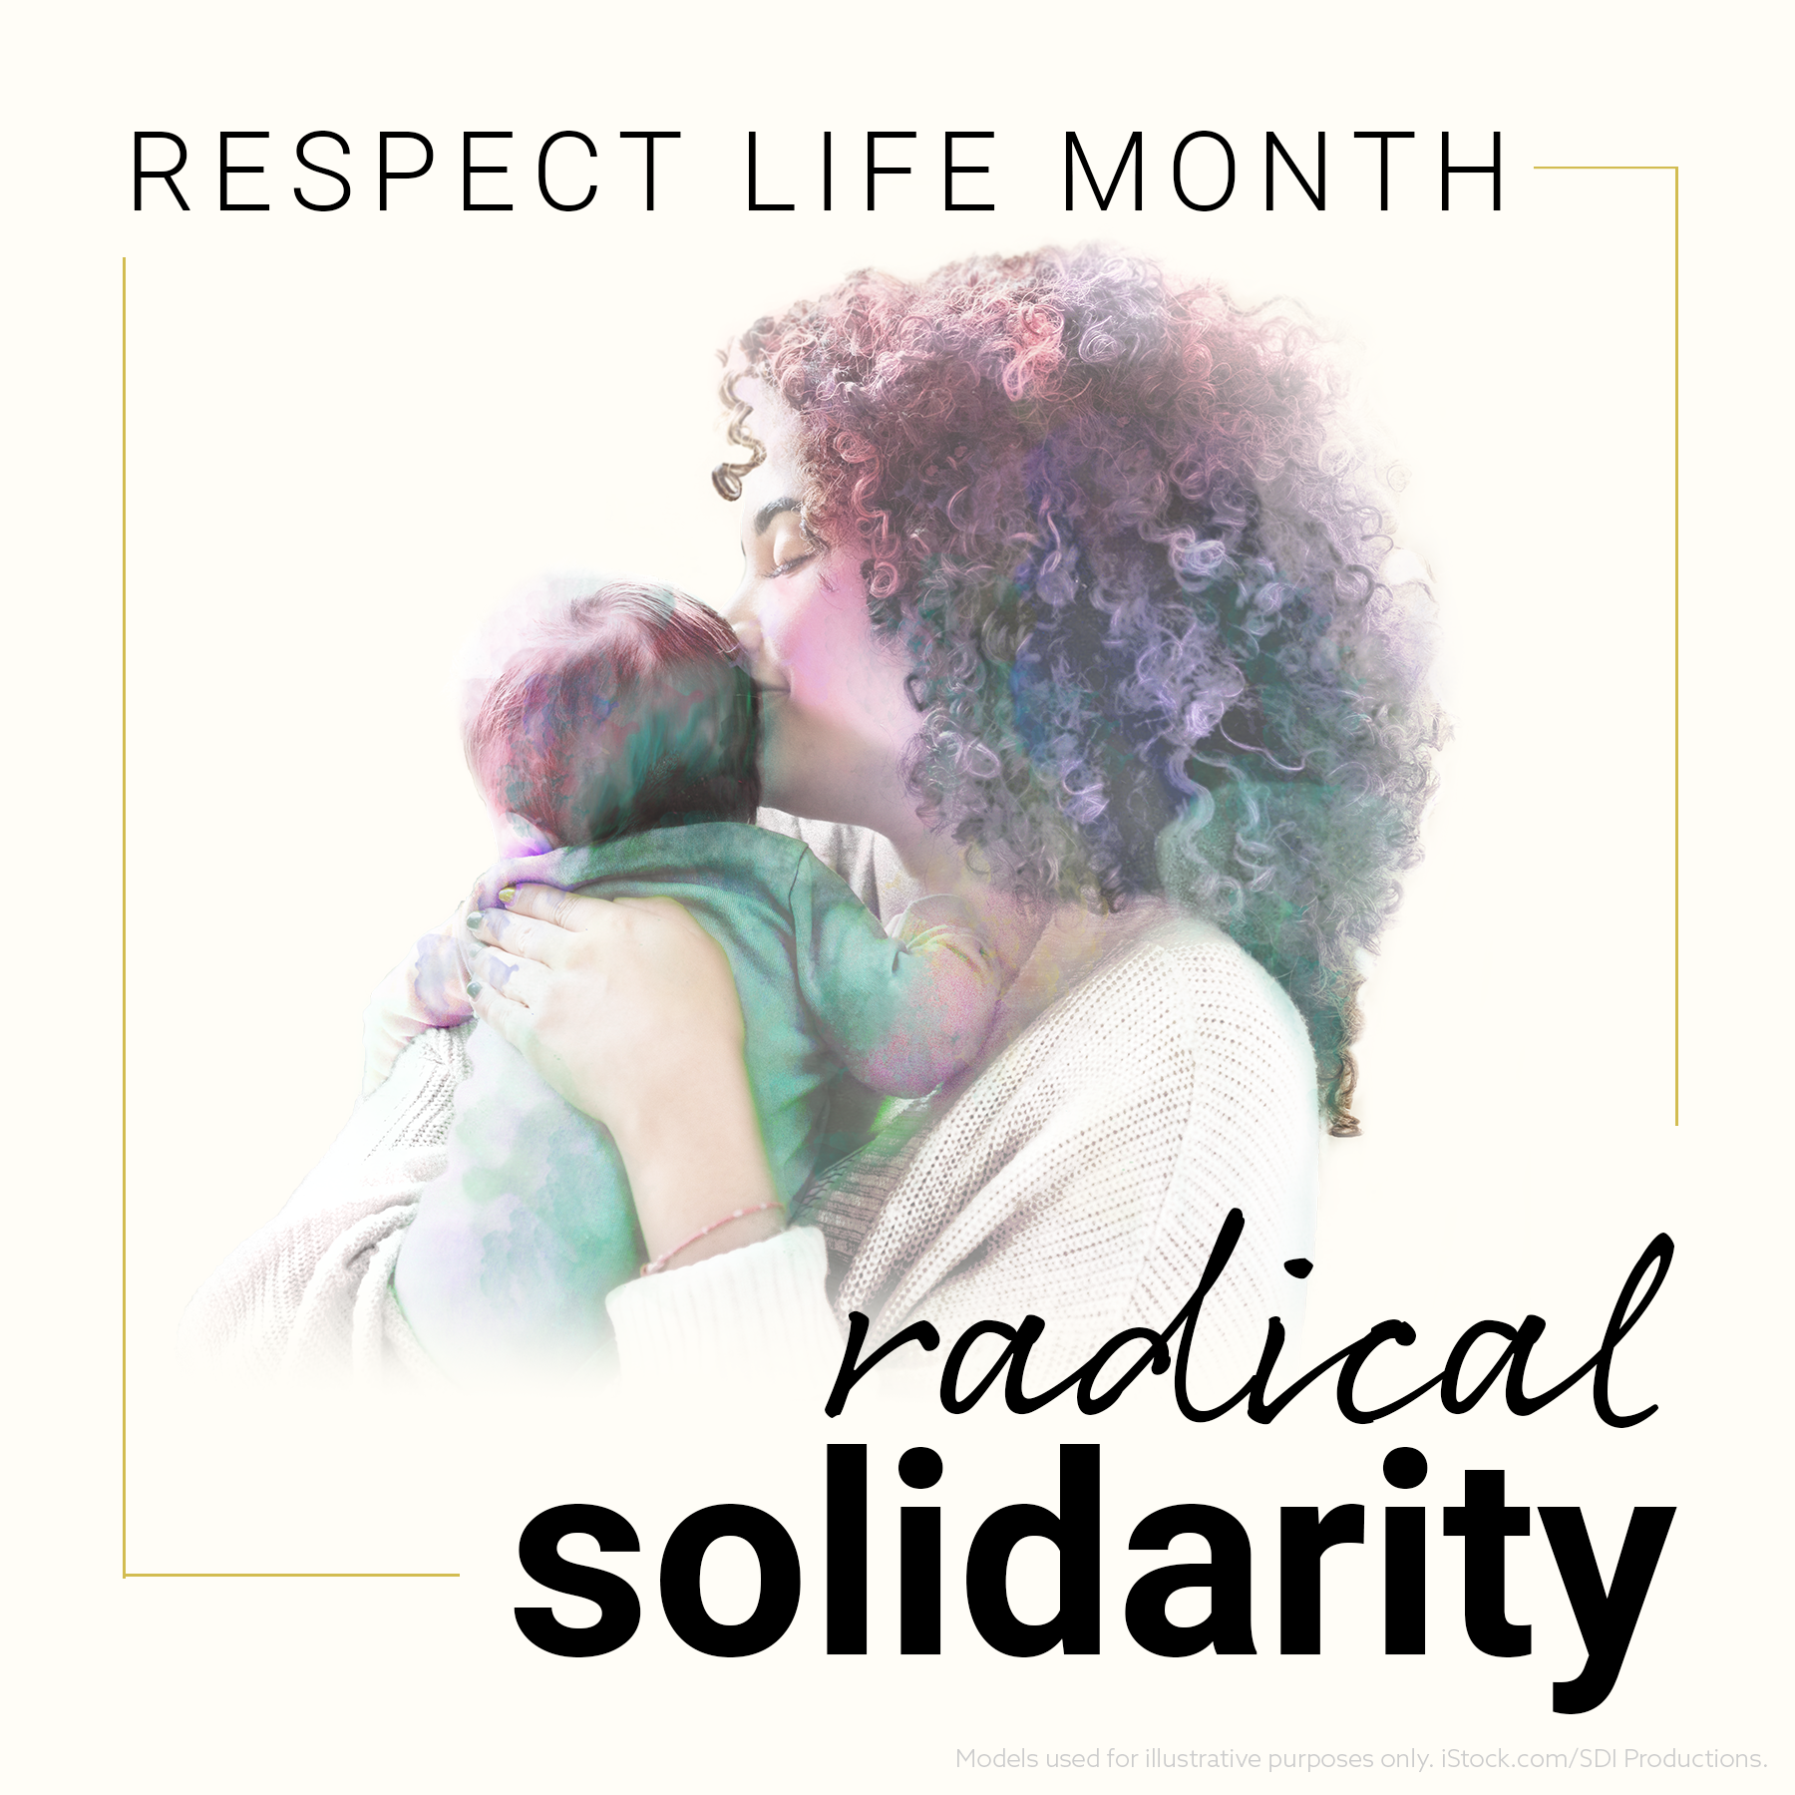
For Your Parish Bulletin:
October is Respect Life Month
Many parish resources from the USCCB for October, Respect Life Month, are available at www.respectlife.org. Also visit the Diocesan website, www.diolc.org/respect-life, for information on Pregnancy Resource Centers, Post-Abortion Healing, and much more.

Pastors and Respect Life Representatives:
Learn 4 Ways to Celebrate Respect Life Month as a Parish
Wednesday, Sept. 20 at 1:30 PM (Central), join Anne Ferreira from the U.S. Conference of Catholic Bishops (USCCB) and Liz Linhares from Flocknote for a live webinar to prepare for Respect Life Month! Anne will be discussing 4 tangible ways you can celebrate as a parish—and sharing loads of free content from the USCCB, including some that is available exclusively to parishes using Flocknote. Register here.

(Reminder) For Your Parish Bulletin:
Post-Abortion Healing Ministry in the Diocese of La Crosse
Do you know someone who is carrying the grief and sorrow of past abortions? Project Rachel Ministry offers a compassionate heart and confidential help. Call 608.860.6698 or email projectrachel@diolc.org.

(Reminder) For Your Parish Bulletin:
Help Relief Efforts for Morocco After the Devastating Earthquake
On Friday, Sept. 8, a magnitude 6.8 earthquake struck Morocco. More than 300,000 people were affected and at least 2,490 were killed. Access to remote areas with the worst destruction—especially in mountain towns—remains difficult. Catholic Relief Services is supporting Caritas Rabat, whose teams mobilized a response within 24 hours to the hardest-to-reach areas. To donate to these efforts, visit www.crs.org or scan the QR code to the right. (Note: Catholic Relief Services is not able to do relief work in Libya, unfortunately. Pray for the victims of the horrific flooding there. You may also do an Internet search for secular organizations that are able to assist in Libya).

(Reminder) For Your Parish Bulletin:
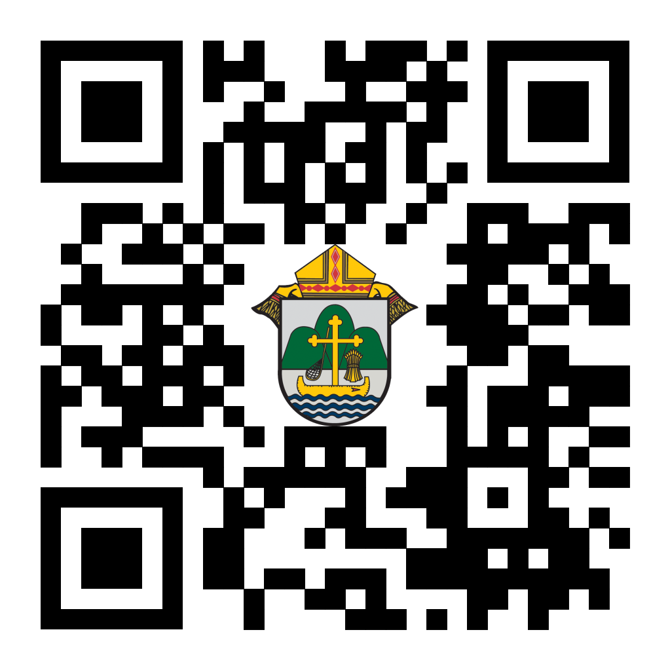
Chalice of Mercy is in Ukraine, Needs our Help
Please donate to the Ukrainian relief efforts of Chalice of Mercy if you are able, and pray for the safety of their volunteers on the ground there, who put their lives on the line. Financial assistance is the biggest need at this time. To give, visit chaliceofmercy.org/donate or use your smartphone’s camera to scan the QR code to the right.

<<Top >>

Director: Jeff Reiter – 608.791.2653 | jreiter@diolc.org
Diocesan Annual Appeal
Last week Thursday (9/14/2023) we sent to all the parishes an email informing them of this year's Diocesan Annual Appeal Allocation. If you have not received it please check your spam. Unless we were directed otherwise, the letter went to the Pastor’s email on record with the Curia offices.
- In that email that was sent a link to sign up and choose your parish’s announcement weekend was included: https://forms.gle/sWxXCPNARTGatTiD7
- This year’s overall target has not changed from the previous year. The overall Appeal is $6,000,000
This year’s theme will focus on the power of triune relationships: God, the Catholic Church, and oneself.
Ecclesiastes 4:12: "Where one alone may be overcome, two together can resist. A three-ply cord is not easily broken."
In May, the Surgeon General declared loneliness an epidemic in this country. (https://www.hhs.gov/about/news/2023/05/03/new-surgeon-general-advisory-raises-alarm-about-devastating-impact-epidemic-loneliness-isolation-united-states.html).
The Catholic Church and her communities and ministries are the perfect antidote to this epidemic. ECC 4:12 underscores the importance of strength through unity, emphasizing the importance of bringing together in faith and community.
Weekly Stewardship quotes (shorter bulletin reflections)
July - September
https://diolc.org/wp-content/uploads/2023/07/July-Sept-Stewardship-Quotes.pdf
- October - December
https://diolc.org/wp-content/uploads/2023/09/Stewardship-Bulletin-Reflections-Oct-Dec-2023.pdf
- Spanish Version
https://diolc.org/wp-content/uploads/2023/09/Stewardship-Bulletin-Reflections-Oct-Dec-2023-Spanish.pdf
Weekly Stewardship Prayers of the Faithful
July - September
https://diolc.org/wp-content/uploads/2023/07/July-Sept-Weekly-Prayers-of-the-Faithful.pdf
- October - December
https://diolc.org/wp-content/uploads/2023/09/Prayers-of-the-Faithful-Oct-Dec-2023.pdf
- Spanish Version
https://diolc.org/wp-content/uploads/2023/09/Prayers-of-the-Faithful-Oct-Dec-2023-Spanish.pdf
Stewardship Bulletin Reflections for Weekends:
09/24
https://diolc.org/wp-content/uploads/2023/08/09.24.23-stewardship-bulletin-announcements.pdf
- 10/01
https://diolc.org/wp-content/uploads/2023/09/10.01.23-stewardship-bulletin-announcements.pdf
- 10/08
https://diolc.org/wp-content/uploads/2023/09/10.08.23-stewardship-bulletin-announcements.pdf
- 10/15
https://diolc.org/wp-content/uploads/2023/09/10.15.23-stewardship-bulletin-announcements.pdf
Stewardship Homily Reflections:
Stewardship reflections for your homily development:
- For Weeks 09/24 - 10/15/23:
https://diolc.org/wp-content/uploads/2023/09/Homily-Guide-09.19.23.pdf
Planned Giving – Leaving a Legacy, Wills, Bequest and Endowments:
We have inherited such treasures from our parents, grandparents and great-grandparents, those whose shoulders we stand on today. Now it is our turn to ensure future generations can enjoy the reverence and beauty of a well-maintained parish. Leveraging the Capital Campaign and providing parishioners with information on Endowments, Trusts and Bequests are just a few ways a parish can help prepare for its future.
Our Estate Planning Guide can help people save several hundred dollars in legal and financial estate planning costs. We have sent out several hundred copies per individual request, and each Parish has received a copy. Do not hesitate to contact our office if you want additional copies.
Our Planned Giving website is diolclegacy.org. People can find calculators, additional information, sign up for a newsletter and request copies of specific estate planning guides and information.
Our website includes instructions on how to do an IRA Rollover, the creation of Donor Advised Funds (DAF), Beneficiary Designations and Stock Transfers. https://diolclegacy.org/?pageID=5
If you would like more legacy-giving information, presentations or ads for your Parish bulletin, please do not hesitate to contact our office or the Catholic Foundation of West Central Wisconsin (cfwcw.org) at 608.519.9892 or email: eboos@cfwcw.org.

<<Top >>

Diocesan Finance Officer: James Reider – 608.791.2668 | jreider@diolc.org

No items this week.

<<Top >>

Director of Vocation Recruitment: Fr. Nate Kuhn – 608.791.2666 | nkuhn@diolc.org

Please keep David Nowicki in prayer as he prepares for ordination to the Diaconate on Sept. 28 in Rome. It will be broadcast on EWTN. You can find the TV schedule at this link. It will also most likely be posted on the EWTN Youtube channel as well.

Vocations Intercessions

Please include the following intercession for vocations for your Sunday prayers of the faithful.
For a strengthening of all vocations, that we may all strive to follow God's call to holiness.
Consider adding a vocations paragraph to your parish bulletin. Below is an example – they will be changed each week. Feel free to use any or all of them.
The first question that Jesus asks in John’s Gospel is, “What are you looking for?” He is speaking to John’s disciples as they follow after Him, desiring to know who Jesus is and what His mission is all about. After the disciples respond, Jesus gives them an instruction, “Come and you will see!” Whether we can hear it or not, that same question is being asked to you. What are YOU looking for? So often, we find ourselves searching, not knowing exactly where to go or what to do in life. We seek things that will hopefully fill the emptiness and longing that we have in our hearts, but nothing seems to satisfy. The real answer to this can be found in Jesus’ response as He invites each of us to follow after Him, to get to know Him, and to follow the path He has placed before us. For some men, that path is a very special invitation to walk in Jesus’ footsteps as a priest. If you or someone you know is interested in discovering more about this call to the priesthood, please contact me at: Fr. Nate Kuhn, Director of Vocational Recruitment for the Diocese of La Crosse, 3710 East Ave. S. PO Box 4004, La Crosse, WI 54602; or by phone at: 608.791.2667. God bless you!
<<Top >>

Director: Very Rev. Woodrow H. Pace – 608.791.2689 | wpace@diolc.org

Fall Ministry Days
Please log into the website to register for Fall Ministry Days using this link: https://diolc.org/vicarforclergy/

Evenings of Reflection
Please register for these sessions by emailing rorth@diolc.org.

La Crosse (Shrine) – 1st Thursdays
Oct. 5, 2023
Nov. 2, 2023
Dec. 7, 2023
Jan. 4, 2024
Feb. 1, 2024
March 7, 2024
April 4, 2024
May 2, 2024

Mosinee – 2nd Thursdays
Oct. 12, 2023
Nov. 9, 2023
Dec. 14, 2023
Jan. 11, 2024
Feb. 8, 2024
March 14, 2024
April 11, 2024
May 9, 2024

Durand – 3rd Tuesdays
Sept. 19, 2023
Nov. 14, 2023
Dec. 19, 2023
Jan. 16, 2024
Feb. 13, 2024
March 19, 2024
April 16, 2024
May 14, 2024

<<Top >>

Director: Christopher Rogers – 608.791.2659 | crogers@diolc.org

SEALED! Fall Diocesan Confirmation Retreat
The SEALED! Diocesan Confirmation Retreat will be held December 9, 2023, at St. Olaf Catholic Church in Eau Claire, WI. Click this link to register and find out more information: https://diolc.org/yya/youth-opportunities/immersion-retreat/

NCYC (National Catholic Youth Conference) Last Call
If you have a group interested in attending NCYC with us November 16-19, 2023, please contact our office ASAP.

Updated Office for Family Life Calendar of Events Through 2025
We, in the Office for Family Life, are working to keep our event planning at least two years out. We have created a calendar that may help you in planning for the next couple of years. You will see the dates have hyperlinks that allow you to add this event to your Google Calendar. Below each event is a hyperlink to the page on our website with more information, including registration links for that particular event. Please follow this link to get a list of events planned so far: https://drive.google.com/file/d/17YHE2dCa267CYfgCXZVP1hSwjTMNfhY-/view?usp=sharing

(Reminder) National Federation for Catholic Youth Ministry (NFCYM) Field Survey
The National Federation for Catholic Youth Ministry (NFCYM) recently launched the 2023 National Youth Ministry Field Survey. This annual survey serves as a crucial instrument to capture the realities and evolving needs of youth ministers in the field. The results of this annual survey allows NFCYM to formulate actionable plans and advocacy initiatives that directly address the needs of youth ministries and the young people they serve.

We firmly believe that the richness and accuracy of the survey's findings are amplified when it resonates with experiences and insights from diverse corners of our national youth ministry landscape. This is where we seek your invaluable support. Please use the link below to complete the survey: https://www.surveymonkey.com/r/YMSurvey23

Every response deepens our understanding and solidifies the foundation upon which we base our future initiatives. Furthermore, NFCYM pledges transparency by sharing a detailed report derived from the survey, ensuring that the insights contributed by youth ministry leaders are accessible to all. You can view the results of past field surveys here: https://nfcym.org/field-survey/

<<Top >>

Diocese of La Crosse | 3710 East Ave S | La Crosse, WI 54601 | 608-788-7700
To unsubscribe from this e-mail message contact mwilson@diolc.org

