Chancery Bulletin - Vol. 8, No. 9.4 | September 26, 2023

- Catechesis & Evangelization  - Chancery  - Communications  - Consecrated Life  - Diaconate  - Marriage & Family Life  - Ministries  - Mission Office  - Sacred Worship | - Safe Environment  - Schools Office  - Social Concerns  - Stewardship and Development  - Temporalities  - Vocations  - Vicar for Clergy  - Youth and Young Adult Ministry  - Past Chancery Bulletins
No items this week.

<<Top >>

Chancellor Very Rev. William Dhein – 608.791.2655 | wdhein@diolc.org
The Annual Mass Counts will be conducted again this year during the month of October. Please find more information and the form here.
<<Top >>

As of Sept. 26

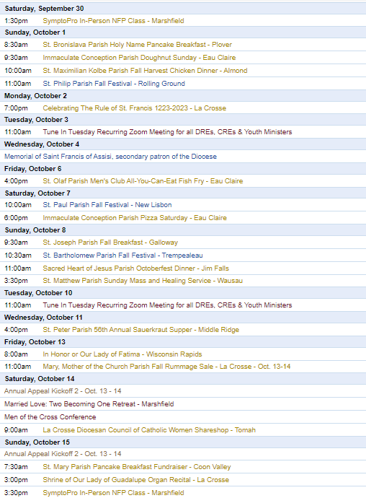
To have your parish events added to the diocesan calendar, diolc.org/calendar, and Catholic Life magazine, please email datebook@diolc.org. Make sure you include the following details: date, beginning/ending times, event location, description, menu and cost, etc. If you have any questions, please call Pam Willer at 608.788.1524 for more information.

<<Top >>

Director: Ann Lankford – 608.791.2658 | alankford@diolc.org
For your Parish Bulletin:
The Catholic Church in the United States is in the midst of a three-year Eucharistic Revival. This movement is to help all Catholics know and believe that the Eucharist is Jesus.
Jesus waits for us.
After Mass, Holy Communion is reserved in the tabernacle. The red sanctuary candle in the front of the church is constantly burning to remind us that Jesus is present in the tabernacle in the sacred Host. He waits for us to come and spend some time with Him, just as we would spend time with any friend. We can speak with Him about anything and simply be quiet in order to listen to Him. It is helpful to bring a book like The Divine Encounter by Mark Hart to have something to help stay focused when distractions arise. This time with the Lord will help bring solace and peace as worries take on a proper perspective, and we will gradually know that when we receive Holy Communion, we are truly receiving Jesus.
Let’s pray this right now and every day this week: Jesus, help me to set aside some time to spend with You in church so that You can strengthen my faith that You are truly present in Holy Communion.
This week, read how Jesus asked Peter and the Apostles to spend time with Him in prayer in Matthew 26:40.
For a list of weekly proclamations on the Eucharist, click here: diolc.org/eucharist/learn.
Adult Faith Formation Opportunities:
- “Sunday Rest: A teaching and practice of different forms of prayer” with Fr. Sam McCarty, Sunday, Oct. 1st, 7:30 p.m., Newman Parish in La Crosse
- “Encounter Jesus, Change your Life” is a Parish Mission being held at St. Patrick’s Catholic Church in Sparta, Oct. 22-24, 6:30-8:30 p.m. This Franciscan University of Steubenville Parish Mission will ignite your desire to be in a loving relationship with Jesus. You will discover the way to engage fully as a disciple of Christ by immersing yourself in HIS PRESENCE. Jesus changed the world in three days, let HIM change yours. Cost: $25
Catechetical Leader Information:
The following brief and inspiring explanation of the reality of Jesus’ true Presence in the Eucharist is provided for your communication with parents. Catechists may also provide the following concise, key points on the Eucharist with the children this week.
The Eucharist strengthens our love for our neighbor:
In reading the life of any saint, we see clearly that they “constantly renewed their capacity for love of neighbor from their encounter with the Eucharistic Lord” (Pope Benedict XVI’s encyclical “God is Love”). When we receive Jesus in Holy Communion, He strengthens us with His Divine power to seek to live with charity toward every person that we meet. We cooperate with this power – His grace – by asking for His help as we encounter any situations, particularly difficult ones. In continuing to seek to live with love, we become more and more the person that God created us to be.
Let’s pray this right now and every day this week: Jesus, as I receive You in Holy Communion, help me to see You in every person I meet and give me Your love for them in my heart.
This week, read how Paul describes to the people of Ephesus to live a life of love in Ephesians 5:1-2.
Suggested picture: a person showing charity toward another person.
Click here for further entries: diolc.org/catechesis/catechetical-leaders-info
Evangelizing Catechesis:
The purpose of a catechist teaching the Catholic Faith to children and young people is to help them encounter Jesus and deepen their friendship with Him. A lesson plan format with a one-page description that assists catechists in this process is found here: diolc.org/catechesis/catechist-training-resources-for-teaching/lesson-plan-format
If further explanation is desired, an excellent workshop is available on “Franciscan at Home”.
Simple directions to register free of charge:
1) Visit franciscanathome.com/diocese-la-crosse and scroll to the bottom of the page.
2) On the right, click the middle blue button: “My parish or school is already registered, and I would like to set up my individual free account…”
3) Click “Create an Account.” Complete the information and click Save. Select the Diocese of La Crosse from a drop-down menu, and then your Institution (your parish) or school, listed first by city and name. Finally, click the "Sign Up" button to have a Dashboard. Scroll down to “Franciscan Tracks” under “Start Learning” on the left and select “The Catechist Track,” and then click on “Foundational Catechist Certification” and then “The Ecclesial Method.”
A Track is a collection of workshops. A workshop is one hour of video, divided into 10-minute segments, with application discussion questions after each video. Small groups are the proven way to experience the workshops. The richness of the content shines out in the discussion.
To print the directions to register and/or for further information, click here: diolc.org/catechesis/catechetical-leaders-info
Reminder: Safe Environment Training for Students Grades Kindergarten through 12th Grade:
For Safe Environment training regarding students in schools and parish programs, age-appropriate powerpoints are available here: diolc.org/safe-environment/library Scroll down to “Diocese of La Crosse Protect and Heal Religious Education Lesson Plans.” Directions for using the PowerPoint and/or printing the slides of each PowerPoint for teaching students are provided on the webpage. All students are to receive training for Safe Environment each year, and it is most appropriate to provide this important training in early fall.

The Office for Catechesis & Evangelization:
Please contact Ann Lankford or Beth Johnson in the Office for Catechesis & Evangelization so we can answer your questions and hear how we can best support you. 608.791.2658

<<Top >>

Director: Erik Archer– 608.791.2661 | earcher@diolc.org
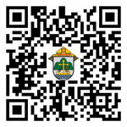
Parish Roundtables | October 9th - 13th:
Our next iteration of Parish Roundtables is scheduled for Oct. 9th - 13th. We have important news to share about new tools for parishes that the diocese will fund and help resource. Our goal is to help free parishes from time spent on Social Media and spend it instead on their ministries. Our emerging system takes the Social Media burden off parish plates. Our next effort is implementing FlockNote across the diocese - an effort the diocese will fund. We’ll discuss these at the roundtable and seek parish feedback.

Thank you so much to the parishes that agreed to host. Our intent continues to meet parishes where they’re at, to listen to what parishes need from us, what we’re doing well and what we can do better. Curia directors will join our communications team to share their updates as well as listen to what parishes need from them. The registration form will be out shortly. 27 individuals completed the post-roundtable survey in the spring and we’re going to factor those comments into our planning process for these fall roundtables.

Please register at: https://forms.office.com/r/HsV4R9JrBE or use your smartphone’s camera to scan the QR code to the right. The roundtable locations and timelines can be found there.

<<Top >>

Director: Sr. Donna Krzmarzick, ISSM – 608.791.2690 | dkrzmarzick@diolc.org

No items this week.

<<Top >>

Director: Deacon Robert Riedl – 608.791.2665 | rriedl@diolclergy.org

Fall Ministry Days:
Please log into the website to register for Fall Ministry Days using this link: https://diolc.org/vicarforclergy/
Deacon Days with the Bishop: (Attendance is Expected)
- 2024 – Aug. 10
- 2025 – Aug. 9
- 2026 – Aug. 8

<<Top >>

Director: Christopher Rogers – 608.791.2659 | crogers@diolc.org

For Parish Secretaries
Men of the Cross Conference Promotional Packet
This week, a packet containing a poster and some postcards will arrive at your parish. Please consider hanging up the promotional poster in your parish spaces and ask one of the men in your parish, perhaps a member of your men’s group or a member of the Knights of Columbus, to use the postcards to personally invite the men of your parish to attend this conference. Your assistance in getting the word out will make all the difference.

For Your Parish Bulletin:
(Reminder) Men of the Cross Conference|Oct. 14 (8:30 a.m.-5:15 p.m.)
The La Crosse Center, La Crosse, WI
Connect with other Catholic men from around the Diocese of La Crosse who will lift you in this role and be encouraged and challenged by men of deep faith. Tickets are $45 per person. Fathers, make this a Father/Son day and bring your high school-age son for free! If you are planning to bring your son, please put his name in the comment section on the online registration form.
So get your family members, best buds, men at your parish, and even acquaintances together and join your brothers from all over the Diocese of La Crosse to reignite your identity as a Catholic man.
For registration and more information, visit www.menofthecross.org or use your smartphone’s camera to scan the QR code to the right.

(Reminder) Natural Family Planning
For Priests, Deacons and Parish staff:
USCCB Free Resources to Download
Diocese of La Crosse NFP Brochure (use diolc.org email for access)

NFP classes are offered to interested couples by the Marriage and Family Life Office. To
inquire about diocesan classes, go to diolc.org/nfp or email ckitzhaber@diolc.org. Read
more regarding NFP on the USCCB web site at www.usccb.org/prolife/issues/nfp.
(Reminder) For Your Parish Bulletin:
A SymptoPro NFP In-Person Class will be offered in the Wausau Deanery at St. John the Baptist Parish, 103 N. 4th Ave., Edgar, WI 54426 on:
Saturday, Sept. 30 at 1:30-3:30 p.m.
Sunday, Oct. 15 at 3-5 p.m.
Please contact Nancy Hackel at nhackel@stjohnedgar.org to register for this 3-session course. Please download the poster here.
(Reminder) For Pastors and Marriage Preparation coordinators:
The Sympto-Pro online course is $135. The in-person course is $100. We are offering a premium product for a discount price to encourage couples to take the course in person, if possible. If you would like to discuss the possibility of having an in-person course in your deanery, please contact Christy Kitzhaber at ckitzhaber@diolc.org. (Most of our SymptoPro instructors are located on the East side of the diocese.)
(Reminder) Marriage Enrichment and Parenting Resources.
For your marriage website: foryourmarriage.org/ or use your smartphone’s camera to scan the QR code to the right. This website from the USCCB helps couples at all stages of life to understand and live God’s plan for happy, holy marriages.

(Reminder) Teaching the Way of Love:
Please visit twl4parents.com/ or use your smartphone’s camera to scan the QR code to the right. This website is full of encouragement and tips for parents to continue to be the primary educators of their children.

(Reminder) Diocesan Website for Clergy and Marriage Ministers Regarding Marriage Preparation:
Use this link: diolc.org/marriage/marriage-preparation/marriage-preparation-for-ministers/ to go directly to the section of our website containing resources for clergy and marriage ministers. There are step-by-step instructions, downloadable guidelines, downloadable forms and much more! Please let us know if we can assist you in this ministry.

(Reminder) Process for Training FOCCUS Facilitators:
The process for training FOCCUS facilitators is as follows: Each parish needs to contact FOCCUS directly to set up an account for your parish, if one has not already been set up, then train your couples directly through FOCCUS. The contact person at FOCCUS is Max Allen. He is happy to work directly with your parish priest or contact person. His contact information is mrallen@foccusinc.com or phone: 402.827.3735, ext. 1317.

<<Top >>

Director: Christopher Ruff – 608.791.0161 | cruff@diolc.org

No items this week.

<<Top >>

Director: Fr. Woodrow Pace – 608.791.2676 | wpace@diolc.org

No items this week.

<<Top >>

Director: Christopher Carstens – 608.791.0161 | ccarstens@diolc.org
Liturgical Calendar
Sept. 27 (Wed.): Rural Life Day, day of thanksgiving for blessings received. Prayer texts from Mass for Various Needs and Occasions: After the Harvest (n.28) can be used with Preface V of the Sundays in Ordinary Time. Readings may be taken from After the Harvest in Lectionary (n.20), nos. 917-921. The Gloria also ought to be said.
Christmas Mass Schedule
The Fourth Sunday of Advent this year falls on Dec. 24. Masses during the day will celebrate the Fourth Sunday of Advent, while Masses on Sunday evening will observe the Vigil for Christmas. Catholics are to attend Mass twice for these two occasions.
One week later, Sunday, Dec. 31, will celebrate the Feast of the Holy Family during the morning, while Sunday evening Masses can observe either the Feast of the Holy Family or the Solemnity of Mary, Mother of God; either Mass will fulfill the faithful’s Sunday obligation. Monday, Jan. 1, is not a Holy Day of obligation in 2024.
<<Top >>

Director: Teresa Brown – 608.791.2679 | tbrown@diolc.org

DIOCESE OF LA CROSSE GUIDELINES FOR REPORTING INSTANCES OF CHILD ABUSE
Through its policies and procedures, the Diocese of La Crosse seeks to provide a prompt, appropriate, and compassionate response to reporters of sexual abuse of a child by any diocesan agent (bishop, priest, deacon, employee, religious, vendor or volunteer). Anyone wishing to make a report of an allegation of sexual abuse should send that report to Mrs. Teresa Brown, Complaint Intake Agent, at the Diocese of La Crosse, P.O. Box 4004, La Crosse, WI 54602-4004. Alternatively, you can contact Mrs. Brown at 608.791.0179 or intakeagent@diolc.org. The reporting form is available through the Diocese of La Crosse Office of Safe Environment or on the diocesan website at: diolc.org/safe-environment/reporting. Individuals are also encouraged to take their reports directly to civil authorities. Copies of the diocesan policy are available through your local Parish and on the diocesan website. If you have any questions about the Diocese of La Crosse and the implementation of the Charter for the Protection of Children and Young People, please contact Teresa Brown, Diocese of La Crosse, at 608.791.2679 or tbrown@diolc.org.

<<Top >>

Superintendent: Thomas Reichenbacher – 608.788.7707 | treichenbacher@diolc.org

No items this week.

<<Top >>

Director: Christopher Ruff – 608.791.0161 | cruff@diolc.org

For Your Parish Bulletin:
(Reminder) YOU ARE INVITED to the Gospel of Life White Mass & Banquet|Oct. 18
Cathedral of St. Joseph the Workman, La Crosse, WI
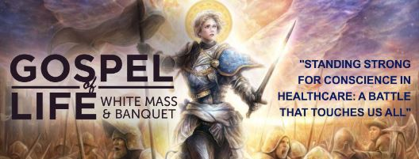
The theme is “Standing Strong for Conscience in Healthcare: A Battle that Touches Us All.”
With the pressures surrounding end-of-life decisions, abortion, vaccines, and transgender drugs and surgeries, how can doctors, nurses, and their patients “stand strong” for conscience rights in keeping with the Church’s teachings about conscience? Fr. Justin Kizewski will address this and more in his keynote at the banquet following Bishop Callahan’s 6 p.m. “White Mass,” at which the faithful honor and pray for Catholic healthcare professionals. All are warmly invited to the Mass, banquet and talk! To learn more and to register, visit www.diolc.org/GospelofLife or scan the QR code to the right.

For La Crosse Area Parish Bulletins:
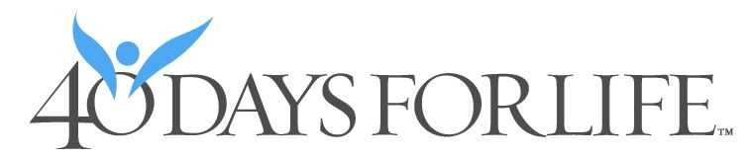
(Reminder) Join 40 Days for Life Vigil Campaign, Sept. 27-Nov. 5
The fall campaign to end abortion will run Sept. 27-Nov. 5 on the sidewalk outside Planned Parenthood, 1201 Caledonia in La Crosse. Please consider coming to pray for an hour, anytime between 7 a.m. and 7 p.m. Sign up at 40daysforlife.com/en/ or scan the QR code to the right. Call Marie Allen for more information or signs: 608.784.5189.

For La Crosse Area Parish Bulletins:
(Reminder) Participate in Life Chain on Respect Life Sunday, Oct. 1
The annual Life Chain in La Crosse will take place from 2-3 p.m. along Losey Blvd. from La Crosse St. to Ferry St., with signs available at each of the intersections. Participants stand silently and prayerfully on the public sidewalks on both sides of the street, holding signs witnessing to the sanctity of human life. Join us for this public witness on Sunday, Oct. 1.
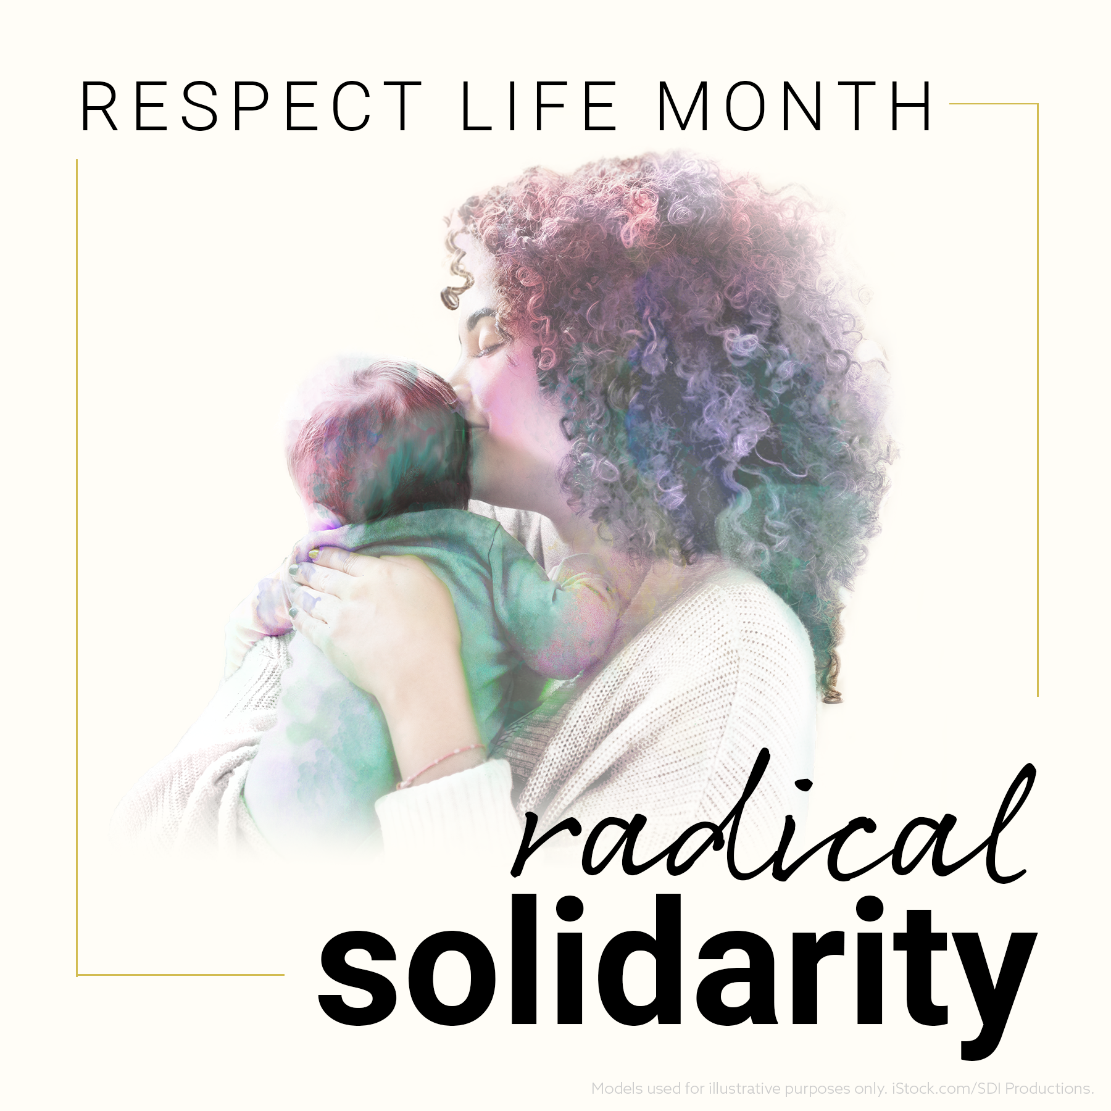
For Your Parish Bulletin:
(Reminder) October is Respect Life Month
Many parish resources from the USCCB for October, Respect Life Month, are available at www.respectlife.org. Also visit the Diocesan website, www.diolc.org/respect-life, for information on Pregnancy Resource Centers, Post-Abortion Healing, and much more.
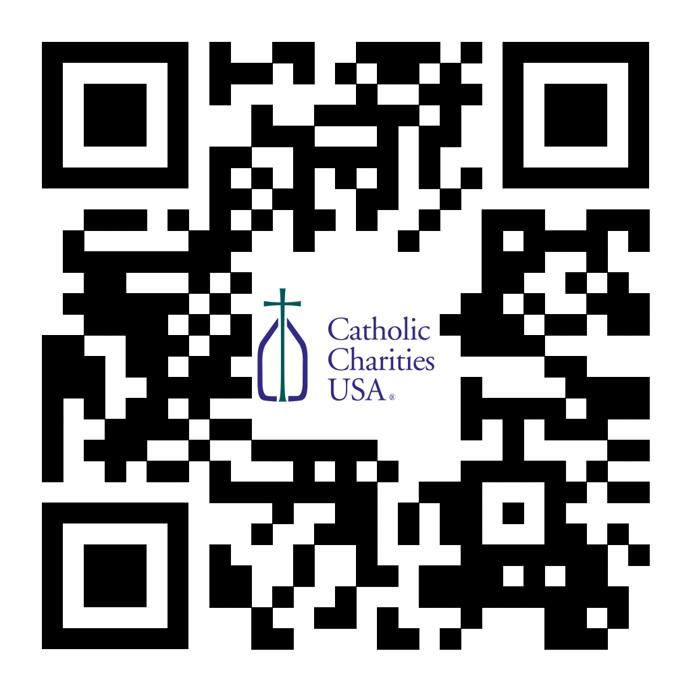
(Reminder) For Your Parish Bulletin:
Pregnant and in distress? Confidential help is available.
Make a confidential call to Catholic Charities at 844.644.7223 (844.64.GRACE) or text 715.600.6391. To learn more, visit cclse.org/i-think-im-pregnant, or scan the QR code to the right. For additional pregnancy support resources and locations, visit diolc.org/pregnancy-resources.
(Reminder) For Your Parish Bulletin:
Help Relief Efforts for Morocco After the Devastating Earthquake
On Friday, Sept. 8, a magnitude 6.8 earthquake struck Morocco. More than 300,000 people were affected and at least 2,490 were killed. Access to remote areas with the worst destruction—especially in mountain towns—remains difficult. Catholic Relief Services is supporting Caritas Rabat, whose teams mobilized a response within 24 hours to the hardest-to-reach areas. To donate to these efforts, visit www.crs.org or scan the QR code to the right. (Note: Catholic Relief Services is not able to do relief work in Libya, unfortunately. Pray for the victims of the horrific flooding there. You may also do an Internet search for secular organizations that are able to assist in Libya).
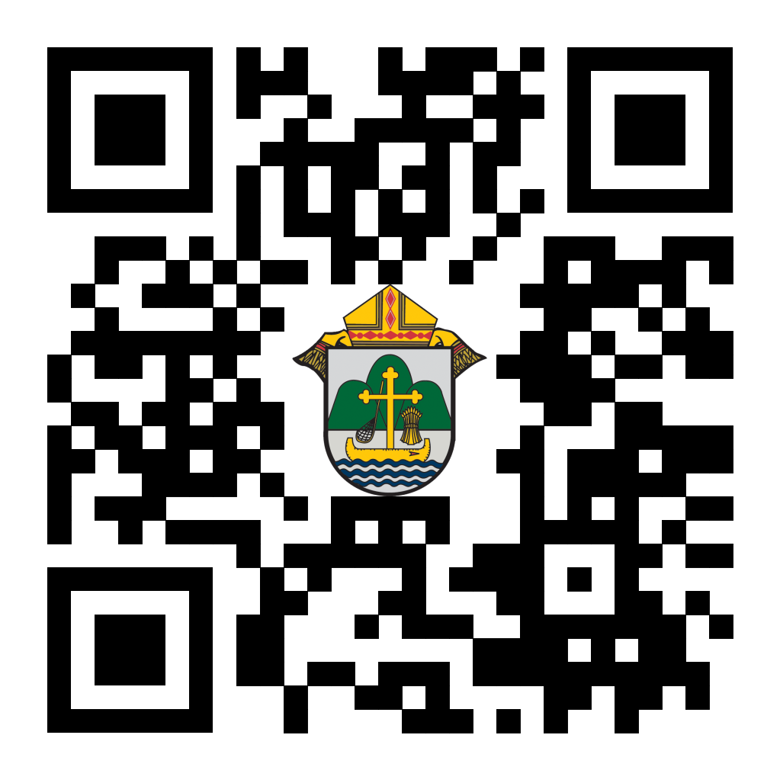
(Reminder) For Your Parish Bulletin:
Chalice of Mercy is in Ukraine, Needs Our Help
Please donate to the Ukrainian relief efforts of Chalice of Mercy if you are able, and pray for the safety of their volunteers on the ground there, who put their lives on the line. Financial assistance is the biggest need at this time. To give, visit chaliceofmercy.org/donate or use your smartphone’s camera to scan the QR code to the right.

See U.S. Bishops’ Action Alerts on Hunger, Respect Life, and other Issues:
Visit votervoice.net/USCCB/home or scan the QR code to the right to learn how to make your voice heard.

<<Top >>

Director: Jeff Reiter – 608.791.2653 | jreiter@diolc.org

Inspired By The Spirit
The September disbursement reports were emailed to the parishes on Sept. 21st. These funds will be reflected on the Sept. 30 statements from St. Ambrose. The Parishes have received just over $14 million to address their case statement needs.

If you wish to withdraw funds, please contact Dennis Herricks, Executive Director of St. Ambrose, at dherricks@stambrosefinancial.com.

The campaign has raised just over $55.9 million, with $38.6 million projected to be distributed to the parishes.

The International Catholic Stewardship Conference (ICSC) has awarded the Inspired By The Spirit Campaign the 2023 Award for Excellence. Thank you to all who have put their time and effort into helping make this campaign a success.
Diocesan Annual Appeal
Two weeks ago Thursday (9/14/2023), we sent all the parishes an email informing them of this year's Diocesan Annual Appeal Allocation. If you have not received it, please check your spam. Unless we were directed otherwise, the letter went to the Pastor’s email on record with the Curia offices.
- In that email that was sent, a link to sign up and choose your parish’s announcement weekend was included: https://forms.gle/sWxXCPNARTGatTiD7
- This year’s overall target has not changed from the previous year. The overall Appeal is $6,000,000
This year’s theme will focus on the power of triune relationships: God, the Catholic Church, and oneself.
Ecclesiastes 4:12: "Where one alone may be overcome, two together can resist. A three-ply cord is not easily broken."
In May, the Surgeon General declared loneliness an epidemic in this country. (https://www.hhs.gov/about/news/2023/05/03/new-surgeon-general-advisory-raises-alarm-about-devastating-impact-epidemic-loneliness-isolation-united-states.html).
The Catholic Church and her communities and ministries are the perfect antidote to this epidemic. ECC 4:12 underscores the importance of strength through unity, emphasizing the importance of bringing together in faith and community.
Weekly Stewardship quotes (shorter bulletin reflections)
October - December
https://diolc.org/wp-content/uploads/2023/09/Stewardship-Bulletin-Reflections-Oct-Dec-2023.pdf
- Spanish Version
https://diolc.org/wp-content/uploads/2023/09/Stewardship-Bulletin-Reflections-Oct-Dec-2023-Spanish.pdf
Weekly Stewardship Prayers of the Faithful
October - December
https://diolc.org/wp-content/uploads/2023/09/Prayers-of-the-Faithful-Oct-Dec-2023.pdf
- Spanish Version
https://diolc.org/wp-content/uploads/2023/09/Prayers-of-the-Faithful-Oct-Dec-2023-Spanish.pdf
Stewardship Bulletin Reflections for Weekends:
- 10/01
https://diolc.org/wp-content/uploads/2023/09/10.01.23-stewardship-bulletin-announcements.pdf
- 10/08
https://diolc.org/wp-content/uploads/2023/09/10.08.23-stewardship-bulletin-announcements.pdf
- 10/15
https://diolc.org/wp-content/uploads/2023/09/10.15.23-stewardship-bulletin-announcements.pdf
- 10/22
https://diolc.org/wp-content/uploads/2023/09/10.22.23-stewardship-bulletin-announcements.pdf
Stewardship Homily Reflections:
Stewardship reflections for your homily development:
- For Weeks 10/01 - 10/22/23:
https://diolc.org/wp-content/uploads/2023/09/Homily-Guide-09.26.23.pdf
Planned Giving – Leaving a Legacy, Wills, Bequest and Endowments:
We have inherited such treasures from our parents, grandparents and great-grandparents, those whose shoulders we stand on today. Now it is our turn to ensure future generations can enjoy the reverence and beauty of a well-maintained parish. Leveraging the Capital Campaign and providing parishioners with information on Endowments, Trusts and Bequests are just a few ways a parish can help prepare for its future.
Our Estate Planning Guide can help people save several hundred dollars in legal and financial estate planning costs. We have sent out several hundred copies per individual request, and each Parish has received a copy. Do not hesitate to contact our office if you want additional copies.
Our Planned Giving website is diolclegacy.org. People can find calculators, additional information, sign up for a newsletter and request copies of specific estate planning guides and information.
Our website includes instructions on how to do an IRA Rollover, the creation of Donor Advised Funds (DAF), Beneficiary Designations and Stock Transfers. https://diolclegacy.org/?pageID=5
If you would like more legacy-giving information, presentations or ads for your Parish bulletin, please do not hesitate to contact our office or the Catholic Foundation of West Central Wisconsin (cfwcw.org) at 608.519.9892 or email: eboos@cfwcw.org.

<<Top >>

Diocesan Finance Officer: James Reider – 608.791.2668 | jreider@diolc.org

Health Enews from Catholic Mutual Group
Please click here for the September edition of CMG Health Enews.

<<Top >>

Director of Vocation Recruitment: Fr. Nate Kuhn – 608.791.2666 | nkuhn@diolc.org

Please keep David Nowicki in prayer as he prepares for ordination to the Diaconate on Sept. 28 in Rome. It will be broadcast on EWTN. You can find the TV schedule at this link. It will also most likely be posted on the EWTN Youtube channel as well.

Vocations Intercessions
Please include the following intercession for vocations for your Sunday prayers of the faithful.
For an up-building of all vocations in the Church and in a particular way for priestly vocations to for the Diocese of La Crosse from our parish.
Consider adding a vocations paragraph to your parish bulletin. Below is an example – they will be changed each week. Feel free to use any or all of them.
Come Follow Me!
When Peter encountered Jesus for the first time, he was busy doing his daily work–fishing. He was minding his own business when Jesus approached him and asked him to put his nets out into the deep water for a catch. Although hesitant, he did as Jesus asked him and caught an overabundance of fish! When they arrived back on shore, Jesus said to Peter, “Come, follow me…” and Peter did. Similarly, the Lord continues to work in our world today, approaching us in our normal daily lives and inviting us to consider following Him. Have you ever considered following the Lord as a priest, like Peter? Do you know of a young man whom you think the Lord may be calling to be a priest? Perhaps this is the Lord’s invitation to follow Him. To begin the conversation or to inquire about what it means to be a priest, please contact me: Fr. Nate Kuhn, Director of Vocational Recruitment for the Diocese of La Crosse, 3710 East Ave. S. PO Box 4004, La Crosse, WI 54602; or by phone at: 608.791.2667. God bless you!
<<Top >>

Director: Very Rev. Woodrow H. Pace – 608.791.2689 | wpace@diolc.org

Fall Ministry Days
Please log into the website to register for Fall Ministry Days using this link: https://diolc.org/vicarforclergy/

Evenings of Reflection
Please register for these sessions by emailing rorth@diolc.org.

La Crosse (Shrine) – 1st Thursdays
Oct. 5, 2023
Nov. 2, 2023
Dec. 7, 2023
Jan. 4, 2024
Feb. 1, 2024
Mar. 7, 2024
Apr. 4, 2024
May 2, 2024

Mosinee – 2nd Thursdays
Oct. 12, 2023
Nov. 9, 2023
Dec. 14, 2023
Jan. 11, 2024
Feb. 8, 2024
Mar. 14, 2024
Apr. 11, 2024
May 9, 2024

Durand – 3rd Tuesdays
Nov. 14, 2023
Dec. 19, 2023
Jan. 16, 2024
Feb. 13, 2024
Mar. 19, 2024
Apr. 16, 2024
May 14, 2024

<<Top >>

Director: Christopher Rogers – 608.791.2659 | crogers@diolc.org

“Understanding Gen Z” Workshop at NET Ministries
On Nov. 9, Dr. Tanita Maddox (from Young Life) will be giving a workshop on understanding Gen Z. She has incredible insight and analysis of Gen Z, their culture(s), and how to bring the Good News to them. You can find all the details at: https://ydisciple.com/understandinggenz
The cost is only $10 to cover the cost of lunch. There will also be a free live stream for those who can't make the drive.
(Reminder) SEALED! Fall Diocesan Confirmation Retreat
The SEALED! Diocesan Confirmation Retreat will be held Dec. 9, 2023, at St. Olaf Catholic Church in Eau Claire, WI. Click this link to register and find out more information: https://diolc.org/yya/youth-opportunities/immersion-retreat/

(Reminder) NCYC (National Catholic Youth Conference) Last Call
If you have a group interested in attending NCYC with us Nov. 16-19, 2023, please contact our office ASAP.

Updated Office for Family Life Calendar of Events Through 2025
In the Office for Family Life, we are working to keep our event planning at least two years out. We have created a calendar that may help you in planning for the next couple of years. You will see the dates have hyperlinks that allow you to add this event to your Google Calendar. Below each event is a hyperlink to the page on our website with more information, including registration links for that particular event. Please follow this link to get a list of events planned so far: https://drive.google.com/file/d/17YHE2dCa267CYfgCXZVP1hSwjTMNfhY-/view?usp=sharing

<<Top >>

Diocese of La Crosse | 3710 East Ave S | La Crosse, WI 54601 | 608-788-7700
To unsubscribe from this e-mail message contact mwilson@diolc.org

