Chancery Bulletin - Vol. 8, No. 9.1 | September 5, 2023

- Catechesis & Evangelization  - Chancery  - Communications  - Consecrated Life  - Diaconate  - Marriage & Family Life  - Ministries  - Mission Office  - Sacred Worship | - Safe Environment  - Schools Office  - Social Concerns  - Stewardship and Development  - Temporalities  - Vocations  - Vicar for Clergy  - Youth and Young Adult Ministry  - Past Chancery Bulletins
No items this week.

<<Top >>

Chancellor Very Rev. William Dhein – 608.791.2655 | wdhein@diolc.org

No items this week.

<<Top >>

As of September 5th, 2023

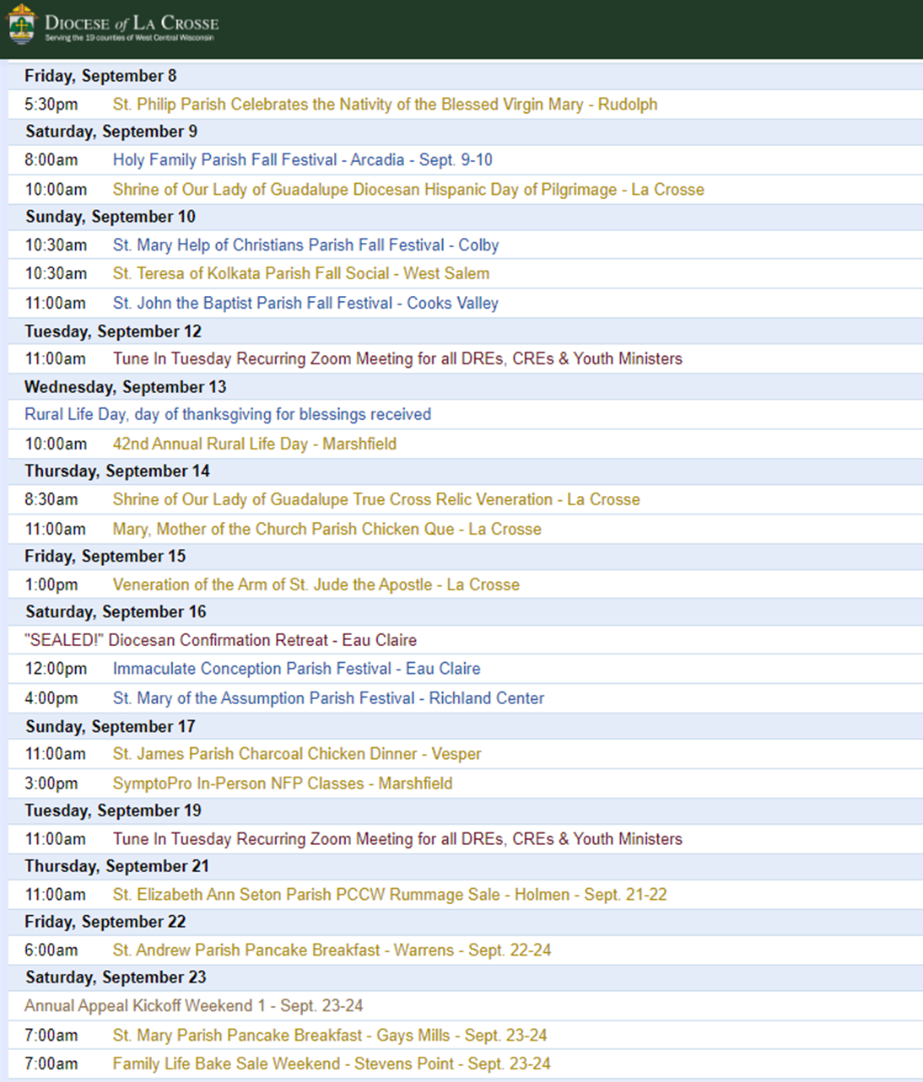

To get your parish events listed on the diocesan calendar, diolc.org/calendar, and in Catholic Life magazine, please send an email to datebook@diolc.org. Make sure you include the following details: date, beginning/ending times, event location, description, menu and cost, etc. If you have any questions, please call Pam Willer at 608.788.1524 for more information.

<<Top >>

Director: Ann Lankford – 608.791.2658 | alankford@diolc.org
(Reminder) Clergy: Study Programs on the Eucharist for Fall
A small group of adults studying the Faith fosters deeper conversion to Jesus Christ. In light of the Eucharistic Revival, please promote small groups in the parish. The list of excellent resources on the Eucharist is available here: diolc.org/catechesis/bible-studies-and-small-group-resources
Clergy: Facilitator Training to lead a Small Group of Adults is Necessary
At Franciscan at Home online learning system, the workshop on “Forming Souls through Small Groups” provides the necessary training for facilitators, including a greater understanding of such aspects as:
- the stages of conversion
- the tendencies of each person in the context of group discussion in order to provide balance in helping the group run smoothly
and the confidence to incorporate:
- Mother Church’s vision of fostering deeper conversion to Jesus Christ and growing in faith
- the essential components of small groups: study, fellowship, preparation to receive Jesus in Holy Communion at Mass and prayer, with the outgrowth of service and evangelization
- practical advice to help a small group thrive
The workshop includes 1 hour of video divided into 10-minute segments followed by practical discussion questions pertinent to the content. To allow for the greatest benefit this workshop, consisting of 2, 1 ½ hour sessions, needs to be completed with a group.
Simple instructions to register for Franciscan at Home for FREE:
- Visit franciscanathome.com/diocese-la-crosse and scroll to the bottom of the page.
- On the right, click the middle blue button: “My parish or school is already registered, and I would like to set up my individual free account…”
- Click “Create an Account.” Complete the information and click Save. Select the Diocese of La Crosse from a drop-down menu, and then your Institution = your parish | school, listed first by city and name. Finally, click on the "Sign Up" button; you will have a Dashboard. Scroll down to “Franciscan Tracks” under “Start Learning” on the left and select the “the Catechist Track” or “The Parish Catechetical Leader Track” or Catechumenal Track (RCIA) and then click on “Forming Souls through Small Groups” under Electives Note: A Track is a collection of workshops.
For your parish bulletin:
A Minute with Jesus is meant to inspire parishioners during the Eucharistic Revival, a movement to help all Catholics know and believe that the Eucharist is Jesus.
The Vital Connection between the Eucharist and Confession
Part of the greatest preparation we can make to receive Jesus’s Body and Blood is to experience His forgiveness and healing in the Sacrament of Reconciliation. If there is sin in my heart, there is no room for Christ. Jesus forgives us of our sins in confession and this frees us, opens our heart to fulfill the deepest desire of our heart – to receive Him. Receiving Jesus brings about a strengthening of faith, hope and charity - a desire to love Him, ourselves, and others.
Let’s pray this right now and every day this week: Jesus, please give me the desire as soon as possible to make a good confession
This week, read how St. John describes the importance of confession in 1 John 1:9.
For a list of all weekly proclamations up to Oct. 1 (with more to be added regularly), click here: diolc.org/eucharist/learn.
(Reminder) For Your Parish Bulletin
Getting to know Jesus Christ in a deeper way: Reading the Catechism in 10 months
We grow in our love for someone as we get to know them better. Would you like to grow in your love for Jesus Christ through coming to know Him better? Reading a few pages of the Catechism each day will help you deepen your understanding of His incredible love for you. A modest schedule of 15 paragraphs per night (roughly 3 pages) has been arranged that will take about 10-15 minutes of reflective reading, 5 nights a week over 38 weeks, beginning Sept. 18th. A schedule is emailed to participants every two weeks. To sign up, email Ann Lankford at alankford@diolc.org with the word Catechism in the subject line. There are usually more than 100 people who participate each year and they express that the fruits are well worth the effort. Please invite your friends to join.
(Reminder) Catechetical Leader Information:
Proven Tools to help Children, Youth and Adults to encounter Christ
- Praying with Scripture (lectio divina) prayer worksheet: diolc.org/catechesis/catechist-training-resources-for-teaching/praying-with-scripture
- Teaching for Conversion lesson plan format: diolc.org/catechesis/catechist-training-resources-for-teaching/lesson-plan-format
- Going Deeper in Prayer for each grade level with a major focus on one prayer: diolc.org/catechesis/prayer
(Reminder) New Catechetical Leader Formation | Sep. 15
Holy Cross Diocesan Center
New DREs, CREs and Youth Ministers are asked to attend a day of formation on Friday, Sept. 15th. This training includes formation in evangelizing catechesis with an explanation of best practices and resources available to you. We will also discuss the Certification Program with Franciscan at Home free for every parish, guidelines on the preparation for Sacraments, implementing Theology of the Body in a gradual way, answer your Safe Environment questions, and have interactive discussion on organizing, developing, and coordinating the Faith Formation Program, including parent involvement, in the parish. The form is available here: diolc.org/catechesis/catechetical-leaders-info
(Reminder) Catechetical Sunday 2023 | Sep. 17
Catechetical Sunday is a wonderful opportunity to reflect on the role that each person plays, by virtue of Baptism, in handing on the faith and being a witness to the Gospel. This year, the Church will celebrate Catechetical Sunday on September 17, 2023 , and the theme is: “Come to Me all you who labor and are burdened” (Matthew 11:28). Those who the parish community has designated to serve as catechists are to be called forth to be commissioned for their service. Please click here for supporting resources from the USCCB: https://www.usccb.org/committees/evangelization-catechesis/come-me-all-you-who-labor-and-are-burdened
Eucharistic Revival for Parent Communications:
A Minute with Jesus is being provided in light of the Eucharistic Revival - a movement to help all Catholics know and believe that the Eucharist is Jesus.
We Respond with Thanksgiving after Receiving Jesus in Holy Communion”
Through the power of the Holy Spirit, and the words of Jesus repeated by the priest, a miracle happens at every Mass. The substance of the bread and wine become the Body, Blood, Soul and Divinity of Jesus, even though the bread and wine still look the same. When we receive Jesus, we want to thank Him for this incredible Gift. Then we can speak with Him about anything that is on our heart. We also want to listen to what He might say to us in the quiet of our heart.
Let’s pray this right now and every day this week: Jesus, I believe in you. Jesus, I hope in You. Jesus, I want to love You with all my heart. Jesus, I thank You for having come to dwell in me as I receive You in Holy Communion. I welcome You into my heart and I ask you to “crowd out” whatever might be there that is not of You. And I desire to give You full reign as my Lord, my Savior and my King. Thank You for giving Your life for me on the Cross, loving me this much and allowing me to receive You into my heart in this present moment. And now that You are so close to me, please help me love You more and more, and serve You by loving the people around me. Amen. Visit diolc.org/deeper for a downloadable Prayer Card with this prayer entitled: “Prayer to Jesus after Holy Communion.
This week, read Psalm 107:1. "Oh give thanks to the Lord, for He is good, for His steadfast love endures forever!"
Suggested: Picture of a person, kneeling at Mass in prayer
Click here for entries before and after Oct 1: diolc.org/catechesis/catechetical-leaders-info
<<Top >>

Director: Erik Archer– 608.791.2661 | earcher@diolc.org
Parish Roundtables | October 9th - 13th
Our next iteration of Parish Roundtables are scheduled for the second week in October. We will reach out to parishes today that we would like to host the gatherings if able. Our intent continues to meet parishes where they’re at, to listen to what parishes need from us, what we’re doing well and what we can do better. Curia directors will join our communications team to share their updates as well as listen to what parishes need from them. The registration form will be out shortly. 27 individuals completed the post-roundtable survey in the spring and we’re going to factor those comments into our planning process for these fall roundtables. Please send ideas / comments to earcher@diolc.org
Your Parish Stories in Catholic Life
Please send story ideas to Erik at earcher@diolc.org. Catholic Life is our diocesan magazine featuring our parishes, our parishioners, our Faith events and writers from across the deaneries. The stories are a witness to Christ’s love and action in our lives. Many people with compelling stories are hesitant to share their stories, but their experiences inspire others and draw them more deeply into the Faith - we need to tell these joyous stories.
Catholic Social Media (CSM) - There are only a few slots left for Wave 1!
A grateful, “thank you” to the early adopter parishes who signed up for the first wave! We will send an email this week with the Wave 1 onboarding schedule. CSM software allows a parish to receive curated social media content, plan its publishing a week prior, and seamlessly connect existing social media accounts. Remaining parishes are “on-boarded” in waves of 10-15 parishes and Catholic Social Media (the service provider) hosts the onboarding, follows up with parishes individually, and provides contact information for personal customer happiness representatives. Our department is paying the bill for this capability because we believe in its power to help parishes reach parishioners. We’re developing the roster of each onboarding wave. Contact earcher@diolc.org to schedule your parish’s wave placement.
Attention Pastors, Parish Administrative Assistants and Secretaries
For those parishes who wish to have Parish Message Lines on the back cover of the November/December 2023 issue of Catholic Life magazine, please enter them by Friday, September 22. The November/December issue is expected to arrive in homes by Thursday, October 26. Please direct questions to Sr. Donna: dkrzmarzick@diolc.org
<<Top >>

Director: Sr. Donna Krzmarzick, ISSM – 608.791.2690 | dkrzmarzick@diolc.org

No items this week.

<<Top >>

Director: Deacon Robert Riedl – 608.791.2665 | rriedl@diolclergy.org

Fall Ministry Days
Please log into the website to register for Fall Ministry Days using this link: https://diolc.org/vicarforclergy/
Deacon Continuing Formation Days
- Marathon - St. Anthony’s Retreat Center - Dec 2, 2023
- La Crosse - Diocesan Center - May 4, 2024
Deacon Days with the Bishop: (Attendance is Expected)
- 2024 - August 10
- 2025 - August 9
- 2026 - August 8

<<Top >>

Director: Christopher Rogers – 608.791.2659 | crogers@diolc.org

No items this week.

<<Top >>

Director: Christopher Ruff – 608.791.0161 | cruff@diolc.org

No items this week.

<<Top >>

Director: Fr. Woodrow Pace – 608.791.2676 | wpace@diolc.org

No items this week.

<<Top >>

Director: Christopher Carstens – 608.791.0161 | ccarstens@diolc.org
RCIA Calendar of Teachings and Liturgies
Please find a 9-month calendar of teachings, retreats, and liturgies for the RCIA here, while a 15-month calendar is available here. Resources for purchase are available here.
Some Liturgical Dates and Notes for the Liturgical Year 2024
Please click here for a list of significant liturgical celebrations for the liturgical year 2024.
<Top >>

Director: Teresa Brown – 608.791.2679 | tbrown@diolc.org

DIOCESE OF LA CROSSE GUIDELINES FOR REPORTING INSTANCES OF CHILD ABUSE
The Diocese of La Crosse, through its policies and procedures, seeks to provide a prompt, appropriate and compassionate response to reporters of sexual abuse of a child by any diocesan agent (bishop, priest, deacon, employee, religious, vendor or volunteer). Anyone wishing to make a report of an allegation of sexual abuse should send that report to Mrs. Teresa Brown, Complaint Intake Agent, at the Diocese of La Crosse, P.O. Box 4004, La Crosse, WI 54602-4004. Alternatively, you can contact Mrs. Brown at 608.791.0179 or intakeagent@diolc.org. The reporting form is available through the Diocese of La Crosse Office of Safe Environment or on the diocesan website at: diolc.org/safe-environment/reporting. Individuals are also encouraged to take their reports directly to civil authorities. Copies of the diocesan policy are available through your local Parish and on the diocesan website. If you have any questions about the Diocese of La Crosse and the implementation of the Charter for the Protection of Children and Young People, please contact Teresa Brown, Diocese of La Crosse, at 608.791.2679 or tbrown@diolc.org.

<<Top >>

Superintendent: Thomas Reichenbacher – 608.788.7707 | treichenbacher@diolc.org

No items this week.

<<Top >>

Director: Christopher Ruff – 608.791.0161 | cruff@diolc.org

For Your Parish Bulletin:
(Reminder) Rural Life Mass | September 13th
11875 US Hwy. 10 in Marshfield
The 42nd Annual Rural Life Day will be held on Sept. 13, 2023, hosted by Ken and Joellen Heiman of Heiman Holsteins, at 11875 US Hwy 10 in Marshfield. The day begins with a 10:00 AM Mass celebrated by Bishop Callahan, followed by awards, recognitions, the blessing of crops and machinery and a catered meal. There will also be wagon rides to tour the ridge-top farm. All are welcome to this celebration of the uniqueness of rural life, giving thanks to God for the contribution of rural values to the life of the Church in the Diocese of La Crosse.

For Your Parish Bulletin:
Gospel of Life White Mass, Banquet & Presentation - Oct. 18
Join us at the Cathedral of St. Joseph the Workman on Wednesday, Oct. 18, the Feast of St. Luke, Patron of Physicians, for the ‘White Mass’ celebrated by Bishop Callahan, in which the faithful honor and pray for Catholic healthcare professionals. The Mass will be followed by a banquet and a keynote presentation by Fr. Justin Kizewski on “Standing Strong for Conscience in Healthcare: A Battle that Touches us All.” Cost for the banquet and presentation is $20/person, $10/students. All the faithful are warmly invited. To learn more and to register, visit www.diolc.org/GospelofLife.

Catholic Charities USA -- Hurricane Relief after Idalia
To assist those suffering in the wake of Hurricane Idalia, consider giving to Catholic Charities USA, which has established a relief fund specifically for this purpose. Visit www.catholiccharitiesusa.org to learn how to donate.

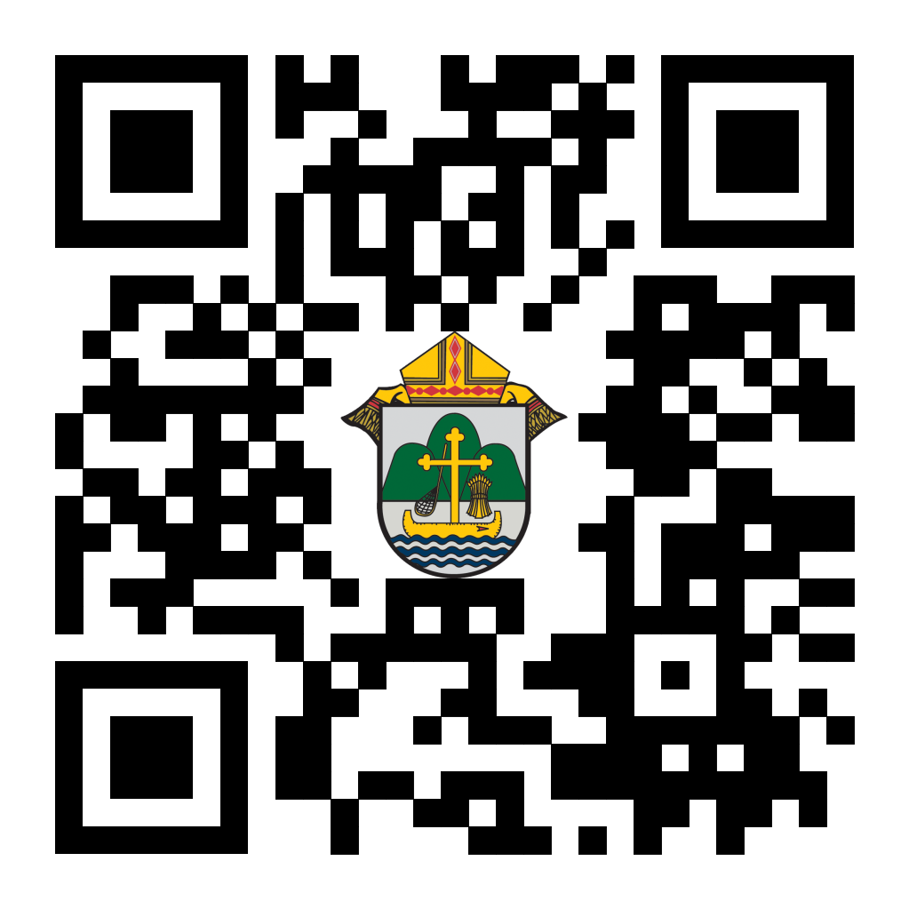
(Reminder) For Your Parish Bulletin:
Chalice of Mercy is in Ukraine, Needs our Help
Please donate to the Ukrainian relief efforts of Chalice of Mercy if you are able, and pray for the safety of their volunteers on the ground there, who put their lives on the line. Financial assistance is the biggest need at this time. To give, visit chaliceofmercy.org/donate or use your smartphone’s camera to scan the QR code to the right.

(Reminder) For Your Parish Bulletin:
Post-Abortion Healing Ministry in the Diocese of La Crosse
Do you know someone who is carrying the grief and sorrow of past abortions? Project Rachel Ministry offers a compassionate heart and confidential help. Call 608.860.6698 or email projectrachel@diolc.org.

<<Top >>

Director: Jeff Reiter – 608.791.2653 | jreiter@diolc.org
Diocesan Annual Appeal
Ecclesiastes 4:12: "Where one alone may be overcome, two together can resist. A three-ply cord is not easily broken."
This year’s theme will focus on the power of triune relationships; God, Church, and oneself. Back in May, the Surgeon General declared loneliness as an epidemic in this country. (https://www.hhs.gov/about/news/2023/05/03/new-surgeon-general-advisory-raises-alarm-about-devastating-impact-epidemic-loneliness-isolation-united-states.html).
The Church and her communities and ministries are the perfect antidote to this epidemic and ECC 4:12 underscores the importance of strength through unity, emphasizing the importance of bringing together in faith and community.
Weekly Stewardship quotes (shorter bulletin reflections)
- July - September
https://diolc.org/wp-content/uploads/2023/07/July-Sept-Stewardship-Quotes.pdf
- October - December
https://diolc.org/wp-content/uploads/2023/09/Stewardship-Bulletin-Reflections-Oct-Dec-2023.pdf
- Spanish Version
https://diolc.org/wp-content/uploads/2023/09/Stewardship-Bulletin-Reflections-Oct-Dec-2023-Spanish.pdf
Weekly Stewardship Prayers of the Faithful
- July - September
https://diolc.org/wp-content/uploads/2023/07/July-Sept-Weekly-Prayers-of-the-Faithful.pdf
- October - December
https://diolc.org/wp-content/uploads/2023/09/Prayers-of-the-Faithful-Oct-Dec-2023.pdf
- Spanish Version
https://diolc.org/wp-content/uploads/2023/09/Prayers-of-the-Faithful-Oct-Dec-2023-Spanish.pdf
Stewardship Bulletin Reflections for Weekends:
- 09/10
https://diolc.org/wp-content/uploads/2023/08/09.10.23-stewardship-bulletin-announcements.pdf
- 09/17
https://diolc.org/wp-content/uploads/2023/08/09.17.23-stewardship-bulletin-announcements.pdf
- 09/24
https://diolc.org/wp-content/uploads/2023/08/09.24.23-stewardship-bulletin-announcements.pdf
- 10/01
https://diolc.org/wp-content/uploads/2023/09/10.01.23-stewardship-bulletin-announcements.pdf
Stewardship Homily Reflections:
Stewardship reflections for your homily development:
- For Weeks 09/03 - 10/01/23:
https://diolc.org/wp-content/uploads/2023/09/Homily-Guide-09.05.23.pdf
Update: Planned Giving – Leaving a Legacy, Wills, Bequest and Endowments:
We have inherited such treasures from our parents, grandparents and great-grandparents, those whose shoulders we stand on today. Now it is our turn to ensure future generations can enjoy the reverence and beauty of a well-maintained parish. Leveraging the Capital Campaign and providing parishioners with information on Endowments, Trusts and Bequests are just a few ways a parish can help prepare for its future.
Our Estate Planning Guide can help people save several hundred dollars in legal and financial estate planning costs. We have sent out several hundred copies per individual request, and each Parish has received a copy. Do not hesitate to contact our office if you want additional copies.
Our Planned Giving website is diolclegacy.org. People can find calculators, additional information, sign up for a newsletter and request copies of specific estate planning guides and information.
Just Added: Instructions on how to do an IRA Rollover, the creation of Donor Advised Funds (DAF), Beneficiary Designations and Stock Transfers. https://diolclegacy.org/?pageID=5
If you would like more legacy-giving information, presentations or ads for your Parish bulletin, please do not hesitate to contact our office or the Catholic Foundation of West Central Wisconsin (cfwcw.org) at 608.519.9892 or email: eboos@cfwcw.org.

<<Top >>

Diocesan Finance Officer: James Reider – 608.791.2668 | jreider@diolc.org

No items this week.

<<Top >>

Director of Vocation Recruitment: Fr. Nate Kuhn – 608.791.2666 | nkuhn@diolc.org

Vocations Intercessions
Please include the following intercession for vocations for your Sunday prayers of the faithful.
That our parish community will nurture marriage, blessed single lives, and religious vocations through their lives of prayer and service, giving witness to God's loving action in the world.
Consider adding a vocations paragraph to your parish bulletin. Below is an example – they will be changed each week. Feel free to use any or all of them.
A Call to Serve
There are few things in life that are more uplifting than being able to help someone or be there for someone in need. When we can use our gifts and talents to make someone else’s life better, it can bring joy to not just our lives, but to those we are able to serve as well. Jesus tells us that there is no greater love than to lay down one’s life for one’s friend. As friends of Christ, we are called to love in this way, to be willing to lay down our life for others. A powerful way to do this is by being a priest of Jesus Christ. He is calling young men to consider this call to serve, to offer their lives out of love for their sisters and brothers. He may be calling YOU! If you or someone you know is interested in discovering more about this call to the priesthood, please contact me at: Fr. Nate Kuhn, Director of Vocational Recruitment for the Diocese of La Crosse, 3710 East Ave. S. PO Box 4004, La Crosse, WI 54602; or by phone at: 608.791.2667. God bless you!

<<Top >>

Director: Very Rev. Woodrow H. Pace – 608.791.2689 | wpace@diolc.org

Fall Ministry Days
Please log into the website to register for Fall Ministry Days using this link: https://diolc.org/vicarforclergy/.

Evenings of Reflection
Please register for these sessions by emailing rorth@diolc.org.

La Crosse (Shrine) - 1st Thursdays
September 7, 2023
October 5, 2023
November 2, 2023
December 7, 2023
January 4, 2024
February 1, 2024
March 7, 2024
April 4, 2024
May 2, 2024

Mosinee - 2nd Thursdays
September 14, 2023
October 12, 2023
November 9, 2023
December 14, 2023
January 11, 2024
February 8, 2024
March 14, 2024
April 11, 2024
May 9, 2024

Durand - 3rd Tuesdays
September 19, 2023
November 14, 2023
December 19, 2023
January 16, 2024
February 13, 2024
March 19, 2024
April 16, 2024
May 14, 2024

<<Top >>

Director: Christopher Rogers – 608.791.2659 | crogers@diolc.org

No items this week.

<<Top >>

Diocese of La Crosse | 3710 East Ave S | La Crosse, WI 54601 | 608-788-7700
To unsubscribe from this e-mail message contact mwilson@diolc.org

