Chancery Bulletin - Vol. 8, No. 10.2 | October 10, 2023

- Catechesis & Evangelization  - Chancery  - Communications  - Consecrated Life  - Diaconate  - Marriage & Family Life  - Ministries  - Mission Office  - Sacred Worship | - Safe Environment  - Schools Office  - Social Concerns  - Stewardship and Development  - Temporalities  - Vocations  - Vicar for Clergy  - Youth and Young Adult Ministry  - Past Chancery Bulletins
No items this week.

<<Top >>

Chancellor Very Rev. William Dhein – 608.791.2655 | wdhein@diolc.org

No items this week.

<<Top >>

As of Oct. 10

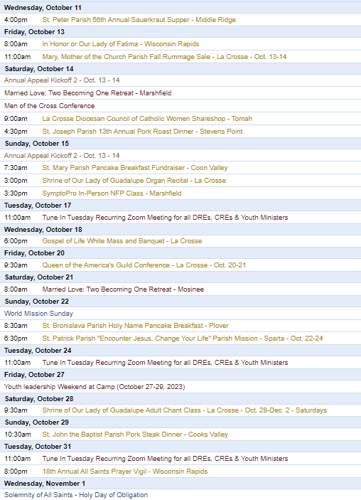

To get your parish events listed on the diocesan calendar, diolc.org/calendar, and in Catholic Life magazine, please send an email to datebook@diolc.org. Make sure you include the following details: date, beginning/ending times, event location, description, menu and cost, etc. If you have any questions, please call Pam Willer at 608.788.1524 for more information.

<<Top >>

Director: Ann Lankford – 608.791.2658 | alankford@diolc.org
For your Parish Bulletin:
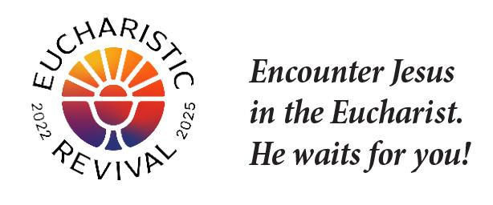
The Eucharsitic Revival, a movement organized by the U.S. Bishops, is to help all Catholics know and believe that the Eucharist is Jesus.
A Minute with Jesus:
God created me out of love.
God will never stop loving me. Our Heavenly Father speaks these words to me in the Bible: “My steadfast (unwavering, always ongoing) love shall not depart from you” (Isaiah 54:10). God proved His love for me in this way: “God so loved the world that He gave His only Son, so that whoever believes in Him may not die but may have eternal life” (John 3:16). God’s boundless love includes Jesus establishing one Church and instituting seven Sacraments so that we may be united with Him. The closest union we can have with Jesus on earth is receiving the Eucharist – His own Body and Blood.
- Let’s pray this right now and every day this week: Heavenly Father, help me to know how much You truly love me.
- This week, read how nothing can separate us from the love of Jesus Christ, except our own choice to reject His love in Romans 8:35, 37-38.
For a list of weekly proclamations on the Eucharist, click here: diolc.org/eucharist/learn.
For your Parish Bulletin:
October is the Month of the Rosary
October is designated by the Catholic Church as the "Month of the Rosary" because in this month the Church celebrates the Marian feast of "Our Lady of the Rosary" on Oct. 7. The feast of Our Lady of the Rosary, also celebrated as Our Lady of Victory, was established by Pope St. Pius V in 1571 to celebrate the miraculous victory of the Christian forces in the Battle of Lepanto on Oct. 7 of that year. The Christians were vastly outnumbered by the Turkish fleet of the Ottoman Empire who were seeking to destroy Christianity. Previous to the decisive battle, St. Pius V had ordered the churches of Rome opened for prayer day and night, encouraging the faithful to petition the intercession of the Blessed Virgin Mary through the recitation of the Rosary, along with all Western Christians. Thus the pope attributed the victory to the power of the Rosary rather than the power of ships and cannons.
In praying the Rosary, we think about one great saving event in the life of Jesus while we pray a decade: one Our Father, ten Hail Mary’s and a Glory Be. While we meditate on a mystery of Jesus’ life, we come to know Him better and find that the events of Jesus’ life provide guidance in dealing with the challenges that we face. Further, we will find greater peace in our lives by praying a Rosary, or just a decade, each day.
A downloadable Prayer Card on the Rosary is available at the link for families to pray together, and catechists/teachers to use in the classroom. (see 4th Grade but can be used for any grade): diolc.org/prayer and for adults at this link: diolc.org/deeper. The simple prayer process is meant to make prayer more personal. The two-sentence reflection about each mystery connects the aspects of Jesus’ life to our daily lives.
Catechetical Leader Information:
October - the month of the Rosary
See information above
October is dedicated to Respect Life
For compelling Respect Life resources to be used in Catholic schools and parishes, for the various grade levels,click here: diolc.org/catechesis/catechist-training-resources-for-teaching/pro-life-teaching-resources
New Catholics serving in the parish
Adults who entered the Catholic Church at Easter are most welcome to assist a catechist, help with the OCIA process or take part in other parish activities. New Catholics however, should not be invited to take on a leadership role, such as being a catechist etc. as they need time to “settle in” for at least a year by growing in their understanding of Church teaching, deepening their prayer life and becoming part of the parish community.
The Eucharistic Revival - a brief reflection:
The following concise, inspiring explanation of the reality of Jesus’ true presence in the Eucharist is provided for your communication with parents, as well as for catechists to provide a concise, key point on the Eucharist each week with the children/youth.
A Minute with Jesus:
“God is love.”
It’s so important to remember that God is not just loving but He is LOVE itself. Our Heavenly Father reveals – shows us – that He is love and that He desires to share His love by creating us. He created each one of us out of love. Our Heavenly Father only wants to love us. We are able to recognize His love in that Our Father sent His only Son to give Himself to us in the Eucharist and to give His life for us on the Cross.
Let’s pray this right now and every day this week: Heavenly Father, thank you for Your love for me.
This week, read how St. John the Evangelist explains how we know that God is love: “Beloved, let us love one another, for love is from God, and whoever loves has been born of God and knows God. Anyone who does not love does not know God, because God is love. In this the love of God was made manifest among us, that God sent his only Son into the world, so that we might live through him. In this is love, not that we have loved God but that He loved us and sent His Son to be the propitiation for our sins. Beloved, if God so loved us, we also ought to love one another. No one has ever seen God; if we love one another, God abides in us and his love is perfected in us” (1 John 4: 7-12).
Click here for further entries: diolc.org/catechesis/catechetical-leaders-info
<<Top >>
Director: Erik Archer– 608.791.2661 | earcher@diolc.org
Catholic Social Media (CSM) - Email Erik to Schedule Your Onboarding:
As Bishop Cozzens said, “Social media is important because this is where many encounter our Faith.” CSM is a software program that allows Danelle, our creative manager, to create and share social media content (feast day material, liturgical events, graphics from curia offices (vocations, catechesis and evangelization, Bishop Callahan videos, etc) to your computer every day. We do the legwork on our end to create the content and parish secretaries simply log on, see a menu of content to choose from, select as much or as little as they want, and then schedule the content for the week. The software makes all this happen and links to each parish’s social media account.
This is a powerful tool that allows parishes to spend less time on social media and use that time to engage in other ministries. Demo: https://vimeo.com/catholicsocialmedia/parish-demo?share=copy
Social media is important because this is where many encounter our Faith. Nic Prenger’s team will “white-glove” onboard parishes and we need 10-15 parishes to volunteer to learn this capability. Wave 1 Parish Training is tomorrow. The capability will be subsequently rolled out across the diocese to interested parishes in phases. Learn more at: https://prengersolutions.com/products/catholic-social-media/for-parishes/.
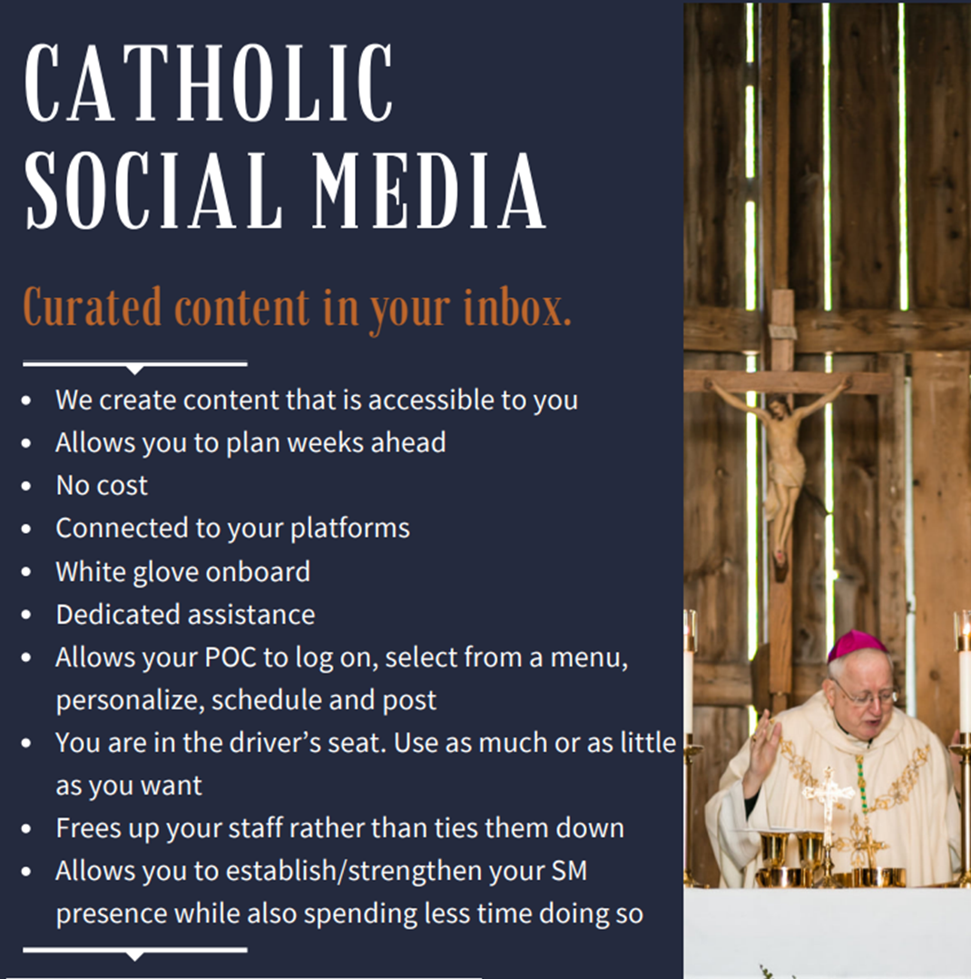
Please call or email me with any questions – I am excited for this opportunity and will visit your parish/pastor in person as needed to help share the benefits. This allows us at the diocese to serve parishes in their mission of reaching parishioners. We will shoulder the financial burden and provide content that is true, good and beautiful. Parishes will simply need to log on, click buttons and their social media will be vibrant with content.
Listing Your Parish Events In The Jan/Feb 2024 Issue Of Catholic Life:
If your parish has events for inclusion in the Jan/Feb issue of Catholic Life, please submit them by Oct. 16. To get your parish events listed on diolc.org/calendar, and in Catholic Life magazine, please send an email to datebook@diolc.org. Please include the following details: date, beginning/ending times, event location, description, dinner menu and cost, etc. If you have any questions, please call Pam Willer at 608.788.1524.
<<Top >>

Director: Sr. Donna Krzmarzick, ISSM – 608.791.2690 | dkrzmarzick@diolc.org

No items this week.

<<Top >>

Director: Deacon Robert Riedl – 608.791.2665 | rriedl@diolclergy.org

(Reminder) Deacon Days with the Bishop: (Attendance is Expected)
- 2024 – Aug. 10
- 2025 – Aug. 9
- 2026 – Aug. 8

(Reminder) Fall Ministry Days:
Please log into the website to register for Fall Ministry Days using this link: https://diolc.org/vicarforclergy/

<<Top >>

Director: Christopher Rogers – 608.791.2659 | crogers@diolc.org

No items this week.

<<Top >>

Director: Christopher Ruff – 608.791.0161 | cruff@diolc.org

No items this week.

<<Top >>

Director: Fr. Woodrow Pace – 608.791.2676 | wpace@diolc.org
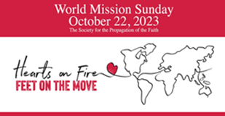
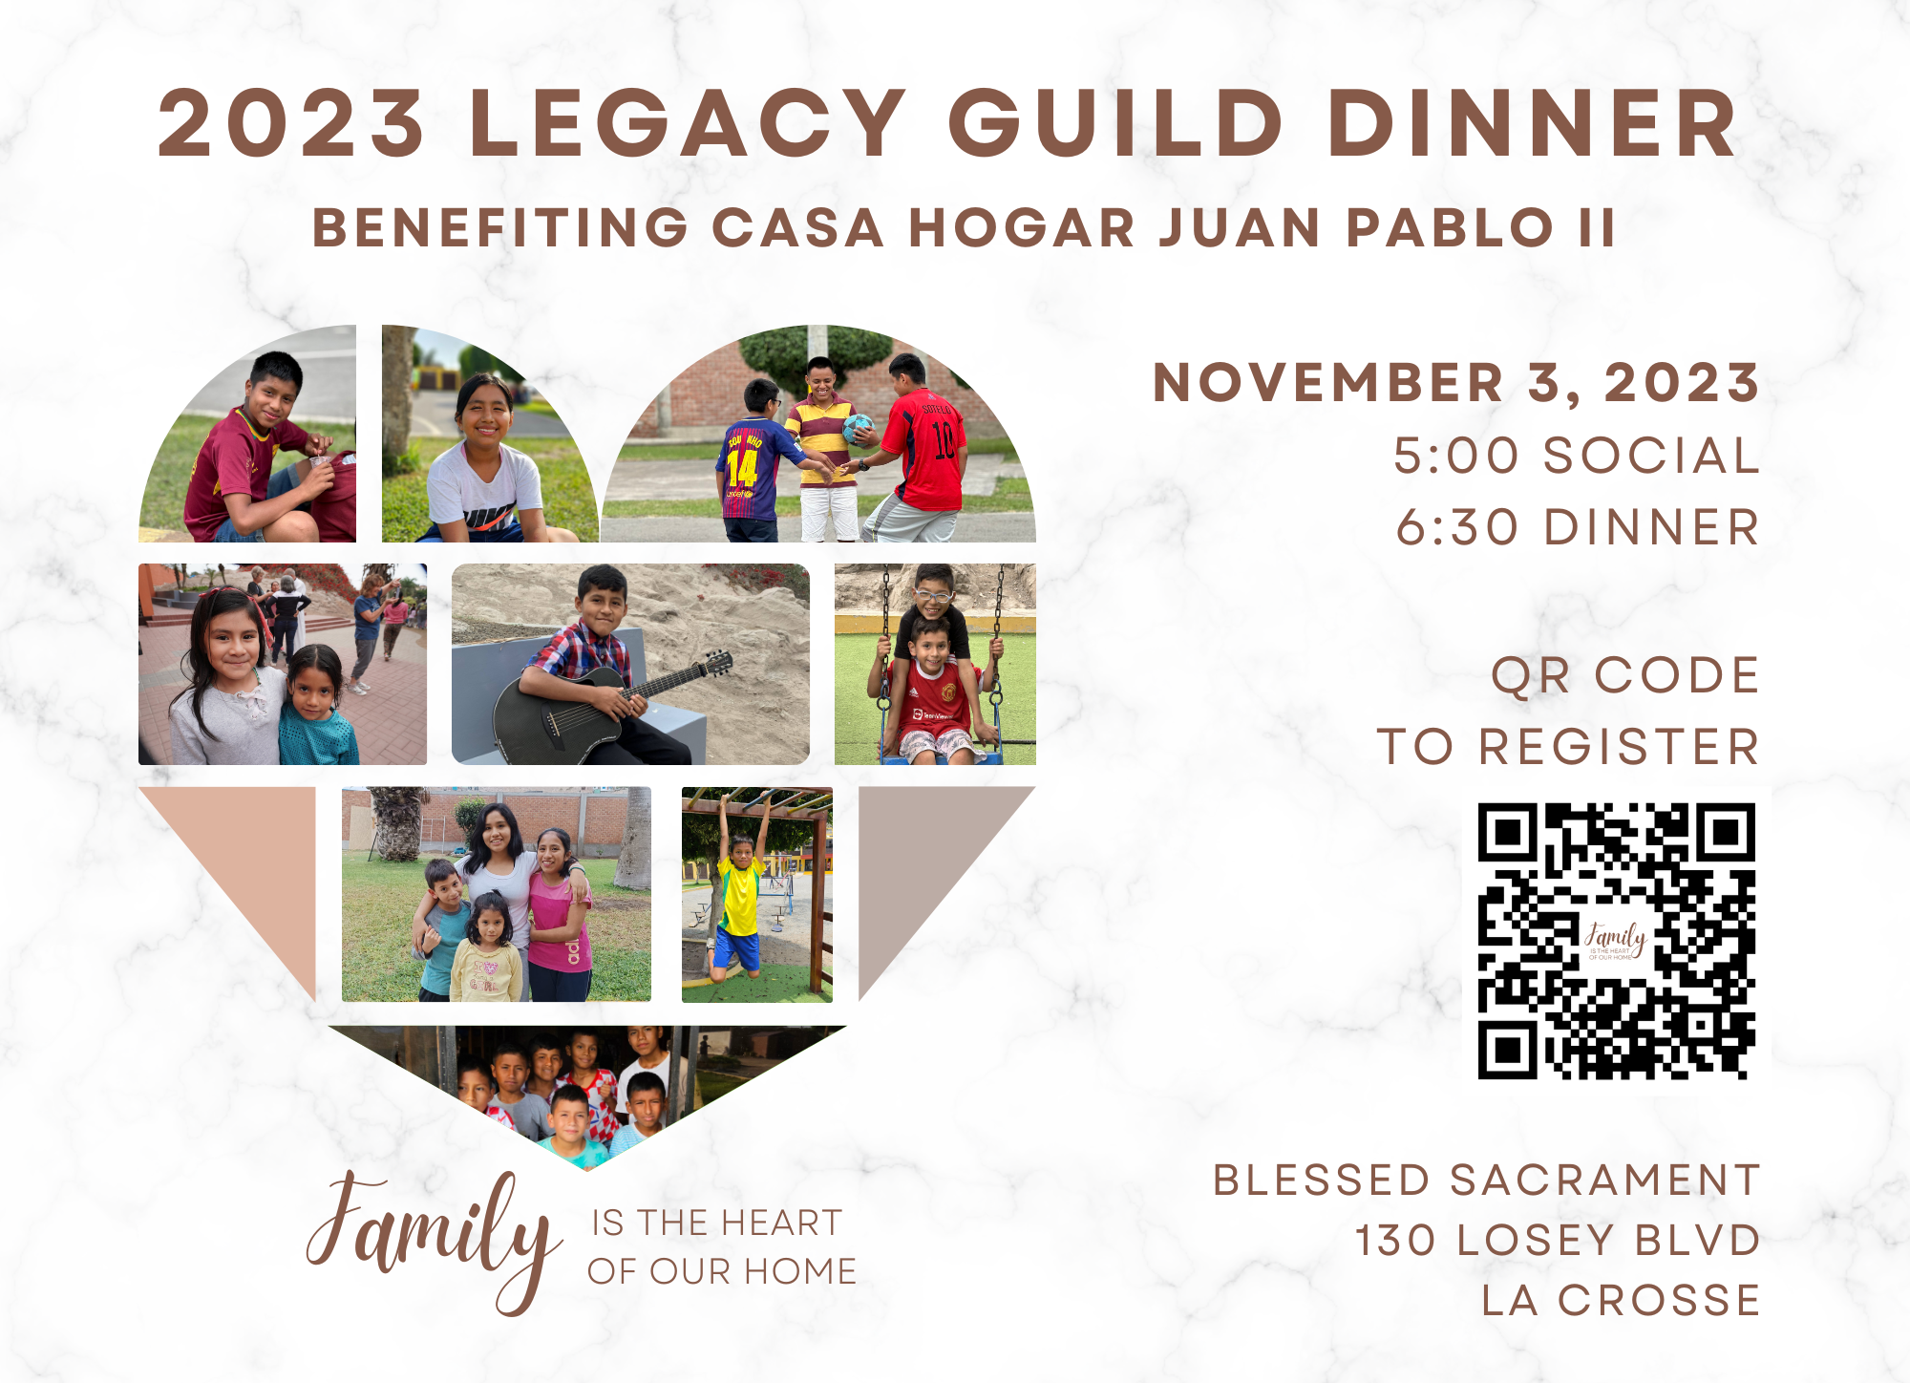
WORLD MISSION SUNDAY, Oct. 21-22, 2023: The annual Sunday worship, prayer and collection for WORLD MISSION SUNDAY (always the penultimate Sunday of October and not to be confused with summer Mission Coop Program) is coming soon. Letters with directions should have arrived at your parishes from the Mission Office, along with posters and envelopes sent directly from the national office of the Society for the Propagation of the Faith. Although envelopes may direct otherwise, please have parishioners submit donations and make checks payable to their local parishes; parishes then submit totals to the Mission Office along with a Parishsoft WMS report. Further information including Bulletin Announcements (week before, week of, and week after WMS, General Intercessions, Homily Helps, and the Message of the Holy Father for WMS 2023 can be found on our World Mission Sunday website. General information regarding Mission work supported by parishes can be found on the Mission Office website. Please contact the Mission Office with any questions. May God answer your prayers and reward your sacrifices with His peace.
2023 Legacy Guild Dinner benefiting Casa Hogar Juan Pablo II |Nov 3 (5 p.m.- 8 p.m.)
Blessed Sacrament Church, La Crosse, WI
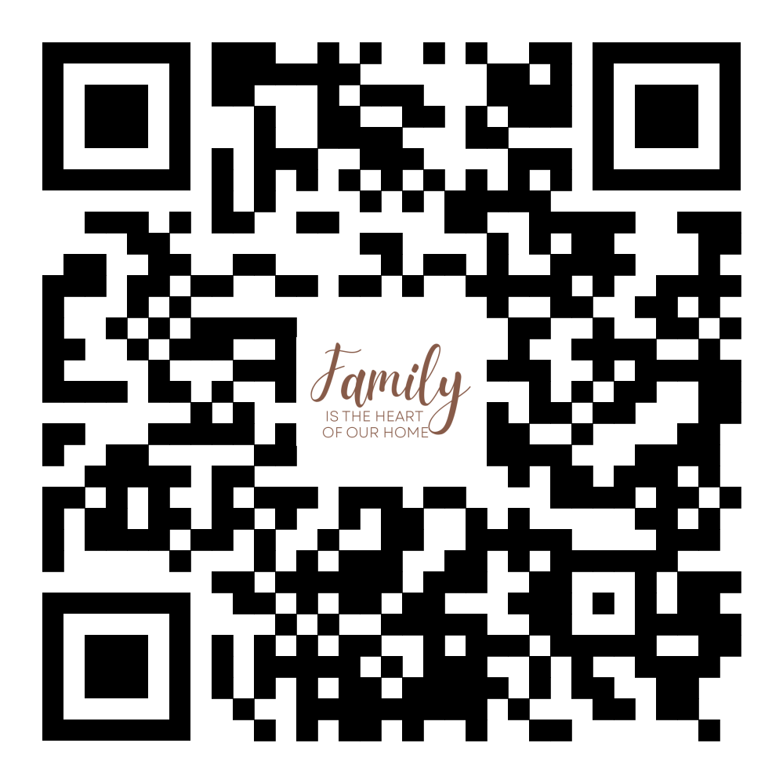
Please join us for the Casa Hogar Juan Pablo II annual benefit dinner. The night will begin with a social at 5 p.m., dinner at 6:30 p.m.; following Msgr. Joseph Hirsch will share an update on what has been going on at Casa Hogar this year. Please use QR code to register or go to www.homeajpm.org/events. Bulletin Editors please share the graphic to the right.

<<Top >>

Director: Christopher Carstens – 608.791.0161 | ccarstens@diolc.org

No items this week.

<<Top >>

Director: Teresa Brown – 608.791.2679 | tbrown@diolc.org

DIOCESE OF LA CROSSE GUIDELINES FOR REPORTING INSTANCES OF CHILD ABUSE
The Diocese of La Crosse, through its policies and procedures, seeks to provide a prompt, appropriate and compassionate response to reporters of sexual abuse of a child by any diocesan agent (bishop, priest, deacon, employee, religious, vendor or volunteer). Anyone wishing to make a report of an allegation of sexual abuse should send that report to Mrs. Teresa Brown, Complaint Intake Agent, at the Diocese of La Crosse, P.O. Box 4004, La Crosse, WI 54602-4004. Alternatively, you can contact Mrs. Brown at 608.791.0179 or intakeagent@diolc.org. The reporting form is available through the Diocese of La Crosse Office of Safe Environment or on the diocesan website at: diolc.org/safe-environment/reporting. Individuals are also encouraged to take their reports directly to civil authorities. Copies of the diocesan policy are available through your local Parish and on the diocesan website. If you have any questions about the Diocese of La Crosse and the implementation of the Charter for the Protection of Children and Young People, please contact Teresa Brown, Diocese of La Crosse, at 608.791.2679 or tbrown@diolc.org.

<<Top >>

Superintendent: Thomas Reichenbacher – 608.788.7707 | treichenbacher@diolc.org

No items this week.

<<Top >>

Director: Christopher Ruff – 608.791.0161 | cruff@diolc.org

For La Crosse Area Parish Bulletins:
Please Get Involved - 40 Days for Life Vigil Campaign, Sept. 27-Nov. 5
The fall campaign to end abortion is underway, through Nov. 5, on the sidewalk outside Planned Parenthood, 1201 Caledonia in La Crosse. Please give one hour a week to pray and silently bear witness to life, anytime between 7 a.m. and 7 p.m. Sign up at 40daysforlife.com/en/ or scan the QR code to the right. Call Marie Allen for more information or signs: 608.784.5189.
For Your Parish Bulletin:
(Reminder) October is Respect Life Month
Many parish resources from the USCCB for October, Respect Life Month, are available at www.respectlife.org. Also visit the Diocesan website, www.diolc.org/respect-life, for information on Pregnancy Resource Centers, Post-Abortion Healing, and much more.
(Reminder) For Your Parish Bulletin:
Pregnant and in distress? Confidential help is available.
Make a confidential call to Catholic Charities at 844.644.7223 (844.64.GRACE) or text 715.600.6391. To learn more, visit cclse.org/i-think-im-pregnant, or scan the QR code to the right. For additional pregnancy support resources and locations, visit diolc.org/pregnancy-resources.
For Your Parish Bulletin:
Post-Abortion Healing Retreats - Rachel’s Vineyard - Encounter God’s Mercy
Rachel's Vineyard is a weekend retreat to help anyone who has struggled with the aftermath of abortion to begin healing through a supportive, trauma-sensitive approach. Each weekend is run by a team of trained volunteers (counselor, priest, and lay people), who care deeply for your needs. Many team members have suffered the same loss. It is understood that your loss may be something you have never shared with another person, even those who are closest to you. All interactions with the Rachel's Vineyard retreat team are completely confidential. These retreats will be offered in the Diocese of Madison on Nov. 10-12, 2023, March 15-17, 2024, and Nov. 8-10 2024. For more information, visit madisondiocese.org/rachel or scan the QR code on the right.
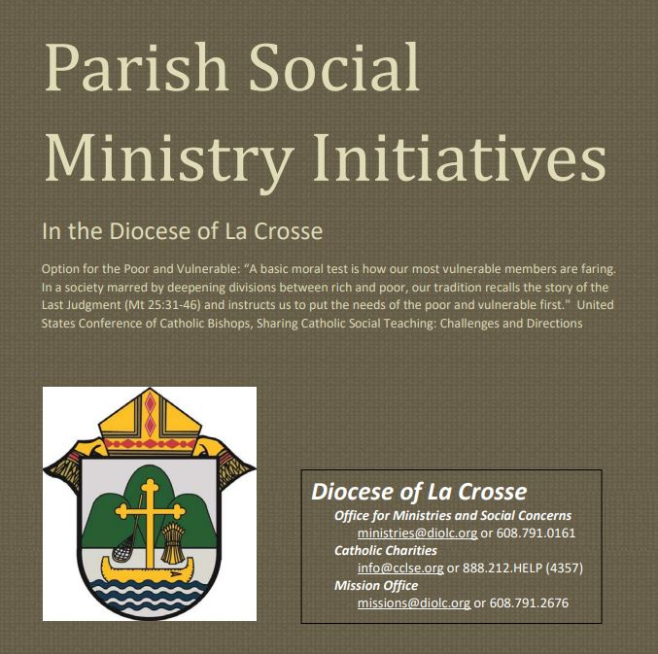
Pastors, Deacons, Parish Social Concerns Representatives:
Are Your Social Ministry Initiatives listed in the Directory?
In order to address most fruitfully the social concerns within our diocese, we are asking the parishes of the diocese to review their current social ministry initiatives (any outreach of charity or social advocacy). If these are not already listed in the diocesan Directory of Parish Social Ministry Initiatives, or if updating is needed, the pastor or someone authorized by him is asked to take a moment to complete and submit this form for each organization/resource.

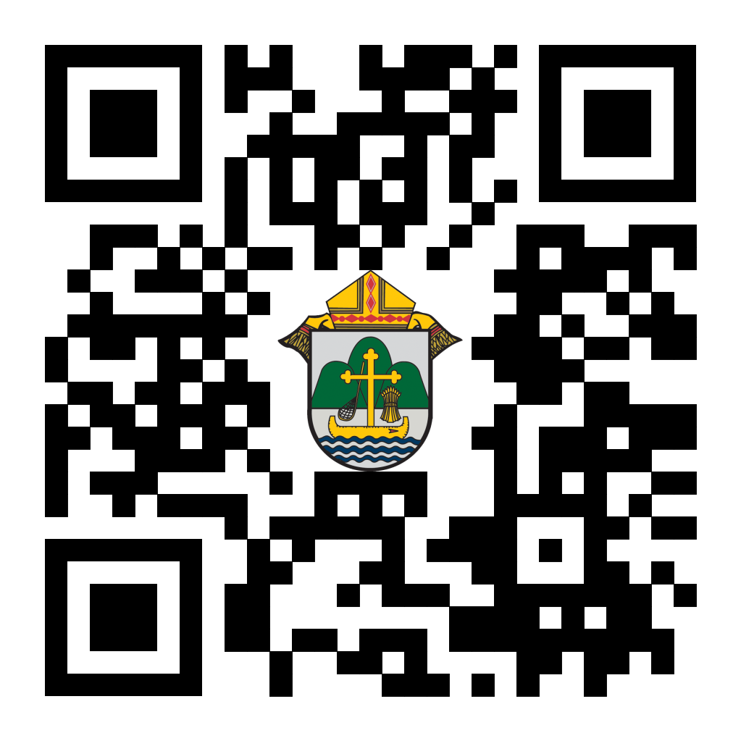
(Reminder) For Your Parish Bulletin:
Chalice of Mercy is in Ukraine, Needs Our Help
Please donate to the Ukrainian relief efforts of Chalice of Mercy if you are able, and pray for the safety of their volunteers on the ground there, who put their lives on the line. Financial assistance is the biggest need at this time. To give, visit chaliceofmercy.org/donate or use your smartphone’s camera to scan the QR code to the right.
For Your Parish Bulletin:
See Important State and Federal Action Alerts from our Bishops:
Visit wisconsincatholic.org/advocacy-network/ or scan the QR code to the right to learn how to make your voice heard on both the state and federal levels, regarding Respect Life, Hunger, and other vital issues..

<<Top >>

Director: Jeff Reiter – 608.791.2653 | jreiter@diolc.org
Diocesan Annual Appeal:
If you have not signed up to let us know when you plan to announce the Diocesan Annual Appeal at your parish, please complete the form at https://forms.gle/sWxXCPNARTGatTiD7
Parish materials will arrive this week, and the website and appeal portal will be updated.
Inspired By The Spirit and Diocesan Annual Appeal:
We have become aware that parishes are again making and using copies of the pledge form. These are parish-specific, and for our electronic banking and gift-scanning process, the pledge form must meet particular specifications to size and QR location to be more efficient, helping keep costs down and ensuring the correct parish and supporter is getting credit for that gift.
If you need more pledge forms, please contact Sarah Komperudskomperud@diolc.org; we will order more. Please allow 14 days for delivery.
Weekly Stewardship quotes (shorter bulletin reflections):
October-December
https://diolc.org/wp-content/uploads/2023/09/Stewardship-Bulletin-Reflections-Oct-Dec-2023.pdf
- Spanish Version
https://diolc.org/wp-content/uploads/2023/09/Stewardship-Bulletin-Reflections-Oct-Dec-2023-Spanish.pdf
Weekly Stewardship Prayers of the Faithful:
October-December
https://diolc.org/wp-content/uploads/2023/09/Prayers-of-the-Faithful-Oct-Dec-2023.pdf
- Spanish Version
https://diolc.org/wp-content/uploads/2023/09/Prayers-of-the-Faithful-Oct-Dec-2023-Spanish.pdf
Stewardship Bulletin Reflections for Weekends:
- 10/15
https://diolc.org/wp-content/uploads/2023/09/10.15.23-stewardship-bulletin-announcements.pdf
- 10/22
https://diolc.org/wp-content/uploads/2023/09/10.22.23-stewardship-bulletin-announcements.pdf
- 10/29
https://diolc.org/wp-content/uploads/2023/09/10.29.23-stewardship-bulletin-announcements.pdf
- 11/05
https://diolc.org/wp-content/uploads/2023/10/11.05.23-stewardship-bulletin-announcements.pdf
- 11/12
https://diolc.org/wp-content/uploads/2023/10/11.12.23-stewardship-bulletin-announcements.pdf

Stewardship Homily Reflections:
Stewardship reflections for your homily development:
- For Weeks 10/15 - 11/12/23:
https://diolc.org/wp-content/uploads/2023/10/Homily-Guide-10.10.23-1.pdf
Planned Giving – Leaving a Legacy, Wills, Bequest and Endowments:
We have inherited such treasures from our parents, grandparents and great-grandparents, those whose shoulders we stand on today. Now it is our turn to ensure future generations can enjoy the reverence and beauty of a well-maintained parish. Leveraging the Capital Campaign and providing parishioners with information on Endowments, Trusts and Bequests are just a few ways a parish can help prepare for its future.
Our Estate Planning Guide can help people save several hundred dollars in legal and financial estate planning costs. We have sent out several hundred copies per individual request, and each Parish has received a copy. Do not hesitate to contact our office if you want additional copies.
Our Planned Giving website is diolclegacy.org. People can find calculators and additional information, sign up for a newsletter and request copies of specific estate planning guides and information.
Our website includes instructions on how to do an IRA Rollover, the creation of Donor Advised Funds (DAF), Beneficiary Designations and Stock Transfers. https://diolclegacy.org/?pageID=5
If you would like more legacy-giving information, presentations or ads for your Parish bulletin, please do not hesitate to contact our office or the Catholic Foundation of West Central Wisconsin (cfwcw.org) at 608.519.9892 or email: eboos@cfwcw.org.

<<Top >>

Diocesan Finance Officer: James Reider – 608.791.2668 | jreider@diolc.org

Catholic Mutual Group - Risk Management Minutes:
With winter approaching, freezing temperatures are inevitable. Special consideration for risks such as frozen pipes is needed. On average 1 in 62 properties suffer a loss related to frozen pipes each year. Parishes and schools are no exception to this statistic. In fact, last year parishes and schools within the Diocese of La Crosse incurred $175,000 in losses related to frozen pipes alone. These are troubling statistics which can be avoided by learning how pipes freeze, taking preventative action, and investing in some tools. Please review the Risk Management Minutes on Protecting Your Property from Freeze Damage and Water and Temperature Sensors.

<<Top >>

Director of Vocation Recruitment: Fr. Nate Kuhn – 608.791.2666 | nkuhn@diolc.org

New Seminarian posters and prayer books are here:
Please remember to pick them up when you are at the Fall Ministry Conference!

Vocations Intercessions:
Please include the following intercession for vocations for your Sunday prayers of the faithful.
That families will strive to make their homes places where children can hear God call them by name.
Consider adding a vocations paragraph to your parish bulletin. Below is an example – they will be changed each week. Feel free to use any or all of them.
Have you asked someone recently?
Do you know someone in your life that you think would make a good priest? Have you ever told them that? If not, you should! A significant, contributing factor to young men discerning the priesthood has been the invitation and encouragement they receive from others, particularly parents, teachers, mentors and role models. Don’t be afraid to tell a young man that they would make a good priest, as that may be just what they have been waiting for. Once you encourage them, don’t hesitate to put them in contact with me to continue that conversation. I can be reached at: Fr. Nate Kuhn, Director of Vocational Recruitment for the Diocese of La Crosse, 3710 East Ave. S. PO Box 4004, La Crosse, WI 54602; or by phone at: 608.791.2667. God bless you!
<<Top >>

Director: Very Rev. Woodrow H. Pace – 608.791.2689 | wpace@diolc.org
Fall Ministry Days:
Please log into the website to register for Fall Ministry Days using this link: https://diolc.org/vicarforclergy/
Evenings of Reflection
Please register for these sessions by emailing rorth@diolc.org.
La Crosse (Shrine) – 1st Thursdays
Nov. 2, 2023
Dec. 7, 2023
Jan. 4, 2024
Feb. 1, 2024
Mar. 7, 2024
Apr. 4, 2024
May 2, 2024
Mosinee – 2nd Thursdays
Oct. 12, 2023
Nov. 9, 2023
Dec. 14, 2023
Jan. 11, 2024
Feb. 8, 2024
Mar. 14, 2024
Apr. 11, 2024
May 9, 2024
Durand – 3rd Tuesdays
Nov. 14, 2023 – MONDOVI
Dec. 19, 2023
Jan. 16, 2024
Feb. 13, 2024
Mar. 19, 2024
Apr. 16, 2024
May 14, 2024
<<Top >>

Director: Christopher Rogers – 608.791.2659 | crogers@diolc.org

No items this week.

<<Top >>

Diocese of La Crosse | 3710 East Ave S | La Crosse, WI 54601 | 608-788-7700
To unsubscribe from this e-mail message contact mwilson@diolc.org

