Chancery Bulletin - Vol. 8, No. 10.3 | October 17, 2023

- Catechesis & Evangelization  - Chancery  - Communications  - Consecrated Life  - Diaconate  - Marriage & Family Life  - Ministries  - Mission Office  - Sacred Worship | - Safe Environment  - Schools Office  - Social Concerns  - Stewardship and Development  - Temporalities  - Vocations  - Vicar for Clergy  - Youth and Young Adult Ministry  - Past Chancery Bulletins
No items this week.

<<Top >>

Chancellor Very Rev. William Dhein – 608.791.2655 | wdhein@diolc.org

No items this week.

<<Top >>

As of Oct. 17

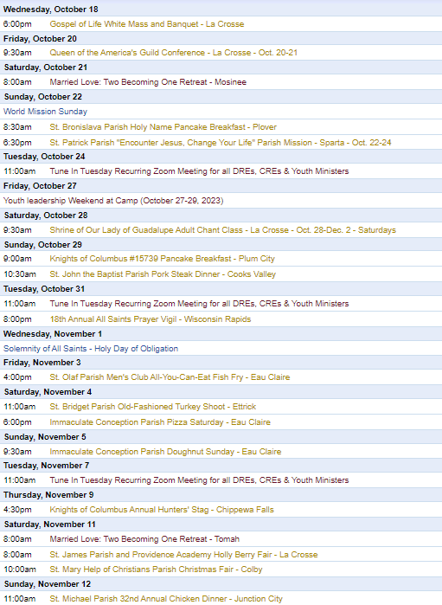
To get your parish events listed on the diocesan calendar, diolc.org/calendar, and in Catholic Life magazine, please send an email to datebook@diolc.org. Make sure you include the following details: date, beginning/ending times, event location, description, menu and cost, etc. If you have any questions, please call Pam Willer at 608.788.1524 for more information.

<<Top >>

Director: Ann Lankford – 608.791.2658 | alankford@diolc.org
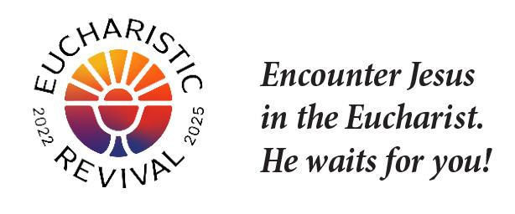
For your Parish Bulletin:
As Catholics, we want to grow in our understanding that the Eucharist is Jesus. This is the focus of the three-year Eucharistic Revival.
God gave you a soul that will live forever.
God created you with a body and a soul. Your soul allows you to think and choose. Your soul gives you the power to choose what is right and good, most importantly to choose to love God and be faithful to Him. We choose to receive God’s love when we receive Jesus in Holy Communion at Mass.
Let’s pray this right now and every day this week: Heavenly Father, help me always to choose to love and be faithful to You.
For a list of additional proclamations on the Eucharist, click here: diolc.org/eucharist/learn.
Bulletin Insert:
A bulletin insert entitled the “Joy of Encountering Jesus in the Eucharist” is available here: diolc.org/eucharist/learn. This resource is excellent for a brief prayer and discussion before parish meetings and parent gatherings.
For your Parish Bulletin:
The Rosary is a powerful Prayer
In praying the Rosary, we think about one great saving event in the life of Jesus while we pray a decade: one Our Father, ten Hail Mary’s and a Glory Be. While we meditate on a mystery of Jesus’ life, we come to know Him better and find that the events of Jesus’ life guide us in dealing with the challenges we face. Further, we will find greater peace by praying a Rosary, or just a decade, each day.
A downloadable Prayer Card on the Rosary is available at the link for families to pray together and catechists/teachers to use in the classroom. (See 4th grade, but can be used for any grade.): diolc.org/prayer and for adults at this link: diolc.org/deeper. The simple format is meant to make prayer more personal. The two-sentence reflection about each mystery connects the aspects of Jesus’ life to our daily lives.
Catechetical Leader Information:
The Eucharistic Revival – a brief proclamation for parents and students:
Please see the brief reflection for the Eucharistic Revival in the section above entitled God gave you a soul that will live forever. The concise, inspiring explanation of the reality of Jesus’ true presence in the Eucharist is provided for your communication with parents and catechists to provide a key point on the Eucharist each week with the children/youth.
Click here for additional entries: diolc.org/catechesis/catechetical-leaders-info
Ministry for Persons with Special Needs:
If children attend the Parish Faith Formation Program or Catholic School with special needs, please get in touch with Ann Lankford about receiving assistance from our long-term consultant, Diane Hietpas. Diane has extensive experience and will travel for meetings with catechists and parents and provide training and suggested resources. Fees are covered through donations from some Knights of Columbus Councils and the Diocesan Council of Catholic Women.
<<Top >>

Director: Erik Archer– 608.791.2661 | earcher@diolc.org

Fall 2023 Parish Roundtables:
Please accept our deepest gratitude for setting aside time to gather with your fellow secretaries and our little team. I am especially grateful to the hosts for their hospitality – thank you.

We very much enjoyed hearing all the “best thing that happened to me in the past week” thoughts. From having a well installed to a shed removed, from a baby saying her first word (“mom”) to a husband’s 85th birthday – the fabric of our faith stories is beautiful.

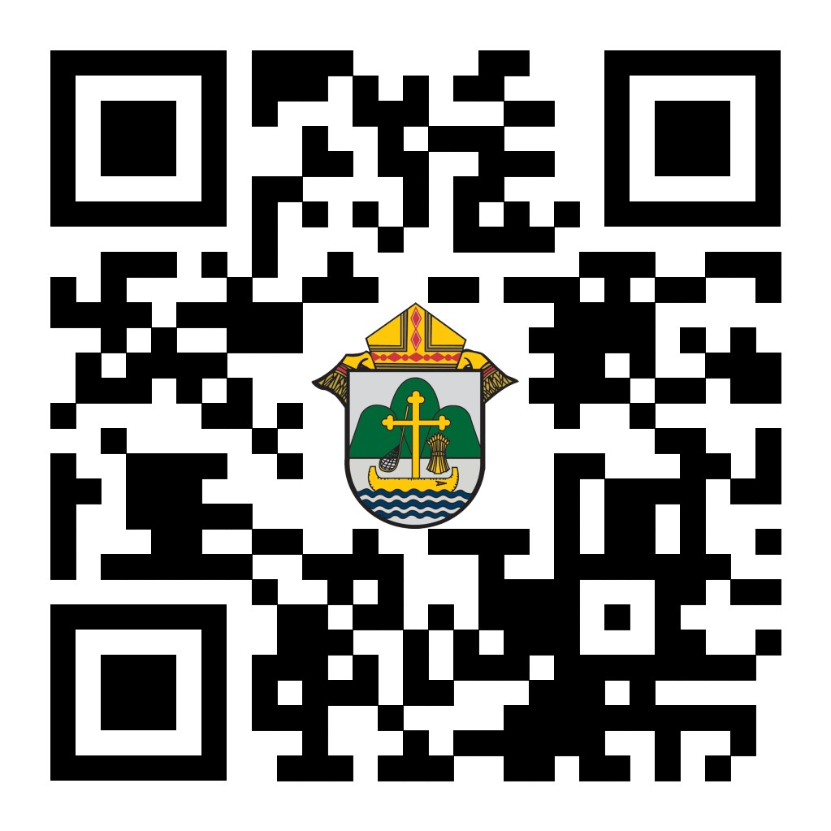
I shared your enthusiasm for Catholic Social Media (CSM) and Flocknote with Bishop Callahan at our huddle this morning – we look forward to organizing our team and efforts to support you and your parish’s engagements with parishioners and the community as a whole. Please be on the lookout for a note from Mitch Fisher. He is CSM’s Director of Customer Experience and is our personal guide to onboarding with them.

We value your thoughts and use your feedback to continually improve the roundtable. Please take a moment to fill out the short survey located at the QR code to the right or the following link: https://forms.office.com/r/A4MQ36DM7G

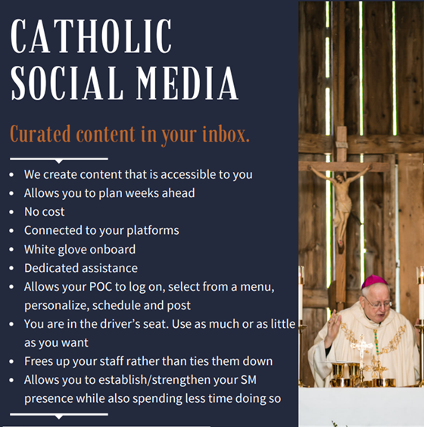
Catholic Social Media (CSM) - Email Erik to Schedule Your Onboarding:
As Bishop Cozzens said, “Social media is important because this is where many encounter our Faith.” CSM is a software program that allows Danelle, our creative manager, to create and share social media content (feast day material, liturgical events, graphics from curia offices (vocations, catechesis and evangelization, Bishop Callahan videos, etc) to your computer every day. We do the legwork on our end to create the content and parish secretaries simply log on, see a menu of content to choose from, select as much or as little as they want, and then schedule the content for the week. The software makes all this happen and links to each parish’s social media account.
This is a powerful tool that allows parishes to spend less time on social media and use that time to engage in other ministries. Demo: https://vimeo.com/catholicsocialmedia/parish-demo?share=copy
Social media is important because this is where many encounter our Faith. Nic Prenger’s team will “white-glove” onboard parishes and we need 10-15 parishes to volunteer to learn this capability. Wave 1 Parish Training is tomorrow. The capability will be subsequently rolled out across the diocese to interested parishes in phases. Learn more at: https://prengersolutions.com/products/catholic-social-media/for-parishes/.
Please call or email me with any questions – I am excited for this opportunity and will visit your parish/pastor in person as needed to help share the benefits. This allows us at the diocese to serve parishes in their mission of reaching parishioners. We will shoulder the financial burden and provide content that is true, good and beautiful. Parishes will simply need to log on, click buttons and their social media will be vibrant with content.
<<Top >>

Director: Sr. Donna Krzmarzick, ISSM – 608.791.2690 | dkrzmarzick@diolc.org

No items this week.

<<Top >>

Director: Deacon Robert Riedl – 608.791.2665 | rriedl@diolclergy.org

No items this week.

<<Top >>

Director: Christopher Rogers – 608.791.2659 | crogers@diolc.org

“the Answer” Eucharistic Rally
We are very excited to announce “the Answer” Eucharistic Rally that will be held on June 7, 2024 at the La Crosse Center in La Crosse, WI. This event kicks off the six days that the Marian Route of the National Eucharistic Pilgrimage will be in the Diocese of La Crosse. “the Answer” Eucharistic Rally will begin with a Eucharistic Procession across the Cameron Street Bridge in La Crosse and will end at the La Crosse Center where the rest of the rally will take place. The day will include Mass, Adoration, Confession, powerful speakers such as Chris Stefanick, Immaculee Ilibagize, and Josh Rosa, music from Luke Spehar, and plenty of vendors. The cost for this event is only $15 per person. This rally is for youth, young adults, adults, families, etc. Tickets will go on sale Dec. 15, 2023. You can find more information about the event and the other days the Marian Route will be in our diocese by visiting: https://diolc.org/the-answer/.

(Reminder) Natural Family Planning
For Priests, Deacons and Parish staff:
USCCB Free Resources to Download
Diocese of La Crosse NFP Brochure (use diolc.org email for access)

NFP classes are offered to interested couples by the Marriage and Family Life Office. To
inquire about diocesan classes, go to diolc.org/nfp or email ckitzhaber@diolc.org. Read
more regarding NFP on the USCCB website at www.usccb.org/prolife/issues/nfp.

(Reminder) Marriage Enrichment and Parenting Resources:
For your marriage website: foryourmarriage.org/ or use your smartphone’s camera to scan the QR code to the right. This website from the USCCB helps couples at all stages of life to understand and live God’s plan for happy, holy marriages.

(Reminder) Teaching the Way of Love:
Please visit twl4parents.com/ or use your smartphone’s camera to scan the QR code to the right. This website is full of encouragement and tips for parents to continue to be the primary educators of their children.

(Reminder) Diocesan Website for Clergy and Marriage Ministers Regarding Marriage Preparation:
Use this link: diolc.org/marriage/marriage-preparation/marriage-preparation-for-ministers/ to go directly to the section of our website containing resources for clergy and marriage ministers. There are step-by-step instructions, downloadable guidelines, downloadable forms and much more! Please let us know if we can assist you in this ministry.

(Reminder) Process for Training FOCCUS Facilitators:
The process for training FOCCUS facilitators is as follows: Each parish needs to contact FOCCUS directly to set up an account for your parish, if one has not already been set up, then train your couples directly through FOCCUS. The contact person at FOCCUS is Max Allen. He is happy to work directly with your parish priest or contact person. His contact information is mrallen@foccusinc.com or phone: 402.827.3735, ext. 1317.

<<Top >>

Director: Christopher Ruff – 608.791.0161 | cruff@diolc.org

No items this week.

<<Top >>

Director: Fr. Woodrow Pace – 608.791.2676 | wpace@diolc.org
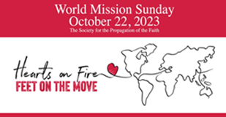
THIS WEEKEND!
WORLD MISSION SUNDAY, Oct. 21-22, 2023:
The annual Sunday worship, prayer and collection for WORLD MISSION SUNDAY (always the penultimate Sunday of October and not to be confused with summer Mission Coop Program) is this weekend! Letters with directions should have arrived at your parishes from the Mission Office, along with posters and envelopes sent directly from the national office of the Society for the Propagation of the Faith. Although envelopes may direct otherwise, please have parishioners submit donations and make checks payable to their local parishes; parishes then submit totals to the Mission Office along with a Parishsoft WMS report. Further information, including Bulletin Announcements (week before, week of, and week after WMS, General Intercessions, Homily Helps, and the Message of the Holy Father for WMS 2023 can be found on our World Mission Sunday website. General information regarding Mission work supported by parishes can be found on the Mission Office website. Please contact the Mission Office with any questions. May God answer your prayers and reward your sacrifices with His peace.
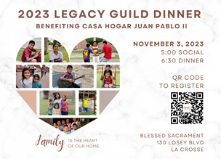
2023 Legacy Guild Dinner benefiting Casa Hogar Juan Pablo II |Nov 3 (5 p.m.- 8 p.m.)
Blessed Sacrament Church, La Crosse, WI:
Please join us for the Casa Hogar Juan Pablo II annual benefit dinner. The night will begin with a social at 5 p.m. and then dinner at 6:30 p.m. After dinner, Monsignor Joseph Hirsch will share an update on what has happened at Casa Hogar this year. Please use the QR code to register or go to www.homeajpm.org/events. Bulletin Editors please share the graphic to the right.
<<Top >>

Director: Christopher Carstens – 608.791.0161 | ccarstens@diolc.org
Christmas Mass Schedule:
This year's Fourth Sunday of Advent falls on Dec. 24. Masses during the day will celebrate the Fourth Sunday of Advent, while Masses on Sunday evening will observe the Vigil for Christmas. Catholics are to attend Mass twice for these two occasions.
One week later, Sunday, Dec. 31, will celebrate the Feast of the Holy Family during the morning, while Sunday evening Masses can observe either the Feast of the Holy Family or the Solemnity of Mary, Mother of God; either Mass will fulfill the faithful's Sunday obligation. Monday, Jan. 1, is not a Holy Day of obligation in 2024.
<<Top >>

Director: Teresa Brown – 608.791.2679 | tbrown@diolc.org

DIOCESE OF LA CROSSE GUIDELINES FOR REPORTING INSTANCES OF CHILD ABUSE:
The Diocese of La Crosse, through its policies and procedures, seeks to provide a prompt, appropriate and compassionate response to reporters of sexual abuse of a child by any diocesan agent (bishop, priest, deacon, employee, religious, vendor or volunteer). Anyone wishing to make a report of an allegation of sexual abuse should send that report to Mrs. Teresa Brown, Complaint Intake Agent, at the Diocese of La Crosse, P.O. Box 4004, La Crosse, WI 54602-4004. Alternatively, you can contact Mrs. Brown at 608.791.0179 or intakeagent@diolc.org. The reporting form is available through the Diocese of La Crosse Office of Safe Environment or on the diocesan website at: diolc.org/safe-environment/reporting. Individuals are also encouraged to take their reports directly to civil authorities. Copies of the diocesan policy are available through your local Parish and on the diocesan website. If you have any questions about the Diocese of La Crosse and the implementation of the Charter for the Protection of Children and Young People, please contact Teresa Brown, Diocese of La Crosse, at 608.791.2679 or tbrown@diolc.org.

<<Top >>

Superintendent: Thomas Reichenbacher – 608.788.7707 | treichenbacher@diolc.org

No items this week.

<<Top >>

Director: Christopher Ruff – 608.791.0161 | cruff@diolc.org

TODAY - Day of Prayer and Fasting for Peace in the Holy Land – Oct. 17:
Cardinal Pierbattista Pizzaball, the Latin Patriarch of Jerusalem, has called for Tuesday, Oct. 17, to be a day of prayer and fasting for peace in the Middle East. The U.S. Bishops have reposted his statement, urging all Catholics and Christians to join in this spiritual effort to overcome evil and violence. But the Cardinal Patriarch went even further, offering himself in exchange for the hostages being held by the Hamas terrorist group. Please offer at least a decade of the Rosary today, fasting, or some other sacrifice. Continue to pray the Rosary daily, asking the intercession of Our Lady, Queen of Palestine, whose feast day falls on the last Sunday of October (Oct. 29). For an inspiring video showing how she is revered in the Holy Land click here, or scan the QR code on the right.

For Your Parish Bulletin:
Donate to Help the Victims of Violence in the Holy Land
Catholic Relief Services, in conjunction with Caritas partners, are working to meet the desperate humanitarian needs caused by the terrorism and fighting in the Holy Land. To learn how you can help, visit www.crs.org or scan the QR code to the right.

For La Crosse Area Parish Bulletins:
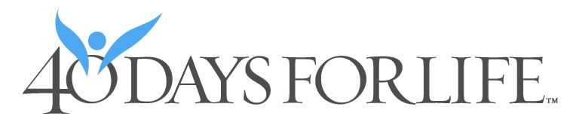
Please Get Involved – 40 Days for Life Vigil Campaign, Sept. 27-Nov. 5
The fall campaign to end abortion is underway, through Nov. 5, on the sidewalk outside Planned Parenthood, 1201 CaledoniaSt. in La Crosse. Please give one hour a week to pray and silently bear witness to life, anytime between 7 a.m. and 7 p.m. Sign up at 40daysforlife.com/en/ or scan the QR code to the right. Call Marie Allen for more information or signs: 608.784.5189.
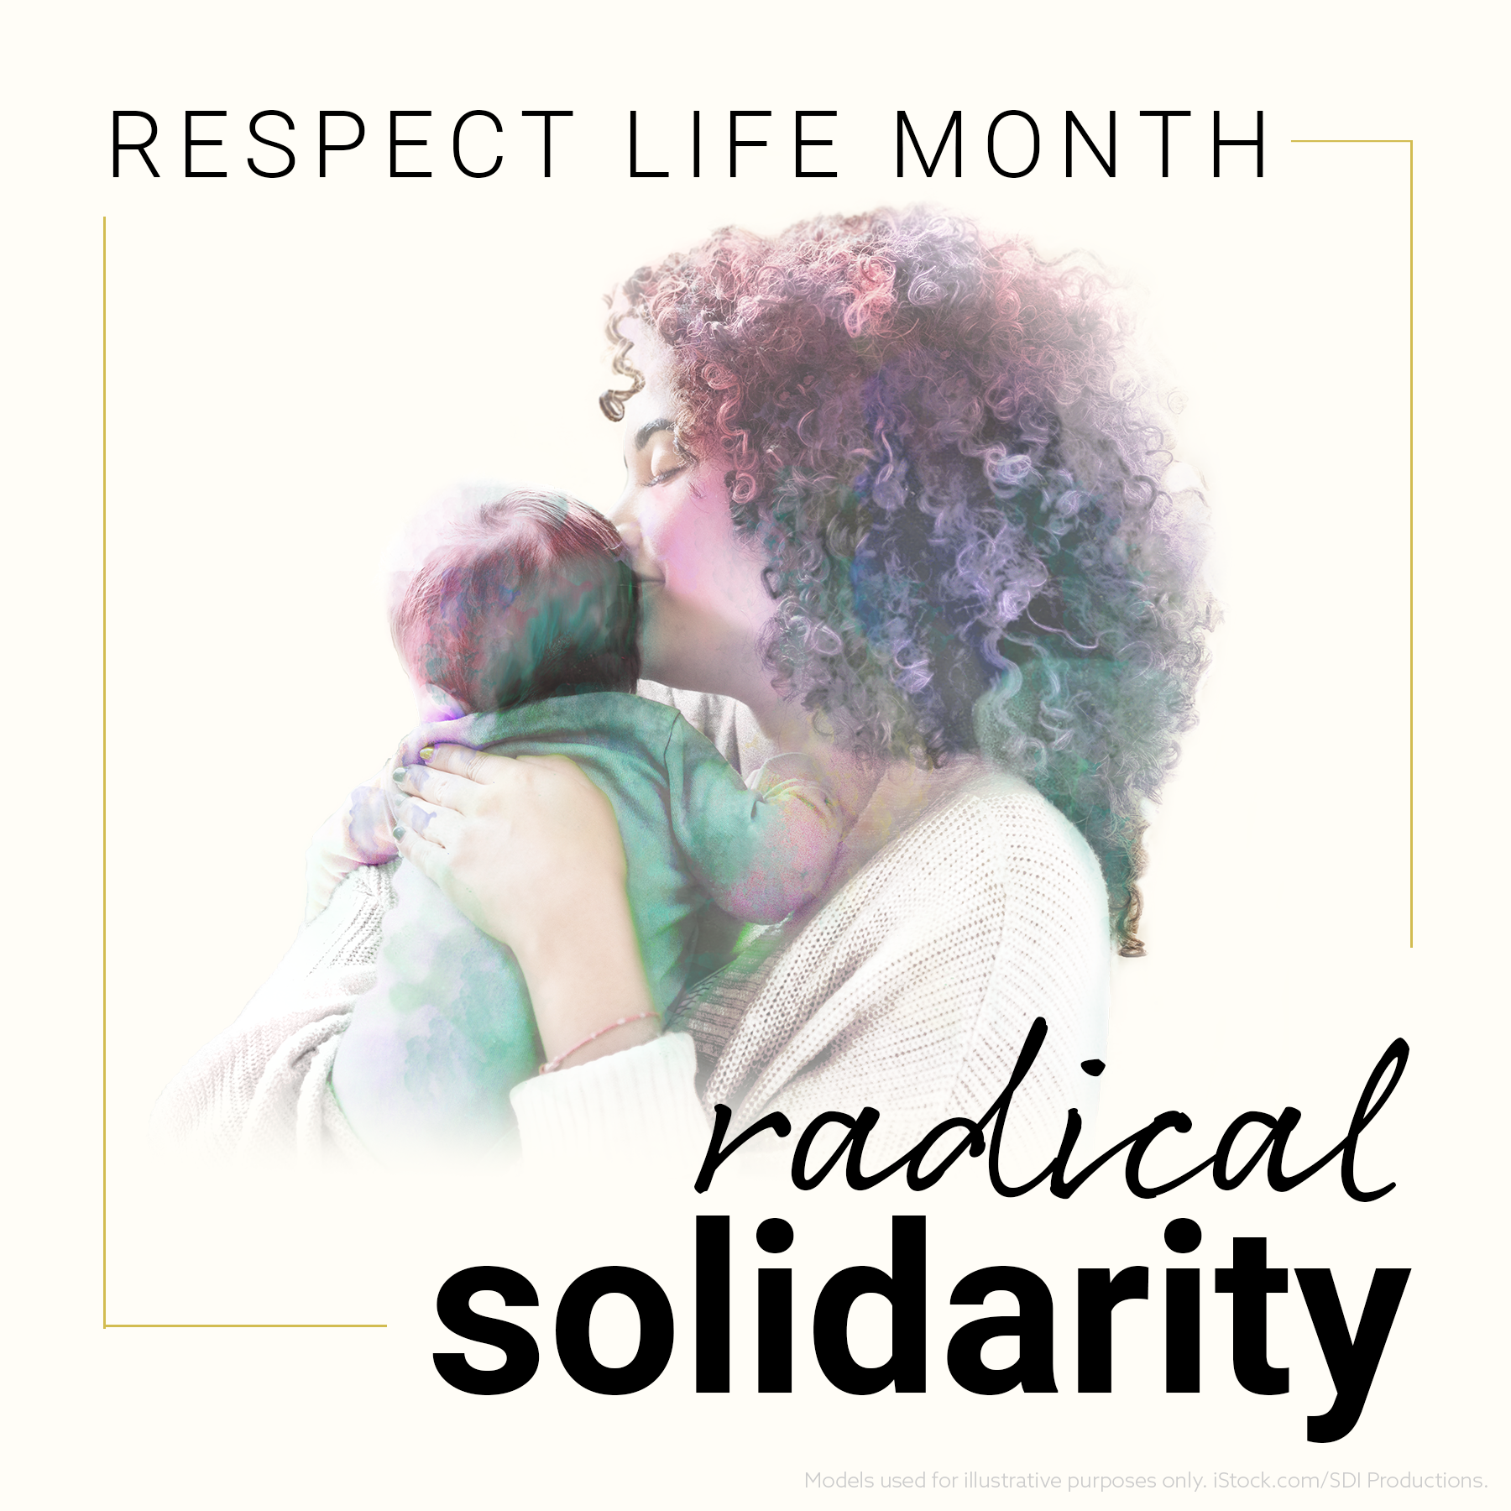
For Your Parish Bulletin:
(Reminder) October is Respect Life Month
Many parish resources from the USCCB for October, Respect Life Month, are available at www.respectlife.org. Also visit the Diocesan website, www.diolc.org/respect-life, for information on Pregnancy Resource Centers, Post-Abortion Healing, and much more.

(Reminder) For Your Parish Bulletin:
Post-Abortion Healing Ministry in the Diocese of La Crosse
Do you know someone who is carrying the grief and sorrow of past abortions? Project Rachel Ministry offers a compassionate heart and confidential help. Call 608.860.6698 or email projectrachel@diolc.org.
For Your Parish Bulletin:
Post-Abortion Healing Retreats - Rachel’s Vineyard - Encounter God’s Mercy
Rachel's Vineyard is a weekend retreat to help anyone who has struggled with the aftermath of abortion to begin healing through a supportive, trauma-sensitive approach. Each weekend is run by a team of trained volunteers (counselor, priest, and lay people), who care deeply for your needs. All interactions with the Rachel's Vineyard retreat team are completely confidential. These retreats will be offered in the Diocese of Madison on Nov. 10-12, 2023, March 15-17, 2024, and Nov. 8-10 2024. For more information, visit madisondiocese.org/rachel or scan the QR code on the right.
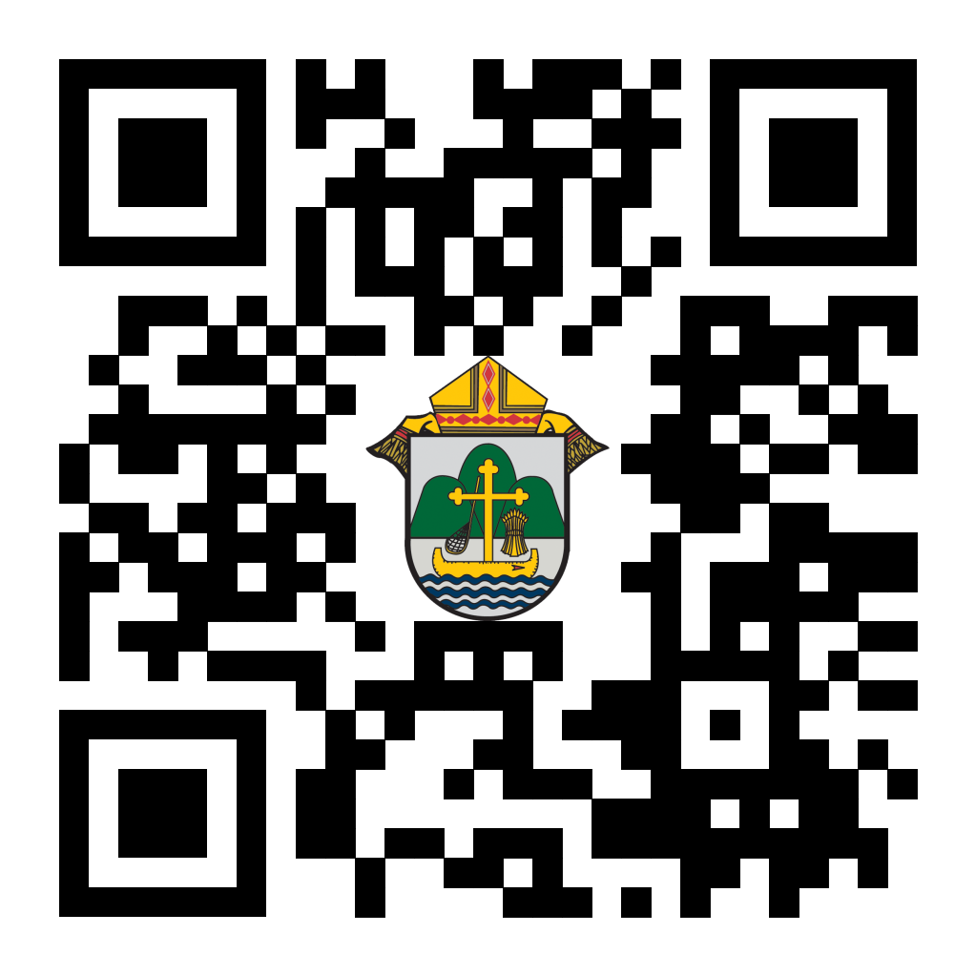
(Reminder) For Your Parish Bulletin:
Chalice of Mercy is in Ukraine, Needs Our Help
Please donate to the Ukrainian relief efforts of Chalice of Mercy if you are able, and pray for the safety of their volunteers on the ground there, who put their lives on the line. Financial assistance is the biggest need at this time. To give, visit chaliceofmercy.org/donate or use your smartphone’s camera to scan the QR code to the right.

For Your Parish Bulletin:
See Important State and Federal Action Alerts from our Bishops:
Visit wisconsincatholic.org/advocacy-network/ or scan the QR code to the right to learn how to make your voice heard on both the state and federal levels, regarding Respect Life, Hunger, and other vital issues.

<<Top >>

Director: Jeff Reiter – 608.791.2653 | jreiter@diolc.org
Diocesan Annual Appeal:
If you have not signed up to let us know when you plan to announce the Diocesan Annual Appeal at your parish, please complete the form at https://forms.gle/sWxXCPNARTGatTiD7
Parish materials will arrive this week, and the website and appeal portal will be updated.
Parishes that fail to sign up by Nov 15, 2023will have their parishioners automatically mailed for the first weekend in December 12/2-3/2023
Inspired By The Spirit and Diocesan Annual Appeal:
We have become aware that parishes are again making and using copies of the pledge form. These are parish-specific, and for our electronic banking and gift-scanning process, the pledge form must meet particular specifications to size and QR location to be more efficient, helping keep costs down and ensuring the correct parish and supporter is getting credit for that gift.
If you need more pledge forms, please contact Sarah Komperudskomperud@diolc.org; we will order more. Please allow 14 days for delivery.
Magisterium AI:
Are you looking for help with a homily, have a specific pastoral question, or are just curious about Catholic Stewardship? You might find the solution on a new Artificial Intelligence (AI) website dedicated to over 6,111 Catholic Church documents. The website provides references to each document cited in the search results. Whether looking for information on the Eucharist, Canon Law, or Catholic Stewardship, this free website can generate results in seconds. Though it's still in Beta form, like any AI site, it will continue to grow and improve with user inquiries. Like all Language Learning Models (LLM), these AI sites are just the beginning and should be reviewed carefully.
https://www.magisterium.com/
Weekly Stewardship quotes (shorter bulletin reflections):
October-December
https://diolc.org/wp-content/uploads/2023/09/Stewardship-Bulletin-Reflections-Oct-Dec-2023.pdf
- Spanish Version
https://diolc.org/wp-content/uploads/2023/09/Stewardship-Bulletin-Reflections-Oct-Dec-2023-Spanish.pdf
Weekly Stewardship Prayers of the Faithful:
October-December
https://diolc.org/wp-content/uploads/2023/09/Prayers-of-the-Faithful-Oct-Dec-2023.pdf
- Spanish Version
https://diolc.org/wp-content/uploads/2023/09/Prayers-of-the-Faithful-Oct-Dec-2023-Spanish.pdf
Stewardship Bulletin Reflections for Weekends:
- 10/22
https://diolc.org/wp-content/uploads/2023/09/10.22.23-stewardship-bulletin-announcements.pdf
- 10/29
https://diolc.org/wp-content/uploads/2023/09/10.29.23-stewardship-bulletin-announcements.pdf
- 11/05
https://diolc.org/wp-content/uploads/2023/10/11.05.23-stewardship-bulletin-announcements.pdf
- 11/12
https://diolc.org/wp-content/uploads/2023/10/11.12.23-stewardship-bulletin-announcements.pdf
Stewardship Homily Reflections:
Stewardship reflections for your homily development:
- For Weeks 10/22 - 11/12/23:
https://diolc.org/wp-content/uploads/2023/10/Homily-Guide-10.17.23.pdf
Planned Giving – Leaving a Legacy, Wills, Bequest, and Endowments:
We have been entrusted with precious treasures passed down from our ancestors, and it's our responsibility to ensure that future generations can also enjoy the splendor and reverence of a well-maintained parish. One way to achieve this is by utilizing the Capital Campaign and providing information on Endowments, Trusts, and Bequests to the parishioners.
Our Estate Planning Guide can help save hundreds of dollars in legal and financial estate planning costs. We have mailed out several hundred copies per individual request, and each Parish has received a copy. Please feel free to contact our office for additional copies.
Visit diolclegacy.org, our Planned Giving website, to find calculators, and more information, sign up for a newsletter, and request specific estate planning guides and information. Our website also provides instructions on how to do an IRA Rollover, the creation of Donor Advised Funds (DAF), Beneficiary Designations, and Stock Transfers. https://diolclegacy.org/?pageID=5
If you require more information on legacy giving, presentations, or ads for your Parish bulletin, please contact our office or the Catholic Foundation of West Central Wisconsin (cfwcw.org) at 608.519.9892 or email eboos@cfwcw.org.
<<Top >>

Diocesan Finance Officer: James Reider – 608.791.2668 | jreider@diolc.org

No items this week.

<<Top >>

Director of Vocation Recruitment: Fr. Nate Kuhn – 608.791.2666 | nkuhn@diolc.org

No items this week.

<<Top >>

Director: Very Rev. Woodrow H. Pace – 608.791.2689 | wpace@diolc.org

No items this week.

<<Top >>

Director: Christopher Rogers – 608.791.2659 | crogers@diolc.org

“the Answer” Eucharistic Rally |June 7
The La Crosse Center, La Crosse, WI
We are very excited to announce “the Answer” Eucharistic Rally that will be held on June 7, 2024 at the La Crosse Center in La Crosse, WI. This event kicks off the 6 days that the Marian Route of the National Eucharistic Pilgrimage will be in the Diocese of La Crosse. “the Answer” Eucharistic Rally will begin with a Eucharistic Procession Across the Cameron Street Bridge in La Crosse and will end at the La Crosse Center where the rest of the rally will take place. The day will include Mass, Adoration, Confession, powerful speakers such as Chris Stefanick, Immaculee Ilibagize, and Josh Rosa, music from Luke Spehar, and plenty of vendors. The cost for this event is only $15 per person. This rally is for youth, young adults, adults, families, etc. Tickets will go on sale December 15, 2023. You can find more information about the event and the other days the Marian Route will be in our diocese by visiting: https://diolc.org/the-answer/.

(Reminder) SEALED! Fall Diocesan Confirmation Retreat
The SEALED! Diocesan Confirmation Retreat will be held Dec. 9, 2023, at St. Olaf Catholic Church in Eau Claire, WI. Click this link to register and find out more information: https://diolc.org/yya/youth-opportunities/immersion-retreat/

(Reminder) NCYC (National Catholic Youth Conference) Last Call
If you have a group interested in attending NCYC with us Nov. 16-19, 2023, please contact our office ASAP.

(Reminder) Updated Office for Family Life Calendar of Events Through 2025:
In the Office for Family Life, we are working to keep our event planning at least two years out. We have created a calendar that may help you in planning for the next couple of years. You will see the dates have hyperlinks that allow you to add this event to your Google Calendar. Below each event is a hyperlink to the page on our website with more information, including registration links for that particular event. Please follow this link to get a list of events planned so far: https://drive.google.com/file/d/17YHE2dCa267CYfgCXZVP1hSwjTMNfhY-/view?usp=sharing

<<Top >>

Diocese of La Crosse | 3710 East Ave S | La Crosse, WI 54601 | 608-788-7700
To unsubscribe from this e-mail message contact mwilson@diolc.org

