Chancery Bulletin – Vol. 8, No. 10.4 | October 24, 2023

- Catechesis & Evangelization  - Chancery  - Communications  - Consecrated Life  - Diaconate  - Marriage & Family Life  - Ministries  - Mission Office  - Sacred Worship | - Safe Environment  - Schools Office  - Social Concerns  - Stewardship and Development  - Temporalities  - Vocations  - Vicar for Clergy  - Youth and Young Adult Ministry  - Past Chancery Bulletins
The Most Reverend William Patrick Callahan, D.D., Bishop of La Crosse, makes the following announcement:
The Reverend Antony Joseph, Pastor of Sacred Heart-St. Patrick Parish in Eau Claire, is released from his appointment at the parish and returns to the authority of the Bishop of Sivangangai, effective October 23, 2023.

<<Top >>

Chancellor Very Rev. William Dhein – 608.791.2655 | wdhein@diolc.org

No items this week.

<<Top >>

As of Oct. 24

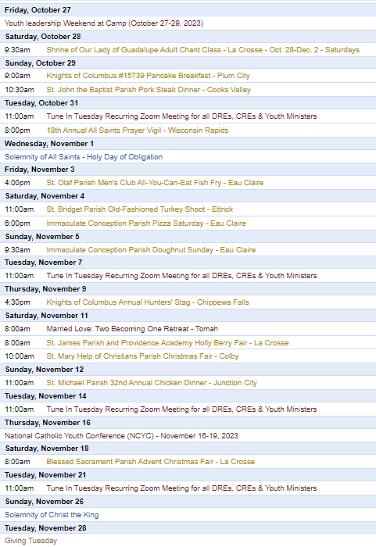
To get your parish events listed on the diocesan calendar, diolc.org/calendar, and in Catholic Life magazine, please send an email to datebook@diolc.org. Make sure you include the following details: date, beginning/ending times, event location, description, menu and cost, etc. If you have any questions, please call Pam Willer at 608.788.1524 for more information.

<<Top >>

Director: Ann Lankford – 608.791.2658 | alankford@diolc.org
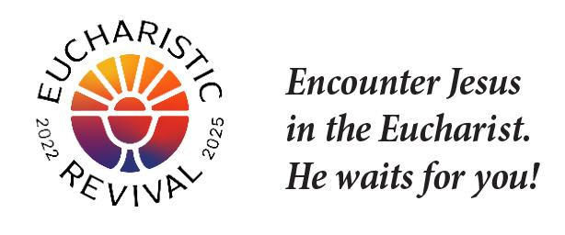
For your Parish Bulletin:
Now is the time for each one of us to grow in our understanding that the Eucharist is Jesus.
God wants you to spend eternity with Him.
Our destiny (goal) is to spend eternity in Heaven with the Blessed Trinity: Father, Son and Holy Spirit. Jesus was willing to die for us so that we may be with Him in Heaven forever. Jesus came on this rescue mission to save His children so that we can spend eternity with Him. Our closest union with Jesus on earth is receiving the Holy Eucharist – Jesus Himself – at Mass.
Let’s pray this right now and every day this week: Jesus, help me to receive Your love. I am so thankful for You, and that You want me to be with You forever.
This week, read how God saved us out of love in John 3:16-17
For a list of additional proclamations on the Eucharist, click here: diolc.org/eucharist/learn.
For your Parish Bulletin:
Courage Apostolate
Everyone is called to chastity. The Courage Apostolate (couragerc.org) is a ministry dedicated to the spiritual needs of persons who experience same-sex attraction and wish to faithfully live the Church's beautiful teachings on human sexuality. A Courage chapter with a trained chaplain is active in our diocese, meeting monthly online. Contact Ann Lankford, the Director of Catechesis and Evangelization for the Diocese of La Crosse, at 608-791-2658 or alankford@diolc.org for details.
For your Parish Bulletin:
Amen App
The Amen app is the free Catholic prayer app that inspires your daily conversation with God through faithful meditations and nourishing Scripture. You are welcome to register for this app from the Augustine Institute by clicking here: www.augustineinstitute.org/program-and-resources/amen
Reminder: Bulletin Insert:
A bulletin insert entitled the “Joy of Encountering Jesus in the Eucharist” is available here: diolc.org/eucharist/learn. This resource is excellent for a brief prayer and discussion before parish meetings and parent gatherings.
Catechetical Leader Information:
Preparation for First Confession
As parents help to prepare their child to receive the Sacrament of Reconciliation, a downloadable prayer card to memorize the Act of Contrition - and to help make it more personal - as well as explanation of the words of the prayer and other resources are available here: diolc.org/prayer See 2nd Grade.
Catechesis of the Good Shepherd is worth checking out
If you are interested in learning more about Catechesis of the Good Shepherd and/or attending a session in your area to see how the children respond, please contact Ann Lankford atalankford@diolc.org. There are currently 15 atria in the Diocese. The fruits are amazing, which provide a foundation for ongoing depth in love for Jesus Christ, the Church and the liturgy! There are possible funds for catechist training.
Focus on the Eucharist – a brief proclamation for parents and students:
Please see above: God wants you to spend eternity with Him. The concise, inspiring explanation of the reality of Jesus’ true presence in the Eucharist is provided for your communication with parents, and catechists to provide a key point on the Eucharist each week.
Click here for additional entries: diolc.org/catechesis/catechetical-leaders-info
Reminder: Ministry for Persons with Special Needs:
If children attend the Parish Faith Formation Program or Catholic School with special needs, please get in touch with Ann Lankford about receiving assistance from our long-term consultant, Diane Hietpas. Diane has extensive experience, with a list of challenges that she may be able to assist the student, teacher and parents found here. Diane will travel for meetings with catechists and parents and provide training and suggested resources. Fees are covered through donations from some Knights of Columbus Councils and the Diocesan Council of Catholic Women. New: The following can be found here: diolc.org/catechesis/catechetical-leaders-info
- A list of challenges that Diane Hietpas may provide assistance with regarding Special Needs
- A document by the U.S. Bishops entitled “Guidelines for the Celebration of the Sacraments with Persons with Special Needs”
<<Top >>

Director: Erik Archer– 608.791.2661 | earcher@diolc.org

No items this week.

<<Top >>

Director: Sr. Donna Krzmarzick, ISSM – 608.791.2690 | dkrzmarzick@diolc.org

No items this week.

<<Top >>

Director: Deacon Robert Riedl – 608.791.2665 | rriedl@diolclergy.org

Watch for a detailed schedule and registration information coming soon!
DEACON FORMATION CONFERENCE – DECEMBER 2-3, 2023
St. Anthony Spirituality Center, Marathon
TOPIC: THE SYNOD ON SYNODALITY

(Please add to your calendars!) Deacon Days with the Bishop:
- 2024 – Aug. 10
- 2025 – Aug. 9
- 2026 – Aug. 8

<<Top >>

Director: Christopher Rogers – 608.791.2659 | crogers@diolc.org

“the Answer” Eucharistic Rally
We are very excited to announce “the Answer” Eucharistic Rally that will be held on June 7, 2024 at the La Crosse Center in La Crosse, WI. This event kicks off the six days that the Marian Route of the National Eucharistic Pilgrimage will be in the Diocese of La Crosse. “the Answer” Eucharistic Rally will begin with a Eucharistic Procession across the Cameron Street Bridge in La Crosse and will end at the La Crosse Center where the rest of the rally will take place. The day will include Mass, Adoration, Confession, powerful speakers such as Chris Stefanick, Immaculee Ilibagize, and Josh Rosa, music from Luke Spehar, and plenty of vendors. The cost for this event is only $15 per person. This rally is for youth, young adults, adults, families, etc. Tickets will go on sale Dec. 15, 2023. You can find more information about the event and the other days the Marian Route will be in our diocese by visiting: https://diolc.org/the-answer/.

(Reminder) Natural Family Planning
For Priests, Deacons and Parish staff:
USCCB Free Resources to Download
Diocese of La Crosse NFP Brochure (use diolc.org email for access)

NFP classes are offered to interested couples by the Marriage and Family Life Office. To
inquire about diocesan classes, go to diolc.org/nfp or email ckitzhaber@diolc.org. Read
more regarding NFP on the USCCB website at www.usccb.org/prolife/issues/nfp.

(Reminder) Marriage Enrichment and Parenting Resources:
For your marriage website: foryourmarriage.org/ or use your smartphone’s camera to scan the QR code to the right. This website from the USCCB helps couples at all stages of life to understand and live God’s plan for happy, holy marriages.

(Reminder) Teaching the Way of Love:
Please visit twl4parents.com/ or use your smartphone’s camera to scan the QR code to the right. This website is full of encouragement and tips for parents to continue to be the primary educators of their children.

(Reminder) Diocesan Website for Clergy and Marriage Ministers Regarding Marriage Preparation:
Use this link: diolc.org/marriage/marriage-preparation/marriage-preparation-for-ministers/ to go directly to the section of our website containing resources for clergy and marriage ministers. There are step-by-step instructions, downloadable guidelines, downloadable forms and much more! Please let us know if we can assist you in this ministry.

(Reminder) Process for Training FOCCUS Facilitators:
The process for training FOCCUS facilitators is as follows: Each parish needs to contact FOCCUS directly to set up an account for your parish, if one has not already been set up, then train your couples directly through FOCCUS. The contact person at FOCCUS is Max Allen. He is happy to work directly with your parish priest or contact person. His contact information is mrallen@foccusinc.com or phone: 402.827.3735, ext. 1317.

<<Top >>

Director: Christopher Ruff – 608.791.0161 | cruff@diolc.org

No items this week.

<<Top >>

Director: Fr. Woodrow Pace – 608.791.2676 | wpace@diolc.org
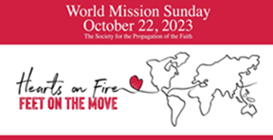
WORLD MISSION SUNDAY (last week-end) THANK YOU Your generous response to the 2023 World Mission Sunday request for prayer and financial support is much appreciated! Parish bookkeepers, please give donors credit for all WMS donations on their Parishsoft parish-giving tax statements. If checks are made payable to SPOF (Society for the Propagation of the Faith) instead of your local parish, please also deposit them (if your bank allows, which most do) into the parish account. The total of these funds is then forwarded in a parish check to the Mission Office, along with the ParishSoft report, which lists the name, address, and donor amount. Additional information can be found on the Mission Office website. Please email the Mission Office with any questions. God bless you for your extra time and efforts for the missions.

<<Top >>

Director: Christopher Carstens – 608.791.0161 | ccarstens@diolc.org

No items this week.

<<Top >>

Director: Teresa Brown – 608.791.2679 | tbrown@diolc.org

DIOCESE OF LA CROSSE GUIDELINES FOR REPORTING INSTANCES OF CHILD ABUSE

The Diocese of La Crosse, through its policies and procedures, seeks to provide a prompt, appropriate and compassionate response to reporters of sexual abuse of a child by any diocesan agent (bishop, priest, deacon, employee, religious, vendor or volunteer). Anyone wishing to make a report of an allegation of sexual abuse should send that report to Mrs. Teresa Brown, Complaint Intake Agent, at the Diocese of La Crosse, P.O. Box 4004, La Crosse, WI 54602-4004. Alternatively, you can contact Mrs. Brown at 608.791.0179 or intakeagent@diolc.org. The reporting form is available through the Diocese of La Crosse Office of Safe Environment or on the diocesan website at: diolc.org/safe-environment/reporting. Individuals are also encouraged to take their reports directly to civil authorities. Copies of the diocesan policy are available through your local Parish and on the diocesan website. If you have any questions about the Diocese of La Crosse and the implementation of the Charter for the Protection of Children and Young People, please contact Teresa Brown, Diocese of La Crosse, at 608.791.2679 or tbrown@diolc.org.

Parish Packets were distributed at Fall Ministry Days. Each folder has information specific to their own parish inside. On the left hand side is the 2023-24 report form, the parish spreadsheet and all current forms. On the right side is information that must be openly displayed at a parish.

Reports are due on March 1, 2024. As of Oct. 20, five (5) parishes have submitted their report. If you have questions or need assistance, please let me know. We can work together by Zoom, phone or in person.

Have all of your staff and volunteers been trained yet? Remember, those that have consistent contact with children need to be background checked and trained before they work with children. If you need a group training done, I can help.

School spreadsheets will be sent out soon. Don’t wait until just before the start of Spring sports to get background information and training completed. Ask for the information now.

Luke 18:17
“Truly I tell you, anyone who will not receive the kingdom of God like a little child will never enter it.”

Superintendent: Thomas Reichenbacher – 608.788.7707 | treichenbacher@diolc.org

No items this week.

<<Top >>

Director: Christopher Ruff – 608.791.0161 | cruff@diolc.org

For Your Parish Bulletin:
Wisconsin Bishops Issue Statement on Hamas Attack and call for Day of Fasting & Prayer
The Bishops of Wisconsin unequivocally condemn the Hamas terrorist attack on unarmed Israeli civilians and the taking of women, children, and elders as hostages. We deplore this and every form of antisemitism. We mourn for the innocent Israelis and Palestinians who will now lose their lives because of this brutality. We pray that the hostages and refugees from this conflict may find safety. May nations welcome them with compassion.
Pope Francis has called for a day of fasting and prayer for peace in the Holy Land on Friday, October 27.

For Your Parish Bulletin:
Donate to Help the Victims of Violence in the Holy Land
Catholic Relief Services, in conjunction with Caritas partners, are working to meet the desperate humanitarian needs caused by the terrorism and fighting in the Holy Land. To learn how you can help, visit www.crs.org or scan the QR code to the right.

For La Crosse Area Parish Bulletins:
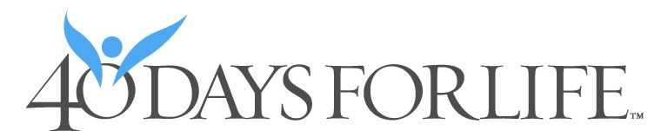
Please Get Involved – 40 Days for Life Vigil Campaign, Sept. 27-Nov. 5
The fall campaign to end abortion is underway, through Nov. 5, on the sidewalk outside Planned Parenthood, 1201 CaledoniaSt. in La Crosse. Please give one hour a week to pray and silently bear witness to life, anytime between 7 a.m. and 7 p.m. Sign up at 40daysforlife.com/en/ or scan the QR code to the right. Call Marie Allen for more information or signs: 608.784.5189.

(Reminder) For Your Parish Bulletin:
Post-Abortion Healing Ministry in the Diocese of La Crosse
Do you know someone who is carrying the grief and sorrow of past abortions? Project Rachel Ministry offers a compassionate heart and confidential help. Call 608.860.6698 or email projectrachel@diolc.org.
For Your Parish Bulletin:
Post-Abortion Healing Retreats - Rachel’s Vineyard - Encounter God’s Mercy
Rachel's Vineyard is a weekend retreat to help anyone who has struggled with the aftermath of abortion to begin healing through a supportive, trauma-sensitive approach. Each weekend is run by a team of trained volunteers (counselor, priest, and lay people), who care deeply for your needs. All interactions with the Rachel's Vineyard retreat team are completely confidential. These retreats will be offered in the Diocese of Madison on Nov. 10-12, 2023, March 15-17, 2024, and Nov. 8-10 2024. For more information, visit madisondiocese.org/rachel or scan the QR code on the right.
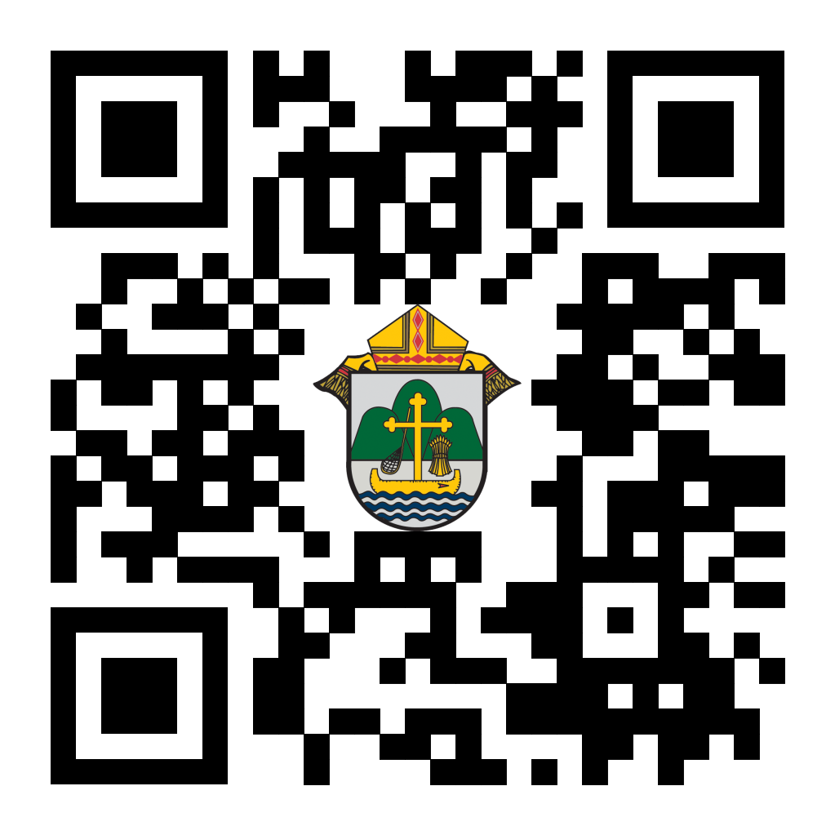
(Reminder) For Your Parish Bulletin:
Chalice of Mercy is in Ukraine, Needs Our Help
Please donate to the Ukrainian relief efforts of Chalice of Mercy if you are able, and pray for the safety of their volunteers on the ground there, who put their lives on the line. Financial assistance is the biggest need at this time. To give, visit chaliceofmercy.org/donate or use your smartphone’s camera to scan the QR code to the right.

<<Top >>

Director: Jeff Reiter – 608.791.2653 | jreiter@diolc.org
Diocesan Annual Appeal:
If you have not signed up to let us know when you plan to announce the Diocesan Annual Appeal at your parish, please complete the form at https://forms.gle/sWxXCPNARTGatTiD7
Parish materials will arrive this week, and the website and appeal portal will be updated.
Parishes that fail to sign up by Nov 15, 2023will have their parishioners automatically mailed for the first weekend in December 12/2-3/2023
Inspired By The Spirit and Diocesan Annual Appeal:
We have become aware that parishes are again making and using copies of the pledge form. These are parish-specific, and for our electronic banking and gift-scanning process, the pledge form must meet particular specifications to size and QR location to be more efficient, helping keep costs down and ensuring the correct parish and supporter is getting credit for that gift.
If you need more pledge forms, please contact Sarah Komperudskomperud@diolc.org; we will order more. Please allow 14 days for delivery.
Magisterium AI:
Are you looking for help with a homily, have a specific pastoral question, or are just curious about Catholic Stewardship? You might find the solution on a new Artificial Intelligence (AI) website dedicated to over 6,111 Catholic Church documents. The website provides references to each document cited in the search results. Whether looking for information on the Eucharist, Canon Law, or Catholic Stewardship, this free website can generate results in seconds. Though it's still in Beta form, like any AI site, it will continue to grow and improve with user inquiries. Like any creative tool AI sites are just the beginning and should be reviewed carefully.
https://www.magisterium.com/
Weekly Stewardship quotes (shorter bulletin reflections):
October-December
https://diolc.org/wp-content/uploads/2023/09/Stewardship-Bulletin-Reflections-Oct-Dec-2023.pdf
- Spanish Version
https://diolc.org/wp-content/uploads/2023/09/Stewardship-Bulletin-Reflections-Oct-Dec-2023-Spanish.pdf
Weekly Stewardship Prayers of the Faithful:
October-December
https://diolc.org/wp-content/uploads/2023/09/Prayers-of-the-Faithful-Oct-Dec-2023.pdf
- Spanish Version
https://diolc.org/wp-content/uploads/2023/09/Prayers-of-the-Faithful-Oct-Dec-2023-Spanish.pdf
Stewardship Bulletin Reflections for Weekends:
- 10/29
https://diolc.org/wp-content/uploads/2023/09/10.29.23-stewardship-bulletin-announcements.pdf
- 11/05
https://diolc.org/wp-content/uploads/2023/10/11.05.23-stewardship-bulletin-announcements.pdf
- 11/12
https://diolc.org/wp-content/uploads/2023/10/11.12.23-stewardship-bulletin-announcements.pdf
- 11/19
https://diolc.org/wp-content/uploads/2023/10/11.19.23-stewardship-bulletin-announcements.pdf
Stewardship Homily Reflections:
Stewardship reflections for your homily development:
- For Weeks 10/29 - 11/19/23:
https://diolc.org/wp-content/uploads/2023/10/Homily-Guide-10.24.23.pdf
Planned Giving – Leaving a Legacy, Wills, Bequest, and Endowments:
We have been entrusted with precious treasures passed down from our ancestors, and it's our responsibility to ensure that future generations can also enjoy the splendor and reverence of a well-maintained parish. One way to achieve this is by utilizing the Capital Campaign and providing information on Endowments, Trusts, and Bequests to the parishioners.
Our Estate Planning Guide can help save hundreds of dollars in legal and financial estate planning costs. We have mailed out several hundred copies per individual request, and each Parish has received a copy. Please feel free to contact our office for additional copies.
Visit diolclegacy.org, our Planned Giving website, to find calculators, and more information, sign up for a newsletter, and request specific estate planning guides and information. Our website also provides instructions on how to do an IRA Rollover, the creation of Donor Advised Funds (DAF), Beneficiary Designations, and Stock Transfers. https://diolclegacy.org/?pageID=5
If you require more information on legacy giving, presentations, or ads for your Parish bulletin, please contact our office or the Catholic Foundation of West Central Wisconsin (cfwcw.org) at 608.519.9892 or email eboos@cfwcw.org.
<<Top >>

Diocesan Finance Officer: James Reider – 608.791.2668 | jreider@diolc.org

Catholic Mutual Group - Risk Management Minutes
Winter weather can be devastating and linger well after the winter itself has passed. The National Oceanic and Environmental Administration (NOAA) indicates between 1980 and 2020, winter storms caused $50.1 billion in weather related property damage in the United States. Cold temperatures and wintry precipitation add to the risks property managers mitigate every day. Please see Fall-Winter Maintenance Guide for preventative actions you can take to reduce property damage due to exposure to winter weather.
Health Enews from Catholic Mutual Group
Please click here for the October edition of CMG Health Enews.
<<Top >>

Director of Vocation Recruitment: Fr. Nate Kuhn – 608.791.2666 | nkuhn@diolc.org

New Seminarian posters and prayer books are here!
If you did not pick them up at Fall Ministry Conference and need some, please email Renee’ Orth at rorth@diolc.org

Vocations Intercessions
Please include the following intercession for vocations for your Sunday prayers of the faithful.
In thanksgiving for those marriages, priests, sisters, brothers, and those living a holy single life who inspire and strengthen us by the witness of their commitment.
Consider adding a vocations paragraph to your parish bulletin. Below is an example – they will be changed each week. Feel free to use any or all of them.
What does your future hold?
When we are young, we look towards the future and wonder what’s in store. Perhaps there are dreams of accomplishing great things, helping others, or being able to change the world. Well, there is a vocational calling that can provide the opportunity to do all of that and so much more: the priesthood! Consider the Lord’s call to the priesthood, a calling that gives young men the opportunity to be part of something greater, the Church. It provides an opportunity to be part of God’s healing mission, a mission to save souls and bring people into deeper relationship with Him. If you or someone you know is interested in discovering this call, please contact me at: Fr. Nate Kuhn, Director of Vocational Recruitment for the Diocese of La Crosse, 3710 East Ave. S. PO Box 4004, La Crosse, WI 54602; or by phone at: 608.791.2667. God bless you!
<<Top >>

Director: Very Rev. Woodrow H. Pace – 608.791.2689 | wpace@diolc.org

Fall Ministry Conference 2023: Attendance numbers were high and information was well distributed. Thank you to the priests and deacons present and those who helped to deliver information to those absent for various reasons. Because October 1 falls on a Tuesday, next year's conference will be relatively later. Please mark your calendars for October 21-22, 2024.

Barb Swieciak offered an update to the information she presented at the Fall Ministry Conference. She writes, “We have three consecrated virgins in the Diocese and one applicant. They are: Barbara Swieciak from La Crosse, consecrated Sept. 8, 1984; Pat Murray from Friendship, consecrated June 8, 1997; Cheri Bowi, from Cadott and working outside the Diocese, consecrated March 25, 2000. Kathleen McCandless, from Rock Falls and teaching 2nd grade at Immaculate Conception where she is a parishioner, is beginning the formation program. We thank them for their witness and encourage your prayers for them in their vocation.

<<Top >>

Director: Christopher Rogers – 608.791.2659 | crogers@diolc.org

“the Answer” Eucharistic Rally |June 7
The La Crosse Center, La Crosse, WI
We are very excited to announce “the Answer” Eucharistic Rally that will be held on June 7, 2024 at the La Crosse Center in La Crosse, WI. This event kicks off the 6 days that the Marian Route of the National Eucharistic Pilgrimage will be in the Diocese of La Crosse. “the Answer” Eucharistic Rally will begin with a Eucharistic Procession Across the Cameron Street Bridge in La Crosse and will end at the La Crosse Center where the rest of the rally will take place. The day will include Mass, Adoration, Confession, powerful speakers such as Chris Stefanick, Immaculee Ilibagize, and Josh Rosa, music from Luke Spehar, and plenty of vendors. The cost for this event is only $15 per person. This rally is for youth, young adults, adults, families, etc. Tickets will go on sale December 15, 2023. You can find more information about the event and the other days the Marian Route will be in our diocese by visiting: https://diolc.org/the-answer/.

(Reminder) SEALED! Fall Diocesan Confirmation Retreat
The SEALED! Diocesan Confirmation Retreat will be held Dec. 9, 2023, at St. Olaf Catholic Church in Eau Claire, WI. Click this link to register and find out more information: https://diolc.org/yya/youth-opportunities/immersion-retreat/

(Reminder) Updated Office for Family Life Calendar of Events Through 2025:
In the Office for Family Life, we are working to keep our event planning at least two years out. We have created a calendar that may help you in planning for the next couple of years. You will see the dates have hyperlinks that allow you to add this event to your Google Calendar. Below each event is a hyperlink to the page on our website with more information, including registration links for that particular event. Please follow this link to get a list of events planned so far: https://drive.google.com/file/d/17YHE2dCa267CYfgCXZVP1hSwjTMNfhY-/view?usp=sharing

<<Top >>

Diocese of La Crosse | 3710 East Ave S | La Crosse, WI 54601 | 608-788-7700
To unsubscribe from this e-mail message contact mwilson@diolc.org

