Chancery Bulletin - Vol. 8, No. 10.1 | October 3, 2023

- Catechesis & Evangelization  - Chancery  - Communications  - Consecrated Life  - Diaconate  - Marriage & Family Life  - Ministries  - Mission Office  - Sacred Worship | - Safe Environment  - Schools Office  - Social Concerns  - Stewardship and Development  - Temporalities  - Vocations  - Vicar for Clergy  - Youth and Young Adult Ministry  - Past Chancery Bulletins

<<Top >>

Chancellor Very Rev. William Dhein – 608.791.2655 | wdhein@diolc.org

No items this week.

<<Top >>

As of Oct. 3

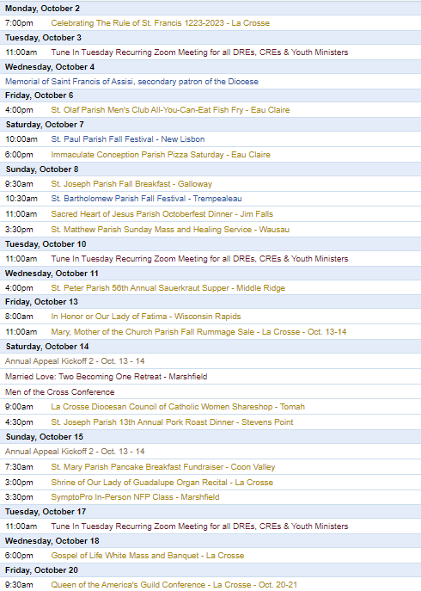
To get your parish events listed on the diocesan calendar, diolc.org/calendar, and in Catholic Life magazine, please send an email to datebook@diolc.org. Make sure you include the following details: date, beginning/ending times, event location, description, menu and cost, etc. If you have any questions, please call Pam Willer at 608.788.1524 for more information.

<<Top >>

Director: Ann Lankford – 608.791.2658 | alankford@diolc.org
For your Parish Bulletin:
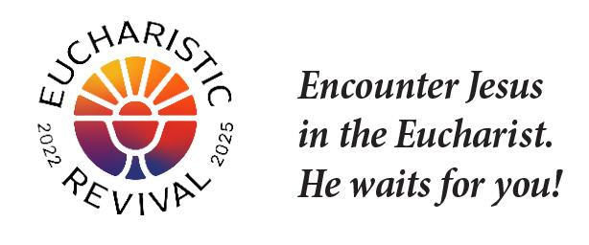
We are in the midst of a three-year Eucharistic Revival. This movement is to help all Catholics know and believe that the Eucharist is Jesus.
“God is love.”
It’s so important to remember that God is not just loving but He is LOVE itself. Our Heavenly Father reveals—shows us—that He is love and that He desires to share His love by creating us. He created each one of us out of love. Our Heavenly Father only wants to love us. We are able to recognize His love in that Our Father sent His only Son to give Himself to us in the Eucharist and to give His life for us on the Cross.
Pray this right now and every day this week: Heavenly Father, thank you for Your love for me.
This week, read how St. John the Evangelist explains how we know that God is love:
“Beloved, let us love one another, for love is from God, and whoever loves has been born of God and knows God. Anyone who does not love does not know God, because God is love. In this the love of God was made manifest among us, that God sent his only Son into the world, so that we might live through him. In this is love, not that we have loved God but that He loved us and sent His Son to be the propitiation for our sins. Beloved, if God so loved us, we also ought to love one another. No one has ever seen God; if we love one another, God abides in us and his love is perfected in us” (1 John 4: 7-12).
For a list of weekly proclamations on the Eucharist, click here: diolc.org/eucharist/learn.
Adult Faith Formation Opportunities:
- “Sunday Rest: A teaching and practice of different forms of prayer - Ignatian Meditation” with Fr. Sam McCarty, Sunday, Oct. 15, 7:30 p.m., Newman Parish in La Crosse
- “Encounter Jesus, Change your Life” is a Parish Mission being held at St. Patrick’s Catholic Church in Sparta, Oct. 22-24, 6:30-8:30 p.m. This Franciscan University of Steubenville Parish Mission will ignite your desire to be in a loving relationship with Jesus. You will discover the way to engage fully as a disciple of Christ by immersing yourself in HIS PRESENCE. Jesus changed the world in three days, let HIM change yours. Cost: $25
Catechetical Leader Information:
The following brief and inspiring explanation of the reality of Jesus’ true presence in the Eucharist is provided for your communication with parents, as well as for catechists to provide a concise, key point on the Eucharist each week with the children/youth.
Jesus Waits For Us:
After Mass, Holy Communion is reserved in the tabernacle. The red sanctuary candle in the front of the church is constantly burning to remind us that Jesus is present in the tabernacle in the sacred Host. He waits for us to come and spend some time with Him, just as we would spend time with any friend. We can speak with Him about anything, and simply be quiet in order to listen to Him. It is helpful to bring a book like, “The Divine Encounter” by Mark Hart to have something to help stay focused when distractions arise. This time with the Lord will help bring solace and peace as worries take on a proper perspective and we will gradually know that when we receive Holy Communion, we are truly receiving Jesus.
Let’s pray this right now and every day this week: Jesus, help me to set aside some time to spend with You in church so that You can strengthen my faith that You are truly present in the Holy Communion.
This week, read how Jesus asked Peter and the Apostles to spend time with Him in prayer in Matthew 26:40.
Suggested Picture: A monstrance with the sacred Host in the middle.
Click here for further entries: diolc.org/catechesis/catechetical-leaders-info
Every Child, Youth And Adult Needs To Hear “The Story of the Bible”:
The most important historical events of the Bible can be briefly described in one story, connected by one common theme: union with God. “The Story of the Bible” portrays the drama of God’s love for every person and the whole human race: how God created us to be united with Him in a relationship of love; how we lost union with God through the original sin; how Jesus reunited us with God in a relationship of love through His passion, death and resurrection; and how the Holy Spirit fosters a continuing unfolding of those saving events in the life of Church, as the Lord’s bride. Often in a catechetical setting, we fall into the habit of teaching individual topics without reference to the greater context of salvation history. In order to draw others into the life of God and the Church we have to help them make this story of the Bible their own. Everything that the Church teaches, Her doctrines, disciplines, worship, and morality makes sense when delivered within the context of the story of the bible. “The Story of the Bible” tells us of our spiritual roots, our dignity, our destiny, and our daily vocation to follow Jesus Christ, providing peace and authentic hope to those we seek to teach and evangelize.

The simple directions to access this workshop, the story of the Bible, which is entitled “Sacred Scripture: The Big Picture,” on Francsican at Home are below:
(Reminder) Simple Directions To Register Free of Charge:
1) Visit franciscanathome.com/diocese-la-crosse and scroll to the bottom of the page.
2) On the right, click the middle blue button: “My parish or school is already registered, and I would like to set up my individual free account…”
3) Click “Create an Account.” Complete the information and click Save. Select the Diocese of La Crosse from a drop-down menu, and then your Institution (your parish) or school, listed first by city and name. Finally, click the "Sign Up" button to have a Dashboard. Scroll down to “Franciscan Tracks” under “Start Learning” on the left and select “The Catechist Track,” and then click on “Foundational Catechist Certification” and then “Sacred Scripture: The Big Picture.”
A Track is a collection of workshops. A workshop is one hour of video, divided into 10-minute segments, with application discussion questions after each video. Small groups are the proven way to experience the workshops. The richness of the content shines out in the discussion.
To print the directions to register and/or for further information, click here: diolc.org/catechesis/catechetical-leaders-info
<<Top >>

Director: Erik Archer– 608.791.2661 | earcher@diolc.org
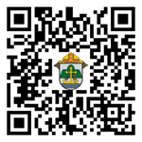
Next Week! Parish Roundtables | Oct. 9-13:
Our next iteration of Parish Roundtables is scheduled for Oct. 9-13. We have important news to share about new tools for parishes that the diocese will fund and help resources. Our goal is to help free parishes from time spent on Social Media and spend it instead on their ministries. Our emerging system takes the Social Media burden off parish plates. Our next effort is implementing FlockNote across the diocese - an effort the diocese will fund. We’ll discuss these at the roundtable and seek parish feedback.
Thank you so much to the parishes that agreed to host. Our intent continues to meet parishes where they’re at, to listen to what parishes need from us, what we’re doing well and what we can do better. Curia directors will join our communications team to share their updates as well as listen to what parishes need from them. The registration form will be out shortly. Twenty-seven individuals completed the post-roundtable survey in the spring and we’re going to factor those comments into our planning process for these fall roundtables.
Please register at: https://forms.office.com/r/HsV4R9JrBE or use your smartphone’s camera to scan the QR code to the right. The roundtable locations and timelines can be found there.
Daily Social Media Content Available to You – Catholic Social Media. Wave 1 Training is Scheduled. Wave 2 is Next!
Demo: https://vimeo.com/catholicsocialmedia/parish-demo?share=copy
Wave 1 Parish Training begins shortly! We purchased software that will make a suite of social media content readily available to every parish with simple clicks of a button. Our diocesan communications team will provide the content for parishes and the software creates customizable versions for every parish, connects a parish’s social media accounts, provides analytics and more. When researching this, our first rules were – that we impose no financial cost on the parishes, it must be easy to learn, it must be easy to maintain, and support must be readily and easily available. Four meetings later, we believe Prenger’s Catholic Social Media program does all these things and will help parishes accelerate their social media engagement.
Social media is important because this is where many encounter our Faith. Nic Prenger’s team will “white-glove” onboard parishes and we need 10-15 parishes to volunteer to learn this capability. The capability will be subsequently rolled out across the diocese to interested parishes in phases. Learn more at: https://prengersolutions.com/products/catholic-social-media/for-parishes/.
Please call or email me with any questions – I am excited for this opportunity and will visit your parish/pastor in person as needed to help share the benefits. This allows us at the diocese to serve parishes in their mission of reaching parishioners. We will shoulder the financial burden and provide content that is true, good and beautiful. Parishes will simply need to log on, click buttons and their social media will be vibrant with content.
Listing Your Parish Events In The Jan/Feb 2024 Issue Of Catholic Life:
If your parish has events for inclusion in the Jan/Feb issue of Catholic Life, please submit them by Oct. 16. To get your parish events listed on diolc.org/calendar, and in Catholic Life magazine, please send an email to datebook@diolc.org. Please include the following details: date, beginning/ending times, event location, description, dinner menu and cost, etc. If you have any questions, please call Pam Willer at 608.788.1524.
<<Top >>

Director: Sr. Donna Krzmarzick, ISSM – 608.791.2690 | dkrzmarzick@diolc.org

No items this week.

<<Top >>

Director: Deacon Robert Riedl – 608.791.2665 | rriedl@diolclergy.org

(Reminder) Fall Ministry Days:
Please log into the website to register for Fall Ministry Days using this link: https://diolc.org/vicarforclergy/
(Reminder) Deacon Days with the Bishop: (Attendance is Expected)
- 2024 – Aug. 10
- 2025 – Aug. 9
- 2026 – Aug. 8

<<Top >>

Director: Christopher Rogers – 608.791.2659 | crogers@diolc.org

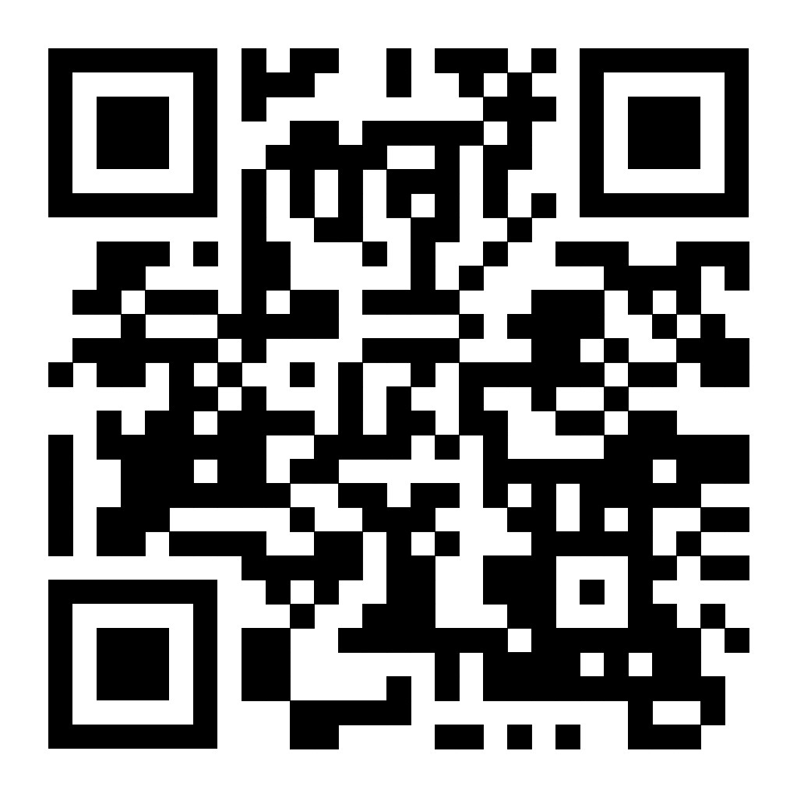
For Your Parish Bulletin:
(Reminder) Men of the Cross Conference|Oct. 14 (8:30 a.m.-5:15 p.m.)
The La Crosse Center, La Crosse, WI
Connect with other Catholic men from around the Diocese of La Crosse who will lift you in this role and be encouraged and challenged by men of deep faith. Tickets are $45 per person. Fathers, make this a Father/Son day and bring your high school-age son for free! If you are planning to bring your son, please put his name in the comment section on the online registration form.
So get your family members, best buds, men at your parish, and even acquaintances together and join your brothers from all over the Diocese of La Crosse to reignite your identity as a Catholic man.
For registration and more information, visit www.menofthecross.org or use your smartphone’s camera to scan the QR code to the right.

(Reminder) Natural Family Planning
For Priests, Deacons and Parish staff:
USCCB Free Resources to Download
Diocese of La Crosse NFP Brochure (use diolc.org email for access)

NFP classes are offered to interested couples by the Marriage and Family Life Office. To
inquire about diocesan classes, go to diolc.org/nfp or email ckitzhaber@diolc.org. Read
more regarding NFP on the USCCB website at www.usccb.org/prolife/issues/nfp.
(Reminder) For Your Parish Bulletin:
A SymptoPro NFP In-Person Class will be offered in the Wausau Deanery at St. John the Baptist Parish, 103 N. 4th Ave., Edgar, WI 54426 on:
Saturday, Sept. 30 1:30-3:30 p.m.
Sunday, Oct. 15 3-5 p.m.
Please contact Nancy Hackel at nhackel@stjohnedgar.org to register for this 3-session course. Please download the poster here.
(Reminder) Marriage Enrichment and Parenting Resources:
For your marriage website: foryourmarriage.org/ or use your smartphone’s camera to scan the QR code to the right. This website from the USCCB helps couples at all stages of life to understand and live God’s plan for happy, holy marriages.

(Reminder) Teaching the Way of Love:
Please visit twl4parents.com/ or use your smartphone’s camera to scan the QR code to the right. This website is full of encouragement and tips for parents to continue to be the primary educators of their children.

(Reminder) Diocesan Website for Clergy and Marriage Ministers Regarding Marriage Preparation:
Use this link: diolc.org/marriage/marriage-preparation/marriage-preparation-for-ministers/ to go directly to the section of our website containing resources for clergy and marriage ministers. There are step-by-step instructions, downloadable guidelines, downloadable forms and much more! Please let us know if we can assist you in this ministry.

(Reminder) Process for Training FOCCUS Facilitators:
The process for training FOCCUS facilitators is as follows: Each parish needs to contact FOCCUS directly to set up an account for your parish, if one has not already been set up, then train your couples directly through FOCCUS. The contact person at FOCCUS is Max Allen. He is happy to work directly with your parish priest or contact person. His contact information is mrallen@foccusinc.com or phone: 402.827.3735, ext. 1317.

<<Top >>

Director: Christopher Ruff – 608.791.0161 | cruff@diolc.org

No items this week.

<<Top >>

Director: Fr. Woodrow Pace – 608.791.2676 | wpace@diolc.org

No items this week.

<<Top >>

Director: Christopher Carstens – 608.791.0161 | ccarstens@diolc.org

No items this week.

<<Top >>

Director: Teresa Brown – 608.791.2679 | tbrown@diolc.org

DIOCESE OF LA CROSSE GUIDELINES FOR REPORTING INSTANCES OF CHILD ABUSE
The Diocese of La Crosse, through its policies and procedures, seeks to provide a prompt, appropriate and compassionate response to reporters of sexual abuse of a child by any diocesan agent (bishop, priest, deacon, employee, religious, vendor or volunteer). Anyone wishing to make a report of an allegation of sexual abuse should send that report to Mrs. Teresa Brown, Complaint Intake Agent, at the Diocese of La Crosse, P.O. Box 4004, La Crosse, WI 54602-4004. Alternatively, you can contact Mrs. Brown at 608.791.0179 or intakeagent@diolc.org. The reporting form is available through the Diocese of La Crosse Office of Safe Environment or on the diocesan website at: diolc.org/safe-environment/reporting. Individuals are also encouraged to take their reports directly to civil authorities. Copies of the diocesan policy are available through your local Parish and on the diocesan website. If you have any questions about the Diocese of La Crosse and the implementation of the Charter for the Protection of Children and Young People, please contact Teresa Brown, Diocese of La Crosse, at 608.791.2679 or tbrown@diolc.org.

<<Top >>

Superintendent: Thomas Reichenbacher – 608.788.7707 | treichenbacher@diolc.org

No items this week.

<<Top >>

Director: Christopher Ruff – 608.791.0161 | cruff@diolc.org

For Your Parish Bulletin - Final Weekend:
Gospel of Life White Mass & Banquet |Oct. 18 (6 p.m.- 9 p.m.)
The Cathedral of St. Joseph The Workman, La Crosse, WI
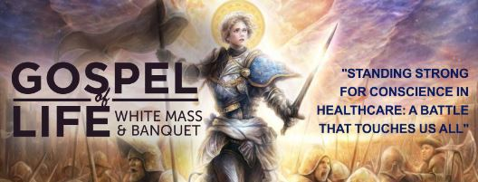
Sunday, Oct. 8 is the deadline to Register for the Gospel of Life White Mass & Banquet. The theme: "Standing Strong for Conscience in Healthcare: A Battle that Touches Us All."
With the pressures surrounding things like end-of-life decisions, abortion, vaccines, and transgender drugs and surgeries, how can doctors, nurses, and their patients "stand strong" for conscience rights, in keeping with the Church's teaching about conscience? Fr. Justin Kizewski will address this and more in his keynote at the banquet following Bishop Callahan's 6 p.m. "White Mass," at which the faithful honor and pray for Catholic healthcare professionals. All are warmly invited to the Mass, banquet and talk! To learn more and to register, visit www.diolc.org/GospelofLife.

To learn more and to register, visit www.diolc.org/GospelofLife or scan the QR code to the right.

For La Crosse Area Parish Bulletins:
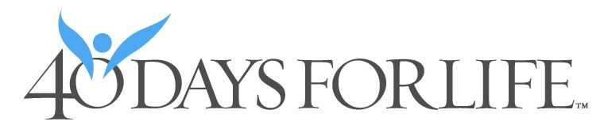
(Reminder) Join 40 Days for Life Vigil Campaign, Sept. 27-Nov. 5
The fall campaign to end abortion will run Sept. 27-Nov. 5 on the sidewalk outside Planned Parenthood, 1201 Caledonia in La Crosse. Please consider coming to pray for an hour, anytime between 7 a.m. and 7 p.m. Sign up at 40daysforlife.com/en/ or scan the QR code to the right. Call Marie Allen for more information or signs: 608.784.5189.
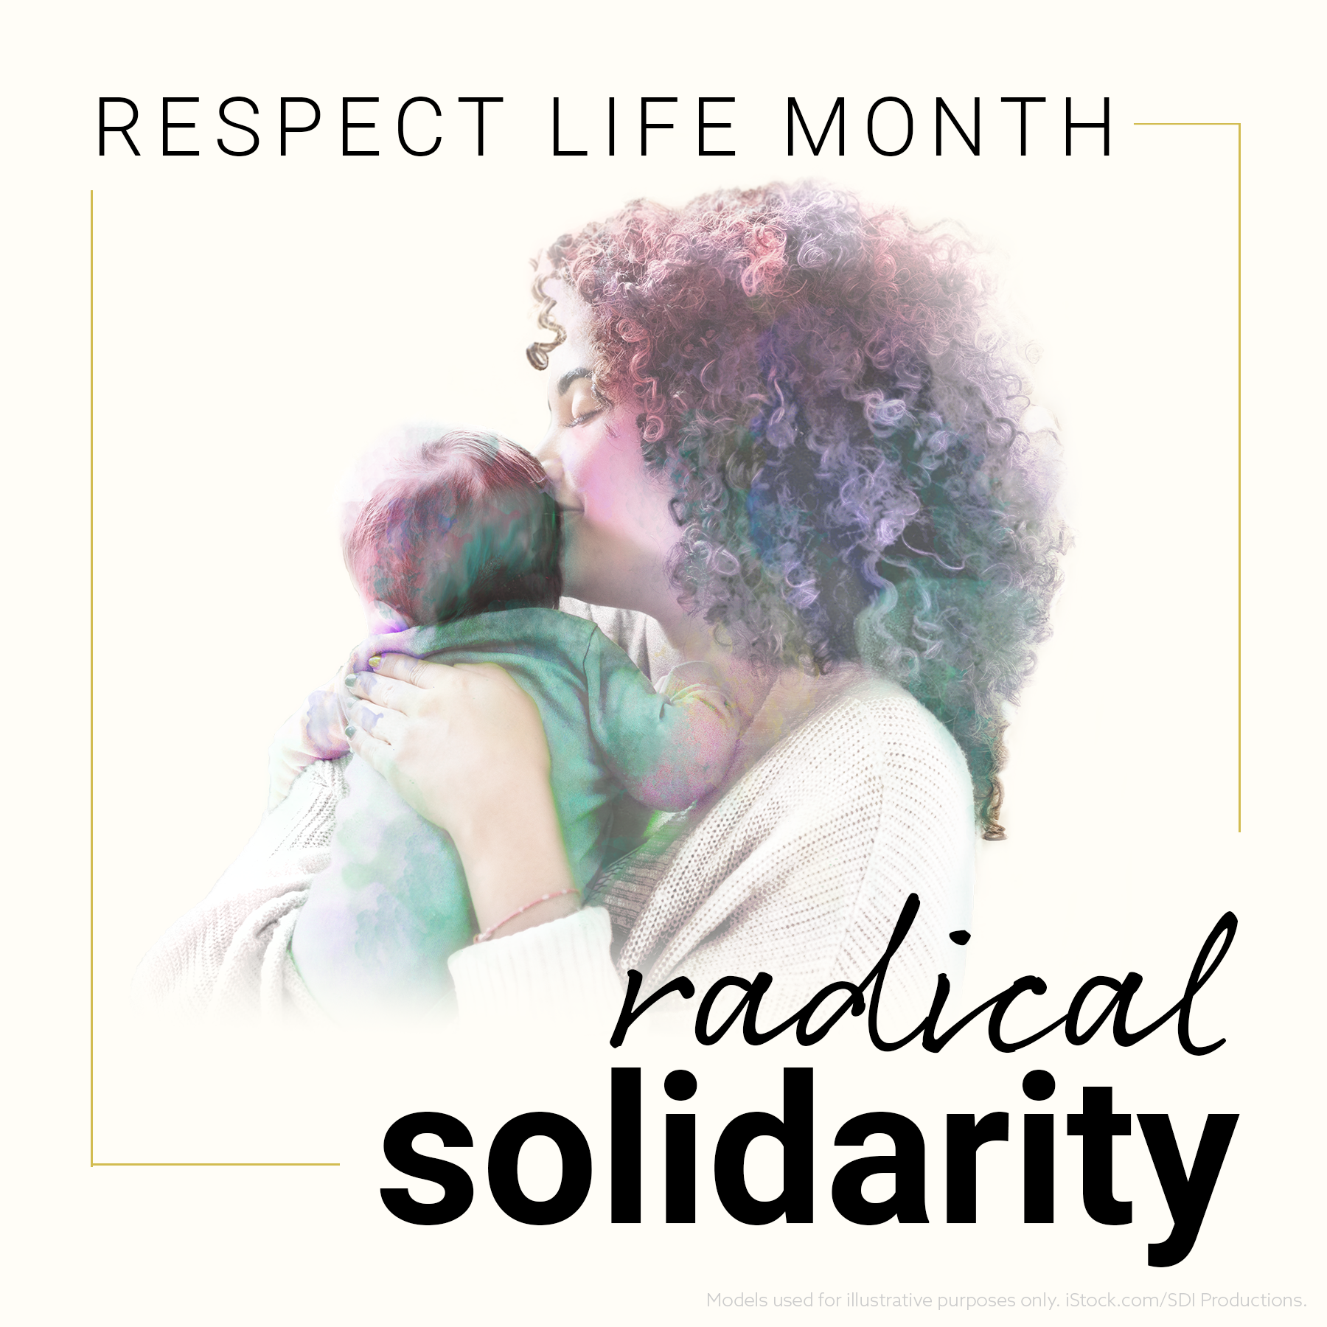
For Your Parish Bulletin:
(Reminder) October is Respect Life Month
Many parish resources from the USCCB for October, Respect Life Month, are available at www.respectlife.org. Also visit the Diocesan website, www.diolc.org/respect-life, for information on Pregnancy Resource Centers, Post-Abortion Healing, and much more.

(Reminder) For Your Parish Bulletin:
Post-Abortion Healing Ministry in the Diocese of La Crosse
Do you know someone who is carrying the grief and sorrow of past abortions? Project Rachel Ministry offers a compassionate heart and confidential help. Call 608.860.6698 or email projectrachel@diolc.org.
(Reminder) For Your Parish Bulletin:
Help Relief Efforts for Morocco After the Devastating Earthquake
On Friday, Sept. 8, a magnitude 6.8 earthquake struck Morocco. More than 300,000 people were affected and at least 2,490 were killed. Access to remote areas with the worst destruction—especially in mountain towns—remains difficult. Catholic Relief Services is supporting Caritas Rabat, whose teams mobilized a response within 24 hours to the hardest-to-reach areas. To donate to these efforts, visit www.crs.org or scan the QR code to the right. (Note: Catholic Relief Services is not able to do relief work in Libya, unfortunately. Pray for the victims of the horrific flooding there. You may also do an Internet search for secular organizations that are able to assist in Libya).

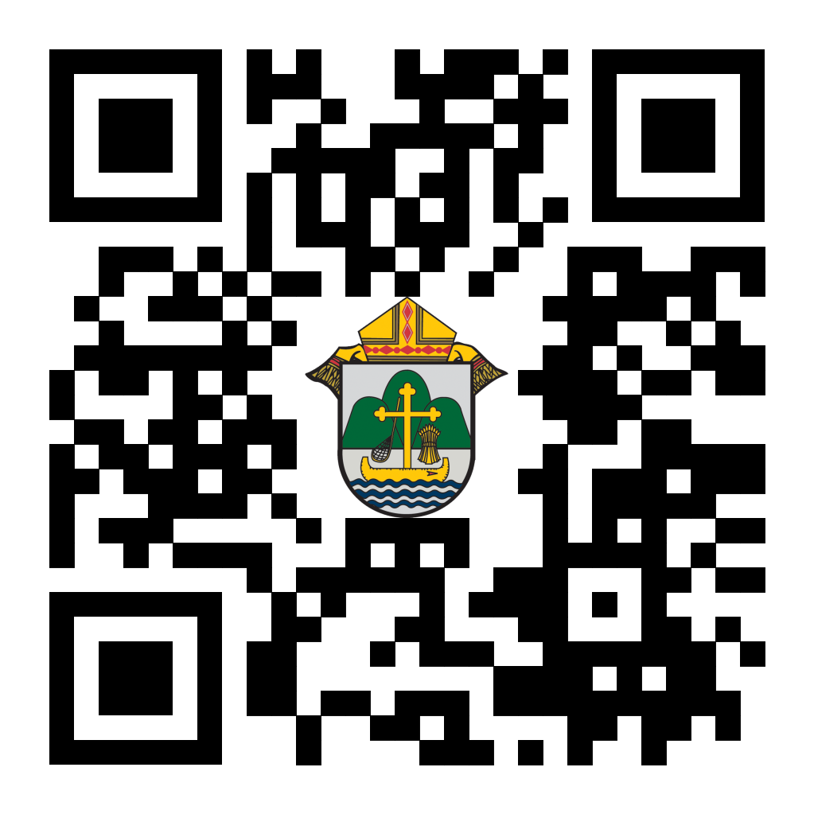
(Reminder) For Your Parish Bulletin:
Chalice of Mercy is in Ukraine, Needs Our Help
Please donate to the Ukrainian relief efforts of Chalice of Mercy if you are able, and pray for the safety of their volunteers on the ground there, who put their lives on the line. Financial assistance is the biggest need at this time. To give, visit chaliceofmercy.org/donate or use your smartphone’s camera to scan the QR code to the right.

See U.S. Bishops’ Action Alerts on Hunger, Respect Life, and other Issues:
Visit votervoice.net/USCCB/home or scan the QR code to the right to learn how to make your voice heard.

<<Top >>

Director: Jeff Reiter – 608.791.2653 | jreiter@diolc.org
Inspired By The Spirit and Diocesan Annual Appeal:
We have become aware that parishes are again making and using copies of the pledge form. These are parish-specific, and for our electronic banking and gift-scanning process, the pledge form must meet particular specifications to size and QR location to be more efficient, helping keep costs down and ensuring the correct parish and supporter is getting credit for that gift.
If you need more pledge forms, please contact Sarah Komperudskomperud@diolc.org; we will order more. Please allow 14 days for delivery.
Diocesan Annual Appeal:
Three weeks ago Thursday (9/14/2023), we sent all the parishes an email informing them of this year's Diocesan Annual Appeal Allocation. If you have not received it, please check your spam. Unless we were directed otherwise, the letter went to the Pastor’s email on record with the Curia offices.
- In that email, a link to sign up and choose your parish’s announcement weekend was included: https://forms.gle/sWxXCPNARTGatTiD7 If you have not done so, please do so as soon as possible.
Weekly Stewardship quotes (shorter bulletin reflections)
October-December
https://diolc.org/wp-content/uploads/2023/09/Stewardship-Bulletin-Reflections-Oct-Dec-2023.pdf
- Spanish Version
https://diolc.org/wp-content/uploads/2023/09/Stewardship-Bulletin-Reflections-Oct-Dec-2023-Spanish.pdf
Weekly Stewardship Prayers of the Faithful:
October - December
https://diolc.org/wp-content/uploads/2023/09/Prayers-of-the-Faithful-Oct-Dec-2023.pdf
- Spanish Version
https://diolc.org/wp-content/uploads/2023/09/Prayers-of-the-Faithful-Oct-Dec-2023-Spanish.pdf
Stewardship Bulletin Reflections for Weekends:
- 10/08
https://diolc.org/wp-content/uploads/2023/09/10.08.23-stewardship-bulletin-announcements.pdf
- 10/15
https://diolc.org/wp-content/uploads/2023/09/10.15.23-stewardship-bulletin-announcements.pdf
- 10/22
https://diolc.org/wp-content/uploads/2023/09/10.22.23-stewardship-bulletin-announcements.pdf
- 10/29
https://diolc.org/wp-content/uploads/2023/09/10.29.23-stewardship-bulletin-announcements.pdf
Stewardship Homily Reflections:
Stewardship reflections for your homily development:
- For Weeks 10/08 - 10/29/23:
https://diolc.org/wp-content/uploads/2023/09/Homily-Guide-10.03.23.pdf
Planned Giving – Leaving a Legacy, Wills, Bequest and Endowments:
We have inherited such treasures from our parents, grandparents and great-grandparents, those whose shoulders we stand on today. Now it is our turn to ensure future generations can enjoy the reverence and beauty of a well-maintained parish. Leveraging the Capital Campaign and providing parishioners with information on Endowments, Trusts and Bequests are just a few ways a parish can help prepare for its future.
Our Estate Planning Guide can help people save several hundred dollars in legal and financial estate planning costs. We have sent out several hundred copies per individual request, and each Parish has received a copy. Do not hesitate to contact our office if you want additional copies.
Our Planned Giving website is diolclegacy.org. People can find calculators and additional information, sign up for a newsletter, and request copies of specific estate planning guides and information.
Our website includes instructions on how to do an IRA Rollover, the creation of Donor Advised Funds (DAF), Beneficiary Designations and Stock Transfers. https://diolclegacy.org/?pageID=5
If you would like more legacy-giving information, presentations or ads for your Parish bulletin, please do not hesitate to contact our office or the Catholic Foundation of West Central Wisconsin (cfwcw.org) at 608.519.9892 or email: eboos@cfwcw.org.

<<Top >>

Diocesan Finance Officer: James Reider – 608.791.2668 | jreider@diolc.org

No items this week.

<<Top >>

Director of Vocation Recruitment: Fr. Nate Kuhn – 608.791.2666 | nkuhn@diolc.org

New Seminarian posters and prayer books are here!
Please remember to pick them up when you are at the Fall Ministry Conference!

Vocations Intercessions
Please include the following intercession for vocations for your Sunday prayers of the faithful.
For an increase in vocations to marriage, blessed single life, the Priesthood and Consecrated Life; especially that more young men and women will have the courage to follow a call from God to serve in the Church.
Consider adding a vocations paragraph to your parish bulletin. Below is an example – they will be changed each week. Feel free to use any or all of them.
How does God speak to me?
Have you ever wondered how God may be speaking to you? Perhaps you are waiting to hear a loud, booming voice come from the heavens to tell you what to do or which way to go. While this isn’t completely out of the question, often God takes a much subtler approach. In 1 Kings, we have the account of the Prophet Elijah standing at the entrance of a cave, waiting for the Lord to appear. As he waits, he encounters a strong, violent wind, a powerful earthquake, and a consuming fire, yet God was not revealing Himself in any of those powerful examples. Finally, as Elijah waited, he heard a soft, quiet whisper. At that, he knelt to the ground and prayed. God often speaks to us, not in grand and impressive ways, but in the silence. When we can still our hearts, that’s when we begin to hear His voice, calling us into relationship and to follow Him. Sometimes that invitation is to follow the Lord as one who lovingly serves others in the priesthood. If you or someone you know is interested in discovering more about this call to the priesthood, please contact me at: Fr. Nate Kuhn, Director of Vocational Recruitment for the Diocese of La Crosse, 3710 East Ave. S. PO Box 4004, La Crosse, WI 54602; or by phone at: 608.791.2667. God bless you!
<<Top >>

Director: Very Rev. Woodrow H. Pace – 608.791.2689 | wpace@diolc.org

No items this week.

<<Top >>

Director: Christopher Rogers – 608.791.2659 | crogers@diolc.org

(Reminder) SEALED! Fall Diocesan Confirmation Retreat
The SEALED! Diocesan Confirmation Retreat will be held Dec. 9, 2023, at St. Olaf Catholic Church in Eau Claire, WI. Click this link to register and find out more information: https://diolc.org/yya/youth-opportunities/immersion-retreat/

(Reminder) NCYC (National Catholic Youth Conference) Last Call
If you have a group interested in attending NCYC with us Nov. 16-19, 2023, please contact our office ASAP.

Updated Office for Family Life Calendar of Events Through 2025
In the Office for Family Life, we are working to keep our event planning at least two years out. We have created a calendar that may help you in planning for the next couple of years. You will see the dates have hyperlinks that allow you to add this event to your Google Calendar. Below each event is a hyperlink to the page on our website with more information, including registration links for that particular event. Please follow this link to get a list of events planned so far: https://drive.google.com/file/d/17YHE2dCa267CYfgCXZVP1hSwjTMNfhY-/view?usp=sharing

<<Top >>

Diocese of La Crosse | 3710 East Ave S | La Crosse, WI 54601 | 608-788-7700
To unsubscribe from this e-mail message contact mwilson@diolc.org

