Chancery Bulletin - Vol. 8, No. 10.5 | October 31, 2023

- Catechesis & Evangelization  - Chancery  - Communications  - Consecrated Life  - Diaconate  - Marriage & Family Life  - Ministries  - Mission Office  - Sacred Worship | - Safe Environment  - Schools Office  - Social Concerns  - Stewardship and Development  - Temporalities  - Vocations  - Vicar for Clergy  - Youth and Young Adult Ministry  - Past Chancery Bulletins
The Most Reverend William Patrick Callahan, D.D., Bishop of La Crosse, makes the following announcements:
The Reverend Zacharie Beya Tshingimba, is appointed Pastor of St. Bridget Parish in Ettrick and St. Ansgar Parish in Blair, with residence at St. Bridget Parish rectory in Ettrick, effective November 3, 2023.
The Reverend Michael E. Klos, Pastor of Nativity of the Blessed Virgin Mary Parish in St. Mary’s Ridge, Sacred Heart Parish in Cashton, and St. Augustine of Hippo Parish in Norwalk, is appointed Pastor of Sacred Heart-St. Patrick Parish in Eau Claire, with residence at Sacred Heart Rectory, effective December 1, 2023.

<<Top >>

Chancellor Very Rev. William Dhein – 608.791.2655 | wdhein@diolc.org

No items this week.

<<Top >>

As of Oct. 31

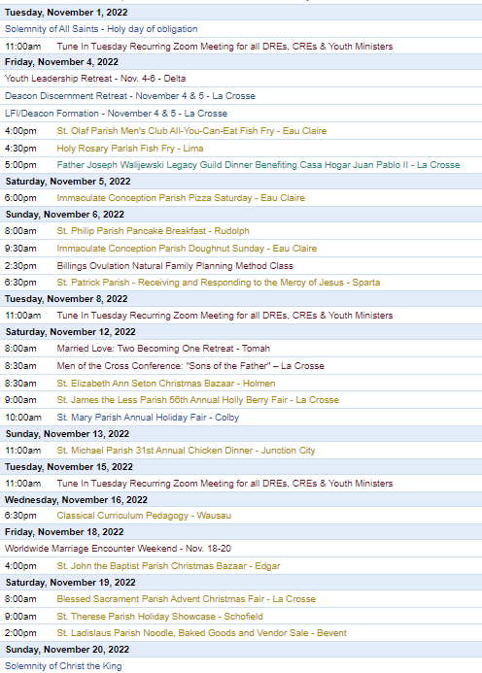
To get your parish events listed on the diocesan calendar, diolc.org/calendar, and in Catholic Life magazine, please send an email to datebook@diolc.org. Make sure you include the following details: date, beginning/ending times, event location, description, menu and cost, etc. If you have any questions, please call Pam Willer at 608.788.1524 for more information.

<<Top >>

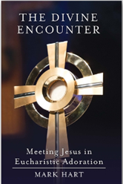
Director: Ann Lankford – 608.791.2658 | alankford@diolc.org
Clergy: Please Promote Adoration
The Divine Encounter: Meeting Jesus in Eucharistic Adoration by Mark Hart is available for a parish give-away this fall or during Advent. Due to bulk orders, the price per book is $2.60 (retail $9.99). A parish order must be 10 or more books. Please help us find someone coming to La Crosse for pickup or postage will need to be paid by the parish. Contact Beth at bjohnson@diolc.org to place your order with the following details:
parish, city, contact person, phone number, number of books, info about pick-up or mail delivery. Flyer with further info available here: diolc.org/catechesis/catechetical-leaders-info
General Intercessions in light of the Eucharistic Revival
Another way to inform parishioners and engage them in the Eucharistic Revival is by including Mass intentions that are focused on praying for renewal each week.
Visit www.eucharisticrevival.org/revival-resources and scroll to General Intercessions -English/Spanish
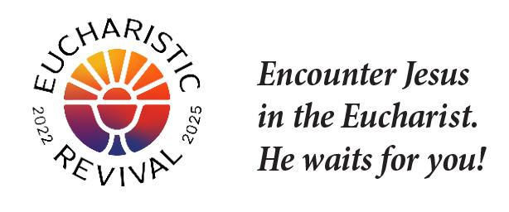
For your Parish Bulletin:
The focus of the Eucharistic Revival is that we grow in our understanding that the Eucharist is truly Jesus.
God wants you to spend eternity with Him.
God desires that you spend eternity in Heaven with the Blessed Trinity – Father, Son and Holy Spirit. Jesus was willing to die for you so that we may be united with Him forever in Heaven. Jesus came on this rescue mission to save His children so that all of us can spend eternity with Him. Our closest union with Jesus on earth is receiving the Holy Eucharist – Jesus Himself – at Mass.
Let’s pray this right now and every day this week: Jesus, help me to receive Your love. I am so thankful for You and that You want me to be with You forever.
For a list of additional proclamations on the Eucharist, click here: diolc.org/eucharist/learn.
Reminder: For your Parish Bulletin:
Courage Apostolate
Everyone is called to chastity. The Courage Apostolate (couragerc.org) is a ministry dedicated to the spiritual needs of persons who experience same-sex attraction and wish to faithfully live the Church's beautiful teachings on human sexuality. A Courage chapter with a trained chaplain is active in our diocese, meeting monthly online. Contact Ann Lankford, the Director of Catechesis & Evangelization at 608-791-2658 or alankford@diolc.org for details.
Reminder: For your Parish Bulletin:
Amen App
The Amen app is the free Catholic prayer app that inspires your daily conversation with God through faithful meditations and nourishing Scripture. You are welcome to register for this app from the Augustine Institute by clicking here: www.augustineinstitute.org/program-and-resources/amen
Jesus and the Eucharist Small Group Study - Lent
Every parish across the Diocese is invited to host the Jesus and the Eucharist study [FREE in English and Spanish] during the Year of Parish Revival. This seven-session series will immerse participants in the initial proclamation of the “Good News” (Sessions 1–4) and unveil God’s saving work in the Eucharist (Sessions 5–7). Each session opens with an exhortation from a different bishop, followed by a prayer reflecting on a Scripture passage. The main lesson is drawn from content created by the Augustine Institute and will include personal testimonies from Catholics across the country, as well as small group discussions. Visit www.eucharisticrevival.org/formation-resources Scroll down for the study materials and training resources.
Catechetical Leader Information:
Must-see 30 minute video with Jason Evert, Mary Hasson and Fr. Boquet
This video is a must-see for all parents, catechetical leaders and catechists on speaking with kids about gender dysphoria, entitled “How to Talk to Your Kids about Human Sexuality “. Click here:
https://ondemand.ewtn.com/free/Home/Play/en/SPH2012
The Eucharistic Revival – a brief proclamation for parents and students:
Please see the brief proclamation above entitled God wants you to spend eternity with Him. The concise, inspiring explanation of the reality of Jesus’ true presence in the Eucharist is provided for your communication with parents and catechists, and to provide a brief proclamation on the Eucharist each week with the children/youth.
Click here for additional entries: diolc.org/catechesis/catechetical-leaders-info

<<Top >>

Director: Erik Archer– 608.791.2661 | earcher@diolc.org

No items this week.

<<Top >>

Director: Sr. Donna Krzmarzick, ISSM – 608.791.2690 | dkrzmarzick@diolc.org

No items this week.

<<Top >>

Director: Deacon Robert Riedl – 608.791.2665 | rriedl@diolclergy.org

(Reminder) Fall Ministry Days:
Please log into the website to register for Fall Ministry Days using this link: https://diolc.org/vicarforclergy/
(Reminder) Deacon Days with the Bishop: (Attendance is Expected)
- 2024 – Aug. 10
- 2025 – Aug. 9
- 2026 – Aug. 8

<<Top >>

Director: Christopher Rogers – 608.791.2659 | crogers@diolc.org

Pilgrimage for Life - January 17-21, 2024
We are excited to offer the Pilgrimage for Life. We will be traveling by coach bus to Washington, DC to participate in the annual March for Life. This opportunity is for anyone ages 13 and up. The estimated cost is estimated to be $400 per person. Parishes/Schools wishing to get a group to join us will have their participants complete the registration online by filling out all of the required forms and pay a non refundable deposit of $100. The remainder of the fee will be paid to the parish/school. All information and registration link can be found at https://diolc.org/yya/youth-opportunities/pilgrimage-for-life/

“the Answer” Eucharistic Rally
We are very excited to announce “the Answer” Eucharistic Rally that will be held on June 7, 2024 at the La Crosse Center in La Crosse, WI. This event kicks off the six days that the Marian Route of the National Eucharistic Pilgrimage will be in the Diocese of La Crosse. “the Answer” Eucharistic Rally will begin with a Eucharistic Procession across the Cameron Street Bridge in La Crosse and will end at the La Crosse Center where the rest of the rally will take place. The day will include Mass, Adoration, Confession, powerful speakers such as Chris Stefanick, Immaculee Ilibagize, and Josh Rosa, music from Luke Spehar, and plenty of vendors. The cost for this event is only $15 per person. This rally is for youth, young adults, adults, families, etc. Tickets will go on sale Dec. 15, 2023. You can find more information about the event and the other days the Marian Route will be in our diocese by visiting: https://diolc.org/the-answer/.

(Reminder) Natural Family Planning
For Priests, Deacons and Parish staff:
USCCB Free Resources to Download
Diocese of La Crosse NFP Brochure (use diolc.org email for access)

NFP classes are offered to interested couples by the Marriage and Family Life Office. To
inquire about diocesan classes, go to diolc.org/nfp or email ckitzhaber@diolc.org. Read
more regarding NFP on the USCCB website at www.usccb.org/prolife/issues/nfp.

(Reminder) Marriage Enrichment and Parenting Resources:
For your marriage website: foryourmarriage.org/ or use your smartphone’s camera to scan the QR code to the right. This website from the USCCB helps couples at all stages of life to understand and live God’s plan for happy, holy marriages.

(Reminder) Teaching the Way of Love:
Please visit twl4parents.com/ or use your smartphone’s camera to scan the QR code to the right. This website is full of encouragement and tips for parents to continue to be the primary educators of their children.

(Reminder) Diocesan Website for Clergy and Marriage Ministers Regarding Marriage Preparation:
Use this link: diolc.org/marriage/marriage-preparation/marriage-preparation-for-ministers/ to go directly to the section of our website containing resources for clergy and marriage ministers. There are step-by-step instructions, downloadable guidelines, downloadable forms and much more! Please let us know if we can assist you in this ministry.

(Reminder) Process for Training FOCCUS Facilitators:
The process for training FOCCUS facilitators is as follows: Each parish needs to contact FOCCUS directly to set up an account for your parish, if one has not already been set up, then train your couples directly through FOCCUS. The contact person at FOCCUS is Max Allen. He is happy to work directly with your parish priest or contact person. His contact information is mrallen@foccusinc.com or phone: 402.827.3735, ext. 1317.

<<Top >>

Director: Christopher Ruff – 608.791.0161 | cruff@diolc.org

No items this week.

<<Top >>

Director: Fr. Woodrow Pace – 608.791.2676 | wpace@diolc.org

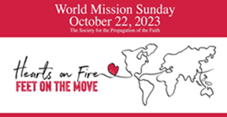WORLD MISSION SUNDAY THANK YOU Your generous response to the 2023 World Mission Sunday request for prayer and financial support is much appreciated! Reminder: Parish bookkeepers, please give donors credit for all WMS donations on their Parishsoft parish-giving tax statements. If checks are made payable to SPOF (Society for the Propagation of the Faith) instead of your local parish, please also deposit them (if your bank allows, which most do) into the parish account. The total of these funds is then forwarded in a parish check to the Mission Office, along with the ParishSoft report, which lists the name, address, and donor amount. Additional information can be found on the Mission Office website. Please email the Mission Office with any questions. God bless you for your extra time and efforts for the missions.
Remembering the Holy Souls with MASS INTENTIONS: If your parish has a surplus of Mass intentions, please remember the Mission Office is happy to forward them to our missionary and senior priests, who will offer them in a very timely manner. Many missionary priests do not receive a salary, and stipends help support their parishes in remote poverty-stricken areas in numerous ways. Especially during this upcoming month of the Poor Souls in Purgatory, let us remember our departed loved ones with the spiritual gift of a Mass.

<<Top >>

Director: Christopher Carstens – 608.791.0161 | ccarstens@diolc.org

The Divine Office Hymnal: Available for Purchase and Optional Liturgical Use
From the Bishops’ Committee on Divine Worship Newsletter, May-June 2023
The USCCB’s Secretariat of Divine Worship announces the publication of The Divine Office Hymnal and its availability for optional liturgical use in the United States, now available for purchase at GIAmusic.com/divineoffice. The pew edition costs $25, while the accompaniment book for piano and organ costs $100. Several indices are included, and it is organized to follow the structure of the Liturgy of the Hours; these features help facilitate the use of the hymnal in a variety of circumstances.
Read more about the Divine Office Hymnal at Adoremus Bulletin.
<<Top >>

Director: Teresa Brown – 608.791.2679 | tbrown@diolc.org

DIOCESE OF LA CROSSE GUIDELINES FOR REPORTING INSTANCES OF CHILD ABUSE

The Diocese of La Crosse, through its policies and procedures, seeks to provide a prompt, appropriate and compassionate response to reporters of sexual abuse of a child by any diocesan agent (bishop, priest, deacon, employee, religious, vendor or volunteer). Anyone wishing to make a report of an allegation of sexual abuse should send that report to Mrs. Teresa Brown, Complaint Intake Agent, at the Diocese of La Crosse, P.O. Box 4004, La Crosse, WI 54602-4004. Alternatively, you can contact Mrs. Brown at 608.791.0179 or intakeagent@diolc.org. The reporting form is available through the Diocese of La Crosse Office of Safe Environment or on the diocesan website at: diolc.org/safe-environment/reporting. Individuals are also encouraged to take their reports directly to civil authorities. Copies of the diocesan policy are available through your local Parish and on the diocesan website. If you have any questions about the Diocese of La Crosse and the implementation of the Charter for the Protection of Children and Young People, please contact Teresa Brown, Diocese of La Crosse, at 608.791.2679 or tbrown@diolc.org.
Parish Packets were distributed at Fall Ministry Days. Each folder has information specific to their own parish inside. On the left hand side is the 2023-24 report form, the parish spreadsheet and all current forms. On the right side is information that must be openly displayed at a parish.
Reports are due on March 1, 2024. As of Oct. 27, six (6) parishes have submitted their report. If you have questions or need assistance, please let me know. We can work together by Zoom, phone or in person.
Have all of your staff and volunteers been trained yet? Remember, those that have consistent contact with children need to be background checked and trained before they work with children. If you need a group training done, I can help.
School spreadsheets will be sent out soon. Don’t wait until just before the start of Spring sports to get background information and training completed. Ask for the information now.
All your children shall be taught by the Lord, and great shall be the peace of your children. Isaiah 54:13

Have a Happy and Safe Halloween
Superintendent: Thomas Reichenbacher – 608.788.7707 | treichenbacher@diolc.org

No items this week.

<<Top >>

Director: Christopher Ruff – 608.791.0161 | cruff@diolc.org

For Your Parish Bulletin:
Wisconsin Bishops’ Statement on Hamas Attack:
“The Bishops of Wisconsin unequivocally condemn the Hamas terrorist attack on unarmed Israeli civilians and the taking of women, children, and elders as hostages. We deplore this and every form of antisemitism. We mourn for the innocent Israelis and Palestinians who will now lose their lives because of this brutality. We pray that the hostages and refugees from this conflict may find safety. May nations welcome them with compassion.”

For Your Parish Bulletin:
Donate to Help the Victims of Violence in the Holy Land
Catholic Relief Services, in conjunction with Caritas partners, are working to meet the desperate humanitarian needs caused by the terrorism and fighting in the Holy Land. To learn how you can help, visit www.crs.org or scan the QR code to the right.

For Parish Bulletins in the La Crosse, Tomah, Arcadia, and Richland Center deaneries:
Please Support “Hope’s Door” Pregnancy and Family Resource Center
Hope’s Door is being planned as a state-of-the-art pregnancy resource center for the La Crosse area. It will be an interfaith, Christ-centered facility that will offer compassionate assistance to women and families, including mentoring and classes, as well as medical resources like ultrasounds and abortion pill reversal treatment. Its services will be in harmony with Catholic teaching. Bishop Callahan recently wrote a letter to area pastors encouraging them to invite the faithful to offer their prayers and financial support to Hope’s Door. To see a flyer and brochure, visit www.diolc.org/respect-life and click on the links, or scan the QR code to the right.

(Reminder) For Your Parish Bulletin:
Post-Abortion Healing Ministry in the Diocese of La Crosse
Do you know someone who is carrying the grief and sorrow of past abortions? Project Rachel Ministry offers a compassionate heart and confidential help. Call 608.860.6698 or email projectrachel@diolc.org.
For Your Parish Bulletin:
Post-Abortion Healing Retreats - Rachel’s Vineyard - Encounter God’s Mercy
Rachel's Vineyard is a weekend retreat to help anyone who has struggled with the aftermath of abortion to begin healing through a supportive, trauma-sensitive approach. Each weekend is run by a team of trained volunteers (counselor, priest, and lay people), who care deeply for your needs. All interactions with the Rachel's Vineyard retreat team are completely confidential. These retreats will be offered in the Diocese of Madison on Nov. 10-12, 2023, March 15-17, 2024, and Nov. 8-10 2024. For more information, visit madisondiocese.org/rachel or scan the QR code on the right.
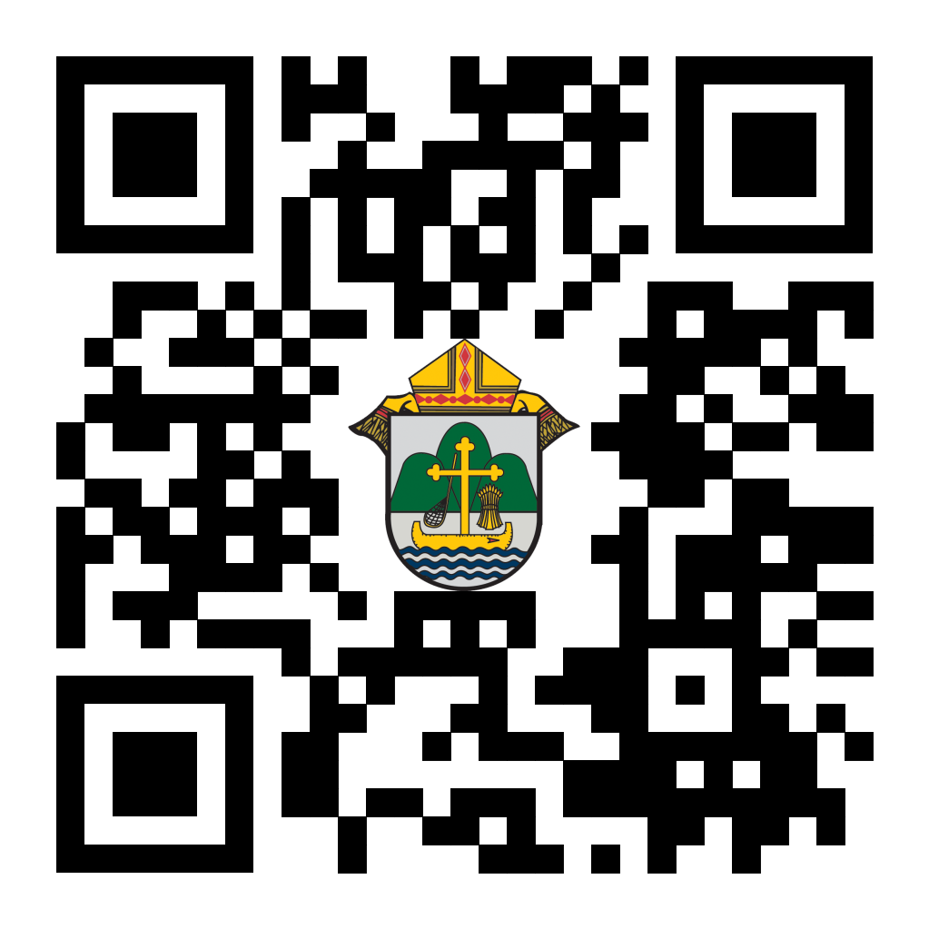
(Reminder) For Your Parish Bulletin:
Chalice of Mercy is in Ukraine, Needs Our Help
Please donate to the Ukrainian relief efforts of Chalice of Mercy if you are able, and pray for the safety of their volunteers on the ground there, who put their lives on the line. Financial assistance is the biggest need at this time. To give, visit chaliceofmercy.org/donate or use your smartphone’s camera to scan the QR code to the right.

<<Top >>

Director: Jeff Reiter – 608.791.2653 | jreiter@diolc.org
Diocesan Annual Appeal:
If you have not signed up to let us know when you plan to announce the Diocesan Annual Appeal at your parish, please complete the form at https://forms.gle/sWxXCPNARTGatTiD7
Parishes that fail to sign up by Nov 15, 2023will have their parishioners automatically mailed for the first weekend in December 12/2-3/2023
In early December we will send a followup mailing for any parish that announced prior to November 11/12. The expected in home date will be December 18. We encourage any parish who wishes to include a letter from the pastor and or the Finance Council to submit a word document. Please include the parish number in the file name. The deadline to submit a letter is November 28, 2023.
Inspired By The Spirit and Diocesan Annual Appeal:
We have become aware that parishes are again making and using copies of the pledge form. These are parish-specific, and for our electronic banking and gift-scanning process, the pledge form must meet particular specifications to size and QR location to be more efficient, helping keep costs down and ensuring the correct parish and supporter is getting credit for that gift.
If you need more pledge forms, please contact Sarah Komperudskomperud@diolc.org; we will order more. Please allow 14 days for delivery.
Magisterium AI:
Are you looking for help with a homily, have a specific pastoral or Canon Law question, or are just curious about Catholic Stewardship? You might find the solution on a new Artificial Intelligence (AI) website dedicated to over 6,111 Catholic Church documents. The website provides references to each document cited in the search results. Whether looking for information on the Eucharist, Canon Law, or Catholic Stewardship, this free (subscription is available) website can generate results in seconds. Though it's still in Beta form, like any AI site, it will continue to grow and improve with user inquiries. Like any creative tool AI sites are just the beginning and should be reviewed carefully.
https://www.magisterium.com/
Weekly Stewardship quotes (shorter bulletin reflections):
October-December
https://diolc.org/wp-content/uploads/2023/09/Stewardship-Bulletin-Reflections-Oct-Dec-2023.pdf
- Spanish Version
https://diolc.org/wp-content/uploads/2023/09/Stewardship-Bulletin-Reflections-Oct-Dec-2023-Spanish.pdf
Weekly Stewardship Prayers of the Faithful:
October-December
https://diolc.org/wp-content/uploads/2023/09/Prayers-of-the-Faithful-Oct-Dec-2023.pdf
- Spanish Version
https://diolc.org/wp-content/uploads/2023/09/Prayers-of-the-Faithful-Oct-Dec-2023-Spanish.pdf
Stewardship Bulletin Reflections for Weekends:
- 11/05
https://diolc.org/wp-content/uploads/2023/10/11.05.23-stewardship-bulletin-announcements.pdf
- 11/12
https://diolc.org/wp-content/uploads/2023/10/11.12.23-stewardship-bulletin-announcements.pdf
- 11/19
https://diolc.org/wp-content/uploads/2023/10/11.19.23-stewardship-bulletin-announcements.pdf
- 11/26
https://diolc.org/wp-content/uploads/2023/10/11.26.23-stewardship-bulletin-announcements.pdf
Stewardship Homily Reflections:
Stewardship reflections for your homily development:
- For Weeks 11/05 - 11/26/23:
https://diolc.org/wp-content/uploads/2023/10/Homily-Guide-10.31.23.pdf
Planned Giving – Leaving a Legacy, Wills, Bequest, and Endowments:
We have been entrusted with precious treasures passed down from our ancestors, and it's our responsibility to ensure that future generations can also enjoy the splendor and reverence of a well-maintained parish. One way to achieve this is by utilizing the Capital Campaign and providing information on Endowments, Trusts, and Bequests to the parishioners.
Our Estate Planning Guide can help save hundreds of dollars in legal and financial estate planning costs. We have mailed out several hundred copies per individual request, and each Parish has received a copy. Please feel free to contact our office for additional copies.
Visit diolclegacy.org, our Planned Giving website, to find calculators, and more information, sign up for a newsletter, and request specific estate planning guides and information. Our website also provides instructions on how to do an IRA Rollover, the creation of Donor Advised Funds (DAF), Beneficiary Designations, and Stock Transfers. https://diolclegacy.org/?pageID=5
If you require more information on legacy giving, presentations, or ads for your Parish bulletin, please contact our office or the Catholic Foundation of West Central Wisconsin (cfwcw.org) at 608.519.9892 or email eboos@cfwcw.org.
<<Top >>

Diocesan Finance Officer: James Reider – 608.791.2668 | jreider@diolc.org

No items this week.

<<Top >>

Director of Vocation Recruitment: Fr. Nate Kuhn – 608.791.2666 | nkuhn@diolc.org

Vocations Intercessions
Please include the following intercession for vocations for your Sunday prayers of the faithful.
That our parish community will nurture marriage, blessed single lives, and religious vocations through their lives of prayer and service, giving witness to God's loving action in the world.
Consider adding a vocations paragraph to your parish bulletin. Below is an example – they will be changed each week. Feel free to use any or all of them.
Called to More
What if there was more? What if I could be more? Sometimes we can look around and think that there isn’t anything more that can be offered to us, that this is the best I can get. We settle for something that leaves us feeling empty and hungering for more. Perhaps this is an opportunity to ask the Lord what He is calling you to do. As we turn to God in the midst of human mediocrity, we can find something that is eternally greater. Consider your vocation and where God may be leading you. Could it be a call to the priesthood? To begin the conversation or to inquire about what it means to be a priest, please contact me: Fr. Nate Kuhn, Director of Vocational Recruitment for the Diocese of La Crosse, 3710 East Ave. S. PO Box 4004, La Crosse, WI 54602; or by phone at: 608.791.2667. God bless you!

<<Top >>

Director: Very Rev. Woodrow H. Pace – 608.791.2689 | wpace@diolc.org
Evenings of Recollection
Please register for these sessions by emailing rorth@diolc.org.
La Crosse (Shrine) – 1st Thursdays
Nov. 2, 2023
Dec. 7, 2023
Jan. 4, 2024
Feb. 1, 2024
Mar. 7, 2024
Apr. 4, 2024
May 2, 2024
Mosinee – 2nd Thursdays
Nov. 9, 2023
Dec. 14, 2023
Jan. 11, 2024
Feb. 8, 2024
Mar. 14, 2024
Apr. 11, 2024
May 9, 2024
Durand – 3rd Tuesdays
Nov. 14, 2023 – MONDOVI
Dec. 19, 2023
Jan. 16, 2024
Feb. 13, 2024
Mar. 19, 2024
Apr. 16, 2024
May 14, 2024
<<Top >>

Director: Christopher Rogers – 608.791.2659 | crogers@diolc.org

Pilgrimage for Life - January 17-21, 2024
We are excited to offer the Pilgrimage for Life. We will be traveling by coach bus to Washington, DC to participate in the annual March for Life. This opportunity is for anyone ages 13 and up. The estimated cost is estimated to be $400 per person. Parishes/Schools wishing to get a group to join us will have their participants complete the registration online by filling out all of the required forms and pay a non refundable deposit of $100. The remainder of the fee will be paid to the parish/school. All information and registration link can be found at https://diolc.org/yya/youth-opportunities/pilgrimage-for-life/

“the Answer” Eucharistic Rally |June 7
The La Crosse Center, La Crosse, WI
We are very excited to announce “the Answer” Eucharistic Rally that will be held on June 7, 2024 at the La Crosse Center in La Crosse, WI. This event kicks off the 6 days that the Marian Route of the National Eucharistic Pilgrimage will be in the Diocese of La Crosse. “the Answer” Eucharistic Rally will begin with a Eucharistic Procession Across the Cameron Street Bridge in La Crosse and will end at the La Crosse Center where the rest of the rally will take place. The day will include Mass, Adoration, Confession, powerful speakers such as Chris Stefanick, Immaculee Ilibagize, and Josh Rosa, music from Luke Spehar, and plenty of vendors. The cost for this event is only $15 per person. This rally is for youth, young adults, adults, families, etc. Tickets will go on sale December 15, 2023. You can find more information about the event and the other days the Marian Route will be in our diocese by visiting: https://diolc.org/the-answer/.

(Reminder) SEALED! Fall Diocesan Confirmation Retreat
The SEALED! Diocesan Confirmation Retreat will be held Dec. 9, 2023, at St. Olaf Catholic Church in Eau Claire, WI. Click this link to register and find out more information: https://diolc.org/yya/youth-opportunities/immersion-retreat/

(Reminder) Updated Office for Family Life Calendar of Events Through 2025:
In the Office for Family Life, we are working to keep our event planning at least two years out. We have created a calendar that may help you in planning for the next couple of years. You will see the dates have hyperlinks that allow you to add this event to your Google Calendar. Below each event is a hyperlink to the page on our website with more information, including registration links for that particular event. Please follow this link to get a list of events planned so far: https://drive.google.com/file/d/17YHE2dCa267CYfgCXZVP1hSwjTMNfhY-/view?usp=sharing

<<Top >>

Diocese of La Crosse | 3710 East Ave S | La Crosse, WI 54601 | 608-788-7700
To unsubscribe from this e-mail message contact mwilson@diolc.org

