Chancery Bulletin - Vol. 8, No. 11.2 | November 14, 2023

- Catechesis & Evangelization  - Chancery  - Communications  - Consecrated Life  - Diaconate  - Marriage & Family Life  - Ministries  - Mission Office  - Sacred Worship | - Safe Environment  - Schools Office  - Social Concerns  - Stewardship and Development  - Temporalities  - Vocations  - Vicar for Clergy  - Youth and Young Adult Ministry  - Past Chancery Bulletins
No items this week.

<<Top >>

Chancellor Very Rev. William Dhein – 608.791.2655 | wdhein@diolc.org

No items this week.

<<Top >>

As of Nov. 14

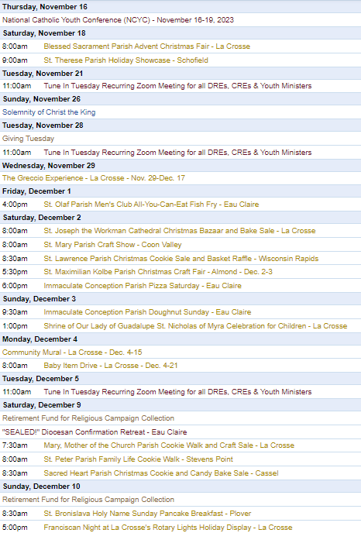
To get your parish events listed on the diocesan calendar, diolc.org/calendar, and in Catholic Life magazine, please send an email to datebook@diolc.org. Make sure you include the following details: date, beginning/ending times, event location, description, menu and cost, etc. If you have any questions, please call Pam Willer at 608.788.1524 for more information.

<<Top >>

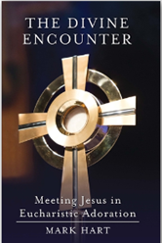
Director: Ann Lankford – 608.791.2658 | alankford@diolc.org

Helping people to realize that the Eucharist is Jesus!
Helping people encounter the healing and renewing presence of Jesus’ Real Presence in the Eucharist is central to the Revival. A reader-friendly book to help people engage in the Eucharistic Revival is available.
The Divine Encounter: Meeting Jesus in Eucharistic Adoration by Mark Hart is available for $2.60 per book (retail $9.99). Contact Beth at bjohnson@diolc.org to place your order. Click here for further info.: diolc.org/catechesis/catechetical-leaders-info
For the Parish Bulletin
Advent: A Time of Preparation
This year, the season of Advent begins on Sunday, December 3rd. Advent is the four weeks we set aside for preparing our hearts before the annual celebrations of Christ’s birth on Christmas. The Incarnation – God becoming man – is the turning point of history. Our Heavenly Father loves us so much that He promised to send us a Savior after the Original Sin of Adam and Eve. And He kept His promise. The Son of God was born in Bethlehem to give His life for us on the cross so that our sins can be forgiven, so that we “may have life, and have it to the full.” (John 10:10). This preparation during Advent is to include interior penance, which involves a conversion of heart toward God and away from sin. Let us take Advent seriously by taking more time for prayer, offering small sacrifices for peace in families and the world, and receiving the Sacrament of Penance.
For your Parish Bulletin:
The Eucharist is Jesus! Let us grow in our understanding and love for this incredible Gift.
Jesus is our greatest Friend.
Jesus loves each one of us and desires to be with us always. Jesus gives Himself to us in the Holy Eucharist, so that He can live in our heart. The Holy Eucharist is Christ’s Body and Blood. We know that Jesus is our greatest Friend because He gives Himself to us completely in the Holy Eucharist. The word Eucharist means thanksgiving.
Let’s pray this right now and every day this week: Jesus, Thank You for giving Yourself to me and being my closest Friend.
For a list of additional proclamations on the Eucharist, click here: diolc.org/eucharist/learn.
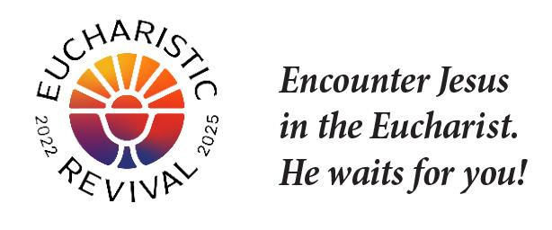
Eucharistic Revival Logos - for Parish Use:
For use on the parish website and communications, various high-resolution logos to draw people’s attention to the Eucharistic Revival are available here: diolc.org/eucharist/lead. Scroll down to Eucharistic Revival Logos.
Jesus and the Eucharist Small Group Study - Lent:
Every parish across the Diocese is invited to host the Jesus and the Eucharist study (Free in English and Spanish) during this Year of Parish Revival. This seven-session series will immerse participants in the initial proclamation of the “Good News” (Sessions 1-4) and unveil God’s saving work in the Eucharist (Sessions 5-7). In addition to a video, each session includes a prayer based on a Scripture passage, two compelling testimonies, and small group discussions. The Augustine Institute produced the series.
Visit diolc.org/eucharist/lead for the study materials and a downloadable Lenten poster.
(Reminder) Catechesis of the Good Shepherd – Learn More:
Catechists and those involved in an atrium, and those interested in knowing more about Catechesis of the Good Shepherd are invited to the fall online gathering. This annual gathering will feature a presentation by Ruth Sutherland, long-time catechist and trainer. The date is Tuesday, Nov. 28th, from 6:15-7:45 p.m.Please email Ann at alankford@diolc.org to register.
Catechetical Leader Information:
Retreat / Formation for Catechists after Christmas
Many parishes provide a retreat-like time for catechists after Christmas. Please consider including some formation available on Franciscan at Home. The 10-minute videos, followed by discussion, provide a fruitful time for catechists and the catechetical leader to strengthen their relationship with Jesus. Simple directions to register are available here: diolc.org/catechesis/catechetical-leaders-info Scroll down to Franciscan at Home online learning. Suggested workshops in the Catechist Track are:
- Introducing the LIturgy to Children
- The Initial Proclamation (Kerygma): Key Doctrines
- Sacred Scripture: The Big Picture
- The Ecclesial Method
Ongoing formation of parents and children that the Eucharist is Jesus:
In communications with parents, always provide a small “dose” of the reality of the Eucharist.
Encourage catechists to present the brief statement about the Eucharist and a few sentences of explanation to strengthen their understanding. See “Jesus is our greatest Friend” above. Click here for entries: diolc.org/catechesis/catechetical-leaders-info
<<Top >>

Director: Erik Archer– 608.791.2661 | earcher@diolc.org

No items this week.
<<Top >>

Director: Sr. Donna Krzmarzick, ISSM – 608.791.2690 | dkrzmarzick@diolc.org
(Reminder) Retirement Fund for Religious:
The annual collection in parishes for the national Retirement Fund for Religious is scheduled for the weekend of Dec. 9-10. Religious sisters, brothers, and religious order priests benefit significantly from this national collection. Please promote the campaign in your parish bulletin, pulpit announcements, and petitions at Mass (sample texts below and further resources here).
For your parish bulletin:
Weekend before the collection (Dec. 2-3)
You can help. Please donate to the Retirement Fund for Religious next week. Your gift will provide essential care for nearly 25,000 senior sisters, brothers and religious order priests who have dedicated their lives to serving others. Let us show our gratitude to these selfless individuals by giving generously.
Weekend of the collection (Dec. 9-10)
Support a lifetime of service. Women and men religious have spent their lives serving others in prayer, ministry, education and care for those in need—usually for little or no pay. Today, their religious communities do not have enough retirement savings. As they age, they require essential care and medications. Please support them by giving to the Retirement Fund for Religious. Your donation makes a difference for nearly 25,000 senior men and women religious.
Please give generously.

<<Top >>

Director: Deacon Robert Riedl – 608.791.2665 | rriedl@diolclergy.org

DATE CORRECTION
Deacon Continuing Formation Conference | Dec. 1-2|
St. Anthony Spirituality Center, Marathon
The correct date for the Deacon Continuing Formation conference is December 1st - December 2nd. Please update your calendar to reflect this correction. The topic is the Synod on Synodality. Check your email for registration form and schedule. The registration deadline is Nov. 22.

<<Top >>

Director: Christopher Rogers – 608.791.2659 | crogers@diolc.org

For Your Parish Bulletin
Domestic Church Retreat - Save the Date
The next Domestic Church Retreat will be held April 13-14, 2024 at Sts. Peter and Paul Parish in Wisconsin Rapids. During the retreat, couples are invited to delve more deeply into the graces of their shared spiritual journey. The retreat’s goal is to strengthen the couple’s spousal union and lead them to experience complete harmony and joy in their marriage through simple formation and meaningful dialogue that intentionally places Christ in the center. To register and find out more information click this link: https://diolc.org/marriage/marriage-enrichment/

(Reminder) Pilgrimage for Life - January 17-21, 2024:
We are excited to offer the Pilgrimage for Life. We will be traveling by coach bus to Washington, DC to participate in the annual March for Life. This opportunity is for anyone ages 13 and up. The estimated cost is estimated to be $400 per person. Parishes/Schools wishing to get a group to join us will have their participants complete the registration online by filling out all of the required forms and pay a non refundable deposit of $100. The remainder of the fee will be paid to the parish/school. All information and registration link can be found at https://diolc.org/yya/youth-opportunities/pilgrimage-for-life/

(Reminder) “the Answer” Eucharistic Rally:
We are very excited to announce “the Answer” Eucharistic Rally that will be held on June 7, 2024 at the La Crosse Center in La Crosse, WI. This event kicks off the six days that the Marian Route of the National Eucharistic Pilgrimage will be in the Diocese of La Crosse. “the Answer” Eucharistic Rally will begin with a Eucharistic Procession across the Cameron Street Bridge in La Crosse and will end at the La Crosse Center where the rest of the rally will take place. The day will include Mass, Adoration, Confession, powerful speakers such as Chris Stefanick, Immaculee Ilibagize, and Josh Rosa, music from Luke Spehar, and plenty of vendors. The cost for this event is only $15 per person. This rally is for youth, young adults, adults, families, etc. Tickets will go on sale Dec. 15, 2023. You can find more information about the event and the other days the Marian Route will be in our diocese by visiting: https://diolc.org/the-answer/ or use your smartphone’s camera to scan the QR code to the right.

<<Top >>

Director: Christopher Ruff – 608.791.0161 | cruff@diolc.org

No items this week.

<<Top >>

Director: Fr. Woodrow Pace – 608.791.2676 | wpace@diolc.org

No items this week.

<<Top >>

Director: Christopher Carstens – 608.791.0161 | ccarstens@diolc.org

No items this week.

<<Top >>

Director: Teresa Brown – 608.791.2679 | tbrown@diolc.org

DIOCESE OF LA CROSSE GUIDELINES FOR REPORTING INSTANCES OF CHILD ABUSE
The Diocese of La Crosse, through its policies and procedures, seeks to provide a prompt, appropriate and compassionate response to reporters of sexual abuse of a child by any diocesan agent (bishop, priest, deacon, employee, religious, vendor or volunteer). Anyone wishing to make a report of an allegation of sexual abuse should send that report to Mrs. Teresa Brown, Complaint Intake Agent, at the Diocese of La Crosse, P.O. Box 4004, La Crosse, WI 54602-4004. Alternatively, you can contact Mrs. Brown at 608.791.0179 or intakeagent@diolc.org. The reporting form is available through the Diocese of La Crosse Office of Safe Environment or on the diocesan website at: diolc.org/safe-environment/reporting. Individuals are also encouraged to take their reports directly to civil authorities. Copies of the diocesan policy are available through your local Parish and on the diocesan website. If you have any questions about the Diocese of La Crosse and the implementation of the Charter for the Protection of Children and Young People, please contact Teresa Brown, Diocese of La Crosse, at 608.791.2679 or tbrown@diolc.org.

<<Top >>

Superintendent: Thomas Reichenbacher – 608.788.7707 | treichenbacher@diolc.org

No items this week.

<<Top >>

Director: Christopher Ruff – 608.791.0161 | cruff@diolc.org

For Your Parish Bulletin:
Please Support Project Milk in this Season of Thanksgiving & Advent
Help the Diocesan Rural Life Committee spread hope and joy by contributing to Project Milk. Founded in 1984 to help feed the poor children of Casa Hogar in Peru, Project Milk provides whole milk powder to the orphanage and the surrounding community. Each year the Rural Life Committee seeks to raise enough money to ship 40,000 lbs. of milk powder at an approximate cost of $80,000. One hundred percent of your monetary gift is used to feed these children and the poor. To give, visit frjoesguild.org/donate, and select “Project Milk” as your designation, or scan the QR code to the right.

(Reminder) For Your Parish Bulletin:
Donate to Help the Victims of Violence in the Holy Land
Catholic Relief Services, in conjunction with Caritas partners, are working to meet the desperate humanitarian needs caused by the terrorism and fighting in the Holy Land. To learn how you can help, visit www.crs.org or scan the QR code to the right.

(Reminder) For Parish Bulletins in La Crosse and the Surrounding Area:
Please Support “Hope’s Door” Pregnancy and Family Resource Center
Hope’s Door is being planned as a state-of-the-art pregnancy resource center for the La Crosse area. It will be an interfaith, Christ-centered facility that will offer compassionate assistance to women and families, including mentoring and classes, as well as medical resources like ultrasounds and abortion pill reversal treatment. Its services will be in harmony with Catholic teaching. Bishop Callahan recently wrote a letter to area pastors encouraging them to invite the faithful to offer their prayers and financial support to Hope’s Door. To see a flier and brochure, visit www.diolc.org/respect-life and click on the links, or scan the QR code to the right.
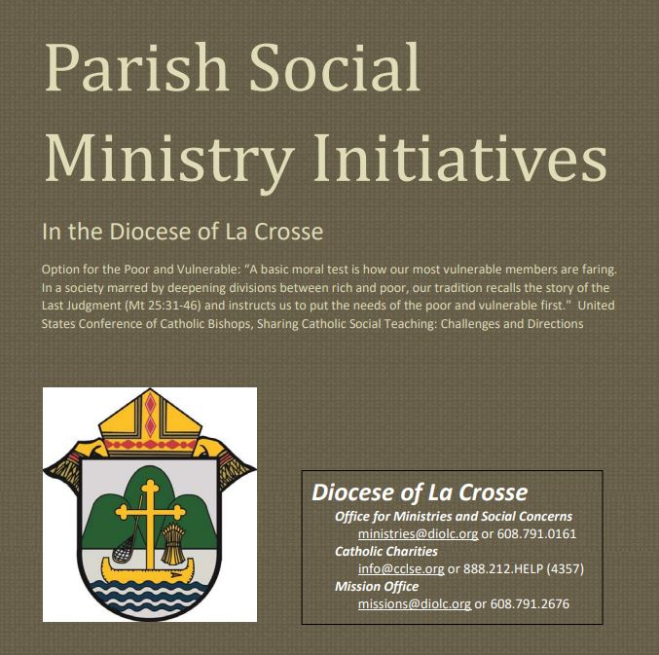
(Reminder) Pastors, Deacons, Parish Social Concerns Representatives:
Are Your Social Ministry Initiatives listed in the Directory?
In order to address most fruitfully the social concerns within our diocese, we are asking the parishes of the diocese to review their current social ministry initiatives (any outreach of charity or social advocacy). If these are not already listed in the diocesan Directory of Parish Social Ministry Initiatives, or if updating is needed, the pastor or someone authorized by him is asked to take a moment to complete and submit this form for each organization/resource.

(Reminder) For Your Parish Bulletin:
Post-Abortion Healing Retreats – Rachel’s Vineyard – Encounter God’s Mercy
Rachel's Vineyard is a weekend retreat to help anyone who has struggled with the aftermath of abortion to begin healing through a supportive, trauma-sensitive approach. Each weekend is run by a team of trained volunteers (counselor, priest, and lay people), who care deeply for your needs. All interactions with the Rachel's Vineyard retreat team are completely confidential. These retreats will be offered in the Diocese of Madison on Nov. 10-12, 2023, March 15-17, 2024, and Nov. 8-10 2024. For more information, visit madisondiocese.org/rachel or scan the QR code on the right.
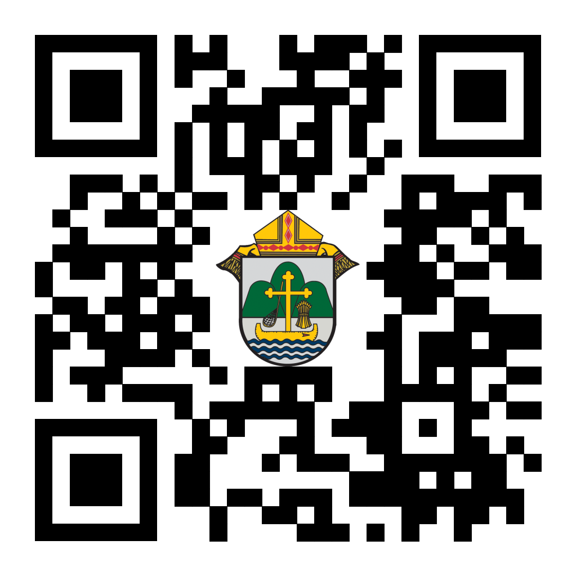
(Reminder) For Your Parish Bulletin:
Chalice of Mercy is in Ukraine, Needs Our Help
Please donate to the Ukrainian relief efforts of Chalice of Mercy if you are able, and pray for the safety of their volunteers on the ground there, who put their lives on the line. Financial assistance is the biggest need at this time. To give, visit chaliceofmercy.org/donate or use your smartphone’s camera to scan the QR code to the right.

<<Top >>

Director: Jeff Reiter – 608.791.2653 | jreiter@diolc.org
Diocesan Annual Appeal:
In early December, we will send a follow-up mailing for any parish that announced and who had their homes mailed before Nov. 12, 2023. The expected in-home date will be Dec. 18. We encourage any parish who wishes to include a letter from the pastor or Finance Council to submit a Word document. Please include the parish number in the file name. The deadline to submit a letter is Nov. 28, 2023.
Inspired By The Spirit and Diocesan Annual Appeal:
We have become aware that parishes are again making and using copies of the pledge form. These are parish-specific, and for our electronic banking and gift-scanning process, the pledge form must meet particular specifications to size and QR location to be more efficient, helping keep costs down and ensuring the correct parish and supporter is getting credit for that gift.
If you need more pledge forms, please contact Sarah Komperudskomperud@diolc.org; we will order more. Please allow 14 days for delivery.
Magisterium AI:
Are you looking for help with a homily, have a specific pastoral or Canon Law question, or are just curious about Catholic Stewardship? You might find the solution on a new Artificial Intelligence (AI) website dedicated to over 6,111 Catholic Church documents. The website provides references to each document cited in the search results. Whether looking for information on the Eucharist, Canon Law, or Catholic Stewardship, this free (subscription is available) website can generate results in seconds. Though it's still in Beta form, like any AI site, it will continue to grow and improve with user inquiries. Like any creative tool, AI sites are just the beginning and should be reviewed carefully.
https://www.magisterium.com/
Weekly Stewardship quotes (shorter bulletin reflections):
October-December
https://diolc.org/wp-content/uploads/2023/09/Stewardship-Bulletin-Reflections-Oct-Dec-2023.pdf
- Spanish Version
https://diolc.org/wp-content/uploads/2023/09/Stewardship-Bulletin-Reflections-Oct-Dec-2023-Spanish.pdf
Weekly Stewardship Prayers of the Faithful:
October-December
https://diolc.org/wp-content/uploads/2023/09/Prayers-of-the-Faithful-Oct-Dec-2023.pdf
- Spanish Version
https://diolc.org/wp-content/uploads/2023/09/Prayers-of-the-Faithful-Oct-Dec-2023-Spanish.pdf
Stewardship Bulletin Reflections for Weekends:
- 11/19
https://diolc.org/wp-content/uploads/2023/10/11.19.23-stewardship-bulletin-announcements.pdf
- 11/26
https://diolc.org/wp-content/uploads/2023/10/11.26.23-stewardship-bulletin-announcements.pdf
- 1203
https://diolc.org/wp-content/uploads/2023/11/12.03.23-stewardship-bulletin-announcements.pdf
- 12/10
https://diolc.org/wp-content/uploads/2023/11/12.10.23-stewardship-bulletin-announcements.pdf
Stewardship Homily Reflections:
Stewardship reflections for your homily development:
- For Weeks 11/19 - 12/10/23:
https://diolc.org/wp-content/uploads/2023/11/Homily-Guide-11.14.23.pdf
Planned Giving – Leaving a Legacy, Wills, Bequest, and Endowments:
We have been entrusted with precious treasures passed down from our ancestors, and it's our responsibility to ensure that future generations can also enjoy the splendor and reverence of a well-maintained parish. One way to achieve this is by utilizing the Capital Campaign and providing information on Endowments, Trusts, and Bequests to the parishioners.
Our Estate Planning Guide can help save hundreds of dollars in legal and financial estate planning costs. We have mailed out several hundred copies per individual request, and each Parish has received a copy. Please feel free to contact our office for additional copies.
Visit diolclegacy.org, our Planned Giving website, to find calculators and more information, sign up for a newsletter, and request specific estate planning guides and information. Our website also provides instructions on how to do an IRA Rollover, the creation of Donor Advised Funds (DAF), Beneficiary Designations, and Stock Transfers. https://diolclegacy.org/?pageID=5
If you require more information on legacy giving, presentations, or ads for your Parish bulletin, please contact our office or the Catholic Foundation of West Central Wisconsin (cfwcw.org) at 608.519.9892 or email eboos@cfwcw.org.
<<Top >>

Diocesan Finance Officer: James Reider – 608.791.2668 | jreider@diolc.org

Health Enews from Catholic Mutual Group:
Please click here for the November edition of CMG Health Enews.
Endowment and Perpetual Care Funds: The endowment and perpetual care funds that were held by BMO were moved to Trust Point as approved by Bishop William Patrick Callahan, the Diocesan Finance Council, and Presbyteral Council. The Investment Committee over a two-year period reviewed 11 requests for proposal to replace BMO and Columbia Threadneedle. Ultimately, the Committee interviewed three of the 11 firms and recommended Trust Point to the Bishop and the Councils.
The endowment and perpetual care funds were transferred from BMO to Trust Point on Nov. 1, 2023. With the transition new donations and perpetual care funds must now be sent to Trust Point.
To transfer endowment funds to your specific endowment, please follow the Trust Point Contribution Instructions - Endowment Trusts. The instructions require you to identify the account for which the funds are intended. You can use the Endowment Trust - Identifying Account Number Matrix to identify your specific account numbers.
To transfer perpetual care funds to your specific fund, please follow the Trust Point Contribution Instructions - Perpetual Care. The instructions require you to identify the account for which the funds are intended. You can use the Perpetual Care - Identifying Account Number Matrix to identify your specific account numbers.
As a result of the transition from BMO to Trust Point all accounts will achieve their maximum distribution of 4% for FY 2024. Please read the Fiscal Year 2024 Disbursement Schedule. Disbursement Schedule for more information on disbursements occurring this fiscal year..
<<Top >>

Director of Vocation Recruitment: Fr. Nate Kuhn – 608.791.2666 | nkuhn@diolc.org

Please include the following intercession for vocations for your Sunday prayers of the faithful.
For an increase in vocations to Marriage, the Priesthood and Consecrated Life; especially that more young men and women will have the courage to follow a call from God to serve in the Church.
Consider adding a vocations paragraph to your parish bulletin. Below is an example – they will be changed each week. Feel free to use any or all of them.
Come Follow Me!
When Peter encountered Jesus for the first time, he was busy doing his daily work, fishing. He was minding his own business when Jesus approached him and asked him to put his nets out into the deep water for a catch. Although hesitant, he did as Jesus asked him and caught an overabundance of fish! When they returned to shore, Jesus said to Peter, “Come, follow me…” and Peter did. Similarly, the Lord continues to work in our world today, approaching us in our everyday lives and inviting us to consider following Him. Have you ever considered following the Lord as a priest, like Peter? Do you know of a young man whom you think the Lord may be calling to be a priest? Perhaps this is the Lord’s invitation to follow Him.
To begin the conversation or to inquire about what it means to be a priest, please contact me: Fr. Nate Kuhn, Director of Vocational Recruitment for the Diocese of La Crosse, 3710 East Ave. S. PO Box 4004, La Crosse, WI 54602; or by phone at: 608.791.2667. God bless you!

<<Top >>

Director: Very Rev. Woodrow H. Pace – 608.791.2689 | wpace@diolc.org

Did you drop off vestments at the Diocesan Center during Fall Ministry Days? Please email Renee’ (rorth@diolc.org) so we know who dropped them off and who is to be picking them up.

<<Top >>

Director: Christopher Rogers – 608.791.2659 | crogers@diolc.org

(Reminder) Pilgrimage for Life – Jan. 17-21, 2024:
We are excited to offer the Pilgrimage for Life. We will be traveling by coach bus to Washington, DC to participate in the annual March for Life. This opportunity is for anyone ages 13 and up. The estimated cost is estimated to be $400 per person. Parishes/Schools wishing to get a group to join us will have their participants complete the registration online by filling out all of the required forms and pay a non refundable deposit of $100. The remainder of the fee will be paid to the parish/school. All information and registration link can be found at https://diolc.org/yya/youth-opportunities/pilgrimage-for-life/

(Reminder) “the Answer” Eucharistic Rally:
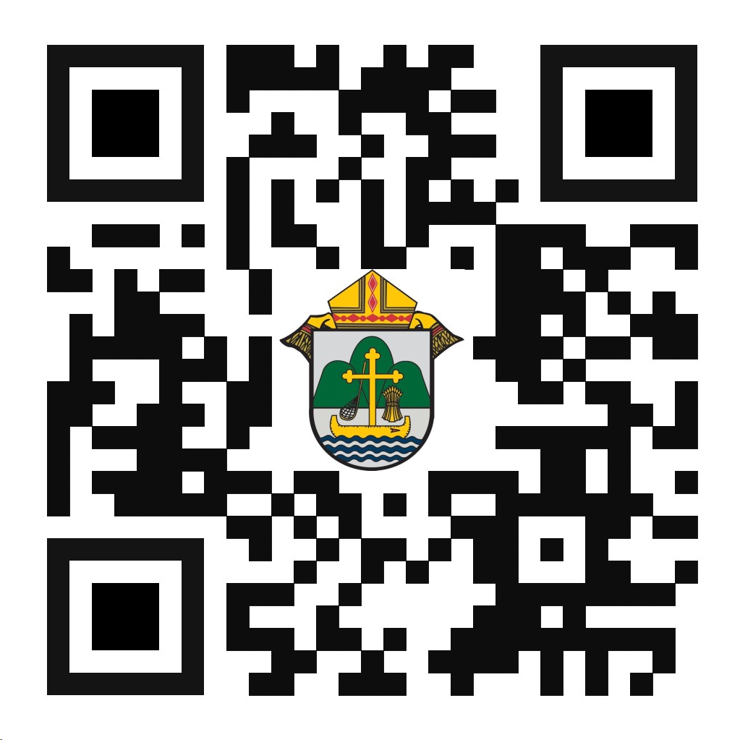
We are very excited to announce “the Answer” Eucharistic Rally that will be held on June 7, 2024 at the La Crosse Center in La Crosse, WI. This event kicks off the six days that the Marian Route of the National Eucharistic Pilgrimage will be in the Diocese of La Crosse. “the Answer” Eucharistic Rally will begin with a Eucharistic Procession across the Cameron Street Bridge in La Crosse and will end at the La Crosse Center where the rest of the rally will take place. The day will include Mass, Adoration, Confession, powerful speakers such as Chris Stefanick, Immaculee Ilibagize, and Josh Rosa, music from Luke Spehar, and plenty of vendors. The cost for this event is only $15 per person. This rally is for youth, young adults, adults, families, etc. Tickets will go on sale Dec. 15, 2023. You can find more information about the event and the other days the Marian Route will be in our diocese by visiting: https://diolc.org/the-answer/ or use your smartphone’s camera to scan the QR code to the right.

(Reminder) SEALED! Fall Diocesan Confirmation Retreat
The SEALED! Diocesan Confirmation Retreat will be held Dec. 9, 2023, at St. Olaf Catholic Church in Eau Claire, WI. Click this link to register and find out more information: https://diolc.org/yya/youth-opportunities/immersion-retreat/

<<Top >>

Diocese of La Crosse | 3710 East Ave S | La Crosse, WI 54601 | 608-788-7700
To unsubscribe from this e-mail message contact mwilson@diolc.org

