Chancery Bulletin - Vol. 8, No. 11.3 | November 21, 2023

- Catechesis & Evangelization  - Chancery  - Communications  - Consecrated Life  - Diaconate  - Marriage & Family Life  - Ministries  - Mission Office  - Sacred Worship | - Safe Environment  - Schools Office  - Social Concerns  - Stewardship and Development  - Temporalities  - Vocations  - Vicar for Clergy  - Youth and Young Adult Ministry  - Past Chancery Bulletins
The Most Reverend William Patrick Callahan, D.D., Bishop of La Crosse, makes the following announcements:

The Reverend Monsignor Robert P. Hundt is reappointed as Judicial Vicar for a term of November 20, 2023, to July 1, 2025.

The Reverend Alan M. Guanella, Pastor of Our Lady Queen of Heaven Parish in Wisconsin Rapids, is appointed as Adjutant Judicial Vicar for a term of November 20, 2023, to July 1, 2028.
CORRECTION: The Reverend Michael E. Klos, Pastor of Nativity of the Blessed Virgin Mary Parish in St. Mary’s Ridge, Sacred Heart Parish in Cashton, and St. Augustine of Hippo Parish in Norwalk, is appointed Pastor of Sacred Heart-St. Patrick Parish in Eau Claire, with residence at Sacred Heart Rectory, effective December 1, 2023. He will continue as Principal of Sacred Heart Catholic School in Cashton.
The Reverend Matthew L. Bowe, Associate Pastor of Queen of the Apostles Parish in Tomah, is also appointed Parochial Administrator of Nativity of the Blessed Virgin Mary Parish in St. Mary’s Ridge, Sacred Heart Parish in Cashton, and St. Augustine of Hippo Parish in Norwalk, effective December 1, 2023. His residence remains at Queen of the Apostles Parish rectory in Tomah.
Mr. Eric Boos, Executive Director of the Catholic Foundation of West Central Wisconsin, submitted his resignation, and it was accepted, effective November 10, 2023.
<<Top >>

Chancellor Very Rev. William Dhein – 608.791.2655 | wdhein@diolc.org

No items this week.

<<Top >>

As of Nov. 21
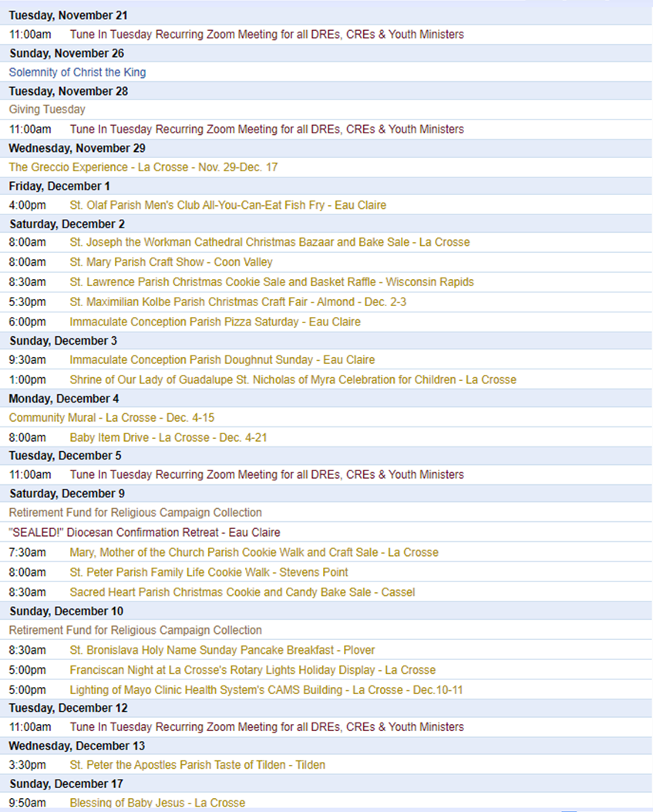

To get your parish events listed on the diocesan calendar, diolc.org/calendar, and in Catholic Life magazine, please send an email to datebook@diolc.org. Make sure you include the following details: date, beginning/ending times, event location, description, menu and cost, etc. If you have any questions, please call Pam Willer at 608.788.1524 for more information.

Listing your parish events in the March/April issue of Catholic Life:
If your parish has any events coming up in March/April, we would love to include them in the latest issue of Catholic Life. To have your events listed, please submit them by Nov. 27. You can also have your parish events listed on diolc.org/calendar. To do so, kindly email datebook@diolc.org and include the date, beginning/ending times, event location, description, dinner menu and cost, etc. If you have any questions, please don't hesitate to call Pam Willer at 608.788.1524.

<<Top >>

Director: Ann Lankford – 608.791.2658 | alankford@diolc.org
For the Parish Bulletin:
The Advent Wreath
Each family is encouraged to set up an Advent wreath, which helps us stay focused on this time of preparation and can be assembled by using evergreen limbs from a tree in the yard and four candles. The evergreens, which retain their green, vibrant life through the year, signify continuous life. The circle of the wreath, which has no beginning or end, symbolizes God's eternity, the soul's immortality, and the everlasting life found in Christ who was victorious over sin and death through His Passion, Death and Resurrection.
The four candles represent the four weeks of Advent. The light of the candles shines in the darkness, which is most evident during this time of the year as it is darker due to shorter daylight hours. We use candles in the Advent wreath and put lights on a Christmas tree, signifying the coming of Christ, who is "the Light that came into the world" to dispel sin's darkness and to radiate God's truth and love. Jesus is the light of the world!
For your Parish Bulletin:
The Eucharist is Jesus! Let us grow in our understanding and love for this incredible Gift.
How do we get to know Jesus better?
Jesus knows each one of us better than we know ourselves and He loves us. Friendship always involves two persons. We want to get to know this Person who loves us so much through reading the Scriptures (the Bible). As we prepare to enter Advent, it is a perfect time to read the Scriptures and remember how Jesus came to us, born as an infant.
Let's pray this right now and every day this week: Jesus, please give me the desire to read the Bible a few minutes each day.
This week, read the words of the Annunciation of Gabriel to Mary that she will be the Mother of the Son of God in Luke 1: 26-38
For additional proclamations on the Eucharist, click here: diolc.org/eucharist/learn.
Bulletin Inserts for Advent:
If the parish is interested in bulletin inserts for Advent, or for use with parent communications,, visit diolc.org/evangelization/questions and scroll to “Liturgical Year.”
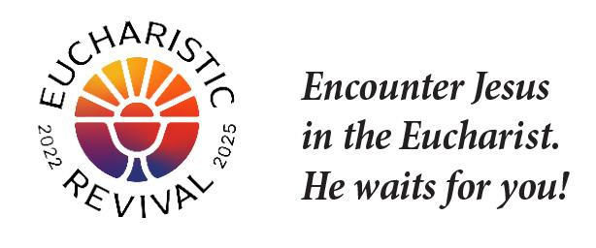
Reminder: Various Logos for the Eucharistic Revival - for Parish Use:
For use on the parish website and communications, various high-resolution logos to draw people’s attention to the Eucharistic Revival are available here: diolc.org/eucharist/lead. Scroll down to Eucharistic Revival Logos.
Reminder: Jesus and the Eucharist Small Group Study - Lent:
Every parish across the Diocese is invited to host the Jesus and the Eucharist study (Free in English and Spanish) during this Year of Parish Revival. This seven-session series will immerse participants in the initial proclamation of the “Good News” (Sessions 1-4) and unveil God’s saving work in the Eucharist (Sessions 5-7). In addition to a video, each session includes a prayer based on a Scripture passage, two compelling testimonies, and small group discussions. The Augustine Institute produced the series.
Visit diolc.org/eucharist/lead for the study materials and a downloadable Lenten poster.
Catechetical Leader Information:
Reminder: Retreat / Formation for Catechists after Christmas
Many parishes provide a retreat-like time for catechists after Christmas. Please consider including some formation available on Franciscan at Home. The 10-minute videos, followed by discussion, provide a fruitful time for catechists and the catechetical leader to strengthen their relationship with Jesus. Simple registration directions are available here: diolc.org/catechesis/catechetical-leaders-info Scroll down to Franciscan at Home online learning. Suggested workshops in the Catechist Track are:
- “Introducing the Liturgy to Children”
- The Good News presented very concisely (“The Kerygma”): Key Doctrines
- The Story of the Bible (“Sacred Scripture: The Big Picture”)
- Teaching for an Encounter with Jesus (“The Ecclesial Method”)
A Minute with Jesus: for parents, parish CCD sessions and Catholic Schools
In communications with parents, always provide a small “dose” of the reality of the Eucharist. Click here for entries or see above: diolc.org/catechesis/catechetical-leaders-info

<<Top >>

Director: Erik Archer– 608.791.2661 | earcher@diolc.org
Attention Pastors, Parish Administrative Assistants and Secretaries:
For those parishes who wish to have Parish Message Lines on the back cover of the January/February 2024 issue of Catholic Life magazine, please enter them by Tuesday, November 28. The January/February issue is expected to arrive in homes by Tuesday, January 2. Please direct questions to Sr. Donna: dkrzmarzick@diolc.org
<<Top >>

Director: Sr. Donna Krzmarzick, ISSM – 608.791.2690 | dkrzmarzick@diolc.org

(Reminder) Retirement Fund for Religious:
The annual collection in parishes for the national Retirement Fund for Religious is scheduled for the weekend of Dec. 9-10. Religious sisters, brothers, and religious order priests benefit significantly from this national collection. Please promote the campaign in your parish bulletin, pulpit announcements, and petitions at Mass (sample texts below and further resources here).
For your parish bulletin:
Weekend of the collection (Dec. 9-10)
Support a lifetime of service. Women and men religious have spent their lives serving others in prayer, ministry, education and care for those in need—usually for little or no pay. Today, their religious communities do not have enough retirement savings. As they age, they require essential care and medications. Please support them by giving to the Retirement Fund for Religious. Your donation makes a difference for nearly 25,000 senior men and women religious.
Please give generously.

New for parish bulletin:
Weekend after the collection (Dec. 16-17)
Our women and men religious offer gratitude. A sister shares, “I thank the Lord for all who give. I don’t think we would make it without them.” Thank you for giving to the Retirement Fund for Religious last week. Your donation makes a difference in the lives of elderly women and men religious. To learn more about how your gift helps, visit retiredreligious.org.

<<Top >>

Director: Deacon Robert Riedl – 608.791.2665 | rriedl@diolclergy.org

DATE CORRECTION:
Deacon Continuing Formation Conference | Dec. 1-2|
St. Anthony Spirituality Center, Marathon
The correct date for the Deacon Continuing Formation conference is Dec. 1-2. Please update your calendar to reflect this correction. The topic is the Synod on Synodality. Check your email for the registration form and schedule or follow this link to download: Registration Form and Schedule The registration deadline is Nov. 22.
<<Top >>

Director: Christopher Rogers – 608.791.2659 | crogers@diolc.org

For Your Parish Bulletin:
Domestic Church Retreat - Save the Date
The next Domestic Church Retreat will be held April 13-14, 2024 at Sts. Peter and Paul Parish in Wisconsin Rapids. During the retreat, couples are invited to delve more deeply into the graces of their shared spiritual journey. The retreat’s goal is to strengthen the couple’s spousal union and lead them to experience complete harmony and joy in their marriage through simple formation and meaningful dialogue that intentionally places Christ in the center. To register and find out more information click this link: https://diolc.org/marriage/marriage-enrichment/

<<Top >>

Director: Christopher Ruff – 608.791.0161 | cruff@diolc.org

No items this week.

<<Top >>

Director: Fr. Woodrow Pace – 608.791.2676 | wpace@diolc.org

No items this week.

<<Top >>

Director: Christopher Carstens – 608.791.0161 | ccarstens@diolc.org

No items this week.

<<Top >>

Director: Teresa Brown – 608.791.2679 | tbrown@diolc.org

DIOCESE OF LA CROSSE GUIDELINES FOR REPORTING INSTANCES OF CHILD ABUSE:
The Diocese of La Crosse, through its policies and procedures, seeks to provide a prompt, appropriate and compassionate response to reporters of sexual abuse of a child by any diocesan agent (bishop, priest, deacon, employee, religious, vendor or volunteer). Anyone wishing to make a report of an allegation of sexual abuse should send that report to Mrs. Teresa Brown, Complaint Intake Agent, at the Diocese of La Crosse, P.O. Box 4004, La Crosse, WI 54602-4004. Alternatively, you can contact Mrs. Brown at 608.791.0179 or intakeagent@diolc.org. The reporting form is available through the Diocese of La Crosse Office of Safe Environment or on the diocesan website at: diolc.org/safe-environment/reporting. Individuals are also encouraged to take their reports directly to civil authorities. Copies of the diocesan policy are available through your local Parish and on the diocesan website. If you have any questions about the Diocese of La Crosse and the implementation of the Charter for the Protection of Children and Young People, please contact Teresa Brown, Diocese of La Crosse, at 608.791.2679 or tbrown@diolc.org.

Reminders:
Letters of Suitability are created by Renee Orth in the Office of the Vicar for Clergy. Please send your requests as soon as possible so they can be created and sent to your location on time. Please look over the print cards and background forms before they are mailed. Many are arriving with errors that cause delays. Full legal names and actual signatures, not digital ones, are required.
I have received 11 parish 2023-24 Safe Environment Reports as of 11-20-23. Nice work! Keep them coming. All parishes should have received their packets. The due date is March 1, 2024, but if you have completed everything, you can send the report early.

Happy Thanksgiving! May the blessings of Thanksgiving fill your heart and home with joy.

<<Top >>

Superintendent: Thomas Reichenbacher – 608.788.7707 | treichenbacher@diolc.org

No items this week.

<<Top >>

Director: Christopher Ruff – 608.791.0161 | cruff@diolc.org

For Your Parish Bulletin:
Please Support Project Milk in this Season of Thanksgiving & Advent
Help the Diocesan Rural Life Committee spread hope and joy by contributing to Project Milk. Founded in 1984 to help feed the poor children of Casa Hogar in Peru, Project Milk provides whole milk powder to the orphanage and the surrounding community. Each year the Rural Life Committee seeks to raise enough money to ship 40,000 lbs. of milk powder at an approximate cost of $80,000. One hundred percent of your monetary gift is used to feed these children and the poor. To give, visit frjoesguild.org/donate, and select “Project Milk” as your designation, or scan the QR code to the right.

(Reminder) For Parish Bulletins in La Crosse and the Surrounding Area:
Please Support “Hope’s Door” Pregnancy and Family Resource Center
Hope’s Door is being planned as a state-of-the-art pregnancy resource center for the La Crosse area. It will be an interfaith, Christ-centered facility that will offer compassionate assistance to women and families, including mentoring and classes, as well as medical resources like ultrasounds and abortion pill reversal treatment. Its services will be in harmony with Catholic teaching. Bishop Callahan recently wrote a letter to area pastors encouraging them to invite the faithful to offer their prayers and financial support to Hope’s Door. To see a flier and brochure, visit www.diolc.org/respect-life and click on the links, or scan the QR code to the right.

<<Top >>

Director: Jeff Reiter – 608.791.2653 | jreiter@diolc.org
Diocesan Annual Appeal:
In early December, we will send a follow-up mailing for any parish that announced and who had their homes mailed before Nov. 12, 2023. The expected in-home date will be Dec. 18. We encourage any parish who wishes to include a letter from the pastor or Finance Council to submit a Word document. Please include the parish number in the file name. The deadline to submit a letter is Nov. 28, 2023. A copy of Bishop’s letter is on the Appeal Portal for your review.
Inspired By The Spirit and Diocesan Annual Appeal:
We have become aware that parishes are again making and using copies of the pledge form. These are parish-specific, and for our electronic banking and gift-scanning process, the pledge form must meet particular specifications to size and QR location to be more efficient, helping keep costs down and ensuring the correct parish and supporter is getting credit for that gift.
If you need more pledge forms, please contact Sarah Komperudskomperud@diolc.org; we will order more. Please allow 14 days for delivery.
Magisterium AI:
Are you looking for help with a homily, have a specific pastoral or Canon Law question, or are just curious about Catholic Stewardship? You might find the solution on a new Artificial Intelligence (AI) website dedicated to over 6,111 Catholic Church documents. The website provides references to each document cited in the search results. Whether looking for information on the Eucharist, Canon Law, or Catholic Stewardship, this free (subscription is available) website can generate results in seconds. Though it's still in Beta form, like any AI site, it will continue to grow and improve with user inquiries. Like any creative tool, AI sites are just the beginning and should be reviewed carefully.
https://www.magisterium.com/
Weekly Stewardship quotes (shorter bulletin reflections):
October-December
https://diolc.org/wp-content/uploads/2023/09/Stewardship-Bulletin-Reflections-Oct-Dec-2023.pdf
- Spanish Version
https://diolc.org/wp-content/uploads/2023/09/Stewardship-Bulletin-Reflections-Oct-Dec-2023-Spanish.pdf
Weekly Stewardship Prayers of the Faithful:
October-December
https://diolc.org/wp-content/uploads/2023/09/Prayers-of-the-Faithful-Oct-Dec-2023.pdf
- Spanish Version
https://diolc.org/wp-content/uploads/2023/09/Prayers-of-the-Faithful-Oct-Dec-2023-Spanish.pdf
Stewardship Bulletin Reflections for Weekends:
- 11/26
https://diolc.org/wp-content/uploads/2023/10/11.26.23-stewardship-bulletin-announcements.pdf
- 1203
https://diolc.org/wp-content/uploads/2023/11/12.03.23-stewardship-bulletin-announcements.pdf
- 12/10
https://diolc.org/wp-content/uploads/2023/11/12.10.23-stewardship-bulletin-announcements.pdf
- 12/17
https://diolc.org/wp-content/uploads/2023/11/12.17.23-stewardship-bulletin-announcements.pdf
Stewardship Homily Reflections:
Stewardship reflections for your homily development:
- For Weeks 11/26 - 12/17/23:
https://diolc.org/wp-content/uploads/2023/11/Homily-Guide-11.21.23.pdf
Planned Giving – Leaving a Legacy, Wills, Bequest, and Endowments:
We have been entrusted with precious treasures passed down from our ancestors, and it's our responsibility to ensure that future generations can also enjoy the splendor and reverence of a well-maintained parish. One way to achieve this is by utilizing the Capital Campaign and providing information on Endowments, Trusts, and Bequests to the parishioners.
Our Estate Planning Guide can help save hundreds of dollars in legal and financial estate planning costs. We have mailed out several hundred copies per individual request, and each Parish has received a copy. Please feel free to contact our office for additional copies.
Visit diolclegacy.org, our Planned Giving website, to find calculators and more information, sign up for a newsletter, and request specific estate planning guides and information. Our website also provides instructions on how to do an IRA Rollover, the creation of Donor Advised Funds (DAF), Beneficiary Designations, and Stock Transfers. https://diolclegacy.org/?pageID=5
Please get in touch with our office for more information on legacy giving, presentations, or ads for your Parish bulletin.
<<Top >>

Diocesan Finance Officer: James Reider – 608.791.2668 | jreider@diolc.org

Catholic Mutual Group - Risk Management Minutes:
An underutilized building is defined as a building that is vacant or mostly vacant, is blighted or severely deteriorated, and contains potential safety hazards, including structural instability, code non-compliance, vermin infestation, vandalism or potential for vandalism, vagrancy, hazardous materials or generally unsafe or hazardous conditions. The building may or may not be considered a public nuisance. When buildings are left unmonitored, the risk of damage to the building and its HVAC, plumbing and electrical systems increases. Maintaining these buildings is critical because these systems are designed for continuous use. To avoid issues, quarterly maintenance is recommended to protect the equipment as it runs at a lower load than it was designed for. Parishes are seeing an increase, with some of their buildings experiencing limited use or being vacant most of the time. Please see the attached LimitedUse Underutilized Buildings offering checklists that will assist in maintaining limited-use or under-utilized buildings. If you have any questions, please get in touch with Ben Burrow with Catholic Mutual Group at (608) 519-9890.
<<Top >>

Director of Vocation Recruitment: Fr. Nate Kuhn – 608.791.2666 | nkuhn@diolc.org

Please include the following intercession for vocations for your Sunday prayers of the faithful.
That families will strive to make their homes places where children can hear God call them by name.
Consider adding a vocations paragraph to your parish bulletin. Below is an example – they will be changed each week. Feel free to use any or all of them.
How does God speak to me?
Have you ever wondered how God may be speaking to you? Perhaps you are waiting for a loud, booming voice from the heavens to tell you what to do or which way to go. While this isn’t entirely out of the question, God often takes a subtler approach. In 1 Kings, we have the account of the Prophet Elijah standing at the cave entrance, waiting for the Lord to appear. As he waits, he encounters a strong, violent wind, a powerful earthquake and a consuming fire. Yet God did not reveal Himself in any of those powerful examples. Finally, as Elijah waited, he heard a soft, quiet whisper. At that, he knelt to the ground and prayed. God often speaks to us, not in grand and impressive ways, but in the silence. When we can still our hearts, we begin to hear His voice, calling us into relationship and to follow Him. Sometimes, that invitation is to follow the Lord as one who lovingly serves others in the priesthood.
If you or someone you know is interested in discovering more about this call to the priesthood, please contact me at: Fr. Nate Kuhn, Director of Vocational Recruitment for the Diocese of La Crosse, 3710 East Ave. S. PO Box 4004, La Crosse, WI 54602; or by phone at: 608.791.2667. God bless you!
<<Top >>

Director: Very Rev. Woodrow H. Pace – 608.791.2689 | wpace@diolc.org

No items this week.

<<Top >>

Director: Christopher Rogers – 608.791.2659 | crogers@diolc.org

No items this week.

<<Top >>

Diocese of La Crosse | 3710 East Ave S | La Crosse, WI 54601 | 608-788-7700
To unsubscribe from this e-mail message contact mwilson@diolc.org

