Chancery Bulletin - Vol. 8, No. 11.4 | November 28, 2023

- Catechesis & Evangelization  - Chancery  - Communications  - Consecrated Life  - Diaconate  - Marriage & Family Life  - Ministries  - Mission Office  - Sacred Worship | - Safe Environment  - Schools Office  - Social Concerns  - Stewardship and Development  - Temporalities  - Vocations  - Vicar for Clergy  - Youth and Young Adult Ministry  - Past Chancery Bulletins
No items this week.

<<Top >>

Chancellor Very Rev. William Dhein – 608.791.2655 | wdhein@diolc.org

No items this week.

<<Top >>

As of Nov. 28

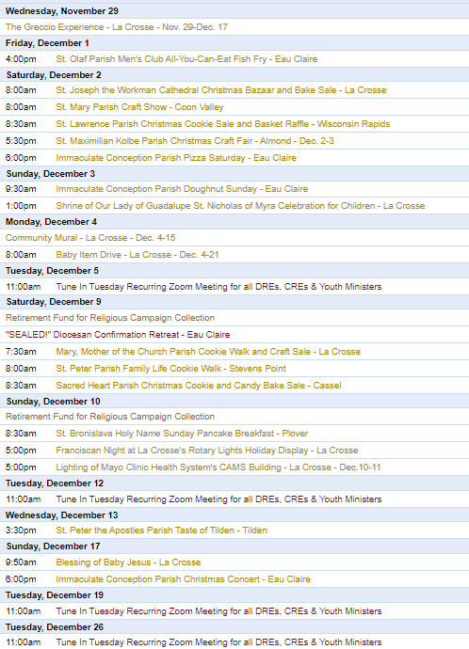
To get your parish events listed on the diocesan calendar, diolc.org/calendar, and in Catholic Life magazine, please send an email to datebook@diolc.org. Ensure you include the following details: date, beginning/ending times, event location, description, menu and cost, etc. If you have any questions, please call Pam Willer at 608.788.1524 for more information.

<<Top >>

Director: Ann Lankford – 608.791.2658 | alankford@diolc.org
For Your Parish Bulletin:
The Season of Advent
The word Advent means “comings,” and it has a threefold character: 1: A season that directs the mind and heart to await Christ’s Second Coming at the end of time.
2: A season to prepare us for Christmas—Christ’s first coming to us
3: A season in which we seek a deeper awareness of Jesus’ coming to us, present in each moment of every day—as indeed, He is Emmanuel, “God with us”; He comes to us most especially in the Holy Eucharist.
The readings from the Sacred Scriptures during the four Sundays of Advent assist us in focusing our attention on these “comings.” The First Sunday of Advent emphasizes Christ’s Second Coming (which is also the ongoing theme for weekday Masses until Dec. 16). The Gospel for the first Sunday of Advent is Mark 13:33-37, and we see the theme of the Second Coming in Jesus’ words: “Be constantly on the watch! Stay awake! You do not know when the appointed time will come.” His words call us to be watchful in prayer, ready for the Lord to come again. This is not meant to be about fear or worry, but we are to “wait in joyful hope.”
For this time of waiting, the Advent Wreath draws a family together around the lighting of one of the four candles, each representing a week of this season. It is a special time to pray a Rosary, or a decade of the Rosary, and focus on the Joyful Mysteries that call to mind the events of Christ’s birth. A prayer card for the Joyful Mysteries of the Rosary can be downloaded here:diolc.org/deeper.
For Your Parish Bulletin:
Reading from the Bible during Advent
There are seven Scripture Readings pertinent to the season of Advent on a downloadable prayer card available here under the title “Praying with Scripture: diolc.org/deeper. Or if you would like to read the Scripture Readings from Mass each day during Advent as a beautiful way to prepare for Christmas, visit bible.usccb.org.
For Your Parish Bulletin:
During this National Eucharistic Revival, let us grow in our understanding and love for the incredible Gift of Jesus’s real Presence in the Eucharist.
How do we get to know Jesus better?
We get to know Jesus better by being with Him “in person.” We do that at Sunday Mass. At the Mass, Jesus is present personally and truly in the Holy Eucharist. He meets us there, and He wants to listen to and speak to us through the Scripture readings and prayers of the Mass.
Let’s pray this right now and every day this week: Jesus, give me the desire to read the Bible a few minutes each day. This week, read how the prophet Isaiah announces the coming of the Messiah in Isaiah 11:1-3. For additional proclamations on the Eucharist, click here: diolc.org/eucharist/learn.
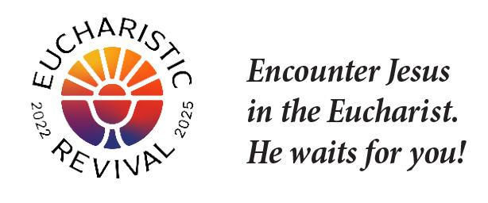
Reminder: Various Logos for the Eucharistic Revival - for Parish Use:
For use on the parish website and communications, various high-resolution logos to draw people’s attention to the Eucharistic Revival are available here: diolc.org/eucharist/lead. Scroll down to Eucharistic Revival Logos.
Catechetical Leader Information:
During Advent, Family Preparation for Christmas
Parents are encouraged to read a Bible Story with their child(ren) each night during this season of Advent—a time of quiet reflection in preparation for the coming of our Savior at Christmas. Bible storybooks are available at any Catholic bookstore.
A Minute with Jesus: for parents, parish CCD sessions and Catholic Schools
In communications with parents, always provide a small “dose” of the reality of the Eucharist. Click here for entries or see above: diolc.org/catechesis/catechetical-leaders-info
<<Top >>

Director: Erik Archer– 608.791.2661 | earcher@diolc.org

No items this week.

<<Top >>

Director: Sr. Donna Krzmarzick, ISSM – 608.791.2690 | dkrzmarzick@diolc.org

No items this week.

<<Top >>

Director: Deacon Robert Riedl – 608.791.2665 | rriedl@diolclergy.org

DATE CORRECTION:
Deacon Continuing Formation Conference | Dec. 1-2|
St. Anthony Spirituality Center, Marathon
The correct date for the Deacon Continuing Formation conference is Dec. 1-2. Please update your calendar to reflect this correction. The topic is the Synod on Synodality. Check your email for the registration form and schedule or follow this link to download: Registration Form and Schedule The registration deadline was Nov. 22.
<<Top >>

Director: Christopher Rogers – 608.791.2659 | crogers@diolc.org

For Your Parish Bulletin:
Worldwide Marriage Encounter
Just as we celebrate Thanksgiving by gathering with family. Why not celebrate your Marriage by attending a Worldwide Marriage Encounter Weekend? It’s a positive, simple, common sense, private experience between husband and wife that revitalizes your marriage. Questions can be directed to 563-920-9419. Weekends are being held February 16-18 in Marshalltown, April 12-14, 2024 in Epworth; September 27-29, 2024 in Dubuque; and November 8-10, 2024 in Holstein.

For Your Parish Bulletin:
Domestic Church Retreat - Save the Date
The next Domestic Church Retreat will be held April 13-14, 2024, at Ss. Peter and Paul Parish in Wisconsin Rapids. During the retreat, couples are invited to delve more deeply into the graces of their shared spiritual journey. The retreat’s goal is to strengthen the couple’s spousal union and lead them to experience complete harmony and joy in their marriage through simple formation and meaningful dialogue that intentionally places Christ in the center. To register and for more information, click this link: https://diolc.org/marriage/marriage-enrichment/

<<Top >>

Director: Christopher Ruff – 608.791.0161 | cruff@diolc.org

No items this week.

<<Top >>

Director: Fr. Woodrow Pace – 608.791.2676 | wpace@diolc.org

No items this week.

<<Top >>

Director: Christopher Carstens – 608.791.0161 | ccarstens@diolc.org
RCIA: To Pastors, Pastoral Associates, and OCIA Coordinators
Bishop Callahan wishes to send Christmas greetings and words of encouragement to those currently participating in the OCIA process. Please return by December 15 this form requesting the names of catechumens preparing for entry into the Church at the Easter Vigil and candidates seeking full communion.
<<Top >>

Director: Teresa Brown – 608.791.2679 | tbrown@diolc.org

DIOCESE OF LA CROSSE GUIDELINES FOR REPORTING INSTANCES OF CHILD ABUSE:
The Diocese of La Crosse, through its policies and procedures, seeks to provide a prompt, appropriate and compassionate response to reporters of sexual abuse of a child by any diocesan agent (bishop, priest, deacon, employee, religious, vendor or volunteer). Anyone wishing to make a report of an allegation of sexual abuse should send that report to Mrs. Teresa Brown, Complaint Intake Agent, at the Diocese of La Crosse, P.O. Box 4004, La Crosse, WI 54602-4004. Alternatively, you can contact Mrs. Brown at 608.791.0179 or intakeagent@diolc.org. The reporting form is available through the Diocese of La Crosse Office of Safe Environment or on the diocesan website at diolc.org/safe-environment/reporting. Individuals are also encouraged to take their reports directly to civil authorities. Copies of the diocesan policy are available through your local Parish and on the diocesan website. If you have any questions about the Diocese of La Crosse and the implementation of the Charter for the Protection of Children and Young People, please contact Teresa Brown, Diocese of La Crosse, at 608.791.2679 or tbrown@diolc.org.

<<Top >>

Superintendent: Thomas Reichenbacher – 608.788.7707 | treichenbacher@diolc.org

No items this week.

<<Top >>

Director: Christopher Ruff – 608.791.0161 | cruff@diolc.org

Pilgrimage for Life | Jan. 17-21 |
Washington D.C.
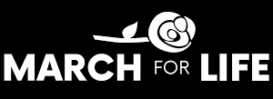
Join us in witnessing to LIFE! Come with us by coach bus to Washington, DC, to participate in the annual March for Life. This opportunity is for anyone ages 13 and up. The estimated cost is $400 per person. Parishes or schools forming a group should have each participant complete the registration online, fill out the required forms and pay a non-refundable deposit of $100. The remainder of the fee will be paid to the parish or school. For more information and to register, visit diolc.org/yya/youth-opportunities/pilgrimage-for-life.

(Reminder) For Your Parish Bulletin:
Please Support Project Milk in this Season of Thanksgiving & Advent
Help the Diocesan Rural Life Committee spread hope and joy by contributing to Project Milk. Founded in 1984 to help feed the poor children of Casa Hogar in Peru, Project Milk provides whole milk powder to the orphanage and the surrounding community. Each year, the Rural Life Committee seeks to raise enough money to ship 40,000 lbs. of milk powder at an approximate cost of $80,000. One hundred percent of your monetary gift feeds these children and the poor. To give, visit frjoesguild.org/donate, and select “Project Milk” as your designation, or scan the QR code to the right.

(Reminder) For Parish Bulletins in La Crosse and the Surrounding Area:
Please Support “Hope’s Door” Pregnancy and Family Resource Center
Hope’s Door is being planned as a state-of-the-art pregnancy resource center for the La Crosse area. It will be an interfaith, Christ-centered facility that will offer compassionate assistance to women and families, including mentoring and classes, as well as medical resources like ultrasounds and abortion pill reversal treatment. Its services will be in harmony with Catholic teaching. Bishop Callahan recently wrote a letter to area pastors encouraging them to invite the faithful to offer their prayers and financial support to Hope’s Door. To see a flier and brochure, visit www.diolc.org/respect-life and click on the links, or scan the QR code to the right.

(Reminder) For Your Parish Bulletin:
Post-Abortion Healing Retreats – Rachel’s Vineyard – Encounter God’s Mercy
Rachel's Vineyard is a weekend retreat to help anyone who has struggled with the aftermath of abortion to begin healing through a supportive, trauma-sensitive approach. Each weekend is run by a team of trained volunteers (counselor, priest, and lay people), who care deeply for your needs. All interactions with the Rachel's Vineyard retreat team are completely confidential. These retreats will be offered in the Diocese of Madison on Nov. 10-12, 2023, March 15-17, 2024, and Nov. 8-10 2024. For more information, visit madisondiocese.org/rachel or scan the QR code on the right.
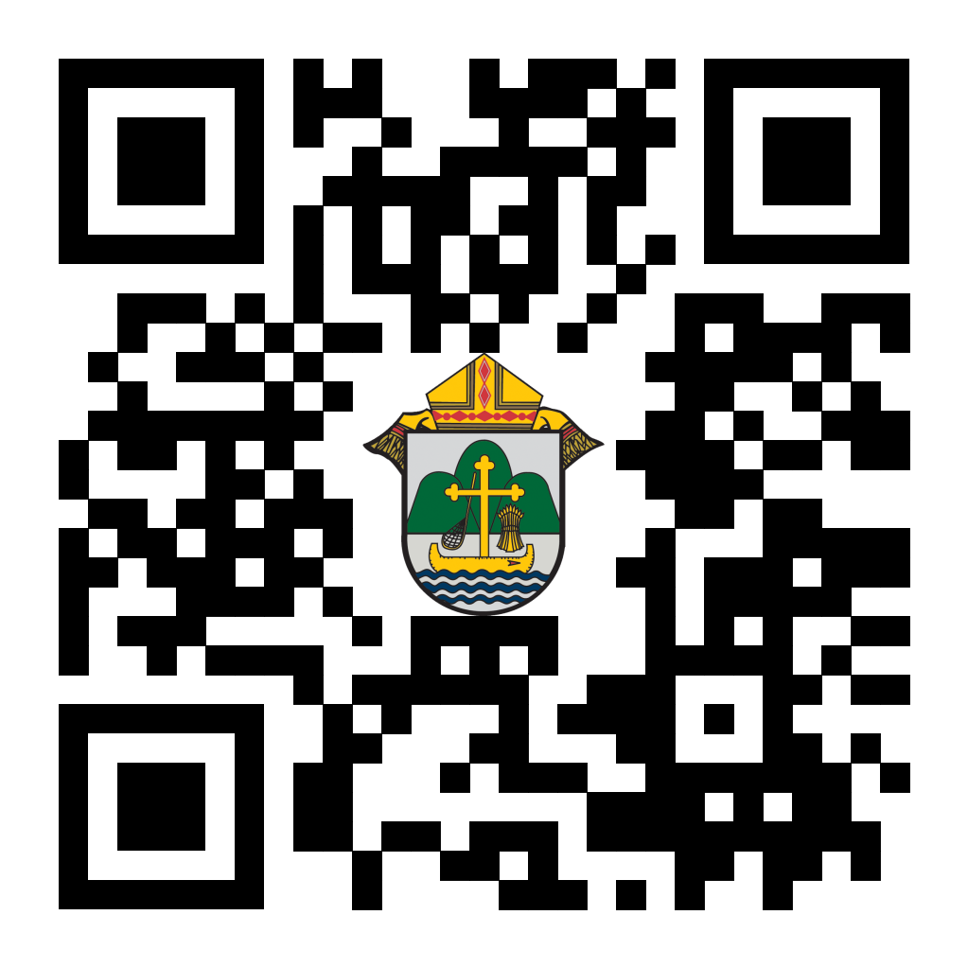
(Reminder) For Your Parish Bulletin:
Chalice of Mercy is in Ukraine, Needs Our Help
Please donate to the Ukrainian relief efforts of Chalice of Mercy if you can, and pray for the safety of their volunteers on the ground there, who put their lives on the line. Financial assistance is the biggest need at this time. To give, visit chaliceofmercy.org/donate or use your smartphone’s camera to scan the QR code to the right.

<<Top >>

Director: Jeff Reiter – 608.791.2653 | jreiter@diolc.org
Diocesan Annual Appeal - Final Reminder:
In early December, we will send a follow-up mailing for any parish that announced and who had their homes mailed before Nov. 12, 2023. The expected in-home date will be Dec. 18. We encourage any parish who wishes to include a letter from the pastor or Finance Council to submit a Word document. Please include the parish number in the file name. The deadline to submit a letter is Nov. 28, 2023. A copy of Bishop’s letter is on the Appeal Portal for your review.
(Reminder) Inspired By The Spirit and Diocesan Annual Appeal:
We have become aware that parishes are again making and using copies of the pledge form. These are parish-specific, and for our electronic banking and gift-scanning process, the pledge form must meet particular specifications to size and QR location to be more efficient, helping keep costs down and ensuring the correct parish and supporter is getting credit for that gift.
If you need more pledge forms, please contact Sarah Komperudskomperud@diolc.org; we will order more. Please allow 14 days for delivery.
Weekly Stewardship quotes (shorter bulletin reflections):
October-December
https://diolc.org/wp-content/uploads/2023/09/Stewardship-Bulletin-Reflections-Oct-Dec-2023.pdf
- Spanish Version
https://diolc.org/wp-content/uploads/2023/09/Stewardship-Bulletin-Reflections-Oct-Dec-2023-Spanish.pdf
Weekly Stewardship Prayers of the Faithful:
October-December
https://diolc.org/wp-content/uploads/2023/09/Prayers-of-the-Faithful-Oct-Dec-2023.pdf
- Spanish Version
https://diolc.org/wp-content/uploads/2023/09/Prayers-of-the-Faithful-Oct-Dec-2023-Spanish.pdf
Stewardship Bulletin Reflections for Weekends:
- 12/03
https://diolc.org/wp-content/uploads/2023/11/12.03.23-stewardship-bulletin-announcements.pdf
- 12/10
https://diolc.org/wp-content/uploads/2023/11/12.10.23-stewardship-bulletin-announcements.pdf
- 12/17
https://diolc.org/wp-content/uploads/2023/11/12.17.23-stewardship-bulletin-announcements.pdf
- 12/24
https://diolc.org/wp-content/uploads/2023/11/12.24.23-stewardship-bulletin-announcements.pdf
Stewardship Homily Reflections:
Stewardship reflections for your homily development:
- For Weeks 12/03 - 12/24/23:
https://diolc.org/wp-content/uploads/2023/11/Homily-Guide-11.28.23.pdf
<<Top >>

Diocesan Finance Officer: James Reider – 608.791.2668 | jreider@diolc.org

No items this week.

<<Top >>

Director of Vocation Recruitment: Fr. Nate Kuhn – 608.791.2666 | nkuhn@diolc.org
Please include the following intercession for vocations for your Sunday prayers of the faithful:
In thanksgiving for those marriages, priests, sisters, and brothers who inspire and strengthen us by the witness of their commitment.
Consider adding a vocations paragraph to your parish bulletin. Below is an example – they will be changed each week. Feel free to use any or all of them.
Have you asked someone recently?
Do you know someone in your life that you think would make a good priest? Have you ever told them that? If not, you should! A significant contributing factor to young men discerning the priesthood has been the invitation and encouragement they receive from others, particularly parents, teachers, mentors, and role models. Don’t be afraid to tell a young man that they would make a good priest, as that may be just what they have been waiting for. Once you encourage them, don’t hesitate to put them in contact with me to continue that conversation. I can be reached at Fr. Nate Kuhn, Director of Vocational Recruitment for the Diocese of La Crosse, 3710 East Ave. S. PO Box 4004, La Crosse, WI 54602; or by phone at 608.791.2667. God bless you!
<<Top >>

Director: Very Rev. Woodrow H. Pace – 608.791.2689 | wpace@diolc.org

No items this week.

<<Top >>

Director: Christopher Rogers – 608.791.2659 | crogers@diolc.org

Pilgrimage for Life | Jan. 17-21 |
Numbers needed ASAP
We are excited to offer the Pilgrimage for Life. We will travel by coach bus to Washington, DC, to participate in the annual March for Life. This opportunity is for anyone ages 13 and up. The estimated cost is estimated to be $400 per person. Parishes/Schools wishing to get a group to join us will have their participants complete the registration online by filling out all of the required forms and paying a nonrefundable deposit of $100. The remainder of the fee will be paid to the parish/school. All information and the registration link can be found at https://diolc.org/yya/youth-opportunities/pilgrimage-for-life/

SEALED! Fall Diocesan Confirmation Retreat - Last Chance to Sign Up!
The SEALED! Diocesan Confirmation Retreat will be held Dec. 9, 2023, at St. Olaf Catholic Church in Eau Claire, WI. Click this link to register and find out more information: https://diolc.org/yya/youth-opportunities/immersion-retreat/

<<Top >>

Diocese of La Crosse | 3710 East Ave S | La Crosse, WI 54601 | 608-788-7700
To unsubscribe from this e-mail message contact mwilson@diolc.org

