Chancery Bulletin - Vol. 8, No. 11.1 | November 7, 2023

- Catechesis & Evangelization  - Chancery  - Communications  - Consecrated Life  - Diaconate  - Marriage & Family Life  - Ministries  - Mission Office  - Sacred Worship | - Safe Environment  - Schools Office  - Social Concerns  - Stewardship and Development  - Temporalities  - Vocations  - Vicar for Clergy  - Youth and Young Adult Ministry  - Past Chancery Bulletins
No items this week.

<<Top >>

Chancellor Very Rev. William Dhein – 608.791.2655 | wdhein@diolc.org

No items this week.

<<Top >>

As of Nov. 7

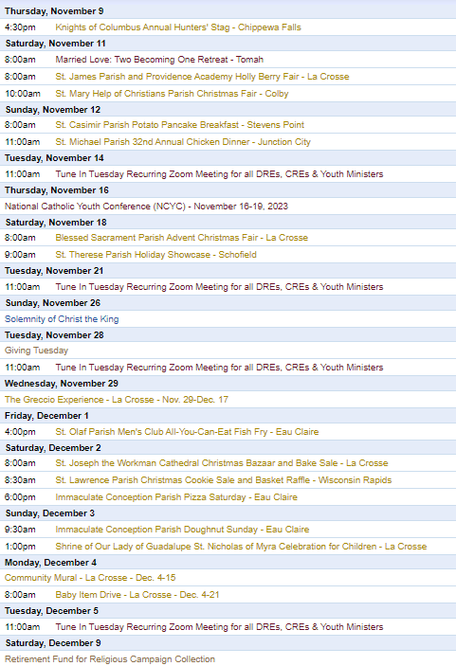
To get your parish events listed on the diocesan calendar, diolc.org/calendar, and in Catholic Life magazine, please send an email to datebook@diolc.org. Make sure you include the following details: date, beginning/ending times, event location, description, menu and cost, etc. If you have any questions, please call Pam Willer at 608.788.1524 for more information.

<<Top >>

Director: Ann Lankford – 608.791.2658 | alankford@diolc.org

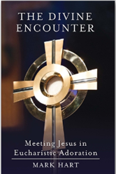
Clergy: Adoration following Mass on the 4 Sundays of Advent:
Adoration of the Blessed Sacrament can be offered after Mass on the four Sundays of Advent. Many people encounter Jesus during a time of silence in His Presence. A reader-friendly book for adoration is available.
The Divine Encounter: Meeting Jesus in Eucharistic Adoration by Mark Hart is available for a parish giveaway during Advent. The price per book is $2.60 (retail $9.99). Contact Beth at bjohnson@diolc.org to place your order. Provide the name of the parish, city, contact person, phone number, number of books, and info about pick-up or mail delivery. You can find a flier with further info available here: diolc.org/catechesis/catechetical-leaders-info
(Reminder) General Intercessions in light of the Eucharistic Revival:
Another way to inform parishioners and engage them in the Eucharistic Revival is by including Mass intentions that are focused on praying for renewal each week. Visit www.eucharisticrevival.org/revival-resources and scroll to General Intercessions -English/Spanish
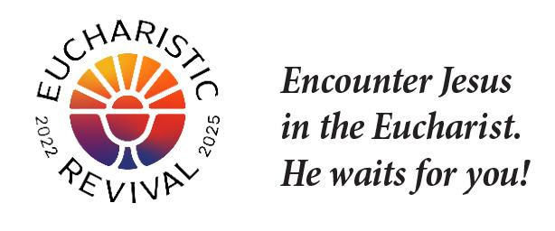
For your Parish Bulletin:
The Eucharistic Revival is meant to stir a deeper love for the incredible Gift of our Eucharistic Lord.
God created you to be His beloved son or daughter
so that you may spend eternity with Him.
God is our Creator, and He only wants what is best for us. We must remember! It is our choice: we want to knowingly be open and receive God’s love; or we can refuse it. God gives us the freedom to choose Him. Let us choose to receive God’s love by receiving the Eucharist—Jesus Himself. Let’s pray this right now and every day this week: God, help me not to prefer anything more than You, nor to substitute anything for You.
Thank You for the grace that will always strengthen me to choose You above everything.
For a list of additional proclamations on the Eucharist, click here: diolc.org/eucharist/learn.
Jesus and the Eucharist Small Group Study - Lent:
Every parish across the Diocese is invited to host the Jesus and the Eucharist study (Free in English and Spanish) during the Year of Parish Revival. This seven-session series will immerse participants in the initial proclamation of the “Good News” (Sessions 1-4) and unveil God’s saving work in the Eucharist (Sessions 5-7). In addition to a video each session, there is a prayer reflecting on a Scripture passage, a personal testimony , as well as small group discussions. The series was produced by the Augustine Institute.
Visit www.eucharisticrevival.org/formation-resources for the study materials and training resources. Click here for a poster: diolc.org/catechesis/catechetical-leaders-info
Catechesis of the Good Shepherd – Learn More:
Catechists and those involved in an atrium, as well as those interested in knowing more about Catechesis of the Good Shepherd, are invited to the fall, online gathering which will feature a presentation by Ruth Sutherland, long-time catechist and trainer. The date is Tuesday, Nov. 28th from 6:15-7:45 p.m. Please email Ann at alankford@diolc.org to register.
Speaker Policy:
In order to defend the integrity and unity of the Faith, a speaker who is being considered to give a presentation on faith and morals on Church property must be approved by the Diocesan Bishop before an invitation is extended. Click here for a list of speakers who are exempt, the form to submit and other information. diolc.org/chancery/speaker-policy
Catechetical Leader Information:
(Reminder) Video about Gender Dysphoria with Jason Evert, Mary Hasson and Father Boquet
(30 min.)
This video is a must-see for all parents, catechetical leaders and catechists on speaking with kids about gender dysphoria, entitled “How to Talk to Your Kids about Human Sexuality.“ Click here:
https://ondemand.ewtn.com/free/Home/Play/en/SPH2012
The Eucharistic Revival – a brief proclamation for parents and students:
Please see the brief proclamation above entitled God created you to be His beloved son or daughter so that you may spend eternity with Him. In communications with parents, always provide a small “dose” of the beauty of our Faith.
Click here for additional entries: diolc.org/catechesis/catechetical-leaders-info
<<Top >>

Director: Erik Archer– 608.791.2661 | earcher@diolc.org

How To Promote the National Eucharistic Revival Webinar |Nov. 14 (1 p.m.):
“Welcome to the Table: Using Digital Communications to Promote the National Eucharistic Revival at Your Parish.” The Catholic Social Media team is partnering with Kris Frank, Chief Mission Officer for the National Eucharistic Congress, to talk about what parishes can do to reach their parishioners and neighbors to invite them into a fuller encounter with the Eucharist. This is for pastors, parish staff, and volunteers, but will contain lots of good food for thought for diocesan employees too. It's everything we know about leveraging social media for the sake of an in-the-flesh encounter at the parish. For registration and more information, visit https://catholicsocialmedia.prengersolutions.com/welcome-to-the-table-eucharistic or use your smartphone’s camera to scan the QR code to the right.
Catholic Social Media (CSM):
Thank you to the parishes currently using CSM and welcome to the parishes joining us on the next training wave next week. I returned from a pilgrimage and will contact parishes today to confirm registration. If you are interested in attending - please email me at earcher@diolc.org. To the many that already emailed me - I have your information and will send confirmation. Thank you!
Phishing Training & Security:
Phishing is a type of cyber-attack involving fraudulent emails or websites appearing to be from a legitimate source, with the intent of tricking the recipient into revealing sensitive information such as passwords, credit card numbers and other personal information. A phishing email may also lead to the recipient unknowingly downloading harmful software.
Phishing attacks continue to grow in sophistication. We have recently seen several phishing attempts in the diocese disguised as emails from trusted people. Most successful phishing attacks create a sense of urgency and take advantage of people’s trust. The best and first line of defense is your vigilance. If in doubt, do not open the email and call the sender to verify the email’s validity.
To help you become more sensitized to phishing attacks and receive training geared to helping you spot characteristics of phishing messages and reinforce best practices for security awareness, we have partnered with Wizer Training. They have several excellent short training videos on a wide range of security topics. The video “4 Easy Ways To Detect A Phishing Email” can be found here: videos.wizer-training.com/videos/3WlpubMXbpSYm2rYFyYh?utm_source=sharing_video_page&utm_medium=referral&utm_campaign=page_sharing
Another video called “Why A Phone Call Is Always Best” is found here: videos.wizer-training.com/videos/2a8d6c6725824cab99197d6d69f55ee3?utm_source=sharing_video_page&utm_medium=referral&utm_campaign=page_sharing
More training videos from Wizer can be found at: www.wizer-training.com/employee-security-awareness-videos
Please use this training for your parish or school. You will need to set up an account to get started. The free version includes their annual video training and quizzes for an unlimited number of users. The Boost (paid) version gives access to their full training library, phishing simulations and exercises. Contact ztudahl@diolc.org for special pricing should you want to purchase the Boost version.
Thank you for your attention to this serious matter. Email security awareness and testing will help us avoid a possible future attack.
<<Top >>

Director: Sr. Donna Krzmarzick, ISSM – 608.791.2690 | dkrzmarzick@diolc.org

Retirement Fund for Religious:
The annual collection in parishes for the national Retirement Fund for Religious is scheduled for the weekend of December 9-10. Religious sisters, brothers, and religious order priests benefit significantly from this national collection. Please promote the campaign in your parish bulletin, pulpit announcements, and petitions at Mass (sample texts below and further resources here).

For your parish bulletin:
Weekend before the collection (Dec. 2-3)
You can help. Please donate to the Retirement Fund for Religious next week. Your gift will provide essential care for nearly 25,000 senior sisters, brothers and religious order priests who have dedicated their lives to serving others. Let us show our gratitude to these selfless individuals by giving generously.

Weekend of the collection (Dec. 9-10)
Support a lifetime of service. Women and men religious have spent their lives serving others in prayer, ministry, education and care for those in need—usually for little or no pay. Today, their religious communities do not have enough retirement savings. As they age, they require essential care and medications. Please support them by giving to the Retirement Fund for Religious. Your donation makes a difference for nearly 25,000 senior men and women religious.
Please give generously.

<<Top >>

Director: Deacon Robert Riedl – 608.791.2665 | rriedl@diolclergy.org

Deacon Continuing Formation Conference | Dec. 2-3 |
St. Anthony Spirituality Center, Marathon
Watch for a detailed schedule and registration information coming soon!
TOPIC: “THE SYNOD ON SYNODALITY”

Deacon Days with the Bishop:
Please add the following dates to your calendar
● 2024 – Aug. 10
● 2025 – Aug. 9
● 2026 – Aug. 8

<<Top >>

Director: Christopher Rogers – 608.791.2659 | crogers@diolc.org

Pilgrimage for Life - January 17-21, 2024:
We are excited to offer the Pilgrimage for Life. We will be traveling by coach bus to Washington, DC to participate in the annual March for Life. This opportunity is for anyone ages 13 and up. The estimated cost is estimated to be $400 per person. Parishes/Schools wishing to get a group to join us will have their participants complete the registration online by filling out all of the required forms and pay a non refundable deposit of $100. The remainder of the fee will be paid to the parish/school. All information and registration link can be found at https://diolc.org/yya/youth-opportunities/pilgrimage-for-life/

“the Answer” Eucharistic Rally:
We are very excited to announce “the Answer” Eucharistic Rally that will be held on June 7, 2024 at the La Crosse Center in La Crosse, WI. This event kicks off the six days that the Marian Route of the National Eucharistic Pilgrimage will be in the Diocese of La Crosse. “the Answer” Eucharistic Rally will begin with a Eucharistic Procession across the Cameron Street Bridge in La Crosse and will end at the La Crosse Center where the rest of the rally will take place. The day will include Mass, Adoration, Confession, powerful speakers such as Chris Stefanick, Immaculee Ilibagize, and Josh Rosa, music from Luke Spehar, and plenty of vendors. The cost for this event is only $15 per person. This rally is for youth, young adults, adults, families, etc. Tickets will go on sale Dec. 15, 2023. You can find more information about the event and the other days the Marian Route will be in our diocese by visiting: https://diolc.org/the-answer/ or use your smartphone’s camera to scan the QR code to the right.

(Reminder) Natural Family Planning
For Priests, Deacons and Parish staff:
USCCB Free Resources to Download
Diocese of La Crosse NFP Brochure (use diolc.org email for access)

NFP classes are offered to interested couples by the Marriage and Family Life Office. To
inquire about diocesan classes, go to diolc.org/nfp or email ckitzhaber@diolc.org. Read
more regarding NFP on the USCCB website at www.usccb.org/prolife/issues/nfp.

(Reminder) Marriage Enrichment and Parenting Resources:
For your marriage website: foryourmarriage.org/ or use your smartphone’s camera to scan the QR code to the right. This website from the USCCB helps couples at all stages of life to understand and live God’s plan for happy, holy marriages.

(Reminder) Teaching the Way of Love:
Please visit twl4parents.com/ or use your smartphone’s camera to scan the QR code to the right. This website is full of encouragement and tips for parents to continue to be the primary educators of their children.

(Reminder) Diocesan Website for Clergy and Marriage Ministers Regarding Marriage Preparation:
Use this link: diolc.org/marriage/marriage-preparation/marriage-preparation-for-ministers/ to go directly to the section of our website containing resources for clergy and marriage ministers. There are step-by-step instructions, downloadable guidelines, downloadable forms and much more! Please let us know if we can assist you in this ministry.

(Reminder) Process for Training FOCCUS Facilitators:
The process for training FOCCUS facilitators is as follows: Each parish needs to contact FOCCUS directly to set up an account for your parish, if one has not already been set up, then train your couples directly through FOCCUS. The contact person at FOCCUS is Max Allen. He is happy to work directly with your parish priest or contact person. His contact information is mrallen@foccusinc.com or phone: 402.827.3735, ext. 1317.

<<Top >>

Director: Christopher Ruff – 608.791.0161 | cruff@diolc.org

No items this week.

<<Top >>

Director: Father Woodrow Pace – 608.791.2676 | wpace@diolc.org

No items this week.

<<Top >>

Director: Christopher Carstens – 608.791.0161 | ccarstens@diolc.org

No items this week.

<<Top >>

Director: Teresa Brown – 608.791.2679 | tbrown@diolc.org

DIOCESE OF LA CROSSE GUIDELINES FOR REPORTING INSTANCES OF CHILD ABUSE
The Diocese of La Crosse, through its policies and procedures, seeks to provide a prompt, appropriate and compassionate response to reporters of sexual abuse of a child by any diocesan agent (bishop, priest, deacon, employee, religious, vendor or volunteer). Anyone wishing to make a report of an allegation of sexual abuse should send that report to Mrs. Teresa Brown, Complaint Intake Agent, at the Diocese of La Crosse, P.O. Box 4004, La Crosse, WI 54602-4004. Alternatively, you can contact Mrs. Brown at 608.791.0179 or intakeagent@diolc.org. The reporting form is available through the Diocese of La Crosse Office of Safe Environment or on the diocesan website at: diolc.org/safe-environment/reporting. Individuals are also encouraged to take their reports directly to civil authorities. Copies of the diocesan policy are available through your local Parish and on the diocesan website. If you have any questions about the Diocese of La Crosse and the implementation of the Charter for the Protection of Children and Young People, please contact Teresa Brown, Diocese of La Crosse, at 608.791.2679 or tbrown@diolc.org.

<<Top >>

Superintendent: Thomas Reichenbacher – 608.788.7707 | treichenbacher@diolc.org

No items this week.

<<Top >>

Director: Christopher Ruff – 608.791.0161 | cruff@diolc.org

For Your Parish Bulletin:
Donate to Help the Victims of Violence in the Holy Land
Catholic Relief Services, in conjunction with Caritas partners, are working to meet the desperate humanitarian needs caused by the terrorism and fighting in the Holy Land. To learn how you can help, visit www.crs.org or scan the QR code to the right.

For Parish Bulletins in the La Crosse, Tomah, Arcadia, and Richland Center deaneries:
Please Support “Hope’s Door” Pregnancy and Family Resource Center
Hope’s Door is being planned as a state-of-the-art pregnancy resource center for the La Crosse area. It will be an interfaith, Christ-centered facility that will offer compassionate assistance to women and families, including mentoring and classes, as well as medical resources like ultrasounds and abortion pill reversal treatment. Its services will be in harmony with Catholic teaching. Bishop Callahan recently wrote a letter to area pastors encouraging them to invite the faithful to offer their prayers and financial support to Hope’s Door. To see a flyer and brochure, visit www.diolc.org/respect-life and click on the links, or scan the QR code to the right.
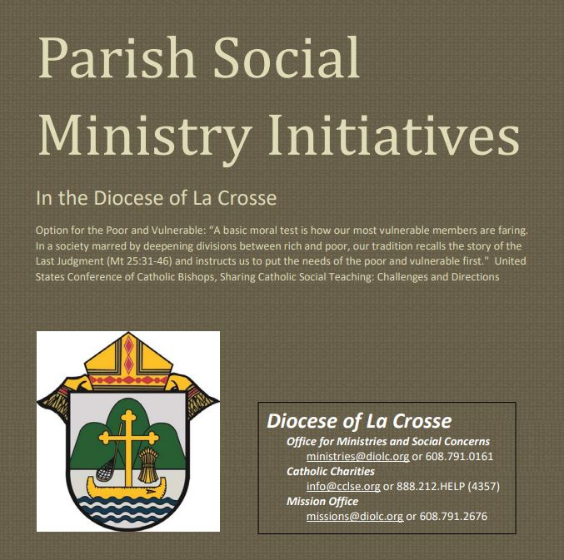
Pastors, Deacons, Parish Social Concerns Representatives:
Are Your Social Ministry Initiatives listed in the Directory?
In order to address most fruitfully the social concerns within our diocese, we are asking the parishes of the diocese to review their current social ministry initiatives (any outreach of charity or social advocacy). If these are not already listed in the diocesan Directory of Parish Social Ministry Initiatives, or if updating is needed, the pastor or someone authorized by him is asked to take a moment to complete and submit this form for each organization/resource.
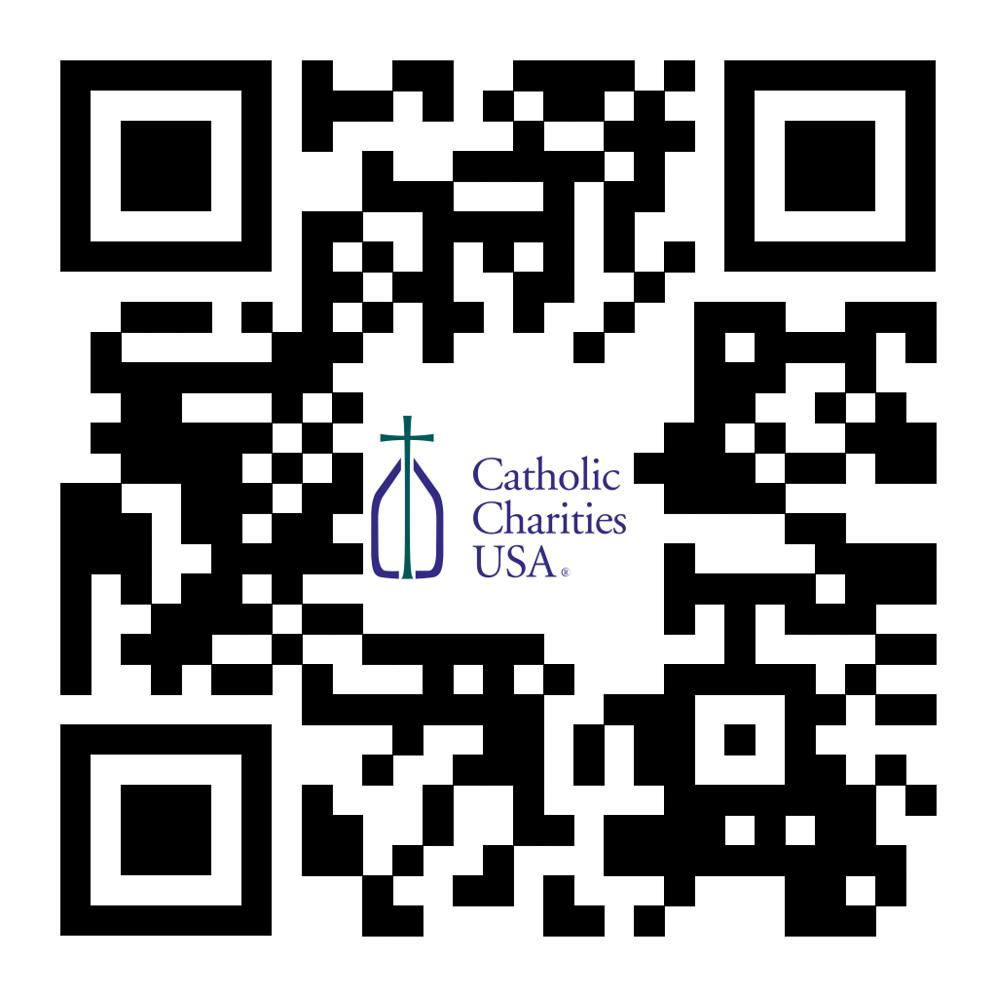
(Reminder) For Your Parish Bulletin:
Pregnant and in distress? Confidential help is available.
Make a confidential call to Catholic Charities at 844.644.7223 (844.64.GRACE) or text 715.600.6391. To learn more, visit cclse.org/i-think-im-pregnant. For additional pregnancy support resources and locations, visit diolc.org/pregnancy-resources.

For Your Parish Bulletin:
Post-Abortion Healing Retreats – Rachel’s Vineyard – Encounter God’s Mercy
Rachel's Vineyard is a weekend retreat to help anyone who has struggled with the aftermath of abortion to begin healing through a supportive, trauma-sensitive approach. Each weekend is run by a team of trained volunteers (counselor, priest, and lay people), who care deeply for your needs. All interactions with the Rachel's Vineyard retreat team are completely confidential. These retreats will be offered in the Diocese of Madison on Nov. 10-12, 2023, March 15-17, 2024, and Nov. 8-10 2024. For more information, visit madisondiocese.org/rachel or scan the QR code on the right.
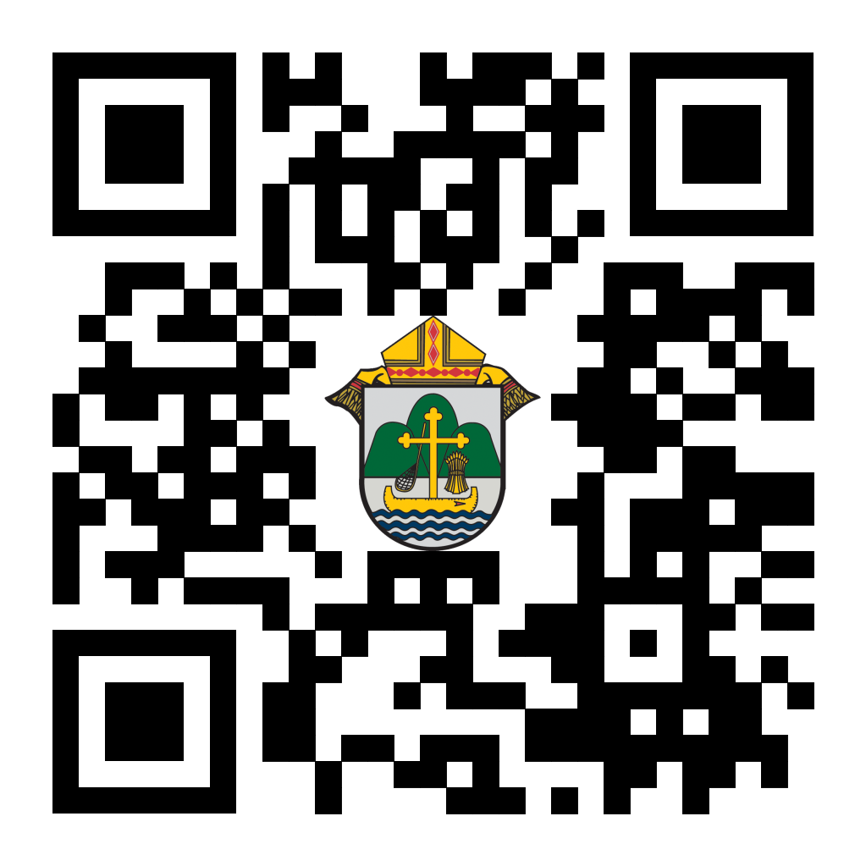
(Reminder) For Your Parish Bulletin:
Chalice of Mercy is in Ukraine, Needs Our Help
Please donate to the Ukrainian relief efforts of Chalice of Mercy if you are able, and pray for the safety of their volunteers on the ground there, who put their lives on the line. Financial assistance is the biggest need at this time. To give, visit chaliceofmercy.org/donate or use your smartphone’s camera to scan the QR code to the right.

<<Top >>

Director: Jeff Reiter – 608.791.2653 | jreiter@diolc.org
Diocesan Annual Appeal:
Final Notice: If you still need to sign up to inform us when you plan to announce the Diocesan Annual Appeal at your parish, please complete the form at https://forms.gle/sWxXCPNARTGatTiD7.
Parishes that fail to sign up byNov 15, 2023will have their parishioners automatically mailed for the first weekend in Dec. 12/2-3/2023
In early December, we will send a follow-up mailing for any parish announced before Nov. 11/12. The expected in-home date will be December 18. We encourage any parish who wishes to include a letter from the pastor and or the Finance Council to submit a Word document. Please include the parish number in the file name. The deadline to submit a letter is Nov. 28, 2023.
Inspired By The Spirit and Diocesan Annual Appeal:
We have become aware that parishes are again making and using copies of the pledge form. These are parish-specific, and for our electronic banking and gift-scanning process, the pledge form must meet particular specifications to size and QR location to be more efficient, helping keep costs down and ensuring the correct parish and supporter is getting credit for that gift.
If you need more pledge forms, please contact Sarah Komperudskomperud@diolc.org; we will order more. Please allow 14 days for delivery.
Magisterium AI:
Are you looking for help with a homily, have a specific pastoral or Canon Law question, or are just curious about Catholic Stewardship? You might find the solution on a new Artificial Intelligence (AI) website dedicated to over 6,111 Catholic Church documents. The website provides references to each document cited in the search results. Whether looking for information on the Eucharist, Canon Law, or Catholic Stewardship, this free (subscription is available) website can generate results in seconds. Though it's still in Beta form, like any AI site, it will continue to grow and improve with user inquiries. Like any creative tool, AI sites are just the beginning and should be reviewed carefully.
https://www.magisterium.com/
Weekly Stewardship quotes (shorter bulletin reflections):
October-December
https://diolc.org/wp-content/uploads/2023/09/Stewardship-Bulletin-Reflections-Oct-Dec-2023.pdf
- Spanish Version
https://diolc.org/wp-content/uploads/2023/09/Stewardship-Bulletin-Reflections-Oct-Dec-2023-Spanish.pdf
Weekly Stewardship Prayers of the Faithful:
October-December
https://diolc.org/wp-content/uploads/2023/09/Prayers-of-the-Faithful-Oct-Dec-2023.pdf
- Spanish Version
https://diolc.org/wp-content/uploads/2023/09/Prayers-of-the-Faithful-Oct-Dec-2023-Spanish.pdf
Stewardship Bulletin Reflections for Weekends:
- 11/12
https://diolc.org/wp-content/uploads/2023/10/11.12.23-stewardship-bulletin-announcements.pdf
- 11/19
https://diolc.org/wp-content/uploads/2023/10/11.19.23-stewardship-bulletin-announcements.pdf
- 11/26
https://diolc.org/wp-content/uploads/2023/10/11.26.23-stewardship-bulletin-announcements.pdf
- 1203
https://diolc.org/wp-content/uploads/2023/11/12.03.23-stewardship-bulletin-announcements.pdf
Stewardship Homily Reflections:
Stewardship reflections for your homily development:
- For Weeks 11/12 - 12/03/23:
https://diolc.org/wp-content/uploads/2023/11/Homily-Guide-11.07.23.pdf
Planned Giving – Leaving a Legacy, Wills, Bequest, and Endowments:
We have been entrusted with precious treasures passed down from our ancestors, and it's our responsibility to ensure that future generations can also enjoy the splendor and reverence of a well-maintained parish. One way to achieve this is by utilizing the Capital Campaign and providing information on Endowments, Trusts, and Bequests to the parishioners.
Our Estate Planning Guide can help save hundreds of dollars in legal and financial estate planning costs. We have mailed out several hundred copies per individual request, and each Parish has received a copy. Please feel free to contact our office for additional copies.
Visit diolclegacy.org, our Planned Giving website, to find calculators, and more information, sign up for a newsletter, and request specific estate planning guides and information. Our website also provides instructions on how to do an IRA Rollover, the creation of Donor Advised Funds (DAF), Beneficiary Designations, and Stock Transfers. https://diolclegacy.org/?pageID=5
If you require more information on legacy giving, presentations, or ads for your Parish bulletin, please contact our office or the Catholic Foundation of West Central Wisconsin (cfwcw.org) at 608.519.9892 or email eboos@cfwcw.org.
<<Top >>

Diocesan Finance Officer: James Reider – 608.791.2668 | jreider@diolc.org
Endowment and Perpetual Care Funds
The endowment and perpetual care funds that were held by BMO were moved to Trust Point as approved by Bishop William Patrick Callahan, the Diocesan Finance Council, and Presbyteral Council. The Investment Committee over a two-year period reviewed 11 requests for proposal to replace BMO and Columbia Threadneedle. Ultimately, the Committee interviewed three of the 11 firms and recommended Trust Point to the Bishop and the Councils.
The endowment and perpetual care funds were transferred from BMO to Trust Point on Nov. 1, 2023. With the transition new donations and perpetual care funds must now be sent to Trust Point.
To transfer endowment funds to your specific endowment, please follow the Trust Point Contribution Instructions - Endowment Trusts. The instructions require you to identify the account for which the funds are intended. You can use the Endowment Trust – Identifying Account Number Matrix to identify your specific account numbers.
To transfer perpetual care funds to your specific fund, please follow the Trust Point Contribution Instructions – Perpetual Care. The instructions require you to identify the account for which the funds are intended. You can use the Perpetual Care - Identifying Account Number Matrix to identify your specific account numbers.
As a result of the transition from BMO to Trust Point all accounts will achieve their maximum distribution of 4% for FY 2024. Please read the Fiscal Year 2024 Disbursement Schedule for more information on disbursements occurring this fiscal year..

Nonprofit Security Grant Program (NSGP) FY2024 Winter Webinar Series – All Events
The Federal Emergency Management Agency’s (FEMA) Grant Programs Directorate (GPD) invites interested organizations to attend upcoming webinars regarding the Nonprofit Security Grant Program (NSGP). The NSGP is a competitive grant awarded to nonprofit organizations at high risk of a terrorist or other extremist attack for the purposes of facility hardening and other security enhancements.
Please note that depending on the timing of a Fiscal Year (FY) 2024 appropriations bill, final FY 2024 information on the NSGP may not be available at the time of the webinars. Interested nonprofits should maintain communication with their State Administrative Agency (SAA) for all deadlines and application requirements.
Date | Time (ET) | Registration Link
Tuesday, Nov.7 | 3:00 PM | Registration link
Thursday, Nov. 9 | 2:00 PM | Registration link
Tuesday, Nov. 14 | 3:00 PM | Registration link
Tuesday, Nov. 28 | 2:00 PM | Registration link
Friday, Dec. 8 | 3:00 PM | Registration link
Tuesday, Dec. 19 | 2:00 PM | Registration link
Wednesday, Dec. 20 | 3:00 PM | Registration link
Following registration, you will receive a calendar invitation via email for the webinar. The link to join the webinar will be contained in that calendar event email. It may take time for this email to arrive – please be patient following registration and be sure to check your junk/spam folders.
Catholic Mutual Group – Taking Care – Saving Lives
CMG is excited to introduce their new training video titled Taking Care – Saving Lives. This 13-minute video provides education about Sudden Cardiac Arrest (SCA) and the importance of responding quickly and effectively in emergency situations. The use of Automatic External Defibrillators (AEDs) can make a difference between life and death. This training highlights that not only is it important to have an AED available, it is important to have appropriate device placement, awareness by all on the location of the AED, and proper maintenance to ensure these life saving devices are available when needed.
You can view the new video from the link below. It has been activated for all users in the optional area of the CMG Connect site. Please contact the CMG Connect team at cmgconnect@catohlicmutual.org if you would like the video activated in the required area, or for specific participation categories. Users should go onto https://cmgconnect.org to take the training if they want to get credit for it. People can view from the link below, but will not be able to print a certificate.
Taking Care - Saving Lives Video
<<Top >>

Director of Vocation Recruitment: Fr. Nate Kuhn – 608.791.2666 | nkuhn@diolc.org

Vocations Intercessions
Please include the following intercession for vocations for your Sunday prayers of the faithful.
For an up-building of all vocations in the Church and in a particular way for priestly vocations for the Diocese of La Crosse from our parish.
Consider adding a vocations paragraph to your parish bulletin. Below is an example – they will be changed each week. Feel free to use any or all of them.
The first question that Jesus asks in John’s Gospel is, “What are you looking for?” He is speaking to John’s disciples as they follow after Him, desiring to know who Jesus is and what His mission is all about. After the disciples respond, Jesus gives them an instruction, “Come and you will see!” Whether we can hear it or not, that same question is being asked to you. What are YOU looking for? So often, we find ourselves searching, not knowing exactly where to go or what to do in life. We seek things that will hopefully fill the emptiness and longing that we have in our hearts, but nothing seems to satisfy. The real answer to this can be found in Jesus’ response as He invites each of us to follow after Him, to get to know Him, and to follow the path He has placed before us. For some men, that path is a very special invitation to walk in Jesus’ footsteps as a priest. If you or someone you know is interested in discovering more about this call to the priesthood, please contact me at: Fr. Nate Kuhn, Director of Vocational Recruitment for the Diocese of La Crosse, 3710 East Ave. S. PO Box 4004, La Crosse, WI 54602; or by phone at: 608.791.2667. God bless you!
<<Top >>

Director: Very Rev. Woodrow H. Pace – 608.791.2689 | wpace@diolc.org

No items this week.

<<Top >>

Director: Christopher Rogers – 608.791.2659 | crogers@diolc.org

Pilgrimage for Life – Jan. 17-21, 2024:
We are excited to offer the Pilgrimage for Life. We will be traveling by coach bus to Washington, DC to participate in the annual March for Life. This opportunity is for anyone ages 13 and up. The estimated cost is estimated to be $400 per person. Parishes/Schools wishing to get a group to join us will have their participants complete the registration online by filling out all of the required forms and pay a non refundable deposit of $100. The remainder of the fee will be paid to the parish/school. All information and registration link can be found at https://diolc.org/yya/youth-opportunities/pilgrimage-for-life/

“the Answer” Eucharistic Rally:
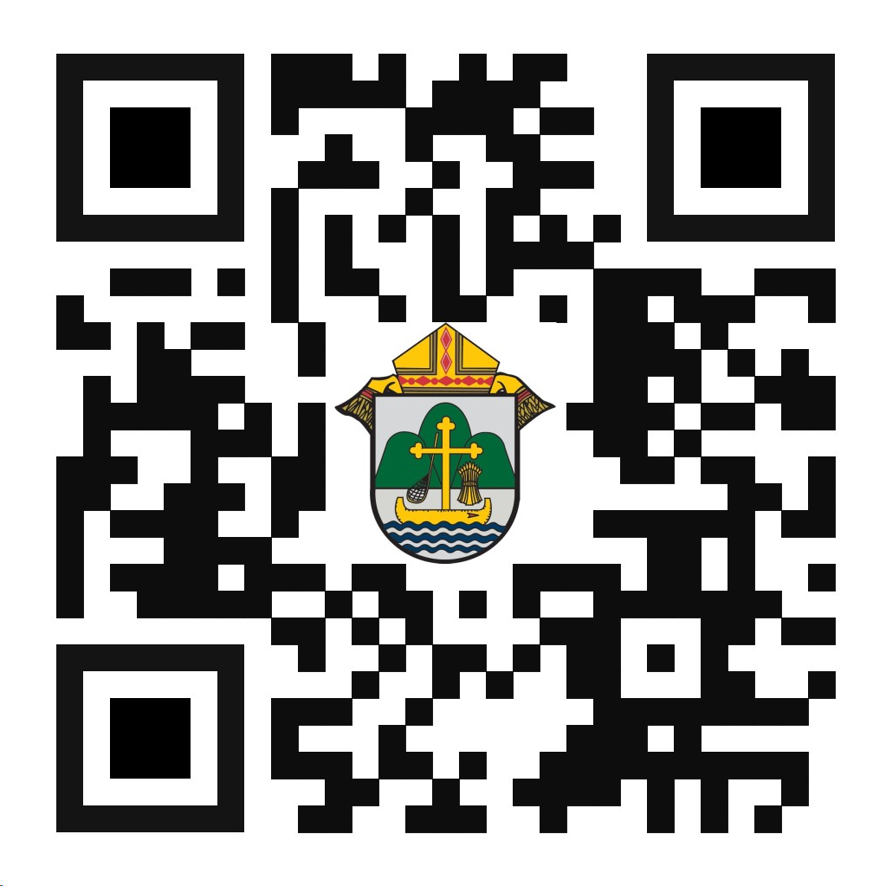
We are very excited to announce “the Answer” Eucharistic Rally that will be held on June 7, 2024 at the La Crosse Center in La Crosse, WI. This event kicks off the six days that the Marian Route of the National Eucharistic Pilgrimage will be in the Diocese of La Crosse. “the Answer” Eucharistic Rally will begin with a Eucharistic Procession across the Cameron Street Bridge in La Crosse and will end at the La Crosse Center where the rest of the rally will take place. The day will include Mass, Adoration, Confession, powerful speakers such as Chris Stefanick, Immaculee Ilibagize, and Josh Rosa, music from Luke Spehar, and plenty of vendors. The cost for this event is only $15 per person. This rally is for youth, young adults, adults, families, etc. Tickets will go on sale Dec. 15, 2023. You can find more information about the event and the other days the Marian Route will be in our diocese by visiting: https://diolc.org/the-answer/ or use your smartphone’s camera to scan the QR code to the right.

(Reminder) SEALED! Fall Diocesan Confirmation Retreat
The SEALED! Diocesan Confirmation Retreat will be held Dec. 9, 2023, at St. Olaf Catholic Church in Eau Claire, WI. Click this link to register and find out more information: https://diolc.org/yya/youth-opportunities/immersion-retreat/

(Reminder) Updated Office for Family Life Calendar of Events Through 2025:
In the Office for Family Life, we are working to keep our event planning at least two years out. We have created a calendar that may help you in planning for the next couple of years. You will see the dates have hyperlinks that allow you to add this event to your Google Calendar. Below each event is a hyperlink to the page on our website with more information, including registration links for that particular event. Please follow this link to get a list of events planned so far: https://drive.google.com/file/d/17YHE2dCa267CYfgCXZVP1hSwjTMNfhY-/view?usp=sharing

<<Top >>

Diocese of La Crosse | 3710 East Ave S | La Crosse, WI 54601 | 608-788-7700
To unsubscribe from this e-mail message contact mwilson@diolc.org

