Chancery Bulletin - Vol. 8, No. 12.3 | December 19, 2023

- Catechesis & Evangelization  - Chancery  - Communications  - Consecrated Life  - Diaconate  - Marriage & Family Life  - Ministries  - Mission Office  - Sacred Worship | - Safe Environment  - Schools Office  - Social Concerns  - Stewardship and Development  - Temporalities  - Vocations  - Vicar for Clergy  - Youth and Young Adult Ministry  - Past Chancery Bulletins
The Most Reverend William Patrick Callahan, D.D., Bishop of La Crosse, makes the following announcement:
The following priests have been elected to the Presbyteral Council for a three-year term, effective December 19, 2023:
Rev. R. John Swing Diocesan Priests Ordained 1963-1984
Rev. Thomas J. Krieg Diocesan Priests Ordained 1986-1993
Rev. James F. Trempe Diocesan Priests Ordained 1994-1997
Rev. Michael E. Klos Diocesan Priests Ordained 1998-2001
Rev. Timothy J. Welles Diocesan Priests Ordained 2002-2008
Rev. Robert M. Letona Diocesan Priests Ordained 2009-2012
Rev. Alan M. Guanella Diocesan Priests Ordained 2013-2018
Rev. Samuel C. McCarty Diocesan Priests Ordained 2019-2023
Rev. William G. Menzel Senior Priests
Rev. Sengole Vethanayagam International Priests
Rev. Canon Aaron Huberfeld Religious Order Priests

<<Top >>

Chancellor Very Rev. William Dhein – 608.791.2655 | wdhein@diolc.org

Chancery Bulletin Schedule:
We will not be publishing a Chancery Bulletin on Tuesday, December 26, 2023, or Tuesday, January 2, 2024 due to the Christmas and New Year holidays.

<<Top >>
As of December 19th, 2023
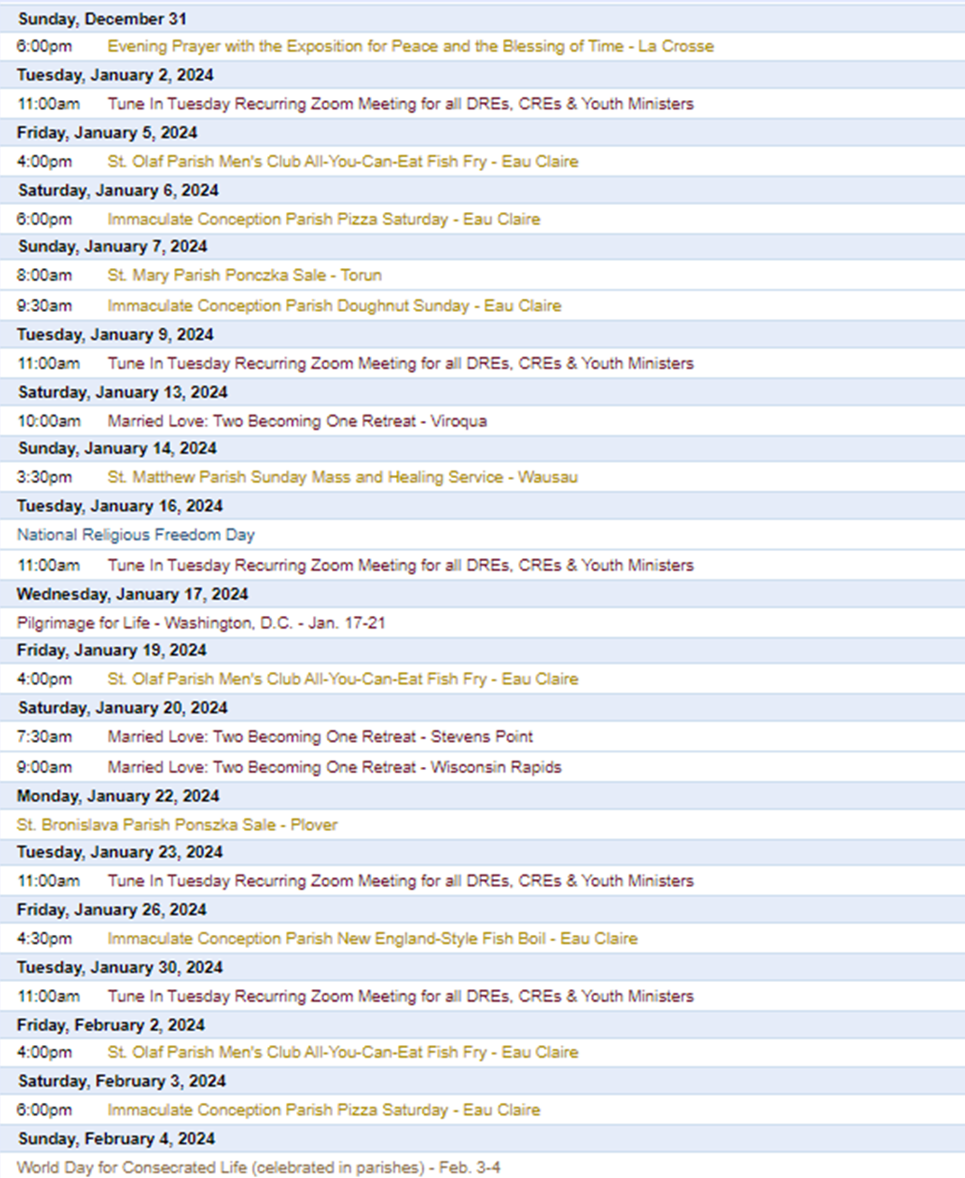

To get your parish events listed on the diocesan calendar, diolc.org/calendar, and in Catholic Life magazine, please send an email to datebook@diolc.org. Ensure you include the following details: date, beginning/ending times, event location, description, menu and cost, etc. If you have any questions, please call Pam Willer at 608.788.1524 for more information.

<<Top >>

Director: Ann Lankford – 608.791.2658 | alankford@diolc.org
For Your Parish Bulletin:
Advent: Preparing Our Hearts for Christ’s Coming
The Gospel for the Fourth Sunday of Advent is Luke 1:2638. Now, the Readings focus on the events surrounding the birth of the Savior. The angel Gabriel announces, "Do not be afraid, Mary, for you have found favor with God. Behold, you will conceive in your womb and bear a Son, and you shall name Him Jesus… The Holy Spirit will come upon you, and the power of the Most High will overshadow you. Therefore, the child to be born will be called holy, the Son of God... for nothing will be impossible for God." The angel's words remind us that Advent is a season of HOPE. We are not to be afraid, for with God, nothing is impossible.
These words can seem like nice thoughts, but how is it possible to have this gift of hope? One telling example stands out in the life of Pope Saint John Paul II. When he first became pope, he spoke these very words to the crowds: "Do not be afraid!" How could he have such hope when the Holy Father, in his native Poland, had lived through the Nazi invasion and the killing of almost everyone that he knew during World War II? In the aftermath of the War, the world believed that the 'Iron Curtain' would never come down. Through Pope John Paul's prayer, unwavering trust in God, and perseverance in calling for its destruction, we witnessed the downfall of this blockade to freedom without a shot being fired.
The season of Advent is a time to grow in the virtue of hope – not to be afraid. One way is to commit to praying three Hail Marys with a specific intention, something that might have seemed impossible heretofore. We will ask Our Lady to pray with us, as she experienced the "impossible." Mary, Mother of the Christ Child, will intercede for us. Let us ask her to prepare our hearts to receive the true Gift of Christmas—Christ Himself—in a much deeper way, as she was the first to receive Him as a newborn Babe on Christmas Day.
Bulletin Insert:
Starting the New Year
At the beginning of 2024, we have a list of opportunities to grow our relationship with Jesus. Choose one that works best for you. Our goal is to strengthen our friendship with Christ, bringing greater peace, joy, and security.. Click here: diolc.org/catechesis/bulletin-inserts
Christmas Welcome Card and Epiphany Blessing of the Home 2024 are available here: diolc.org/catechesis/bulletin-inserts
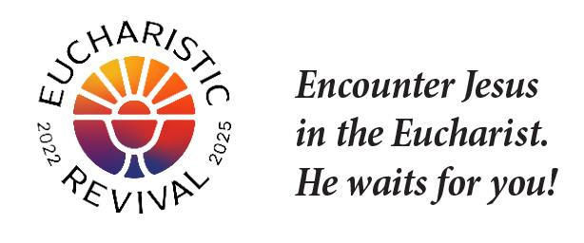
For Your Parish Bulletin:
A Minute with Jesus during the Eucharistic Revival, a time for deeper understanding and love of Jesus’ Gift of Himself to us in Holy Communion
Jesus came into the world to save us.
Jesus was born in Bethlehem, which means “house of bread.” Because there was no room in the inn (motel), Jesus was born in a stable and laid in a manger, which is significant because it was a feeding trough for animals. This was all part of God’s plan for His birth on earth, to point to the fact that Jesus came to save us. This is really the whole meaning of Christmas. Jesus came to give us Himself as food – He literally is the Bread of Life – supernatural bread (this is Jesus Himself) that saves us, that spiritually nourishes and strengthens us with His grace.
Let’s pray this right now and every day this week: Jesus, thank You for coming into the world as our Savior.
This week, read how the birth of Jesus took place in Luke 2: 1-7
Bulletin editors: For proclamations entitled A Minute with Jesus for upcoming weeks, click here: diolc.org/eucharist/learn.
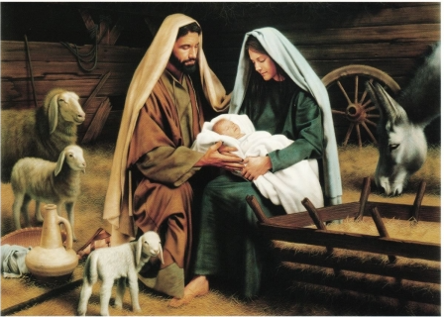
Catechetical Leader Information:
Wishes for a most Blessed Christmas
To each DRE, CRE, Youth Minister and Catechist,
I want to wish you and your family a most Blessed Christmas. May your celebrations of the birth of our Savior be filled with abundant peace and joy. Thank you for all of your time, effort, and prayer that you provide in service to the families of the parish. With prayer and thanksgiving, Ann.
Advent 2023 — Receiving the Sacrament of Reconciliation
It was requested that age-appropriate examinations of conscience be developed for children and young people preparing to go to confession. Grades 2-3, 4-5, 6-9 and 10-12 are available here: diolc.org/catechesis/catechetical-leaders-info

<<Top >>

Director: Erik Archer– 608.791.2661 | earcher@diolc.org

Flocknote—Approval and Next Steps:
Our office’s request to purchase Flocknote for the diocese was approved, and we’re in contact with the Flocknote team to finalize the contract. We will roll out the software in phases to parishes as interest grows. We have 16 slots for this first allotment of paid licenses. Contact me at earcher@diolc.org if you would like one of these spots.

Why should you and your parish leap to Flocknote?
- Over 10,000 churches and 45 dioceses use Flocknote to help parishes communicate to their parishioners via text and email. From the Archdiocese of Los Angeles to the Diocese of Fargo (where this North Dakotan grew up), these dioceses are equipping their parishes and schools with this capability.
- Knowing that it is critical for a pastor to reach their parishioners, they built a system anyone can use. The success of every parish, even the least tech-savvy, is their goal.
- Mirrors how ministries work - parishes can customize groups and tailor messages
- It focuses on email and text, which are proven and important means of communication.
- No one feels like they are on a mass distro list. Flocknote provides template texts and emails that parishes can send to specific groups.
- The Flocknote team personally assists each parish. They provide a central signup page for parishioners to sign up, assign a dedicated account manager to our diocese, create custom webinars as we need them, and personally call each parish to assist when needed.
Features: Features of Flocknote - Easy to use Church Software
Texting: Church Texting with Flocknote
Their comprehensive help page: Flocknote Help Center

<<Top >>

Director: Sr. Donna Krzmarzick, ISSM – 608.791.2690 | dkrzmarzick@diolc.org

No items this week.

<<Top >>

Director: Deacon Robert Riedl – 608.791.2665 | rriedl@diolclergy.org

No items this week.

<<Top >>

Director: Christopher Rogers – 608.791.2659 | crogers@diolc.org

50th Wedding Anniversary Lists
Please submit the names of those couples celebrating their 50th Jubilee Wedding Anniversaries in the year 2024 by January 22, 2024, by filling out this form and emailing it to crogers@diolc.org.

For Your Parish Bulletin
“The ANSWER” Eucharistic Rally Tickets are now on sale!
The time has come to say “Yes!” to this life-changing event that will be held June 7, 2024 at the La Crosse Center. Discounted tickets are now available for purchase. However, you may also want to check with your parish office as there are some parishes that have already begun purchasing group tickets and reserving buses for this event. Please check out the official website for all the detailed information. The registration link is found at the following link or by using your smartphone’s camera to scan the QR code to the right. https://diolc.org/the-answer/ (you can also paste this QR code into your bulletin for fast parishioner use)

For Your Parish Bulletin:
"Behold: God is With Us" Young Adult Retreat - January 27, 2024
The world needs Jesus. Our souls need Jesus. Out of God's abundant love for us, He became man: the Word became flesh and dwelt among us (John 1:14). Jesus is the answer to the longings of our heart, and He is our way to eternal life. Knowing He would ascend into heaven, Jesus leaves us Himself- body, blood, soul, and divinity- under the guise of simple bread and simple wine. Why? So that our intimate love and union with Him (flesh to flesh) may continue in this life as we await the perfection of His love and union in the next. "Behold: God is With Us" or "Behold," for short, is an opportunity for you to retreat from the busyness and stresses of this world and find rest and consolation in Jesus and other young adults like you. All 18-35 year olds are welcome to join us for a day of enriching talks, silent prayer/reflection, small group discussion, adoration, confession, and Mass. Most importantly, learn how to remain connected post-retreat to a lively community of young adults striving for Sainthood. This day-long retreat will occur at Blessed Sacrament Parish in La Crosse, WI. Check-ins will begin at 8:30 am, and the retreat will conclude after the 4:30 pm vigil Mass. An optional after party will take place to follow! Breastfeeding babies are welcome! Lunch will be provided! All of this and more for the low cost of $20. Let us behold the Lord together! Register here: https://argentasoftware.com/interfaces/49870/frmEventTicketSalesForm.aspx?EventID=4042 or use your smartphone to scan the QR code to the right (you can also paste this QR code into your bulletin for fast parishioner use)

A CHRISTMAS GIFT FOR MARRIED COUPLES:
Worldwide Marriage Encounter Weekend
Couples: do you want to give each other something really special this Christmas? How about a gift filled with romance and excitement? That's just the beginning of what you will receive on a Worldwide Marriage Encounter Weekend. For more information call Denise and Greg at (563)920-9419. Upcoming weekends are February 16-18 in Marshalltown, April 12-14, 2024 in Epworth and September 27-29 in Dubuque.

For Your Parish Bulletin:
Retrouvaille
Marriage in Distress? No matter how hopeless it seems, forgiveness and trust are possible. Retrouvaille is a Catholic-based program that helps couples through difficult times in their marriages, some even after separation or divorce. It is not counseling or group therapy. The next program begins with a weekend on February 16-18, 2024 in the Wausau area. Call 1-877-922-HOPE (4673). Fully Confidential. More at www.HelpOurMarriage.org No couple is turned away for lack of finances. Please click on this link or use your camera’s smartphone to scan the QR code to the right to access the brochure. (you can also paste this QR code into your bulletin for fast parishioner use) https://drive.google.com/file/d/1DyrLYH74WoOSYOzA0cFue2lLAQrOZtmv/view?usp=sharing

For Your Parish Bulletin:
Domestic Church Retreat - Save the Date
The next Domestic Church Retreat will be held April 13-14, 2024 at Sts. Peter and Paul Parish in Wisconsin Rapids. During the retreat, couples are invited to delve more deeply into the graces of their shared spiritual journey. The retreat’s goal is to strengthen the couple’s spousal union and lead them to experience complete harmony and joy in their marriage through simple formation and meaningful dialogue that intentionally places Christ in the center. To register and find out more information, click this link: https://diolc.org/marriage/marriage-enrichment/

<<Top >>

Director: Christopher Ruff – 608.791.0161 | cruff@diolc.org

No items this week.

<<Top >>

Director: Fr. Woodrow Pace – 608.791.2676 | wpace@diolc.org

No items this week.

<<Top >>

Director: Christopher Carstens – 608.791.0161 | ccarstens@diolc.org
Upcoming Liturgical Calendar Advisories:
From the USCCB’s Committee on Divine Worship
On Sunday evening, December 31, the Mass of the Holy Family is celebrated, while at the Liturgy of the Hours Evening Prayer I of the Solemnity of Mary, the Holy Mother of God is used. In celebrations with the people, however, Evening Prayer II of the Holy Family may take place. Because Holy Mary, Mother of God falls on a Monday, the precept to attend Mass is abrogated, and Funeral Masses are permitted.
According to the Roman Missal, “Where the Solemnity of the Epiphany is transferred to Sunday, if this Sunday occurs on January 7 or 8, the Feast of the Baptism of the Lord is celebrated on the following Monday” (Proper of Time). Therefore, this Feast will take place on Monday, January 8, 2024, with only one reading before the Gospel. The First Week in Ordinary Time begins on the following day, Tuesday, January 9, and the readings assigned to Monday may be joined to those of Tuesday so that the opening of each book will be read.
Televised Mass Schedule for Christmas
· Eau Claire, Channel 18, at 5:30 a.m. on Christmas Day.
· La Crosse, Channel 19, at 5:30 a.m. on Christmas Day.
· Marshfield (Public Access), Channel 990, at 10:00 a.m. and 6:00 p.m. on Christmas Day.
· Stevens Point (Public Access), Channel 984 and Channel 3, at 12:30, 3:30, and 8:30 p.m. on Christmas Day.
· Trempealeau County (Public Access), Channel 18/618, at 11:00 a.m. on Christmas Day.
· Wausau, Channel 12, at 5:00 and 6:00 a.m. on Christmas Day
· Wausau (Public Access), Channel 980, at 12:00 noon on Christmas Day.
· Wisconsin Rapids (Public Access), Channel 985 and Channel 3: at 8:00 a.m. and 10:00 a.m. on Christmas Day.
<<Top >>

Director: Teresa Brown – 608.791.2679 | tbrown@diolc.org

DIOCESE OF LA CROSSE GUIDELINES FOR REPORTING INSTANCES OF CHILD ABUSE
The Diocese of La Crosse, through its policies and procedures, seeks to provide a prompt, appropriate and compassionate response to reporters of sexual abuse of a child by any diocesan agent (bishop, priest, deacon, employee, religious, vendor or volunteer). Anyone wishing to make a report of an allegation of sexual abuse should send that report to Mrs. Teresa Brown, Complaint Intake Agent, at the Diocese of La Crosse, P.O. Box 4004, La Crosse, WI 54602-4004. Alternatively, you can contact Mrs. Brown at 608.791.0179 or intakeagent@diolc.org. The reporting form is available through the Diocese of La Crosse Office of Safe Environment or on the diocesan website at: diolc.org/safe-environment/reporting or use your camera’s smartphone to scan the QR code to the right. (you can also paste this QR code into your bulletin for parishioner use) Individuals are also encouraged to take their reports directly to civil authorities. Copies of the diocesan policy are available through your local Parish and on the diocesan website. If you have any questions about the Diocese of La Crosse and the implementation of the Charter for the Protection of Children and Young People, please contact Teresa Brown, Diocese of La Crosse, at 608.791.2679 or tbrown@diolc.org.

<<Top >>

Superintendent: Thomas Reichenbacher – 608.788.7707 | treichenbacher@diolc.org

No items this week.

<<Top >>

Director: Christopher Ruff – 608.791.0161 | cruff@diolc.org

For Your Parish Bulletin:
Please Support Project Milk this Christmas Season
Help the Diocesan Rural Life Committee spread hope and joy by contributing to Project Milk. Founded in 1984 to help feed the poor children of Casa Hogar in Peru, Project Milk provides whole milk powder to the orphanage and the surrounding community. Each year, the Rural Life Committee seeks to raise enough money to ship 40,000 lbs. of milk powder at an approximate cost of $80,000. One hundred percent of your monetary gift is used to feed these children and the poor. To give, visit frjoesguild.org/donate, and select “Project Milk” as your designation, or scan the QR code to the right.
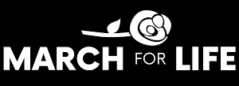
(Reminder) For Your Parish Bulletin:
Pilgrimage for LIFE – Join us!! | Jan. 17-21 | Washington D.C.
Adults - Youths - Families: Your pro-life witness is needed more than ever! Come with us by coach bus to Washington, DC, to participate in the annual March for Life. For ages 13 and up, $400/person. Parish or school groups must have each participant complete the registration online, fill out the required forms and pay a non-refundable deposit of $100. The remainder of the fee will be paid to the parish or school. For more information and to register, visit diolc.org/yya/youth-opportunities/pilgrimage-for-life or scan the QR code to the right. (you can also paste this QR code into your bulletin for fast parishioner use)
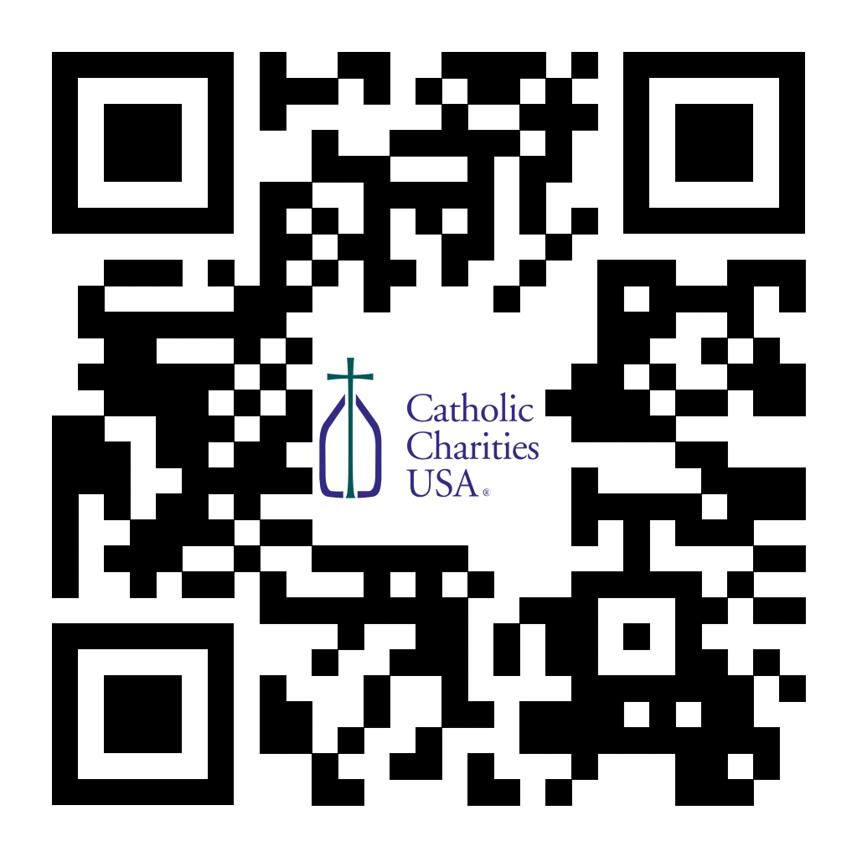
Pastors - CCHD Collection Jan. 27-28 or Feb. 3-4:
Bishop Callahan designated the last weekend of January (27-28) or the first weekend of February (3-4) for the CCHD collection. Parishes should have received a shipment of envelopes from the USCCB for this purpose. Checks should be made payable to your parish (CCHD on the memo line), with one check from the parish for the total made payable to the Diocese of La Crosse and sent to the Office for Ministries and Social Concerns.
(Reminder) For Your Parish Bulletin:
Post-Abortion Healing Ministry in the Diocese of La Crosse
Do you know someone who is carrying the grief and sorrow of past abortions? Project Rachel Ministry offers a compassionate heart and confidential help. Call 608.860.6698 or email projectrachel@diolc.org.

(Reminder) For Your Parish Bulletin:
Post-Abortion Healing Retreats – Rachel’s Vineyard – Encounter God’s Mercy
Rachel's Vineyard is a weekend retreat to help anyone who has struggled with the aftermath of abortion to begin healing through a supportive, trauma-sensitive approach. Each weekend is run by a team of trained volunteers (counselor, priest, and lay people), who care deeply for your needs. All interactions with the Rachel's Vineyard retreat team are completely confidential. These retreats will be offered in the Diocese of Madison on March 15-17, 2024, and Nov. 8-10 2024. For more information, visit madisondiocese.org/rachel or use your smartphone’s camera to scan the QR code on the right. (you can also paste this QR code into your bulletin for fast parishioner use)

<<Top >>

Director: Jeff Reiter – 608.791.2653 | jreiter@diolc.org
The Year End 2023 Gifts:
We will accept all gifts postmarked 12/31/2023 or earlier as 2023 donations. This includes The Diocesan Annual Appeal, Inspired By The Spirit gifts, and Father Joseph Walijewski Guild gifts. The envelope must be postmarked, and the check must be dated 12/31/2023 or earlier to be accepted.
Gifts for the Diocesan Annual Appeal and Inspired By The Spirit received at the parish, either by the basket or office drop off, will be accepted as 2023 if the mailing comes in a parish envelope and the donor’s check is dated no later than 12/31/2023. The parish must send the gifts with a postmark date no later than 1/05/2024.
Inspired By The Spirit and Diocesan Annual Appeal:
We have become aware that parishes are again making and using copies of the pledge form. These are parish-specific, and for our electronic banking and gift-scanning process, the pledge form must meet particular specifications to size and QR location to be more efficient, helping keep costs down and ensuring the correct parish and supporter is getting credit for that gift.
If you need more pledge forms, please contact Sarah Komperud at skomperud@diolc.org; we will order more. Please allow 14 days for delivery.
(Reminder) Diocesan Annual Appeal:
In mid-January 2024, we will send a follow-up mailing for any parish that announced and who had their homes mailed between and including the weekends of Nov. 18/19, 2023, and Dec. 16/17, 2023. The expected in-home date will be Jan. 27/28, 2024. We encourage any parish who wishes to include a letter from the pastor or finance council to submit a Word document. Please include the parish number in the file name. The deadline to submit a letter is Jan. 05, 2024.
The next scheduled mailing will be our Holy Week mailing. The Holy Week Mailing will be focused on
- Parishes over goal: we will mail those who gave in the last two years (2021 & 2022) but have not yet given this year (LYBUNTS and SYBUNTS).
- Parishes under goal will have all those who have not yet supported the DAA mailed (LYBUNTS, SYBUNTS, and Never/New).
If you need more pledge forms, please contact Sarah Komperudskomperud@diolc.org; we will order more. Please allow 14 days for delivery.
If you have any questions or concerns, please do not hesitate to contact our office.
Weekly Stewardship Quotes (shorter bulletin reflections):
October-December
- https://diolc.org/wp-content/uploads/2023/09/Stewardship-Bulletin-Reflections-Oct-Dec-2023.pdf
  - Spanish Version
https://diolc.org/wp-content/uploads/2023/09/Stewardship-Bulletin-Reflections-Oct-Dec-2023-Spanish.pdf

January - March 2024
- https://diolc.org/wp-content/uploads/2023/12/Stewardship-Reflections-Jan-March-2024.docx
  - Spanish Version
https://diolc.org/wp-content/uploads/2023/12/Stewardship-Reflections-Jan-March-2024-Spanish.docx
Weekly Stewardship Prayers of the Faithful:
October-December
- https://diolc.org/wp-content/uploads/2023/09/Prayers-of-the-Faithful-Oct-Dec-2023.pdf
  - Spanish Version
https://diolc.org/wp-content/uploads/2023/09/Prayers-of-the-Faithful-Oct-Dec-2023-Spanish.pdf

January - March 2024
- https://diolc.org/wp-content/uploads/2023/12/Stewardship-Prayers-of-the-Faithful-Jan-March-2024.docx
  - Spanish Version
https://diolc.org/wp-content/uploads/2023/12/Stewardship-Prayers-of-the-Faithful-Jan-March-2024-Spanish.docx
Stewardship Bulletin Reflections for Weekends:
- 12/24
https://diolc.org/wp-content/uploads/2023/11/12.24.23-stewardship-bulletin-announcements.pdf
- 12/31
https://diolc.org/wp-content/uploads/2023/12/12.31.23-stewardship-bulletin-announcements.pdf
- 01/07/24
https://diolc.org/wp-content/uploads/2023/12/01.07.24-stewardship-bulletin-announcements.pdf
- 01/14/24
https://diolc.org/wp-content/uploads/2023/12/01.14.24-stewardship-bulletin-announcements.pdf
- 01/21/24
https://diolc.org/wp-content/uploads/2023/12/01.21.24-stewardship-bulletin-announcements.pdf
Stewardship Homily Reflections:
Stewardship reflections for your homily development:
- For Weeks 12/24 - 01/14/24:
https://diolc.org/wp-content/uploads/2023/12/Homily-Guide-12.19.23-1.pdf
Planned Giving – Leaving a Legacy, Wills, Bequest, and Endowments:
We have been entrusted with precious treasures passed down from our ancestors, and it's our responsibility to ensure that future generations can also enjoy the splendor and reverence of a well-maintained parish. One way to achieve this is by utilizing the Capital Campaign and providing information on Endowments, Trusts, and Bequests to the parishioners.
Our Estate Planning Guide can help save hundreds of dollars in legal and financial estate planning costs. We have mailed out several hundred copies per individual request, and each Parish has received a copy. Please feel free to contact our office for additional copies.
Visit diolclegacy.org, our Planned Giving website, to find calculators and more information, sign up for a newsletter, and request specific estate planning guides and information. Our website also provides instructions on how to do an IRA Rollover, the creation of Donor Advised Funds (DAF), Beneficiary Designations, and Stock Transfers. https://diolclegacy.org/?pageID=5
Please contact Jeff Reiter at jreiter@diolc.org for more information on legacy giving, presentations, or ads for your Parish bulletin.
<<Top >>

Diocesan Finance Officer: James Reider – 608.791.2668 | jreider@diolc.org

Health Enews from Catholic Mutual Group:
Please click here for the December edition of CMG Health Enews.
Diocese of La Crosse Shared Services Program: Pastors and Parochial Administrators throughout the Diocese have requested help with parish bookkeeping. Parishes have reported difficulty finding qualified personnel to maintain their accounting records, pay bills, payroll, etc. The Finance office is pleased to offer a new program to meet these needs called Shared Services. Shared Services bookkeeper(s) working from the Finance office will record accounts payable, accounts receivable, receipts, disbursements, and payroll at a competitive rate. Parish selects specific Shared Services a la carte, paying only for whichever services they need.
Shared Services Description:
Pastor’s Summary
Diocesan Shared Services provides bookkeeping services to parishes on an ‘as selected’ basis. Each parish chooses only the bookkeeping services they need. Shared Services works only within ParishSOFT Accounting software, so subscribing parishes must use that platform. (Transition to ParishSOFT Accounting is available for parishes using QuickBooks Online.) Pastors and others they designate retain online access to all parish financial records at all times. Fees for Shared Services are cost based, as determined by the number of bookkeeping transactions recorded. In general, fees will be greater for parishes selecting more services, having a larger payroll, etc. Shared Services fees are market competitive, comparable to accounting firm service fees, and similar to those charged by other diocesean finance offices. Pastors, Shared Services wants to learn more about your bookkeeping needs. Please click here for a no-obligation survey.
Available Shared Services include, but are not limited to:
1. Transition Planning. Consultations with the pastor, current bookkeeper, secretary, and parish council set mutual goals, timelines, reports, and other measurable outcomes to ensure Shared Services reliably meets or exceeds parish expectations.
2. Process Review. Best practice process review designs timely data sharing, documentation, roles, and responsibilities for efficient collaboration between parish personnel and Shared Services.
3. Vendor Payment. Parish personnel scan and electronically transmit vendor invoices to Shared Services upon receipt. Shared Services codes and prepares accounts payable and checks on a mutually agreed schedule. Pastors approve payments for Shared Services check issuance.
4. Maintain account registers. Vendor history and transactional records for all parish disbursements are recorded and coordinated by Shared Services.
5. 1099 Forms. Prepare, record, and maintain Misc.-1099 forms as needed.
6. Contribution Receipts. Parish personnel scan and electronically transmit deposit slips, tally sheets, and other contribution documentation to Shared Services as they arrive. Shared Services codes and records timely and accurate updates to the general ledger.
7. Payroll. Parish personnel scan and electronically transmit employee documents, including time sheets, approved pay rates, tax status, benefits profile, and schedules to Shared Services. Shared Services configures software payroll setup for each employee per state, federal, diocesan, and parish laws and policies. Periodic payrolls are prepared per parish schedule for pastor approval before Shared Services check issuance.
8. Tax payments. Shared Services calculates and prepares Federal, Social Security/Medicare (FICA), and State quarterly and annual tax obligation payments. Pastor approves payments before Shared Services check issuance.
9. Benefits payments. Shared Services prepares payments to benefits vendors per schedule. Pastor approves payments before Shared Services check issuance.
10. Reconciliations. Parish personnel scan and electronically transmit checking, savings, investment, endowment, cemetery perpetual care, bank, and investment statements to Shared Services for timely reconciliation to the general ledger. Shared Services records timely and accurate updates to the parish general ledger.
11. Reports. Shared Services generates standard monthly financial statements, including Statements of Activity, Financial Position, Cash Flow, and Trial Balance for the Pastor, Finance Council, and others. Additional reports and report interpretation are available as needed.
Subscribed parishes will perform the following functions:
1. Collect, count, and deposit the Sunday offering and record parishioner giving and contributions to ParishSOFT Family Suite on a timely basis.
2. Maintain the family/member census information.
3. Maintain banking and investment relationships.
4. Maintain all parish calendars, registrations, and events.
5. Manage employee-related functions.
6. Retain responsibility for parish financial performance and reporting through regular review and oversight.
Pastors, Shared Services wants to learn more about your bookkeeping needs. Please click here for a no-obligation survey. Please share your interest in any of the Shared Services outlined above and direct any questions regarding Shared Services to Claudia Weinberger, cweinberger@diolc.org.
<<Top >>

Director of Vocation Recruitment: Fr. Nate Kuhn – 608.791.2666 | nkuhn@diolc.org
Please include the following intercession for vocations for your Sunday prayers of the faithful:
That through our vocations to marriage, priesthood, single life, and religious life we may be signs of God's presence and love in the world.
Consider adding a vocations paragraph to your parish bulletin:
Below is an example – they will be changed each week. Feel free to use any or all of them.
Come Follow Me!
When Peter encountered Jesus for the first time, he was busy doing his daily work, fishing. He was minding his own business when Jesus approached him and asked him to put his nets out into the deep water for a catch. Although hesitant, he did as Jesus asked him and caught an overabundance of fish! When they arrived back on shore, Jesus said to Peter, “Come, follow me…” and Peter did. In just the same way, the Lord continues to work in our world today, approaching us in our normal, daily lives and inviting us to consider following Him. Have you ever considered following the Lord as a priest, like Peter? Do you know of a young man whom you think the Lord may be calling to be a priest? Perhaps this is the Lord’s invitation to follow Him. To begin the conversation or to inquire about what it means to be a priest, please contact me: Fr. Nate Kuhn, Director of Vocational Recruitment for the Diocese of La Crosse, 3710 East Ave. S. PO Box 4004, La Crosse, WI 54602; or by phone at 608.791.2667. God bless you!
<<Top >>

Director: Very Rev. Woodrow H. Pace – 608.791.2689 | wpace@diolc.org

No items this week.

<<Top >>

Director: Christopher Rogers – 608.791.2659 | crogers@diolc.org

For Your Parish Bulletin:
“the ANSWER” Eucharistic Rally Tickets are now on sale!
The time has come to say “Yes!” to this life-changing event that will be held June 7, 2024 at the La Crosse Center. Discounted tickets are now available for purchase. However, you may also want to check with your parish office as there are some parishes that have already begun purchasing group tickets and reserving buses for this event. Please check out the official website for all the detailed information, including the link to purchase online tickets https://diolc.org/the-answer/ or use your smartphone’s camera to scan the QR code on the right. (you can also paste this QR code into your bulletin for fast parishioner use)
Pilgrimage for LIFE – Join us!! | Jan. 17-21 | Washington D.C
We are excited to offer the Pilgrimage for Life. We will travel by coach bus to Washington, DC to participate in the annual March for Life. This opportunity is for anyone ages 13 and up. The estimated cost is $400 per person. Parishes/Schools wishing to get a group to join us will have their participants complete the registration online by filling out all of the required forms and paying a non-refundable deposit of $100. The remainder of the fee will be paid to the parish/school. All information and registration link can be found at https://diolc.org/yya/youth-opportunities/pilgrimage-for-life/ or use your smartphone’s camera to scan the QR code on the right. (you can also paste this QR code into your bulletin for fast parishioner use)
SEALED! Spring Diocesan Confirmation Retreat:
The SEALED! Diocesan Confirmation Retreat will be held March 2, 2024 at Holy Spirit Catholic Church in Stevens Point, WI. Online registration is now available. Please click this link to register and find out more information: https://diolc.org/yya/youth-opportunities/immersion-retreat/ or use your smartphone’s camera to scan the QR code on the right. (you can also paste this QR code into your bulletin for fast parishioner use)

For Your Parish Bulletin:
"Behold: God is With Us" Young Adult Retreat - January 27, 2024
The world needs Jesus. Our souls need Jesus. Out of God's abundant love for us, He became man: the Word became flesh and dwelt among us (John 1:14). Jesus is the answer to the longings of our heart, and He is our way to eternal life. Knowing He would ascend into heaven, Jesus leaves us Himself- body, blood, soul, and divinity- under the guise of simple bread and simple wine. Why? So that our intimate love and union with Him (flesh to flesh) may continue in this life as we await the perfection of His love and union in the next. "Behold: God is With Us" or "Behold", for short, is an opportunity for you to retreat from the busyness and stresses of this world and find rest and consolation in Jesus and other young adults like you. All 18-35 year olds are welcome to join us for a day of enriching talks, silent prayer/reflection, small group discussion, adoration, confession, and Mass. Most importantly, learn how to remain connected post-retreat to a lively community of young adults striving for Sainthood. This day-long retreat will occur at Blessed Sacrament Parish in La Crosse, WI. Check-ins will begin at 8:30am and the retreat will conclude after the 4:30 pm vigil Mass. An optional after party will take place to follow! Breastfeeding babies are welcome! Lunch will be provided! All of this and more for the low cost of $20. Let us behold the Lord together! Register here: https://argentasoftware.com/interfaces/49870/frmEventTicketSalesForm.aspx?EventID=4042, or use your smartphone’s camera to scan the QR code on the right. (you can also paste this QR code into your bulletin for fast parishioner use)

<<Top >>

Diocese of La Crosse | 3710 East Ave S | La Crosse, WI 54601 | 608-788-7700
To unsubscribe from this e-mail message contact mwilson@diolc.org

