Chancery Bulletin - Vol. 8, No. 12.1 | December 5, 2023

- Catechesis & Evangelization  - Chancery  - Communications  - Consecrated Life  - Diaconate  - Marriage & Family Life  - Ministries  - Mission Office  - Sacred Worship | - Safe Environment  - Schools Office  - Social Concerns  - Stewardship and Development  - Temporalities  - Vocations  - Vicar for Clergy  - Youth and Young Adult Ministry  - Past Chancery Bulletins
The Most Reverend William Patrick Callahan, D.D., Bishop of La Crosse, makes the following announcement:
In accord with the norm of canon 553, §2, the following priests are named vicars forane (deans) for a three-year term, effective December 5, 2023:
The Very Rev. Georgekutty Thayilkuzhithottu for the Arcadia Deanery;
The Very Rev. Jesse D. Burish for the Chippewa Falls Deanery;
The Very Rev. D. Joseph Redfern for the Durand Deanery;
The Very Rev. James R. Kurzynski for the Eau Claire Deanery;
The Rev. Msgr. Steven J. Kachel for the La Crosse Deanery;
The Very Rev. Douglas C. Robertson for the Marshfield Deanery;
The Very Rev. Eric R. Berns for the Tomah Deanery;
The Very Rev. Rajendran Anandan for the Prairie du Chien Deanery;
The Very Rev. Joseph M. Richards for the Richland Center Deanery;
The Very Rev. John A. Potaczek for the Stevens Point Deanery;
The Very Rev. Peter J. Kieffer for the Thorp Deanery;
The Very Rev. Sebastian J. Kolodziejczyk for the Wausau Deanery;
The Very Rev. Robert A. Schaller for the Wisconsin Rapids Deanery.

<<Top >>

Chancellor Very Rev. William Dhein – 608.791.2655 | wdhein@diolc.org

No items this week.

<<Top >>

As of Dec. 5

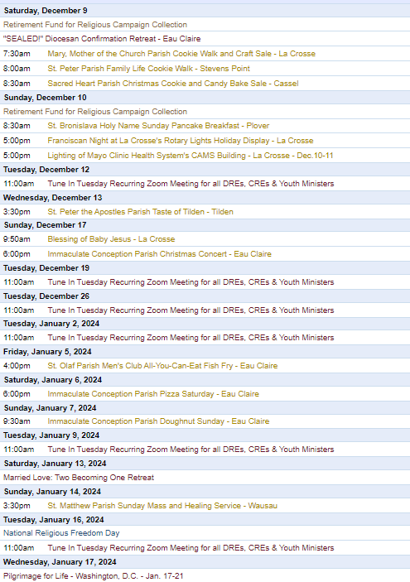
To get your parish events listed on the diocesan calendar, diolc.org/calendar, and in Catholic Life magazine, please send an email to datebook@diolc.org. Make sure you include the following details: date, beginning/ending times, event location, description, menu and cost, etc. If you have any questions, please call Pam Willer at 608.788.1524 for more information.

<<Top >>

Director: Ann Lankford – 608.791.2658 | alankford@diolc.org
For Your Parish Bulletin:
Advent: Preparing Our Hearts for Christ’s Coming
The Gospel for the Second Sunday of Advent is Mark 1:1-8, and the distinctive theme is John the Baptist. John was sent as a messenger to prepare for the coming of the Savior. John was “…a herald’s voice in the desert crying, make ready the way of the Lord.” A great way to prepare our hearts for Christ’s coming is to receive the Sacrament of reconciliation, i.e. confession. It brings peace to the mind and soul to set aside the busyness of the season, quiet down with an examination of conscience and receive God’s grace through this sacrament of healing and forgiveness. This cleansing and “making room” for the Lord prepares us to receive all that He wants to give us.
Brief bulletin entries for the Third and Fourth Sundays of Advent are available here: diolc.org/catechesis/bulletin-inserts
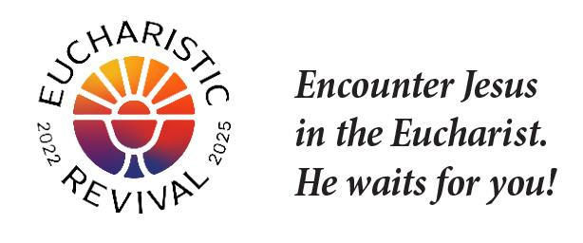
For Your Parish Bulletin:
A Minute with Jesus during the National Eucharistic Revival
Does Jesus understand everything about me?
Jesus knows exactly what you are feeling and understands. Where you are, Jesus has been; He shares every joy and every pain with you. Let’s pray this right now and every day this week: If you have something painful in your heart, speak with Jesus about it and give it to Him.
This week, read from Scripture how the angel appears to Joseph and guides him to take his wife Mary into his home in Matthew 1: 18-25. Note: Mary and Joseph were married in the Jewish tradition, which is referred to as being betrothed. There are two parts to betrothal: marriage and, after one year, sharing a common home.
Bulletin editors: For proclamations entitled A Minute with Jesus for upcoming weeks, click here: diolc.org/eucharist/learn.
Advent 2023: Resources for Meditation:
- Bishop Barron’s daily Gospel reflections - www.wordonfire.org/reflections/advent
- Fr. Joseph Mary Wolfe, MFVA - Weekly Advent Reflection Videos (2 min.): What can we give Jesus for Christmas? www.ewtn.com/catholicism/seasons-and-feast-days/advent-14416
- Hallow’s Advent Pray25 with C.S. Lewis - https://hallow.com/blog/pray25/
- Matthew Kelly: Best Advent Ever - www.dynamiccatholic.com/advent.htm
- EWTN daily Advent Reflections - www.ewtn.com/catholicism/reflections/advent
- Seven Scripture Readings for Advent on a downloadable prayer card available under the title “Praying with Scripture - diolc.org/deeper.
- Scripture Readings from Mass each day during Advent - bible.usccb.org.
Catechetical Leader Information:
Bishop’s Education Endowment Trust (BEET) Grants:
The 2023-24 BEET grant application window is now open. The method for applying for the BEET grant for the 2024-25 fiscal year is to complete an online Google Form (application). The deadline for submission is Friday, Jan. 19, 2024, with the online application being disabled by 4:30 p.m. A required part of the process is approval by your pastor or dean. The approval deadline for pastors or deans is Friday, Jan. 26, 2024.
The instructions and the application form are on the Office for Catechesis & Evangelization main webpage, and by clicking here: https://diolc.org/schools/beet-grant/ Since the online application form must be completed in one sitting, the questions on the application form are included with the instructions so that you can prepare your answers ahead of time. Please call the Office for C & E with questions regarding grant applications.

“the ANSWER” Eucharistic Rally |June 7
The La Crosse Center, La Crosse, WI
We are very excited to announce “the Answer” Eucharistic Rally that will be held on June 7, 2024 at the La Crosse Center in La Crosse, WI. This event kicks off the first day that the National Eucharistic Pilgrimage will be in the Diocese of La Crosse. “the Answer” Eucharistic Rally will begin with a Eucharistic Procession Across the Cameron Street Bridge in La Crosse. It will end at the La Crosse Center where the rest of the rally will take place. The day will include Mass, Adoration, Confession, powerful speakers such as Chris Stefanick, Immaculee Ilibagize, and Josh Rosa, music from Luke Spehar, and plenty of vendors. The cost for this event is only $15 per person. This rally is for middle and high school youth, young adults, adults, families, etc. Tickets will go on sale December 15, 2023. You can find more information about the event by visiting https://diolc.org/the-answer/. For such an important event, it would be amazing if every parish brought a bus full of parishioners.
Advent: A Time for More Quiet Prayer:
Children and young people need help to quiet down in prayer in order to encounter the person of Jesus. A tool to help foster this encounter and to make prayer more personal is a prayer card for each grade level found here: diolc.org/catechesis/prayer
(Reminder) A Minute with Jesus: For Parents, Parish CCD Sessions and Catholic Schools:
In communications with parents, always provide a small “dose” of the reality of the Eucharist. Click here for entries or see above: diolc.org/catechesis/catechetical-leaders-info
<<Top >>

Director: Erik Archer– 608.791.2661 | earcher@diolc.org
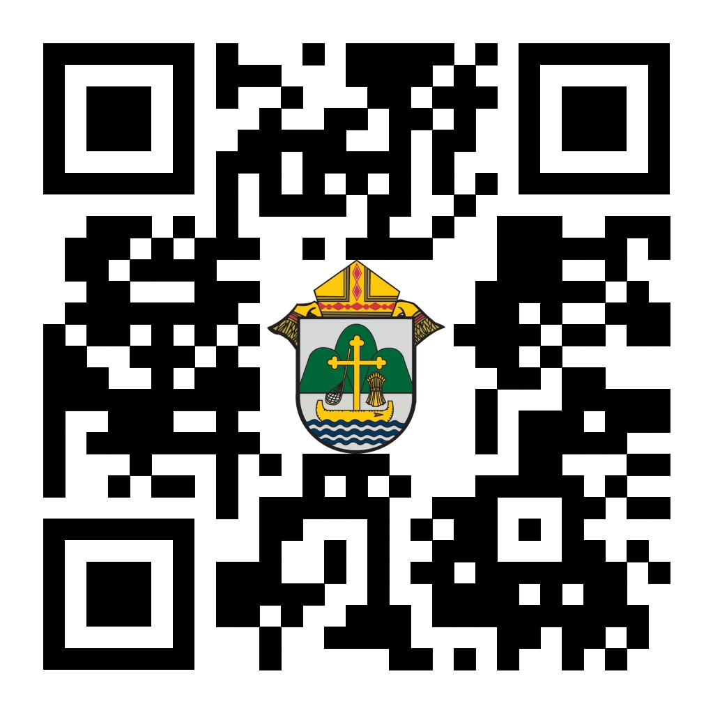
Bishop Callahan Advent Remarks:
“As the year draws to a close and the hopes for 2024 dawn, I am grateful to have the opportunity to pass along my own Advent greetings to you…” Please share Bishop Callahan’s Advent remarks by visiting https://www.youtube.com/watch?v=e0cKXO0q9t8 or by using your smartphone’s camera to scan the QR code to the right.
Catholic Social Media (CSM) Wave 2 Complete:
A grateful, “thank you!” to the 21 parishes that attended our Wave 2 training last week. One of our diocesan pastors using CSM said, “The content is uplifting and people in the parish love it. I like that there is content with a spiritual message or something for the parishioners to ponder and think about.”
A parish secretary remarked, “The ease of posting is AMAZING! The content is fun and keeps you thinking about the importance of the day. Every day with our faith is a special celebration or remembrance. It's beautiful and begs to be shared.”
Stay tuned for information on the next wave of training!
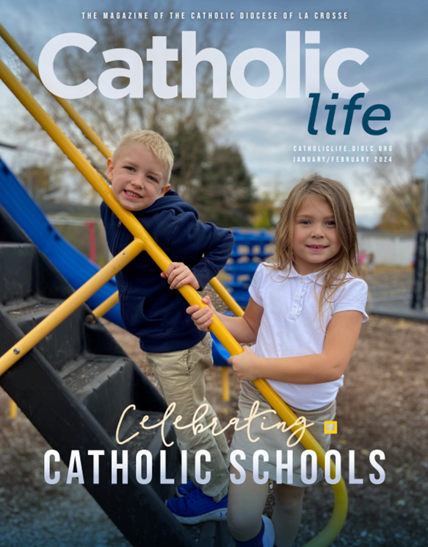
Next Issue of Catholic Life:
We are about to send the next issue of Catholic Life to the printer. The issue celebrates our Catholic schools (issue cover image to the right). Father Wolf is featured on pages 3 & 4 and tells the story of running to hide from a FSPA sister when he was a little boy (did you also know that his first car was a blue 1963 VW Beetle?). We dedicate four pages to the classical school that Newman Catholic Schools is set to open in 2024. The Holy Spirit is powerfully leading this process. Our superintendent shares his thoughts about the "Schools of Redeemed Sinners" and Andrew tells us about Father Kuhn, basketball (a non-injury-related basketball story), playing kiddos in dodgeball and the importance of Catholic schools in discerning a vocation. Father Robertson closes out the issue with his thoughts on Catholic Education. Thank you to all the writers who help share these stories of our Faith and relationships.
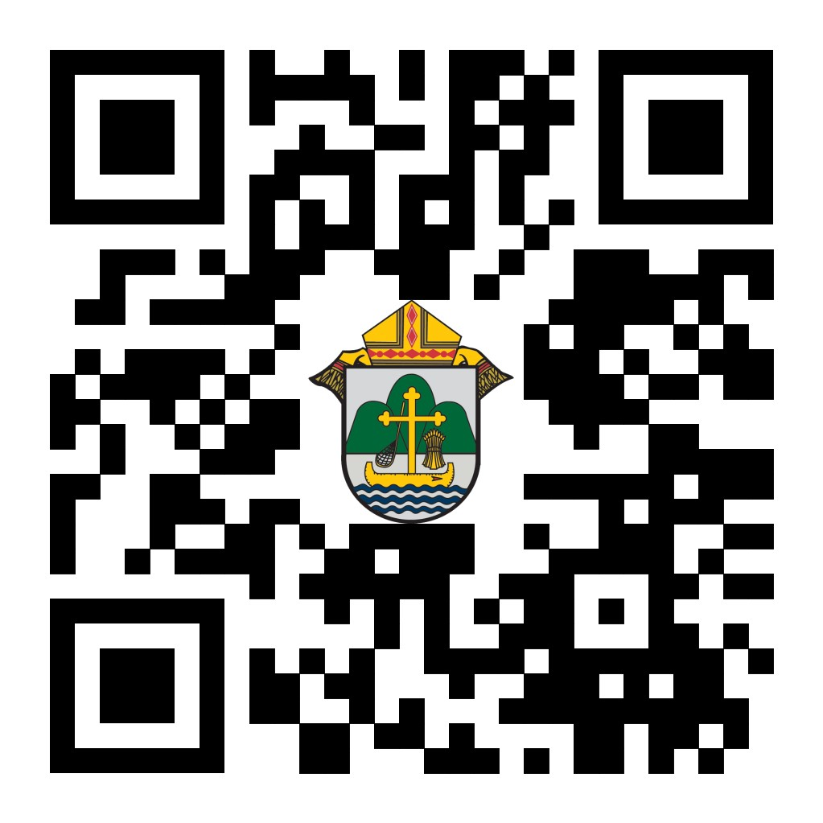
“Do I Have To Do Everything Around Here?”
Not only is this something you may find yourself thinking on a monthly/weekly/daily basis, but it is also the title of the newest “Coffee with Kevin” podcast that debuts later this week.
<<Top >>

Director: Sr. Donna Krzmarzick, ISSM – 608.791.2690 | dkrzmarzick@diolc.org

(Reminder) Retirement Fund for Religious:
The annual collection in parishes for the national Retirement Fund for Religious is scheduled for the weekend of Dec. 9-10. Religious sisters, brothers and religious order priests benefit significantly from this national collection. Please promote the campaign in your pulpit announcements and petitions at Mass (sample texts below and further resources here).
For your parish bulletin (weekends after the collection):
Our women and men religious offer gratitude. A sister shares, “I thank the Lord for all who give. I don’t think we would make it without them.” Thank you for giving to the Retirement Fund for Religious. Your donation makes a difference in the lives of elderly women and men religious. To learn more about how your gift helps, visit retiredreligious.org.
Attention parish bookkeepers:
All donations for the Retirement Fund for Religious should be run through parish bookkeeping and then submitted payable to the Diocese of La Crosse with “Retirement Fund for Religious” in the memorandum line. Thank you.
<<Top >>

Director: Deacon Robert Riedl – 608.791.2665 | rriedl@diolclergy.org

No items this week.

<<Top >>

Director: Christopher Rogers – 608.791.2659 | crogers@diolc.org

No items this week.

<<Top >>

Director: Christopher Ruff – 608.791.0161 | cruff@diolc.org

No items this week.

<<Top >>

Director: Fr. Woodrow Pace – 608.791.2676 | wpace@diolc.org

No items this week.

<<Top >>

Director: Christopher Carstens – 608.791.0161 | ccarstens@diolc.org
RCIA: To Pastors, Pastoral Associates, and RCIA Coordinators:
Bishop Callahan wishes to send Christmas greetings and words of encouragement to those currently participating in the RCIA process. Please return this form by Dec. 15 requesting the names of catechumens preparing for entry into the Church at the Easter Vigil and candidates seeking full communion.
Upcoming Liturgical Calendar Advisories:
From the USCCB’s Committee on Divine Worship
On Sunday evening, Dec. 31, the Mass of the Holy Family is celebrated, while at the Liturgy of the Hours Evening Prayer I of the Solemnity of Mary, the Holy Mother of God is used. In celebrations with the people, however, Evening Prayer II of the Holy Family may take place. Because Holy Mary, Mother of God falls on a Monday, the precept to attend Mass is abrogated, and Funeral Masses are permitted.
According to the Roman Missal, “Where the Solemnity of the Epiphany is transferred to Sunday, if this Sunday occurs on Jan. 7 or 8, the Feast of the Baptism of the Lord is celebrated on the following Monday” (Proper of Time). Therefore, this Feast will occur on Monday, Jan. 8, 2024, with only one reading before the Gospel. The First Week in Ordinary Time begins on the following day, Tuesday, Jan. 9, and the readings assigned to Monday may be joined to those of Tuesday so that the opening of each book will be read.
<<Top >>

Director: Teresa Brown – 608.791.2679 | tbrown@diolc.org

DIOCESE OF LA CROSSE GUIDELINES FOR REPORTING INSTANCES OF CHILD ABUSE:
The Diocese of La Crosse, through its policies and procedures, seeks to provide a prompt, appropriate and compassionate response to reporters of sexual abuse of a child by any diocesan agent (bishop, priest, deacon, employee, religious, vendor or volunteer). Anyone wishing to make a report of an allegation of sexual abuse should send that report to Mrs. Teresa Brown, Complaint Intake Agent, at the Diocese of La Crosse, P.O. Box 4004, La Crosse, WI 54602-4004. Alternatively, you can contact Mrs. Brown at 608.791.0179 or intakeagent@diolc.org. The reporting form is available through the Diocese of La Crosse Office of Safe Environment or on the diocesan website at: diolc.org/safe-environment/reporting. Individuals are also encouraged to take their reports directly to civil authorities. Copies of the diocesan policy are available through your local Parish and on the diocesan website. If you have any questions about the Diocese of La Crosse and the implementation of the Charter for the Protection of Children and Young People, please contact Teresa Brown, Diocese of La Crosse, at 608.791.2679 or tbrown@diolc.org.

<<Top >>

Superintendent: Thomas Reichenbacher – 608.788.7707 | treichenbacher@diolc.org

No items this week.

<<Top >>

Director: Christopher Ruff – 608.791.0161 | cruff@diolc.org

For Your Parish Bulletin:
Pilgrimage for LIFE – Let’s Bear Witness!! | Jan. 17-21 | Washington D.C.
Your pro-life witness is needed more than ever! Come with us by coach bus to Washington, DC, to participate in the annual March for Life. For ages 13 and up, $400/person.Parish or school groups must have each participant complete the registration online, fill out the required forms and pay a non-refundable deposit of $100. The remainder of the fee will be paid to the parish or school. For more information and to register, visit diolc.org/yya/youth-opportunities/pilgrimage-for-life or scan the QR code to the right.

(Reminder) For Your Parish Bulletin:
Post-Abortion Healing Ministry in the Diocese of La Crosse
Do you know someone who is carrying the grief and sorrow of past abortions? Project Rachel Ministry offers a compassionate heart and confidential help. Call 608.860.6698 or email projectrachel@diolc.org.

(Reminder) For Your Parish Bulletin:
Post-Abortion Healing Retreats – Rachel’s Vineyard – Encounter God’s Mercy
Rachel's Vineyard is a weekend retreat to help anyone who has struggled with the aftermath of abortion to begin healing through a supportive, trauma-sensitive approach. Each weekend is run by a team of trained volunteers (counselor, priest, and lay people), who care deeply for your needs. All interactions with the Rachel's Vineyard retreat team are completely confidential. These retreats will be offered in the Diocese of Madison on Nov. 10-12, 2023, March 15-17, 2024, and Nov. 8-10 2024. For more information, visit madisondiocese.org/rachel or scan the QR code on the right.

<<Top >>

Director: Jeff Reiter – 608.791.2653 | jreiter@diolc.org
Diocesan Annual Appeal:
In mid-January 2024, we will send a follow-up mailing for any parish that announced and who had their homes mailed for the weekend of Nov. 18/19, 2023 and Dec. 16/17, 2023. The expected in-home date will be Jan. 27/28, 2024. We encourage any parish who wishes to include a letter from the pastor or Finance Council to submit a Word document. Please include the parish number in the file name. The deadline to submit a letter is Jan. 05, 2024.
The next scheduled mailing will be our Holy Week mailing.
- Parishes over goal those who gave in the last two years (2021 & 2022) but have not yet given this year (LYBUNTS and SYBUNTS).
- Parishes under goal will have all those who have not yet supported the DAA mailed (LYBUNTS, SYBUNTS, and Never).
(Reminder) Inspired By The Spirit and Diocesan Annual Appeal:
We have become aware that parishes are again making and using copies of the pledge form. These are parish-specific, and for our electronic banking and gift-scanning process, the pledge form must meet particular specifications to size and QR location to be more efficient, helping keep costs down and ensuring the correct parish and supporter is getting credit for that gift.
If you need more pledge forms, please contact Sarah Komperudskomperud@diolc.org; we will order more. Please allow 14 days for delivery.
Weekly Stewardship Quotes (shorter bulletin reflections):
October-December
- https://diolc.org/wp-content/uploads/2023/09/Stewardship-Bulletin-Reflections-Oct-Dec-2023.pdf
  - Spanish Version
https://diolc.org/wp-content/uploads/2023/09/Stewardship-Bulletin-Reflections-Oct-Dec-2023-Spanish.pdf

January - March 2024
- https://diolc.org/wp-content/uploads/2023/12/Stewardship-Reflections-Jan-March-2024.docx
  - Spanish Verison
https://diolc.org/wp-content/uploads/2023/12/Stewardship-Reflections-Jan-March-2024-Spanish.docx
Weekly Stewardship Prayers of the Faithful:
October-December
- https://diolc.org/wp-content/uploads/2023/09/Prayers-of-the-Faithful-Oct-Dec-2023.pdf
  - Spanish Version
https://diolc.org/wp-content/uploads/2023/09/Prayers-of-the-Faithful-Oct-Dec-2023-Spanish.pdf

January - March 2024
- https://diolc.org/wp-content/uploads/2023/12/Stewardship-Prayers-of-the-Faithful-Jan-March-2024.docx
  - Spanish Version
https://diolc.org/wp-content/uploads/2023/12/Stewardship-Prayers-of-the-Faithful-Jan-March-2024-Spanish.docx
Stewardship Bulletin Reflections for Weekends:
- 12/10
https://diolc.org/wp-content/uploads/2023/11/12.10.23-stewardship-bulletin-announcements.pdf
- 12/17
https://diolc.org/wp-content/uploads/2023/11/12.17.23-stewardship-bulletin-announcements.pdf
- 12/24
https://diolc.org/wp-content/uploads/2023/11/12.24.23-stewardship-bulletin-announcements.pdf
- 12/31
https://diolc.org/wp-content/uploads/2023/12/12.31.23-stewardship-bulletin-announcements.pdf
Stewardship Homily Reflections:
Stewardship reflections for your homily development:
- For Weeks 12/10 - 12/31/23:
https://diolc.org/wp-content/uploads/2023/12/Homily-Guide-12.05.23.pdf

Planned Giving – Leaving a Legacy, Wills, Bequest and Endowments:
We have been entrusted with precious treasures passed down from our ancestors, and it's our responsibility to ensure that future generations can also enjoy the splendor and reverence of a well-maintained parish. One way to achieve this is by utilizing the Capital Campaign and providing information on Endowments, Trusts and Bequests to the parishioners.
Our Estate Planning Guide can help save hundreds of dollars in legal and financial estate planning costs. We have mailed out several hundred copies per individual request, and each Parish has received a copy. Please feel free to contact our office for additional copies.
Visit diolclegacy.org, our Planned Giving website, to find calculators and more information, sign up for a newsletter, and request specific estate planning guides and information. Our website also provides instructions on how to do an IRA Rollover, the creation of Donor Advised Funds (DAF), Beneficiary Designations, and Stock Transfers. https://diolclegacy.org/?pageID=5
Please contact our office for more information on legacy giving, presentations, or ads for your Parish bulletin.
<<Top >>

Diocesan Finance Officer: James Reider – 608.791.2668 | jreider@diolc.org
Diocese of La Crosse Shared Services Program: The Diocese is establishing bookkeeping services for parishes called Shared Services. Parishes have reported issues finding personnel to maintain their accounting records, pay bills, etc. Shared Services will hire bookkeeper(s) working for and at the Diocese. The Shared Services team will provide accounts payable, accounts receivable, receipts and/or payroll services for a fee. Each Parish may decide the extent of the services it desires to be provided.
If your Parish is interested in our Shared Services program, please click here to access the survey and click here for the program description.

Catholic Mutual Group - Event Coverage:
Catholic Mutual Group (CMG) held a discussion with K&K Insurance, the third-party special event insurance coverage carrier. The conversations addressed K&K Insurance’s stricter underwriting stance on special event coverage. K&K Insurance has additional guidelines for certain types of exposures and their requirements for these events. Below are additional applications or guidelines that must be completed for these exposures.

Liquor Liability – Applicants will need to complete a Liquor Liability Application. The application will require confirmation of “Bring Your Own Booze”, estimated total sales at the event, or if alcohol is included with the purchase of a ticket, the total cost of the alcohol for the event and information on the server’s experience/training.

Dunk Tanks – Applicants will need to provide a picture of the device, verification the device will be set out of the way of other patrons, and a signed copy of the Dunk Tank Guidelines.

Inflatables – Applicants must provide a picture of the device, verify who is setting up the inflatable and who is operating the inflatable during the event. If a vendor is providing and operating an inflatable, the applicant will need to provide a copy of the company’s certificate of insurance. If the parish is setting up and operating the inflatable, the applicant must provide a signed copy of the Inflatable Guidelines. NO inflatables, including water slides over 24 feet, wrecking balls, laser tag, jump-off or other inflatables, will be accepted.

Vendors – Applicants who are not parishioners, vendors, or exhibitors must have coverage in place with at least $1 million in coverage and name the parish as additional insured. Applicants must complete the Vendors Additional Insured Form for vendors at the event.

Hayrides – Applicants will need to provide a picture of the device, verification the device’s path is out of the way of other patrons walking, a completed copy of the Hayride Guidelines, and a copy of the hayride rules and regulations. Some regulations are speed, stay seated, arms in, etc.

Pony Rides – Applicants will need to provide a copy of the company’s certificate of insurance with $1 million in coverage with the parish named as additional insured. If the parish is operating the pony ride, the parish will need to verify if the pony will be tethered or free walking, if waivers will be signed, handwashing stations are present with signs noting the importance of handwashing after touching animals, and a completed copy of the Pony Ride Guidelines.

Please get in touch with Ben Burrow with Catholic Mutual about these changes or other risk management issues if you have any questions.
<<Top >>
Director of Vocation Recruitment: Fr. Nate Kuhn – 608.791.2666 | nkuhn@diolc.org

No items this week.

<<Top >>

Director: Very Rev. Woodrow H. Pace – 608.791.2689 | wpace@diolc.org

No items this week.

<<Top >>

Director: Christopher Rogers – 608.791.2659 | crogers@diolc.org

No items this week.

<<Top >>

Diocese of La Crosse | 3710 East Ave S | La Crosse, WI 54601 | 608-788-7700
To unsubscribe from this e-mail message contact mwilson@diolc.org

