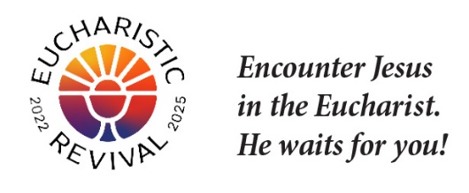
Jesus and the Eucharist Series
In light of the Eucharistic Revival, and during this year of Parish Revival, all parishes are encouraged to host Jesus and the Eucharist Series in small groups. The purpose of these small groups is to provide an opportunity for deeper love and understanding of the Eucharist through encounters with the Person of Jesus, leading to more committed prayer, faithful reception of the Sacraments, and a strengthening of the parish community.
Thank you for agreeing to be the organizer of the Jesus and the Eucharist Series “…for such a time as this.” (Esther 4:14) As the organizer of Jesus and the Eucharist Series, the following 5 Planning Steps are to assist you to with preparations now for hosting small groups during Lent.
Forming a Core Team is optional. Your Core Team may be big or small. We recommend forming a Core Team, as it will reduce your work and be particularly helpful for reaching out to all of your parish community, inviting them to this small group series, and recruiting table facilitators.
Step 1: Form Core Team:
- Possible members
- Parishioners recommended by your Pastor
- Staff member who is responsible for evangelization, faith formation, or RCIA
- A representative of each of the cultural families in your parish
- If your parish has a school, a parishioner who is a connected and active school parent
- Other parishioners with the desire and available time, including:
    - Parishioners with the gift of hospitality
    - Parishioners with the gift of organization
    - Parishioners who have facilitated small groups at your parish
    - Parishioners who have taken leadership roles (past or present) such as faith formation teachers, members of various counsels, and school teachers if your parish has a school
    - Parishioners who regularly attend Adoration
    - Other names that arise from reviewing your parish directory
- Review list of possible Core Team Members with your pastor.
- Invite members
- Meet to decide on the details
Step 2: Plan Revival Small Group Series
- Invite all parishioners to participate as well as existing small groups
- Set the dates/times of the 7 sessions; you are encouraged to start the week of Feb. 11 (Ash Wednesday is Feb. 14) and finish during Holy Week
- Format of Series: 7 sessions; Parish provides room with tables and screen to watch video; Participants stay at tables for entire session; No pre-work or home-work
  - Adult Series; Relevant for high school and middle school students too
- Video: Parish downloads and presses play; Video runs for entire 2 hours guiding the session; Content begins with the “Good News” also referred to as the “initial proclamation” and builds to God’s saving work in the Eucharist
- Invite existing off-site small groups to use this Series
- Set Core Team meetings and oversee the work

Step 3: Reserve Parish Calendar and Space
- Reserve 7 sessions on the parish calendar
- Reserve room(s) with tables and a video screen

Step 4: Prepare Communications Plan and Calendar
- Prepare communications plan. Consider electronic and traditional communications
- Plan key promotion weekends: January 14, 21, 28, and February 4
- Ask the Priest to promote and to include in homily; brief personal testimony after Mass
- Parish promotional materials: Posted to webpage diolc.org/eucharist/lead (bulletin text/insert, poster, pulpit announcements)

Step 5: Recruit Table Facilitators
- Estimate number of table facilitators needed by estimated number of parishioners attending; Recommended 6 per table including participants and table facilitator
- Prepare a list of parishioners to invite from parish records
- Invite parishioners to be table facilitators: Table facilitator invitation available here:
diolc.org/lead Start inviting now.
- A word of encouragement: Video and participant materials are intentionally designed to make the role of table facilitator simple; the role is limited to facilitating table discussion with “Table Discussion Guidelines” and a “Process for Sharing” included. There is no pre-work or home-work.
Step 6: Access and Download the Videos
- You may wish to download the videos so that you can play them without needing to be connected to the Internet. While it may be simplest to stream them online (by visiting here and clicking on “View Video”), some parish halls or meeting rooms may not have good Wi-Fi, and even where Wi-Fi is good, sometimes the signal can weaken or drop, resulting in glitches.
- To download the session videos, first click here to complete a form requesting the language you desire. You will then receive an email from the Augustine Institute with all 7 files to download.
- You cannot receive the English and Spanish versions simultaneously; whatever language you selected in the form for the Augustine Institute will be the language you receive downloads for. If you want both languages, fill out the form twice (once for English and once for Spanish).
- See How to Access and Download the Video. Go through the steps for downloading well ahead of each Session, in case you have any difficulties.
- Make sure to allow time for the download to complete, because it will be a large file. Once the download is finished, make sure you can locate and play the downloaded file from the computer.
- The downloaded file will have Closed Captions (CC) as an option. To turn them on/off, find and use the toggle option. If this proves difficult, there will be a link to download a file with CC fixed onto the video.
- When meeting for a Session, locate the downloaded, saved file, and play the video from that file.
- If there is a strong Wi-Fi connection, one can alternatively play the video from the Internet link by visiting here and clicking on “View Video.”

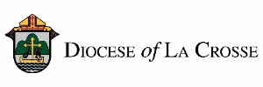
NOTE: For implementation in the Diocese of La Crosse, we have adapted these training and promotional materials for the Jesus and the Eucharist series from those produced by the National Eucharistic Revival Team in collaboration with the Augustine Institute.
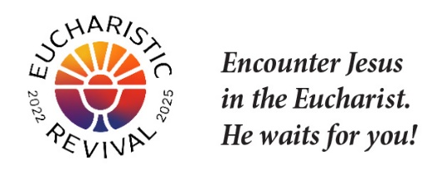

Note: The following text includes points for inviting a parishioner to be part of the Core Team.
Personal invitation is the best way to invite someone but email or a letter will work.

The Eucharistic Revival is a historic and transformative national movement to help the faithful fall in love with Jesus, especially in the Eucharist, and be inspired and equipped to share that love with others. This Lent, we will host parish-wide small groups using the foundational Eucharistic Revival Series entitled “Jesus and the Eucharist.” I am the person who is organizing this small group series for the parish.

I am forming a Core Team to plan and implement this parish-wide small group series, and I would like to invite you to prayerfully consider joining me in this work as a Core Team member. Listed below is a brief overview of what is involved for your consideration.

You already have what it takes—a love of the Lord, especially in the Eucharist, and a desire to build up the Body of Christ in his Church. You are not asked to be an expert on this Series, the Bible or the Catechism of the Catholic Church.

Our first Core Team meeting is [insert date, time and location]. This is what is needed:

  - Faithfulness/Desire: Faithful, practicing Catholic who prays and desires to help others fall in love with Jesus, especially in the Eucharist, and be inspired and equipped to share that love with others
  - Available Time: Has the time available to attend Core Team meetings to plan and roll out the small group series
  - Experience: Preferably has participated in and/or facilitated a small group
  - Participate in the 7 sessions of the series (or as many as possible) assisting in your role, which may be helping with room set-up, hospitality, or child care, and/or being a table facilitator or small group member.

God is abundantly blessing our efforts for Revival in our country, and so many are answering Jesus’s call to come back and receive Him in the Eucharist. Please let me know by [insert date] if you will join me in this important work. I hope you say "yes"!

NOTE: For implementation in the Diocese of La Crosse, we have adapted these training and promotional materials for the Jesus and the Eucharist series from those produced by the National Eucharistic Revival Team in collaboration with the Augustine Institute.

