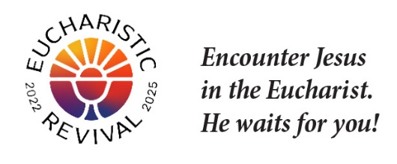

Note: The following are suggested points for inviting a parishioner to be a Table Facilitator.
Personal invitation is the best way to invite someone but email or a letter will work.

Dear [insert Name]
The Eucharistic Revival is a historic and transformative national movement to help the faithful fall in love with Jesus, especially in the Eucharist, and be inspired and equipped to share that love with others. This Lent, we will host parish-wide small groups using the foundational Eucharistic Revival Series entitled Jesus and the Eucharist. I am the person who is organizing this series for the parish, along with a Core Team of parishioners.

“Jesus and the Eucharist” is a 7-week series that has been created by the Eucharistic Revival team specifically for the Year of Parish Revival. The series begins with the “Good News,” of what God has done for us and builds to God’s saving work in the Eucharist. The series will begin on [insert the date and time] and be completed by Easter.

I am writing to ask you to prayerfully consider being a table facilitator for this parish wide series. You are not asked to be an expert on this series. You already have what it takes—a love of the Lord, especially in the Eucharist, and a desire to build up the body of Christ in His Church.

The series was designed to make the role of table facilitator easy to do. Your role is limited to the table discussions; there is no home-work or pre-work.

- Attend one gathering: for Table Facilitators (approx. 30 minutes) that will give an overview of the “Jesus and the Eucharist” Series and explain the “Table Discussion Guidelines” and “Process for Sharing” that will be used for table discussions and give ideas to keep the open table discussion positive.

- Faithful: Faithful practicing Catholic who desires to help others grow in their faith through the parish wide Eucharistic Revival small group study.

- Attend: Attend all 7 sessions of the series (or most of them), arriving a little early to welcome those parishioners who sit down at your table for the session.

- Encourage: Encourage and joyfully support the table members as you facilitate the discussions. Let members know you hear and see them, and value their input. Be a good listener.

God is abundantly blessing our efforts for Revival in our country, and so many are answering Jesus’s call to come back and receive Him in the Eucharist. Please let me know by [insert date] if you will join me in this important work. I hope you say “yes”!

Thank you. Sincerely in Christ,

[insert your name]

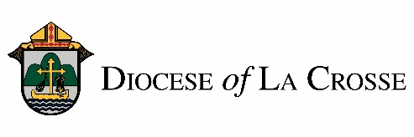

NOTE: For implementation in the Diocese of La Crosse, we have adapted these training and promotional materials for the Jesus and the Eucharist series from those produced by the National Eucharistic Revival Team in collaboration with the Augustine Institute.

