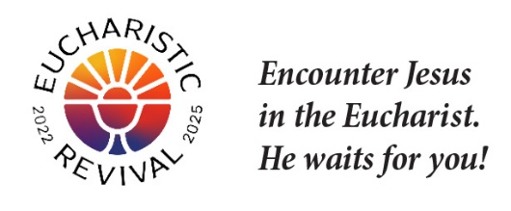
Jesus and the Eucharist Series
Hosting the Sessions

  - Step 1: Access and Download the Videos
    - You may wish to download the videos so that you can play them without needing to be connected to the Internet. While it may be simplest to stream them online (by visiting here and clicking on “View Video”), some parish halls or meeting rooms may not have good Wi-Fi, and even where Wi-Fi is good, sometimes the signal can weaken or drop, resulting in glitches.
    - To download the session videos, first click here to complete a form requesting the language you desire. You will then receive an email from the Augustine Institute with all 7 files to download.
    - You cannot receive the English and Spanish versions simultaneously; whatever language you selected in the form for the Augustine Institute will be the language you receive downloads for. If you want both languages, fill out the form twice (once for English and once for Spanish).
    - See How to Access and Download the Video. Go through the steps for downloading well ahead of your Session, in case you have any difficulties.
    - Make sure to allow time for the download to complete, because it will be a large file. Once the download is finished, make sure you can locate and play the downloaded file from your computer.
    - The downloaded file will have Closed Captions (CC) as an option. To turn them on/off, find and use the toggle option. If this proves difficult, there will be a link to download a file with CC fixed onto the video.
    - When you meet for your Session, locate the downloaded file you have saved, and play the video from that file.
    - If you have a strong Wi-Fi connection, you can alternatively play the video from the Internet link by visiting here and clicking on “View Video.”

  - Step 2: Print and Place Participant Handout at Tables
    - Find the handouts for each Session here by clicking on “Download Handout.”
    - You may print double-sided and staple. For Session 1 only, also print/provide the 1-Page Study Overview.

  - Step 3: Prepare Meeting Room
    - Tables: Tables with 6 chairs each; name tags & markers; Participant Handout; pens for note-taking.
    - Audio/Visual: Set up screen and test audio.
    - Hospitality: Water, coffee, and cookies.

  - Step 4: Staff the Event
    - Parish Staff on site: Greet participants as arrive & thank as leave; start video & oversee.
    - If providing childcare, make preparations.
  - Step 5: Repeat the process for the remaining Sessions
    - Prepare in the same fashion; thank & encourage table facilitators throughout.
    - Take the opportunity to invite participants to other parish activities/offerings.
    - Invite facilitators to help start or grow a parish small group ministry.

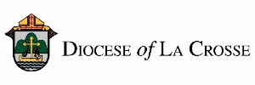
NOTE: For implementation in the Diocese of La Crosse, we have adapted these training and promotional materials for the Jesus and the Eucharist series from those produced by the National Eucharistic Revival Team in collaboration with the Augustine Institute.

