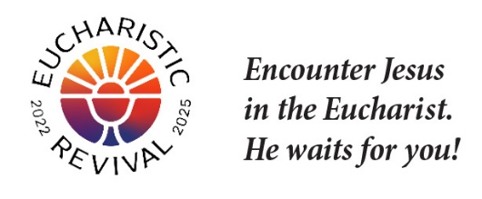

Note: The following text includes points for inviting parishioners to participate in this Series. Personal invitation is the best way to invite someone but email or a letter will work.

Dear [Specific Person’s Name]:

The Eucharistic Revival is a historic and transformative national movement to help the faithful fall in love with Jesus, especially in the Eucharist, and be inspired and equipped to share that love with others. This Lent, we will host parish-wide small groups using the foundational Eucharistic Revival Series entitled “Jesus and the Eucharist.” I am the person who is organizing this small group series for the parish.

“Jesus and the Eucharist” is a 7-week series that has been created by the Eucharistic Revival team specifically for the Year of Parish Revival. The series begins with the “Good News,” of what God has done for us and builds to Jesus’ true Presence and saving work in the Eucharist. The series will begin the week of February 11th and and be completed by Easter.

This Series will be offered on the following day(s) and time(s)

- [insert the date(s) and time(s)]

You may register for “Jesus and the Eucharist Series”, at no cost, by:

- Visiting the parish website [insert the link]
- Emailing [insert the person’s name and email]
- Calling [provide the name(s) and phone number(s)]

If you have any questions, please let me know.

God is abundantly blessing our efforts for Revival in our country, and so many are answering Jesus’s call to grow in their understanding and love for Him truly present in the Eucharist. Please keep the Eucharistic Revival in your prayers.

Sincerely in Christ,
[Lead Organizer’s Name and phone number]

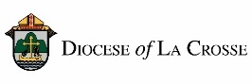
NOTE: For implementation in the Diocese of La Crosse, we have adapted these training and promotional materials for the Jesus and the Eucharist series from those produced by the National Eucharistic Revival Team in collaboration with the Augustine Institute.

