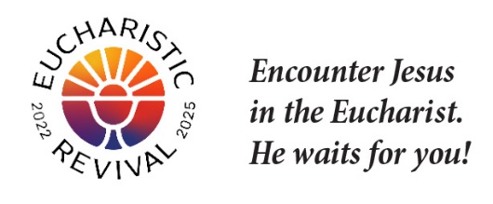
Jesus and the Eucharist Series
Sample Bulletin Announcement

Dear Parishioners,

As we continue the Eucharistic Revival this Lent, we would like to invite you to grow closer to Jesus alongside fellow parishioners through the “Jesus and the Eucharist” series, specifically designed for the current Year of Parish Revival. We will be joining many other parishes throughout the diocese and the nation in participating in this small-group initiative.

The videos and brief handouts for each session include rich spiritual content and powerful testimonies. They also provide engaging discussion questions for small-group breakouts. This is a great opportunity to dive more deeply into the richness of our Eucharistic faith.

This study will be a special time to grow in community within our parish as we walk this sacred year together, and we really desire you to join us.

Please join us on <day(s), date(s), time> <at location/room name/meeting place>
[Note: You may wish to indicate the date for the initial meeting, or all the dates, as you choose].

Hospitality will be provided, and we hope to see you there!

<Pastor can insert name>

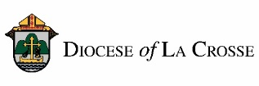
NOTE: For implementation in the Diocese of La Crosse, we have adapted these training and promotional
materials for the Jesus and the Eucharist series from those produced by the National Eucharistic Revival Team in collaboration with the Augustine Institute.

