Chancery Bulletin - Vol. 9, No. 1.2 | January 16, 2024

- Catechesis & Evangelization  - Chancery  - Communications  - Consecrated Life  - Diaconate  - Marriage & Family Life  - Ministries  - Mission Office  - Sacred Worship | - Safe Environment  - Schools Office  - Social Concerns  - Stewardship and Development  - Temporalities  - Vocations  - Vicar for Clergy  - Youth and Young Adult Ministry  - Past Chancery Bulletins
No items this week.

<<Top >>

Chancellor Very Rev. William Dhein – 608.791.2655 | wdhein@diolc.org

No items this week.

<<Top >>

As of Jan. 16, 2024

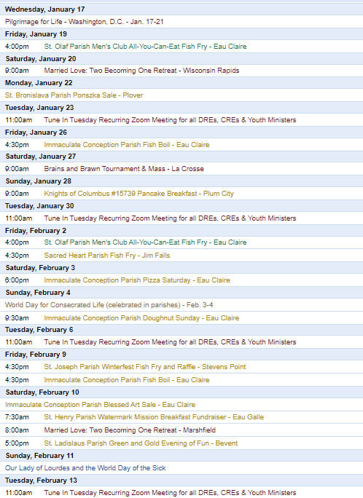
To get your parish events listed on the diocesan calendar, diolc.org/calendar, and in Catholic Life magazine, please send an email to datebook@diolc.org. Make sure you include the following details: date, beginning/ending times, event location, description, menu and cost, etc. If you have any questions, please call Pam Willer at 608.788.1524 for more information.

<<Top >>

Director: Ann Lankford – 608.791.2658 | alankford@diolc.org
(Reminder) Clergy: Jesus and the Eucharist Series during Lent:
During this Year of the Parish, a central focus is on the Jesus and the Eucharist Series for small groups. The Series was produced by the Augustine Institute in collaboration with the National Team. The Series is outstanding in beauty and presentation and is also broadly evangelizing because it puts the Gift of the Eucharist in the context of the whole story of salvation! Parishes are invited to host this Series during Lent and need only one or two people to serve as the main organizers. All the tools needed to locate the videos, handouts and help promote/organize groups are located here: diolc.org/eucharist/lead
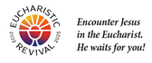
(Reminder) Bulletin Insert:
Encounter Jesus! Join Us in a Lenten Small Group Series
“Jesus and the Eucharist” is a seven-week series that is compelling, beautiful and presented in a way that is personal and understandable for individuals at any level of faith. The bulletin insert is available here: diolc.org/catechesis/bulletin-inserts. Parish contact information must be filled in at the bottom of the word-format bulletin insert.
A Minute with Jesus: Why does Jesus want to stay with us always?
You know that Jesus wants to stay with you always because He loves you unconditionally. Why? Because He wants to be with the person He loves. How do you (we) know He loves you so much? Jesus gave His life for you by dying on the Cross so that your sins can be forgiven.
Let’s pray this right now and every day this week. Thank You Jesus that You want to be with me all the time. This week, read Psalm 139: 13-16 which speaks of how well God knows me and how close He is to me.
Bulletin editors: For proclamations entitled A Minute with Jesus for upcoming weeks, click here: diolc.org/eucharist/learn.
(Reminder) Catechetical Leader Information:
BEET Grants: Bishop’s Education Endowment Trust Grants: deadline is Jan. 19
The 2024-25 Bishop’s Education Endowment Trust (BEET) grant application window is open. The method for applying for the BEET grant for the 2024-25 fiscal year is to complete an online Google Form (application). The deadline for submission is Friday, Jan. 19, 2024, with the online application being disabled by 4:30 p.m. A required part of the process is approval by your pastor or dean. The approval deadline for pastors or deans is Friday, Jan. 26, 2024.
The instructions and the application form are on the Office for Catechesis and Evangelization main webpage, and by clicking here: https://diolc.org/schools/beet-grant/. Since the online application form must be completed in one sitting, the questions on the application form are included with the instructions so that you can prepare your answers ahead of time. Please call the Office for Catechesis and Evangelization with questions regarding grant applications.
“the ANSWER” Eucharistic Rally: Purchase tickets at a reduced rate!
Please consider organizing a bus for catechists, interested adults and 7th-12th grade students to attend this incredible Eucharistic Rally on Friday, June 7, 2024, at the La Crosse Center. Join us for a Eucharistic Procession with Bishop Barron and Bishop Callahan, excellent speakers, music, vendors, and, of course, Mass, adoration and confession. Discounted tickets are now available for purchase. The official website provides detailed information, including the link to purchase online tickets. Visit the website by clicking on this link: https://diolc.org/the-answer/ or by using your smartphone’s camera to scan the QR code to the right. Note: “the Answer” Eucharistic Rally will be such an amazing event; this will serve as the Catechetical Leaders Conference for 2024.
Catechesis of the Good Shepherd:
Have you considered this amazing formation of children that forms both their minds and hearts? Anyone who has witnessed a session in an atrium is convinced that there is nothing like it. A list of training is available here: diolc.org/catechesis/catechetical-leaders-info
(Reminder) January is Pro-life Month:
For Pro-Life resources to be used during the month of January for different age groups, click here: diolc.org/catechesis/catechist-training-resources-for-teaching/pro-life-teaching-resources
<<Top >>

Director: Erik Archer– 608.791.2661 | earcher@diolc.org

Flocknote Update:
How does Flocknote accelerate, simplify and enhance your parish communications? Why should you use it? I can share a slew of testimonials from parishes across the country, but let me share a point of contact within our own diocese. Rebecca at Our Lady Queen of Heaven Parish in Wisconsin Rapids graciously offered to help others navigate Flocknote as needed. Please! Reach out to her for an inside-the-parish perspective. Reach her at rzalar@our-lady.org.

Training dates are set! Session 1 is February 1st at 9 a.m. and the alternate session is February 7th at 2 p.m. Parishes can attend either and parishes attending the first session can attend the second if questions arise. I will send an email with the link.

We will also offer a Flocknote “second-semester” training in ~2 months to help teach further capabilities once parishes establish the groundwork and are familiar with the basic processes.

Demonstrating how user-friendly this is, the Flocknote team established weekly “office hours” just for our diocese in which they are standing by to answer phone calls. They are available via email and phone whenever needed, but this standing block of time is also devoted to our parishes.

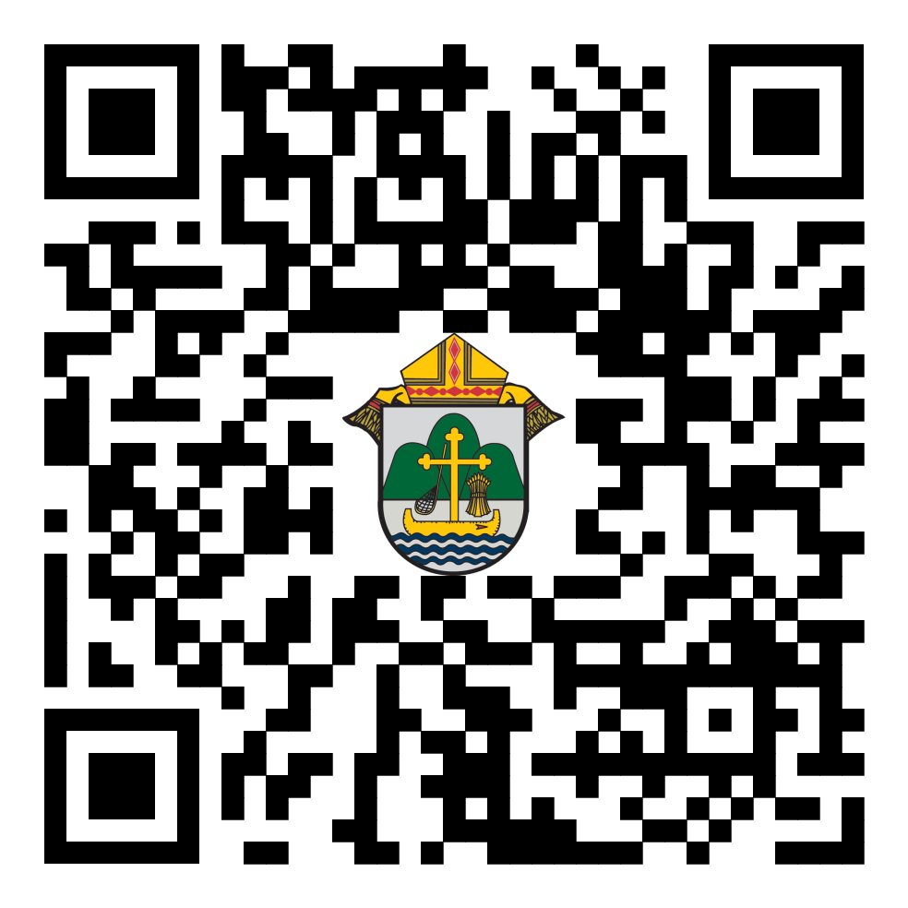
For Your Parish Bulletin:
The Truth, Beauty and Goodness of our Faith on Flickr
Our Faith is beautiful and one of the many ways we witness this is through photographs. The Diocese of La Crosse shares photos from across the diocese on its Flickr page. You can locate the page by clicking on the following link or by using your camera’s smartphone to scan the QR code to the right. https://www.flickr.com/photos/diolc/albums/

We travel about the diocese helping parishes by taking pictures, video, live streaming and gathering video clips of parish events and then providing them with the media to use at their parish as desired. Email Erik at earcher@diolc.org if you would like us to attend one of your events, take pictures or videos and produce/process them and share them with you.

Catholic Life Story Ideas:
Do you have a Faith story to share within your parish? An individual or family whose faith journey is inspiring? These are the fabric of our Faith but, as Horace said, “Many brave men lived before Agamemnon, but all are weighed down in unending night, unwept and unknown, because they lacked a sacred bard.” Let us be their bard - email earcher@diolc.org with story ideas.

Thank you:
Just that - thank you for all that you do for your parishes and parishioners. Thank you for being willing to trust us and try these new efforts. We pursue these efforts because we know that they will help your parish connect with each other and the community outside your church. But we also know that it takes time, of which none of us has enough, to volunteer, be trained and implement. So… thank you!

<<Top >>

Director: Sr. Donna Krzmarzick, ISSM – 608.791.2690 | dkrzmarzick@diolc.org
(Reminder) World Day of Prayer for Consecrated Life (Celebrated in Parishes Feb. 3-4):
In 1997, Pope Saint John Paul II instituted a day of prayer for women and men in consecrated life. This celebration is attached to the Feast of the Presentation of the Lord on Feb. 2. This Feast is also known as Candlemas Day, the day on which candles are blessed, symbolizing Christ, who is the light of the world. So, too, those in consecrated life are called to reflect the light of Jesus Christ to all peoples. The celebration of World Day of Prayer for Consecrated Life is transferred to the following Sunday in order to highlight the gift of consecrated persons for the whole Church.
Please pray for consecrated persons at Holy Mass in the Prayers of the Faithful and include a mention in your parish bulletin (samples are below). For more information: USCCB, NRVC
(Reminder) Prayers of the Faithful:
For those in consecrated life, that they may persevere in their commitment to the Lord and serve with joyful hearts and total dedication. We pray to the Lord…
(Reminder) For your Parish Bulletin
World Day of Prayer for Consecrated Life will be celebrated in parishes on the weekend of Feb. 3-4. Please pray for all those who have answered the call to consecrated life, aspiring towards joy-filled holiness in the service of the Church and world. Pray also for many more laborers to enter the vineyard so that Jesus Christ may be better known, experienced, and loved.
<<Top >>

Director: Deacon Robert Riedl – 608.791.2665 | rriedl@diolclergy.org
(Reminder) For Your Calendar!
May 4 – Continuing Formation–La Crosse Diocesan Center
June 1 – Ordination to the Diaconate–Cathedral of St Joseph the Workman in La Crosse
June 7-12 – National Eucharistic Procession–Diocese of La Crosse
· Friday, June 7 – “the Answer” – Eucharistic Rally
o La Crosse Center – Downtown La Crosse
o To register and for more information visit:
https://diolc.org/the-answer/ and
https://diolc.org/pilgrimage/
· Sunday, June 9 – Holy Hour for Deacons and Families
o SS. Peter and Paul – WI Rapids
o 5-6 pm with Sunday Mass to follow at 6 p.m.
o Deacons of Wisconsin Rapids Deanery will lead Holy Hour
· More details are also available on NEP Website –
https://www.eucharisticpilgrimage.org/
· Sign up on the website to stay informed!
June 22 – Ordination to the Priesthood – Cathedral of St Joseph the Workman in La Crosse
August 10 – Bishop’s Day with Deacons and Wives – La Crosse Diocesan Center

<<Top >>

Director: Christopher Rogers – 608.791.2659 | crogers@diolc.org

(Reminder) 50th Wedding Anniversary Lists:
Please submit the names of those couples celebrating their 50th Jubilee Wedding Anniversaries in the year 2024 by Jan. 22, 2024, by filling out this form and emailing it to crogers@diolc.org.

For Your Parish Bulletin:
50th Wedding Anniversaries
Congratulations to all couples who are celebrating their 50th Jubilee Wedding Anniversary in 2024. The Diocese of La Crosse would like to invite you to a special Mass and social/dinner as an opportunity to celebrate your marriage and bless your covenant love. Please contact the Diocese crogers@diolc.org or your Parish Office.

(Reminder) For Your Parish Bulletin:
“the ANSWER” Eucharistic Rally Tickets are now on sale!
The time has come to say “Yes!” to this life-changing event on June 7, 2024, at the La Crosse Center. Discounted tickets are now available for purchase. However, you may also want to check with your parish office as there are some parishes that have already begun purchasing group tickets and reserving buses for this event. Please check out the official website for all the detailed information. The registration link is found at the following link or by using your smartphone’s camera to scan the QR code to the right. https://diolc.org/the-answer/ (You can also paste this QR code into your bulletin for fast parishioner use.)

(Reminder) For Your Parish Bulletin:
"Behold: God is With Us" Young Adult Retreat - Jan. 27, 2024
The world needs Jesus. Our souls need Jesus. Out of God's abundant love for us, He became man: the Word became flesh and dwelt among us (John 1:14). Jesus is the answer to the longings of our hearts, and He is our way to eternal life. Knowing He would ascend into heaven, Jesus leaves us Himself- body, blood, soul, and divinity- under the guise of simple bread and simple wine. Why? So that our intimate love and union with Him (flesh to flesh) may continue in this life as we await the perfection of His love and union in the next. "Behold: God is With Us" or "Behold," for short, is an opportunity for you to retreat from the busyness and stresses of this world and find rest and consolation in Jesus and other young adults like you. All 18-35-year-olds are welcome to join us for a day of enriching talks, silent prayer/reflection, small group discussion, adoration, confession, and Mass. Most importantly, learn how to remain connected post-retreat to a lively community of young adults striving for Sainthood. This day-long retreat will occur at Blessed Sacrament Parish in La Crosse, WI. Check-ins will begin at 8:30 a.m., and the retreat will conclude after the 4:30 p.m. Vigil Mass. An optional after party will take place to follow! Breastfeeding babies are welcome! Lunch will be provided! All of this and more for the low cost of $20. Let us behold the Lord together! Register here: https://argentasoftware.com/interfaces/49870/frmEventTicketSalesForm.aspx?EventID=4042 or use your smartphone to scan the QR code above (you can also paste this QR code into your bulletin for fast parishioner use)

(Reminder) Worldwide Marriage Encounter Weekend:
WHEN ALL THE HUSTLE-BUSTLE OF THE HOLIDAYS ARE OVER... Don't you and your spouse deserve a beautiful, romantic weekend away together? If you agree, then you'll want to attend a Worldwide Marriage Encounter Weekend. For more info, contact Denise and Greg at (563) 920-9419. Upcoming dates: Feb. 16-18 in Marshalltown, April 12-14, 2024, in Epworth, Sept. 27-29 in Dubuque and Nov. 8-10 in Holstein, IA.

(Reminder) For Your Parish Bulletin:
Retrouvaille
Is your marriage in distress? No matter how hopeless it seems, forgiveness and trust are possible. Retrouvaille is a Catholic-based program that helps couples through difficult times in their marriages, some even after separation or divorce. It is not counseling or group therapy. The next program begins with a weekend on February 16-18, 2024, in the Wausau area. Call 1-877-922-HOPE (4673). Fully Confidential. More at www.HelpOurMarriage.org No couple is turned away for lack of finances. Please click on this link or use your camera’s smartphone to scan the QR code to the right to access the brochure. (you can also paste this QR code into your bulletin for fast parishioner use) https://drive.google.com/file/d/1DyrLYH74WoOSYOzA0cFue2lLAQrOZtmv/view?usp=sharing

(Reminder) For Your Parish Bulletin:
Domestic Church Retreat - Save the Date
The next Domestic Church Retreat will be held April 13-14, 2024, at Ss. Peter and Paul Parish in Wisconsin Rapids. During the retreat, couples are invited to delve more deeply into the graces of their shared spiritual journey. The retreat aims to strengthen the couple’s spousal union and lead them to experience complete harmony and joy in their marriage through simple formation and meaningful dialogue that intentionally places Christ in the center. To register and find out more information, click this link: https://diolc.org/marriage/marriage-enrichment/

<<Top >>

Director: Christopher Ruff – 608.791.0161 | cruff@diolc.org

Attention Deacons, Leaders of Prayer, and Lay Formation Graduates:
We invite your leadership in drawing your fellow parishioners closer to Jesus in the Eucharist this Lent. Talk to your pastor about helping run a small-group series created by the Augustine Institute in collaboration with the National Eucharistic Revival Team. Called “Jesus and the Eucharist,” this outstanding 7-session series is being used nationwide. It is free of charge, easy to use, and powerfully inspiring not only for devoted Catholics, but even for those unsure of their beliefs. Learn more and sample it at diolc.org/eucharist/lead.

<<Top >>

Director: Fr. Woodrow Pace – 608.791.2676 | wpace@diolc.org
Mission Co-op Program Summer 2024: The assignment of missionaries to parishes usually takes place for us at the end of January and the beginning of February. Many requests and applications are in and being organized. So here are some last-minute notes for missionaries and pastors:
Missionaries/International priests: Many thanks to all who have completed the annual application process. If you have confirmed your diocese or religious order, all is set. If you are unsure if your bishop or religious superior has completed the application process, please have him submit the application by January 31, 2024, to ensure you are not missed for 2024. A new application must be submitted each year, even if you have been in our program in previous years. Please see diolc.org/missions/ for more information.
Pastors: If you have any special requests regarding: which MCP missionary to be assigned this summer to your Parish(es), please let us know as soon as possible. We try during the assignment process to accommodate any particular mission request or 'exceptions to the rule' request. For example, the appeals are usually to be held in the months of June, July and August, but exceptions can be made with certain precautions. The specific weekend date of the appeal is mutually arranged between you and the missionary, but we can sometimes help with the flexibility charism of the missionary group, if possible. If you have any questions, please contact the Mission Office.
*Additional consideration: We realize the MC week-end is a good opportunity for you to fulfill other obligations or get a little rest away from your parish(es); however, if you would be willing to accept a religious Sister or lay-missionary (instead of a priest who could offer all the week-end Masses), please let us know.
Friendly Reminder – Mission Co-op Program (MCP) 2023 and World Mission Sunday 2023: Please send the Mission Office any outstanding collections for Mission Coop appeals given this past summer and also for World Mission Sunday (Oct. 22, 2023). Our missionaries are still suffering extra hardships and some disbursements are being delayed due to non-receipt of some parishes' collections. Thank you for your generous, prayerful and monetary support.
Please direct collections designated for Retirement Fund for Religious in a separate check to the Diocese of La Crosse Finance Office. (They are not processed through the Mission Office). Thank you for your generous support.
<<Top >>

Director: Christopher Carstens – 608.791.0161 | ccarstens@diolc.org
Rite of Election | Feb. 18 | Cathedral of St. Joseph the Workman
The Rite of Election and the Call to Continuing Conversion will be held at the Cathedral of St. Joseph the Workman on Sunday, Feb. 18 at 2 p.m. It is an occasion that marks entry into the period of Purification and Enlightenment that coincides with Lent. It is a wonderful opportunity for candidates and catechumens to see the larger Church, be introduced to their new Cathedral, and receive the grace of the Rite. The registration form for Rite of Election is available here.
<<Top >>

Director: Teresa Brown – 608.791.2679 | tbrown@diolc.org

DIOCESE OF LA CROSSE GUIDELINES FOR REPORTING INSTANCES OF CHILD ABUSE
The Diocese of La Crosse, through its policies and procedures, seeks to provide a prompt, appropriate and compassionate response to reporters of sexual abuse of a child by any diocesan agent (bishop, priest, deacon, employee, religious, vendor or volunteer). Anyone wishing to make a report of an allegation of sexual abuse should send that report to Mrs. Teresa Brown, Complaint Intake Agent, at the Diocese of La Crosse, P.O. Box 4004, La Crosse, WI 54602-4004. Alternatively, you can contact Mrs. Brown at 608.791.0179 or intakeagent@diolc.org. The reporting form is available through the Diocese of La Crosse Office of Safe Environment or on the diocesan website at: diolc.org/safe-environment/reporting. Individuals are also encouraged to take their reports directly to civil authorities. Copies of the diocesan policy are available through your local Parish and on the diocesan website. If you have any questions about the Diocese of La Crosse and the implementation of the Charter for the Protection of Children and Young People, please contact Teresa Brown, Diocese of La Crosse, at 608.791.2679 or tbrown@diolc.org.

<<Top >>

Superintendent: Thomas Reichenbacher – 608.788.7707 | treichenbacher@diolc.org

No items this week.

<<Top >>

Director: Christopher Ruff – 608.791.0161 | cruff@diolc.org
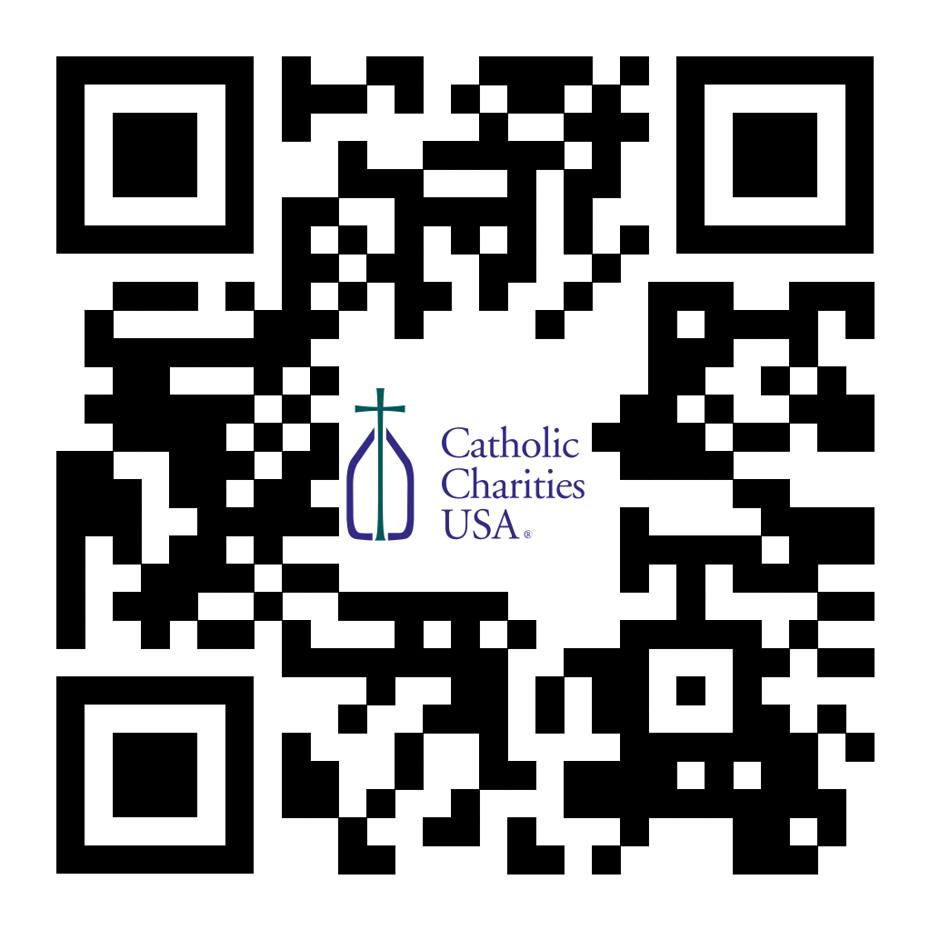
(Reminder) Pastors – Catholic Campaign for Human Development (CCHD) Collection Jan. 27-28 or Feb. 3-4:
Bishop Callahan designated the last weekend of January (27-28) or the first weekend of February (3-4) for the CCHD collection. Parishes should have received a shipment of envelopes from the USCCB for this purpose. Checks should be made payable to your parish (CCHD on the memo line), with one check from the parish for the total made payable to the Diocese of La Crosse and sent to the Office for Ministries and Social Concerns.
For Your Parish Bulletin
January Pro-Life Events, Prayers and Intentions
Though the 1973 Roe v. Wade decision declaring a right to abortion was overturned by the U.S. Supreme Court on June 24, 2022, many states’ laws are hostile to preborn children. And so our pro-life prayers and efforts are just as important as ever. Learn more, find resources, and see how you can make a difference at the diocesan website (diolc.org/respect-life) and the U.S. Bishop’s website (respectlife.org).

(Reminder) For Your Parish Bulletin:
Post-Abortion Healing Ministry in the Diocese of La Crosse
Do you know someone who is carrying the grief and sorrow of past abortions? Project Rachel Ministry offers a compassionate heart and confidential help. Call 608.860.6698 or email projectrachel@diolc.org.

(Reminder) For Your Parish Bulletin:
Post-Abortion Healing Retreats – Rachel’s Vineyard – Encounter God’s Mercy
Rachel's Vineyard is a weekend retreat to help anyone who has struggled with the aftermath of abortion to begin healing through a supportive, trauma-sensitive approach. Each weekend is run by a team of trained volunteers (counselor, priest, and lay people) who care deeply for your needs. All interactions with the Rachel's Vineyard retreat team are completely confidential. These retreats will be offered in the Diocese of Madison on March 15-17, 2024, and Nov. 8-10 2024. For more information, visit madisondiocese.org/rachel or use your smartphone’s camera to scan the QR code on the right. (you can also paste this QR code into your bulletin for fast parishioner use)

(Reminder) For Your Parish Bulletin:
Chalice of Mercy is in Ukraine, Needs Our Help
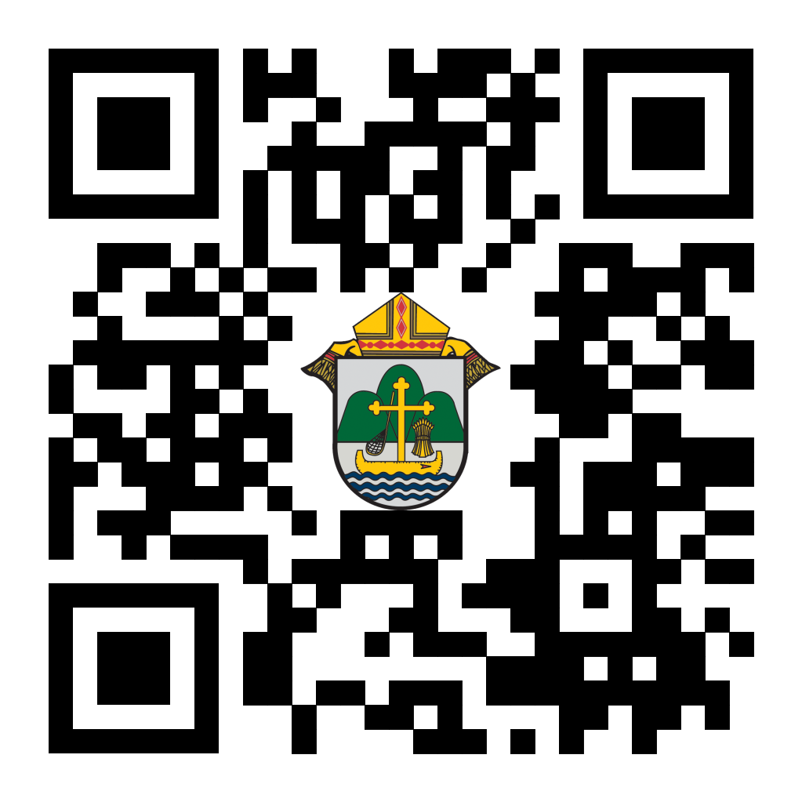
Please donate to the incredible Ukrainian relief efforts of Chalice of Mercy, and pray for the safety of their volunteers on the ground there, who put their lives on the line. Financial assistance is the biggest need at this time. Chalice of Mercy was founded in Chippewa Falls by Valentyna Pavsyukova in 2007 and it has been able to ship medical and other humanitarian supplies valued at more than $40 million since the Russian invasion in February of 2022. To give, visit chaliceofmercy.org/donate or use your smartphone’s camera to scan the QR code to the right.

<<Top >>

Director: Jeff Reiter – 608.791.2653 | jreiter@diolc.org
(Reminder) The Year End 2023 Gifts:
We have closed the 2023 gift calendar year for tax purposes. Tax statements will be mailed during the last week of January.
(Reminder) Inspired By The Spirit and Diocesan Annual Appeal:
We have become aware that parishes are again making and using copies of the pledge form. These are parish-specific, and for our electronic banking and gift-scanning process, the pledge form must meet particular specifications to size and QR location to be more efficient, helping keep costs down and ensuring the correct parish and supporter is getting credit for that gift.
If you need more pledge forms, please contact Sarah Komperud at skomperud@diolc.org; we will order more. Please allow 14 days for delivery.
(Reminder) Diocesan Annual Appeal:
A follow-up mailing for those parishes that announced and who had their homes mailed between and including the weekends of Nov. 18/19, 2023, and Dec. 16/17, 2023, has been mailed. The expected delivery date to homes is 1/22-23/2024. It has taken the United States Post Service an average of 11 days to process our mail from drop to the mailboxes.
The next scheduled mailing will be our Holy Week mailing. The Holy Week Mailing will be focused on:
- Parishes over goal: we will mail those who gave in the last two years (2021 & 2022) but have yet to give this year (LYBUNTS and SYBUNTS).
- Parishes under goal will have all those who still need to support the DAA mailed (LYBUNTS, SYBUNTS, and Never/New).
If a parish wishes to include a letter from the Pastor and/or Finance Council, the due date to receive those letters in the Stewardship Office is March 5, 2024. Please be sure the letter is in a Word document format and the parish number is included in the file name.
If you need more pledge forms, please contact Sarah Komperudskomperud@diolc.org; we will order more. Please allow 14 days for delivery. If you have any questions or concerns, please do not hesitate to contact our office.
Weekly Stewardship Quotes (shorter bulletin reflections):
January - March 2024
- https://diolc.org/wp-content/uploads/2023/12/Stewardship-Reflections-Jan-March-2024.docx
  - Spanish Version
https://diolc.org/wp-content/uploads/2023/12/Stewardship-Reflections-Jan-March-2024-Spanish.docx
Weekly Stewardship Prayers of the Faithful:
January - March 2024
- https://diolc.org/wp-content/uploads/2023/12/Stewardship-Prayers-of-the-Faithful-Jan-March-2024.docx
  - Spanish Version
https://diolc.org/wp-content/uploads/2023/12/Stewardship-Prayers-of-the-Faithful-Jan-March-2024-Spanish.docx
Stewardship Bulletin Reflections for Weekends:
- 01/21/24
https://diolc.org/wp-content/uploads/2023/12/01.21.24-stewardship-bulletin-announcements.pdf
- 01/28/24
https://diolc.org/wp-content/uploads/2024/01/01.28.24-stewardship-bulletin-announcements.pdf
- 02/04/24
https://diolc.org/wp-content/uploads/2024/01/02.04.24-stewardship-bulletin-announcements.pdf
- 02/11/24
https://diolc.org/wp-content/uploads/2024/01/02.11.24-stewardship-bulletin-announcements.pdf
Stewardship Homily Reflections:
Stewardship reflections for your homily development:
- For Weeks 01/21/24 - 02/04/24
https://diolc.org/wp-content/uploads/2024/01/Homily-Guide-01.16.24.pdf
(Reminder) Planned Giving – Leaving a Legacy, Wills, Bequest, and Endowments:
We have been entrusted with precious treasures passed down from our ancestors, and it's our responsibility to ensure that future generations can also enjoy the splendor and reverence of a well-maintained parish. One way to achieve this is by utilizing the Capital Campaign and providing information on Endowments, Trusts, and Bequests to the parishioners.
Our Estate Planning Guide can help save hundreds of dollars in legal and financial estate planning costs. We have mailed out several hundred copies per individual request, and each Parish has received a copy. Please feel free to contact our office for additional copies.
Visit diolclegacy.org, our Planned Giving website, to find calculators and more information, sign up for a newsletter, and request specific estate planning guides and information. Our website also provides instructions on how to do an IRA Rollover, the creation of Donor Advised Funds (DAF), Beneficiary Designations, and Stock Transfers. https://diolclegacy.org/?pageID=5
Please contact Jeff Reiter at jreiter@diolc.org for more information on legacy giving, presentations, or ads for your Parish bulletin.
<<Top >>

Diocesan Finance Officer: James Reider – 608.791.2668 | jreider@diolc.org

Health Enews from Catholic Mutual Group :
Please click here for the January edition of CMG Health Enews.

Priests’ 2024 – 2025 Salary Schedule:
The Priests’ Salary Schedule for 2024-2025 can be accessed by clicking here. The priest’s salary schedule is also on the diocesan website under Temporalities. Note these rates are effective July 1, 2024.
Mileage Rate for 2024:
Please note the new IRS mileage rate effective Jan. 1, 2024, is $0.67 per mile. The previous rate was $0.655 per mile. The Diocesan Curia reimburses mileage at the IRS mileage rate in effect at the time of travel. Each parish or school may elect to pay whatever rate they would like as long as it does not exceed the IRS mileage rate.
<<Top >>

Director of Vocation Recruitment: Fr. Nate Kuhn – 608.791.2666 | nkuhn@diolc.org

No items this week.

<<Top >>

Director: Very Rev. Woodrow H. Pace – 608.791.2689 | wpace@diolc.org

No items this week.

<<Top >>

Director: Christopher Rogers – 608.791.2659 | crogers@diolc.org

(Reminder) For Your Parish Bulletin:
“the ANSWER” Eucharistic Rally Tickets are now on sale!
The time has come to say “Yes!” to this life-changing event held on June 7, 2024, at the La Crosse Center. Discounted tickets are now available for purchase. However, you may also want to check with your parish office as there are some parishes that have already begun purchasing group tickets and reserving buses for this event. Please check out the official website for all the detailed information, including the link to purchase online tickets https://diolc.org/the-answer/ or use your smartphone’s camera to scan the QR code on the right. (you can also paste this QR code into your bulletin for fast parishioner use)

(Reminder) SEALED! Spring Diocesan Confirmation Retreat:
The SEALED! Diocesan Confirmation Retreat will be held March 2, 2024, at Holy Spirit Catholic Church in Stevens Point, WI. Online registration is now available. Please click this link to register and find out more information: https://diolc.org/yya/youth-opportunities/immersion-retreat/ or use your smartphone’s camera to scan the QR code on the right. (you can also paste this QR code into your bulletin for fast parishioner use).

(Reminder) For Your Parish Bulletin:
"Behold: God is With Us" Young Adult Retreat - January 27, 2024
The world needs Jesus. Our souls need Jesus. Out of God's abundant love for us, He became man: the Word became flesh and dwelt among us (John 1:14). Jesus is the answer to the longings of our heart, and He is our way to eternal life. Knowing He would ascend into heaven, Jesus leaves us Himself- body, blood, soul, and divinity- under the guise of simple bread and simple wine. Why? So that our intimate love and union with Him (flesh to flesh) may continue in this life as we await the perfection of His love and union in the next. "Behold: God is With Us" or "Behold", for short, is an opportunity for you to retreat from the busyness and stresses of this world and find rest and consolation in Jesus and other young adults like you. All 18-35-year-olds are welcome to join us for a day of enriching talks, silent prayer/reflection, small group discussion, adoration, confession, and Mass. Most importantly, learn how to remain connected post-retreat to a lively community of young adults striving for Sainthood. This day-long retreat will occur at Blessed Sacrament Parish in La Crosse, WI. Check-ins will begin at 8:30 am and the retreat will conclude after the 4:30 pm vigil Mass. An optional after party will take place to follow! Breastfeeding babies are welcome! Lunch will be provided! All of this and more for the low cost of $20. Let us behold the Lord together! Register here: https://argentasoftware.com/interfaces/49870/frmEventTicketSalesForm.aspx?EventID=4042, or use your smartphone’s camera to scan the QR code on the right. (you can also paste this QR code into your bulletin for fast parishioner use)

<<Top >>

Diocese of La Crosse | 3710 East Ave S | La Crosse, WI 54601 | 608-788-7700
To unsubscribe from this e-mail message contact mwilson@diolc.org

