Chancery Bulletin - Vol. 9, No. 1.3 | January 23, 2024

- Catechesis & Evangelization  - Chancery  - Communications  - Consecrated Life  - Diaconate  - Marriage & Family Life  - Ministries  - Mission Office  - Sacred Worship | - Safe Environment  - Schools Office  - Social Concerns  - Stewardship and Development  - Temporalities  - Vocations  - Vicar for Clergy  - Youth and Young Adult Ministry  - Past Chancery Bulletins

The Most Reverend William Patrick Callahan, D.D., Bishop of La Crosse, makes the following
announcements:
Deacon Martin W. Kulak, appointed to serve as Deacon at St. Francis of Assisi Parish in Ellsworth, has requested the status of Senior Deacon and that request is granted effective January 1, 2024.
The following priests have been appointed to the College of Consultors for a five-year term, effective January 4, 2024:
The Reverend Monsignor Joseph G. Diermeier, V.G.
The Reverend Monsignor Michael J. Gorman, V.G.
The Very Reverend William A. Dhein, V.G.
The Reverend Alan M. Guanella
The Reverend Thomas J. Krieg
The Reverend Samuel C. McCarty
The Reverend William G. Menzel

<<Top >>

Chancellor Very Rev. William Dhein – 608.791.2655 | wdhein@diolc.org

No items this week.

<<Top >>

As of Jan. 23

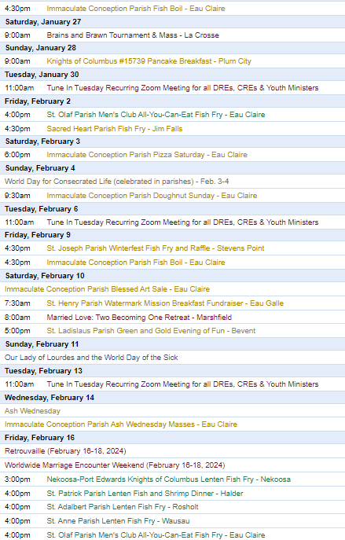
To have your parish events listed on the diocesan calendar, diolc.org/calendar, and in Catholic Life magazine, please send an email to datebook@diolc.org. Make sure you include the following details: date, beginning/ending times, event location, description, menu and cost, etc. If you have any questions, please call Pam Willer at 608.788.1524 for more information.

<<Top >>

Director: Ann Lankford – 608.791.2658 | alankford@diolc.org
Clergy and Parish Leaders:
Listen to a compelling webinar by Dr. Mary Healy, Professor at Sacred Heart Seminary in Detroit and a member of the Pontifical Biblical Commission, as she explains “What Eucharistic Revival Looks Like?” and why this term was chosen by the Bishops.
This is an inspiring presentation, roughly 45 min., and available here: www.eucharisticrevival.org/parishpointperson.
Resources for hosting Jesus and the Eucharist Series:
Parishes are invited to host Jesus and the Eucharist Series during Lent and need only one or two people to serve as the main organizers. All the tools needed to locate the videos, handouts and help to promote and organize groups, including a poster/flyer and bulletin insert, are located here: diolc.org/eucharist/lead
Bulletin Insert:
Eucharistic Adoration: A Privileged Place of Encountering Jesus
Anyone may stop at church to “make a visit” and be with Jesus who is truly present in the Holy Eucharist. To download the bulletin insert click here: diolc.org/eucharist/learn.
Note: If the parish has not yet used these bulletin inserts, there will soon be a sixth one by Chris Carstens. These six bulletin inserts may be used for the six weeks of Lent.
Bulletin Announcements:
Lenten Series - One of the Best!
You are invited to join a small group during Lent for the Jesus and the Eucharist Series. The seven sessions are outstanding in beauty and presentation with inspiring testimonies that draw participants to a deeper faith in the Real Presence of Jesus in the Eucharist. (List the day(s) and time(s) that the Series will be offered and who to contact to register.)
A Minute with Jesus:
Why does Jesus want to live in your heart?
God has created each person absolutely unique – there is only one of you. Jesus knows you and loves you, and wants to be with you always. Jesus has a love in His Heart that only you can receive. If you don’t receive Jesus’ love for you, it will be “wasted.” And likewise, you have a love in your heart that only you can give to Jesus. If you don’t give that love, there will be an empty place in Jesus’ Heart.
Let’s pray this right now and every day this week. Jesus, I want to receive all the love You have for me, and I want to give You all of my love.
This week, read about how much God loves you in John 3:16. To make this personal, replace “the world” with your own name.
Bulletin editors: For proclamations entitled A Minute with Jesus for upcoming weeks, click here: diolc.org/eucharist/learn.
Please promote “the ANSWER” Eucharistic Rally:
“The Answer” Eucharistic Rally on Friday, June 7, 2024, is for catechetical leaders, catechists, interested adults, families, parents and their 7-12 grade students. This will be the largest event for our diocese; you don’t want to miss it. Please encourage the people of the parish to join us for a Eucharistic Procession with Bishop Barron and Bishop Callahan, excellent speakers, music, vendors, and, of course, Mass, adoration and confession. Discounted tickets are now available for purchase. Please share the QR code to the right in your bulletin and emails. It makes registering simple and fast.
Will you provide a Save the Date Card to everyone who might be interested? Can you imagine the effects of such a gathering? The Save the Date Card (with four per page) is available here: diolc.org/catechesis/catechetical-leaders Thank you for your support and encouragement!
(Reminder) Catechesis of the Good Shepherd:
Have you considered this amazing formation of children that forms both their minds and hearts? Anyone who has witnessed a session in an atrium is convinced that there is nothing like it. A list of training is available here: diolc.org/catechesis/catechetical-leaders-info
Speaker Policy:
If you intend to invite a speaker to the parish, the paperwork that is part of the speaker policy must be submitted before the speaker is invited, as required by the Chancery Office. See further information and the form here: diolc.org/chancery/speaker-policy, which can be found at the bottom of the Diocesan website. There are those who are exempt, as noted on the webpage.
<<Top >>

Director: Erik Archer– 608.791.2661 | earcher@diolc.org

No items this week.

<<Top >>

Director: Sr. Donna Krzmarzick, ISSM – 608.791.2690 | dkrzmarzick@diolc.org

No items this week.

<<Top >>

Director: Deacon Robert Riedl – 608.791.2665 | rriedl@diolclergy.org

No items this week.

<<Top >>

Director: Christopher Rogers – 608.791.2659 | crogers@diolc.org

No items this week.

<<Top >>

Director: Christopher Ruff – 608.791.0161 | cruff@diolc.org

Attention Deacons, Leaders of Prayer, and Lay Formation Graduates:
We invite your leadership in drawing your fellow parishioners closer to Jesus in the Eucharist this Lent. Talk to your pastor about helping run a small-group series created by the Augustine Institute in collaboration with the National Eucharistic Revival Team. Called “Jesus and the Eucharist,” this outstanding 7-session series is being used nationwide. It is free of charge, easy to use, and powerfully inspiring not only for devoted Catholics but even for those unsure of their beliefs. Learn more and sample it at diolc.org/eucharist/lead.

<<Top >>

Director: Fr. Woodrow Pace – 608.791.2676 | wpace@diolc.org

No items this week.

<<Top >>

Director: Christopher Carstens – 608.791.0161 | ccarstens@diolc.org
Rite of Election | Feb. 18 | Cathedral of St. Joseph the Workman:
The Rite of Election and the Call to Continuing Conversion will be held at the Cathedral of St. Joseph the Workman on Sunday, Feb. 18 at 2 p.m. It is an occasion that marks entry into the period of Purification and Enlightenment that coincides with Lent. It is a wonderful opportunity for candidates and catechumens to see the larger Church, be introduced to their new Cathedral, and receive the grace of the Rite. The registration form for Rite of Election is available here.
<<Top >>

Director: Teresa Brown – 608.791.2679 | tbrown@diolc.org

DIOCESE OF LA CROSSE GUIDELINES FOR REPORTING INSTANCES OF CHILD ABUSE:
The Diocese of La Crosse, through its policies and procedures, seeks to provide a prompt, appropriate and compassionate response to reporters of sexual abuse of a child by any diocesan agent (bishop, priest, deacon, employee, religious, vendor or volunteer). Anyone wishing to make a report of an allegation of sexual abuse should send that report to Mrs. Teresa Brown, Complaint Intake Agent, at the Diocese of La Crosse, P.O. Box 4004, La Crosse, WI 54602-4004. Alternatively, you can contact Mrs. Brown at 608.791.0179 or intakeagent@diolc.org. The reporting form is available through the Diocese of La Crosse Office of Safe Environment or on the diocesan website at: diolc.org/safe-environment/reporting. Individuals are also encouraged to take their reports directly to civil authorities. Copies of the diocesan policy are available through your local Parish and on the diocesan website. If you have any questions about the Diocese of La Crosse and the implementation of the Charter for the Protection of Children and Young People, please contact Teresa Brown, Diocese of La Crosse, at 608.791.2679 or tbrown@diolc.org.

<<Top >>

Superintendent: Thomas Reichenbacher – 608.788.7707 | treichenbacher@diolc.org

No items this week.

<<Top >>

Director: Christopher Ruff – 608.791.0161 | cruff@diolc.org
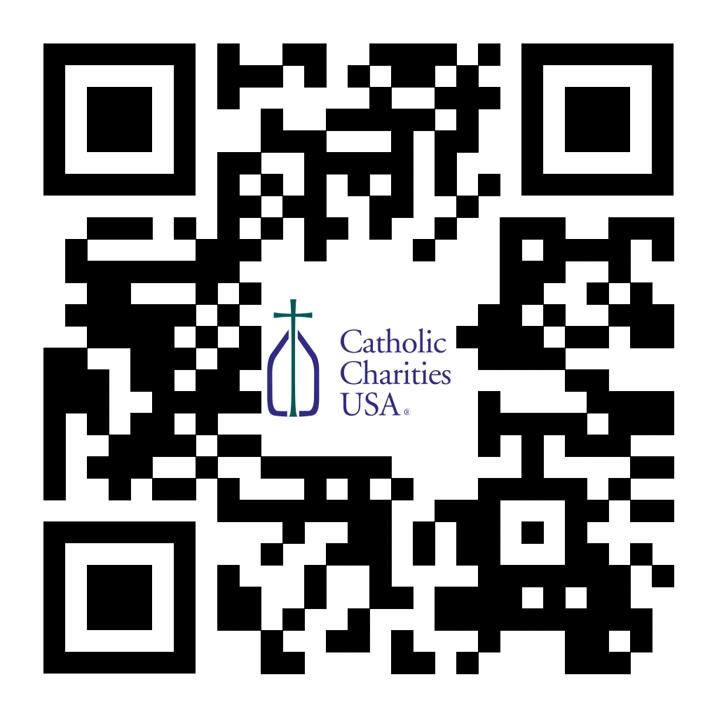
(Reminder) Pastors – Catholic Campaign for Human Development (CCHD) Collection Jan. 27-28 or Feb. 3-4:
Bishop Callahan designated the last weekend of January (27-28) or the first weekend of February (3-4) for the CCHD collection. Parishes should have received a shipment of envelopes from the USCCB for this purpose. Checks should be made payable to your parish (CCHD on the memo line), with one check from the parish for the total made payable to the Diocese of La Crosse and sent to the Office for Ministries and Social Concerns.
(Reminder) For Your Parish Bulletin
January Pro-Life Events, Prayers and Intentions
Though the 1973 Roe v. Wade decision declaring a right to abortion was overturned by the U.S. Supreme Court on June 24, 2022, many states’ laws are hostile to preborn children. And so our pro-life prayers and efforts are just as important as ever. Learn more, find resources, and see how you can make a difference at the diocesan website (diolc.org/respect-life) and the U.S. Bishop’s website (respectlife.org).

For Your Parish Bulletin:
Post-Abortion Healing Ministry Phone Line and Retreats
Do you know someone who is carrying the grief and sorrow of past abortions? Project Rachel Ministry offers a compassionate heart and confidential help. Call 608.860.6698 or email projectrachel@diolc.org. There are also post-abortion healing retreats offered in the Diocese of Madison (March 15-17, 2024 and Nov. 8-10 2024). For more information, visit madisondiocese.org/rachel or use your smartphone’s camera to scan the QR code on the right. (you can also paste this QR code into your bulletin for fast parishioner use)

Feast of Blessed Brother James Miller – Feb. 13
A native of Stevens Point and a De La Salle Christian Brother and missionary, Brother James Miller was gunned down while repairing a wall at the school where he worked in Huehuetenango, Guatemala on Feb. 13, 1982. He was declared a martyr and beatified by Pope Francis on Dec. 7, 2019. He stands as an example of fidelity to the Gospel and humble and fearless service on behalf of the poor and the vulnerable. To learn more, visit diolc.org/blessed-brother-james-miller, or scan the QR code to the right.

For Your Parish Bulletin:
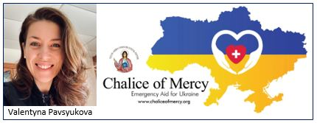
Give to Chalice of Mercy for Ukraine Relief
The people of Ukraine continue to suffer indiscriminate missile attacks from Russian forces, often aimed at population centers, and at power stations to destroy the capacity for people to heat their homes in winter. Please consider donating to Valentyna Pavsyukova’s extraordinarily effective mission, Chalice of Mercy, to help pay for continued shipments of warm clothing, medical supplies and much more. Visit chaliceofmercy.org/donate. For more information on Chalice of Mercy and links to media stories, visit diolc.org/chalice-of-mercy.

<<Top >>

Director: Jeff Reiter – 608.791.2653 | jreiter@diolc.org
(Final Reminder) The Year End 2023 Gifts:
We have closed the 2023 gift calendar year for tax purposes. Tax statements should be in homes during the last week of January.
(Reminder) Inspired By The Spirit and Diocesan Annual Appeal:
We have become aware that parishes are again making and using copies of the pledge form. These are parish-specific, and for our electronic banking and gift-scanning process, the pledge form must meet particular specifications to size and QR location to be more efficient, helping keep costs down and ensuring the correct parish and supporter is getting credit for that gift.
If you need more pledge forms, please contact Sarah Komperud at skomperud@diolc.org; we will order more. Please allow 14 days for delivery.
(Reminder) Diocesan Annual Appeal:
The next scheduled mailing will be our Holy Week mailing. The Holy Week Mailing will be focused on:
- Parishes over goal: we will mail those who gave in the last two years (2021 & 2022) but have yet to give this year (LYBUNTS and SYBUNTS).
- Parishes under goal will have all those who still need to support the DAA mailed (LYBUNTS, SYBUNTS, and Never/New).
If a parish wishes to include a letter from the Pastor and/or Finance Council, the due date to receive those letters in the Stewardship Office is March 5, 2024. Please be sure the letter is in a Word document format and the parish number is included in the file name.
If you need more pledge forms, please contact Sarah Komperudskomperud@diolc.org; we will order more. Please allow 14 days for delivery. If you have any questions or concerns, please do not hesitate to contact our office.
Weekly Stewardship Quotes (shorter bulletin reflections):
January - March 2024
- https://diolc.org/wp-content/uploads/2023/12/Stewardship-Reflections-Jan-March-2024.docx
  - Spanish Version
https://diolc.org/wp-content/uploads/2023/12/Stewardship-Reflections-Jan-March-2024-Spanish.docx
Weekly Stewardship Prayers of the Faithful:
January - March 2024
- https://diolc.org/wp-content/uploads/2023/12/Stewardship-Prayers-of-the-Faithful-Jan-March-2024.docx
  - Spanish Version
https://diolc.org/wp-content/uploads/2023/12/Stewardship-Prayers-of-the-Faithful-Jan-March-2024-Spanish.docx
Stewardship Bulletin Reflections for Weekends:
- 01/28/24
https://diolc.org/wp-content/uploads/2024/01/01.28.24-stewardship-bulletin-announcements.pdf
- 02/04/24
https://diolc.org/wp-content/uploads/2024/01/02.04.24-stewardship-bulletin-announcements.pdf
- 02/11/24
https://diolc.org/wp-content/uploads/2024/01/02.11.24-stewardship-bulletin-announcements.pdf
- 02/18/24
https://diolc.org/wp-content/uploads/2024/01/02.18.24-stewardship-bulletin-announcements.pdf
Stewardship Homily Reflections:
Stewardship reflections for your homily development:
- For Weeks 01/2824 - 02/18/24
https://diolc.org/wp-content/uploads/2024/01/Homily-Guide-01.23.24.pdf
Planned Giving – Leaving a Legacy, Wills, Bequest, and Endowments:
We have been entrusted with precious treasures passed down from our ancestors, and it's our responsibility to ensure that future generations can also enjoy the splendor and reverence of a well-maintained parish. One way to achieve this is by utilizing the Capital Campaign and providing information on Endowments, Trusts, and Bequests to the parishioners.
Our Estate Planning Guide can help save hundreds of dollars in legal and financial estate planning costs. We have mailed out several hundred copies per individual request, and each Parish has received a copy. Please feel free to contact our office for additional copies.
Visit diolclegacy.org, our Planned Giving website, to find calculators and more information, sign up for a newsletter, and request specific estate planning guides and information. Our website also provides instructions on how to do an IRA Rollover, the creation of Donor Advised Funds (DAF), Beneficiary Designations, and Stock Transfers. https://diolclegacy.org/?pageID=5
Please contact Jeff Reiter at jreiter@diolc.org for more information on legacy giving, presentations, or ads for your Parish bulletin.
<<Top >>

Diocesan Finance Officer: James Reider – 608.791.2668 | jreider@diolc.org
DioLC 2024 Winter Parish Finance Webinar | Feb. 15th 9:00 am - 12:00 pm | Zoom:
The Office for Temporalities is hosting the winter parish finance webinar. We will be using ZOOM as our hosting platform. Registration is required. Click here to register. There will be only one session, which will be recorded and posted to diolc.org/temporalities/ following the Feb. 15th session. Parish Finance Contacts, Finance Council Chairpersons, Parish Administrative Assistants and Secretaries, Pastors, and other parish staff are welcome to attend. Registration is required to receive the meeting link. Click here to register. The webinar will last about 3 hours.
Meeting Agenda
9:00 to 9:30 a.m. – FY2023 Annual Report wrapup – Nick Lichter, Finance Staff
- Recap results from the FY2023 Annual Report. Discuss how best to use the FY2024 ParishBalanceTool. Set the timeline for completing the FY2024 Annual Report.
9:30 to 10:00 a.m. – Parish savings, endowments and Perpetual Care accounts Claudia Weinberger, James Reider and staff
- A review of diocesan policy regarding savings, endowments and Perpetual Care accounts. Claudia, James Reider and staff
  - A review of accounts and what makes them different from parish savings.
  - Endowments investment policy
    - Endowment trustee board
    - USCCB Socially Responsible Investments
    - Distributions
    - Reconciliations and accounting
  - Perpetual Care investment policy
    - Governance
    - Reconciliations and accounting
10:00-10:20 a.m. - Inspired by the Spirit Campaign. Jeff Reiter – Director of Stewardship & Development
- Review of the campaign and next steps
10:20-10:30am - Break
10:30-11:00 a.m. Shared Services Accounting – James Reider and staff
- Shared accounting services at other dioceses
- Benefits to parishes, subscribed and unsubscribed
- Timeline and milestones
11:00-11:15 a.m. Catholic Mutual – Ben Burrows Catholic Mutual
- Review of insurance program and outlook for the year ahead.
11:15-11:35 a.m. St. Ambrose Financial Services – Dennis Herricks, Executive Director SAFS
- Review of St. Ambrose Services and outlook for the year ahead.
11:35-noon Building and Grounds – Kathy Haverland and staff
- Special collections for building projects and renovations. Line 22 exceptions.
Click here to register. Contact nlichter@diolc.org with any questions.
<<Top >>

Director of Vocation Recruitment: Fr. Nate Kuhn – 608.791.2666 | nkuhn@diolc.org

Please include the following intercession for vocations for your Sunday prayers of the faithful:
That our parish communities will nurture holy single lives, marriage, and religious vocations through their lives of prayer and service, giving witness to God's loving action in the world.
Consider adding a vocations paragraph to your parish bulletin:
Below is an example – they will be changed each week. Feel free to use any or all of them.
Have you asked someone recently?
Do you know someone in your life that you think would make a good priest? Have you ever told them that? If not, you should! A significant contributing factor to young men discerning the priesthood has been the invitation and encouragement they receive from others, particularly parents, teachers, mentors and role models. Don’t be afraid to tell a young man that they would make a good priest, as that may be just what they have been waiting for. Once you encourage them, don’t hesitate to put them in contact with me to continue that conversation. I can be reached at: Fr. Nate Kuhn, Director of Vocational Recruitment for the Diocese of La Crosse, 3710 East Ave. S. PO Box 4004, La Crosse, WI 54602; or by phone at: 608.791.2667. God bless you!
<<Top >>

Director: Very Rev. Woodrow H. Pace – 608.791.2689 | wpace@diolc.org

Annual Priest Retreat:
Held at the Redemptorist Retreat Center, Oconomowoc. This retreat is required for priests in their first five years following ordination and is an option for the annual canonical retreat for all other priests serving in the diocese. There is no cost for the retreat outside of what is deducted from each participant’s Continuing Ed Fund. The retreat is scheduled during the Third Week of Easter, Monday noon through Friday, April 22-26, 2024. Ending with the final Mass before lunch. If you want the room reserved beyond the retreat days, let us know. Please contact the Office of the Vicar for Clergy if you have any questions, 608.791.2689.

<<Top >>

Director: Christopher Rogers – 608.791.2659 | crogers@diolc.org

No items this week.

<<Top >>

Diocese of La Crosse | 3710 East Ave S | La Crosse, WI 54601 | 608-788-7700
To unsubscribe from this e-mail message contact mwilson@diolc.org

