Chancery Bulletin - Vol. 9, No. 1.4 | January 30, 2024

- Catechesis & Evangelization  - Chancery  - Communications  - Consecrated Life  - Diaconate  - Marriage & Family Life  - Ministries  - Mission Office  - Sacred Worship | - Safe Environment  - Schools Office  - Social Concerns  - Stewardship and Development  - Temporalities  - Vocations  - Vicar for Clergy  - Youth and Young Adult Ministry  - Past Chancery Bulletins
No items this week.

<<Top >>

Chancellor Very Rev. William Dhein – 608.791.2655 | wdhein@diolc.org

No items this week.

<<Top >>

As of Jan. 30

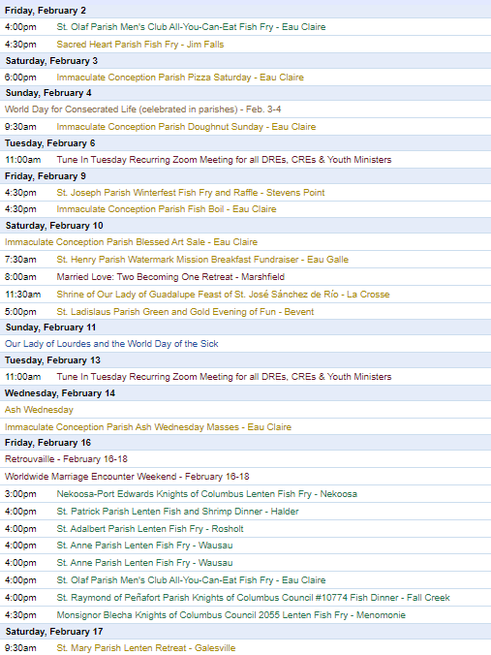
To have your parish events listed on the diocesan calendar, diolc.org/calendar, and in Catholic Life magazine, please send an email to datebook@diolc.org. Make sure you include the following details: date, beginning/ending times, event location, description, menu and cost, etc. If you have any questions, please call Pam Willer at 608.788.1524 for more information.

<<Top >>

Director: Ann Lankford – 608.791.2658 | alankford@diolc.org
Clergy: A Lenten Resource from the National Eucharistic Revival Team (Just Out):
There are many beautiful themes in the upcoming Lenten readings that tie in well with the Eucharistic Revival. As you prepare your homilies, the National Eucharistic Revival Team is providing the Preaching Series Guide, a resource to help prepare kerygmatic, Eucharistic homilies this Lent.
The intention of this guide is not to replace personal discernment and prayer with “talking points,” and it should not be taken as a homily substitute. Instead, this resource is meant as a tool to help identify missionary and kerygmatic themes and connections between the readings–breaking open the Scriptures for the faithful to prepare to celebrate the breaking of the bread. Click here for a downloadable copy in English and Spanish.
(Reminder) Clergy and Parish Leaders: “What Eucharistic Revival Looks Like?”
Dr. Mary Healy, Professor at Sacred Heart Seminary in Detroit, presents a roughly 45-minute inspiring webinar that is available here: www.eucharisticrevival.org/parishpointperson.
(Reminder) Bulletin Insert:
Eucharistic Adoration: A Privileged Place of Encountering Jesus
In this series of bulletin inserts on key themes of the Eucharistic Revival, the fifth insert focuses on Eucharistic Adoration, explaining that anyone may stop at church to “make a visit” and be with Jesus who is truly present in the Holy Eucharist. To download the bulletin insert click here: diolc.org/eucharist/learn. Note: The six bulletin inserts may be used for the weeks of Lent.
Bulletin Announcements:
Lenten Series – One of the Best!
Lent is a time to grow in your understanding of the Eucharist. The Eucharist is Jesus! You are invited to join a small group during Lent for the Jesus and the Eucharist Series. The seven sessions are outstanding in beauty and presentation with inspiring testimonies that draw participants to a deeper faith in the Real Presence of Jesus in the Eucharist. (List the day(s) and time(s) that the Series will be offered and who to contact to register.)
Attention Parishes:
All the tools needed for Jesus and the Eucharist Series to locate the videos and handouts and help to promote and organize groups, including a poster/flyer and bulletin insert, are located here: diolc.org/eucharist/lead
A Minute with Jesus:
Jesus is truly present in the Holy Eucharist.
When we look at the consecrated Host at Mass, our eyes see only bread, but the reality is we are looking at Jesus truly present. Jesus, grant me the grace to believe this truth, that though “hidden”, You are truly present in Holy Communion. It is important to remember that what we are not able to see with our eyes, we grasp by choosing to believe – with faith’s consent.
Let’s pray this right now and every day this week: Lord, I want to believe. Please help me to believe that what You say is true, especially helping the part of me that sometimes questions. This week, read about the father of a sick boy who asked Jesus to help him believe what seemed impossible in Mark 9:20-27.
Bulletin editors: For proclamations entitled A Minute with Jesus for upcoming weeks, click here: diolc.org/eucharist/learn.
Please promote “the ANSWER” Eucharistic Rally:
“The Answer” Eucharistic Rally on Friday, June 7, 2024 will be an incredible event for each participant and for our diocese; you don’t want to miss it. Please encourage the people of the parish to join us for a Eucharistic Procession with Bishop Barron and Bishop Callahan, internationally-known speakers such as Chris Stefanick, Immaculee, Josh Rosa, and our own Fr. Justin Kizewski, music, vendors, and, of course, Mass, adoration and confession. Discounted tickets are now available for purchase. Please share the QR code to the right in your bulletin and emails. It makes registering simple and fast.
Will you provide a Save the Date Card to everyone who might be interested? Can you imagine the effects of such a gathering? The save-the-date card (with four per page) is available here: diolc.org/catechesis/catechetical-leaders Thank you for your support and encouragement!
Visit a Catechesis of the Good Shepherd Atrium:
There are currently 18 atria in the Diocese of La Crosse, with two atria preparing to open and one to open next fall. If you would like contact information for the catechist in a specific city so that you may observe a session in the atrium, please contact Ann Lankford at alankford@diolc.org.
(Reminder) Speaker Policy:
If you intend to invite a speaker to the parish, the paperwork that is part of the speaker policy must be submitted before the speaker is invited, as required by the Chancery Office. See further information and the form here: diolc.org/chancery/speaker-policy, which can be found at the bottom of the diocesan website. There are those who are exempt, as noted on the webpage.
<<Top >>

Director: Erik Archer– 608.791.2661 | earcher@diolc.org

Flocknote Training This Week:
More than 40 parishes are now registered for Flocknote – more than 1/4 of all parishes in the diocese! The first training session is this Thursday at 9 a.m. There is no need to register – simply click on the Zoom link previously emailed to parishes to join. Email Erik at earcher@diolc.org if you would like to join.
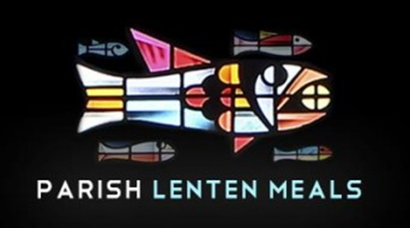
Fish Frynder is Live!:
Visit diolc.org/fishfrynder For a complete list of all diocesan parish lenten meals, organized by day, visit the Fish Frynder at diolc.org/fishfrynder or by using your smartphone’s camera to scan the QR code to the right. If your parish meal is not listed and you wish to be included, email your meal information to datebook@diolc.org. Please include the date, beginning/ending times, event location, description, menu and cost.
Bishop Callahan Catholic Schools Week Message:
Bishop Callahan’s Easter message is available to share. Please click this link: youtube.com/watch?v=uQ2tfUeKY1k or use your smartphone’s camera to scan this QR code. Please share this with your Catholic school(s) and include this in your bulletin for our faithful.

“Thank a Teacher:”
We created a Google form in 2023 that allowed students, parents and the community to send words of thanks and encouragement to our Catholic school teachers, faculty and administration. The response was overwhelming and nearly 300 comments were submitted. Please visit diolc.org/schools/ or use your smartphone’s camera to scan the QR code to the right. We send these to the referenced teacher or staff member so this matters a great deal. Please include this in your bulletin and share widely.
Listing your parish events in the May/June issue of Catholic Life:
If your parish has events for inclusion in the May/June issue of Catholic Life, please submit them by Feb. 14th. To get your parish events listed on diolc.org/calendar, and in Catholic Life magazine, please send an email to datebook@diolc.org. Make sure to include the following details: date, beginning/ending times, event location, description, menu and cost, etc. If you have any questions, please call Pam Willer at 608.788.1524.
<<Top >>

Director: Sr. Donna Krzmarzick, ISSM – 608.791.2690 | dkrzmarzick@diolc.org

No items this week.

<<Top >>

Director: Deacon Robert Riedl – 608.791.2665 | rriedl@diolclergy.org

For Your Calendar:
May 4: Continuing Formation–La Crosse Diocesan Center
June 1: Ordination to the Diaconate–Cathedral of St Joseph the Workman in La Crosse
June 7-12: National Eucharistic Procession–Diocese of La Crosse
· Friday, June 7 – “the Answer” – Eucharistic Rally
o La Crosse Center – Downtown La Crosse
o To register and for more information use your smartphone to scan the QR code to the right or visit:
https://diolc.org/the-answer/ and
https://diolc.org/pilgrimage/
· Sunday, June 9 – Holy Hour for Deacons and Families
o SS. Peter and Paul – WI Rapids
o 5-6 pm with Sunday Mass to follow at 6 p.m.
o Deacons of Wisconsin Rapids Deanery will lead Holy Hour
· More details are also available on NEP Website –
https://www.eucharisticpilgrimage.org/
· Sign up on the website to stay informed!
June 22: Ordination to the Priesthood – Cathedral of St Joseph the Workman in La Crosse
August 10: Bishop’s Day with Deacons and Wives – La Crosse Diocesan Center.

<<Top >>

Director: Christopher Rogers – 608.791.2659 | crogers@diolc.org

For Your Parish Bulletin:
50th Wedding Anniversaries
Congratulations to all couples who are celebrating their 50th Jubilee Wedding Anniversary in 2024. The Diocese of La Crosse would like to invite you to a special Mass and social/dinner as an opportunity to celebrate your marriage and bless your covenant love. Please contact the Diocese crogers@diolc.org or your Parish Office.

(Reminder) For Your Parish Bulletin:
“the ANSWER” Eucharistic Rally Tickets are now on sale!
The time has come to say “Yes!” to this life-changing event on June 7, 2024, at the La Crosse Center. Discounted tickets are now available for purchase. However, you may also want to check with your parish office as there are some parishes that have already begun purchasing group tickets and reserving buses for this event. Please check out the official website for all the detailed information. The registration link is found at the following link or by using your smartphone’s camera to scan the QR code to the right. https://diolc.org/the-answer/ (You can also paste this QR code into your bulletin for fast parishioner use.)

(Reminder) Worldwide Marriage Encounter Weekend:
WHEN ALL THE HUSTLE-BUSTLE OF THE HOLIDAYS ARE OVER... Don't you and your spouse deserve a beautiful, romantic weekend away together? If you agree, then you'll want to attend a Worldwide Marriage Encounter Weekend. For more info, contact Denise and Greg at (563) 920-9419. Upcoming dates: Feb. 16-18 in Marshalltown, April 12-14, 2024, in Epworth, Sept. 27-29 in Dubuque and Nov. 8-10 in Holstein, IA.

(Reminder) For Your Parish Bulletin:
Retrouvaille
Is your marriage in distress? No matter how hopeless it seems, forgiveness and trust are possible. Retrouvaille is a Catholic-based program that helps couples through difficult times in their marriages, some even after separation or divorce. It is not counseling or group therapy. The next program begins with a weekend on Feb. 16-18, 2024, in the Wausau area. Call 1-877-922-HOPE (4673). Fully Confidential. More at www.HelpOurMarriage.org No couple is turned away for lack of finances. Please click on this link or use your camera’s smartphone to scan the QR code to the right to access the brochure. (you can also paste this QR code into your bulletin for fast parishioner use) https://drive.google.com/file/d/1DyrLYH74WoOSYOzA0cFue2lLAQrOZtmv/view?usp=sharing

(Reminder) For Your Parish Bulletin:
Domestic Church Retreat - Save the Date
The next Domestic Church Retreat will be held April 13-14, 2024, at Ss. Peter and Paul Parish in Wisconsin Rapids. During the retreat, couples are invited to delve more deeply into the graces of their shared spiritual journey. The retreat aims to strengthen the couple’s spousal union and lead them to experience complete harmony and joy in their marriage through simple formation and meaningful dialogue that intentionally places Christ in the center. To register and find out more information, click this link: https://diolc.org/marriage/marriage-enrichment/

<<Top >>

Director: Christopher Ruff – 608.791.0161 | cruff@diolc.org

Attention Deacons, Leaders of Prayer, and Lay Formation Graduates:
We invite your leadership in drawing your fellow parishioners closer to Jesus in the Eucharist this Lent. Talk to your pastor about helping run a small-group series created by the Augustine Institute in collaboration with the National Eucharistic Revival Team. Called “Jesus and the Eucharist,” this outstanding 7-session series is being used nationwide. It is free of charge, easy to use, and powerfully inspiring not only for devoted Catholics but even for those unsure of their beliefs. Learn more and sample it at diolc.org/eucharist/lead.

<<Top >>

Director: Fr. Woodrow Pace – 608.791.2676 | wpace@diolc.org

No items this week.

<<Top >>

Director: Christopher Carstens – 608.791.0161 | ccarstens@diolc.org
(Reminder) Rite of Election | Feb. 18 | Cathedral of St. Joseph the Workman:
The Rite of Election and the Call to Continuing Conversion will be held at the Cathedral of St. Joseph the Workman on Sunday, Feb. 18, at 2 p.m. It is an occasion that marks entry into the period of Purification and Enlightenment that coincides with Lent. It is a wonderful opportunity for candidates and catechumens to see the larger Church, be introduced to their new Cathedral, and receive the grace of the Rite. The registration form for Rite of Election is available here.
Optional Memorial of Blessed James Miller (Feb. 13)
Bishop Callahan announced in a May 15, 2023 letter to priests that the Holy See had granted his request to include Blessed James Miller and Blessed Solanus Casey as optional memorials in the proper calendar of the Diocese of La Crosse on Feb. 13 and July 30, respectively. The Collect for Blessed James Miller and the Second Reading from the Office of Readings are available here; the Collect for Blessed Solanus Casey and the Second Reading from the Office of Readings are available here.
Lenten Regulations:
The season of Lent begins on Ash Wednesday, Feb. 14. Lenten regulations are as follows:
1. Catholics who have celebrated their 14th birthday are to abstain from meat on Ash Wednesday, all Fridays in Lent, and Good Friday.
2. In addition to abstaining from meat, Catholics who have celebrated their 18th birthday, until they celebrate their 59th birthday, are to fast on Ash Wednesday and Good Friday. Those who are bound to this regulation may eat only one full meal. Two smaller meals are permitted if necessary to maintain strength according to one’s needs, but eating solid foods between meals is not permitted.
Liturgical Calendar:
Feb. 23 (Friday): Day of Prayer and Penance for Diocesan and Universal Church needs. (Note: this observance is the Friday of the first week of Lent, not Friday after Ash Wednesday.) See more information at https://diolc.org/wp-content/uploads/2016/08/Day-of-Prayer-and-Penance-What-is-it.pdf.
Easter Vigil Start Time:
Sunset in La Crosse on Saturday, March 30 is to be at 7:30 p.m. So that the Vigil may begin in darkness, 8:15 should be the earliest beginning time for the vigil.
<<Top >>

Director: Teresa Brown – 608.791.2679 | tbrown@diolc.org

DIOCESE OF LA CROSSE GUIDELINES FOR REPORTING INSTANCES OF CHILD ABUSE:
The Diocese of La Crosse, through its policies and procedures, seeks to provide a prompt, appropriate and compassionate response to reporters of sexual abuse of a child by any diocesan agent (bishop, priest, deacon, employee, religious, vendor or volunteer). Anyone wishing to make a report of an allegation of sexual abuse should send that report to Mrs. Teresa Brown, Complaint Intake Agent, at the Diocese of La Crosse, P.O. Box 4004, La Crosse, WI 54602-4004. Alternatively, you can contact Mrs. Brown at 608.791.0179 or intakeagent@diolc.org. The reporting form is available through the Diocese of La Crosse Office of Safe Environment or on the diocesan website at: diolc.org/safe-environment/reporting. Individuals are also encouraged to take their reports directly to civil authorities. Copies of the diocesan policy are available through your local Parish and on the diocesan website. If you have any questions about the Diocese of La Crosse and the implementation of the Charter for the Protection of Children and Young People, please contact Teresa Brown, Diocese of La Crosse, at 608.791.2679 or tbrown@diolc.org.

As of today, I have received 27 parish reports and 1 school report. Have you begun working on your 2023-24 Safe Environment Report yet? They are due on March 1. If you have questions or need any assistance, please don’t wait until March 1. Contact me now and I will assist you.

This year is an onsite audit. The auditing team is from StoneBridge Business Partners located in Rochester, NY. They will be visiting 1 school and 3 parishes. These sites have not been selected yet. They are scheduled Sept. 2-6, 2024.

P - Praise
R - Respect
O - Offer Help to
T - Talk With
E - Encourage
C - Care For
T - Treasure
Children

<<Top >>

Superintendent: Thomas Reichenbacher – 608.788.7707 | treichenbacher@diolc.org

No items this week.

<<Top >>

Director: Christopher Ruff – 608.791.0161 | cruff@diolc.org
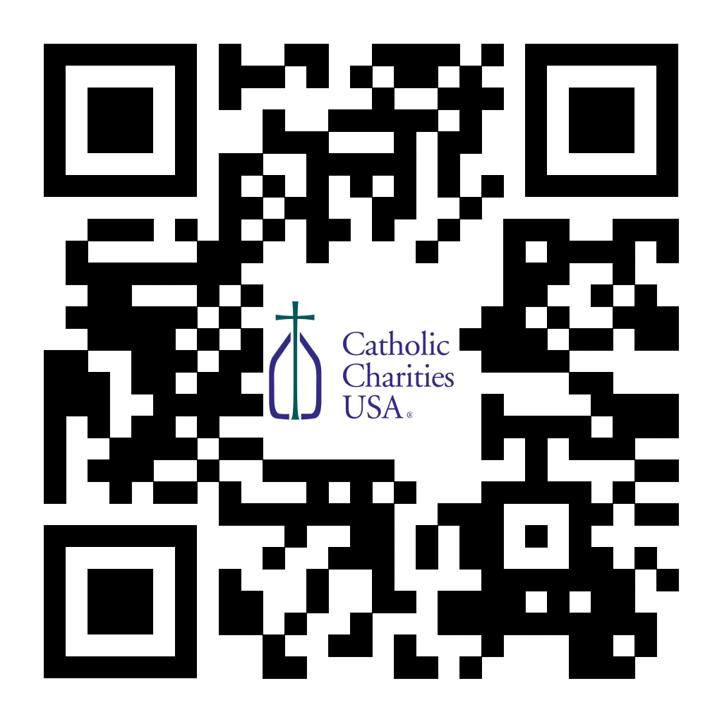
(Reminder) Pastors – Final Weekend – Catholic Campaign for Human Development (CCHD) Collection:
Bishop Callahan designated the last weekend of January (27-28) or the first weekend of February (3-4) for the CCHD collection. Parishes should have received a shipment of envelopes from the USCCB for this purpose. Checks should be made payable to your parish (CCHD on the memo line), with one check from the parish for the total made payable to the Diocese of La Crosse and sent to the Office for Ministries and Social Concerns.
For Your Parish Bulletin:
Please Donate to Project Milk!
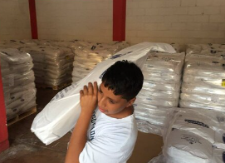
Your help is needed, as we prepare to purchase whole powdered milk for the children of Casa Hogar and other surrounding orphanages in Peru. We are $32,000 short of funding to purchase a full shipping container, which is 800 bags of milk (we currently have enough for 500 bags). Please consider donating by visiting frjoesguild.org/donate/ or scanning the QR code on the right. Select “Project Milk” from the designation menu. If you prefer to donate by mail, scroll down that webpage for instructions, and write “Project Milk” on the memo line of your check. The Children of Casa Hogar and the members of the Rural Life Committee thank you!

For Your Parish Bulletin:
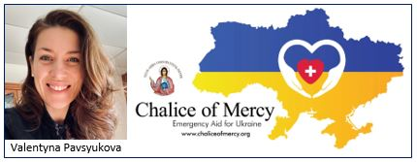
Give to Chalice of Mercy for Ukraine Relief
The people of Ukraine continue to suffer indiscriminate missile attacks from Russian forces, often aimed at population centers, and at power stations to destroy the capacity for people to heat their homes in winter. Please consider donating to Valentyna Pavsyukova’s extraordinarily effective mission, Chalice of Mercy, to help pay for continued shipments of warm clothing, medical supplies and much more. To donate, and for more information on Chalice of Mercy and links to media stories, visit diolc.org/chalice-of-mercy, or scan the QR code on the right.

For Your Parish Bulletin:
Feast of Blessed Brother James Miller – Feb. 13
A native of Stevens Point and a De La Salle Christian Brother and missionary, Brother James Miller was gunned down while repairing a wall at the school where he worked in Huehuetenango, Guatemala on Feb. 13, 1982. He was declared a martyr and beatified by Pope Francis on Dec. 7, 2019. He stands as an example of fidelity to the Gospel and humble and fearless service on behalf of the poor and the vulnerable. His gravesite in Ellis, Wis., will be a stop along the Eucharistic Pilgrimage on June 10, 2024. To learn more about Blessed Brother Miller, visit diolc.org/blessed-brother-james-miller, or scan the QR code to the right.

For Your Parish Bulletin:
Abby Johnson Speaking at April 13 DCCW Convention in La Crosse
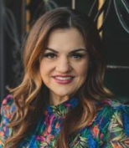
You are invited to come hear pro-life leader Abby Johnson at the Radisson Hotel in La Crosse on Saturday, April 13, at the La Crosse Diocesan Council of Catholic Women (DCCW) Biennial Convention. Abby was a Planned Parenthood director before undergoing a profound conversion in 2009, when she witnessed an ultrasound-guided abortion. Her story was portrayed in the major 2019 film Unplanned. To learn more and to register, visit dccw.org, or scan the QR code to the right.

<<Top >>

Director: Jeff Reiter – 608.791.2653 | jreiter@diolc.org
(Reminder) Inspired By The Spirit and Diocesan Annual Appeal:
We have become aware that parishes are again making and using copies of the pledge form. These are parish-specific, and for our electronic banking and gift-scanning process, the pledge form must meet particular specifications to size and QR location to be more efficient, helping keep costs down and ensuring the correct parish and supporter is getting credit for that gift.
If you need more pledge forms, please contact Sarah Komperud at skomperud@diolc.org; we will order more. Please allow 14 days for delivery.
(Reminder) Diocesan Annual Appeal:
The next scheduled mailing will be our Holy Week mailing. The Holy Week Mailing will be focused on:
- Parishes over goal: we will mail those who gave in the last two years (2021 & 2022) but have yet to give this year (LYBUNTS and SYBUNTS).
- Parishes under goal will have all those who still need to support the DAA mailed (LYBUNTS, SYBUNTS, and Never/New).
If a parish wishes to include a letter from the Pastor and/or Finance Council, the due date to receive those letters in the Stewardship Office is March 5, 2024. Please be sure the letter is in a Word document format and the parish number is included in the file name.
If you need more pledge forms, please contact Sarah Komperudskomperud@diolc.org; we will order more. Please allow 14 days for delivery. If you have any questions or concerns, please do not hesitate to contact our office.
Weekly Stewardship Quotes (shorter bulletin reflections):
January - March 2024
- https://diolc.org/wp-content/uploads/2023/12/Stewardship-Reflections-Jan-March-2024.docx
  - Spanish Version
https://diolc.org/wp-content/uploads/2023/12/Stewardship-Reflections-Jan-March-2024-Spanish.docx
Weekly Stewardship Prayers of the Faithful:
January - March 2024
- https://diolc.org/wp-content/uploads/2023/12/Stewardship-Prayers-of-the-Faithful-Jan-March-2024.docx
  - Spanish Version
https://diolc.org/wp-content/uploads/2023/12/Stewardship-Prayers-of-the-Faithful-Jan-March-2024-Spanish.docx
Stewardship Bulletin Reflections for Weekends:
- 02/04/24
https://diolc.org/wp-content/uploads/2024/01/02.04.24-stewardship-bulletin-announcements.pdf
- 02/11/24
https://diolc.org/wp-content/uploads/2024/01/02.11.24-stewardship-bulletin-announcements.pdf
- 02/18/24
https://diolc.org/wp-content/uploads/2024/01/02.18.24-stewardship-bulletin-announcements.pdf
- 0/25/24
https://diolc.org/wp-content/uploads/2024/01/02.25.24-stewardship-bulletin-announcements.pdf
Stewardship Homily Reflections:
Stewardship reflections for your homily development:
- For Weeks 02/04/24 - 02/25/24
https://diolc.org/wp-content/uploads/2024/01/Homily-Guide-01.30.24.pdf
Planned Giving – Leaving a Legacy, Wills, Bequest, and Endowments:
We have been entrusted with precious treasures passed down from our ancestors, and it's our responsibility to ensure that future generations can also enjoy the splendor and reverence of a well-maintained parish. One way to achieve this is by utilizing the Capital Campaign and providing information on Endowments, Trusts, and Bequests to the parishioners.
Our Estate Planning Guide can help save hundreds of dollars in legal and financial estate planning costs. We have mailed out several hundred copies per individual request, and each Parish has received a copy. Please feel free to contact our office for additional copies.
Visit diolclegacy.org, our Planned Giving website, to find calculators and more information, sign up for a newsletter, and request specific estate planning guides and information. Our website also provides instructions on how to do an IRA Rollover, the creation of Donor Advised Funds (DAF), Beneficiary Designations, and Stock Transfers. https://diolclegacy.org/?pageID=5
Please contact Jeff Reiter at jreiter@diolc.org for more information on legacy giving, presentations, or ads for your Parish bulletin.
<<Top >>

Diocesan Finance Officer: James Reider – 608.791.2668 | jreider@diolc.org

Reconciliation of Endowments and/or Perpetual Care:
To reconcile Endowments and/or Perpetual Care, a calculation is needed to determine Realized
and Unrealized gains/losses using the TrustPoint statement. Please use the percentages below to determine gains and losses for the Dec. 31, 2023, Trust Point statements. You can determine if your endowment is 50/50; 60/40; or 70/30 by looking at the top of your endowment statement. Example: Diocese of La Crosse Endowment Trust 70/30 Agency.

Quarterly Percentage to use to calculate Realized Gain/Loss and Unrealized Gain/Loss:
- 50/50 0.0005398
- 60/40 0.0006476
- 70/30 0.0007073

The percentage will be the same for all cemeteries for Perpetual Care Investments. The Realized Gain/Loss and Unrealized Gain/Loss percentage for perpetual care investments is 0.0008150.
We will provide future quarterly Realized Gain/Loss and Unrealized Gain/Loss percentages when the quarterly statements are issued.
<<Top >>

Director of Vocation Recruitment: Fr. Nate Kuhn – 608.791.2666 | nkuhn@diolc.org

No items this week.

<<Top >>

Director: Very Rev. Woodrow H. Pace – 608.791.2689 | wpace@diolc.org

No items this week.

<<Top >>

Director: Christopher Rogers – 608.791.2659 | crogers@diolc.org

(Reminder) For Your Parish Bulletin:
“the ANSWER” Eucharistic Rally Tickets are now on sale!
The time has come to say “Yes!” to this life-changing event held on June 7, 2024, at the La Crosse Center. Discounted tickets are now available for purchase. However, you may also want to check with your parish office as there are some parishes that have already begun purchasing group tickets and reserving buses for this event. Please check out the official website for all the detailed information, including the link to purchase online tickets https://diolc.org/the-answer/ or use your smartphone’s camera to scan the QR code on the right. (You can also paste this QR code into your bulletin for fast parishioner use.)

(Reminder) SEALED! Spring Diocesan Confirmation Retreat:
The SEALED! Diocesan Confirmation Retreat will be held March 2, 2024, at Holy Spirit Catholic Church in Stevens Point, Wis. Online registration is now available. Please click this link to register and find out more information: https://diolc.org/yya/youth-opportunities/immersion-retreat/ or use your smartphone’s camera to scan the QR code on the right. (You can also paste this QR code into your bulletin for fast parishioner use.)

<<Top >>

Diocese of La Crosse | 3710 East Ave S | La Crosse, WI 54601 | 608-788-7700
To unsubscribe from this e-mail message contact mwilson@diolc.org

