Chancery Bulletin - Vol. 9, No. 1.1 | January 9, 2024

- Catechesis & Evangelization  - Chancery  - Communications  - Consecrated Life  - Diaconate  - Marriage & Family Life  - Ministries  - Mission Office  - Sacred Worship | - Safe Environment  - Schools Office  - Social Concerns  - Stewardship and Development  - Temporalities  - Vocations  - Vicar for Clergy  - Youth and Young Adult Ministry  - Past Chancery Bulletins
The Most Reverend William Patrick Callahan, D.D., Bishop of La Crosse, makes the following
announcement:

Deacon Patrick McKeough, serving as Deacon at St. Mark Parish in Rothschild, has requested the status of Senior Deacon and it has been granted, effective December 21, 2023.

<<Top >>

Chancellor Very Rev. William Dhein – 608.791.2655 | wdhein@diolc.org

No items this week.

<<Top >>

As of Jan. 9, 2024

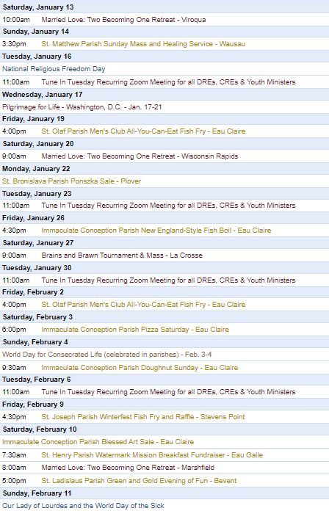
To get your parish events listed on the diocesan calendar, diolc.org/calendar, and in Catholic Life magazine, please send an email to datebook@diolc.org. Ensure you include the following details: date, beginning/ending times, event location, description, menu and cost, etc. If you have any questions, please call Pam Willer at 608.788.1524 for more information.

<<Top >>

Director: Ann Lankford – 608.791.2658 | alankford@diolc.org
Clergy: Jesus and the Eucharist Series during Lent:
During this Year of the Parish, a central focus is on the Jesus and the Eucharist Series for small groups. The Series was produced by the Augustine Institute in collaboration with the National Team. The Series is outstanding in beauty and presentation and is also broadly evangelizing because it puts the Gift of the Eucharist in the context of the whole story of salvation! Parishes are invited to host this Series during Lent and need only one or two people to serve as the main organizers. All the tools needed to locate the videos, handouts and help promote/organize groups are located here: diolc.org/eucharist/lead
Bulletin Insert:
Encounter Jesus! Join Us in a Lenten Small Group Series
“Jesus and the Eucharist” is a seven-week series that is compelling, beautiful and presented in a way that is personal and understandable for individuals at any level of faith. The bulletin insert is available here: diolc.org/catechesis/bulletin-inserts. Parish contact information, located at the bottom of the word-format bulletin insert, must be filled in.
Bulletin Announcement: A Minute with Jesus:
Jesus’ name means “God saves”
The angel told Joseph in a dream that this Child was to be called “Jesus, for He will save His people from their sin” (Matthew 1: 21). Jesus saves us from our sins by dying on the Cross and then giving us His Resurrected Body in the Eucharist. The Holy Eucharist is the Church’s most precious treasure. What a Gift, that we may have a life-giving encounter with Jesus, truly present in the Eucharist.
Let’s pray this right now and every day this week: Jesus, thank You for coming into the world to give us the greatest Gift – Yourself in the Holy Eucharist.
This week, read the account of the angel appearing to Joseph in Matthew 1: 18-25
Catechetical Leader Information:
BEET Grants: Bishop’s Education Endowment Trust Grants: due Jan. 19
The 2024-25 Bishop’s Education Endowment Trust (BEET) grant application window is open. The method for applying for the BEET grant for the 2024-25 fiscal year is to complete an online Google Form (application). The deadline for submission is Friday, Jan. 19, 2024, with the online application being disabled by 4:30 p.m. A required part of the process is approval by your pastor or dean. The approval deadline for pastors or deans is Friday, Jan. 26, 2024.
The instructions and the application form are on the Office for Catechesis & Evangelization main webpage, and by clicking here: https://diolc.org/schools/beet-grant/. Since the online application form must be completed in one sitting, the questions on the application form are included with the instructions so that you can prepare your answers ahead of time. Please call the Office for C & E with questions regarding grant applications.
Webinar: Returning to the Eucharist: Preparing for Lent with Dr. Brant Pitre:
January 10, 2024 | 10 a.m.
Tune in as Dr. Pitre prepares webinar attendees for Lent by returning to the Eucharist. His presentation includes:
- What don't people know about the Eucharist?
- How are Lent and Eucharistic devotion connected?
- How can parishes focus on the Blessed Sacrament during the Eucharistic Revival?
- And more! Click the link below or use your smartphone’s camera to scan the QR code to the right to register: https://augustineinstitute-org.zoom.us/webinar/register/WN_TOIS7zx_RLOP1KzZj8TxuQ?utm_campaign
January is Pro-life Month
For Pro-Life resources to be used during the month of January for different age groups, click here: diolc.org/catechesis/catechist-training-resources-for-teaching/pro-life-teaching-resources/
<<Top >>
Director: Erik Archer– 608.791.2661 | earcher@diolc.org

Thank a Teacher!
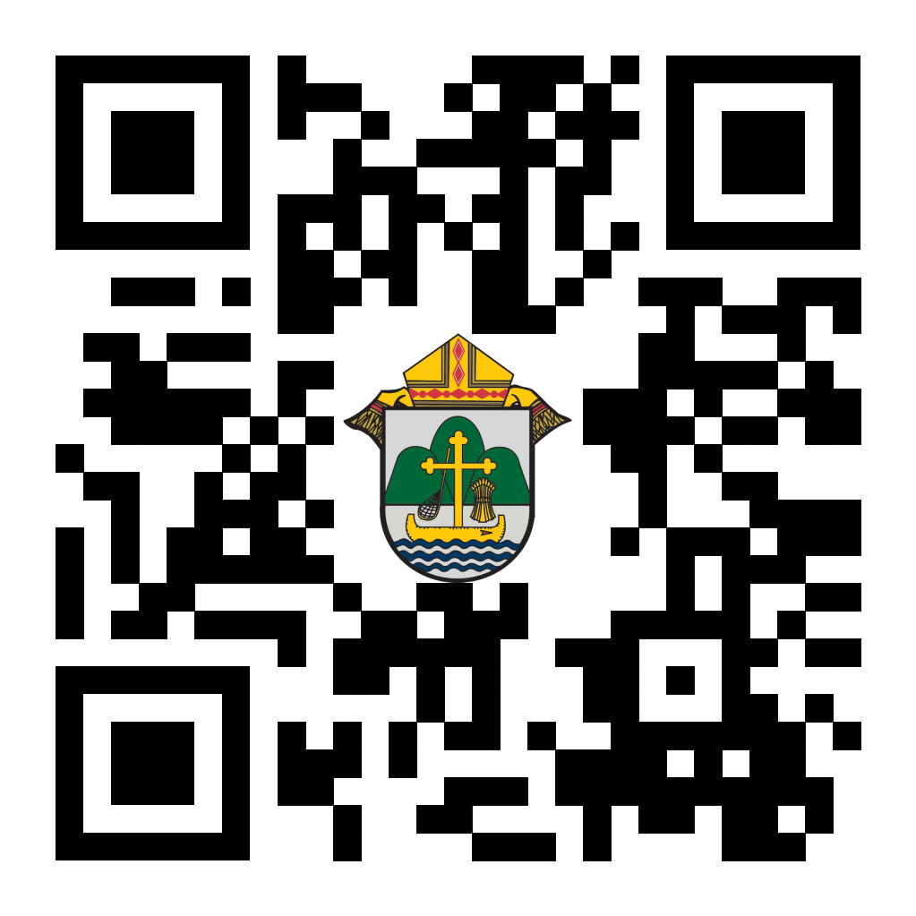
Catholic Schools Week is approaching and we began a new tradition last year of creating a “Thank-a-Teacher” Google form where families, parishioners and fellow educators can submit an anonymous (or provide their name) “thank-you” to one of dedicated and compassionate Catholic Schools professionals from across our 19 counties. We package the comments for our Superintendent who then sends them to the referenced schools. We also share some of these comments on our social media platforms and these tend to be among the most engaging posts we publish. So… please share the link below in your email correspondences and the QR code to the right in your parish bulletin to build a wave of thank-yous to our Catholic School teachers, admin and staff!
https://docs.google.com/forms/d/e/1FAIpQLSdVRihT0pGOGH2PrmGEYSyvWg8oklPfxoczSKktPKYF1TT-Yw/viewform
Catholic Social Media Wave 3 Training:
Wave 3 training is scheduled for January 24th at 11 a.m! This software helps automate your social media postings so you free up time to focus on other ministries. We’re learning the process as well and will continue to improve the menu of catechetical, informational, event-based and playful posts for you to share. Please email Erik at earcher@diolc.org to be added. We are shouldering the cost - it is free to you.

Flocknote:
We received over 20 requests from parishes asking to be included in our first rollout of 40 parishes. Thank you! We briefed Bishop Callahan on the progress and he is excited about the engagement thus far. Email Erik at earcher@diolc.org to add your parish. We are shouldering the cost for this as well - it is free to you. Use your smartphone’s camera to scan the QR code to the right to learn more.
<<Top >>

Director: Sr. Donna Krzmarzick, ISSM – 608.791.2690 | dkrzmarzick@diolc.org
World Day of Prayer for Consecrated Life (Celebrated in Parishes February 3-4):
In 1997, Pope Saint John Paul II instituted a day of prayer for women and men in consecrated life. This celebration is attached to the Feast of the Presentation of the Lord on Feb. 2nd. This Feast is also known as Candlemas Day, the day on which candles are blessed, symbolizing Christ, who is the light of the world. So, too, those in consecrated life are called to reflect the light of Jesus Christ to all peoples. The celebration of World Day of Prayer for Consecrated Life is transferred to the following Sunday in order to highlight the gift of consecrated persons for the whole Church.
Please pray for consecrated persons at Holy Mass in the Prayers of the Faithful and include a mention in your parish bulletin (samples are below). For more information: USCCB, NRVC
Prayers of the Faithful
For those in consecrated life, that they may persevere in their commitment to the Lord and serve with joyful hearts and total dedication. We pray to the Lord…
For your Parish Bulletin
World Day of Prayer for Consecrated Life will be celebrated in parishes on the weekend of Feb. 3-4. Please pray for all those who have answered the call to consecrated life, aspiring towards joy-filled holiness in the service of the Church and world. Pray also for many more laborers to enter the vineyard so that Jesus Christ may be better known, experienced, and loved.
<<Top >>

Director: Deacon Robert Riedl – 608.791.2665 | rriedl@diolclergy.org

For Your Calendar!
May 4—Continuing Formation— La Crosse Diocesan Center
June 1—Ordination to the Diaconate—Cathedral of St Joseph the Workman in La Crosse
June 7-12 – National Eucharistic Procession – Diocese of La Crosse
· Friday, June 7 – “The Answer – Eucharistic Rally”
o La Crosse Center – Downtown La Crosse
o To register and for more information visit:
https://diolc.org/the-answer/ and
https://diolc.org/pilgrimage/
· Sunday, June 9 – Holy Hour for Deacons and Families
o SS Peter and Paul – WI Rapids
o 5-6 pm with Sunday Mass to follow at 6 pm
o Deacons of WI Rapids Deanery will lead Holy Hour
· More details are also available on NEP Website -
https://www.eucharisticpilgrimage.org/
· Signup on the website to stay informed!
June 22—Ordination to the Priesthood—Cathedral of St Joseph the Workman in La Crosse
August 10—Bishop’s Day with Deacons and Wives—La Crosse Diocesan Center

<<Top >>

Director: Christopher Rogers – 608.791.2659 | crogers@diolc.org

50th Wedding Anniversary Lists:
Please submit the names of those couples celebrating their 50th Jubilee Wedding Anniversaries in the year 2024 by January 22, 2024, by filling out this form and emailing it to crogers@diolc.org.

For Your Parish Bulletin
“The ANSWER” Eucharistic Rally Tickets are now on sale!
The time has come to say “Yes!” to this life-changing event on June 7, 2024, at the La Crosse Center. Discounted tickets are now available for purchase. However, you may also want to check with your parish office as there are some parishes that have already begun purchasing group tickets and reserving buses for this event. Please check out the official website for all the detailed information. The registration link is found at the following link or by using your smartphone’s camera to scan the QR code to the right. https://diolc.org/the-answer/ (you can also paste this QR code into your bulletin for fast parishioner use)

For Your Parish Bulletin:
"Behold: God is With Us" Young Adult Retreat - January 27, 2024
The world needs Jesus. Our souls need Jesus. Out of God's abundant love for us, He became man: the Word became flesh and dwelt among us (John 1:14). Jesus is the answer to the longings of our heart, and He is our way to eternal life. Knowing He would ascend into heaven, Jesus leaves us Himself- body, blood, soul, and divinity- under the guise of simple bread and simple wine. Why? So that our intimate love and union with Him (flesh to flesh) may continue in this life as we await the perfection of His love and union in the next. "Behold: God is With Us" or "Behold," for short, is an opportunity for you to retreat from the busyness and stresses of this world and find rest and consolation in Jesus and other young adults like you. All 18-35-year-olds are welcome to join us for a day of enriching talks, silent prayer/reflection, small group discussion, adoration, confession, and Mass. Most importantly, learn how to remain connected post-retreat to a lively community of young adults striving for Sainthood. This day-long retreat will occur at Blessed Sacrament Parish in La Crosse, WI. Check-ins will begin at 8:30 am, and the retreat will conclude after the 4:30 pm vigil Mass. An optional after party will take place to follow! Breastfeeding babies are welcome! Lunch will be provided! All of this and more for the low cost of $20. Let us behold the Lord together! Register here: https://argentasoftware.com/interfaces/49870/frmEventTicketSalesForm.aspx?EventID=4042 or use your smartphone to scan the QR code above (you can also paste this QR code into your bulletin for fast parishioner use)

Worldwide Marriage Encounter Weekend:
WHEN ALL THE HUSTLE-BUSTLE OF THE HOLIDAYS ARE OVER....... Don't you and your spouse deserve a beautiful, romantic weekend away together? If you agree, then you'll want to attend a Worldwide Marriage Encounter Weekend. For more info, contact Denise and Greg at (563)920-9419. Upcoming dates: February 16-18 in Marshalltown, April 12-14, 2024, in Epworth, September 27-29 in Dubuque and November 8-10 in Holstein, IA

For Your Parish Bulletin:
Retrouvaille
Is your marriage in Distress? No matter how hopeless it seems, forgiveness and trust are possible. Retrouvaille is a Catholic-based program that helps couples through difficult times in their marriages, some even after separation or divorce. It is not counseling or group therapy. The next program begins with a weekend on February 16-18, 2024, in the Wausau area. Call 1-877-922-HOPE (4673). Fully Confidential. More at www.HelpOurMarriage.org No couple is turned away for lack of finances. Please click on this link or use your camera’s smartphone to scan the QR code to the right to access the brochure. (you can also paste this QR code into your bulletin for fast parishioner use) https://drive.google.com/file/d/1DyrLYH74WoOSYOzA0cFue2lLAQrOZtmv/view?usp=sharing

For Your Parish Bulletin:
Domestic Church Retreat - Save the Date
The next Domestic Church Retreat will be held April 13-14, 2024, at Sts. Peter and Paul Parish in Wisconsin Rapids. During the retreat, couples are invited to delve more deeply into the graces of their shared spiritual journey. The retreat aims to strengthen the couple’s spousal union and lead them to experience complete harmony and joy in their marriage through simple formation and meaningful dialogue that intentionally places Christ in the center. To register and find out more information, click this link: https://diolc.org/marriage/marriage-enrichment/

<<Top >>

Director: Christopher Ruff – 608.791.0161 | cruff@diolc.org

No items this week.

<<Top >>

Director: Fr. Woodrow Pace – 608.791.2676 | wpace@diolc.org

A Blessed and joy-filled new year to everyone! We continue to appreciate your commitments to the Missions sharing the Good News that Christ the Savior is our source of hope and fulfillment, especially in corners of the world suffering under adverse poverty and restricted religious freedoms. Your prayers and financial support open opportunities that would otherwise remain out of reach.

Lenten Mite Boxes/Missionary Childhood Association (MCA): As we leave the beautiful Christmas Season, Ash Wednesday is super-early this year (Feb. 14). Lenten mite box orders are being placed using last year’s requested amounts/shipping addresses. Please notify the Mission Office with quantity and shipping address changes by this Thursday Jan.11 if there are any differences from last year’s orders. Lenten Mite Boxes are to be distributed to all Catholic School and Parish Religious Education (CCD) programs for Grade School and Middle School students. A letter with more details regarding MCA will be sent to all Catholic school principals and DRE’s/CRE’s in the near future. If you have any questions, please call or e-mail the Mission Office.

Friendly Reminder - Mission Co-op Program (MCP) 2023 and World Mission Sunday 2023: Please send the Mission Office any outstanding collections for Mission Coop appeals given this past summer and also for World Mission Sunday (October 22, 2023). Our missionaries are still suffering extra hardships and some disbursements are being delayed due to non-receipt of some parishes' collections. Thank you for your generous prayerful and monetary support.
Please direct collections designated for Retirement Fund for Religious in a separate check to Diocese of La Crosse Finance Office. (They are not processed through the Mission Office). Thank you for your generous support.

<<Top >>

Director: Christopher Carstens – 608.791.0161 | ccarstens@diolc.org

No items this week.

<<Top >>

Director: Teresa Brown – 608.791.2679 | tbrown@diolc.org

DIOCESE OF LA CROSSE GUIDELINES FOR REPORTING INSTANCES OF CHILD ABUSE
The Diocese of La Crosse, through its policies and procedures, seeks to provide a prompt, appropriate and compassionate response to reporters of sexual abuse of a child by any diocesan agent (bishop, priest, deacon, employee, religious, vendor or volunteer). Anyone wishing to make a report of an allegation of sexual abuse should send that report to Mrs. Teresa Brown, Complaint Intake Agent, at the Diocese of La Crosse, P.O. Box 4004, La Crosse, WI 54602-4004. Alternatively, you can contact Mrs. Brown at 608.791.0179 or intakeagent@diolc.org. The reporting form is available through the Diocese of La Crosse Office of Safe Environment or on the diocesan website at: diolc.org/safe-environment/reporting. Individuals are also encouraged to take their reports directly to civil authorities. Copies of the diocesan policy are available through your local Parish and on the diocesan website. If you have any questions about the Diocese of La Crosse and the implementation of the Charter for the Protection of Children and Young People, please contact Teresa Brown, Diocese of La Crosse, at 608.791.2679 or tbrown@diolc.org.

2023-24 Safe Environment Reports are due on March 1, 2024. All parishes should have received their packets. If you need any help completing the forms, contact Teresa Brown at 608-791-2679 or tbrown@diolc.org for assistance.
May the new year bless you with health, happiness and joy!
Superintendent: Thomas Reichenbacher – 608.788.7707 | treichenbacher@diolc.org

No items this week.

<<Top >>

Director: Christopher Ruff – 608.791.0161 | cruff@diolc.org
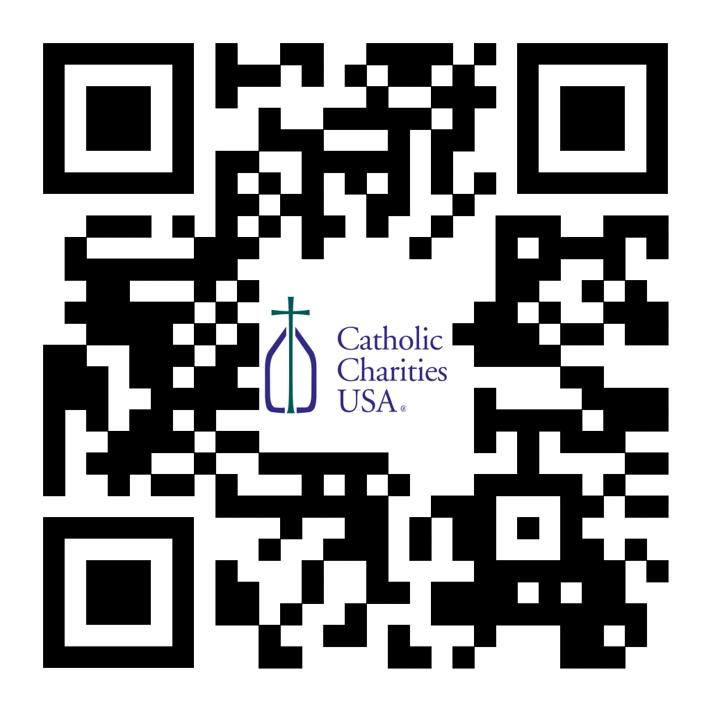
Pastors - Catholic Campaign for Human Development (CCHD) Collection Jan. 27-28 or Feb. 3-4:
Bishop Callahan designated the last weekend of January (27-28) or the first weekend of February (3-4) for the CCHD collection. Parishes should have received a shipment of envelopes from the USCCB for this purpose. Checks should be made payable to your parish (CCHD on the memo line), with one check from the parish for the total made payable to the Diocese of La Crosse and sent to the Office for Ministries and Social Concerns.
(Reminder) For Your Parish Bulletin:
Post-Abortion Healing Ministry in the Diocese of La Crosse
Do you know someone who is carrying the grief and sorrow of past abortions? Project Rachel Ministry offers a compassionate heart and confidential help. Call 608.860.6698 or email projectrachel@diolc.org.

(Reminder) For Your Parish Bulletin:
Post-Abortion Healing Retreats – Rachel’s Vineyard – Encounter God’s Mercy
Rachel's Vineyard is a weekend retreat to help anyone who has struggled with the aftermath of abortion to begin healing through a supportive, trauma-sensitive approach. Each weekend is run by a team of trained volunteers (counselor, priest, and lay people) who care deeply for your needs. All interactions with the Rachel's Vineyard retreat team are completely confidential. These retreats will be offered in the Diocese of Madison on March 15-17, 2024, and Nov. 8-10 2024. For more information, visit madisondiocese.org/rachel or use your smartphone’s camera to scan the QR code on the right. (you can also paste this QR code into your bulletin for fast parishioner use)

For Your Parish Bulletin:
CALIX—For Help with Addiction from a Catholic Perspective.
Do you or a family member or friend need help with an addiction concern? CALIX (calixsociety.org) is an association of Catholics in addiction and family members and friends affected by addiction who are maintaining their sobriety through participation in their Catholic faith and a 12-step program. You can make a confidential call to 612.383.8232 (Jim R.) or 651.587.4668 (Jim B.) for information on meetings and recovery support. You need not disclose your name.

Learn about Wisconsin’s Safe Haven “Baby Box” Provision
State legislation passed on Dec. 6, 2023, authorizes the installation of newborn infant safety devices (“Baby Boxes”) in hospitals, fire stations, and law enforcement agency buildings where a parent can anonymously relinquish an infant under the age of 72 hours. This law embraces both mother and child, providing women with a last resort that protects their own safety and that of their child. It gives birth mothers the security of knowing that their children will find love and stability.
For a press release from the Wisconsin Catholic Conference praising this legislation, click here or scan the QR code to the right.

<<Top >>

Director: Jeff Reiter – 608.791.2653 | jreiter@diolc.org
The Year End 2023 Gifts:
We have closed the 2023 gift calendar year for tax purposes. Tax statements will be mailed during the last week of January.
Inspired By The Spirit and Diocesan Annual Appeal:
We have become aware that parishes are again making and using copies of the pledge form. These are parish-specific, and for our electronic banking and gift-scanning process, the pledge form must meet particular specifications to size and QR location to be more efficient, helping keep costs down and ensuring the correct parish and supporter is getting credit for that gift.
If you need more pledge forms, please contact Sarah Komperud at skomperud@diolc.org; we will order more. Please allow 14 days for delivery.
Diocesan Annual Appeal:
Next week, a follow-up mailing for those parishes that announced and who had their homes mailed between and including the weekends of Nov. 18/19, 2023, and Dec. 16/17, 2023, will drop into the mail stream. It has taken the United States Post Service an average of 11 days to process our mail from drop to the mailboxes.
The next scheduled mailing will be our Holy Week mailing. The Holy Week Mailing will be focused on
- Parishes over goal: we will mail those who gave in the last two years (2021 & 2022) but have yet to give this year (LYBUNTS and SYBUNTS).
- Parishes under goal will have all those who still need to support the DAA mailed (LYBUNTS, SYBUNTS, and Never/New).
If you need more pledge forms, please contact Sarah Komperudskomperud@diolc.org; we will order more. Please allow 14 days for delivery. If you have any questions or concerns, please do not hesitate to contact our office.
Weekly Stewardship Quotes (shorter bulletin reflections):
January - March 2024
- https://diolc.org/wp-content/uploads/2023/12/Stewardship-Reflections-Jan-March-2024.docx
  - Spanish Version
https://diolc.org/wp-content/uploads/2023/12/Stewardship-Reflections-Jan-March-2024-Spanish.docx
Weekly Stewardship Prayers of the Faithful:
January - March 2024
- https://diolc.org/wp-content/uploads/2023/12/Stewardship-Prayers-of-the-Faithful-Jan-March-2024.docx
  - Spanish Version
https://diolc.org/wp-content/uploads/2023/12/Stewardship-Prayers-of-the-Faithful-Jan-March-2024-Spanish.docx
Stewardship Bulletin Reflections for Weekends:
- 01/14/24
https://diolc.org/wp-content/uploads/2023/12/01.14.24-stewardship-bulletin-announcements.pdf
- 01/21/24
https://diolc.org/wp-content/uploads/2023/12/01.21.24-stewardship-bulletin-announcements.pdf
- 01/28/24
https://diolc.org/wp-content/uploads/2024/01/01.28.24-stewardship-bulletin-announcements.pdf
- 02/04/24
https://diolc.org/wp-content/uploads/2024/01/02.04.24-stewardship-bulletin-announcements.pdf
Stewardship Homily Reflections:
Stewardship reflections for your homily development:
- For Weeks 01/14/24 - 02/04/24
https://diolc.org/wp-content/uploads/2024/01/Homily-Guide-01.09.24.pdf
Planned Giving – Leaving a Legacy, Wills, Bequest, and Endowments:
We have been entrusted with precious treasures passed down from our ancestors, and it's our responsibility to ensure that future generations can also enjoy the splendor and reverence of a well-maintained parish. One way to achieve this is by utilizing the Capital Campaign and providing information on Endowments, Trusts, and Bequests to the parishioners.
Our Estate Planning Guide can help save hundreds of dollars in legal and financial estate planning costs. We have mailed out several hundred copies per individual request, and each Parish has received a copy. Please feel free to contact our office for additional copies.
Visit diolclegacy.org, our Planned Giving website, to find calculators and more information, sign up for a newsletter, and request specific estate planning guides and information. Our website also provides instructions on how to do an IRA Rollover, the creation of Donor Advised Funds (DAF), Beneficiary Designations, and Stock Transfers. https://diolclegacy.org/?pageID=5
Please contact Jeff Reiter at jreiter@diolc.org for more information on legacy giving, presentations, or ads for your Parish bulletin.
<<Top >>

Diocesan Finance Officer: James Reider – 608.791.2668 | jreider@diolc.org
Budget Items:
Effective January 1, 2024, health insurance rose 5% and all risk insurance rose approximately 15%. For the 1st half of FY 2025 (Jan. 1 to June 30, 2025) it is recommended for budgeting purposes to increase the health insurance by an additional five percent and 10% for all risk insurance.
Internal Revenue Service (IRS) Mileage Rate:
The IRS has announced that the 2024 standard mileage rate for business travel has increased to 67 cents per mile, effective Jan. 1, 2024.
Catholic Mutual Group (CMG) - Slip Trips and Falls:
The Diocese of La Crosse continues a conscious effort to reduce injuries for workers and the public. Over the past year, the Diocese has achieved this goal by reducing claim severity and expense. In 2023, approximately 40% of the year's workers' compensation claims occurred in January, February, and March. These three months averaged approximately five claims per month, while the remaining nine months averaged approximately two claims per month. January, February, and March are the most problematic months within the Diocese. Parishes, employees, and volunteers must know indoor and outdoor hazards. When you observe a hazard, address the issue immediately or report it to the appropriate personnel to correct it. Many of the claims in the months of January, February, and March for both employees and the public were related to slips on the ice. Please review the attached Catholic Mutual CARES document related to Ice and Snow Removal. With a conscious effort, we can continue improving and making our parishes and schools safer for everyone. If you have any questions, please contact Ben Burrow with Catholic Mutual. Ben’s email is BBurrow@catholicmutual.org.
Diocese of La Crosse Shared Services Program: (Second notice)
Pastors: Links in prior Shared Services postings may not have worked properly. We respectfully request that any parish interested in Shared Services respond (again) by completing the survey using this link or one of the links below.
Pastors and Parochial Administrators throughout the Diocese have requested help with parish bookkeeping. Parishes have reported difficulty finding qualified personnel to maintain their accounting records, pay bills, payroll, etc. The Finance office is pleased to offer a new program to meet these needs called Shared Services. Shared Services bookkeeper(s) working from the Finance office will record accounts payable, accounts receivable, receipts, disbursements, and payroll at a competitive rate. Parish selects specific Shared Services a la carte, paying only for whichever services they need.
Shared Services Description:
Pastor’s Summary
Diocesan Shared Services provides bookkeeping services to parishes on an ‘as selected’ basis. Each parish chooses only the bookkeeping services they need. Shared Services works only within ParishSOFT Accounting software, so subscribing parishes must use that platform. (Transition to ParishSOFT Accounting is available for parishes using QuickBooks Online.) Pastors and others they designate retain online access to all parish financial records at all times. Fees for Shared Services are cost based, as determined by the number of bookkeeping transactions recorded. In general, fees will be greater for parishes selecting more services, having a larger payroll, etc. Shared Services fees are market competitive, comparable to accounting firm service fees, and similar to those charged by other diocesean finance offices. Pastors, Shared Services wants to learn more about your bookkeeping needs. Please click here for a no-obligation survey.
Available Shared Services include, but are not limited to:
1. Transition Planning. Consultations with the pastor, current bookkeeper, secretary, and parish council set mutual goals, timelines, reports, and other measurable outcomes to ensure Shared Services reliably meets or exceeds parish expectations.
2. Process Review. Best practice process review designs timely data sharing, documentation, roles, and responsibilities for efficient collaboration between parish personnel and Shared Services.
3. Vendor Payment. Parish personnel scan and electronically transmit vendor invoices to Shared Services upon receipt. Shared Services codes and prepares accounts payable and checks on a mutually agreed schedule. Pastors approve payments for Shared Services check issuance.
4. Maintain account registers. Shared Services records and coordinates vendor history and transactional records for all parish disbursements.
5. 1099 Forms. Prepare, record, and maintain Misc.-1099 forms as needed.
6. Contribution Receipts. Parish personnel scan and electronically transmit deposit slips, tally sheets, and other contribution documentation to Shared Services as they arrive. Shared Services codes and records timely and accurate updates to the general ledger.
7. Payroll. Parish personnel scan and electronically transmit employee documents, including time sheets, approved pay rates, tax status, benefits profile, and schedules to Shared Services. Shared Services configures software payroll setup for each employee per state, federal, diocesan, and parish laws and policies. Periodic payrolls are prepared per parish schedule for pastor approval before Shared Services check issuance.
8. Tax payments. Shared Services calculates and prepares Federal, Social Security/Medicare (FICA), and State quarterly and annual tax obligation payments. Pastor approves payments before Shared Services check issuance.
9. Benefits payments. Shared Services prepares payments to benefits vendors per schedule. Pastor approves payments before Shared Services check issuance.
10. Reconciliations. Parish personnel scan and electronically transmit checking, savings, investment, endowment, cemetery perpetual care, bank, and investment statements to Shared Services for timely reconciliation to the general ledger. Shared Services records timely and accurate updates to the parish general ledger.
11. Reports. Shared Services generates standard monthly financial statements, including Statements of Activity, Financial Position, Cash Flow, and Trial Balance for the Pastor, Finance Council, and others. Additional reports and report interpretation are available as needed.
Subscribed parishes will perform the following functions:
1. Collect, count, and deposit the Sunday offering and record parishioner giving and contributions to ParishSOFT Family Suite on a timely basis.
2. Maintain the family/member census information.
3. Maintain banking and investment relationships.
4. Maintain all parish calendars, registrations, and events.
5. Manage employee-related functions.
6. Retain responsibility for parish financial performance and reporting through regular review and oversight.
Pastors, Shared Services wants to learn more about your bookkeeping needs. Please click here for a no-obligation survey. Please share your interest in any of the Shared Services outlined above and direct any questions regarding Shared Services to Claudia Weinberger, cweinberger@diolc.org.
<<Top >>

Director of Vocation Recruitment: Fr. Nate Kuhn – 608.791.2666 | nkuhn@diolc.org

Please include the following intercession for vocations for your Sunday prayers of the faithful:
That young men and women will listen to the Holy Spirit in their hearts and respond to the cry from deep within to vocations of marriage, single blessedness, priesthood and religious life.
Consider adding a vocations paragraph to your parish bulletin:
Below is an example – they will be changed each week. Feel free to use any or all of them.
How does God speak to me?
Have you ever wondered how God may be speaking to you? Perhaps you are waiting to hear a loud, booming voice come from the heavens to tell you what to do or which way to go. While this isn’t completely out of the question, often God takes a much subtler approach. In 1 Kings, we have the account of the Prophet Elijah standing at the cave entrance, waiting for the Lord to appear. As he waits, he encounters a strong, violent wind, a powerful earthquake, and a consuming fire, yet God was not revealing Himself in any of those powerful examples. Finally, as Elijah waited, he heard a soft, quiet whisper. At that, he knelt to the ground and prayed. God often speaks to us, not in grand and impressive ways, but in the silence. When we can still our hearts, that’s when we begin to hear His voice, calling us into relationship and to follow Him. Sometimes that invitation is to follow the Lord as one who lovingly serves others in the priesthood. If you or someone you know is interested in discovering more about this call to the priesthood, please contact me at: Fr. Nate Kuhn, Director of Vocational Recruitment for the Diocese of La Crosse, 3710 East Ave. S. PO Box 4004, La Crosse, WI 54602; or by phone at: 608.791.2667. God bless you!
<<Top >>

Director: Very Rev. Woodrow H. Pace – 608.791.2689 | wpace@diolc.org

No items this week.

<<Top >>

Director: Christopher Rogers – 608.791.2659 | crogers@diolc.org

For Your Parish Bulletin:
“the ANSWER” Eucharistic Rally Tickets are now on sale!
The time has come to say “Yes!” to this life-changing event that will be held June 7, 2024, at the La Crosse Center. Discounted tickets are now available for purchase. However, you may also want to check with your parish office as there are some parishes that have already begun purchasing group tickets and reserving buses for this event. Please check out the official website for all the detailed information, including the link to purchase online tickets https://diolc.org/the-answer/ or use your smartphone’s camera to scan the QR code on the right. (you can also paste this QR code into your bulletin for fast parishioner use)

SEALED! Spring Diocesan Confirmation Retreat:
The SEALED! Diocesan Confirmation Retreat will be held March 2, 2024, at Holy Spirit Catholic Church in Stevens Point, WI. Online registration is now available. Please click this link to register and find out more information: https://diolc.org/yya/youth-opportunities/immersion-retreat/ or use your smartphone’s camera to scan the QR code on the right. (you can also paste this QR code into your bulletin for fast parishioner use)

For Your Parish Bulletin:
"Behold: God is With Us" Young Adult Retreat - January 27, 2024
The world needs Jesus. Our souls need Jesus. Out of God's abundant love for us, He became man: the Word became flesh and dwelt among us (John 1:14). Jesus is the answer to the longings of our heart, and He is our way to eternal life. Knowing He would ascend into heaven, Jesus leaves us Himself- body, blood, soul, and divinity- under the guise of simple bread and simple wine. Why? So that our intimate love and union with Him (flesh to flesh) may continue in this life as we await the perfection of His love and union in the next. "Behold: God is With Us" or "Behold", for short, is an opportunity for you to retreat from the busyness and stresses of this world and find rest and consolation in Jesus and other young adults like you. All 18-35-year-olds are welcome to join us for a day of enriching talks, silent prayer/reflection, small group discussion, adoration, confession, and Mass. Most importantly, learn how to remain connected post-retreat to a lively community of young adults striving for Sainthood. This day-long retreat will occur at Blessed Sacrament Parish in La Crosse, WI. Check-ins will begin at 8:30 am and the retreat will conclude after the 4:30 pm vigil Mass. An optional after party will take place to follow! Breastfeeding babies are welcome! Lunch will be provided! All of this and more for the low cost of $20. Let us behold the Lord together! Register here: https://argentasoftware.com/interfaces/49870/frmEventTicketSalesForm.aspx?EventID=4042, or use your smartphone’s camera to scan the QR code on the right. (you can also paste this QR code into your bulletin for fast parishioner use)
<<Top >>

Diocese of La Crosse | 3710 East Ave S | La Crosse, WI 54601 | 608-788-7700
To unsubscribe from this e-mail message contact mwilson@diolc.org

