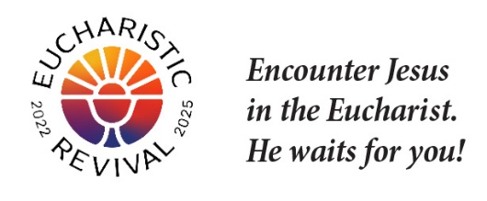
Dear [Small Group Facilitator Name]:

The Eucharistic Revival is a historic and transformative national movement to help the faithful fall in love with Jesus, especially in the Eucharist, and be inspired and equipped to share that love with others. This Lent, we will host parish-wide small groups using the foundational Eucharistic Revival Series entitled “Jesus and the Eucharist.” I am the person who is organizing this small group series for the parish.

“Jesus and the Eucharist” is a 7-week series that has been created by the Eucharistic Revival team specifically for the Year of Parish Revival. The series begins with the “Good News,” of what God has done for us and builds to God’s saving work in the Eucharist. The series will begin on [insert the date and time] and be completed by Easter.

As a facilitator of a small group associated with our parish, I am writing to invite you and your small group to join our parish-wide small group study (your small group is welcome to sit together at one of the tables) or, alternatively, to use the “Jesus and the Eucharist” series in your small group meetings.

If you wish to use the “Jesus and the Eucharist” study in your small group meetings, below are some additional details for your consideration:

- Each of the 7 sessions are roughly 2 hours, with about half the time as table discussion.
- The series includes a video and participant handout for each session free of charge, although you will have to print the participant handouts. A screen will be needed.
- The video and participant handouts are posted to diolc.org/eucharist/lead. You will need to download the video in advance, and simply press play when you are ready to start. The video will run the entire 2 hours guiding you through a welcome by an Archbishop or Bishop, a time of lectio prayer, teachings and testimonies, and table discussions. A professional host guides the process.
- There is no pre-work or home-work.

God is abundantly blessing our efforts for Revival in our country, and so many are answering Jesus’s call to grow in their understanding and love for Him truly present in the Eucharist. Please keep the Eucharistic Revival in your prayers. Contact me if you have questions.

Sincerely in Christ,
[Lead Organizer’s Name]

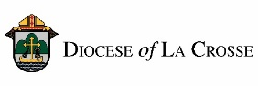
NOTE: For implementation in the Diocese of La Crosse, we have adapted these training and promotional materials for the Jesus and the Eucharist series from those produced by the National Eucharistic Revival Team in collaboration with the Augustine Institute.

