Chancery Bulletin - Vol. 9, No. 2.4 | February 27, 2024

- Catechesis & Evangelization  - Chancery  - Communications  - Consecrated Life  - Diaconate  - Marriage & Family Life  - Ministries  - Mission Office  - Sacred Worship | - Safe Environment  - Schools Office  - Social Concerns  - Stewardship and Development  - Temporalities  - Vocations  - Vicar for Clergy  - Youth and Young Adult Ministry  - Past Chancery Bulletins
The Most Reverend William Patrick Callahan, D.D., Bishop of La Crosse, makes the following announcement:

The Reverend Sebastian Saleth Pitchai, Parochial Administrator of St. Bartholomew Parish in Trempealeau and St. Mary Parish in Galesville, is appointed Pastor, with continued residence at St. Bartholomew Parish rectory in Trempealeau, effective February 27, 2024.

<<Top >>

Chancellor Very Rev. William Dhein – 608.791.2655 | wdhein@diolc.org

No items this week.

<<Top >>

As of Feb. 27

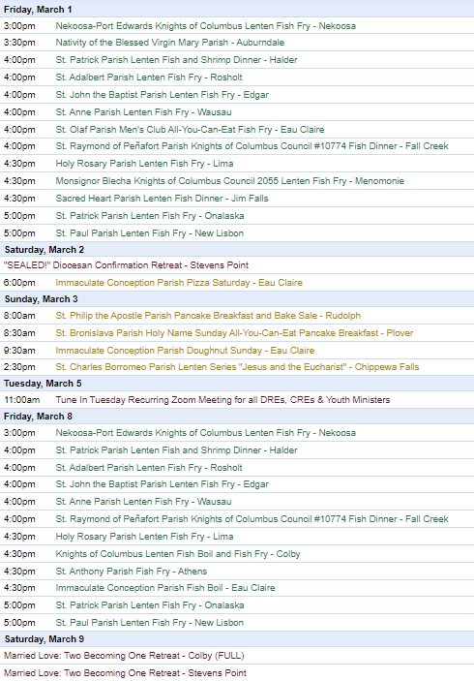
To have your parish events listed on the diocesan calendar, diolc.org/calendar, and in Catholic Life magazine, please send an email to datebook@diolc.org. Make sure you include the following details: date, beginning/ending times, event location, description, menu and cost, etc. If you have any questions, please call Pam Willer at 608.788.1524 for more information.

<<Top >>

Director: Ann Lankford – 608.791.2658 | alankford@diolc.org
Bulletin Insert:
Praying with Scripture during Lent
There are a variety of ways to deepen your relationship with Jesus. The following offers one of the treasures of our Catholic heritage as a tool for your personal spiritual growth. Praying with Scripture is a way of spending time with a Scripture passage (10-15 min) and allowing the Holy Spirit to make a connection between the passage and your own life.
Click here for the bulletin insert diolc.org/catechesis/bulletin-inserts
Bulletin Announcements:
A good reason to attend “the ANSWER” Eucharistic Rally on June 7
This revival is about God stirring our hearts to believe that the Holy Eucharist is truly Jesus. Join others who are seeking God and praying for revival for our country. The answer to our troubled nation and our troubled hearts is the Eucharist because the Eucharist is Jesus. Visit diolc.org/the-answer or use your smartphone’s camera to scan the QR code to the right for more information. You won’t want to miss this!
Lent:
What is repentance?
After Jesus spent forty days in the desert, He began His public ministry by proclaiming, “Repent and believe in the Gospel” (Mark 1:15). Understanding Jesus’ words is critical for our spiritual life. The word repentance means a reorientation of our whole life, a return to God with our whole heart, a turning away from sin, with repugnance toward the sinful actions we have committed. At the same time repentance entails the desire and resolution to change one’s life, with hope in God’s mercy and trust in the help of His grace. This conversion (change) of heart is accompanied by a sincere sorrow and repentance of heart, due to offending God, our neighbor and ourself. (See Catechism of the Catholic Church, paragraph 1431)
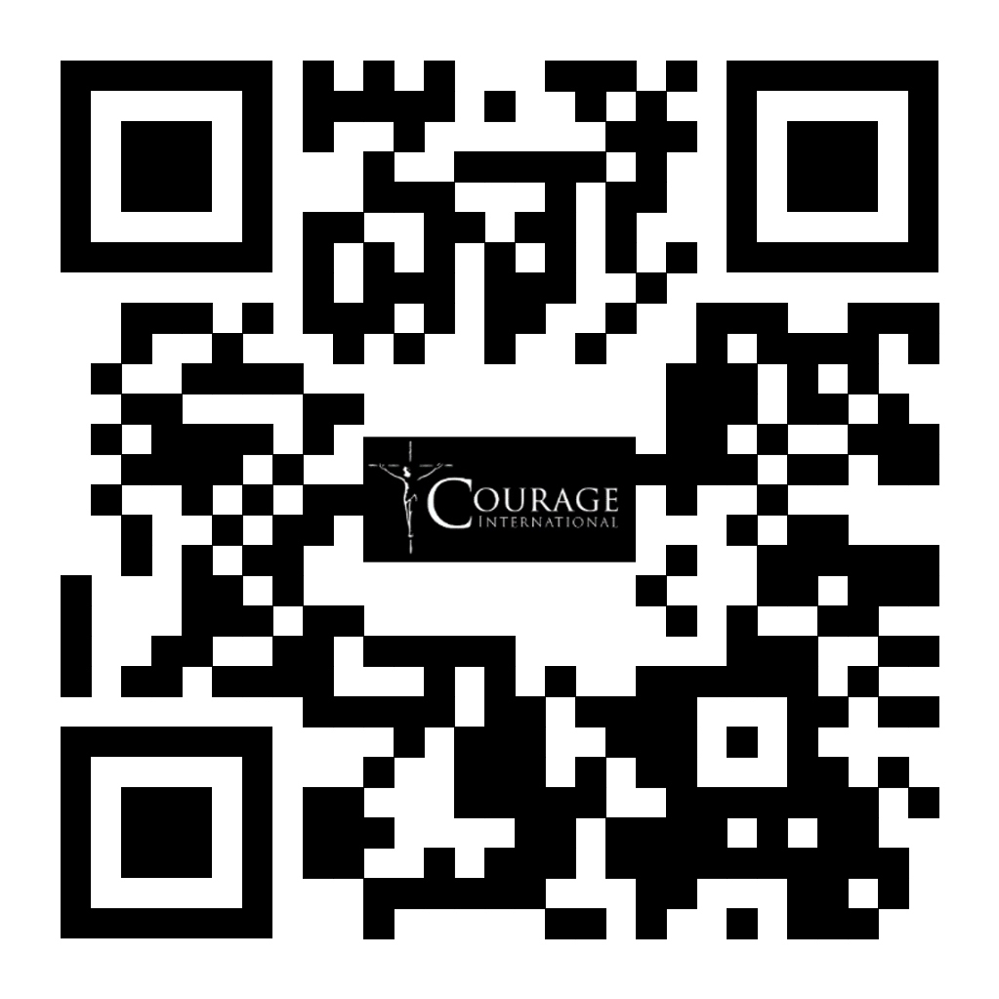
A Minute with Jesus:
As Catholics, we believe that Jesus is truly present in the Eucharist.
We humbly give our assent to what has been handed on to us for the last 2,000 years through the one Church that Jesus founded. This assent (giving our “yes – I choose to believe”) involves our commitment to persistence in prayer and study of Scripture in asking Jesus for deeper understanding regarding His true presence in the Eucharist.
Let’s pray this right now and every day this week: “Lord Jesus, I believe; please help my unbelief.”
This week, read how a father gives his assent to believing that Jesus can heal his son in Mark 9:20-27.
Bulletin editors: For upcoming weeks of proclamations entitled A Minute with Jesus, click here: diolc.org/eucharist/learn.
Courage Apostolate:
Are you experiencing same-sex attraction and looking for answers? The Courage Apostolate is a ministry dedicated to the spiritual needs of persons who experience same-sex attraction, and who want to live by the Catholic Church's beautiful teaching on human sexuality by seeking to live the virtue of chastity, which every person is called to do. A Courage Chapter with a trained chaplain is active in the Diocese of La Crosse and meets one time per month. If you are interested in a Courage Chapter, please contact Ann Lankford, Office for Catechesis and Evangelization, Diocese of La Crosse at (608) 791-2658 or alankford@diolc.org. Resources can be found here: www.couragerc.org or by using your camera’s smartphone to scan the QR code to the right.
Catechetical Leader Information:
Free Prayer Books for Children and Booklets for Parents
The office received an amazing Christmas gift this year. The Word Among Us had to clear part of a warehouse in 30 days. They shipped current books, booklets and pamphlets to us on a semi-truck because we had placed several bulk orders with them. Will you please click on the link below and fill in the number of books that you need for 2nd, 3rd and 4th Grades, as well as a booklet for parents entitled "Getting More Out of Your Child's First Communion." If each parish requests the number of books based on the current number of students in these grades, there should be enough, but this will be based on first come, first served. Click here for a picture of the books as well as a brief description. We hope that each Catechetical Leader will provide these for the children. Note: In the last two weeks, emails have been sent about this to all Catechetical Leaders, so many have already registered.
https://docs.google.com/forms/d/e/1FAIpQLSeldTqZoG0-mGQ9tTv7m-ant7cOWESV4ru7YFAnNJ18jHi_YA/viewform?usp=sf_link
Focus on Prayer during Lent:
Lent is a time when more time should be set aside for prayer. Praying with Scripture is a privileged place to encounter Jesus. In this simple way of prayer, the Holy Spirit makes a connection between the Scripture passage and the person’s life. Praying with Scripture can be used with any age level. For a downloadable page, click here: diolc.org/catechesis/catechist-training-resources-for-teaching
(Reminder) Responding to Transgender Beliefs Webinar |March 19 | Online
Dr. Mary Hasson, the Director of the Person and Identity Project at the Ethics and Public Policy Center in Washington DC, will present a webinar on Tuesday, March 19, 2024 at 1 p.m. To register, visit the link below or use your camera’s smartphone to scan the QR code to the right. us06web.zoom.us/webinar/register/WN_9DQHSNcuT0yRbIJG_jPu5A#/registration
Retreat for Individuals with Chronic Illness or Disability and Caregivers:
Join National Catholic Partnership on Disability (NCPD) for a heartwarming retreat specially crafted for individuals navigating the challenges of chronic illness or disability alongside their dedicated caregivers. This event offers a sanctuary for reflection, connection and rejuvenation during the Lenten season. While designed with persons facing physical health challenges in mind, all are welcome to attend, fostering a supportive community of understanding and hope. Come embrace this unique opportunity to find solace, share experiences, and discover the strength that can arise from collective resilience. Together, let's journey through Lent with courage, compassion, and the unwavering hope that binds us all. Learn more and register here: https://ncpd.org/events/hope-lent-online-retreat.

FREE Seminar Series - Serving Persons with Special Needs:
Thursday, March 7, 14, 21, and April 11, 18, 25 - 2 - 3:30 p.m.
National Catholic Partnership on Disability (NCPD) will offer education to Church leadership in relation to the new pastoral statement on disability, belonging, and the Church. It will explore foundational and aspirational concepts related to the full participation of persons with disabilities in the Church across six seminars. The series features Archbishop Emeritus Joseph E. Kurtz, D.D., persons who experience a broad spectrum of disabilities, and theologians such as Dr. Jana Bennet from the University of Dayton and Dr. David Cloutier from The Catholic University of America, to name a few. No cost to attend. Click here to register.
(Reminder) Children with Special Needs:
Guidelines for the Celebration of the Sacraments with Persons with Disabilities
These guidelines by the US Conference of Catholic Bishops provide the criterion for the reception of all the Sacraments, helping to determine proper readiness with great pastoral care for persons with special needs. First confession is always to be received before first holy Communion. Click here: diolc.org/catechesis/ministry-for-person-with-special-needs
<<Top >>

Director: Erik Archer– 608.791.2661 | earcher@diolc.org

Spring Roundtable Registration:
Our initial planning for the spring roundtables is complete, and we are grateful for our host parishes who agreed to set aside time and space for our gatherings. Thank you! We will publish an agenda shortly. Please take a moment to register and pay particular attention to the last question, which provides a space for you to share your thoughts on topics of discussion that are valuable to you and your fellow parishes. https://forms.gle/cVwbYCmnPnnURS8X8

Great Work!:
The team and I conducted our weekly check-in with our Flocknote point of contact, and she mentioned that our parish/diocesan effort and momentum are the best they have ever seen. They work with over 10,000 parishes, so the comment is a meaningful attestation to your investment and elbow grease. Thank you. Many of you are passionate advocates, and we would like to connect parishes who have questions with you so their questions are answered locally and by trusted fellow parishes. Please email Erik at earcher@diolc.org if you are willing to assist.

Significant Upgrade:
The National Eucharistic Pilgrimage (NEP) website received a major update last week, significantly improving its functionality and usefulness. The website now includes specific information for every NEP stop on all four routes. Each stop is clickable, allowing the viewer to access a timeline of events at that particular stop, as well as a Google map that shows exactly where the NEP can be encountered. Please visit https://www.eucharisticpilgrimage.org/ and share the QR code to the right with your parishioners and place it in your bulletin. This is a fantastic asset and a way for our faithful to find exact information about the NEP’s national timeline and locations. Locally, our diocesan information remains located at: https://diolc.org/pilgrimage/.

QR Codes - They Work (and are ideal for bulletins):
Occasionally, a person tells us that a person told them that they don’t know how to use a QR code and therefore, the practice should be stopped. As of this morning, the “the ANSWER” registration page QR code has 321 scans - representing just under half of all current total registrations. QR codes work! In our walkabouts, we see that we can often underestimate the technological literacy of our various age groups. When questions arise, please help teach - we don’t want to retreat from a means of communication native to many and teachable to others.

<<Top >>

Director: Sr. Donna Krzmarzick, ISSM – 608.791.2690 | dkrzmarzick@diolc.org

No items this week.

<<Top >>

Director: Deacon Robert Riedl – 608.791.2665 | rriedl@diolclergy.org

For Your Calendar:
May 4: Continuing Formation – La Crosse Diocesan Center
June 1: Ordination to the Diaconate – Cathedral of St Joseph the Workman in La Crosse
June 7-12: National Eucharistic Procession – Diocese of La Crosse
· Friday, June 7 – “the Answer” – Eucharistic Rally
o La Crosse Center – Downtown La Crosse
o To register and for more information use your smartphone to scan the QR code to the right or visit:
diolc.org/the-answer/ and
diolc.org/pilgrimage/
· Sunday, June 9 – Holy Hour for Deacons and Families
o SS. Peter and Paul – WI Rapids
o 4:45 p.m. - 5:45 p.m. with Sunday Mass to follow at 6 p.m.
o Deacons of Wisconsin Rapids Deanery will lead Holy Hour
· More details are also available on NEP Website –
eucharisticpilgrimage.org/
· Sign up on the website to stay informed!
June 22: Ordination to the Priesthood – Cathedral of St. Joseph the Workman in La Crosse
Aug. 10: Bishop’s Day with Deacons and Wives – La Crosse Diocesan Center.

<<Top >>

Director: Christopher Rogers – 608.791.2659 | crogers@diolc.org

(Reminder) For Your Parish Bulletin:
Exciting Update about “the ANSWER” Eucharistic Rally!
Perhaps the most exciting thing about this rally is that ticket requests have been rolling in. We are grateful to all who have registered so far. We recently received word that Bishop Robert Barron from the Diocese of Winona-Rochester and Founder of Word on Fire ministries will be the homilist at the Mass that day. We are also excited to announce the organizations, schools, and ministries that are helping to sponsor this event. Thank you to the Franciscan Sisters of Perpetual Adoration, FOCUS, EWTN, Viterbo University, Saint Mary’s University, the Diocesan Council of Catholic Women, Pioneer Catholic, and Crosswoods Camp! Don’t miss this amazing day! The registration link is found at the following link or by using your smartphone’s camera to scan the QR code to the right. diolc.org/the-answer/ (You can also paste this QR code into your bulletin for fast parishioner use.)

(Reminder) For Your Parish Bulletin:
Natural Family Planning Talk |March 16 |Diocesan Center in La Crosse, WI
Soon to be Dr. Ruby Gravorak will present a talk on Natural Family Planning on March 16th at 11:30 am in the Diocesan Center in La Crosse, WI. This talk will be part of the Married Love 2 Becoming 1 program and all coordinators and Openness to Life presenters, as well as the public are invited to attend. Please email Chris Rogers at crogers@diolc.org if you plan to attend.
(Reminder) For Your Parish Bulletin:
Domestic Church Retreat |April 13-14 |Ss. Peter and Paul Parish in Wisconsin Rapids
During the retreat, couples are invited to delve more deeply into the graces of their shared spiritual journey. The retreat aims to strengthen the couple’s spousal union and lead them to experience complete harmony and joy in their marriage through simple formation and meaningful dialogue that intentionally places Christ in the center. To register and find out more information, click this link: diolc.org/marriage/marriage-enrichment/
<<Top >>

Director: Christopher Ruff – 608.791.0161 | cruff@diolc.org

No items this week.

<<Top >>

Director: Fr. Woodrow Pace – 608.791.2676 | wpace@diolc.org

No items this week.

<<Top >>

Director: Christopher Carstens – 608.791.0161 | ccarstens@diolc.org
Calendar Note:
March 25, 2024 (The Annunciation of the Lord moved out of Holy Week)
From the USCCB’s Committee on Divine Worship’s November 2023 Newsletter: “The Solemnity of the Annunciation of the Lord on March 25, 2024, is impeded by Monday of Holy Week. According to the Universal Norms on the Liturgical Year and the Calendar, no. 60, the Annunciation is therefore transferred to Monday of the Second Week of Easter, in this case, April 8, 2024.”
(Reminder) Chrism Mass |March 26 |St. Joseph the Workman Cathedral in La Crosse
The Chrism Mass is one of the diocesan highlights at which the Bishop blesses the oils for the celebration of the Sacraments of Baptism and the Anointing of the Sick, and consecrates the Sacred Chrism used in the Sacraments of Confirmation and Holy Orders. Priests also renew their priestly promises at this Mass, and the faithful pray for them. The Chrism Mass will be celebrated on Tuesday, March 26, at 10:30 a.m., at St. Joseph the Workman Cathedral in La Crosse. Please consider attending!
(Reminder) Easter Vigil Start Time:
Sunset in La Crosse on Saturday, March 30 is to be at 7:30 p.m. So that the Vigil may begin in darkness, 8:15 should be the earliest beginning time for the vigil.
Liturgical Reminders:
5th Sunday of Lent: In the Dioceses of the United States, the practice of covering crosses and images throughout the church from the Fifth Sunday may be observed. Crosses remain covered until the end of the Celebration of the Lord’s Passion on Good Friday, but images remain covered until the beginning of the Easter Vigil.
Mass of the Lord’s Supper:
- Altar may be decorated with flowers. (Rubric for Holy Thursday [=HT], 5)
- At the beginning of the Liturgy of the Eucharist, there may be a procession of the faithful in which gifts for the poor may be presented with the bread and wine. (HT, 14)
- Adoration is not to take place in a monstrance: “The Blessed Sacrament should be reserved in a closed tabernacle or pyx. Under no circumstances may it be exposed in a monstrance.” (Paschalis Sollemnitatis, n.55)
- Holy water stoups are emptied after Mass.
Good Friday:
- Good Friday liturgy may not be celebrated in the absence of a priest. (Rubric for Good Friday [=GF], 4)
- Only one cross may be used for adoration. (GF, 19)
Easter Vigil
- The Paschal Candle is to be replaced each year: “The paschal candle should be prepared, which for effective symbolism must be made of wax, never be artificial, be renewed each year, be only one in number, and be of sufficiently large size so that it may evoke the truth that Christ is the light of the world.” (Paschalis Sollemnitatis, n.82)
- If a deacon is not present to carry the Paschal Candle in the procession, the candle is carried by another minister and not the priest. (Rubric for the Easter Vigil [=EV], 15 and following)
- Lights in the church building are turned on when the Paschal Candle is placed in its stand at the front of the church at the end of the entrance procession, before the Exsultet. (EV, 17)
- If possible, the Priest intones triple Alleluia. (EV, 34)
- It is appropriate for the baptism of infants to take place at the Easter Vigil. (Rite of Baptism for Children, n.9; also Roman Missal, Easter Vigil rubric n.38)
<<Top >>

Director: Teresa Brown – 608.791.2679 | tbrown@diolc.org

DIOCESE OF LA CROSSE GUIDELINES FOR REPORTING INSTANCES OF CHILD ABUSE:
The Diocese of La Crosse, through its policies and procedures, seeks to provide a prompt, appropriate and compassionate response to reporters of sexual abuse of a child by any diocesan agent (bishop, priest, deacon, employee, religious, vendor or volunteer). Anyone wishing to make a report of an allegation of sexual abuse should send that report to Mrs. Teresa Brown, Complaint Intake Agent, at the Diocese of La Crosse, P.O. Box 4004, La Crosse, WI 54602-4004. Alternatively, you can contact Mrs. Brown at 608.791.0179 or intakeagent@diolc.org. The reporting form is available through the Diocese of La Crosse Office of Safe Environment or on the diocesan website at: diolc.org/safe-environment/reporting. Individuals are also encouraged to take their reports directly to civil authorities. Copies of the diocesan policy are available through your local Parish and on the diocesan website. If you have any questions about the Diocese of La Crosse and the implementation of the Charter for the Protection of Children and Young People, please contact Teresa Brown, Diocese of La Crosse, at 608.791.2679 or tbrown@diolc.org.

<<Top >>

Superintendent: Thomas Reichenbacher – 608.788.7707 | treichenbacher@diolc.org

No items this week.

<<Top >>

Director: Christopher Ruff – 608.791.0161 | cruff@diolc.org

For Your Parish Bulletin:
Ask Congress to Act Now to Strengthen the Child Tax Credit
The House of Representatives recently acted with strong bipartisan support to pass a tax package that included a strengthened Child Tax Credit. It is now time for the Senate to act. Reach out to Senators Tammy Baldwin and Ron Johnson and encourage them to move forward with the recent bipartisan CTC provision in the Tax Relief for American Families and Workers Act of 2024 without modification. We must ensure more children in need have access to full CTC benefits that foster the welcoming of new life and the building of the family. For more information and to learn how to make your voice heard, visit votervoice.net/USCCB/home or scan the QR code to the right.

For Your Parish Bulletin:
Please Donate to Project Milk!
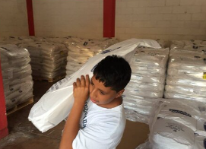
Your help is needed, as we prepare to purchase whole powdered milk for the children of Casa Hogar and other surrounding orphanages in Peru. We are $32,000 short of funding to purchase a full shipping container, which is 800 bags of milk (we currently have enough for 500 bags). Please consider donating by visiting frjoesguild.org/donate/ or scanning the QR code on the right. Select “Project Milk” from the designation menu. If you prefer to donate by mail, scroll down that webpage for instructions, and write “Project Milk” on the memo line of your check. The Children of Casa Hogar and the members of the Rural Life Committee thank you!

For Your Parish Bulletin:
Abby Johnson Speaking at April 13 DCCW Convention in La Crosse
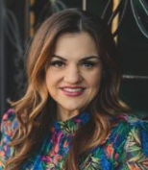
You are invited to come hear pro-life leader Abby Johnson at the Radisson Hotel in La Crosse on Saturday, April 13, at the La Crosse Diocesan Council of Catholic Women (DCCW) Biennial Convention. Abby was a Planned Parenthood director before undergoing a profound conversion in 2009, when she witnessed an ultrasound-guided abortion. Her story was portrayed in the major 2019 film Unplanned. To learn more and to register, visit dccw.org, or scan the QR code to the right.

<<Top >>

Director: Jeff Reiter – 608.791.2653 | jreiter@diolc.org

Inspired By The Spirit and Diocesan Annual Appeal:
We have become aware that parishes are again making and using copies of the pledge form. These are parish-specific, and for our electronic banking and gift-scanning process, the pledge form must meet particular specifications regarding size and QR location to be more efficient. Meeting these specifications helps keep costs down and ensures the correct parish and supporter get credit for that gift.
If you need more pledge forms, please contact Sarah Komperud at skomperud@diolc.org; we will order more. Please allow 14 days for delivery. If you have any questions or concerns, please do not hesitate to contact our office.
(Reminder) Diocesan Annual Appeal:
The next scheduled mailing will be our Holy Week mailing. The Holy Week Mailing will include:
- Parishes over goal: we will mail those who gave in the last two years (2021 & 2022) but have yet to give this year (LYBUNTS and SYBUNTS).
- Parishes under goal will have all those who still need to support the DAA mailed (LYBUNTS, SYBUNTS, and Never/New).
Final Reminder If a parish wishes to include a letter from the Pastor and/or Finance Council, the due date to receive those letters in the Stewardship Office is March 5, 2024. Please be sure the letter is in Word format and includes the parish number in the file name.
What is Stewardship?
Sometimes, the best way to explain something is to say what it isn’t.
Stewardship is not…
- All about money.
  - The central point of stewardship is growing in friendship with the Holy Trinity and each other. It’s about growing in a relationship and helping each other reach Heaven!
- A campaign or a program.
  - Stewardship is a lifestyle. It is living a virtuous life of gratitude and generosity on our path to growing in holiness. Stewardship is a fruit of our discipleship that leads to evangelization – helping disciples become disciple-makers.
- Self-centered.
  - Seeing God as the source of all good things reminds us that we are His children, made in His image and likeness. Seeing others as God’s children helps us become Christ-centered.
- Something the Church recently made up.
  - Stewardship is not a fad. It comes directly from the Bible. It’s how God expected His people to live since the beginning. Stewardship helps us from putting other “gods” before God.
- About comparing myself to others.
  - Stewardship is about comparing myself to myself. How am I becoming a better version of myself each day? Am I using my gifts as God intended and not worrying about what others think?
- About doing the bare minimum required.
  - When our discipleship evolves from obligation to love, we attend Mass not because we have to but because we want to. That’s how it is with love; you want to spend more time with the other person.
- Results-oriented.
  - Getting more people to Mass, getting more volunteers, or increasing offertory are good secondary stewardship goals, but if our actions don’t lead people to God, they are not worth doing.
- Random acts of kindness.
  - Stewardship is intentional. It is rooted in love, not random, with no strings attached. Stewardship takes time. Stewardship means investing in others and the Holy Trinity.
- About the “what.”
  - The busyness of the “what” in parish activities may lead to anxiety, frustration, and anger that can cause people to move away from God. Focus on the “why” – growing closer to Christ. God calls us to be obedient and faithful, not perfect.
- Fund-raising.
  - Stewardship is giving from our “first fruits” – our first and best without expecting anything in return. Through our giving, we unite our sacrifice with Jesus to do the will of God, the Father.
- Something I do on my own.
  - God has given each of us gifts. How we use those gifts is our gift back to God. No gift is too small or insignificant. Stewardship transforms not only our own lives but the lives of our diocesan and parish communities.
Weekly Stewardship Quotes (shorter bulletin reflections):
January - March 2024
- diolc.org/wp-content/uploads/2023/12/Stewardship-Reflections-Jan-March-2024.docx
  - Spanish Version
diolc.org/wp-content/uploads/2023/12/Stewardship-Reflections-Jan-March-2024-Spanish.docx
Weekly Stewardship Prayers of the Faithful:
January - March 2024
- diolc.org/wp-content/uploads/2023/12/Stewardship-Prayers-of-the-Faithful-Jan-March-2024.docx
  - Spanish Version
diolc.org/wp-content/uploads/2023/12/Stewardship-Prayers-of-the-Faithful-Jan-March-2024-Spanish.docx
Stewardship Bulletin Reflections for Weekends:
- 03/03/24
diolc.org/wp-content/uploads/2024/02/03.03.24-stewardship-bulletin-announcements.pdf
- 03/10/24
https://diolc.org/wp-content/uploads/2024/02/03.10.24-stewardship-bulletin-announcements.pdf
- 03/17/24
https://diolc.org/wp-content/uploads/2024/02/03.17.24-stewardship-bulletin-announcements.pdf
- 03/24
https://diolc.org/wp-content/uploads/2024/02/03.24.24-stewardship-bulletin-announcements.pdf

Stewardship Homily Reflections:
Stewardship reflections for your homily development:
- For Weeks 03/03/24 - 03/17/24
https://diolc.org/wp-content/uploads/2024/02/Homily-Guide-02.27.24.pdf
Planned Giving – Leaving a Legacy, Wills, Bequest, and Endowments:
We have been entrusted with precious treasures passed down from our ancestors, and it's our responsibility to ensure that future generations can also enjoy the splendor and reverence of a well-maintained parish. One way to achieve this is by utilizing the Capital Campaign and providing information on Endowments, Trusts, and Bequests to the parishioners.
Our Estate Planning Guide can help save hundreds of dollars in legal and financial estate planning costs. We have mailed out several hundred copies per individual request, and each Parish has received a copy. Please feel free to contact our office for additional copies.
Visit diolclegacy.org, our Planned Giving website, to find calculators and more information, sign up for a newsletter, and request specific estate planning guides and information. Our website also provides instructions on how to do an IRA Rollover, the creation of Donor Advised Funds (DAF), Beneficiary Designations, and Stock Transfers. diolclegacy.org/?pageID=5
Please contact Jeff Reiter at jreiter@diolc.org for more information on legacy giving, presentations, or ads for your Parish bulletin.
<<Top >>

Diocesan Finance Officer: James Reider – 608.791.2668 | jreider@diolc.org

No items this week.

<<Top >>

Director of Vocation Recruitment: Fr. Nate Kuhn – 608.791.2666 | nkuhn@diolc.org

Please Include the Following Intercession for Vocations for your Sunday Prayers of the Faithful:
For a strengthening of all vocations, that we may all strive to follow God's call to holiness.
Consider Adding a Vocations Paragraph to Your Parish Bulletin:
Below is an example – they will be changed each week. Feel free to use any or all of them.
What Are You Looking For?
The first question that Jesus asks in John’s Gospel is, “What are you looking for?” He is speaking to John’s disciples as they follow after Him, desiring to know who Jesus is and what His mission is all about. After the disciples respond, Jesus instructs them, “Come and you will see!” Whether we can hear it or not, that same question is being asked to you. What are YOU looking for? So often, we find ourselves searching, not knowing exactly where to go or what to do in life. We seek things that will hopefully fill the emptiness and longing that we have in our hearts, but nothing seems to satisfy them. The real answer to this can be found in Jesus’ response as He invites each of us to follow after Him, to get to know Him, and to follow the path He has placed before us. For some men, that path is a very special invitation to walk in Jesus’ footsteps as a priest. If you or someone you know is interested in discovering more about this call to the priesthood, please contact me at: Fr. Nate Kuhn, Director of Vocational Recruitment for the Diocese of La Crosse, 3710 East Ave. S. PO Box 4004, La Crosse, WI 54602; or by phone at: (608) 791.2667. God bless you!
<<Top >>

Director: Very Rev. Woodrow H. Pace – 608.791.2689 | wpace@diolc.org

(Reminder) Annual Priest Retreat |April 22-26| Redemptorist Retreat Center, Oconomowoc
This retreat is required for priests in their first five years following ordination and is an option for the annual canonical retreat for all other priests serving in the diocese. Speaker for the Priest Retreat is Fr. Bob Thorn. There is no cost for the retreat outside of what is deducted from each participant’s Continuing Ed Fund. The retreat is scheduled during the Fourth Week of Easter, Monday noon through Friday, April 22-26, 2024, ending with the final Mass before lunch. Please register at this link: Annual Priest Retreat. Add 1 registrant to the form and please supply the information requested in the drop-down menu. If there are no dietary restrictions, please enter “none.” If you want the room reserved beyond the retreat days, let us know. Please contact the Office of the Vicar for Clergy if you have any questions, at 608.791.2689.

<<Top >>

Director: Christopher Rogers – 608.791.2659 | crogers@diolc.org

Family Camp:
There will be a Family Camp that will take place at Crosswoods Camp in Mason, WI. The cost is $350 for a family of four with an additional $30 for each person above that number. It starts on Friday afternoon to early evening and ends on Sunday at noon. Will be taking the families on adventures and also including family-style meals as well as arts and crafts, prayer, faith talks, family time, bonfires, Mass and great fellowship! Please contact Cheryl Kauffer at goshawkcpk@gmail.com for more information.

Adventure Camp:
We will have two weeks for your group to choose from. Week 1: June 23-28, 2024 and Week 2: July 7-12, 2024. These two weeks are for youth in grades 6-12. The cost is $430 per person (including adults) for an early bird registration (registered before June 10, 2024). Regular price after June 10, 2024 rises to $450 per person (including adults). For more information, including a downloadable poster and registration link, click here: diolc.org/yya/youth-opportunities/adventure-camp/.

There will also be a STOW-Away week for high school students. The dates are July 28-31, 2024. The cost is $295 plus any parish fees. Please contact Chris Rogers if you are interested in participating in the STOW-Away Camp.

(Reminder) For Your Parish Bulletin:
Exciting Update about “the ANSWER” Eucharistic Rally!
Perhaps the most exciting thing happening regarding this rally is that ticket requests have been rolling in. We are grateful to all who have registered so far. We recently received word that Bishop Robert Barron from the Diocese of Winona-Rochester and Founder of Word on Fire Ministries will be the homilist at the Mass that day. We are also excited to announce the organizations, schools, and ministries that are helping to sponsor this event. Thank you to the Franciscan Sisters of Perpetual Adoration, FOCUS, EWTN, Viterbo University, Saint Mary’s University, the Diocesan Council of Catholic Women, Pioneer Catholic, and Crosswoods Camp! Don’t miss this amazing day! The registration link is found at the following link or by using your smartphone’s camera to scan the QR code to the right. diolc.org/the-answer/ (You can also paste this QR code into your bulletin for fast parishioner use.)

<<Top >>

Diocese of La Crosse | 3710 East Ave S | La Crosse, WI 54601 | 608-788-7700
To unsubscribe from this e-mail message contact mwilson@diolc.org

