Chancery Bulletin - Vol. 9, No. 3.2 | March 12, 2024

- Catechesis & Evangelization  - Chancery  - Communications  - Consecrated Life  - Diaconate  - Marriage & Family Life  - Ministries  - Mission Office  - Sacred Worship | - Safe Environment  - Schools Office  - Social Concerns  - Stewardship and Development  - Temporalities  - Vocations  - Vicar for Clergy  - Youth and Young Adult Ministry  - Past Chancery Bulletins
No items this week.

<<Top >>

Chancellor Very Rev. William Dhein – 608.791.2655 | wdhein@diolc.org

No items this week.

<<Top >>

As of March 12

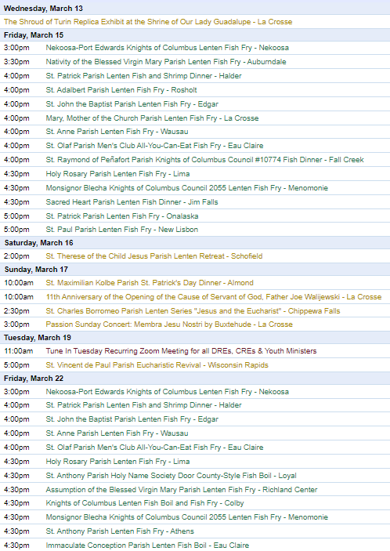
To have your parish events listed on the diocesan calendar, diolc.org/calendar, and in Catholic Life magazine, please email datebook@diolc.org. Make sure you include the following details: date, beginning/ending times, event location, description, menu and cost, etc. If you have any questions, please call Pam Willer at 608.788.1524 for more information.

<<Top >>

Director: Ann Lankford – 608.791.2658 | alankford@diolc.org
Bulletin Insert: Holy Week Schedule with boxes for Parish times
A brief explanation of each day of Holy Week that includes fillable boxes with fillable parish service times fare located here: diolc.org/catechesis/bulletin-inserts
Easter Pew Card:
An Easter Pew Card is provided so each parish may ask visitors to provide their contact info. This is an excellent opportunity to contact them, welcome them (or welcome them back) to the parish, and assist them in becoming engaged in parish life.
Visit diolc.org/catechesis/bulletin-inserts
Bulletin Announcements:
(Reminder) Biggest Event for the Diocese of La Crosse on June 7
Do you need to be inspired regarding your Catholic faith? Then the Answer Eucharistic Rally is for you! Chris Stefanick is an internationally acclaimed author, speaker, and television host who has devoted his life to inspiring people to live a bold, contagious faith. Chris will present on Friday, June 7 at the La Crosse Center. Come and bring a friend with you to enjoy this beautiful opportunity. Visit diolc.org/the-answer or use your smartphone’s camera to scan the QR code to the right for more information. You won’t want to miss this!
Novena for Our Country and the World:
If you are interested in being part of a worldwide call to prayer and receive spiritual nourishment and encouragement once a month, leading up to the feast of Our Lady of Guadalupe, visit novena.cardinalburke.com The novena is for the conversion of the people of the Americas to Christ through the intercession of Our Lady of Guadalupe because our world is in need of God’s grace and because Our Lady’s intercession is among the surest ways to secure it. The novena begins on March 12, but people are welcome to begin at any time. Further details may be found at novena.cardinalburke.com.
Lent: Pray the Sign of the Cross more reverently
The sign of the cross is a prayer and there is so much to this sign. To hand on the Catholic Faith as our ancestors have done, let us pray with our children at home in the morning, at mealtime and at bedtime, and especially about important decisions, beginning prayer with the sign of the cross. We must teach future generations the meaning of this most important sign. For a downloadable prayer card and teaching on the sign of the cross, visit diolc.org/deeper
A Minute with Jesus:
Jesus is the “Living Bread from Heaven.”
Jesus said, “I am the living bread that came down from Heaven; whoever eats this bread will live forever.” (John 6:51). Jesus gave this living bread for the first time to His Apostles at the Last Supper. Jesus gives this living Bread to us in Holy Communion. The living Bread is Jesus Himself.
Let’s pray this right now and every day this week: Jesus, please strengthen my faith to believe that You are the “living Bread” received in Holy Communion.
This week, read the explanation that Jesus gives that He is the “living Bread from Heaven” in John 6: 48-51
Bulletin editors: For upcoming weeks of proclamations entitled A Minute with Jesus, click here: diolc.org/eucharist/learn.
Catechetical Leader Information:
(Reminder) Free Prayer Books for Children and Booklets for Parents
The office received an amazing Christmas gift this year. The Word Among Us had to clear part of a warehouse in 30 days. They shipped current books, booklets and pamphlets to us on a semi-truck because we had placed several bulk orders with them. Will you please click on the link below and fill in the number of books you need for 2nd, 3rd and 4th Grades, as well as a booklet for parents entitled "Getting More Out of Your Child's First Communion." If each parish requests the number of books based on the current number of students in these grades, there should be enough, but this will be based on first come, first served. Click here for a picture of the books and a brief description. We hope that each Catechetical Leader will provide these for the children. Note: In the last two weeks, emails have been sent about this to all Catechetical Leaders, so many have already registered.
docs.google.com/forms/d/e/1FAIpQLSeldTqZoG0-mGQ9tTv7m-ant7cOWESV4ru7YFAnNJ18jHi_YA/viewform?usp=sf_link
<<Top >>
Director: Erik Archer– 608.791.2661 | earcher@diolc.org

Josh Rosa (Acclaimed & Nationally Renowned Musician):
Josh Rosa is one of the several internationally renowned speakers and musicians who will join us for the “ANSWER” Eucharistic Rally on June 7th. He created and shared a personal invitation, which you can find here. Please also share the QR code to the right in your bulletins to further share this heartfelt message he recorded just for us.
facebook.com/joshua.rosa2/posts/pfbid08QQavVqHed7ieKZdYjHVorfPZPqzgUWF2tJDya8UnLXvkxKa16C1L574ZbTQMtQil

Meet Our Marian Route National Eucharistic Pilgrims!:
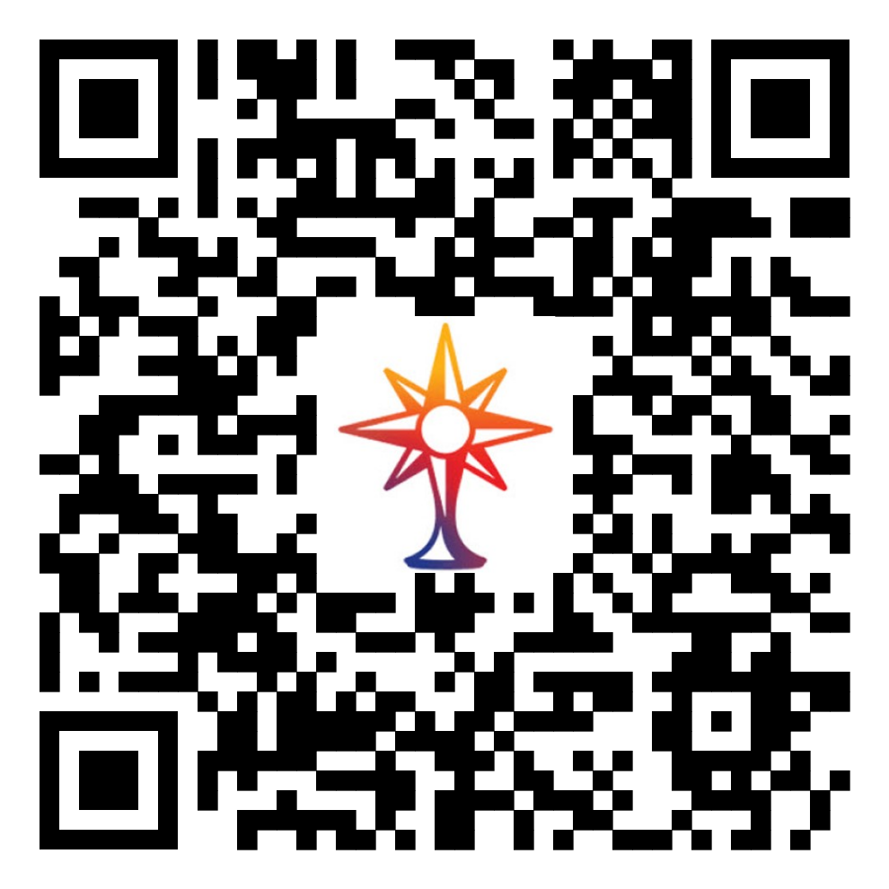
The National Eucharistic Pilgrims have been identified and their pictures, biographies and the route they are traveling are all available here: eucharisticpilgrimage.org/perpetual-pilgrims or by using your smartphone’s camera to scan the QR code to the right. Please consider adding this to your bulletin as it helps the mind shift from the concept of a National Eucharistic Pilgrimage to the concrete and specific knowledge of who will accompany Jesus through our diocese and be present at each stop, with each parish and at every event. These are the men and women we will encounter on their journey with Christ to Indianapolis. These bios and pictures allow parishes hosting the pilgrimage to develop specific welcome products if so desired.

Corpus Christi Processions:
To assist readers in finding a local Corpus Christi procession, we would like to add details for Corpus Christi processions occurring around the diocese to our next issue of Catholic Life. Please send your parish’s procession information to Pam Willer at pwiller@diolc.org by next Monday.

Parishes, DREs & School Systems:
How do you hold on to your faith through high school and college? The National Catholic Register reported in 2018 that ~80% of Catholic college students stop practicing the faith. We produced a video that can be shared within religious education programs, young adult gatherings, a fast viewing at the start of a class or wherever the Holy Spirit leads you to share. The speaker is a young adult, a college student and someone who speaks from experience, making the clip especially engaging for our targeted audiences. The video is shareable and located here: youtube.com/watch?v=g_B4H93g7ho
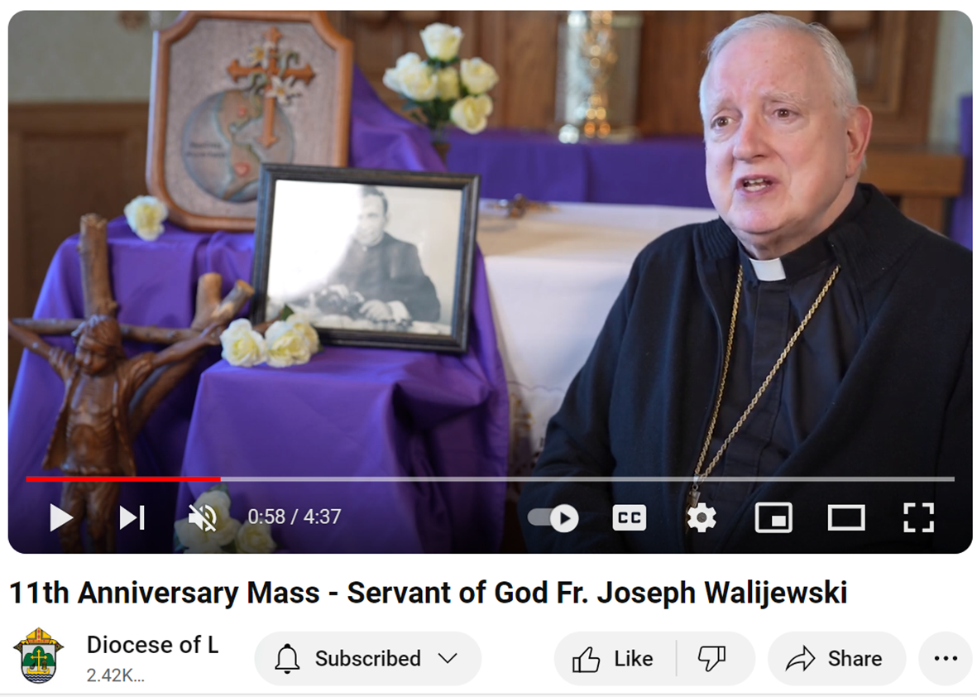
Bishop Callahan’s Father Joe 11th Anniversary Mass Message:
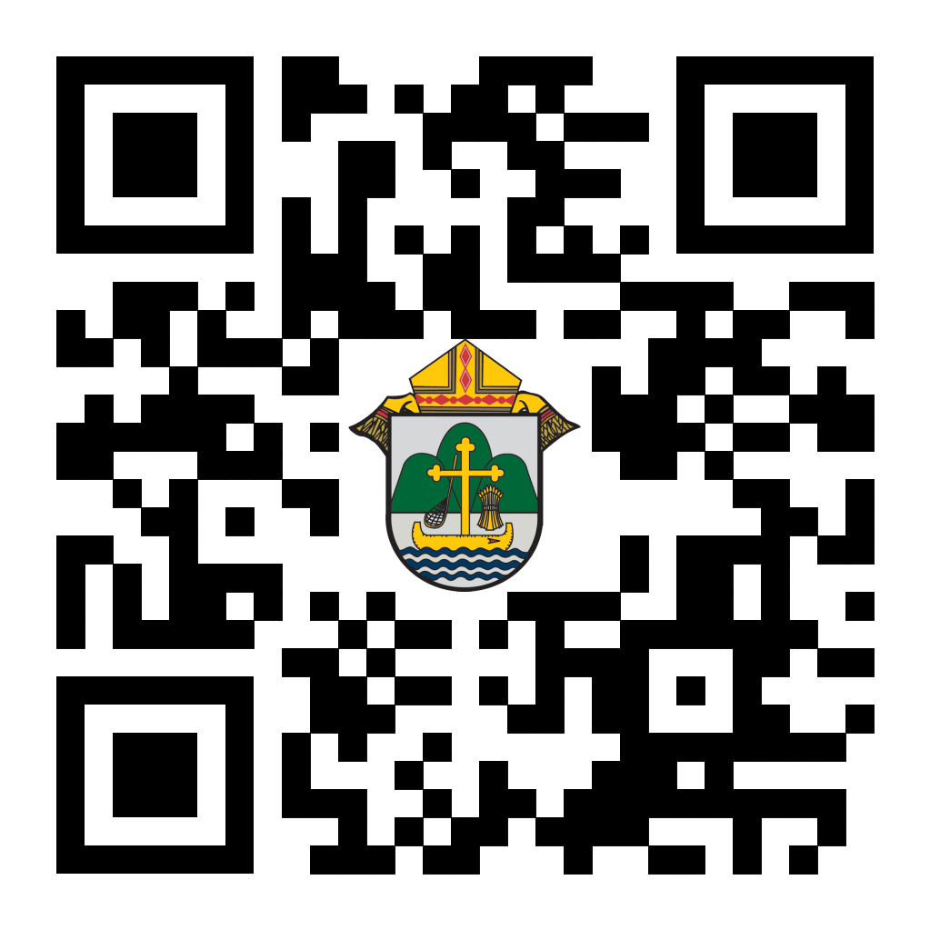
“Another servant of God followed Christ with no less zeal [than Saint Francis.]” Please share Bishop Callahan’s recently published message on your social media pages and in your bulletin. Bishop Callahan announces an invitation to Father Joe's 11th Anniversary Mass and also helps direct viewers to a site where they can submit prayer intentions. The QR code is located to the right.
Attention Pastors, Parish Administrative Assistants and Secretaries:
For those parishes who wish to have Parish Message Lines on the back cover of the May/June 2024 issue of Catholic Life magazine, please enter them by Tuesday, March 26. The May/June issue is expected to arrive in homes by approximately Wednesday, May 1. Please direct questions to Sr. Donna: dkrzmarzick@diolc.org
<<Top >>

Director: Sr. Donna Krzmarzick, ISSM – 608.791.2690 | dkrzmarzick@diolc.org

No items this week.

<<Top >>

Director: Deacon Robert Riedl – 608.791.2665 | rriedl@diolclergy.org

No items this week.

<<Top >>

Director: Christopher Rogers – 608.791.2659 | crogers@diolc.org

Worldwide Marriage Encounter Weekend:
MARRIED COUPLES: A Worldwide Marriage Encounter Weekend is like springtime. It’s a weekend of fresh air, the rebirth of romance and new beginnings. If you’d like to make your marriage even more special than it already is, sign up now at wwme.org or call Greg & Denise at 563.920.9419. Upcoming dates: April 12-14 in Epworth, Sept. 27-29 in Dubuque and Nov. 8-10 in Holstein, IA.

(Reminder) For Your Parish Bulletin:
Exciting Update about “the ANSWER” Eucharistic Rally!
Perhaps the most exciting thing about this rally is that ticket requests have been rolling in. We are grateful to all who have registered so far. We recently received word that Bishop Robert Barron from the Diocese of Winona-Rochester and Founder of Word on Fire ministries will be the homilist at the Mass that day. We are also excited to announce the organizations, schools, and ministries that are helping to sponsor this event. Thank you to the Franciscan Sisters of Perpetual Adoration, FOCUS, EWTN, Viterbo University, Saint Mary’s University, the Diocesan Council of Catholic Women, Pioneer Catholic, and Crosswoods Camp! Don’t miss this amazing day! The registration link is found at the following link, or you can scan the QR code to the right using your smartphone's camera. diolc.org/the-answer/ (You can also paste this QR code into your bulletin for fast parishioner use.)

(Reminder) For Your Parish Bulletin:
Natural Family Planning Talk |March 16|Diocesan Center in La Crosse, WI
Soon to be Dr. Ruby Gravorak will present a talk on Natural Family Planning on March 16th at 11:30 a.m. in the Diocesan Center in La Crosse, WI. This talk will be part of the Married Love 2 Becoming 1 program and all coordinators and Openness to Life presenters, as well as the public are invited to attend. Please email Chris Rogers at crogers@diolc.org if you plan to attend.
(Reminder) For Your Parish Bulletin:
Domestic Church Retreat |April 13-14|Ss. Peter and Paul Parish in Wisconsin Rapids
During the retreat, couples are invited to delve more deeply into the graces of their shared spiritual journey. The retreat aims to strengthen the couple’s spousal union and lead them to experience complete harmony and joy in their marriage through simple formation and meaningful dialogue that intentionally places Christ in the center. To register and find out more information, click this link: diolc.org/marriage/marriage-enrichment/
<<Top >>

Director: Christopher Ruff – 608.791.0161 | cruff@diolc.org

No items this week.

<<Top >>

Director: Fr. Woodrow Pace – 608.791.2676 | wpace@diolc.org

No items this week.

<<Top >>

Director: Christopher Carstens – 608.791.0161 | ccarstens@diolc.org
(Reminder) Calendar Note:
March 25, 2024 (The Annunciation of the Lord moved out of Holy Week)
From the USCCB’s Committee on Divine Worship November 2023 Newsletter
The Solemnity of the Annunciation of the Lord on March 25, 2024, is impeded by Monday of Holy Week. According to the Universal Norms on the Liturgical Year and the Calendar, no. 60, the Annunciation is therefore transferred to Monday of the Second Week of Easter, in this case, April 8, 2024.
(Reminder) Chrism Mass | March 26 | St. Joseph the Workman Cathedral La Crosse
The Chrism Mass is one of the diocesan highlights. At it, the Bishop blesses the oils for the celebration of the Sacraments of Baptism and the Anointing of the Sick and consecrates the Sacred Chrism used in the Sacraments of Confirmation and Holy Orders. Priests also renew their priestly promises at this Mass and the faithful pray for them. The Chrism Mass will be celebrated on Tuesday, March 26, at 10:30 a.m., at St. Joseph the Workman Cathedral in La Crosse. Please consider attending!
(Reminder) Easter Vigil Start Time:
Sunset in La Crosse on Saturday, March 30 is to be at 7:30 p.m. So that the Vigil may begin in darkness, 8:15 p.m. should be the earliest beginning time for the vigil.
(Reminder) Some Liturgical Reminders:
5th Sunday of Lent
In the Dioceses of the United States, the practice of covering crosses and images throughout the church from the Fifth Sunday may be observed. Crosses remain covered until the end of the Celebration of the Lord’s Passion on Good Friday, but images remain covered until the beginning of the Easter Vigil.
Mass of the Lord’s Supper:
- Altar may be decorated with flowers. (Rubric for Holy Thursday [=HT], 5)
- At the beginning of the Liturgy of the Eucharist, there may be a procession of the faithful in which gifts for the poor may be presented with the bread and wine. (HT, 14)
- Adoration is not to take place in a monstrance: “The Blessed Sacrament should be reserved in a closed tabernacle or pyx. Under no circumstances may it be exposed in a monstrance.” (Paschalis Sollemnitatis, n.55)
- Holy water stoups are emptied after Mass.
Good Friday:
- Good Friday liturgy may not be celebrated in the absence of a priest. (Rubric for Good Friday [=GF], 4)
- Only one cross may be used for adoration. (GF, 19)
Easter Vigil:
- The Paschal Candle is to be replaced each year: “The paschal candle should be prepared, which for effective symbolism must be made of wax, never be artificial, be renewed each year, be only one in number, and be of sufficiently large size so that it may evoke the truth that Christ is the light of the world.” (Paschalis Sollemnitatis, n.82)
- If a deacon is not present to carry the Paschal Candle in the procession, the candle is carried by another minister and not the priest. (Rubric for the Easter Vigil [=EV], 15 and following)
- Lights in the church building are turned on when the Paschal Candle is placed in its stand at the front of the church at the end of the entrance procession, before the Exsultet. (EV, 17)
- If possible, the Priest intones triple Alleluia. (EV, 34)
- It is appropriate for the baptism of infants to take place at the Easter Vigil. (Rite of Baptism for Children, n.9; also Roman Missal, Easter Vigil rubric n.38)
Faculties for Adult Confirmation:
Presently, a priest has the permission, either in virtue of universal Church law or by grant of the diocesan bishop, to confirm the following persons:
(a) those persons who are no longer infants and whom he baptizes (cf. Cann. 530, 1°; 566, §1; 882; 883, 2° and 885, §2; RCIA, Nos. 14, 24, 215 and 305);
(b) those persons who have attained the use of reason but already have been baptized in another church or ecclesial communion, when they are received by him into full communion with the Catholic Church (cf. Cann. 883, 2° and 885, §2; RCIA, No. 481; NSC, No. 35);
(c) the baptized Catholic who has been an apostate from the faith (cf. Can. 883, 2°; NSC, No. 28);
(d) the baptized Catholic who through no fault of his or her own has been raised in a non-Catholic religion or joined a non-Catholic religion (ibid);
(e) the baptized Catholic who through no fault of his or her own never put the faith into practice. (cf. Can. 884, §1; NSC, No. 29).
(f) those who are in danger of death (cf. Cann. 566 §1 and 883, 3°)
If, however, a priest wishes to confirm a baptized Catholic who has been practicing the faith (that is, he or she is not in the circumstances described above), permission for the faculty to do so must be requested from the diocesan bishop (Can. 882, Can. 884, §1). If you have any questions about this faculty, please call the Office of Sacred Worship at 608.791.2674.
<<Top >>

Director: Teresa Brown – 608.791.2679 | tbrown@diolc.org

DIOCESE OF LA CROSSE GUIDELINES FOR REPORTING INSTANCES OF CHILD ABUSE:
The Diocese of La Crosse, through its policies and procedures, seeks to provide a prompt, appropriate and compassionate response to reporters of sexual abuse of a child by any diocesan agent (bishop, priest, deacon, employee, religious, vendor or volunteer). Anyone wishing to make a report of an allegation of sexual abuse should send that report to Mrs. Teresa Brown, Complaint Intake Agent, at the Diocese of La Crosse, P.O. Box 4004, La Crosse, WI 54602-4004. Alternatively, you can contact Mrs. Brown at 608.791.0179 or intakeagent@diolc.org. The reporting form is available through the Diocese of La Crosse Office of Safe Environment or on the diocesan website at: diolc.org/safe-environment/reporting. Individuals are also encouraged to take their reports directly to civil authorities. Copies of the diocesan policy are available through your local Parish and on the diocesan website. If you have any questions about the Diocese of La Crosse and the implementation of the Charter for the Protection of Children and Young People, please contact Teresa Brown, Diocese of La Crosse, at 608.791.2679 or tbrown@diolc.org.

<<Top >>

Superintendent: Thomas Reichenbacher – 608.788.7707 | treichenbacher@diolc.org

No items this week.

<<Top >>

Director: Christopher Ruff – 608.791.0161 | cruff@diolc.org

For Your Parish Bulletin:
La Crosse Area Pregnancy Resource Center Networking Event |March 18 |Onalaska Public Library
Hear from representatives from Agape, New Life Resource Center, Birthright, Hope's Door, and Catholic Charities Pregnancy Resources, who will share briefly about their organizations, followed by time for questions and networking. The event takes place from 5-6 pm at the Onalaska Public Library, 741 Oak Avenue S. in Onalaska (small snack provided).
All are welcome to attend, but this will be especially appealing to anyone working with pregnant women and families in need.

(Reminder) For Your Parish Bulletin:
Abby Johnson Speaking at April 13 DCCW Convention in La Crosse:
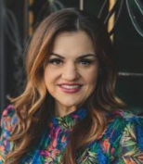
You are invited to come hear pro-life leader Abby Johnson at the Radisson Hotel in La Crosse on Saturday, April 13, at the La Crosse Diocesan Council of Catholic Women (DCCW) Biennial Convention. Abby was a Planned Parenthood director before undergoing a profound conversion in 2009, when she witnessed an ultrasound-guided abortion. Her story was portrayed in the major 2019 film Unplanned. To learn more and to register, visit ldccw.org, or scan the QR code to the right.

(Reminder) For Your Parish Bulletin:
Chalice of Mercy is in Ukraine, Needs Our Help:
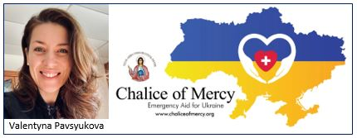
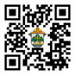
Please donate to the Ukrainian relief efforts of Chalice of Mercy if you are able, and pray for the safety of Valentyna Pavsyukova and the other volunteers on the ground there, who put their lives at risk. Financial assistance is the biggest need at this time. To give, visit chaliceofmercy.org/donate or use your smartphone’s camera to scan the QR code to the right.

For Your Parish Bulletin:
“Six Tips for Talking to ‘Pro-Choice People’ (What We’ve Learned from Talking to More than 5000)” |April 27 |St. James Parish, La Crosse:
Come to a pro-life breakfast and talk featuring Emily Geiger, Director of Education & Outreach for the Equal Rights Institute (ERI). Emily is the former Co-President of Oles for Life at St. Olaf College, where she worked to transform campus culture using ERI’s apologetics to foster respectful and productive dialogues about abortion. A sought-after speaker, Emily frequently gives talks on college campuses, in high schools, and for churches and conferences, and she regularly appears in interviews, including appearances on MSNBC, BBC Newsday, EWTN, Focus on the Family, Relevant Radio, and Christianity Today. To learn more and to register, visit diolc.org/respect-life or scan the QR code to the right.

Tell Congress! Tiny preborn lives are at stake:
From a USCCB Letter to Congress: "The often-painful experience of infertility is a challenge facing an increasing number of families…. We can understand the profound desire that motivates some of these couples to go to great lengths to have children, and we support morally licit means of doing so. The solution, however, can never be a medical process that involves the creation of countless preborn children and results in most of them being frozen or discarded and destroyed.” To learn more, and to make your voice heard on this and other action alerts, visit votervoice.net/USCCB/home or scan the QR code to the right.

<<Top >>

Director: Jeff Reiter – 608.791.2653 | jreiter@diolc.org
Inspired By The Spirit and Diocesan Annual Appeal:
We have become aware that parishes are again making and using copies of the pledge form. These are parish-specific, and for our electronic banking and gift-scanning process, the pledge form must meet particular specifications regarding size and QR location to be more efficient. Meeting these specifications helps keep costs down and ensures the correct parish and supporter get credit for that gift.
If you need more pledge forms, please contact Sarah Komperud at skomperud@diolc.org; we will order more. Please allow 14 days for delivery. If you have any questions or concerns, please do not hesitate to contact our office.
(Reminder) What is Stewardship?
Sometimes, the best way to explain something is to say what it isn’t.
Stewardship is not…
- All about money.
  - The central point of stewardship is growing in friendship with the Holy Trinity and each other. It’s about growing in a relationship and helping each other reach Heaven!
- A campaign or a program.
  - Stewardship is a lifestyle. It is living a virtuous life of gratitude and generosity on our path to growing in holiness. Stewardship is a fruit of our discipleship that leads to evangelization – helping disciples become disciple-makers.
- Self-centered.
  - Seeing God as the source of all good things reminds us that we are His children, made in His image and likeness. Seeing others as God’s children helps us become Christ-centered.
- Something the Church recently made up.
  - Stewardship is not a fad. It comes directly from the Bible. It’s how God expected His people to live since the beginning. Stewardship helps us from putting other “gods” before God.
- About comparing myself to others.
  - Stewardship is about comparing myself to myself. How am I becoming a better version of myself each day? Am I using my gifts as God intended and not worrying about what others think?
- About doing the bare minimum required.
  - When our discipleship evolves from obligation to love, we attend Mass not because we have to but because we want to. That’s how it is with love; you want to spend more time with the other person.
- Results-oriented.
  - Getting more people to Mass, getting more volunteers, or increasing offertory are good secondary stewardship goals, but if our actions don’t lead people to God, they are not worth doing.
- Random acts of kindness.
  - Stewardship is intentional. It is rooted in love, not random, with no strings attached. Stewardship takes time. Stewardship means investing in others and the Holy Trinity.
- About the “what.”
  - The busyness of the “what” in parish activities may lead to anxiety, frustration, and anger that can cause people to move away from God. Focus on the “why” – growing closer to Christ. God calls us to be obedient and faithful, not perfect.
- Fund-raising.
  - Stewardship is giving from our “first fruits” – our first and best without expecting anything in return. Through our giving, we unite our sacrifice with Jesus to do the will of God, the Father.
- Something I do on my own.
  - God has given each of us gifts. How we use those gifts is our gift back to God. No gift is too small or insignificant. Stewardship transforms not only our own lives but the lives of our diocesan and parish communities.
Weekly Stewardship Quotes (shorter bulletin reflections):
January - March 2024
- diolc.org/wp-content/uploads/2023/12/Stewardship-Reflections-Jan-March-2024.docx
  - Spanish Version
diolc.org/wp-content/uploads/2023/12/Stewardship-Reflections-Jan-March-2024-Spanish.docx
April - June 2024
- diolc.org/wp-content/uploads/2024/02/Stewardship-Bulletin-Reflections-April-June-2024.docx
  - Spanish Version
diolc.org/wp-content/uploads/2024/02/Stewardship-Bulletin-Reflections-April-June-2024-Spanish.docx
Weekly Stewardship Prayers of the Faithful:
January - March 2024
- diolc.org/wp-content/uploads/2023/12/Stewardship-Prayers-of-the-Faithful-Jan-March-2024.docx
  - Spanish Version
diolc.org/wp-content/uploads/2023/12/Stewardship-Prayers-of-the-Faithful-Jan-March-2024-Spanish.docx
April - June 2024
- diolc.org/wp-content/uploads/2024/02/Stewardship-Prayers-of-the-Faithful-April-June-2024.docx
  - Spanish Version
diolc.org/wp-content/uploads/2024/02/Stewardship-Prayers-of-the-Faithful-April-June-2024-Spanish.docx
Stewardship Bulletin Reflections for Weekends:
- 03/17/24
diolc.org/wp-content/uploads/2024/02/03.17.24-stewardship-bulletin-announcements.pdf
- 03/24/24
diolc.org/wp-content/uploads/2024/02/03.24.24-stewardship-bulletin-announcements.pdf
- 03/31/24
diolc.org/wp-content/uploads/2024/02/03.31.24-stewardship-bulletin-announcements.pdf
- 04/07/24
diolc.org/wp-content/uploads/2024/03/04.07.24-stewardship-bulletin-announcements.pdf

Stewardship Homily Reflections:
Stewardship reflections for your homily development:
- For Weeks 03/17/24 - 4/07/24
diolc.org/wp-content/uploads/2024/03/Homily-Guide-03.12.24.pdf
Planned Giving – Leaving a Legacy, Wills, Bequest, and Endowments:
We have been entrusted with precious treasures passed down from our ancestors, and it's our responsibility to ensure that future generations can also enjoy the splendor and reverence of a well-maintained parish. One way to achieve this is by utilizing the Capital Campaign and providing information on Endowments, Trusts, and Bequests to the parishioners.
Our Estate Planning Guide can help save hundreds of dollars in legal and financial estate planning costs. We have mailed out several hundred copies per individual request, and each Parish has received a copy. Please feel free to contact our office for additional copies.
Visit diolclegacy.org, our Planned Giving website, to find calculators and more information, sign up for a newsletter, and request specific estate planning guides and information. Our website also provides instructions on how to do an IRA Rollover, the creation of Donor Advised Funds (DAF), Beneficiary Designations, and Stock Transfers. diolclegacy.org/?pageID=5
Please contact Jeff Reiter at jreiter@diolc.org for more information on legacy giving, presentations, or ads for your Parish bulletin.
<<Top >>

Diocesan Finance Officer: James Reider – 608.791.2668 | jreider@diolc.org

No items this week.

<<Top >>

Director of Vocation Recruitment: Fr. Nate Kuhn – 608.791.2666 | nkuhn@diolc.org

Please Include the Following Intercession for Vocations for your Sunday Prayers of the Faithful:
For an increase in vocations to marriage, blessed single life, the Priesthood, and Consecrated Life, especially that more young men and women will have the courage to follow a call from God to serve in the Church.

Consider Adding a Vocations Paragraph to Your Parish Bulletin:
Below is an example – they will be changed each week. Feel free to use any or all of them.
How does God speak to me?
Have you ever wondered how God may be speaking to you? Perhaps you are waiting to hear a loud, booming voice come from the heavens to tell you what to do or which way to go. While this isn’t completely out of the question, often God takes a much subtler approach. In 1 Kings, we have the account of the Prophet Elijah standing at the cave entrance, waiting for the Lord to appear. As he waits, he encounters a strong, violent wind, a powerful earthquake, and a consuming fire, yet God was not revealing Himself in any of those powerful examples. Finally, as Elijah waited, he heard a soft, quiet whisper. At that, he knelt to the ground and prayed. God often speaks to us, not in grand and impressive ways, but in the silence. When we can still our hearts, that’s when we begin to hear His voice, calling us into relationship and to follow Him. Sometimes that invitation is to follow the Lord as one who lovingly serves others in the priesthood. If you or someone you know is interested in discovering more about this call to the priesthood, please contact me at: Fr. Nate Kuhn, Director of Vocational Recruitment for the Diocese of La Crosse, 3710 East Ave. S. PO Box 4004, La Crosse, WI 54602; or by phone at: 608.791.2667. God bless you!
<<Top >>

Director: Very Rev. Woodrow H. Pace – 608.791.2689 | wpace@diolc.org

No items this week.

<<Top >>

Director: Christopher Rogers – 608.791.2659 | crogers@diolc.org

Family Camp:
A family Camp will take place at Crosswoods Camp in Mason, WI. The cost is $350 for a family of four, with an additional $30 for each person above that number. It starts on Friday afternoon to early evening and ends on Sunday at noon. The camp will take the families on adventures and include family-style meals, arts and crafts, prayer, faith talks, family time, bonfires, Mass, and great fellowship! Please contact Cheryl Kauffer at goshawkcpk@gmail.com for more information.

Adventure Camp:
We will have two weeks for your group to choose from. Week 1: June 23-28, 2024 and Week 2: July 7-12, 2024. These two weeks are for youth in grades 6-12. The cost is $430 per person (including adults) for an early bird registration (registered before June 10, 2024). The regular price after June 10, 2024, rises to $450 per person (including adults). For more information, including a downloadable poster and registration link, click here: diolc.org/yya/youth-opportunities/adventure-camp/.

There will also be a STOW-Away week for high school students. The dates are July 28-31, 2024. The cost is $295 plus any parish fees. Please contact Chris Rogers if you are interested in participating in the STOW-Away Camp.

(Reminder) For Your Parish Bulletin:
Exciting Update about “the ANSWER” Eucharistic Rally!
Perhaps the most exciting thing happening regarding this rally is that ticket requests have been rolling in. We are grateful to all who have registered so far. We recently received word that Bishop Robert Barron from the Diocese of Winona-Rochester and Founder of Word on Fire Ministries will be the homilist at the Mass that day. We are also excited to announce the organizations, schools, and ministries that are helping to sponsor this event. Thank you to the Franciscan Sisters of Perpetual Adoration, FOCUS, EWTN, Viterbo University, Saint Mary’s University, the Diocesan Council of Catholic Women, Pioneer Catholic, and Crosswoods Camp! Don’t miss this amazing day! The registration link is found at the following link, or you can scan the QR code to the right using your smartphone's camera. diolc.org/the-answer/ (You can also paste this QR code into your bulletin for fast parishioner use.)

<<Top >>

Diocese of La Crosse | 3710 East Ave S | La Crosse, WI 54601 | 608.788.7700
To unsubscribe from this e-mail message contact mwilson@diolc.org

