Chancery Bulletin - Vol. 9, No. 3.3 | March 19, 2024

- Catechesis & Evangelization  - Chancery  - Communications  - Consecrated Life  - Diaconate  - Marriage & Family Life  - Ministries  - Mission Office  - Sacred Worship | - Safe Environment  - Schools Office  - Social Concerns  - Stewardship and Development  - Temporalities  - Vocations  - Vicar for Clergy  - Youth and Young Adult Ministry  - Past Chancery Bulletins
A Note From Bishop William Patrick Callahan

May the Lord give you peace.

I write to inform you that at 10:30 am today, I will host a press conference at the Holy Cross Diocesan Center to announce that His Holiness, Pope Francis, has accepted my retirement request. I have enjoyed my time with all of you in my service to the Diocese and extend my gratitude for your support while I served as your Bishop. I will maintain a residence at the Diocesan Center and hope to assist as I continue as your Emeritus Bishop.

It is with joy that I also share with you that at this same press conference, I will introduce Bishop Gerard W. Battersby as my successor. Bishop Battersby will be installed as the 11th Bishop of the Diocese of La Crosse on 20 May 2024.

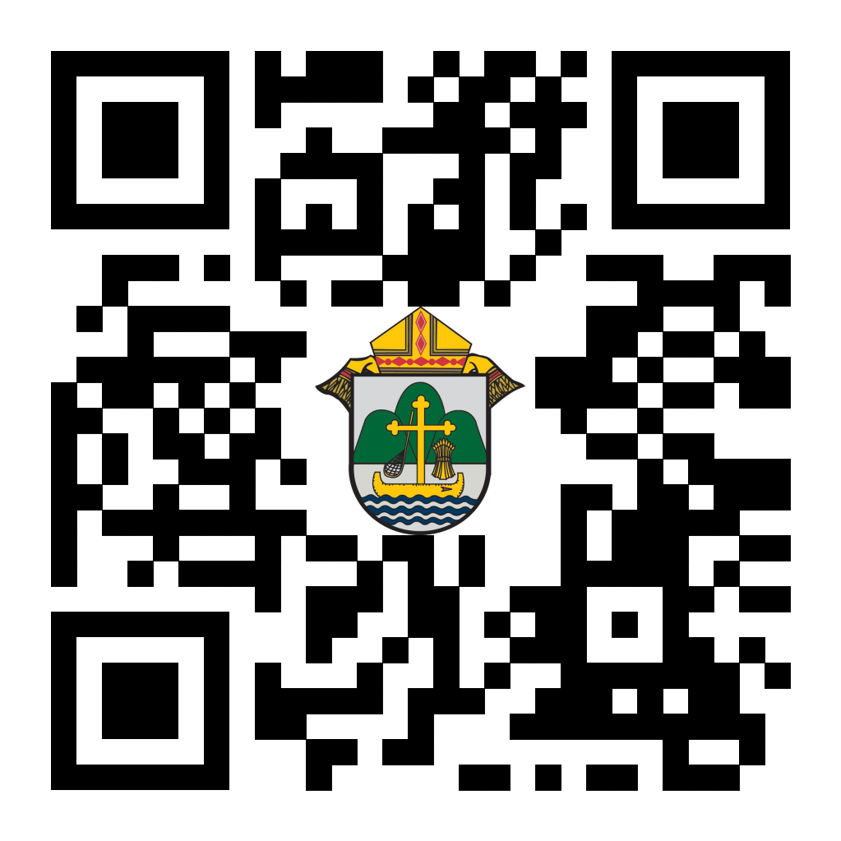
I extend my personal invitation to all of you to attend the press conference in person or via live-stream.

With personal good wishes and prayers, I am,

Very truly yours in Christ,

Bishop William Patrick Callahan

(Press Conference Link: diolc.org/live or accessible using QR code to the right)

<<Top >>

Chancellor Very Rev. William Dhein – 608.791.2655 | wdhein@diolc.org

No items this week.

<<Top >>

As of March 19
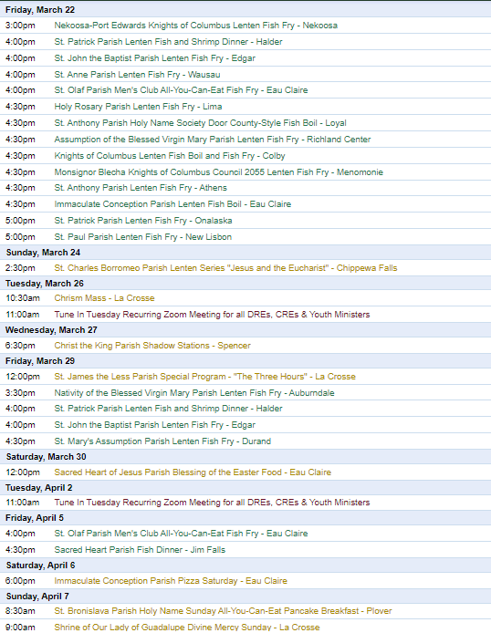
To have your parish events listed on the diocesan calendar, diolc.org/calendar, and in Catholic Life magazine, please send an email to datebook@diolc.org. Make sure you include the following details: date, beginning/ending times, event location, description, menu and cost, etc. If you have any questions, please call Pam Willer at 608.788.1524 for more information.

<<Top >>

Director: Ann Lankford – 608.791.2658 | alankford@diolc.org
(Reminder) Bulletin Insert:
Holy Week Schedule with Boxes for Parish Times
A brief explanation of each day of Holy Week that includes fillable boxes with fillable parish service times fare located here: diolc.org/catechesis/bulletin-inserts
(Reminder) Easter Pew Card:
An Easter pew card is provided so each parish may ask visitors to provide their contact info. This is an excellent opportunity to contact them, welcome them (or welcome them back) to the parish, and assist them in becoming engaged in parish life.
Visit diolc.org/catechesis/bulletin-inserts
(Reminder) Bulletin Announcements:
Why Attend the Answer Eucharistic Rally on June 7?
“The Answer” will be a great way to grow in your knowledge and love for Jesus truly present in the Eucharist. Join others across the Diocese to hear internationally known speakers, including Bishop Barron, Chris Stefanick, Immaculée Illibagiza, Josh Roza and our own Fr. Justin Kizewski. The day will include a eucharistic procession, Mass, adoration, and confessions. Visit diolc.org/the-answer or use your smartphone’s camera to scan the QR code to the right for more information. You won’t want to miss this!
(Reminder) Novena for Our Country and the World:
If you are interested in being part of a worldwide call to prayer and receiving spiritual nourishment and encouragement once a month leading up to the feast of Our Lady of Guadalupe, visit novena.cardinalburke.com. The novena is for converting the people of the Americas to Christ through the intercession of Our Lady of Guadalupe because our world needs God’s grace and because Our Lady’s intercession is among the surest ways to secure it. The novena begins on March 12, but people are welcome to start anytime. Further details may be found at novena.cardinalburke.com.
RCIA Elect and Candidates:
The elect and candidates will want to learn and pray the Apostles’ Creed in these final days before Holy Saturday. They will also be praying the Apostles’ Creed during their baptism or renewal of baptismal promises. Visit diolc.org/deeper for a downloadable prayer card that makes the Apostles’ Creed more personal. A downloadable resource page explaining the words of the prayer is also available at the same link.
A Minute with Jesus:
Jesus Wants to Live in Our Heart Always
At the Last Supper, Jesus gave His Apostles – the first priests – the command to repeat His actions and words: to “do this in memory of Me.” The presence of Christ, by the change of bread and wine in becoming His Body and Blood, takes place by the power of Jesus’ Word and the Holy Spirit. The priest, in the role of Christ through his ordination, pronounces the words of Jesus, but their power and grace are God’s. At Mass, as the priest speaks the words of Jesus, the bread and wine become His Body and Blood by the power of the Holy Spirit. Jesus wants us to receive Him at Mass every Sunday because He wants to live in our hearts.
Let’s pray this right now and every day this week: Thank you, Jesus, for Father __________ (include the name of your priest here), who stands in for You, and thereby, we are able to receive You in Holy Communion at Mass.
This week, read the passage of Jesus instituting the Holy Eucharist at the Last Supper in Matthew 26:26-28.
Bulletin editors: For upcoming weeks of proclamations entitled A Minute with Jesus, click here: diolc.org/eucharist/learn.
Eucharistic Miracles Exhibit:
Is your parish /school or deanery interested in hosting the eucharistic miracles exhibit? Details can be found here: diolc.org/eucharist/learn Scroll down to the orange banner. There has been a great turnout at parishes that have hosted the exhibit.
DREs, CREs, and Youth Minister’s Information:
Grade-Specific Examinations of Conscience
Parishes asked our office to develop examinations of conscience appropriate for the various age levels. To do so, for grades 2-3, 4-5, 6-9 and 10-12, please visit: diolc.org/catechesis/catechist-training-resources-for-teaching/lent-resources
Effectively Responding to Transgender Beliefs | Today at 1 pm | Webinar
Dr. Mary Hasson, Director of the Person and Identity Project, will present a topic that everyone should know. This webinar will be understandable and helpful. Click here to register or scan the QR code to the right using your smartphone's camera.
What is truly forming our children?
Catechesis of the Good Shepherd is profoundly impacting our children, ages 3-12. There is nothing else that forms the mind and heart of each child who participates in knowing and loving Jesus in a deep and committed way. Training will be offered this summer at two different sites: Wisconsin Rapids and La Crosse. For further details and a brochure, visit diolc.org/catechesis/catechetical-leaders-info. If you want to sit in on a session with children, contact Ann for a parish near you.
Guidelines for First Holy Communion:
In many parishes, well-intentioned leaders want each child to have a specific role at Mass so that the children feel a greater sense of being part of the celebration. However noble this intention may be, this desire for each child “to do” something at Mass improperly forms children and is not the way to approach coming to the table of the Lord for the first time. Help your catholic school teachers and catechists to teach the proper sense of active and conscious participation in the Mass as taught by the Second Vatican Ecumenical Council. An article on “Active Participation”, which speaks to the matter at hand, is available here: diolc.org/catechesis/sacramental-prep/first-confession.
Furthermore, the reader of the Liturgy of the Word is a ministerial role. This designated role should be filled by commissioned individuals who have been properly trained to proclaim the Word of God. Avoid breaking a single reading into separate sections for several children to read. See Chapter II of “Instruction on Certain Matters to be Observed or to be Avoided Regarding the Most Holy Eucharist” at the link above.
Planning for Next Year - Excellent New Textbook Series:
An authentic catechetical renewal requires new catechetical models that help children, teachers, parents, and families discover their authentic Catholic identity and reinvigorate fruitful participation in the Church’s life and mission. Augustine Institute has developed a new Kindergarten—8th grade textbook series. The “Four Golden Catechetical Threads” are necessary to teach children and young people in the current culture. Visit wordoflifeseries.org for more information.
<<Top >>
Director: Erik Archer– 608.791.2661 | earcher@diolc.org
New Bishop - Press Release:
Our office issued a press release this morning at 6:05 am announcing that Pope Francis accepted Bishop Callahan’s request to retire and appointed Bishop Battersby as the new Bishop of the Diocese of La Crosse. We will host a press conference at 10:30 am in the Diocesan Center refectory—all are welcome. The press conference will be live-streamed at diolc.org/live and is also accessible using the QR code to the right.
(Reminder) Spring Roundtable Registration:
Our initial planning for the spring roundtables is complete, and we are grateful to our host parishes who agreed to set aside time and space for our gatherings. Thank you! We will publish an agenda shortly. Please take a moment to register and pay particular attention to the last question, which provides a space for you to share your thoughts on topics of discussion that are valuable to you and your fellow parishes. Please register here!!
(Reminder) Attention Pastors, Parish Administrative Assistants and Secretaries:
For those parishes who wish to have Parish Message Lines on the back cover of the May/June 2024 issue of Catholic Life magazine, please enter them by Tuesday, March 26. The May/June issue is expected to arrive in homes by approximately Wednesday, May 1. Please direct questions to Sr. Donna: dkrzmarzick@diolc.org
<<Top >>

Director: Sr. Donna Krzmarzick, ISSM – 608.791.2690 | dkrzmarzick@diolc.org

No items this week.

<<Top >>

Director: Deacon Robert Riedl – 608.791.2665 | rriedl@diolclergy.org

(Reminder) For Your Calendar:
May 4: Continuing Formation – La Crosse Diocesan Center
June 1: Ordination to the Diaconate – Cathedral of St Joseph the Workman in La Crosse
June 7-12: National Eucharistic Procession – Diocese of La Crosse
· Friday, June 7 – “the Answer” – Eucharistic Rally
o La Crosse Center – Downtown La Crosse
o To register and for more information use your smartphone to scan the QR code to the right or visit:
diolc.org/the-answer/ and
diolc.org/pilgrimage/
· Sunday, June 9 – Holy Hour for Deacons and Families
o SS. Peter and Paul – WI Rapids
o 4:45 p.m. - 5:45 pm with Sunday Mass to follow at 6 p.m.
o Deacons of Wisconsin Rapids Deanery will lead Holy Hour
· More details are also available on NEP Website –
eucharisticpilgrimage.org/
· Sign up on the website to stay informed!
June 22: Ordination to the Priesthood – Cathedral of St. Joseph the Workman in La Crosse
Aug. 10: Bishop’s Day with Deacons and Wives – La Crosse Diocesan Center.

<<Top >>

Director: Christopher Rogers – 608.791.2659 | crogers@diolc.org

Worldwide Marriage Encounter Weekend:
Attention Married Couples: Easter Sunday is like a Worldwide Marriage Encounter Weekend because it’s a weekend full of fresh love, rebirth, and new beginnings. All married couples deserve a richer, fuller life together! For more information, call Denise and Greg at 563-920-9419 or sign up at wwme.org/apply. Upcoming dates are April 12-14 in Epworth, IA; September 27-29 in Dubuque, IA; and November 8-10 in Holstein, IA.

(Reminder) For Your Parish Bulletin:
Exciting Update about “the ANSWER” Eucharistic Rally!
Perhaps the most exciting thing about this rally is that ticket requests have been rolling in. We are grateful to all who have registered so far. We recently received word that Bishop Robert Barron from the Diocese of Winona-Rochester and Founder of Word on Fire ministries will be the homilist at the Mass that day. We are also excited to announce the organizations, schools, and ministries helping to sponsor this event. Thank you to the Franciscan Sisters of Perpetual Adoration, FOCUS, EWTN, Viterbo University, Saint Mary's University, the Diocesan Council of Catholic Women, Pioneer Catholic, and Crosswoods Camp! Don't miss this amazing day! The registration link is found at the following link, or you can scan the QR code to the right using your smartphone's camera. diolc.org/the-answer/ (You can also paste this QR code into your bulletin for fast parishioner use.)

For Your Parish Bulletin:
(Change of Date) Natural Family Planning Talk | March 23 at 10:00 am | Diocesan Center in La Crosse, WI
Soon to be Dr. Ruby Gravorak will present a talk on Natural Family Planning on March 23rd at 10:00 am in the Diocesan Center in La Crosse, WI. This talk will be part of the Married Love 2 Becoming 1 program and all coordinators and Openness to Life presenters and the public are invited to attend. Please email Chris Rogers at crogers@diolc.org if you plan to attend.
(Reminder) For Your Parish Bulletin:
Domestic Church Retreat |April 13-14|Ss. Peter and Paul Parish in Wisconsin Rapids
During the retreat, couples are invited to delve more deeply into the graces of their shared spiritual journey. The retreat aims to strengthen the couple’s spousal union and lead them to experience complete harmony and joy in their marriage through simple formation and meaningful dialogue that intentionally places Christ in the center. To register and find out more information, click this link: diolc.org/marriage/marriage-enrichment/

<<Top >>

Director: Christopher Ruff – 608.791.0161 | cruff@diolc.org

No items this week.

<<Top >>

Director: Fr. Woodrow Pace – 608.791.2676 | wpace@diolc.org

No items this week.

<<Top >>

Director: Christopher Carstens – 608.791.0161 | ccarstens@diolc.org
(Reminder) Calendar Note:
March 25, 2024 (The Annunciation of the Lord moved out of Holy Week)
From the USCCB’s Committee on Divine Worship November 2023 Newsletter
The Solemnity of the Annunciation of the Lord on March 25, 2024, is impeded by Monday of Holy Week. According to the Universal Norms on the Liturgical Year and the Calendar, no. 60, the Annunciation is therefore transferred to Monday of the Second Week of Easter, in this case, April 8, 2024.
(Reminder) Chrism Mass | March 26 at 10:30 am |St. Joseph the Workman Cathedral in La Crosse:
The Chrism Mass is one of the diocesan highlights. At it, the Bishop blesses the oils for the celebration of the Sacraments of Baptism and the Anointing of the Sick and consecrates the Sacred Chrism used in the Sacraments of Confirmation and Holy Orders. Priests also renew their priestly promises at this Mass and the faithful pray for them. The Chrism Mass will be celebrated on Tuesday, March 26, at 10:30 am, at St. Joseph the Workman Cathedral in La Crosse. Please consider attending!
(Reminder) Liturgical Reminders:
5th Sunday of Lent
- In the Dioceses of the United States, the practice of covering crosses and images throughout the church from the Fifth Sunday may be observed. Crosses remain covered until the end of the Celebration of the Lord’s Passion on Good Friday, but images remain covered until the beginning of the Easter Vigil.
Mass of the Lord’s Supper
- The altar may be decorated with flowers. (Rubric for Holy Thursday [=HT], 5)
- At the beginning of the Liturgy of the Eucharist, there may be a procession of the faithful in which gifts for the poor may be presented with the bread and wine. (HT, 14)
- Adoration is not to take place in a monstrance: “The Blessed Sacrament should be reserved in a closed tabernacle or pyx. Under no circumstances may it be exposed in a monstrance.” (Paschalis Sollemnitatis, n.55)
- Holy water stoups are emptied after Mass.
Good Friday
- Good Friday liturgy may not be celebrated in the absence of a priest. (Rubric for Good Friday [=GF], 4)
- Only one cross may be used for adoration. (GF, 19)
Easter Vigil
- The Paschal Candle is to be replaced each year: “The paschal candle should be prepared, which for effective symbolism must be made of wax, never be artificial, be renewed each year, be only one in number, and be of sufficiently large size so that it may evoke the truth that Christ is the light of the world.” (Paschalis Sollemnitatis, n.82)
- If a deacon is not present to carry the Paschal Candle in the procession, the candle is carried by another minister and not the priest. (Rubric for the Easter Vigil [=EV], 15 and following)
- Lights in the church building are turned on when the Paschal Candle is placed in its stand at the front of the church at the end of the entrance procession, before the Exsultet. (EV, 17)
- If possible, the Priest intones triple Alleluia. (EV, 34)
- It is appropriate for the baptism of infants to take place at the Easter Vigil. (Rite of Baptism for Children, n.9; also Roman Missal, Easter Vigil rubric n.38)
(Reminder) Faculties for Adult Confirmation:
Presently, a priest has the permission, either in virtue of universal Church law or by grant of the diocesan bishop, to confirm the following persons:
(a) those persons who are no longer infants and whom he baptizes (cf. Cann. 530, 1°; 566, §1; 882; 883, 2° and 885, §2; RCIA, Nos. 14, 24, 215 and 305);
(b) those persons who have attained the use of reason but already have been baptized in another church or ecclesial communion, when they are received by him into full communion with the Catholic Church (cf. Cann. 883, 2° and 885, §2; RCIA, No. 481; NSC, No. 35);
(c) the baptized Catholic who has been an apostate from the faith (cf. Can. 883, 2°; NSC, No. 28);
(d) the baptized Catholic who through no fault of his or her own has been raised in a non-Catholic religion or joined a non-Catholic religion (ibid);
(e) the baptized Catholic who through no fault of his or her own never put the faith into practice. (cf. Can. 884, §1; NSC, No. 29).
(f) those who are in danger of death (cf. Cann. 566 §1 and 883, 3°)
If, however, a priest wishes to confirm a baptized Catholic who has been practicing the faith (that is, he or she is not in the circumstances described above), permission for the faculty to do so must be requested from the diocesan bishop (Can. 882, Can. 884, §1). If you have any questions about this faculty, please call the Office of Sacred Worship at (608) 791-2674.
<<Top >>

Director: Teresa Brown – 608.791.2679 | tbrown@diolc.org

DIOCESE OF LA CROSSE GUIDELINES FOR REPORTING INSTANCES OF CHILD ABUSE:
The Diocese of La Crosse, through its policies and procedures, seeks to provide a prompt, appropriate and compassionate response to reporters of sexual abuse of a child by any diocesan agent (bishop, priest, deacon, employee, religious, vendor, or volunteer). Anyone wishing to make a report of an allegation of sexual abuse should send that report to Mrs. Teresa Brown, Complaint Intake Agent, at the Diocese of La Crosse, P.O. Box 4004, La Crosse, WI 54602-4004. Alternatively, you can contact Mrs. Brown at 608.791.0179 or intakeagent@diolc.org. The reporting form is available through the Diocese of La Crosse Office of Safe Environment or on the diocesan website at: diolc.org/safe-environment/reporting. Individuals are also encouraged to take their reports directly to civil authorities. Copies of the diocesan policy are available through your local Parish and on the diocesan website. If you have any questions about the Diocese of La Crosse and the implementation of the Charter for the Protection of Children and Young People, please contact Teresa Brown, Diocese of La Crosse, at 608.791.2679 or tbrown@diolc.org.

(Reminder) 2023-24 Safe Environment Reports Are Past Due:
Are you one of the 35 Parishes that did not send their annual Safe Environment Report by the March 1 due date? Contact the Office of Safe Environment this week if you have not already done so to discuss your progress and expected completion date.

Four schools have not submitted their report as of March 18. If you have not already contacted Teresa with an expected due date, do so this week.
April is National Child Abuse Prevention Month:
Go Blue Day – Friday, April 5, 2024. Wear your favorite blue in honor of your commitment to preventing child abuse. Post to social media with the hashtag #EveryChildNeedsAHero.

Blue Sunday – Sunday, April 28, 2024. Honor child abuse prevention in your house of worship with these petition ideas:
- Pray that God brings an end to child abuse.
- Pray that children be taught their value and have the courage to speak out about any abuse they may be facing.
- Pray that God strengthens families, provides for their needs, and surrounds them with support and individuals who will teach and model good parenting skills.
- Pray for the victims who have come forward, to feel supported and loved as they heal from the wounds of abuse.
- Pray for strength and stamina for those who investigate and seek to eliminate child abuse in this county.
- Pray for growing openness toward collaboration and innovation in your community where the most vulnerable members are valued.
- Pray that your community be characterized by faith, hope, and love.
“ Have a heart that never hardens, and a temper that never tires and touch that never hurts”
~Charles Dickens~
Superintendent: Thomas Reichenbacher – 608.788.7707 | treichenbacher@diolc.org

No items this week.

<<Top >>

Director: Christopher Ruff – 608.791.0161 | cruff@diolc.org

(Reminder) For Your Parish Bulletin:
Abby Johnson April 13 Luncheon and Talk in La Crosse:
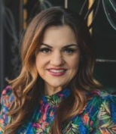
You are invited to come hear pro-life leader Abby Johnson at the Radisson Hotel in La Crosse on Saturday, April 13, sponsored by the La Crosse Diocesan Council of Catholic Women. Abby was a Planned Parenthood director before undergoing a profound conversion in 2009, when she witnessed an ultrasound-guided abortion. Her story was portrayed in the major 2019 film Unplanned. To learn more and to register, visit ldccw.org, or scan the QR code to the right.

(Reminder) For Your Parish Bulletin:
“Six Tips for Talking to ‘Pro-Choice People’ (What We’ve Learned from Talking to More than 5000)” |April 27 |St. James Parish, La Crosse
Come to a pro-life breakfast and talk featuring Emily Geiger, Director of Education & Outreach for the Equal Rights Institute (ERI). Emily is the former Co-President of Oles for Life at St. Olaf College, where she worked to transform campus culture using ERI’s apologetics to foster respectful and productive dialogues about abortion. A sought-after speaker, Emily frequently gives talks on college and high school campuses and for churches and conferences. She has also been interviewed on MSNBC, BBC Newsday, EWTN, Focus on the Family, Relevant Radio, and Christianity Today. To learn more and to register, visit diolc.org/respect-life or scan the QR code to the right.

Tell Congress! Tiny Preborn Lives Are at Stake:
From a USCCB Letter to Congress: "The often-painful experience of infertility is a challenge facing an increasing number of families…. We can understand the profound desire that motivates some of these couples to go to great lengths to have children, and we support morally licit means of doing so. The solution, however, can never be a medical process that involves the creation of countless preborn children and results in most of them being frozen or discarded and destroyed.” To learn more, and to make your voice heard on this and other action alerts, visit votervoice.net/USCCB/home or scan the QR code to the right.

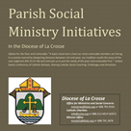
Pastors, Deacons, Parish Social Concerns Representatives:
Are Your Social Ministry Initiatives Listed in the Directory?
In order to most fruitfully address the social concerns within our diocese, we are asking the parishes to review their current social ministry initiatives (any outreach of charity or social advocacy). If these are not already listed in the diocesan Directory of Parish Social Ministry Initiatives, or if updating is needed, the pastor or someone authorized by him is asked to take a moment to complete and submit this form for each organization/resource.
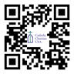
(Reminder) For Your Parish Bulletin:
Pregnant and in Distress? Confidential Help is Available
Make a confidential call to Catholic Charities at 844.644.7223 (844.64.GRACE) or text 715.600.6391. To learn more, visit cclse.org/i-think-im-pregnant. For additional pregnancy support resources and locations, visit diolc.org/pregnancy-resources.
<<Top >>

Director: Jeff Reiter – 608.791.2653 | jreiter@diolc.org
Inspired By The Spirit and Diocesan Annual Appeal:
We have become aware that parishes are again making and using copies of the pledge form. These are parish-specific, and for our electronic banking and gift-scanning process, the pledge form must meet particular specifications regarding size and QR location to be more efficient. Meeting these specifications helps keep costs down and ensures the correct parish and supporter get credit for that gift.
If you need more pledge forms, please contact Sarah Komperud at skomperud@diolc.org; we will order more. Please allow 14 days for delivery. If you have any questions or concerns, please do not hesitate to contact our office.
(Final Reminder) What is Stewardship?
Sometimes, the best way to explain something is to say what it isn’t.
Stewardship is not…
- All about money.
  - The central point of stewardship is growing in friendship with the Holy Trinity and each other. It’s about growing in a relationship and helping each other reach Heaven!
- A campaign or a program.
  - Stewardship is a lifestyle. It is living a virtuous life of gratitude and generosity on our path to growing in holiness. Stewardship is a fruit of discipleship that leads to evangelization—helping disciples become disciple-makers.
- Self-centered.
  - Seeing God as the source of all good things reminds us that we are His children, made in His image and likeness. Seeing others as God’s children helps us become Christ-centered.
- Something the Church recently made up.
  - Stewardship is not a fad. It comes directly from the Bible. It’s how God expected His people to live since the beginning. Stewardship helps us from putting other “gods” before God.
- About comparing myself to others.
  - Stewardship is about comparing myself to myself. How am I becoming a better version of myself each day? Am I using my gifts as God intended and not worrying about what others think?
- About doing the bare minimum required.
  - When our discipleship evolves from obligation to love, we attend Mass not because we have to but because we want to. That’s how it is with love; you want to spend more time with the other person.
- Results-oriented.
  - Getting more people to Mass, getting more volunteers, or increasing offertory are good secondary stewardship goals, but if our actions don’t lead people to God, they are not worth doing.
- Random acts of kindness.
  - Stewardship is intentional, rooted in love, not random, with no strings attached. It takes time and means investing in others and the Holy Trinity.
- About the “what.”
  - The busyness of the “what” in parish activities may lead to anxiety, frustration, and anger that can cause people to move away from God. Focus on the “why” – growing closer to Christ. God calls us to be obedient and faithful, not perfect.
- Fund-raising.
  - Stewardship is giving from our “first fruits” – our first and best without expecting anything in return. Through our giving, we unite our sacrifice with Jesus to do the will of God, the Father.
- Something I do on my own.
  - God has given each of us gifts. How we use those gifts is our gift back to God. No gift is too small or insignificant. Stewardship transforms not only our own lives but the lives of our diocesan and parish communities.
Weekly Stewardship Quotes (shorter bulletin reflections):
January - March 2024
- diolc.org/wp-content/uploads/2023/12/Stewardship-Reflections-Jan-March-2024.docx
  - Spanish Version
diolc.org/wp-content/uploads/2023/12/Stewardship-Reflections-Jan-March-2024-Spanish.docx
April - June 2024
- diolc.org/wp-content/uploads/2024/02/Stewardship-Bulletin-Reflections-April-June-2024.docx
  - Spanish Version
diolc.org/wp-content/uploads/2024/02/Stewardship-Bulletin-Reflections-April-June-2024-Spanish.docx
Weekly Stewardship Prayers of the Faithful:
January - March 2024
- diolc.org/wp-content/uploads/2023/12/Stewardship-Prayers-of-the-Faithful-Jan-March-2024.docx
  - Spanish Version
diolc.org/wp-content/uploads/2023/12/Stewardship-Prayers-of-the-Faithful-Jan-March-2024-Spanish.docx
April - June 2024
- diolc.org/wp-content/uploads/2024/02/Stewardship-Prayers-of-the-Faithful-April-June-2024.docx
  - Spanish Version
diolc.org/wp-content/uploads/2024/02/Stewardship-Prayers-of-the-Faithful-April-June-2024-Spanish.docx
Stewardship Bulletin Reflections for Weekends:
- 03/24/24
diolc.org/wp-content/uploads/2024/02/03.24.24-stewardship-bulletin-announcements.pdf
- 03/31/24
diolc.org/wp-content/uploads/2024/02/03.31.24-stewardship-bulletin-announcements.pdf
- 04/07/24
diolc.org/wp-content/uploads/2024/03/04.07.24-stewardship-bulletin-announcements.pdf
- 04/14/24
diolc.org/wp-content/uploads/2024/03/04.14.24-stewardship-bulletin-announcements.pdf

Stewardship Homily Reflections:
Stewardship reflections for your homily development:
- For Weeks 03/24/24 - 4/14/24
diolc.org/wp-content/uploads/2024/03/Homily-Guide-03.19.24.pdf
Planned Giving – Leaving a Legacy, Wills, Bequest, and Endowments:
We have been entrusted with precious treasures passed down from our ancestors, and it's our responsibility to ensure that future generations can also enjoy the splendor and reverence of a well-maintained parish. One way to achieve this is by utilizing the Capital Campaign and providing information on Endowments, Trusts, and Bequests to the parishioners.
Our Estate Planning Guide can help save hundreds of dollars in legal and financial estate planning costs. We have mailed out several hundred copies per individual request, and each Parish has received a copy. Please feel free to contact our office for additional copies.
Visit diolclegacy.org, our Planned Giving website, to find calculators and more information, sign up for a newsletter, and request specific estate planning guides and information. Our website also provides instructions on how to do an IRA Rollover, the creation of Donor Advised Funds (DAF), Beneficiary Designations, and Stock Transfers. diolclegacy.org/?pageID=5
Please contact Jeff Reiter at jreiter@diolc.org for more information on legacy giving, presentations, or ads for your Parish bulletin.
<<Top >>

Diocesan Finance Officer: James Reider – 608.791.2668 | jreider@diolc.org

No items this week.

<<Top >>

Director of Vocation Recruitment: Fr. Nate Kuhn – 608.791.2666 | nkuhn@diolc.org

Please Include the Following Intercession for Vocations for your Sunday Prayers of the Faithful:
Pray in thanksgiving for marriages, priests, sisters, brothers, and those who live holy single lives, who inspire and strengthen us by their witness of commitment.

Consider Adding a Vocations Paragraph to Your Parish Bulletin:
Below is an example – they will be changed each week. Feel free to use any or all of them.
Have you asked someone recently?
Do you know someone in your life that you think would make a good priest? Have you ever told them that? If not, you should! A significant, contributing factor to young men discerning the priesthood has been the invitation and encouragement they receive from others, particularly parents, teachers, mentors and role models. Don’t be afraid to tell a young man that they would make a good priest, as that may be just what they have been waiting for. Once you encourage them, don’t hesitate to put them in contact with me to continue that conversation. I can be reached at: Fr. Nate Kuhn, Director of Vocational Recruitment for the Diocese of La Crosse, 3710 East Ave. S. PO Box 4004, La Crosse, WI 54602; or by phone at: 608.791.2667. God bless you!
<<Top >>

Director: Very Rev. Woodrow H. Pace – 608.791.2689 | wpace@diolc.org

(Reminder) Annual Priest Retreat |April 22-26| Redemptorist Retreat Center, Oconomowoc
This retreat is required for priests in their first five years following ordination and is an option for the annual canonical retreat for all other priests serving in the diocese. The speaker for the Priest Retreat is Fr. Bob Thorn. There is no cost for the retreat outside of what is deducted from each participant’s Continuing Ed Fund. The retreat is scheduled during the Fourth Week of Easter, Monday noon through Friday, April 22-26, 2024, ending with the final Mass before lunch. Please register at this link: Annual Priest Retreat. Add 1 registrant to the form and please supply the information requested in the drop-down menu. If there are no dietary restrictions, please enter “none.” If you want the room reserved beyond the retreat days, let us know. Please contact the Office of the Vicar for Clergy if you have any questions, at 608.791.2689.

<<Top >>

Director: Christopher Rogers – 608.791.2659 | crogers@diolc.org

(Reminder) Family Camp:
A family Camp will take place at Crosswoods Camp in Mason, WI. The cost is $350 for a family of four, with an additional $30 for each person above that number. It starts on Friday afternoon to early evening and ends on Sunday at noon. The camp will take the families on adventures and include family-style meals, arts and crafts, prayer, faith talks, family time, bonfires, Mass, and great fellowship! Please contact Cheryl Kauffer at goshawkcpk@gmail.com for more information.

(Reminder) Adventure Camp:
We will have two weeks for your group to choose from. Week 1: June 23-28, 2024 and Week 2: July 7-12, 2024. These two weeks are for youth in grades 6-12. The cost is $430 per person (including adults) for an early bird registration (registered before June 10, 2024). After June 10, 2024, the regular price rises to $450 per person (including adults). For more information, including a downloadable poster and registration link, click here: diolc.org/yya/youth-opportunities/adventure-camp/.

There will also be a STOW-Away week for high school students from July 28 to 31, 2024. The cost is $295 plus any parish fees. Please contact Chris Rogers if you are interested in participating in the STOW-Away Camp.

(Reminder) For Your Parish Bulletin:
Exciting Update about “the ANSWER” Eucharistic Rally!
Perhaps the most exciting thing happening regarding this rally is that ticket requests have been rolling in. We are grateful to all who have registered so far. We recently received word that Bishop Robert Barron from the Diocese of Winona-Rochester and Founder of Word on Fire Ministries will be the homilist at the Mass that day. We are also excited to announce the organizations, schools, and ministries that are helping to sponsor this event. Thank you to the Franciscan Sisters of Perpetual Adoration, FOCUS, EWTN, Viterbo University, Saint Mary’s University, the Diocesan Council of Catholic Women, Pioneer Catholic, and Crosswoods Camp! Don’t miss this amazing day! The registration link is found at the following link, or you can scan the QR code to the right using your smartphone's camera. diolc.org/the-answer/ (You can also paste this QR code into your bulletin for fast parishioner use.)

<<Top >>

Diocese of La Crosse | 3710 East Ave S | La Crosse, WI 54601 | 608-788-7700
To unsubscribe from this e-mail message contact mwilson@diolc.org

