**Parish Small Group Series   
Key Sessions from the**

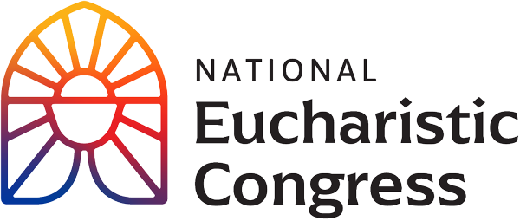

**Catch the Fire!  
Catch the Love!**

The Eucharistic Congress was held in Indianapolis in July and upward of 60,000 people participated. It is profoundly moving when we remember that this massive crowd in attendance, from all over our nation, was there for the same reason: our faith in the Real Presence of Jesus Christ in the Blessed Sacrament. There was a large contingent from our Diocese that attended, including those on the bus and those that drove themselves. The feedback continues to be that this Congress was an amazing experience, blessed by God with a palpable sense of supernatural unity that existed among the massive throng of participants.

Since the Eucharistic Congress was so outstanding, there is a feeling of responsibility and a deep desire to bring this home to fellow parishioners. Therefore, a small group series has been developed using the professional recordings of the Congress. The series allows people of the Diocese to share in this incredible event, and grow together with other, like-minded Catholics.

You are invited to participate in the *Eucharistic Congress Small Group* series that will be seven, 90-minute sessions, that are beautiful, compelling, and understandable for people at all levels of faith.The seriescenters around the Revival Sessions that were attended by all participants. The sessions are user-friendly, and free of charge.

Each session incorporates an inspiring keynote speaker with a compelling message, a short personal testimony, small group discussion and opportunities to encounter our Eucharistic Lord in prayer. The series is informative without being “academic.” It feeds both mind and heart.   
  
You won’t want to miss this!

Ann Lankford

(In a box:) Give Parish details here on date/time/location and who to contact to sign up