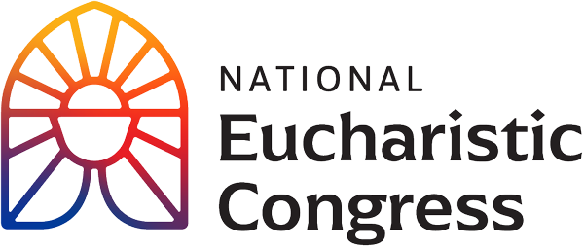

**Parish Small Groups Series**

**Catch the Fire!  
Catch the Love!**

Note: *The following text includes points for inviting parishioners to participate in this Series. Personal invitation is the best way to invite someone but email or a letter will work.*

Dear [Specific Person’s Name]:

The Eucharistic Revival is a historic and transformative national movement to help the faithful fall in love with Jesus, especially in the Eucharist, and be inspired and equipped to share that love with others. This fall, we will host parish-wide small groups using the compelling Eucharistic Congress main Revival Sessions. I am the person who is organizing this small group series for the parish.

The “Eucharistic Congress Parish Small Group Series” is 7 sessions that makes use of the professional recordings from Indianapolis The series follows the themes of the Congress and each session .

This Series will be offered on the following day(s) and time(s)

* [insert the date(s) and time(s)]

You may register for “Eucharistic Congress Parish Small Group Series”, at no cost, by:

* Visiting the parish website [insert the link]
* Emailing [insert the person’s name and email]
* Calling [provide the name(s) and phone number(s)]

If you have any questions, please let me know.

God is abundantly blessing our efforts for Revival in our country, and so many are answering Jesus’s call to grow in their understanding and love for Him truly present in the Eucharist. Please keep the Eucharistic Revival in your prayers.

Sincerely in Christ,

[Lead Organizer’s Name and phone number]

