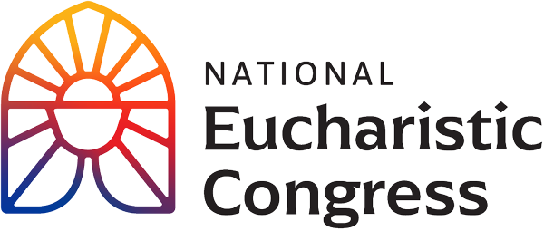

**Parish Small Groups Series**

**Catch the Fire!  
Catch the Love!**

Dear [Small Group Facilitator Name]:

The Eucharistic Revival is a historic and transformative national movement to help the faithful fall in love with Jesus, especially in the Eucharist, and be inspired and equipped to share that love with others. We will host parish-wide small groups using the videos from the National Eucharistic Congress. I am the person who is organizing this small group series for the parish.

The “Eucharistic Congress Parish Small Group” series is 7, 90 minute sessions that have been put together by the Office for Catechesis and Evangelization, Diocese of La Crosse. The series follows the themes of the Congress, which are geared toward the Year of Going Out. The series will begin on [insert the date and time] and be completed by [date].

As a facilitator of a small group associated with our parish, I am writing to invite you and your small group to join our parish-wide small group study (your small group is welcome to sit together at one of the tables) or, alternatively, to use the “Eucharistic Congress Parish Small Group” series in your small group meetings.

If you wish to use the “Eucharistic Congress Parish Small Group” study in your small group meetings, below are some additional details for your consideration:

* Each of the 7 sessions are roughly 90 minutes, using key segments from the Congress. The main Revival Sessions, where all 60,000 people attended, are the sessions that are being used for this series.
* The series includes a video and participant handout for each session free of charge, although you will have to print the participant handouts. A screen will be needed.
* The video and participant handouts are posted to diolc.org/eucharist/parishioners. You will need to have good Wi-Fi available to play the videos. The videos cannot be downloaded as the videos are posted on EWTN On Demand.
* The Facilitator Copy for each session notates in red the starting time and ending time for each segment that will be viewed. The “timer” is at the bottom of the video screen and starts in the left-hand corner. The timer is a white dot which shows the timing when the cursor is placed over the white dot. The “start” button is a triangle also at the bottom, left-hand corner of the screen. After clicking on the triangle, the video will begin playing. When you place the cursor on the bottom of the video screen, at the white button, you will see the timing for the specific point of the recording. To move the white button to the next segment of the video, simply slide the white dot using the cursor to the next timed portion of the video.
* There is no pre-work or home-work.

God desires Revival in our country and He is abundantly blessing our efforts to respond. Many are answering Jesus’s call to grow in their understanding and love for Him truly present in the Eucharist. Please keep the Eucharistic Revival in your prayers. Contact me if you have questions.

Sincerely in Christ,

[Lead Organizer’s Name]

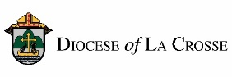*NOTE: For implementation in the Diocese of La Crosse, we have adapted these training and promotional materials for the Eucharistic Congress Parish Small Group series from those produced by the National Eucharistic Revival Team in collaboration with the Augustine Institute.*