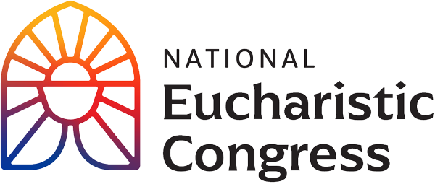

**Parish Small Groups Series**

**Catch the Fire!  
Catch the Love!**

**The Eucharist is the life of the Church.**

“The Eucharist is the source and summit of our faith. Another way to say it is the Eucharist is the heart of the Church. It’s the life of the Church. It makes the Church, as Pope St. John Paul II said. So, the Eucharistic life of the Church is strengthened as individuals come to understand *Who* the Eucharist is and how they are called them to deeper union with Jesus. That’s going to affect every area of their life. It means they go to confession more, they seek to live a moral life, they’ll be more charitable. The Eucharist is the heart of all that. It’s the means that Jesus gave us to continue His living presence among us and transform us into His Body. The Church needs to be the Body of Christ in the world. This will happen by people being more deeply drawn into the heart of the Eucharist. We are strong as a Church when we are united to the Lord in the Eucharist.” Bishop Andrew Cozzens

Session 4: **“This is My Body”**Speakers challenge us to accept our call as disciples and live the Gospel by loving God and our neighbor with all our heart.

1. **Opening Prayer**: join with Matt Maher in singing “Your grace is enough” and “Here I am Lord.” A sheet with the lyrics is included. Matt has become one of the most popular and critically acclaimed Catholic artists in the country. He has provided the Church with songs expressing God’s greatness and our need for His grace. He and his band travel worldwide throughout the year to bring their signature brand of praise and worship to audiences.
2. **Tim Glemkowski** has served as the founding CEO of the National Eucharistic Congress, Inc. Prior to this role, he served in the Archbishop’s Office for the Archdiocese of Denver as the Director of Strategy, helping to set up for a time of apostolic mission.
3. **Mark Hublar’s conversion story as told by Mark and his parents**.
4. **Sr. Miriam Heidland** provides a brief overview and then introduces **Drew Mariani who gives his personal testimony**. Drew is an award-winning journalist, writer, and broadcaster. He hosts *The Drew Mariani Show* on Relevant Radio.
5. **Gloria Purvis** is an author, commentator, and the host of The Gloria Purvis Podcast. She is a strong Catholic voice for life issues, religious liberty, and racial justice. She has presented a powerful video series entitled *Racism, Human Dignity and the Catholic Church* through the Word on Fire Institute.
6. **Group discussion**   
   -What was the most important point for you from what you have seen in this segment? Why did this seem to stand out for you? In light of this, write down something that you would want to pass on to a family member or friend?

-In light of these sessions, in what way is your friendship with Jesus being strengthened?

1. Introduction to a time of prayer by Montse Alvarado and then **prayer led by Fr. Josh Johnson** with **praise and workshop music with Matt Maher**. You are invited to join in using the **sheet** **provided**, which contains the words to the prayer and lyrics of the praise and worship music.
2. **Closing Prayer in church (if convenient)**

“Holy Spirit, come! Lead us to all truth. Grant us a faith that is not afraid to be bold. Enkindle in us a flame of hope that sets our hearts ablaze with love for You. Father, in the Name of Jesus, we ask that You would raise up saints, prophets, and martyrs to meet the needs of our day, and may we be numbered among them. Amen.”

If you would like to re-watch a segment or the entire session, visit **diolc.org/eucharist/parishioners**. Click the **Video:** July 20 Revival Session. Videos are free.