**Pastors: Please share this information with your parish secretary/bookkeeper(s)**

The only **donor information** which needs to be forwarded to the Mission Office includes **name, address, and donation amount.** Other contact information may be removed from the emailed report.

**World Mission Sunday Report directly from ParishSOFT**

***How to use ParishSOFT Contribution List to generate the World Mission Sunday donor list***

Navigate to and click on the **Offering** tab (1).

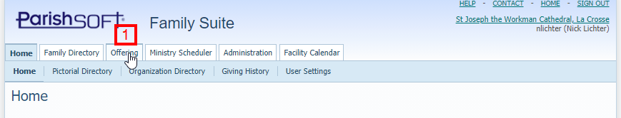

A new window opens displaying the Offering tiles, and on the left column a nested menu of navigation choices. Select Reports, or Reports -> Donor (2).

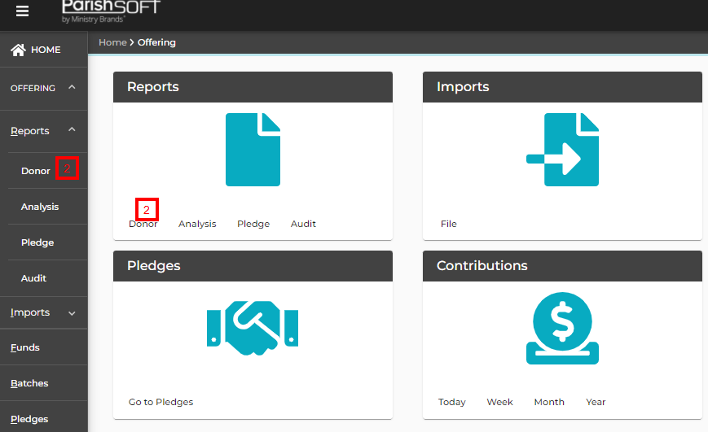

Choose the Contribution Detail Statement Report (3) from the Select a Donor Report dropdown box. Enter **Start Date 7-1-2024** and **End Date 12-31-2024** (4). Please note: the date range will depend on when you last disbursed WMS funds to the Mission Office, ending on the present date (or the end of the calendar year).

**(CONTINUED ON OTHER SIDE)**

**(CONTINUED FROM PREVIOUS PAGE)**

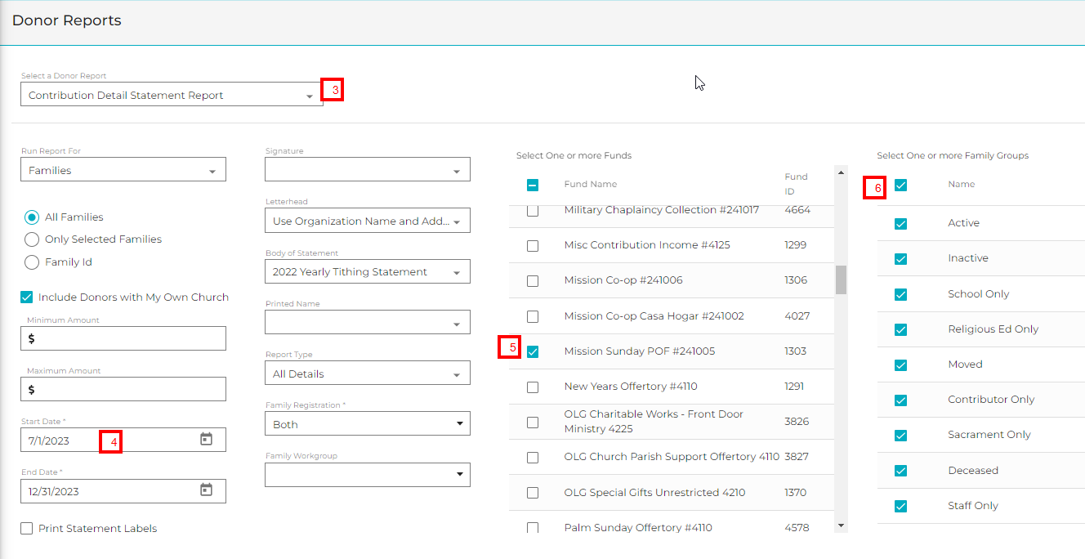

7/1/2024

12/31/2024

Next, scroll though the **Funds** column and toggle the checkbox for **Mission Sunday** (5). In the Family Group column toggle the checkbox for **Name** (6) to select all of the Family Groups.

To export and download the listing choose the **Export** icon (7) in the top left corner of the screen.

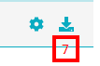

This will download an Excel or PDF file of your donors. You can open the file, check it for accuracy and then email it as an attachment to Marga Apel in the Mission Office ([mapel@diolc.org](mailto:mapel@diolc.org))

The only **donor information** which needs to be forwarded includes **name, address, and donation amount.** Other contact information may be removed from the emailed report.

**Thank you and God bless you for your extra time and efforts for the Missions! It is deeply appreciated.**