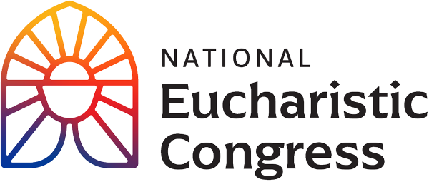

**Parish Small Groups Series**

**Catch the Fire!  
Catch the Love!**

**Hosting the Sessions**

**Materials for the Seven Sessions**  
Everything you need to run a successful small group series is found at **diolc.org/eucharist/parishioners**.  Be sure to print the handouts for each session ahead of time.  You are encouraged, well in advance of each session, to play through the video according to the allotted times as provided on the corresponding Facilitator Copy. This will allow you to become familiar with the parts of each particular session.

* + **Step 1: Access the Videos**
    - Before deciding where the sessions will be held, check the link here **diolc.org/eucharist/parishioners** and then click on July 17 Opening Ceremony to see if you have good Wi-Fi available. If not, another space will need to be found.
    - The videos cannot be downloaded as the videos are on EWTN On Demand.
    - You will have Closed Captions (CC) as an option, in the bottom right corner noted as CC. To turn them on/off, find and use the toggle option.
    - Always open the Internet link well ahead of time and open the video to be prepared for the session.
    - The main Revival Sessions, where all 60,000 people attended, are the sessions that are being used for this series. For these seven sessions, key segments have been timed out for a total of 90 minutes for each session.

**Playing the Timed Segments of the Videos**

* + - The Facilitator Copy for each session notates in red the starting time and ending time for each segment that will be viewed. The “timer” is at the bottom of the video screen and starts in the left-hand corner. The timer is a white dot which shows the timing when the cursor is placed over the white dot. The “start” button is a triangle also at the bottom, left-hand corner of the screen. After clicking on the triangle, the video will begin playing. When you place the cursor on the bottom of the video screen, at the white button, you will see the timing for the specific point of the recording. To move the white button to the next segment of the video, simply slide the white dot using the cursor to the next timed portion of the video.
  + **Step 2: Print and Place Participant Handout(s) at Tables**
    - Find the handouts for each Session by clicking here: **diolc.org/eucharist/parishioners**
    - You may print double-sided and staple when needed. For some sessions there is an additional handout that includes a Litany of Prayer or Lyrics to a song(s).
  + **Step 3: Prepare Meeting Room**
    - Tables: Tables with 6 chairs each; name tags & markers; Participant Handout; pens for note-taking.
    - Audio/Visual: Set up screen and test audio.
    - Hospitality: Water, coffee, and cookies.
  + **Step 4: Staff the Event**
    - Parish Staff on site: Greet participants as arrive & thank as leave; start video & oversee.
    - If providing childcare, make preparations.
  + **Step 5: Repeat the process for the remaining Sessions**
    - Prepare in the same fashion; thank & encourage table facilitators throughout.
    - Take the opportunity to invite participants to other parish activities/offerings.
    - Invite facilitators to help start or grow a parish small group ministry.

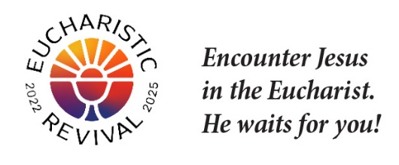

*NOTE: For implementation in the Diocese of La Crosse, we have adapted these training and promotional materials for the Eucharistic Congress Parish Small Group series from those produced by the National Eucharistic Revival Team in collaboration with the Augustine Institute.*