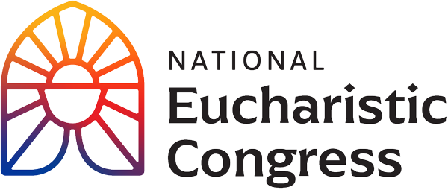

**Parish Small Groups Series**

**Catch the Fire!  
Catch the Love!**

**The Eucharist is the real and loving presence of the Lord**“In the Eucharist, we encounter the One Who gave everything for us, Who sacrificed Himself in order to give us life, Who loved us to the end. We become credible witnesses to the joy and transforming beauty of the Gospel only when we recognize that the love we celebrate in this Sacrament cannot be kept to ourselves but demands to be shared with all.”  
Greeting of His Holiness Pope Francis to the Organizing Committee of the National Eucharistic Congress in the United States of America on June 19, 2023

Session 6: **“To the Ends of the Earth”**For access to the videos that are part of this Eucharistic Congress series, visit **diolc.org/eucharist/parishioners**. Click the **Video:** July 21 Revival Session.   
Speakers inspire hope for God’s plan in this historic Year of Mission, and explain how to be part of this exciting new chapter.

1. **Opening Prayer**: Pray the *Our Father* very slowly, from the heart.
2. **Interview with permanent pilgrims** who walked on the Eucharistic pilgrimage from the four corners of the United States. Begin with the words “Welcome back to our coverage” at 15:00 and conclude with the words “I am really looking forward to see what will come about” at 23:52.

(9 minutes)

1. **Chris Stefanick** is one of the most engaging defenders of the Christian faith on the scene today. His TV shows, videos and radio spots reach millions of people. Chris is also the founder of Real Life Catholic. Begin with the words “Jesus Christ desires to be invited into every aspect of your lives” at 43:05 and conclude with the words at “God bless you. Thank you” at 1:03:10. (20 minutes)
2. **Personal Testimony** by a young woman. Begin with the words “Even though I grew up in the faith” at 1:03:18 and conclude with the words “I am very excited about what He has in store for the future” at 1:07:38. (4 minutes)
3. **Mother Adela Galinda** was born in Nicaragua and later moved to the United States. She founded a bilingual religious family: Servants of the Pierced Hearts of Jesus and Mary Religious Sisters, Brothers and Priests, and Lay Apostles of the Pierced Hearts.  
   Begin with the words “This morning I am filled with so much joy” at 1:11:20 and conclude with the words “bringing Jesus to the ends of the earth” at 1:21:00.   
   (10 minutes)
4. **At this point, close the link to the Revival Session and click the second link (that is provided on the Diocesan website) for the Closing Mass July 21  
   Opening Song and Procession.** Begin with the words of the song, “Alleluia Sing to Jesus” at 8:30 and conclude with the words **“**here on earth both Priest and Victim in the Eucharistic Feast” at **10:18.** (2 minutes) The Hymn sheet for participants includes the words of only two stanzas of the song.
5. **Homily by Cardinal Tagle, Special Papal Delegate from the Vatican in Rome**.   
   Begin with the words “My dear brothers and sisters” at 50:19 and conclude with the words at the end of the homily “We have received Jesus. Let us go to proclaim Jesus zealously and joyfully for the life of the world” at 115:10 (27 minutes)
6. **Small Group Discussion**

-What was the most important point for you from what you have seen thus far? Why did this seem to stand out for you? In light of this, write down something that you would want to pass on to a family member or friend?  
-From this takeaway of what moved you the most, how can you use this to help deepen your relationship with Jesus? In other words, in your daily prayer life, what small addition can you add or adjust that is doable and sustainable? (such as good spiritual reading, one page a day, or a weekly 5 min. visit to the Blessed Sacrament for a personal conversation with Jesus). (15 minutes)

1. **Closing Prayer in church (if convenient)**

“Holy Spirit, come! Lead us to all truth. Grant us a faith that is not afraid to be bold. Enkindle in us a flame of hope that sets our hearts ablaze with love for You. Father, in the Name of Jesus, we ask that You would raise up saints, prophets, and martyrs to meet the needs of our day, and may we be numbered among them. Amen.”