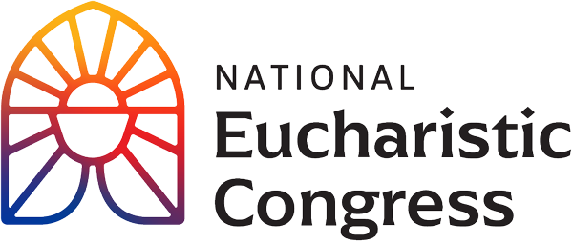

**Parish Small Groups Series**

**Catch the Fire!  
Catch the Love!**

**You are Invited to Enter into this Profound Moment for the Church**The 10th National Eucharistic Congress was a Catholic experience unlike any other, with a historic outpouring of God’s grace. 60,000+ participants of our Catholic family gathered to experience profound, personal renewal through the power of Christ’s love. Like the first Pentecost, may the grace of the Holy Spirit strengthen you in your belief, love and devotion for Jesus, truly present in the Holy Eucharist. You are invited to enter into this Eucharistic Congress through experiencing the evening sessions in the context of a small group at your parish.   
  
**Session 1:** **“From the Four Corners”**

**Opening Night Ceremony**: As the recordings of the Congress begin, the four branches of the National Eucharistic Pilgrimage converge at the venue in a powerful symbol of unity. Gathered as one Church, you will be invited to present your wounded and imperfect heart to the triune God who loves you. Just as He did on the road to Emmaus, Our Lord will listen to your worries and reveal Himself once more in the breaking of the bread.

1. **Introduction to the first Revival Session**, which provides the context and purpose of the Eucharistic Congress with Kathryn Hadro, EWTN host, Fr. Aquinas Builbeau, O.P., chaplain at Catholic University of America and Peter Burak, V.P. of Renewal Ministries.
2. **A short, dramatic video** to welcome Jesus in the Holy Eucharist.
3. **Bishop Cozzens speaks with Jesus** in the Blessed Sacrament exposed on the altar.
4. **Time of silence** Take a few minutes of silence right now to ask Jesus for the grace that you would like to receive for your heart, and for your family. If one thing comes to mind, pray for that. If no specific intention comes to mind, you might use the following: Ask Jesus

for the grace of a deeper experience of His love for you.

**5. Group discussion**

-What was it like for you to see Bishop Cozzens talk to Jesus, like a normal conversation?

-What was the most important point for you from what you have seen thus far? Why did this seem to stand out for you? In light of this, write down something that you would want to pass on to a family member or friend?  
  
-From this takeaway of what moved you the most, how can you use this to help deepen your relationship with Jesus? In other words, in your daily prayer life, what small addition can you add or adjust that is doable and sustainable? Such as good spiritual reading, one page a day, or a weekly 5 min. visit to the Blessed Sacrament for a personal conversation with Jesus.

1. **Keynote by Sr. Bethany Madonna**, Phoenix Local Superior, Sisters of Life
2. **Personal Reflection Questions**  
   “Where is fear holding me back?

Are there places in my life where I have been foolish, clinging to worldly ways, seeking comfort, avoiding the demands of discipleship?

Are there times when I have been slow of heart, dragging my feet, resisting the Lord’s will?

Where am I in need of answers? Where am I without hope?”

Sr. Bethany encourages us to “bring all of it to Jesus, nothing is too much for Him. Ask for His mercy; ask for His grace and then surrender to Him.”

**Closing Prayer** (as prayed by Sr. Bethany) Pray in church is possible

“Holy Spirit, come! Lead us to all truth. Grant us a faith that is not afraid to be bold. Enkindle in us a flame of hope that sets our hearts ablaze with love for You. Father, in the Name of Jesus, we ask that You would raise up saints, prophets, and martyrs to meet the needs of our day, and may we be numbered among them. Amen.”

If you would like to re-watch a segment or the entire session, visit **<https://diolc.org/eucharist/parishioners>** and click the Video: **July 17 Opening Ceremony**.   
Videos are FREE.