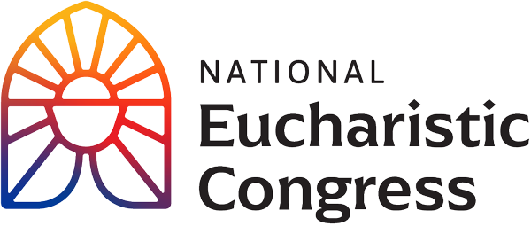

**Parish Small Groups Series**

**Catch the Fire!  
Catch the Love!**

You are invited to open your heart to enter into the experience of the 10th National Eucharistic Congress. “Let us be open to how the Holy Spirit wants to work in each of us, to strengthen us, to form us, and to fill us with missionary zeal. What a consolation this gathering and the fruits of this gathering will be to the Heart of Jesus loving us in the Eucharist. Come, Holy Spirit!”   
Bishop Andrew Cozzens, Chairman of the Board, National Eucharistic Congress, Inc.

Revival Session 2: **“The Greatest Love Story”**

For access to the videos that are part of the Eucharistic Congress series, visit [**https://diolc.org/eucharist/parishioners**](https://diolc.org/eucharist/parishioners) Click the Video: **July 18 Revival Session.**

In this revival session, you’ll encounter the Heart of our God and learn just how much He loves you. Fr. Mike Schmitz will deliver a keynote address.

1. **Introduction to the second Revival Session** with Kathryn Hadro, EWTN host, Fr. Aquinas Builbeau, O.P., chaplain at Catholic University of America and Peter Burak, V.P. of Renewal Ministries. Who told you about Jesus, the Church, the Eucharist?   
   (Beginning of the video to “Who is your life told you about this mystery” at 7:33)   
   (8 minutes)
2. **A personal testimony by Lila Rose** of Live Action of how her life was changed by the Holy Eucharist. Lila is a writer, speak, and activist who has devoted her life to ending abortion and making America a more welcoming place to families. She founded and serves as president of Live Action, a human rights organization.   
   (Begin with intro “This incredible woman who is a mother herself” at 34 minutes and end with “May we ask our Beloved Jesus in the Eucharist to give us the strength to follow His call at 45:53) (12 minutes)
3. **A keynote address by Father Mike Schmitz**, the director of Youth and Young Adult Ministry for the Diocese of Duluth chaplain for the Newman Center, University of Minnesota, Duluth. Father Mike shares The Greatest Love Story.   
   Begin with “It is now my great privilege to introduce one of those extraordinary priests” at 1:49:20 through 2:24:10 and then continue on with the next two parts) 35 min.
4. **Music** starts at2:24:11 and ends at 2:25:52   
   A song is sung that leads to the next part of the session.   
   Sister Miriam Heidland, SOLT leads us to examine what is happening in our heart after hearing Fr. Mike’s presentation. Sister Miriam served as one of the emcees at the Congress. She is an author and Podast host. She leads healing retreats for priests and religious sisters across the nation. Sister Miriam was a former Division I athlete who had a radical conversion and joined the Society of Our Lady of the Most Holy Trinity (SOLT).   
   **Sr. Miriam Heidland invites us to be open to the Holy Spirit**   
   Continue at 2:25:52 with “You are invited to open your heart, and notice what is happening inside you right now.   
   Allow the Holy Spirit to bring to mind an area of your life that you need to repent of.  
   What are the fire extinguishers in your life that put out the fire of God’s love? What do You, Jesus, want me to know about that part of my life?  
   What do you want us to know about Your love, right there? For You are good and kind, and nothing is overwhelming to You, Jesus.  
   Jesus, please give me the grace to receive You; to open my heart to You and turn back to You. Lead me into Your love and be with me in every way.” (2:29.22) 4 minutes
5. **Adoration of the Blessed Sacrament** begins with Pange Lingua – Sing My Tongue – at 2:29:23 Lyrics to the four hymns are provided. Stop after a minutes of silence that follows the end of the hymn “Let All Mortal Flesh Keep Silence” at 2:41:20 18 minutes
6. **Group Discussion** (15 minutes)

-What was the most important point for you from what you have seen thus far? Why did this seem to stand out for you? In light of this, write down something that you would want to pass on to a family member or friend?  
-From this takeaway of what moved you the most, how can you use this to help deepen your relationship with Jesus? In other words, in your daily prayer life, what small addition can you add or adjust that is doable and sustainable? (such as good spiritual reading, one page a day, or a weekly 5 min. visit to the Blessed Sacrament for a personal conversation with Jesus).

**Closing Prayer**Pray an *Our Father* slowly with deep devotion and love from your heart.