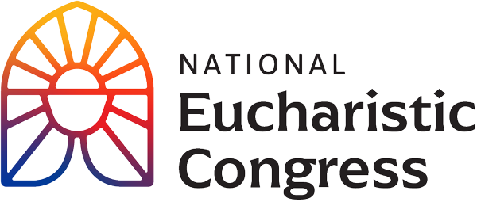

**Parish Small Groups Series**

**Catch the Fire!  
Catch the Love!**

You are invited to open your heart to enter into the experience of the National Eucharistic Congress. “Let us be open to how the Holy Spirit wants to work in each of us, to strengthen us, to form us, and to fill us with missionary zeal. What a consolation this gathering and the fruits of this gathering will be to the Heart of Jesus loving us in the Eucharist. Come, Holy Spirit!”   
Bishop Andrew Cozzens, Chairman of the Board, National Eucharistic Congress, Inc.

Revival Session 2: **“The Greatest Love Story”**

In this revival session, you’ll encounter the Heart of our God and learn just how much He loves you. Fr. Mike Schmitz will deliver the keynote address.

1. **Introduction to the second Revival Session** with Kathryn Hadro, EWTN host, Fr. Aquinas Builbeau, O.P., chaplain at Catholic University of America and Peter Burak, V.P. of Renewal Ministries. ”Who told you about Jesus, the Church, the Eucharist?”
2. **A personal testimony by Lila Rose** of Live Action, how her life was changed by the Holy Eucharist. Lila is a writer, speaker, and activist who has devoted her life to ending abortion and making America a more welcoming place to families. She founded and serves as president of Live Action, a human rights organization.
3. **A keynote address by Father Mike Schmitz**, the director of Youth and Young Adult Ministry for the Diocese of Duluth and chaplain for the Newman Center, University of Minnesota, Duluth. Father Mike shares The Greatest Love Story.   
   “Knowledge can make us great, but only love can make us a saint.”
4. **Music**   
   A song is sung that leads to the next part of the session.   
   Sister Miriam Heidland, SOLT leads us to examine what is happening in our heart after hearing Fr. Mike’s presentation. Sister Miriam served as one of the emcees at the Congress. She is an author and Podast host. She leads healing retreats for priests and religious sisters across the nation. Sister Miriam was a former Division I athlete who had a radical conversion and joined the Society of Our Lady of the Most Holy Trinity (SOLT).   
   **Sr. Miriam Heidland invites us to be open to the Holy Spirit**   
   “You are invited to open your heart, and notice what is happening inside you right now.

Allow the Holy Spirit to bring to mind an area of your life that you need to repent of.

What are the fire extinguishers in your life that put out the fire of God’s love?

What do You, Jesus, want me to know about that part of my life?

What do you want us to know about Your love, right there? For You are good and kind, and nothing is overwhelming to You, Jesus.

Jesus, please give me the grace to receive You; to open my heart to You and turn back to You.

Lead me into Your love and be with me in every way.”

1. **Adoration of the Blessed Sacrament** begins with Pange Lingua – Sing My Tongue. Lyrics to the four hymns are provided on the handout.
2. **Group Discussion**

-What was the most important point for you from what you have seen thus far? Why did this seem to stand out for you? In light of this, write down something that you would want to pass on to a family member or friend?  
-From this takeaway of what moved you the most, how can you use this to help deepen your relationship with Jesus? In other words, in your daily prayer life, what small addition can you add or adjust that is doable and sustainable? (such as good spiritual reading, one page a day, or a weekly 5 min. visit to the Blessed Sacrament for a personal conversation with Jesus).

**Closing Prayer**Pray an *Our Father* slowly, with deep devotion and love for Our Heavenly Father, from your heart.

If you would like to re-watch a segment or the entire session, visit [**https://diolc.org/eucharist/parishioners**](https://diolc.org/eucharist/parishioners) and click the Video: **July 18 Revival Session.**