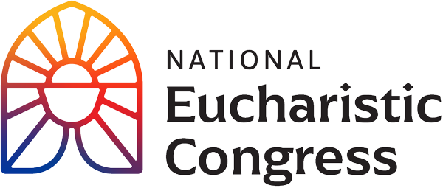

**Parish Small Groups Series**

**Catch the Fire!  
Catch the Love!**

**This is a moment of great hope for the Church.**

“The Eucharistic Revival is a work of the Holy Spirit. Ask for the Holy Spirit to come.   
This is a very difficult time in our country and in our society. A society, in so many ways, that is living without God. Jesus is the only answer to the questions of the human heart. He is the only One who can actually heal our heart. He is the only One who can heal our country.   
The goal of the Eucharistic Revival is to invite people to encounter Jesus in the Eucharist because He is alive in the Eucharist. This is the way He has chosen to give Himself to us…. This is a moment of great hope for the Church.”  
Bishop Andrew Cozzens, Chairman of the Board, National Eucharistic Congress, Inc.

Session 3: **“Into Gethsemane”**Experience redemptive healing from the effects of sin as two dynamic speakers implore you to recognize our brokenness as humans, and ask God to heal and unite us through prayer.

For access to the videos that are part of the Eucharistic Congress series, visit **<https://diolc.org/eucharist/parishioners>.** Click the **Video:** July 19 Revival Session. Videos are FREE.

1. **Introduction to the third Revival Session**, with Kathryn Hadro, EWTN host, Fr. Aquinas Builbeau, O.P., chaplain at Catholic University of America and Peter Burak, V.P. of Renewal Ministries. The focus of the session is being with the Lord in Gethsemane: Will you stay awake and spend one hour with Me? (See Matthew 26:40-41)

(Beginning of the video to 13:20 Stop the video with the words: “A man called the Help Line and said he watched the Congress Holy Hour and now intends to return to the Church after being away many years…. The Holy Spirit is working.) (14 minutes)

1. **Intro of a personal testimony by Sr. Miriam Heidland, SOLT**Begin at 58:08 with “I want to show you a video of someone who struggled with addiction” and continue through Jeff’s testimony 1:03:12 (5 min.)  
   Note: Continue the video through the end of Sr. Josephine Garrett’s talk at 1:40:50.)
2. **Sr. Josephine Garrett** was born and raised Baptist in Houston, Texas, and entered the Catholic Church after college. In 2011, she began her religious formation with the Sisters of the Holy Family of Nazareth. She is a nationally certified and licensed counselor and serves as a Catholic school counselor in Tyler, Texas.   
   (1:04:39 – 1:40:50 the full presentation) (36 minutes)
3. **Group discussion** (15 min)  
   -What was the most important point for you from what you have seen thus far? Why did this seem to stand out for you? In light of this, write down something that you would want to pass on to a family member or friend?
4. **Time of prayer led by** **Fr. Boniface Hicks O.S.B. prays to Jesus** in the Blessed Sacrament exposed on the altar.  
   Each participate is to receive the Litany of Prayer. Participants may listen and respond to Fr. Boniface or read along using the handout.  
   Fr. Boniface has been a monk of Saint Vincent Archabbey since 1998. He is a Catholic priest and serves as both the Director of Spiritual Formation and Director of the Institute for Ministry Formation at St. Vincent Seminary.  
   (Begin the video as Fr. Boniface prays “Jesus, I believe in You. Jesus, I believe in Your real presence in the Eucharist” at 2:06:39 and stop the video with the words “Fill each of our hearts as we worship you and receive you in all your love in this Holy Eucharist. We make this prayer in your name, Jesus Christ our Lord. Amen” at 2:18:24 (12 minutes).
5. **Personal Reflection:**

How were you affected by praying this Litany? Choose two invocations and the response that stirred you and include them in your prayer this next week. (5 min.)

1. **Closing Prayer in church (if convenient)**

Holy Spirit, come! Lead us to all truth. Grant us a faith that is not afraid to be bold. Enkindle in us a flame of hope that sets our hearts ablaze with love for You. Father, in the Name of Jesus, we ask that You would raise up saints, prophets, and martyrs to meet the needs of our day, and may we be numbered among them. Amen.